https://www.1formatik.com/2541/comment-modifier-lespacement-entre-les-lignes-en-html

https://www.w3schools.com/html/html_blocks.asp

https://www.w3schools.com/html/tryit.asp?filename=tryhtml_block_div

https://openclassrooms.com/forum/sujet/gerer-lespacement-entre-2-champs-sur-meme-ligne

https://www.w3schools.com/tags/att_input_list.asp

https://www.w3schools.com/tags/tryit.asp?filename=tryhtml5_datalist

https://www.w3schools.com/tags/tryit.asp?filename=tryhtml5_datalist

https://developer.mozilla.org/fr/docs/Web/HTML/Element/Input/color

https://www.toutjavascript.com/faq/index.php3?ID=84

https://www.w3schools.com/html/html_styles.asp

https://forums.commentcamarche.net/forum/affich-2505944-html-couleur-de-fond-dans-un-bloc

https://www.delftstack.com/fr/howto/html/html-button-with-image/

padding in lists make space between lists element

margin in lists make space between if you have a background

:first-of-type

paddinf in spacxe between element and chnou dakhle fih

margin about the page

div {

margin-bottom: 10px;

}

label {

display: inline-block; to align input

width: 150px;

text-align: right;

}

input{

text-align:start;

display: block;

}

label{

float: left;

width: 120px; other method

text-align: left;

}

<p class="formfield">

<label for="taxt" class="ok">Alamat:</label> to align label midlle textarea

<textarea name="taxt"></textarea><br>

</p>

.formfield * {

vertical-align: middle;

}

padding-inline-start: 5px; to control text padding

<div class="text-center">

<button type="submit">Submit</button> to put button middle of page

</div>

.text-center {

text-align: center;

}

margin-right: 8px;

margin-bottom: 8px; space between elem in a flex

box-sizing:border-box ( for padding)

position: absolute;

left: 0px; au haut a gauche

top: 0px;

<select>

<option hidden>Menu</option>

</select>

<input type="radio" id="html" name="fav_language" value="HTML">

<label for="html">HTML</label><br>

<input type="radio" id="css" name="fav_language" value="CSS">

<label for="css">CSS</label><br>

<input type="radio" id="javascript" name="fav_language" value="JavaScript">

<label for="javascript">JavaScript</label>

/* Container holding the image and the text */

.container {

position: relative;

text-align: center;

color: white;

}

/* Bottom left text */

.bottom-left {

position: absolute;

bottom: 8px;

left: 16px;

}

/* Top left text */

.top-left {

position: absolute;

top: 8px;

left: 16px;

}

/* Top right text */

.top-right {

position: absolute;

top: 8px;

right: 16px;

}

/* Bottom right text */

.bottom-right {

position: absolute;

bottom: 8px;

right: 16px;

}

/* Centered text */

.centered {

position: absolute;

top: 50%;

left: 50%;

transform: translate(-50%, -50%);

}

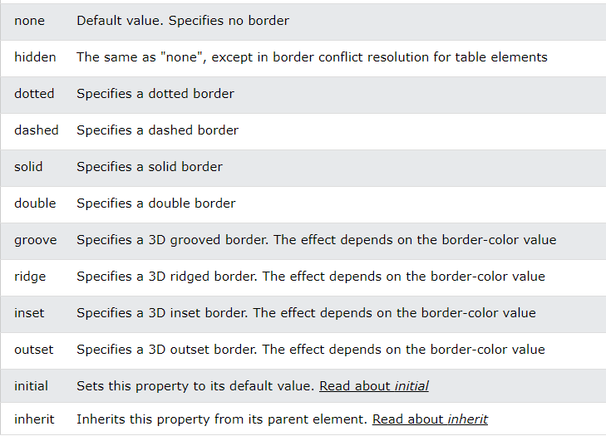

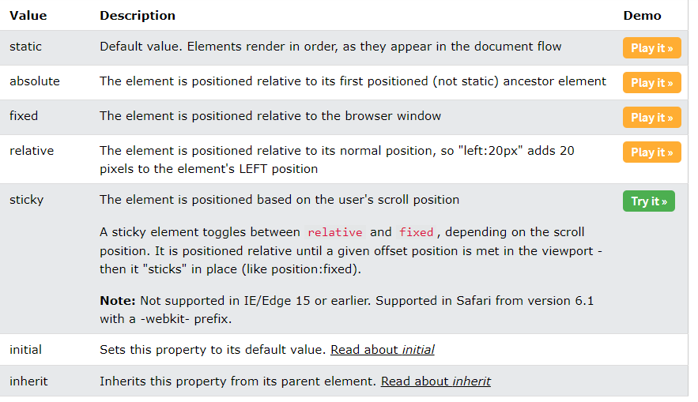

<ul>  
  <li>Coffee</li>  
  <li>Tea</li>  
  <li>Milk</li>  
</ul>

<dl>  
  <dt>Coffee</dt>  
  <dd>- black hot drink</dd>  
  <dt>Milk</dt>  
  <dd>- white cold drink</dd>  
</dl>

<ul>

<li><a href="#home">Home</a></li>

<li><a href="#news">News</a></li>

<li><a href="#contact">Contact</a></li>

<li><a href="#about">About</a></li>

</ul>

ul {

list-style-type: none;

margin: 0;

padding: 0;

overflow: hidden;

background-color: #333333;

}

li {

float: left;

}

li a {

display: block;

color: white;

text-align: center;

padding: 16px;

text-decoration: none;

}

li a:hover {

background-color: #111111;

}

<form>  
  <input type="radio" id="html" name="fav_language" value="HTML">  
  <label for="html">HTML</label><br>  
  <input type="radio" id="css" name="fav_language" value="CSS">  
  <label for="css">CSS</label><br>  
  <input type="radio" id="javascript" name="fav_language" value="JavaScript">  
  <label for="javascript">JavaScript</label>  
</form>

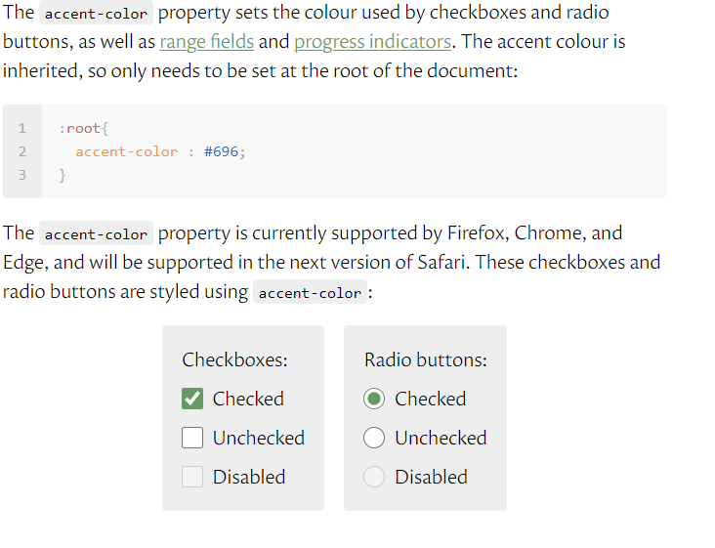

Start=””