Java script :

How to know if a checkbox is chekcked ?

<!DOCTYPE html>

<html>

<body>

<p>Display some text when the checkbox is checked:</p>

<label for="myCheck">Checkbox:</label>

<input type="checkbox" id="myCheck" onclick="myFunction()">

<p id="text" style="display:none">Checkbox is CHECKED!</p>

<script>

function myFunction() {

var checkBox = document.getElementById("myCheck");

var text = document.getElementById("text");

if (checkBox.checked == true){

text.style.display = "block";

} else {

text.style.display = "none";

}

}

</script>

</body>

</html>

How to know which radio button is chekcked ?

<div id="rates">

<input type="radio" id="r1" name="rate" value="Fixed Rate"> Fixed Rate

<input type="radio" id="r2" name="rate" value="Variable Rate"> Variable Rate

<input type="radio" id="r3" name="rate" value="Multi Rate" checked="checked"> Multi Rate

</div>

var rates = document.getElementsByName('rate');

var rate_value;

for(var i = 0; i < rates.length; i++){

if(rates[i].checked){

rate_value = rates[i].value;

}

}

Arrays

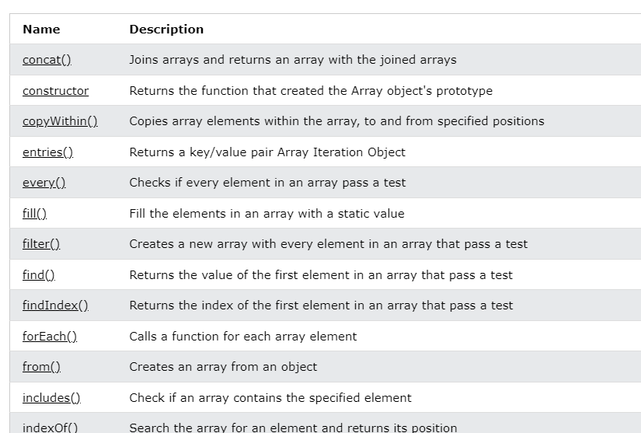

Funtion .trim()

Enleve les espaces

Get selected option in select element

var yourSelect = document.getElementById( "your-select-id" );

alert( yourSelect.options[ yourSelect.selectedIndex ].value )

Put mouse on an element

document.getElementById(frmObj.id).focus();

document.getElementById(frmObj.id).select();

Trouver un caractere

indexOf() retourne la position du premier caractère trouvé, et s'il n'y en a pas la valeur -1 est retournée.

var myString = 'Le JavaScript est plutôt cool';

var result = myString.indexOf('JavaScript');

if (result > -1) {

alert('La chaîne contient le mot "Javascript" qui débute à la position ' + result);

}

Vérifier si une chaine est un nombre

En [javascript](http://dev.petitchevalroux.net/javascript/index.html" \o "javascript) la **fonction isNaN()** (pour Is Not A Number) permet de **tester** si une **chaine de caractères** est un **nombre**.