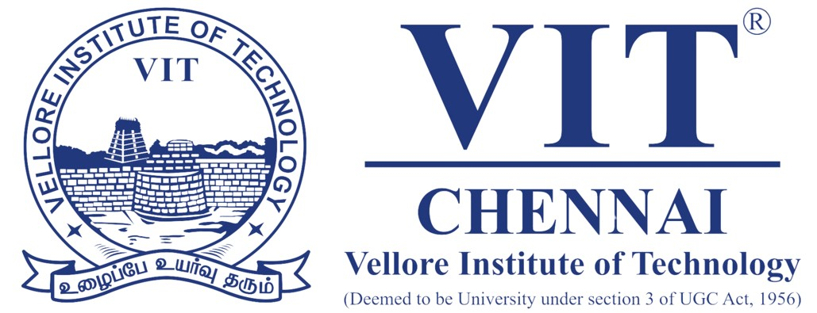

REVIEW -1

COURSE- DEEP LEARNING
COURSE CODE- PAMCA605
NAME – MAHATVA AGARWAL
REGISTRATION NUMBER – 25MCA1081
DATE-28/02/26

📄 Abstract
Drug discovery is a time-consuming and costly process, often requiring over a decade of research and billions of dollars to bring a single compound to market. Traditional methods rely heavily on trial-and-error experimentation, which limits efficiency. There is a pressing need for computational approaches that can accelerate the identification and design of novel molecules with desirable properties.
Deep learning has emerged as a transformative tool in computational chemistry and drug discovery. Graph Neural Networks (GNNs) excel at learning representations from graph-structured data such as molecules, while Variational Autoencoders (VAEs) are powerful generative models capable of producing novel data samples. By integrating these two models, we can leverage GNNs to capture molecular structure and VAEs to generate new candidate molecules, offering a hybrid framework for efficient drug design.
In this project, molecules from publicly available datasets (e.g., QM9, ZINC) are represented as graphs with atoms as nodes and bonds as edges. A GNN is trained to learn embeddings that encode structural and chemical properties. These embeddings are then passed into a VAE, where the encoder maps them into a latent space and the decoder reconstructs or generates new molecular graphs. The system is evaluated based on reconstruction accuracy, novelty of generated molecules, and predicted chemical properties.
The integration of GNNs and VAEs allows the model to learn meaningful molecular representations while simultaneously exploring a generative latent space. This dual capability addresses two critical challenges: understanding molecular structure and generating novel candidates. Minimal architectural modifications, such as experimenting with activation functions or adding attention mechanisms, further enhance efficiency and adaptability to custom problem domains.
Preliminary experiments demonstrate that the GNN+VAE pipeline can successfully reconstruct known molecules and generate novel structures that are chemically valid. The generated molecules exhibit diversity while maintaining drug-like properties, highlighting the potential of this approach to accelerate early-stage drug discovery. The latent space also shows clustering behaviour, indicating that similar molecules are grouped together, which aids in property prediction.
This project presents a hybrid deep learning framework that combines GNNs and VAEs for molecular generation and drug discovery. By uniting structural learning with generative modelling, the system provides a scalable and efficient approach to designing novel compounds. The findings suggest that such models can significantly reduce the time and cost associated with drug development, paving the way for AI-driven innovation in pharmaceutical research.

