Curriculum – Vitae
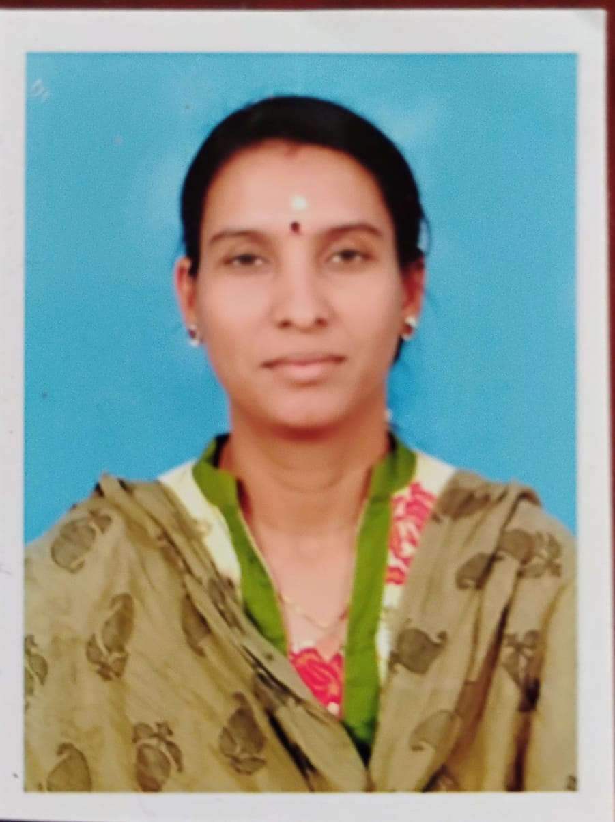
S.Mahalakshmi
12,Kamatchi Nagar First Street,
Kovaipudur,
Coimbatore-42
Email: mahatvr@gmail.com
Mobile No : +91-9790372277 / 8248237023

OBJECTIVE:

To achieve a challenging position, which would continuously challenge my skills , abilities and knowledge, thereby to share my ideas with others and to work with full dedication and sincerity in an esteemed organization that offers professional growth while being resourceful , Innovative and flexible.

PROFESSIONAL SUMMARY:

- I have Six year of Experience in teaching
- Having Two year of Work Experience in Information Technology.

WORK EXPERIENCE:

- CBM College of Arts and Science ,,Coimabtore Jul’24 – Till Date
Working as Software Trainer and BOSCH BRIDGE Soft Skill Trainer

- Kalvi Thunai ,Pachapalayam,Coimabtore Oct‘16 – Aug’22
Working as Software Trainer and BOSCH BRIDGE Soft Skill Trainer

- Daze Technologies, Kovaipudur, Coimbatore Feb‘12- Aug’13
Working as Chief Software Trainer and BDM

- A J K –College of arts and science,Coimbatore June‘07- May’08
Worked as lecturer.

- Lashron Technologies, Chennai May’06 – Oct’06
Software Engineer Trainee
Worked as a Software Engineer Trainee in Lashron Technologies, Chennai.

- Thiru VI.KA Government arts College , Tiruvarur Sep’05 – Apr’06
Worked as a lecturer in department of Computer science

PROJECT EXPERIENCE:

- NAT-V Soft-Tech, Chennai Dec’04 – Apr‘05
Software Engineer Trainee
CERTICATION:
- Soft Skill Trainer from BOSCH India Pvt Ltd
- NSQF – Level-5 Trainer from MEPSC

SOFTWARE SKILLS:

Operating System : Windows
Languages : C, C++,Java.
Database : Oracle8i,MS Access
Web Designing : HTML,ASP,ASP.Net,PHP,Frame Works
Packages : MS- Office, Visual Basic
Scripting Languages : Java Script.
ACADEMIC QUALIFICATION:

- Mphil in Computer science from Periyar university in April 2007 .

- MCA from A.V.C College (Autonomous) Mayiladuthurai, Bharathidasan University with First Class with distinction 80.08% in April 2005.

- B.Sc(Computer Science) from Rabiammal Ahamed Maideen,College For Women Tiruvarur, Bharathidasan University with First Class with distinction 79. 59 % in April 2002.

- Completed B.Ed in St.Mark’s College Of Education , Tamilnadu Teacher Education Universitywith First Class with distinction 78.8 % in May 2014.

- HSC Passed in First Class, 51.92% from Sri GRM Girls Higher Secondary School Tiruvarur in April 1999.

- SSLC Passed in First Class, 72.80% from ST.Joseph Girls Higher Secondary School Mannargudi in April 1997.

PROJECT DETAILS:

1. Project Title : School Management System.
Technologies : ASP.Net with Oracle
Team Size : Two

Project description:It is a complete package for school management. It covers all areas of the school management from tracking of applications form, admission entries, maintaining student records, staff details, academic performance records of students, attendance of a particular for staff and student. This package also helps staff to prepare timetable and monitor distribution of books and uniforms.
2. Project Title : Database Extractor and Interface Publishing.
Technologies : ASP.NET, ADO.NET, and XML.
Team Size : one.
Client : NAT-V Soft-Tech, Chennai.

Project description:

This Product covers all database conversions and Separate Modules for offline mail to branch Office and Head - Office Operations. Easy, Effective, More Secure and better then the Existing System.
3. Project Title : Tamilnadu Tourism.
Technologies : Javascript,Vbscript,ASP
Team Size : one

Project description:
This project has useful for people who are interested to visiting Tamilnadu.This project gives information like fact file , restaurant and important phone numbers ,etc. This project includes Feedback which is used to further development of website.
PERSONAL PROFILE:

Name : S.Mahalakshmi
Gender : Female
Date of Birth : 01-04-1982
Marital Status : Married
Husband’s Name : Mr.M.R.Raja Sekar
Address : 12,Kamatchi Nagar First Street,
Kovaipudur,
Coimbatore-42
Tamilnadu, India.

DECLARATION:

I hereby declare you that the information given above is true to the best of my knowledge and belief.

PLACE: Coimbatore
Yours Faithfully
DATE : S.Mahalakshmi

