
TECHWIZ 7
APTECH GARDEN
PROJECT DOCUMENTATION
BUDGET BASICS
Student Expense Tracker & Financial Literacy Web Application
TEAM MEMBERS
1. M. AMAN
2. MAHAVEER
3. LUKSH
4. TALHA
5. KASHAN

SUBMISSION DATE
26/09/2026
Prepared according to the supplied Project Report Document Template

Document Information
Item | Details
Project / Application | Budget Basics / Outlay — Student Expense Tracker
Institute | APTECH GARDEN
Team | TECHWIZ 7
Team Members | M. AMAN; MAHAVEER; LUKSH; TALHA; KASHAN
Document Version | 1.0
Submission Date | 26/09/2026
Source Basis | Supplied student expenses ZIP + supplied Project Report Document Template

Scope note: This report documents the implemented React/Vite project in the supplied ZIP. Where the source does not establish a fact, the report labels the point as unspecified or notes the limitation rather than inventing project details.

Contents
• 1. Executive Summary & Problem Definition
• 1.1 Project Title & Overview
• 1.2 Problem Statement
• 1.3 Proposed Solution
• 2. System Architecture & Information Flow
• 2.1 Information Architecture & Sitemap
• 2.2 System Architecture & Information Flow
• 2.3 User Journey / Operational Flow
• 3. Functional & System Specifications
• 3.1 Functional Requirements Matrix
• 3.2 Module-by-Module System Specifications
• 3.3 Data Model & Storage
• 4. Hardware, Software & Development Requirements
• 4.1 Development & Operational Hardware
• 4.2 Software Environment & Technical Tooling
• 5. Non-Functional Quality Attributes
• 6. Implementation & Installation Setup
• 6.1 Installation Steps (Mandatory Run Guide)
• 6.2 Project Directory & Component Structure
• 6.3 Configuration and Deployment Notes
• 7. Test Data & Validation Scenarios
• 7.1 Sample Test Data Configurations
• 7.2 Validation Coverage
• 7.3 Verification Notes & Known Limitations
• 8. AI Usage Statement & Declarations
• 9. Deliverables Verification Checklist
• Appendix A — Source Inventory
• Appendix B — Data Dictionary & Key Calculations
• Appendix C — Viva / Demonstration Flow

1. Executive Summary & Problem Definition

1.1 Project Title & Overview
• Project Title: BUDGET BASICS — Student Expense Tracker & Financial Literacy Web Application.
• Project Domain / Category: Student financial literacy, personal budgeting, savings awareness, and expense tracking.
• Platform Type: Responsive client-side Single Page Application (SPA) built with React and Vite.
• Package Name: outlay (defined in package.json).
• Application Title in HTML: Budget Basic – Expense Tracker.
• Version: 1.0.
The project combines an educational budgeting website with an interactive expense-planning workspace. The application contains a landing page, authentication interface, protected dashboard, educational modules, calculators, quizzes, search/filtering, infographics, feedback, theme switching, visitor tracking, and a local FAQ/chat assistant.

1.2 Problem Statement
Students commonly need to understand basic financial concepts while managing limited day-to-day spending. A learning-only site does not show the practical effect of expenses, while a tracker-only interface may not explain why a spending choice matters. Budget Basics addresses this combined need by placing budgeting education and lightweight expense tracking in the same browser application.
The supplied implementation deliberately avoids a backend database. Expense records, the selected currency, the monthly budget, theme preference, and selected session information are handled in browser storage. The system therefore works as a local educational/demo tracker rather than a bank-grade financial platform.

1.3 Proposed Solution
The proposed solution gives a student a simple flow from learning to action: understand budgeting concepts, set a monthly target, record expenses, review daily/weekly/monthly totals, and use learning tools to improve financial decisions. The same interface also offers goal planning, a needs-versus-wants quiz, common money-mistake guidance, and an FAQ assistant.
• Primary user: student / beginner personal-budget user.
• Core operations: create expense, store expense, summarize spending, analyze spending, and delete transaction.
• Learning operations: read budgeting concepts, classify needs/wants, calculate a 50-30-20 split, calculate savings-goal time, browse mistakes/infographics, and search learning content.
• Persistence: localStorage and sessionStorage in the browser.
• Backend/API: none identified in the supplied source.
Important source observation: The landing-page copy describes local expense records as “encrypted”, but the supplied source code stores JSON directly in localStorage and does not implement an encryption routine. The report therefore documents browser-local storage as the actual implementation and treats encryption as not implemented.

2. System Architecture & Information Flow

2.1 Information Architecture & Sitemap
React Router provides client-side navigation. The application is divided into public educational routes, an authentication route, and a protected dashboard route. PageLayout supplies common navigation, footer, and back-to-top behavior for most content pages.
Route | Module | Purpose
/ | Landing Page | Hero section, four-step overview, features, FAQs, global navigation.
/auth | Authentication | Sign In / Sign Up UI; writes a local user object to browser storage.
/dashboard | Financial Dashboard | Monthly budget, expense entry, summaries, analytics, and transaction deletion; protected by ProtectedRoute.
/budgeting-basics | Budgeting Basics | Key terms, sample student monthly budget, knowledge check.
/needs-vs-wants | Needs vs Wants | Eight-item interactive classification quiz with score and feedback.
/50-30-20-rule | 50-30-20 Rule | Income-based Needs, Wants, Savings calculator.
/savings-goals | Savings Goals | Goal, target, current savings, monthly contribution and time-to-goal calculator.
/money-mistakes | Money Mistakes | Accordion list of common mistakes, scenarios, and corrective actions.
/infographics | Infographics | Topic filtering for basics, budgeting, and savings.
/search | Search | Keyword search, topic filter, and A-Z sorting across three local content datasets.
/about | About / Contact | Project purpose, feedback form, contact information.
/sitemap | Sitemap | List of main site links.

Figure 1 below shows the high-level architecture and the direction in which user actions move through React, route modules, browser storage, and static JSON datasets.
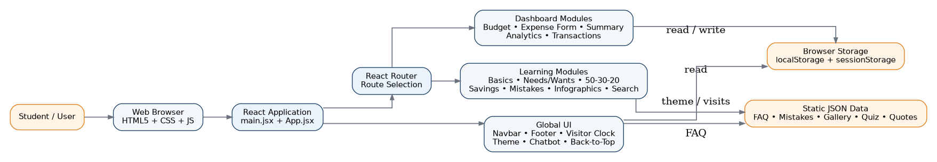
Figure 1 — High-Level System Architecture & Information Flow

2.2 System Architecture & Information Flow
Layer | Technology / Mechanism | Project Evidence / Responsibility
Presentation Layer | HTML5, JSX, CSS, React components | Navbar, Hero, Footer, forms, cards, analytics bars, quizzes, accordions and chat widget.
Application Layer | React functional components and hooks | useState/useEffect/useMemo, event handling, client-side calculations and dynamic rendering.
Routing Layer | React Router DOM | BrowserRouter + Routes + Route; ProtectedRoute for /dashboard.
State / Persistence Layer | localStorage + sessionStorage | Expenses, budget, currency, theme, user/session and visit counter.
Content Layer | Static JSON | FAQ, quotes, money mistakes, infographics, and needs-vs-wants quiz items.
Build / Dev Layer | Vite + React plugin | Development server, build command, and preview command.

2.3 User Journey / Operational Flow
The application supports two broad journeys: a learning journey through the educational pages and a tracking journey through the authenticated dashboard. The tracking path validates expense input before persisting it and then recalculates summary/analytics views.
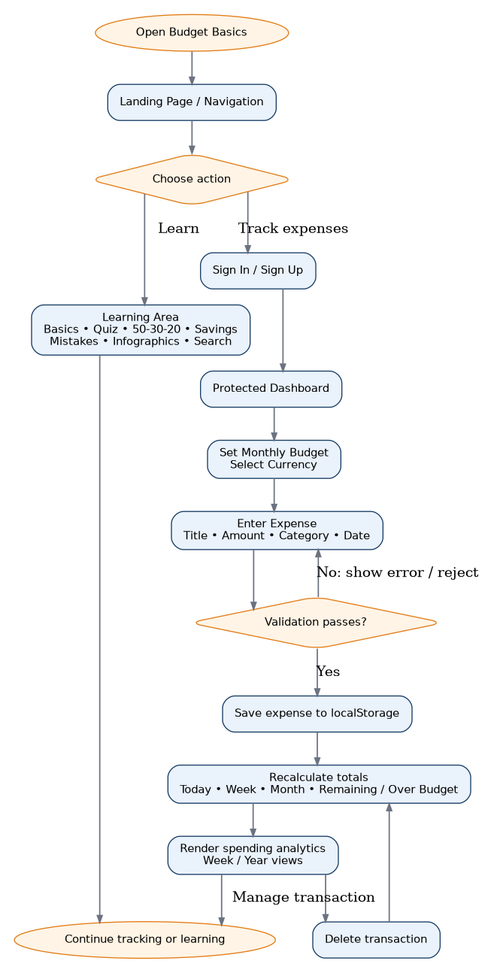
Figure 2 — User Journey and Expense Tracking Flow

3. Functional & System Specifications

3.1 Functional Requirements Matrix
ID | Module Name | Functional Description | Implementation Approach
FR-01 | Landing & Navigation | Displays the main landing page, navigation links, hero actions, feature overview, FAQs, and footer navigation. | React components + React Router + CSS.
FR-02 | Financial Learning Hub | Presents budgeting basics, needs/wants education, money-mistake guidance, infographics, search, and learning content. | Reusable PageLayout + page components + local JSON datasets.
FR-03 | Authentication UI | Provides Sign In and Sign Up modes, validates required fields, creates a local user object, and routes to the dashboard. | React state + localStorage user record; no server authentication.
FR-04 | Protected Dashboard | Checks localStorage for outlay_user before rendering the dashboard. | ProtectedRoute + Navigate.
FR-05 | Budget Planner | Allows a monthly budget target and currency selection. | React state + localStorage persistence.
FR-06 | Expense Entry | Captures title, amount, category, and date; rejects invalid or future-dated entries. | ExpenseForm validation + client-side object creation.
FR-07 | Spending Summary | Calculates today, current week, current month, remaining budget or over-budget amount. | SummaryCards + date comparisons + arithmetic.
FR-08 | Spending Analytics | Shows seven-day weekly bars or January–December current-year bars, with percentage widths relative to the target budget. | Dashboard derived statistics + dynamic bar rendering.
FR-09 | Transaction Management | Lists recent transactions newest-first and permits deletion. | ExpenseList + parent state filtering.
FR-10 | 50-30-20 Calculator | Calculates 50% Needs, 30% Wants, and 20% Savings from a positive monthly income. | Client-side arithmetic + validation.
FR-11 | Savings Goals | Calculates remaining amount, estimated months, and percentage progress. | Client-side validation + Math.ceil + progress bar.
FR-12 | Needs vs Wants Quiz | Presents eight items, records answers, updates score, provides explanations, and supports restart. | React state + needsVsWantsItems.json.
FR-13 | Search & Filter | Combines three content datasets and filters by query/topic; supports A-Z sorting. | useMemo + array filter/sort.
FR-14 | Infographics Filter | Filters four gallery records by all/basics/budgeting/savings. | React state + array filtering.
FR-15 | Feedback & Contact | Validates name, email, rating and comments; shows session-only confirmation. | Regex email check + React state.
FR-16 | FAQ / Q&A Assistant | Matches user input against four predefined FAQ records and returns a matched or fallback response. | Local JSON + keyword/phrase matching.
FR-17 | Theme Switching | Toggles light/dark theme and persists preference. | ThemeContext + localStorage + document class.
FR-18 | Visitor Clock | Displays date/time and increments a browser visit counter once per session. | setInterval + localStorage + sessionStorage.
FR-19 | Back to Top | Appears after scrolling and smoothly returns to page top. | scroll event + window.scrollTo.

3.2 Module-by-Module System Specifications
Module | System Specification
Landing Page | Hero + “How it works” + key advantages + FAQ + footer. Primary actions route to Sign Up and Sign In.
Authentication | Two modes. Required email/password are checked client-side; Sign Up additionally requires name. User information is stored under outlay_user and dashboard navigation follows.
Dashboard | Loads outlay_user, outlay_currency, outlay_target_budget and outlay_expenses. Provides budget control, SummaryCards, ExpenseForm, analytics toggle and ExpenseList.
ExpenseForm | Currency options: PKR, USD, EUR. Categories: Food, Transport, Shopping, Bills, Other. Date is limited to today or earlier. Amount must be > 0 and title/date are required.
SummaryCards | Calculates Today’s Spend, This Week, This Month, and either Remaining Budget or Over Budget. Week is constructed around the current Sunday–Saturday week.
ExpenseList | Copies and sorts transactions by descending date. Shows category icon, title, category/date, amount, and a delete action.
Budgeting Basics | Contains six key concepts, a sample monthly budget totaling rs15,000 income, and a simple Needs/Wants knowledge check.
Needs vs Wants | Loads eight JSON quiz items; shows one item at a time, updates score for correct answers, explains the answer, and supports restart.
50-30-20 Rule | Validates positive income and derives three allocations from 50/30/20 percentages.
Savings Goals | Validates goal name, positive target, non-negative current savings, and positive monthly contribution. Shows remaining amount, months, and progress.
Money Mistakes | Loads five mistake scenarios and toggles each accordion item open/closed.
Infographics | Loads four gallery cards and filters by all/basics/budgeting/savings.
Search | Combines 5 money mistakes + 4 infographics + 8 needs/wants items = 17 searchable records. Query checks title and description; topic filtering and A-Z sorting are supported.
Feedback / Contact | Validates required name, valid email pattern, rating, and comments. Successful submission only changes current-page state.
Chatbot | Starts with a greeting, stores chat messages in component state, performs simple keyword/phrase matching against 4 FAQ entries, and shows an educational fallback response.
Theme / Global UI | ThemeContext persists light/dark mode. VisitorClock updates every second and tracks a per-session visit count. BackToTop becomes visible after 400px scroll.

3.3 Data Model & Storage

3.3.1 Expense Object
Field | Type | Purpose
id | string | Unique client-generated identifier using Date.now().toString().
title | string | Expense title/description entered by the user.
amount | number | Positive numeric amount.
category | string | Food, Transport, Shopping, Bills, or Other.
date | string | Selected expense date in YYYY-MM-DD format.
createdAt | string | ISO timestamp created when the record is added.

3.3.2 Browser Storage Keys
Key | Storage | Purpose
outlay_user | localStorage | User name, email and authTime used by dashboard protection/UI.
outlay_expenses | localStorage | Serialized expense array.
outlay_currency | localStorage | Selected currency symbol/string.
outlay_target_budget | localStorage | Monthly budget target.
outlay_theme | localStorage | light/dark theme preference.
budgetbasics_visits | localStorage | Visitor counter value.
budgetbasics_session_counted | sessionStorage | Prevents multiple visit increments during one session.

3.3.3 Static JSON Datasets
File | Records | Use
chatbotFaq.json | 4 | FAQ / Q&A assistant.
financialQuotes.json | 6 | Financial tips/quotes dataset; QuotesTicker component exists but its App import is commented out.
infographicsGallery.json | 4 | Infographic gallery.
moneyMistakes.json | 5 | Common money mistakes and fixes.
needsVsWantsItems.json | 8 | Quiz items, correct category, and explanation.

4. Hardware, Software & Development Requirements

4.1 Development & Operational Hardware
• Processor: The project does not specify a minimum CPU model. A modern computer capable of running Node.js and a contemporary browser is sufficient for development.
• System Memory: No project-specific RAM requirement is defined in the source. Actual requirements depend on the editor, browser, and development tooling used.
• Display Output: A modern browser display is required. index.html includes responsive viewport metadata.
• Storage Space: Exact disk capacity is not specified. The application source is small, but development also requires npm dependencies.

4.2 Software Environment & Technical Tooling
• Frontend: React 18.3.1 + React DOM 18.3.1.
• Routing: React Router DOM 7.18.4.
• Build Tool: Vite 6.0.7 with @vitejs/plugin-react 4.3.4.
• Language: JavaScript / JSX with React functional components and hooks.
• Styling: Plain CSS files per module/page; no Bootstrap/Tailwind dependency is present in package.json.
• Data Storage: Browser localStorage/sessionStorage and static JSON resources.
• External Services: No backend, database, payment gateway, or external AI API is identified in the supplied source.
• Run commands defined by package.json: npm run dev, npm run build, npm run preview.

4.3 Runtime / Browser Capabilities
The application relies on standard browser features including ES modules, localStorage, sessionStorage, Date/Intl APIs, DOM events, and client-side routing. It should therefore be tested in a current browser with these capabilities enabled.

5. Non-Functional Quality Attributes
Quality Attribute | Project-specific Observation
Usability | Clear navigation labels, form labels, summary cards, validation messages, educational notes, and single-purpose tools support straightforward student workflows.
Responsiveness | The HTML includes viewport metadata and CSS organizes pages with flexible grids and layouts designed for web use.
Performance | Most operations are local: calculations, filtering, sorting and storage do not require network round-trips.
Maintainability | The project separates pages, components, CSS, context and JSON data, making individual features easier to locate and update.
Data locality | Expense data remains in browser storage and is not posted to a server by the supplied code.
Accessibility support | Form labels and selected aria-label/title attributes are present for key controls, including chatbot and transaction deletion.
Reliability | The source contains validation for expense amounts/dates, savings-goal inputs, budget income, and feedback fields.
Security limitations | The authentication UI is client-side only. Passwords are not stored or verified against a backend. localStorage is not encrypted by the supplied implementation.
Scalability limitation | Because there is no backend database, data is tied to the browser/device storage and is not designed for multi-device synchronization.

Implementation consistency note: The landing-page text says “custom tags”, but ExpenseForm currently exposes five fixed categories only: Food, Transport, Shopping, Bills, and Other.

6. Implementation & Installation Setup

6.1 Installation Steps (Mandatory Run Guide)
1. Extract the supplied submission ZIP archive to a local development folder.
2. Open the application folder that contains index.html, package.json, vite.config.js, and the src/ directory.
3. Install dependencies with: npm install
4. Start the development server with: npm run dev
5. Open the local URL displayed by Vite in a modern web browser.
6. For a production build, run: npm run build
7. For a local preview of a production build, run: npm run preview.
Clean-install recommendation: The supplied ZIP includes node_modules. For another machine, run npm install from the project folder instead of depending on the archived node_modules directory, because native/optional packages can be platform-specific.

6.2 Project Directory & Component Structure
Path / File | Role
index.html | HTML entry point and document title; loads src/main.jsx.
package.json | Project metadata, React/Router dependencies, and Vite scripts.
package-lock.json | NPM lock file for dependency resolution.
vite.config.js | Vite React plugin configuration.
src/main.jsx | Creates the React root, StrictMode, ThemeProvider, and App.
src/App.jsx | Global BrowserRouter, route definitions, VisitorClock and ChatbotWidget.
src/components/ | Navbar, Footer, PageLayout, Hero, HowItWorks, ProtectedRoute, ExpenseForm, ExpenseList, SummaryCards, ChatbotWidget, VisitorClock, BackToTop and related CSS.
src/pages/ | Landing, Auth, Dashboard, Budgeting Basics, Needs/Wants, 50-30-20, Savings Goals, Money Mistakes, Infographics, Search, About/Contact and Sitemap.
src/context/ | ThemeContext for light/dark theme state and persistence.
src/data/ | JSON datasets for FAQ, quotes, gallery, mistakes and quiz items.
src/style/ | Shared content-page styling.
public/ | logo.png, favicon.svg and icons.svg.

6.3 Configuration and Deployment Notes
• The application is a Vite SPA; normal development uses npm run dev.
• The deployment target must serve the built SPA entry point and support client-side route fallback to index.html when direct navigation is used.
• No runtime environment variables are required by the supplied source.
• No database migration or server configuration is required because the supplied implementation uses browser storage and static JSON.
• For a clean build on a target system, install dependencies fresh with npm install and then run npm run build.

7. Test Data & Validation Scenarios

7.1 Sample Test Data Configurations
ID | Scenario | Test Input | Expected Behavior | Basis
TC-01 | Expense title validation | Leave Title blank; Amount 500; Date today | Validation message “Please enter an expense title.”; expense must not be added. | Source-verified
TC-02 | Expense amount validation | Title Lunch; Amount -100 | Validation message for amount > 0; expense must not be added. | Source-verified
TC-03 | Future-date validation | Title Taxi; Amount 500; Date tomorrow | Alert rejects the future-dated expense. | Source-verified
TC-04 | Valid expense creation | Lunch / 500 / Food / today | A new expense object is created, inserted at the beginning, and persisted through the Dashboard state/localStorage effect. | Source-verified
TC-05 | 50-30-20 calculator | Income = 15,000 | Needs = 7,500; Wants = 4,500; Savings = 3,000. | Logic calculation
TC-06 | Savings goal calculator | Target 50,000; Current 5,000; Monthly 3,000 | Remaining = 45,000; Months = 15; Progress = 10%. | Logic calculation
TC-07 | Needs/Wants quiz | Answer all eight items | Correct answers increment score; explanation appears; final score is shown; restart returns to item 1. | Source-verified
TC-08 | Search/filter | Query “saving”; topic “savings”; sort A-Z | Matching records are filtered; A-Z sorts by title. | Source-verified
TC-09 | Feedback validation | Blank name; malformed email; no rating; blank comments | Field-level validation messages are shown. | Source-verified
TC-10 | Theme persistence | Switch light → dark → refresh | Theme stored in outlay_theme and restored by ThemeContext. | Source-verified
TC-11 | Visitor session counting | Reload pages in same session | Visit count should increase once for the session because sessionStorage marks the session as counted. | Source-verified
TC-12 | Dashboard budget state | Set monthly budget = 40,000 and add expenses | Summary and analytics use the stored target budget in client-side calculations. | Source-verified

7.2 Validation Coverage
Area | Validation Rule | Status
Authentication | Required email/password; name required in Sign Up mode. | Client-side only.
Expense amount | parseFloat + amount > 0. | Implemented.
Expense date | Rejects dates after today; date required. | Implemented.
Savings target | Positive numeric target. | Implemented.
Current savings | Must not be negative. | Implemented.
Monthly contribution | Must be greater than zero. | Implemented.
Feedback name | Non-empty trimmed value. | Implemented.
Feedback email | Regex /^[^\s@]+@[^\s@]+\.[^\s@]+$/. | Implemented.
Feedback rating/comments | Both required. | Implemented.
Search | Query/topic filters; no-result message. | Implemented.

7.3 Verification Notes & Known Limitations
The source code was inspected for route definitions, module logic, data structures, validation rules, storage keys, and calculations. A full production build was not successfully completed from the archived node_modules in this Linux environment because the package contains a platform-specific Rollup optional dependency set and its Vite launcher lacked executable permission. This is an environment/package-archive issue, not evidence that the project source itself is invalid.
• Recommended final verification: remove or ignore archived node_modules on the target machine, run npm install, then run npm run build.
• Authentication is localStorage-based and therefore does not provide server-side account verification.
• Feedback submission is session-only; the form does not POST data to a service.
• Dashboard supports add/delete transactions but does not implement an edit-transaction workflow.
• There is no multi-user backend or cloud synchronization.
• The in-app “AI Q&A Assistant” is rule-based FAQ matching and should not be described as an external generative AI service.

8. AI Usage Statement & Declarations
The supplied application includes a component named “AI Q&A Assistant”. Its implementation reads chatbotFaq.json and performs simple keyword/phrase matching to select one of four predefined educational responses. There is no external model API, API key, server endpoint, or SDK for an external AI provider in the supplied project source.
• UI/UX & Asset Generation: No specific external design or AI asset-generation tool is identified in the supplied project source.
• Code & Logic Structuring: No specific external coding-assistance tool is identified in the supplied project source.
• In-application assistance: chatbotFaq.json provides four predefined Q/A records and the ChatbotWidget selects a response by keyword/phrase matching.
• Declaration: This report records tool/AI usage that can be established from the supplied source. Unrecorded development-time usage cannot be verified from the ZIP.

8.1 AI Assistant Logic Flow
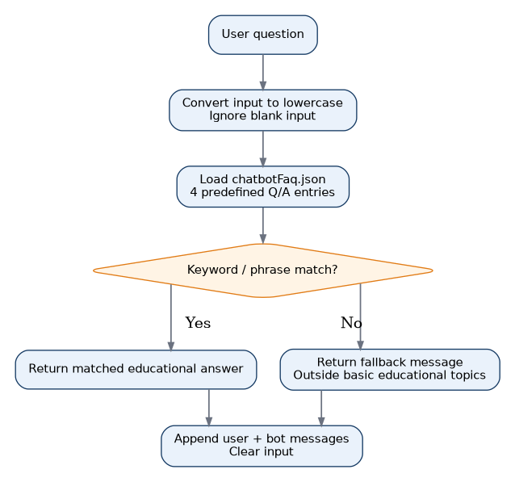
Figure 3 — Rule-Based FAQ / Q&A Assistant Logic Flow

9. Deliverables Verification Checklist
Status | Deliverable | Verification
✓ | Complete Project Source Code ZIP Archive | Supplied and inspected.
✓ | Formal Documentation Project Report | This completed report.
✓ | Project-specific First / Cover Page | Included in this report with TECHWIZ 7, APTECH GARDEN, title, team members and submission date.
— | Technical ReadMe File | README.md is present in the project tree but contains no substantive deployment instructions.
— | Video Demonstration Recording (.mp4) | No .mp4 video was identified in the supplied project archive.
✓ | Test Datasets & Static Configuration Files | JSON datasets are present under src/data/.

Submission note: The template lists a technical ReadMe and video as expected deliverables. They are marked according to the actual supplied ZIP contents rather than being assumed present.

Appendix A — Source Inventory
The following inventory summarizes the implementation files relevant to documentation. “Present” means the file was found in the supplied project tree.
Path / Group | Status | Documented Role / Observation
src/App.jsx | Present | Global routing and widgets.
src/main.jsx | Present | React bootstrap and ThemeProvider.
src/components/AuthPage.jsx | Present | Duplicate/alternate auth component exists; route currently imports src/pages/AuthPage.jsx.
src/components/ProtectedRoute.jsx | Present | Dashboard route guard.
src/components/ExpenseForm.jsx | Present | Expense creation and validation.
src/components/ExpenseList.jsx | Present | Transaction rendering/deletion.
src/components/SummaryCards.jsx | Present | Today/week/month/remaining summary logic.
src/components/ChatbotWidget.jsx | Present | FAQ keyword-matching chat.
src/context/ThemeContext.jsx | Present | Theme persistence.
src/pages/*.jsx | Present | Primary application pages.
src/data/*.json | Present | Static datasets.
public/logo.png | Present | Project logo displayed in navbar/footer and included on this report cover.
README.md | Present | File exists but contains no substantive text.

Appendix B — Data Dictionary & Key Calculations

B.1 50-30-20 Rule
The BudgetSplit page applies the following client-side formulas when monthly income is a positive number:
• Needs = Monthly Income × 0.50
• Wants = Monthly Income × 0.30
• Savings = Monthly Income × 0.20
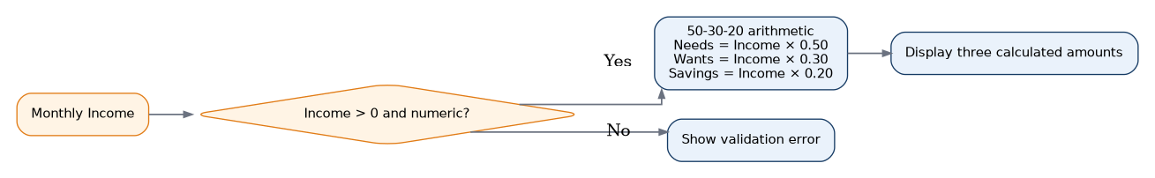
Figure 4 — 50-30-20 Calculator Flow

B.2 Savings Goal Formula
• Remaining = max(Target − Current Savings, 0)
• Estimated Months = ceil(Remaining ÷ Monthly Contribution)
• Progress % = min((Current Savings ÷ Target) × 100, 100)
Example from the implemented placeholders: Target 50,000; Current 5,000; Monthly Contribution 3,000 → Remaining 45,000; 15 months; 10% current progress.

B.3 Dashboard Summary Formula
• Today’s Spend = sum of expenses whose date equals today.
• This Week = sum of expenses whose date is within the current Sunday–Saturday set generated by the code.
• This Month = sum of expenses whose date begins with the current YYYY-MM prefix.
• Remaining Budget = max(Monthly Budget − This Month, 0).
• When monthly spending exceeds the budget, the fourth summary card shows the Over Budget amount instead of Remaining Budget.

B.4 Search and Filter Flow
Figure 5 — Search, Topic Filter and A-Z Sorting Flow

Appendix C — Viva / Demonstration Flow
A practical project demonstration can follow the same implemented navigation and logic used in the source code:
1. Open the landing page and explain the purpose of Budget Basics.
2. Show the navigation and explain the educational modules.
3. Open Sign Up / Sign In and explain client-side authentication behavior.
4. Enter the dashboard, set the monthly budget, and choose a currency.
5. Add a valid expense and show the transaction list updating.
6. Explain Today / Week / Month / Remaining-or-Over-Budget calculations.
7. Switch the analytics view between Week and Year and explain the bar calculation.
8. Open Budgeting Basics and show the sample budget + knowledge check.
9. Demonstrate the 50-30-20 calculator and the Savings Goals calculator.
10. Demonstrate the Needs vs Wants quiz, Money Mistakes accordion, Infographics filter, and Search page.
11. Open the FAQ assistant and show a supported question such as “What is a need?”
12. Toggle dark mode and refresh to demonstrate theme persistence.
13. Show the Feedback page and demonstrate validation with invalid and then valid input.
Viva limitation statement: For an accurate explanation, describe the application as a client-side educational expense tracker. Do not claim a server database, encrypted local storage, external AI model, or real financial-service integration because these are not implemented in the supplied source.

