Technical System Documentation
for
Quality Council of India: SAMAR Certification Portal
22nd July 2026

Document control
Version | Date | Author | Reviewer | Approver | Change Description
1.0 | 22-Jul-2026 | Webority Technologies | Webority Technologies | Webority Technologies | Initial version.

Contents
Document control 2
Contents 3
1. Introduction 7
1.1 Purpose 7
1.2 Scope 7
1.3 Out of scope 7
1.4 Intended audience 8
1.5 Definitions and acronyms 8
1.6 A note on precision 9
2. System overview 10
2.1 What SAMAR does 10
2.2 The four applications 10
2.3 Who uses the system 11
2.4 The certification journey end to end 13
2.5 Two sectors, one process 14
3. Functional architecture 15
3.1 Registration and onboarding 15
3.2 Building an application 16
3.3 The application lifecycle 16
3.4 DRDO approval 18
3.5 Fees and payment 19
3.6 Allocating the assessment 21
3.7 Conducting the assessment 21
3.8 The assessment lifecycle 22
3.9 Quality check 26
3.10 The rating committee 26
3.11 Certificates 27
3.12 Notifications 28
3.13 Support tickets 28
3.14 Audit trail 28
3.15 Reports and dashboards 29
3.16 What QCI can configure 29
4. Roles and access 31
4.1 How access is decided 31
4.2 The nine roles 31
4.3 What each role can do in the portal 32
4.4 Where each role starts 34
5. Technical architecture 36
5.1 Shape of the system 36
5.2 The API 36
5.3 The web portal 37
5.4 The assessor mobile application 38
5.5 The applicant mobile application 40
5.6 Patterns used across the system 40
5.7 Technology 41
6. Data architecture 43
6.1 The core entities 43
6.2 The questionnaire 45
6.3 How an assessment is scored 46
6.4 Keeping organisations apart 47
6.5 Retention and deletion 47
7. Security 48
7.1 Signing in 48
7.2 Sessions and tokens 48
7.3 Resetting a password 49
7.4 Protecting data in transit 50
7.5 Protecting data at rest 50
7.6 Limiting abuse 50
7.7 Traceability 51
8. The API 52
8.1 Conventions 52
8.2 Authentication endpoints 52
8.3 Endpoints by module 53
8.4 Public endpoints 54
8.5 Error handling 54
9. External integrations 56
9.1 ICICI EazyPay 56
9.2 Business Central 57
9.3 Zoho Desk 59
9.4 Email 59
9.5 Configuration 59
10. Glossary 61
Appendix A: API endpoints by module 63
Appendix B: Core entities 64
Appendix C: Role capability matrix 65
Applications and certificates 65
Assessments 66
Organisations, units and users 67
Master data and system 67
Support tickets 68
Appendix D: Screens 68
Web portal 68
Assessor mobile application 69
Applicant mobile application 70
Appendix E: Email templates 70
Appendix F: Reference data 72
Appendix G: State reference 73
Application states 73
Assessment states 73
Payment states 74
Certificate states 74

1. Introduction

1.1 Purpose
This document describes the SAMAR Certification Portal as it is built. It records what the system does, how it is put together, how the certification workflow runs from a vendor's first registration through to an issued certificate, and how it connects to the payment gateway, the ERP and the support desk.
It is written so that a reader who has never seen the source code can understand the system's behaviour, and so that a technically fluent reader can follow its architecture and data model without opening a repository. Where a rule is enforced by the software rather than by policy, this document says so, because those are the rules that cannot be varied without a change request.

1.2 Scope
The document covers:
- The business context of the SAMAR scheme and the four applications that deliver it.
- Every functional module, including the application and assessment lifecycles, fee calculation, on-site assessment execution, quality check, rating committee, and certificate issuance.
- The nine user roles and what each can do.
- Technical architecture of the API, the web portal and both mobile applications, including the offline design used by assessors in the field.
- The data model and the assessment scoring method.
- Authentication, authorisation and the wider security design.
- The API surface and its conventions.
- The four external systems SAMAR integrates with.

1.3 Out of scope
Hosting, server infrastructure, environments, deployment procedure, release pipelines and day-to-day operations are not covered here. Those remain with Webority Technologies under the ongoing engagement and are documented separately. This document describes what the software is and does, not where it runs.
Commercial terms, project plans and support arrangements are likewise out of scope.

1.4 Intended audience
Two readers are assumed. A QCI project owner who needs to understand what the system does, who uses it and how the certification process is enforced will find that in sections 2 to 4. A technical reviewer who needs architecture, data design, security posture and integration behaviour will find that in sections 5 to 9. Each section opens in plain language before going into detail, so the first reader can stop where the second one starts.

1.5 Definitions and acronyms
Term | Meaning
SAMAR | The certification scheme this system administers. Vendors supplying the defence and aerospace sector are assessed against a published questionnaire and awarded a rating level.
QCI | Quality Council of India, the body that owns and runs the SAMAR scheme.
DRDO | Defence Research and Development Organisation. Approves applications and consumes the certified vendor register.
Applicant | The vendor organisation seeking certification.
Enterprise | An applicant organisation as recorded in the system. One enterprise may hold several units.
Unit | A single site or facility belonging to an enterprise. Certification is granted per unit, not per enterprise.
Assessor | A qualified individual who conducts the on-site or remote assessment.
Lead assessor | The assessor accountable for an assessment. Allocates parameters, runs the meetings and submits the assessment.
Co-assessor | A further assessor on the team, responsible for the parameters allocated to them.
Rating committee | The panel that reviews a completed assessment and decides whether to certify.
Parameter | A group of assessment questions covering one subject. The unit of allocation to an assessor and the unit of scoring.
Discipline | The top level of the questionnaire. Groups related parameters.
SAMAR ID | The identifier every user signs in with. Email addresses are not login credentials.
Sector | Whether an application is assessed as manufacturing or as a service. The two follow the same lifecycle with different questionnaires.
API | Application Programming Interface. The service the web portal and mobile applications call to do everything.
JWT | JSON Web Token. The signed credential a client presents on each request after signing in.
OTP | One-time password. A six-digit code sent by email to confirm identity.
ERP | Enterprise Resource Planning. Here, Microsoft Dynamics 365 Business Central, which raises invoices and receipts.
GST | Goods and Services Tax, applied to the certification fee.
TDS | Tax Deducted at Source, which an applicant may elect where the fee configuration permits it.

1.6 A note on precision
Every behaviour described here was verified against the running source code rather than taken from earlier design notes. Where an older internal document described something that the software does differently, this document follows the software. Numbers such as fee rates, validity periods and attempt limits are the values the system actually applies; several are configurable by a System Admin, and those are identified where they appear.

2. System overview

2.1 What SAMAR does
A vendor that wants to supply the defence and aerospace sector needs a credible, independent statement of how well it is run. SAMAR provides that. A vendor registers, describes the site it wants assessed, pays the certification fee, and is then visited by a QCI-appointed assessment team. The team scores the site against a published questionnaire. A rating committee reviews the result and, if satisfied, certifies the site at a rating level from 1 to 5.
The portal exists because that process has a lot of moving parts and several parties who each see a different slice of it. The applicant needs to submit and track. DRDO needs to approve who enters the scheme and to consult the register afterwards. QCI operations staff need to allocate assessors, run quality checks and convene committees. Assessors need to work on a factory floor where there is often no mobile signal. All of it has to be auditable, because a certificate carries weight.
Certification is granted to a unit, not to a company. An enterprise with four factories runs four assessments and holds four certificates. A certificate is valid for three years by default, and the system opens a recertification window before it expires.

2.2 The four applications
The system is one service with three front ends. Everything the front ends do goes through a single API, which owns the rules, the data and the connections to outside systems. Nothing writes to the database except the API.
Application | Who uses it | What it is for
SAMAR API | No direct users | Holds all business rules, workflow, scoring and data. Talks to the payment gateway, ERP, support desk and email service.
Web portal | All eight staff and applicant roles | The main working surface. Applications, approvals, allocation, quality check, committee meetings, certificates, master data and reporting.
Assessor mobile app | Assessors | Used on site to run the assessment. Works fully offline and synchronises when a connection returns.
Applicant mobile app | Applicant staff | Lets an applicant view their applications and supply site photographs.

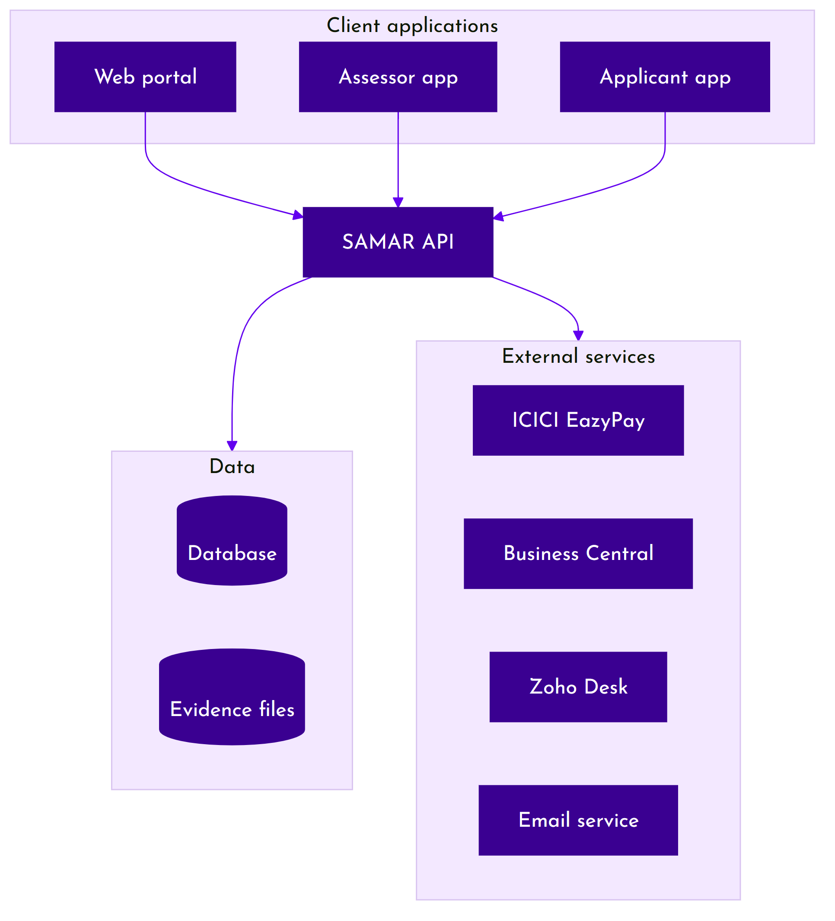
Figure 1: System context

2.3 Who uses the system
There are nine roles. Eight are held by people; the ninth is a machine account used by the ERP connection and is never signed into by a human. Section 4 sets out what each role can do.
Role | Belongs to | In one line
System Admin | QCI | Owns master data, the questionnaire, fee configuration and user administration across the whole system.
DRDO Admin | DRDO | Approves or rejects applications entering the scheme, and verifies organisations.
DRDO Lab | DRDO | Reads the certified vendor register. No write access anywhere.
Operations Manager | QCI | Allocates assessment teams and performs the quality check on completed assessments.
Operations Admin | QCI | Processes applications day to day, runs rating committee meetings and records committee decisions.
Assessor | QCI panel | Conducts assessments. Sees only the assessments they are assigned to.
Enterprise Admin | Applicant | The applicant's main account. Creates units, submits applications, pays, and manages its own users.
Unit Admin | Applicant | Works on applications for the specific units assigned to them.
ERP Integration | Machine | Used by Business Central to return invoice and receipt files. One endpoint, no interface.

Which role works in which application:
Role | Web portal | Assessor app | Applicant app
System Admin | Yes | No | No
DRDO Admin | Yes | No | No
DRDO Lab | Yes | No | No
Operations Manager | Yes | No | No
Operations Admin | Yes | No | No
Assessor | Yes | Yes | No
Enterprise Admin | Yes | No | Yes
Unit Admin | Yes | No | Yes
ERP Integration | No | No | No

Note: The ERP Integration role has no interface. It is used only by Business Central to return invoice and receipt files to the system.

2.4 The certification journey end to end
The stages below are what an applicant experiences. Each is expanded in section 3.
Stage | What happens | Who acts
1. Register | The vendor registers, confirms a one-time password sent by email, and receives a SAMAR ID and password. | Applicant
2. Set up the enterprise | Company details, statutory documents and one or more units are recorded. | Enterprise Admin
3. Build the application | A five-step form captures the unit, its products or services, processes, suppliers and declarations. | Enterprise Admin or Unit Admin
4. Submit | The application is locked for editing and sent onward. | Enterprise Admin or Unit Admin
5. DRDO approval | Where the scheme requires it, DRDO approves or rejects the application. Rejection is final. | DRDO Admin
6. Pay | The system calculates the fee, the applicant pays through the gateway, and the ERP raises an invoice and receipt. | Enterprise Admin or Unit Admin
7. Allocate | An assessment is created automatically on payment. A lead assessor, any co-assessors and the dates are set. | Operations Manager
8. Assess | The team works through the site: parameter allocation, photographs, opening meeting, site tour, data capture, scoring and closing meeting. | Assessors
9. Quality check | The completed assessment is reviewed. It is either approved or sent back with per-question comments. | Operations Manager
10. Rating committee | The assessment is put before a committee, which may adjust scores, send it back, or certify. | Operations Admin and committee
11. Certify | A certificate is generated with a rating level, a validity period and a publicly verifiable number. | System
12. Renew | Before expiry the recertification window opens and the unit may apply again. | Applicant

2.5 Two sectors, one process
An application is either manufacturing or service. Both follow the same lifecycle, the same fee model, the same quality check and the same committee. They differ in what is captured and what is asked.
 | Manufacturing | Service
What is described | Products, raw materials, bought-out parts, key processes, stores and production capacity. | Services offered, key resources, outsourced components and key processes.
Extra classification | None beyond vendor category. | A service provider type: annual maintenance contract, critical service provider, or civil works contractor.
Questionnaire | Selected by sector, enterprise size and vendor category. | Selected by the same three, plus service provider type.
Assessment mode | On-site visit. | Conducted remotely, and a meeting link is mandatory when the assessment is scheduled.
Certificate scope | Recorded as Manufacturing. | Recorded as Service.

3. Functional architecture
This section describes what the system does, module by module, in the order an application passes through them.

3.1 Registration and onboarding
A vendor registers themselves. They supply an organisation name, a contact name, an email address and optionally a mobile number. No password is chosen at this point. The system creates the organisation and a first user, generates a six-digit one-time password and emails it.
When the code is confirmed, the system generates the account password, activates the user as Enterprise Admin for the new organisation, and emails the SAMAR ID together with the password. From then on the SAMAR ID is the login credential. Email addresses are not used to sign in and are not required to be unique.
A SAMAR ID looks like SAMAR-040226-1: a fixed prefix, the account creation date, and the account number. Every user in the system has one, including assessors and QCI staff, who are created by an administrator rather than self-registering and receive their credentials by email.
Before an organisation can submit anything it has to complete its profile. The system checks for the PAN, the GST registration and the certificate of incorporation, and refuses submission until all three are present.

Units
Certification applies to a unit. A unit is created from the address entered when an application is started: the system matches that address to an existing unit or creates a new one, so units come into being through the application rather than being registered separately beforehand. An Enterprise Admin assigns each unit's Unit Admin, and a Unit Admin sees only the units recorded against their account. A unit may hold only one live application at a time, which prevents duplicate assessments of the same site.

3.2 Building an application
Applications are created through a five-step form. Manufacturing and service applications use different forms because they capture different things, but both produce the same kind of application record.
Step | Manufacturing captures | Service captures
1. Enterprise | Organisation details, statutory registrations and the unit being assessed. | Same.
2. Operations | Key processes, outsourced processes, stores and production capacity. | Key processes, outsourced processes and key resources.
3. Products or services | Products, raw materials and bought-out parts. | Services offered and outsourced components.
4. Declarations | Vendor category, DRDO vendor stores, third-party certifications and customer references. | Vendor category, service provider type, DRDO vendor labs and customer references.
5. Review | A read-only summary before submission. | Same.

Work in progress is saved as a draft and can be returned to. Draft is the only state in which an application can be edited, and the only state from which it can be deleted.
Each application is given a number of the form SAMAR-482-0726, combining a sequence number with the month and year. The number is generated when the draft is created, not at submission, so it can be quoted in correspondence from the outset.

3.3 The application lifecycle
An application moves through seven states. Two of them are final.
State | What it means | Editable
Draft | Being prepared by the applicant. The only editable state. | Yes
DRDO approval pending | Submitted and awaiting a DRDO decision. | No
Payment pending | Cleared to pay, either because DRDO approved it or because approval is not required. | No
Payment completed | Fee received. An assessment record now exists and awaits a team. | No
In progress | The assessment has been scheduled. The whole assessment runs inside this one application state. | No
Certified | Final. A certificate has been issued. | No
Rejected | Final. DRDO declined the application. | No

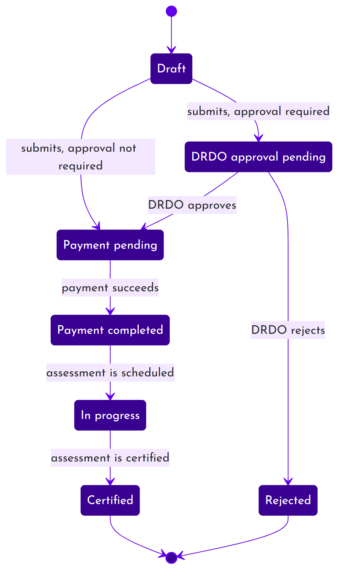
Figure 2: Application lifecycle
Who can move an application, and what has to be true first:
From | To | Triggered by | Conditions
Draft | DRDO approval pending | Enterprise Admin or Unit Admin | Organisation profile complete, and the scheme requires DRDO approval.
Draft | Payment pending | Enterprise Admin or Unit Admin | Organisation profile complete, and the scheme does not require DRDO approval.
DRDO approval pending | Payment pending | DRDO Admin | Approval recorded, with remarks.
DRDO approval pending | Rejected | DRDO Admin | Rejection recorded, with a reason. Final.
Payment pending | Payment completed | The system | A payment has been confirmed as successful.
Payment completed | In progress | The system | Follows automatically once the assessment is scheduled.
In progress | Certified | The system | Follows automatically once the assessment is certified and a certificate exists.

Note: Whether DRDO approval is required at all is a system-wide setting a System Admin controls, not a per-application choice.
Every move is recorded with the previous state, the new state, who made it, the role they held, any remarks, and the time. That history is what an audit of a certificate decision would follow.

3.4 DRDO approval
Where the scheme requires it, a submitted application waits for a DRDO Admin to approve or reject it. Approval releases the application for payment and stamps the approval time and remarks. Rejection is final: the application cannot be revived, and the applicant would have to start a new one. Both outcomes email the applicant.

3.5 Fees and payment

How the fee is worked out
The fee depends on two things about the applicant: the sector and the size band of the enterprise. Together they select a rate card. Each rate card holds a base certification fee, a food and accommodation charge that covers the assessment visit, the GST rate, and whether that card permits a TDS deduction.
The calculation runs in this order:
1. Take the base certification fee and add the food and accommodation charge. That is the amount payable.
2. Apply GST to the amount payable.
3. If the applicant has elected TDS and the rate card permits it, calculate TDS on the amount payable, before GST.
4. The total is the amount payable, plus GST, less any TDS.
Only two TDS rates are accepted, 2% and 10%. Any other value is refused. If an applicant elects TDS on a rate card that does not permit it, the election is ignored rather than rejected.

The rate card
The rates currently loaded are the same for both sectors:
Enterprise size | Base certification fee | Food and accommodation | Amount payable | GST at 18% | Total
Startup | ₹30,000 | ₹2,000 | ₹32,000 | ₹5,760 | ₹37,760
Micro | ₹35,000 | ₹2,000 | ₹37,000 | ₹6,660 | ₹43,660
Small | ₹40,000 | ₹2,000 | ₹42,000 | ₹7,560 | ₹49,560
Medium | ₹45,000 | ₹2,000 | ₹47,000 | ₹8,460 | ₹55,460
Large | ₹50,000 | ₹2,000 | ₹52,000 | ₹9,360 | ₹61,360

Note: All amounts are excl. GST until the GST column, which applies GST at 18%. TDS is not enabled on any rate card as currently configured, so the total column is what an applicant pays today.
A System Admin or Operations Admin can change the base fee, the food and accommodation charge, the GST rate and the TDS switch for any sector and size combination through the portal. The two sectors, the five size bands, the two permitted TDS rates and the calculation itself are fixed in the software and would need a change request.

Paying
The applicant is quoted the fee, confirms, and is sent to ICICI EazyPay. The system recalculates the fee at that moment rather than trusting the figure the browser holds, and stores the full breakdown against the payment. That snapshot is what appears on the invoice, so a later change to the rate card cannot alter a payment already made.
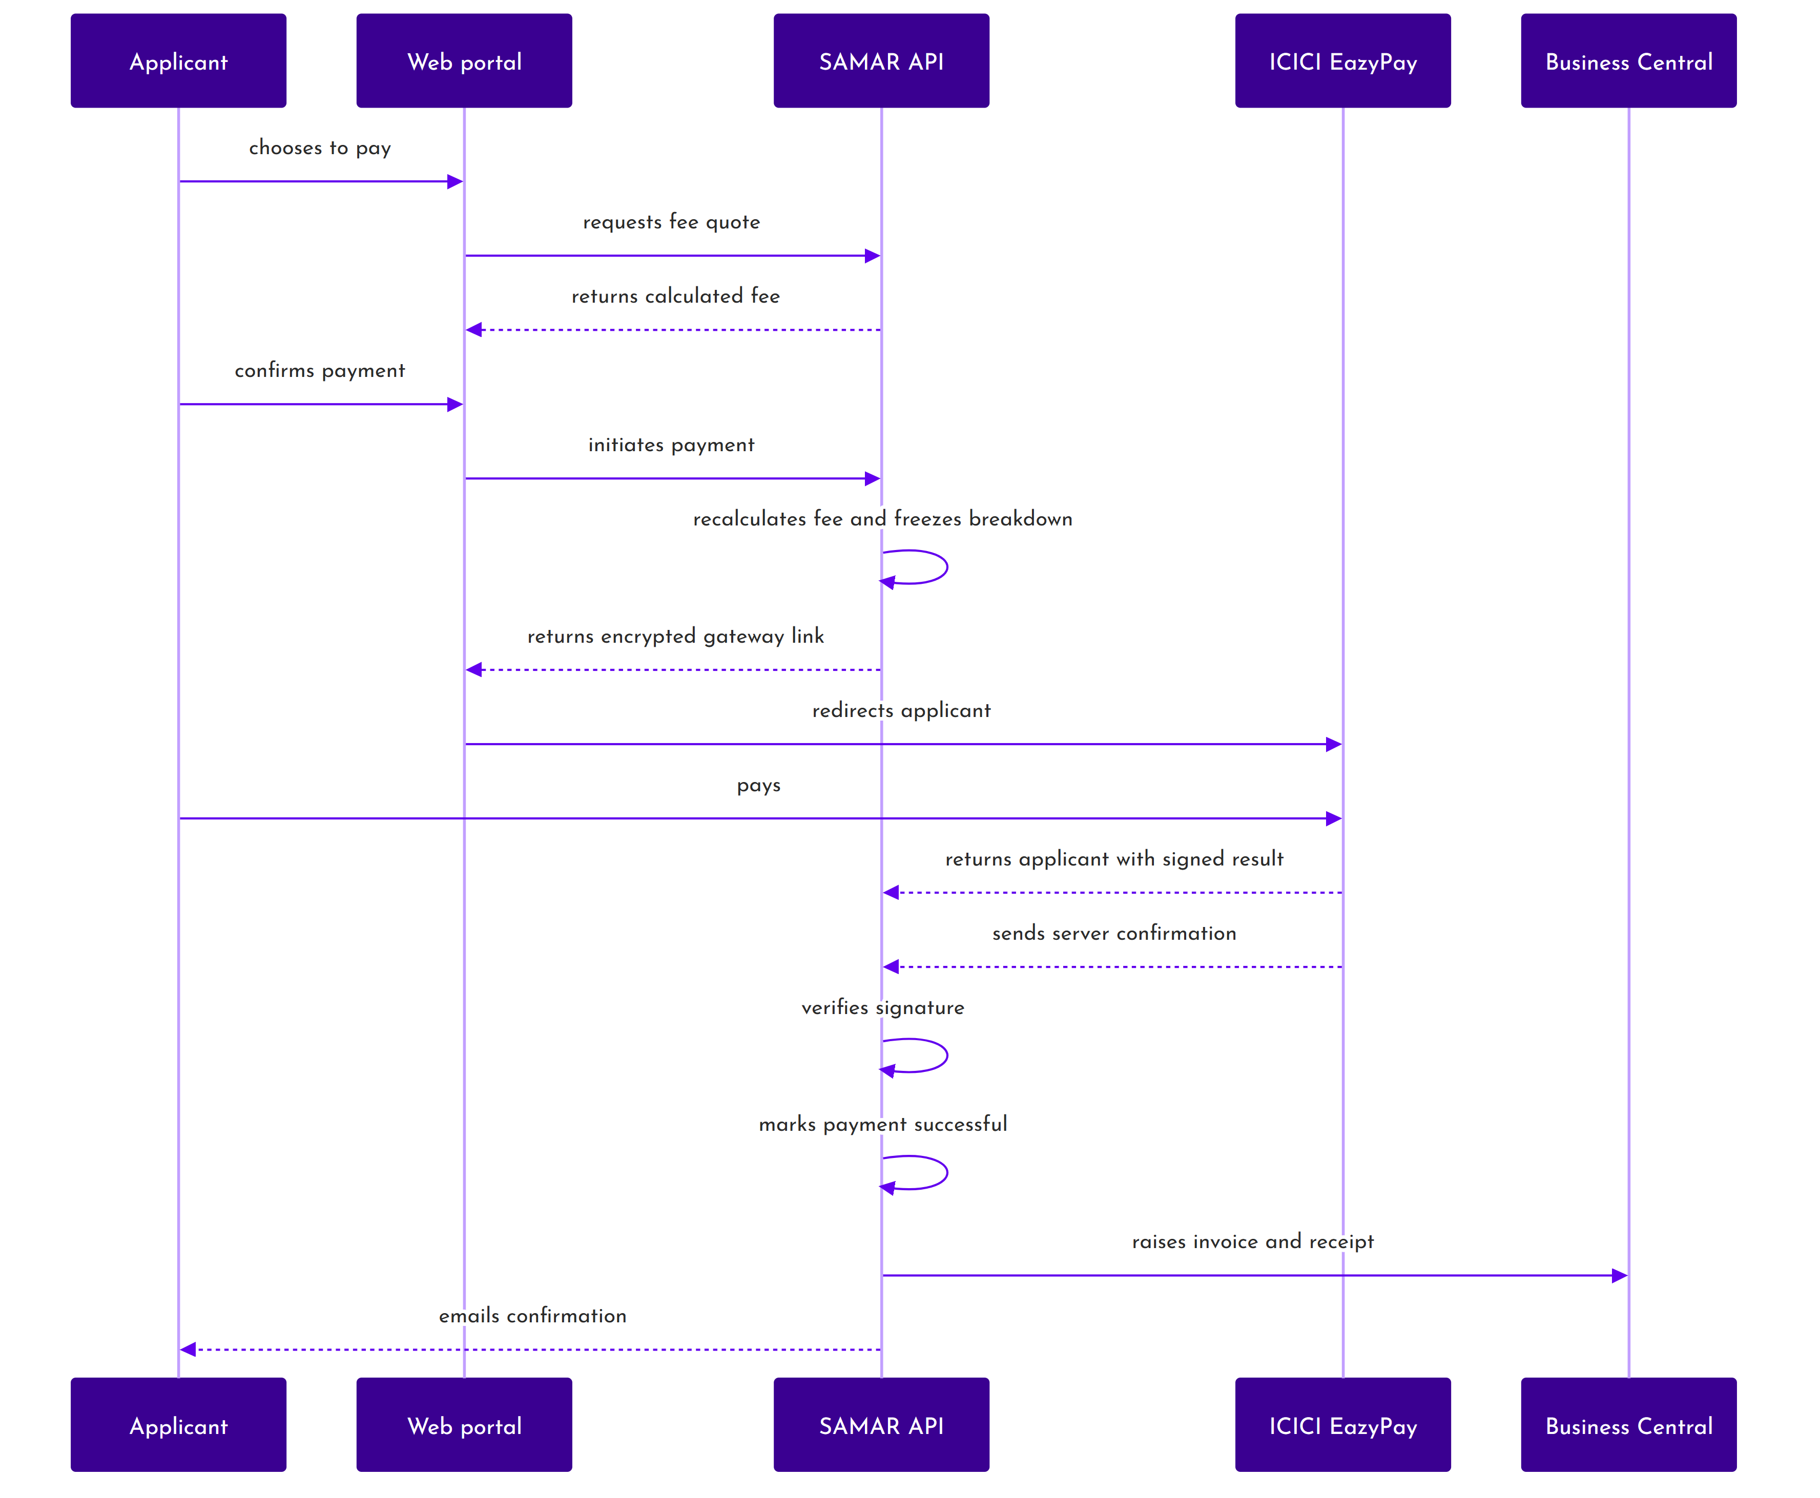
Figure 3: Payment flow
Payment confirmation arrives twice: once when the applicant is returned to the portal, and once as a direct server-to-server message from the bank. Both are signature-checked, and either can complete the payment, so a customer who closes the browser mid-payment is still recorded correctly. Duplicate confirmations are ignored.
Once a payment succeeds the application moves to payment completed, an assessment record is created automatically, and an invoice and receipt are raised in the ERP. If a payment fails, only the payment record changes; the application stays where it is and the applicant can try again.
Fees are not refundable. The applicant's declaration states that the amount is non-refundable, non-adjustable and non-transferable regardless of the certification outcome, and the system has no refund function.

3.6 Allocating the assessment
When payment completes, an assessment is created and waits for a team. An Operations Manager names a lead assessor, adds any co-assessors, and sets the start and end dates. For a service-sector assessment a meeting link is also required, because those are conducted remotely.
The system refuses an allocation that would breach any of these:
- Every named person must actually hold the assessor role.
- Every assessor must be approved for the state the unit is in. An assessment cannot be scheduled at all if the unit has no state recorded.
- No assessor may already be booked on another assessment whose dates overlap.
- The team cannot be changed once any part of the assessment has begun.
Rescheduling reuses the same screen. Changing the dates of an already-scheduled assessment increments a reschedule counter, which is the signal an assessor's device uses to discard whatever it holds for that assessment and pull the server's copy down again. The server is authoritative: any local changes not yet synced give way to it. Rescheduling is therefore meant to happen before on-site work begins. Changing the team without changing the dates does not trigger the discard, but does re-notify the applicant.

3.7 Conducting the assessment
The on-site work is done in the assessor mobile application, in seven steps. Some are the lead assessor's alone.
Step | What happens | Who
1. Parameter allocation | The lead divides the assessment parameters among the team. Every team member must receive at least one. | Lead only
2. Site pictures | Interior and exterior photographs of the site are captured. | Any member
3. Opening meeting | The opening meeting is held and attendance recorded. | Lead only
4. Site tour | Titled photographs are taken through the tour of the site. | Any member
5. Basic information | Details of the unit are captured or confirmed against what was declared. | Lead only
6. Assessment parameters | Each assessor answers the questions for the parameters allocated to them, with evidence photographs. | Each member
7. Closing meeting | The closing meeting is held, comments recorded and attendance taken. | Lead only

The assessment is bracketed by a punch-in and a punch-out. Punching in requires the assessor's location and takes a photograph of them where the camera allows; together these evidence attendance at the site. Every photograph taken during the assessment is stamped with the location and time it was captured.
Parameter allocation locks the first time it is saved. This is deliberate: once work has been divided and started, silently moving a parameter between assessors would orphan answers already given.
Co-assessors finish their own work first; the lead can only close the field work once every member has. Co-assessors then confirm their part on the web portal before the lead can submit the assessment for quality check.

3.8 The assessment lifecycle
An assessment moves through ten states.
State | What it means
Allocation pending | Created on payment. Waiting for a team and dates.
Scheduled | Team and dates set. Waiting for the assessor to start.
In progress | Field work under way. All seven steps happen here.
Field work complete | Every team member has finished on site.
Quality check | With the Operations Manager for review.
Quality check feedback | Sent back with comments against specific questions.
Ready for committee | Passed quality check. Waiting to be put before a committee.
Committee review | Attached to a rating committee meeting.
Committee feedback | The committee has sent it back.
Certified | Final. A certificate has been issued.

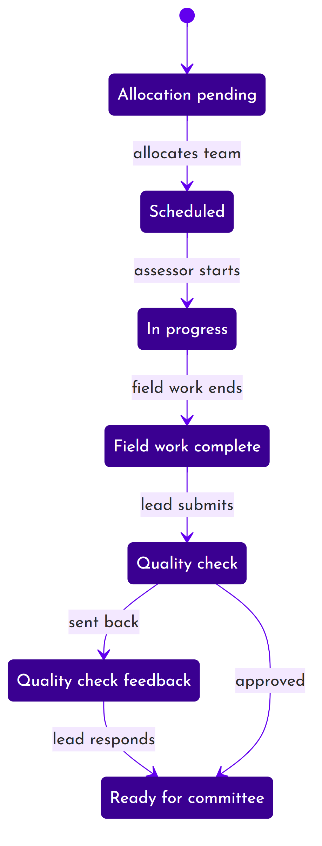
Figure 4: Assessment from allocation through quality check
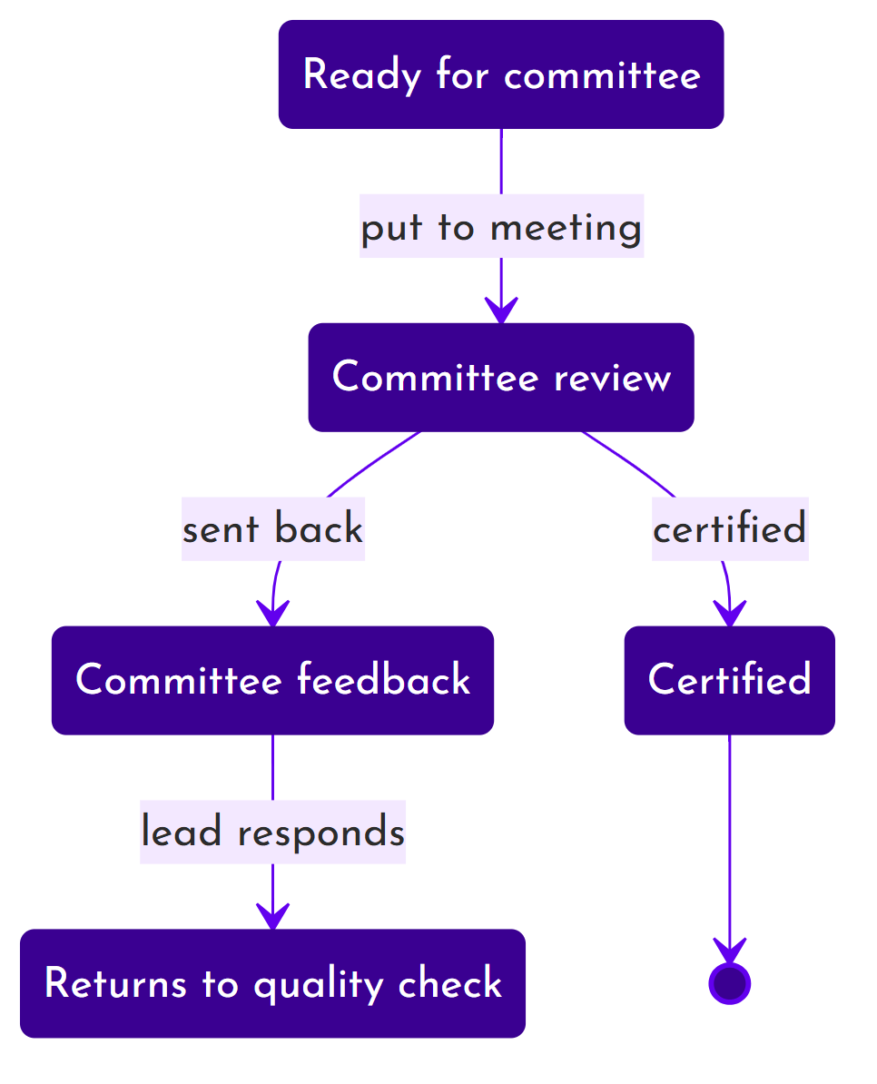
Figure 5: Committee review and certification
The moves, and who makes them:
From | To | Triggered by | Conditions
Allocation pending | Scheduled | Operations Manager | Team and dates valid, no assessor clashes.
Scheduled | In progress | Any team member | The assessor starts the assessment.
In progress | Field work complete | The system | Every team member has finished their field work.
Field work complete | Quality check | Lead assessor | Every question on every allocated parameter answered, and a score calculated.
Quality check | Ready for committee | Operations Manager | Approved.
Quality check | Quality check feedback | Operations Manager | Sent back with comments on named questions.
Quality check feedback | Ready for committee | Lead assessor | The lead has responded to the comments.
Ready for committee | Committee review | Operations Admin | Attached to a rating committee meeting.
Committee review | Certified | Operations Admin | Recorded at the meeting, applied when the meeting is closed.
Committee review | Committee feedback | Operations Admin | Recorded at the meeting. Limited to two send-backs.
Committee feedback | Quality check | Lead assessor | The response re-enters the quality check loop, not the committee.

3.9 Quality check
The Operations Manager reviews the submitted assessment and either approves it or sends it back. Sending it back attaches a comment to each question in question, so the assessor sees exactly what needs attention rather than a general instruction.
When the lead responds, every question's review marker is cleared and the score is recalculated, so the second review starts clean rather than carrying stale flags.

3.10 The rating committee
Assessments that pass quality check are grouped into a rating committee meeting. A meeting has a chair, a convenor and members, drawn from a register of committee members maintained in the portal. Committee members are people recorded against meetings; they are not user accounts and do not sign in.
During the meeting the committee can:
- Adjust the score on any individual question. The committee's score overrides the assessor's for that question.
- Send the assessment back with clarifications, at most twice.
- Certify it.
Decisions are recorded as the meeting proceeds but are not applied until the meeting is closed. Closing the meeting applies every recorded decision at once, issues certificates for those certified, generates the minutes and sends the notifications. That is a deliberate design point: it means a decision can be revised while the meeting is still running.

3.11 Certificates
A certificate is created automatically when an assessment is certified. There is no manual issue function. Each certificate records the organisation, the unit, the scope as manufacturing or service, the final score, the rating level, and the period of validity.
Property | How it is set
Certificate number | The issue date followed by part of the issuing user's SAMAR ID. A suffix is added if the same person issues more than one on the same day.
Type | Initial where the unit has never held a certificate, renewal where it has. Determined automatically.
Validity | Three years by default, taken from a system setting a System Admin can change. A renewal continues from the previous certificate's expiry, so there is no gap.
Rating level | Level 1 to 5, derived from the final score.
Status | Active on issue. A renewed predecessor is marked as renewed.

The certificate is produced as a two-sided PDF carrying a QR code. Scanning it opens the public verification page. Verification needs no login and returns the certificate number, the organisation and unit, the address, the rating level, the status, the validity dates and the scope. It does not disclose the score, the assessment, the internal identifiers, or the certificate file itself.
Before a certificate expires the recertification window opens, ninety days ahead by default. Only then can the unit apply again. Reminder emails are sent when the window opens, thirty days out, seven days out, and on expiry, each sent once.
A certificate is issued automatically and then either runs to expiry or is superseded by a renewal. There is no way in the application to suspend or revoke a certificate. The data model carries suspended and revoked states, and the authorisation layer names who would be allowed to set them, but no screen and no API endpoint does so; those states can be reached today only by a direct change to the database. If withdrawing a certificate is a real requirement for QCI, it is currently unbuilt, and is listed in the findings note.
Where QCI needs to stop a certified vendor, the lever the system provides is at the account level rather than the certificate. Deactivating the vendor's user account blocks it from signing in, and deactivating the organisation blocks every account under it; both are enforced at login. This restricts the vendor's access to the portal, but it does not change the certificate, and the public verification page will continue to report the certificate as valid until it expires.

3.12 Notifications
The system sends email. There is no SMS, push or in-app messaging. Thirty-five templates cover the process, grouped as application, payment, assessment, certificate, committee, security and system messages. Each has a subject held in the database and a body held as a template file, and each is addressed either to a named role or directly to the person concerned.
Every email that is attempted is recorded, whether it succeeded or failed, together with the subject and body actually sent. Appendix E lists the full set.

3.13 Support tickets
Applicants raise support tickets from the portal. The Support screen is given to the Enterprise Admin and Unit Admin roles, and a ticket can carry up to five attachments. Tickets are held in Zoho Desk rather than in SAMAR; the portal only creates them. It does not list or display existing tickets, so once a ticket is raised the conversation continues in Zoho Desk.
Everything after creation, viewing, replying, adding further attachments and closing, is done by QCI staff in the Zoho Desk agent console, not in the SAMAR portal. Each ticket carries the raiser's organisation, so a QCI agent can see which enterprise it came from and one organisation's tickets stay separate from another's.
Note: The API that receives a ticket does not itself restrict who may create one; the applicant-only rule is applied by the portal, which shows the Support screen to Enterprise Admin and Unit Admin only. Enforcing that rule on the API as well is noted in the accompanying findings for QCI.

3.14 Audit trail
Changes to the entities that matter are recorded automatically: users, applications, assessments, units, roles, documents, organisations, committee members and committee meetings. Each entry keeps what changed, the values before and after, who did it, the role they held, their address and the request that carried it.
Sign-in activity is recorded alongside: successful sign-ins, failed attempts, account lockouts, password changes and resets, and role assignments. Passwords, tokens and one-time codes are replaced with a redaction marker before anything is stored.
Entries are never edited, only added. They are kept for two years by default and then removed. Where a change is made by a scheduled task rather than a person, it is attributed to a named system actor with the script that made it, so an unattributed change is a genuine anomaly rather than routine background work.

3.15 Reports and dashboards
Five roles land on a dashboard scoped to what they are responsible for: System Admin, DRDO Admin, Operations Manager, Operations Admin and Enterprise Admin. An Enterprise Admin sees their own applications, payments and certificates. Operations roles see the pipeline: what is waiting for allocation, what is in the field, what is queued for quality check, what is awaiting committee. DRDO Admin sees approvals pending and the certified register. The System Admin sees system-wide counts, master data and the audit log. The other three roles open straight onto a work list instead of a dashboard: an assessor onto their scheduled assessments, a Unit Admin onto their applications, and a DRDO Lab onto the certified vendor register.
Assessment reports and committee minutes are generated as PDFs and attached to the relevant emails.

3.16 What QCI can configure
A good deal of the system's behaviour is data rather than code, and can be changed in the portal without a software release.
Setting | Effect | Who can change it
DRDO approval required | Whether submitted applications wait for DRDO approval or go straight to payment. | System Admin
Certificate validity | How long a certificate lasts. Three years by default. | System Admin
Recertification window | How far before expiry a unit may reapply. Ninety days by default. | System Admin
Application submission open | Whether new applications may be submitted at all. | System Admin
Maintenance mode | Blocks applicant access while work is carried out. Staff roles are unaffected. | System Admin
Fee configuration | Base fee, food and accommodation, GST rate and TDS switch, per sector and size. | System Admin
Assessment questionnaire | Disciplines, parameters, questions, answer options and their weightings. | System Admin
Reference lists | Vendor categories, stores, raw materials, bought-out parts, key processes, service resources, vendor labs, assessor domains, third-party certifications. | System Admin
Feedback questions | The questions applicants are asked about the assessment experience. | System Admin

4. Roles and access

4.1 How access is decided
Access is decided by role. There is no separate permission list to maintain: what a role can do is defined in the software, and a user gets it by holding that role. A role assignment can be scoped to an organisation and to a unit, can be switched off without being deleted, and can carry an expiry date.
Three checks run on every request that changes something:
1. The endpoint itself is restricted to particular roles. A user without one of them is refused outright.
2. The specific record is then checked. This is where ownership matters: whether the application belongs to your organisation, whether the unit is one of yours, whether you are on the assessment team, and whether the record is in a state that permits the action.
3. A few areas apply their own additional checks, notably support tickets, which combine the requester's identity with their organisation.
The second check is the one that matters most. Being an Enterprise Admin does not let you see another enterprise's applications; being an assessor does not let you see an assessment you are not on.
The tables in this section describe what each role can do through the web portal, because that is how the roles are used in practice. The API behind the portal enforces its own role rules, and in a few places it will accept a request from a role that the portal gives no screen to. Those cases are noted where they matter; they do not change what a user can do by using the product.

4.2 The nine roles
Role | Scope | What it is for
System Admin | Whole system | Master data, the questionnaire, fee configuration, users across all organisations, and the audit trail.
DRDO Admin | Whole system | Approves or rejects submitted applications, and monitors the assessment pipeline read-only.
DRDO Lab | Whole system, read only | Consults the certified vendor register. Can open a certified vendor's assessment detail.
Operations Manager | Whole system | The only role that can allocate an assessment team. Performs quality check, and manages assessor accounts.
Operations Admin | Whole system | Processes applications, and owns the rating committee: schedules meetings, manages members, and records committee decisions.
Assessor | Own assessments | Conducts assessments. Sees only assessments they are a team member of.
Enterprise Admin | Own organisation | Creates and submits applications, pays, renews, assigns each unit's Unit Admin, and manages users in their organisation. Units come into being from the application address.
Unit Admin | Assigned units | Creates and updates applications for their units. Cannot delete or renew, and cannot create units.
ERP Integration | One endpoint | Machine account. Used by Business Central to return invoice and receipt files.

Note: Committee members are people recorded against rating committee meetings. They are not a role and do not have accounts.

4.3 What each role can do in the portal
The tables below summarise what each role can do through the web portal; Appendix C carries the full matrix. Own means the action is allowed but limited to the user's own organisation, unit or assessment.

Applications
Action | Who can do it
View the list | System Admin, DRDO Admin, Operations Manager, Operations Admin, Enterprise Admin, Unit Admin
Create | Enterprise Admin, Unit Admin
Update | Enterprise Admin (own), Unit Admin (own unit). Only while in draft, DRDO approval pending or payment pending.
Delete | Enterprise Admin (own). Only while in draft.
Submit | Enterprise Admin (own), Unit Admin (own unit). Only from draft.
Renew | Enterprise Admin (own). Only once certified.
Approve or reject | DRDO Admin only

Assessments
Action | Who can do it
View the list | DRDO Admin, Operations Manager, Operations Admin, Assessor
View one | As above (DRDO Admin read-only, Assessor only if on the team), plus DRDO Lab for a certified vendor's assessment
Allocate a team | Operations Manager only
Conduct and submit | Assessor, only for assessments they are on
Quality check and approve | Operations Manager only
Schedule a committee meeting | Operations Admin only
Record the committee decision | Operations Admin only

Certificates
Action | Who can do it
View and download | System Admin, DRDO Admin, Operations Manager, Operations Admin. Enterprise Admin and Unit Admin for their own.
Verify publicly | Anyone, without signing in
Issue | Nobody directly. Issued automatically on certification.

Master data and configuration
Action | Who can do it
View reference lists and the questionnaire | Every signed-in user
Create or edit the questionnaire, parameters and disciplines | System Admin
Activate or deactivate questionnaire items | System Admin
Create, edit, and activate or deactivate every other reference list | System Admin
Fee configuration | System Admin
Feedback questions | System Admin
System settings | System Admin
Audit and activity logs | System Admin

Note: Reference data is deliberately readable by every signed-in user, because applicants need to pick from those lists when building an application. Only changing it is restricted. Reference and questionnaire items are never deleted, only deactivated, so that historic applications and assessments keep resolving the values they were built with; there is no delete action and no delete endpoint for this data. In the portal, all configuration and master-data editing is a System Admin screen; the API additionally permits DRDO Admin to edit the questionnaire and Operations Admin to edit fee configuration and feedback questions, but the portal gives neither role a screen for it.

4.4 Where each role starts
Role | Landing screen
System Admin | System dashboard
DRDO Admin | DRDO dashboard
DRDO Lab | Certified vendors
Operations Manager | Operations dashboard
Operations Admin | Operations dashboard
Assessor | Scheduled assessments
Enterprise Admin | Enterprise dashboard
Unit Admin | My applications

The menu each role sees is fixed to that role. A user holding more than one role is treated as holding the first one recorded against them, so overlapping roles are not combined.

5. Technical architecture

5.1 Shape of the system
One service holds the rules and the data. Three clients call it. Nothing else touches the database, and no business rule lives in a client, so the web portal and the two mobile applications cannot disagree about what is allowed.
The API is organised in layers. A request arrives at a route, passes through a chain of checks, reaches a controller, and is handed to a service that does the actual work. Data access is through a model layer. Workflow rules are held in state machines rather than scattered through controllers, which is why the transition tables in section 3 can be stated so precisely: they are configuration, not prose.
Layer | Responsibility
Routing | Maps each URL to a controller and declares which roles may reach it.
Middleware | Authentication, token type, session validity, maintenance mode, request and response formatting, file safety, rate limiting and security headers.
Controllers | Validate the request, check the caller may act on this particular record, and delegate.
Services | The business logic: authentication, fee calculation, payment gateway, ERP, email, state machines, PDF generation.
Policies | Decide whether a given user may perform a given action on a given record.
Models | Data access, relationships, derived values and per-record rules.
Database | Storage, referential integrity and indexing.

5.2 The API
The API is built on Laravel 12 running PHP 8.4, with MySQL 8 behind it. It exposes roughly 294 endpoints under a single version prefix. Sixty-one controllers, thirty-three services, twenty-five policies and sixty-seven models make up the codebase, over a schema of 117 migrations.
Two design choices are worth drawing out because they shape everything else.

State machines
Application and assessment workflow are each defined as a state machine: a list of states, the moves permitted between them, who may make each move, and what must be true first. A move that is not in the table cannot happen, whatever screen it is attempted from. Each move writes a history entry and may fire follow-on work, such as creating the assessment when payment completes, or creating the certificate when an assessment is certified.

Immutable questionnaire snapshots
When an assessment is created, the applicable parameters, questions and answer options are copied into the assessment rather than referenced. Editing the master questionnaire afterwards has no effect on assessments already under way. Without this, changing a question's weighting would silently rewrite the score of every historic assessment, and a certificate could no longer be defended.

5.3 The web portal
The portal is a React 19 single-page application built with Vite. It holds no business rules; it renders what the API allows and calls the API for everything.
Concern | Approach
Structure | Screens per role, shared components, and a service layer wrapping every API call.
State | Redux Toolkit, with slices organised per role and per domain.
Routing | Over 100 routes. Each route maps a role to the screen that role should see.
Navigation | A fixed menu per role.
Forms | Formik with schema validation, and server-side validation errors mapped back onto the offending fields.
Session | Tokens held in browser session storage, encrypted. Closing the browser ends the session.
Inactivity | The user is warned at fifty-nine minutes idle and signed out at sixty.
Version awareness | The application checks its own build against the server and reloads if the user is running a stale copy.

5.4 The assessor mobile application
This is the most demanding part of the system. Assessors work inside factories where there is frequently no signal, for hours at a time, capturing photographs and answers that must not be lost. The application is therefore built to work with no connection at all, and to treat connectivity as an occasional bonus rather than a precondition.
It is a React Native application. Four mechanisms make the offline behaviour dependable.

Everything needed is downloaded first
Before the visit the application pulls the whole assessment down into a local database: the parameters, the questions, the answer options, any answers already given, and the reference lists the forms need. A co-assessor who has never opened the assessment online can still complete it offline.

Reads are served locally during the assessment
Between punching in and punching out, the assessment's own working data, the responses, the evidence, the meetings and the site photographs, is read only from the local database, with no server call attempted. That removes the class of failure where a weak signal produces a slow request, a timeout and a confusing error in the middle of an assessment. Two reads are deliberately left online because they are shared across the team rather than owned by one device: the parameter allocation, which the lead authors, and the team-wide comment view. Both fetch when there is a connection and are otherwise served from what was last downloaded.

Writes go to a queue
Every action, from a punch-in to an answer to a photograph, is written to a local queue first and confirmed to the assessor immediately. A background process drains that queue to the server whenever there is a connection, in the order the actions were taken.
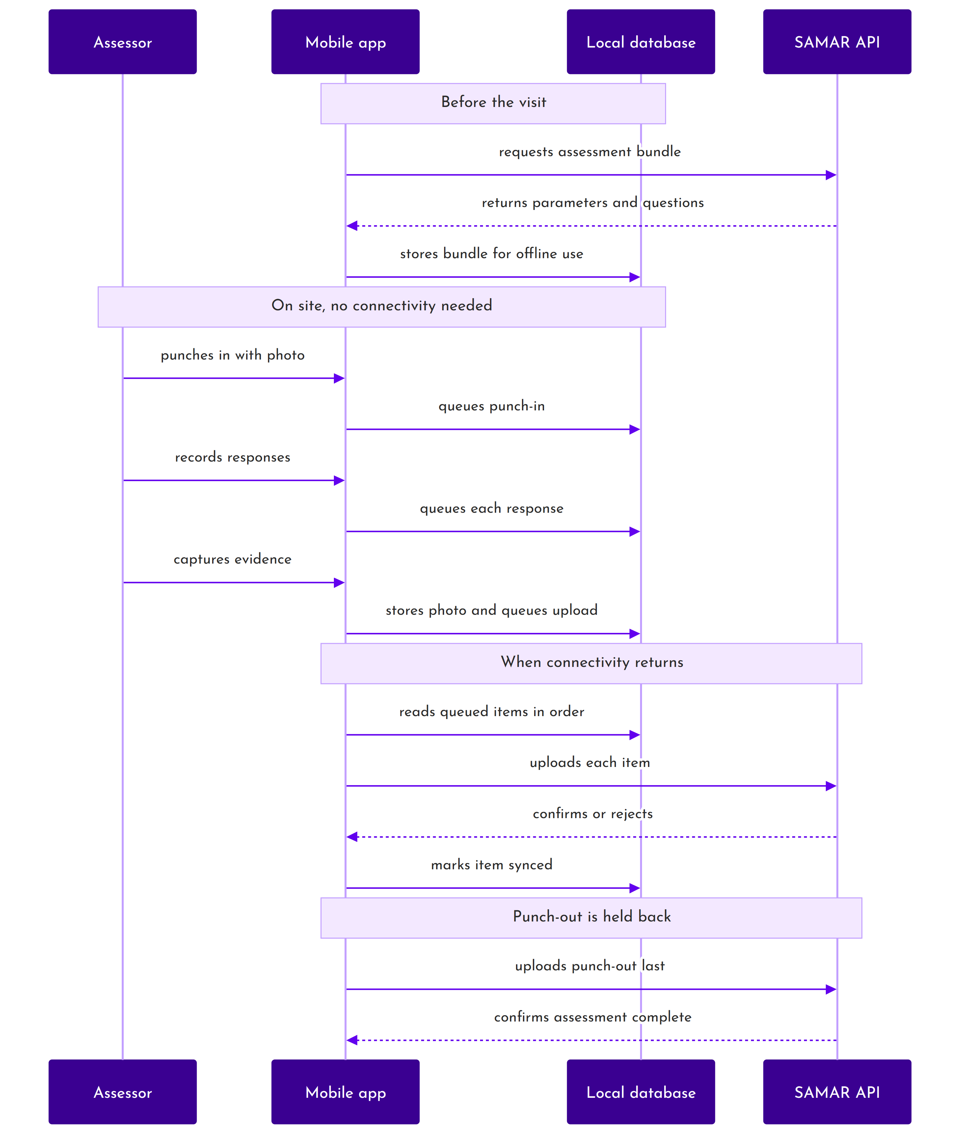
Figure 6: How offline work reaches the server
Each queued item carries a client-generated identifier, so if a confirmation is lost and the item is sent twice, the server recognises the duplicate rather than recording the work twice. Failures are separated into those worth retrying, such as a dropped connection, and those that are not, such as a rejected value; only the second kind is abandoned, and it is surfaced to the assessor.

Punch-out waits for everything else
The punch-out is deliberately held back until every earlier item for that assessment has reached the server. This makes the record trustworthy: if the server shows an assessor punched out, all the field data up to that point is present. Without the rule, a punch-out could arrive over a brief signal while the photographs behind it were still queued.

Rescheduling
A reschedule is meant to happen before on-site work begins, and when it does the server's version is authoritative. The reschedule carries a version marker; when the device sees a newer one it discards the assessment it holds and downloads the server's copy afresh. Anything captured locally for that assessment and not yet synced is lost in the process. There is one narrow safety valve: the automatic discard is skipped while unsynced items are still queued, so those rows are not silently deleted before a sync is attempted. It is not a guarantee that the work survives. If an assessment is rescheduled after work has started, the server is treated as final and the device's changes give way to it on the next sync.

Photographs
A photograph is written to durable storage the moment it is taken, and only then stamped with location and time. The two steps are separate because waiting for a location fix before saving risked losing the image if the operating system reclaimed the camera's temporary file.

5.5 The applicant mobile application
The applicant application is much smaller. It lets an applicant sign in, see their applications, and supply site photographs and site-tour images for a scheduled assessment. It uses the same account model, the same token handling and the same queue-then-send approach for the photographs it captures, but it has no assessment execution, no scoring and no meeting handling. Its offline behaviour covers the four photograph operations and nothing more, because that is all it does.

5.6 Patterns used across the system
Pattern | Where it is used | Why
State machine | Application and assessment workflow | Keeps the permitted moves in one place, with history written automatically.
Policies | Every record-level access decision | Separates the question of whether a user may act on a record from the handling of the request.
Snapshotting | Questionnaire copied per assessment, fee breakdown stored per payment | Protects completed work from later configuration changes.
Adapter | Payment gateway | The gateway sits behind a common interface, so a second gateway would not disturb the callers.
Outbox queue | Both mobile applications | Lets a client accept work with no connection and reconcile later.
Case conversion | Every request and response | The API speaks camelCase to clients and snake_case internally, converted automatically.
Soft deletion | Most records | Records are marked deleted rather than removed, so history stays intact.

5.7 Technology
Component | Technology | Version
API framework | Laravel | 12
Language | PHP | 8.4
Database | MySQL | 8
Authentication | JSON Web Tokens | -
Web portal | React with Vite | 19 and 7
Portal state | Redux Toolkit | 2
Portal interface | Material UI 7, and React Bootstrap 2 on Bootstrap 5.3 | -
Mobile | React Native | 0.85
Mobile storage | SQLite, with the device keychain for credentials | -
PDF generation | wkhtmltopdf, with a second engine for simple documents | -
Spreadsheets | PhpSpreadsheet | 5
Images | Intervention Image | 3
API documentation | OpenAPI | 3.1

6. Data architecture

6.1 The core entities
An organisation holds units and employs users. A unit applies for certification. An application is assessed once, may be paid for more than once if earlier attempts failed, and results in a certificate. The assessment carries the parameters and questions copied for it, and the answers given against them.
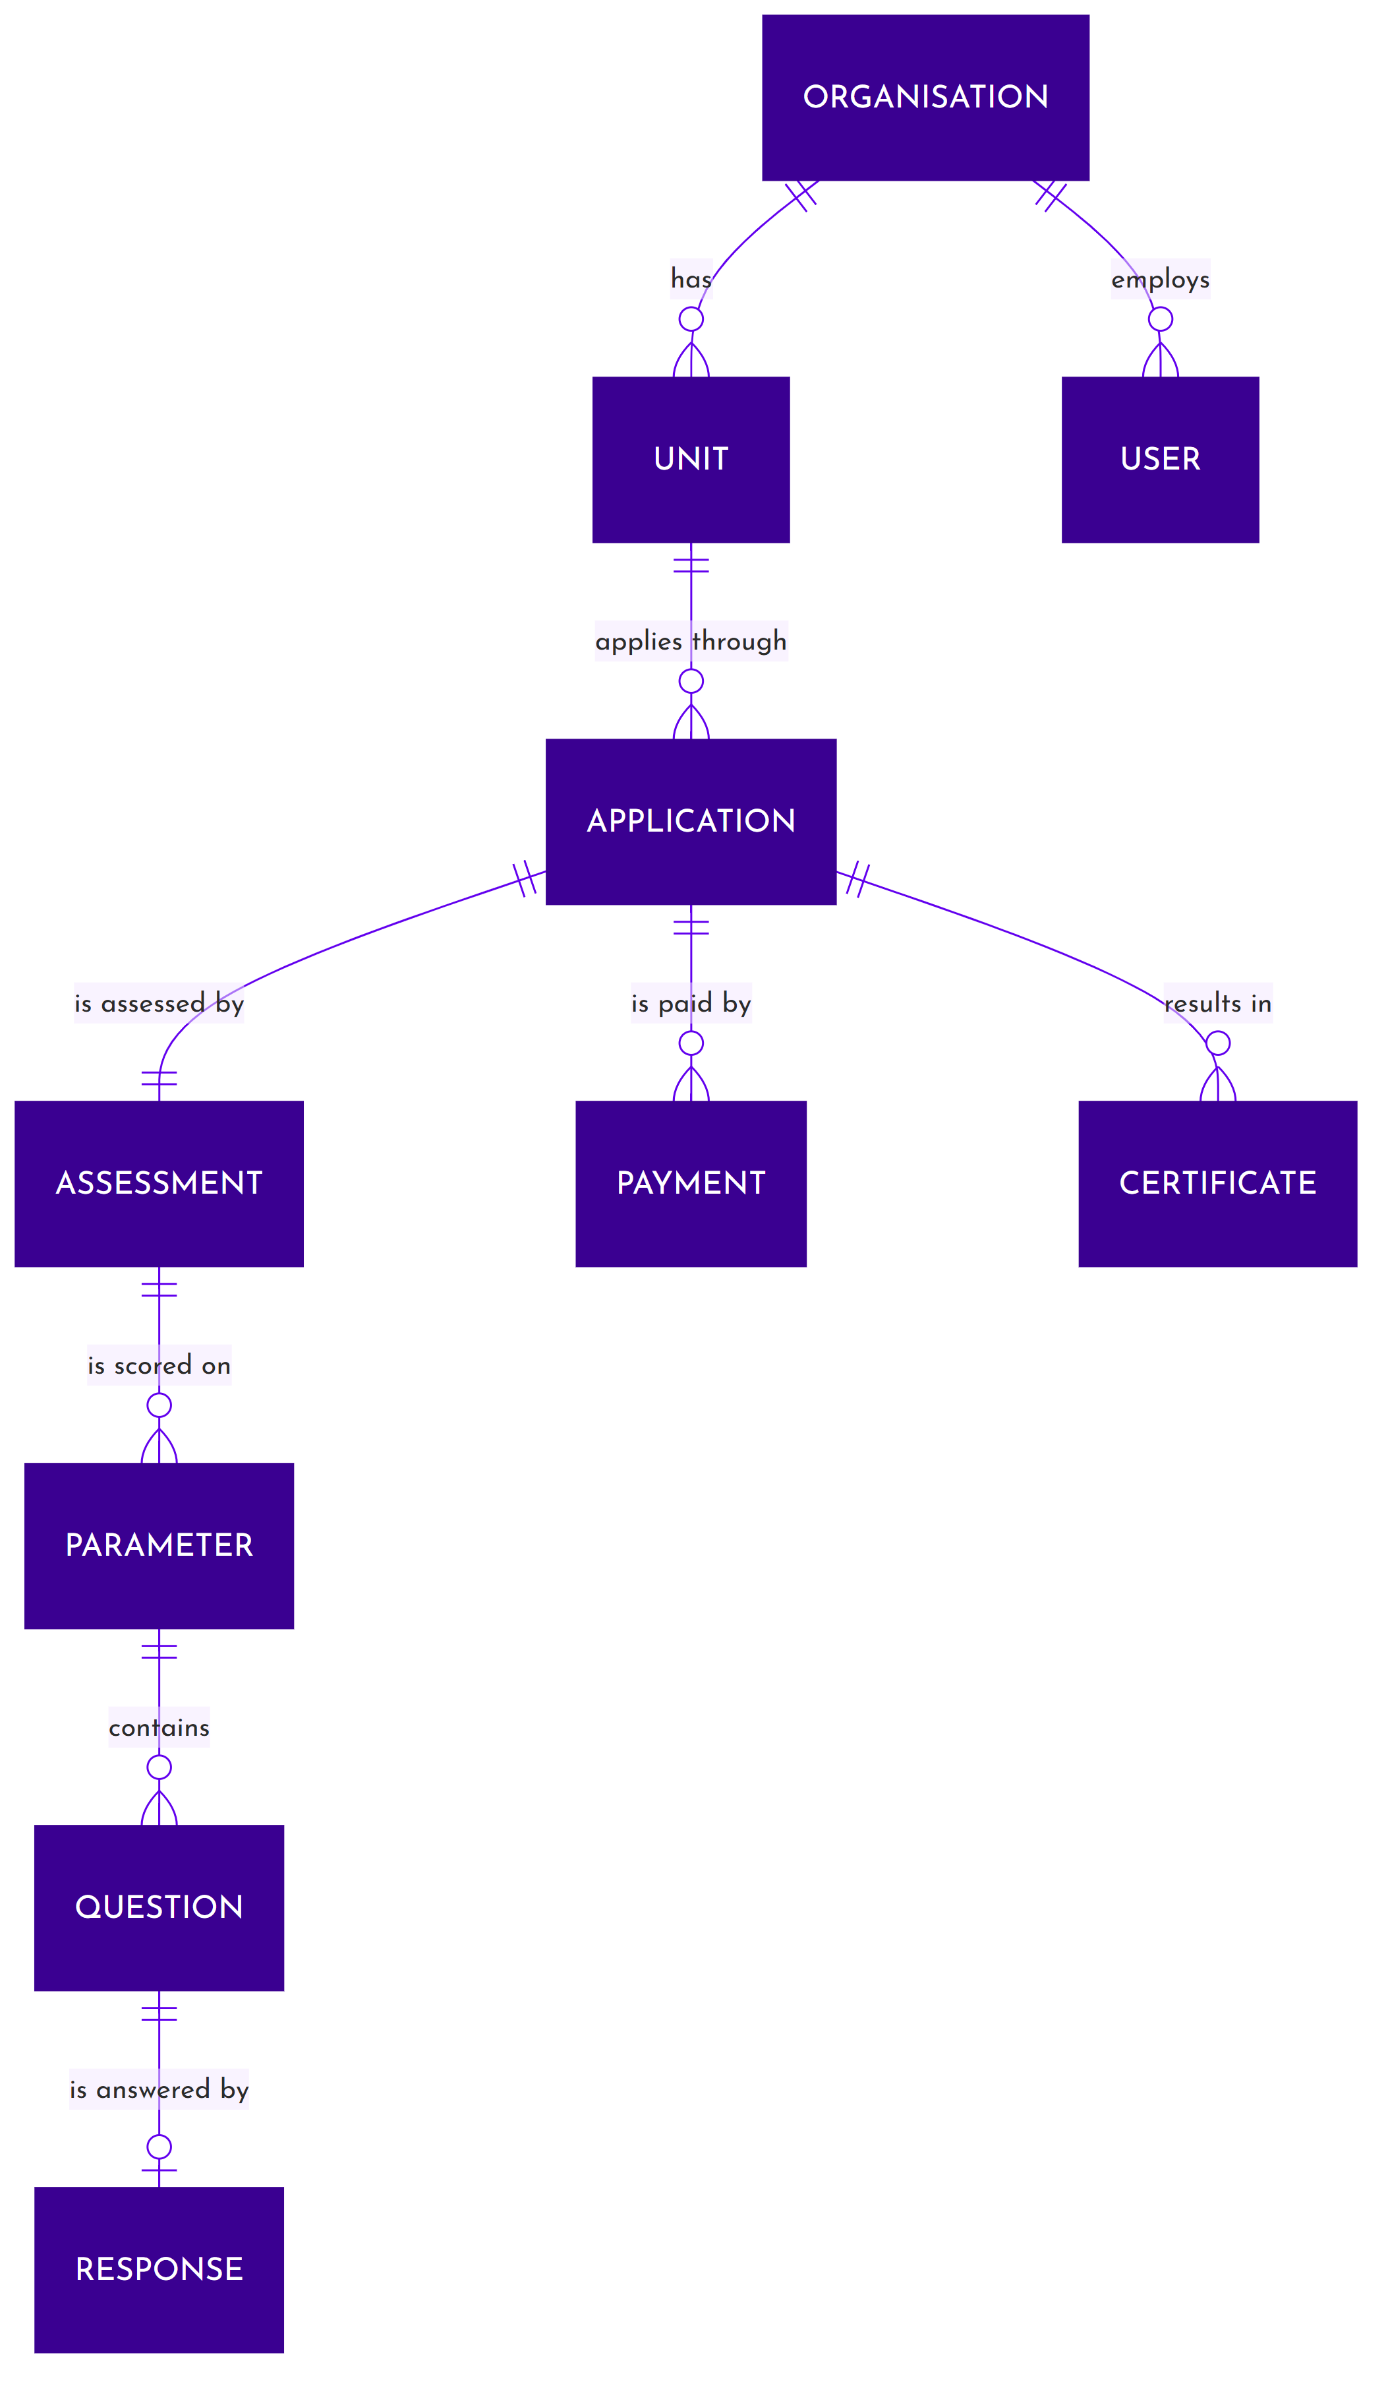
Figure 7: Core entity relationships
Entity | What it holds
Organisation | The applicant company: name, statutory registrations, verification and profile status.
Unit | A site belonging to an organisation, with its address, district, state and pin code. Certification is per unit.
User | An account, identified by SAMAR ID, belonging to an organisation where applicable.
Role | One of the nine roles. Assigned to a user through a link that may be scoped to an organisation and unit, switched off, or given an expiry.
Application | The certification request: sector, enterprise size, vendor category, the declared operational detail, and its position in the lifecycle.
Assessment | The assessment of one application: the team, the dates, the step progress, the score and its position in the lifecycle.
Assessment parameter | A parameter copied into an assessment, with the team member it is allocated to.
Assessment question | A question copied into an assessment, with its weighting and its five answer options flattened onto the record.
Response | The answer to one question: the option chosen, its score, any committee override, and the weighted result.
Payment | A payment attempt, its gateway references, its status and the frozen fee breakdown.
Certificate | An issued certificate: number, type, scope, score, rating level, validity and status.
Committee meeting | A rating committee sitting, its chair, convenor, members and the assessments put before it.
Audit entry | One recorded change or security event.

6.2 The questionnaire
The questionnaire has four levels. A discipline is a subject area. A parameter is a group of questions within it, and is the unit both of allocation to an assessor and of scoring. A question sits under a parameter and carries a weighting. Each question offers five answer options, each worth a score.
Level | Holds | Example
Discipline | A subject area, tied to one sector. | Quality Management System
Parameter | A group of questions. Allocated to one assessor and scored as a unit. | Document Control
Question | A question with a weighting expressed as a percentage of its parameter. | Are all quality documents properly controlled and versioned?
Option | One of five answers, each carrying a score from 1 to 5. | Yes, fully implemented with documented evidence

Which parameters apply to a given assessment is decided by the sector, the enterprise size, the vendor category and, for service applications, the service provider type. A manufacturing application is matched on the first three; a service application on all four.
The weightings of the active questions within a parameter must total exactly one hundred per cent. If they do not, the system takes the parameter out of use automatically rather than letting it distort a score. That rule is what keeps every parameter's score on the same one-to-five scale.
The six disciplines currently loaded:
Sector | Discipline | Parameters
Manufacturing | Quality Management System | Document Control, Process Management, Internal Audit
Manufacturing | Production Management | Production Planning, Equipment Maintenance
Manufacturing | Safety and Environment | Workplace Safety, Environmental Compliance
Service | Service Quality Management | Service Standards, Customer Satisfaction, Quality Monitoring and Improvement
Service | Service Delivery | Service Operations, Service Level Agreements
Service | Service Safety and Compliance | Workforce Safety and Training, Regulatory and Contractual Compliance

Note: A parameter exists once per applicable combination, so the fourteen parameter names above are held as 140 records across the size bands and service provider types.

6.3 How an assessment is scored
Scoring runs in three steps.

Step one, per question
The option the assessor chose carries a score from 1 to 5. If the rating committee has overridden that question, the committee's score is used instead. The result is multiplied by the question's weighting to give a weighted score.

Step two, per parameter
The weighted scores of the answered questions in a parameter are added together. Because the weightings within a parameter total one hundred per cent, the result sits on the same one-to-five scale as the individual answers.

Step three, the assessment
The parameter scores are averaged. Every parameter counts equally; parameters are not themselves weighted. The result, to two decimal places, is the assessment's final score.
The final score maps to a rating level:
Final score | Rating level
Above 4.5 | Level 5
Above 3.5 and up to 4.5 | Level 4
Above 2.5 and up to 3.5 | Level 3
Above 1.5 and up to 2.5 | Level 2
Up to 1.5 | Level 1

The rating level is what appears on the certificate and on public verification. The numeric score is held internally and is not disclosed publicly.
There is no not-applicable answer. A parameter that does not apply is simply not allocated to anyone, and then plays no part in the score. Once a parameter is allocated, every question in it must be answered before the assessment can be submitted.
Where the committee overrides scores, the system keeps both figures: the effective total including the overrides, and the assessor's original total. Both appear in the minutes, so the committee's effect on the outcome is visible. If an assessor later revises an answer, any committee override on that question is cleared, so a stale override cannot mask a new answer.

6.4 Keeping organisations apart
Applicant data is separated by organisation, and within an organisation by unit. That separation is applied by the checks described in section 4.1 rather than by a blanket database filter, which means it is enforced deliberately at each point rather than assumed.
Records also carry the organisation they belong to automatically when created, taken from the account creating them, so a record cannot be filed against the wrong organisation by accident.

6.5 Retention and deletion
Data | Retention
Applications, assessments, certificates, payments | Kept indefinitely. Deletions are marks rather than removals, so history and audit remain intact.
Audit entries | Two years by default, then removed.
Error records | Archived after ninety days, removed after a year.
Email records | Kept with the subject and body actually sent.
Expired login sessions | Cleared automatically.
Evidence photographs and documents | Held against the assessment for as long as the assessment is held.

Certificates are never deleted. A superseded certificate is marked renewed and linked to the one that replaced it, so the chain from a unit's first certificate to its current one can be followed.

7. Security

7.1 Signing in
Users sign in with a SAMAR ID and password, not an email address. The identifier is case-insensitive. A wrong password returns the same message whether or not the account exists, so the sign-in page cannot be used to discover which accounts are real.
Where two-factor authentication is switched on for an account, the password check is followed by a six-digit code sent by email. No token is issued until the code is confirmed. The pending sign-in is valid for fifteen minutes, deliberately longer than the code itself so a user can request a fresh code without starting again. A code may be resent up to three times.
Password and code rules:
Control | Setting
Minimum password length | Seven characters
Password storage | Hashed. Passwords are never stored or transmitted in readable form after issue.
One-time code length | Six digits, stored hashed
Code validity | Two minutes
Code attempts | Five, then a thirty-minute lock
Failed sign-in attempts | Ten, then a thirty-minute lock on the account
Code resends | Three per sign-in attempt

Note: Password length is the only complexity rule applied. Composition rules are not enforced.

7.2 Sessions and tokens
After a successful sign-in the client receives two credentials: a short-lived access token used on every request, and a longer-lived refresh token used only to obtain a new access token.
Property | Setting
Access token lifetime | Fifteen minutes
Refresh token lifetime | Two hours
Signing | HMAC SHA-256
Withdrawal | Tokens can be blacklisted, with no grace period
Refresh behaviour | One use only. Refreshing retires the token presented and issues a new pair.
Idle timeout | Sixty minutes
Liveness window | Thirty minutes

Refresh tokens are single-use. Presenting one retires it immediately and issues a fresh pair, so a captured refresh token cannot be replayed after the legitimate client has used it.
Every session is recorded with the device type, device name, address and last activity. A request bearing a token whose session has been ended is refused with a message explaining why, so a user displaced by another sign-in is told what happened rather than seeing an unexplained error.

One session at a time
All eight human roles are limited to one active session, but the limit is applied per class of device rather than globally. A browser session and a mobile application session can be live at the same time; a second browser sign-in ends the first. This is deliberate: an assessor needs the mobile application signed in while also using the portal.
The ERP Integration account is the single exception and may hold concurrent sessions, because the ERP makes batched calls that would otherwise displace one another.

Idle handling
Web sessions are ended after sixty minutes without activity. Mobile sessions are deliberately exempt from that check, because an assessor working offline inside a factory legitimately makes no server calls for hours while queuing work locally. Ending their session for inactivity would lose the assessment. A scheduled sweep closes genuinely abandoned sessions every fifteen minutes, and the ERP account is excluded from that too.

7.3 Resetting a password
There is no emailed reset link. A user asks for a reset against their SAMAR ID, receives a six-digit code by email, and sets a new password with it. Completing a reset ends every session that user holds, on every device, which is the correct behaviour if the reset was prompted by a suspected compromise.
Changing a password while signed in does not end other sessions, since the user is already proven.

7.4 Protecting data in transit
All traffic is over HTTPS. The assessor mobile application additionally pins the certificate authority it will accept, so a device that has been fitted with an intercepting certificate cannot silently read or alter assessment traffic. That is a meaningful control for an application carrying defence-sector assessment evidence over networks the operator does not control.
Responses carry a standard set of security headers covering transport security, content type handling, framing, referrer policy and content security.

7.5 Protecting data at rest
Data | Protection
Passwords | Hashed, never reversible.
One-time codes | Hashed before storage.
Web session tokens | Encrypted in browser session storage, cleared when the browser closes.
Mobile session tokens | Held in the device keychain, protected by the operating system.
Evidence photographs | Stored privately and served only to callers entitled to them.
Certificate files | Stored privately. Downloading one requires an authenticated, entitled caller.
Audit entries | Passwords, tokens and codes redacted before the entry is written.

7.6 Limiting abuse
Sign-in, registration, password reset and token refresh are rate limited. Account lockout applies on top, so a distributed attempt is slowed by the rate limit while a focused attempt on one account is stopped by the lockout.
Uploads are constrained by type and size, and are checked before being stored. Support ticket attachments are limited to five files of ten megabytes each, in a fixed set of document and image formats.

7.7 Traceability
The audit trail described in section 3.14 is the security record as well as the operational one. Sign-ins, failed attempts, lockouts, password changes and resets, and role assignments are all recorded with the actor, the address and the time. Entries are added and never edited.
Because certification decisions carry weight, the trail is designed so that a specific question can be answered afterwards: who moved this application, when, holding what role, and what did the record look like before and after.

8. The API

8.1 Conventions
Everything the portal and the mobile applications do goes through one versioned REST interface. It is worth understanding its conventions, because they are applied uniformly and explain the shape of every response.
Convention | Detail
Versioning | All endpoints sit under a version prefix, so a future revision can run alongside the current one.
Format | JSON in and out. A version header is returned on every response.
Naming | Clients send and receive camelCase. The API converts to and from its internal naming automatically.
Authentication | A bearer token on every protected call. Access tokens and refresh tokens are not interchangeable and are rejected if presented in the wrong place.
Envelope | Responses carry a success flag, a message and a data payload.
Errors | A failure returns the flag as false, a message, and where relevant a map of field names to the problems found.
Paging | List endpoints take a page number and a page size, capped to protect the service, plus search and filter terms.
Dates | Machine-readable timestamps are returned in a consistent format; user-facing times are rendered in IST.

8.2 Authentication endpoints
Purpose | Notes
Register | Creates the organisation and first user, and sends a verification code.
Verify code | Confirms registration, generates the password and emails the credentials.
Resend code | Issues a fresh verification code.
Sign in | Returns tokens, or a pending session when two-factor is enabled.
Verify sign-in code | Completes a two-factor sign-in and returns tokens.
Resend sign-in code | Limited to three per attempt.
Check active session | Reports whether the account is already signed in on another device of the same class. Requires the password, so it cannot be used anonymously.
Refresh | Exchanges a refresh token for a new pair. Single use.
Sign out | Ends all sessions for the user and withdraws the token.
Current user | Returns the signed-in user with their roles.
Change password | Requires the current password.
Forgot and reset password | Code-based reset. Completing it ends every session.
Two-factor status, enable, disable | Disabling requires the current password.

8.3 Endpoints by module
The interface exposes roughly 294 endpoints. Grouped by what they serve:
Module | What it covers
Organisations and units | Organisation profile, verification, status, and unit management.
Users | Account creation, update, status changes and role assignment, scoped by the caller's own role.
Applications | Draft creation for both sectors, update, submission, DRDO approval and rejection, renewal, listing by lifecycle stage, and the detail view.
Fees and payments | Fee quotation, payment initiation, payment history, invoices and receipts, and the two gateway callbacks.
Assessments | Allocation and scheduling, starting, step progress, parameter allocation, responses and evidence, meetings, attendance, site pictures, site tour, submission, quality check, and committee actions.
Committee | Meetings, members, participants, assessment attachment, decisions, scores and minutes.
Certificates | Listing, detail, download, and public verification.
Master data | The questionnaire, disciplines, parameters, questions and options, fee configuration, vendor categories, stores, raw materials, bought-out parts, key processes, service resources, vendor labs, assessor domains, third-party certifications, countries, states, districts and pin codes.
Support | Raising and listing tickets and viewing one.
System | Health, status, settings, audit and activity logs, error logs, and user guides.
ERP | A single endpoint used by Business Central to return invoice and receipt files.

Note: Appendix A groups the endpoints by module with their methods. The live specification is generated from the code and is the authoritative reference for exact request and response shapes.

8.4 Public endpoints
Four things are reachable without signing in, and it is worth being explicit about them:
Endpoint | Why it is public | What it exposes
Certificate verification | QR codes on certificates must work for anyone. | Certificate number, organisation, unit, address, rating level, status, validity and scope. Not the score, not the assessment, not the file.
System status | Lets the clients detect maintenance mode before signing in. | Service status only.
Health | Service monitoring. | Service and database availability.
Payment callbacks | The bank must be able to reach them. | Nothing. They accept signed notifications and are signature-checked.

8.5 Error handling
Validation failures return the offending fields and the reason for each, which is what lets the portal put an error next to the right box rather than showing a general message. Authorisation failures distinguish between not being signed in and not being permitted. Session failures carry a specific code so the client can explain that the user was signed out by another sign-in rather than showing a generic error.
Server errors are recorded internally with the context needed to diagnose them, grouped so that a recurring fault is visible as one problem rather than a thousand entries.

9. External integrations
SAMAR connects to four external systems.
System | Purpose | Direction
ICICI EazyPay | Collects the certification fee. | Out to pay, back to confirm
Microsoft Dynamics 365 Business Central | Raises invoices and receipts against settled payments. | Both ways
Zoho Desk | Holds support tickets. | Out on demand
Email service | Delivers all system email. | Out

9.1 ICICI EazyPay
The certification fee is collected through ICICI EazyPay. When an applicant chooses to pay, the system assembles the payment request, encrypts it, and sends the applicant to the bank's hosted page. SAMAR never handles card or account details; they are entered on the bank's page.

What is sent
The request carries a fixed set of seventeen mandatory fields: the payment reference, the merchant identifiers, the amount, the applicant's contact details, their PAN, TAN and GST registration, the unit address, district, pin code, state and country, a description of what is being paid for, the contact person and the payment date.
Each of those fields is cleaned before it is sent. Line breaks and separator characters are removed and lengths are trimmed, because the gateway rejects the whole request if a field contains an embedded newline. In practice that mattered: applicants paste multi-line addresses.
The assembled request is encrypted with the merchant key and passed as an encrypted link. The plain request, the applicant's mobile number and the encrypted link are deliberately kept out of the logs.

How confirmation comes back
Confirmation arrives by two independent routes, and either is sufficient.
Route | How it arrives | What it does
Return | The applicant's browser is redirected back carrying a signed result. | Verifies the signature, records the outcome, and sends the applicant to the confirmation page. Sends the confirmation email.
Server notification | The bank posts an encrypted message directly to the system. | Decrypts, verifies, and records the outcome if it has not already been recorded.

Both are signature-checked before anything is recorded. A successful result is only accepted with a valid signature. A failed or cancelled result is accepted without one, since there is nothing to protect. If a signature does not verify on a payment already recorded as successful, the payment is not downgraded; the discrepancy is recorded for investigation instead, because the money has already moved.
Where the amount the bank reports collecting differs from the amount billed, the payment is still accepted and the difference is flagged for manual attention. Refusing it would leave an applicant who has genuinely paid unable to proceed.

9.2 Business Central
Invoicing is done in Microsoft Dynamics 365 Business Central rather than in SAMAR. When a payment settles, SAMAR asks Business Central to raise the invoice and the receipt. Business Central generates the documents and returns the files, which SAMAR stores against the payment and makes available to the applicant in the portal.
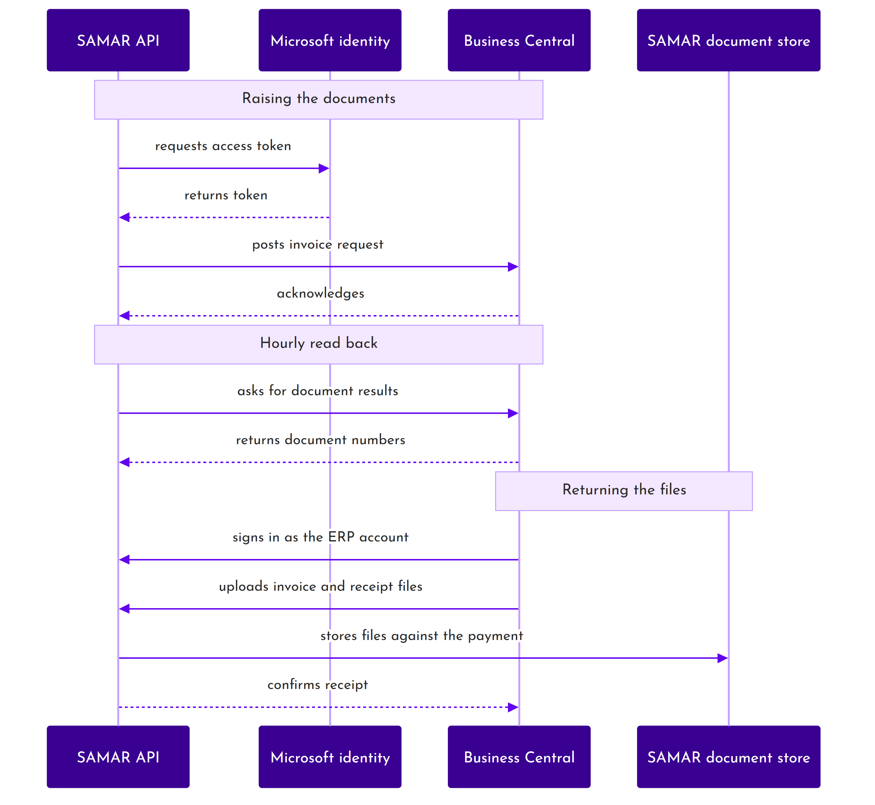
Figure 8: Invoice and receipt exchange
The connection authenticates as an application against Microsoft's identity service, so there is no user password involved. Requests carry the portal identity, the board, the location and the ledger codes that Business Central needs to file the entry correctly; those values are configuration rather than code.
Two scheduled tasks keep the two systems aligned. One reads back document results hourly. The other retries pushes that failed, every half hour, so a temporary outage at either end resolves itself rather than needing manual repair.
Documents come back the other way through a dedicated machine account, the ERP Integration role, which has exactly one endpoint available to it and no interface. That account is the single exception to the one-session rule, because Business Central makes batched calls that would otherwise displace one another.
An ERP failure never rolls back a settled payment. The two are deliberately decoupled: if invoicing fails, the payment stands and the invoice is retried.

9.3 Zoho Desk
Support tickets live in Zoho Desk. SAMAR holds no ticket records of its own; the portal is a one-way window that only creates them. Raising a ticket creates or reuses a contact in Zoho, creates the ticket, and uploads any attachments.
Alongside the subject and description, each ticket carries the raiser's role, the issue category, type and sub-category, and their organisation. The organisation is taken from the signed-in account rather than from the form, which is what allows a QCI agent to see which enterprise a ticket came from and what keeps one enterprise's tickets away from another's.
In the portal the Support screen is given to the Enterprise Admin and Unit Admin roles, and a ticket can carry up to five attachments. The portal does not list or display existing tickets. Everything after creation, viewing, replying, adding attachments and closing, happens in the Zoho Desk agent console. The API that receives a ticket does not itself restrict who may create one; the applicant-only rule is a portal convention, noted for QCI in the accompanying findings.

9.4 Email
All system email is delivered through an external mail service over an authenticated connection. Email is the only notification channel; there is no SMS or push messaging, and one-time codes are therefore delivered by email.
Delivery is attempted as part of the request that triggers it. Where an email fails, the failure is recorded and the underlying action still completes: a registration is not lost because a message could not be sent, and a password reset still works even if the confirmation does not arrive.

9.5 Configuration
Each integration is switched on or off independently and holds its own credentials. Turning one off degrades that capability without stopping the rest of the system: with the support desk unavailable, ticket raising reports itself as unavailable rather than failing obscurely.
Integration | What has to be configured
ICICI EazyPay | Merchant and sub-merchant identifiers, encryption key, the gateway addresses, and the return and notification addresses.
Business Central | Tenant, application credentials, environment and company, plus the board, portal name, location and ledger codes, and the machine account used for the return path.
Zoho Desk | Organisation and department identifiers, application credentials, and the regional endpoint.
Email | Mail host, port, credentials, encryption, and the from name and address.

10. Glossary
Terms as they are used in this document and in the system. Section 1.5 carries the acronyms.
Term | Meaning
Allocation | Naming the assessors who will conduct an assessment and setting its dates. Done by an Operations Manager.
Assessment | The evaluation of one application against the questionnaire. One application has exactly one assessment.
Certificate number | The identifier printed on a certificate and used for public verification. Formed from the issue date and part of the issuing user's SAMAR ID.
Committee member | A person seated on a rating committee. Recorded against meetings, not a user account.
Discipline | The top level of the questionnaire, grouping related parameters within one sector.
Draft | An application still being prepared. The only state in which it can be edited or deleted.
Enterprise size | One of five bands - startup, micro, small, medium or large - which together with the sector selects the fee rate card.
Evidence | A photograph attached to an answer, to a site tour, or to the record of a site.
Field work | The part of an assessment carried out on site in the assessor application, between punching in and punching out.
Lead assessor | The assessor accountable for an assessment. Allocates parameters, runs the meetings and submits for quality check.
Option | One of the five answers offered for a question, each carrying a score from 1 to 5.
Parameter | A group of questions covering one subject. The unit of allocation to an assessor and the unit of scoring.
Parameter allocation | Dividing an assessment's parameters among the team. Locks once saved.
Punch in and punch out | The start and end of an assessor's on-site work, evidenced with a photograph and a location.
Quality check | Review of a submitted assessment by an Operations Manager before it goes to committee.
Rating committee | The panel that reviews a completed assessment and decides whether to certify it.
Rating level | The published outcome, from Level 1 to Level 5, derived from the final score.
Rate card | The fee configuration for one combination of sector and enterprise size.
Recertification window | The period before a certificate expires during which the unit may apply again. Ninety days by default.
Reschedule counter | A number incremented when an assessment's dates change, telling assessor devices to discard and re-download.
Response | An assessor's answer to one question, together with its score and any committee override.
SAMAR ID | The identifier every user signs in with, in the form SAMAR-DDMMYY-N.
Sector | Whether an application is assessed as manufacturing or as a service.
Send-back | Returning an assessment to the lead assessor with comments, from quality check or from committee. Committee send-backs are limited to two.
Service provider type | For service applications only: annual maintenance contract, critical service provider, or civil works contractor.
Site tour | The walk through the site during an assessment, recorded as titled photographs.
Unit | A single site belonging to an enterprise. Certification is granted per unit.
Vendor category | The classification of what the applicant supplies. Contributes to selecting the questionnaire.
Weighting | A question's share of its parameter's score, as a percentage. The active questions in a parameter always total one hundred.

Appendix A: API endpoints by module
Grouped by module, with the operations each supports. The generated specification remains the authoritative reference for exact request and response shapes.
Module | Operations
Authentication | Register, verify code, resend code, sign in, verify sign-in code, resend sign-in code, check active session, refresh, sign out, current user, change password, forgot password, reset password, resend reset code, two-factor status, enable and disable.
Organisations | List, view, create, update, verify, change status, profile completeness.
Units | List, view, change spoke, list unit users. Units are created and their address updated through the application flow, not a standalone unit endpoint.
Users | List, view, create, update, change status, assign roles, list by role.
Applications | List, list by lifecycle stage, view, create manufacturing draft, create service draft, update, delete, submit, DRDO approve, DRDO reject, renew, fee quote, progress, feedback.
Payments | Fee quote, initiate, list, view, invoices, receipts, gateway return callback, gateway server notification.
Assessments | List, view, schedule and reschedule, start, step progress, parameter list, my assignments, bulk assign parameters, responses, response evidence, punch in, punch out, opening meeting, closing meeting, meeting comments, meeting participants, attendance, site pictures, site tour pictures, basic information, co-assessor submit, submit for quality check, quality check decision, address quality check feedback, committee decision, committee scores, address committee feedback, report download.
Committee | Meetings list, view, create, update, cancel, complete, members list and management, participants, attach and detach assessments, decisions, minutes.
Certificates | List, view, download, public verification.
Questionnaire | Disciplines, parameters, parameter detail, questions, question options, each with list, view, create, update and status change (activate/deactivate). There is no delete.
Fee configuration | List, view, create, update.
Manufacturing reference data | Vendor categories, stores, raw materials, bought-out parts, key processes.
Service reference data | Vendor categories, vendor labs, key resources, outsourced components, key processes.
Common reference data | Assessor domains, third-party certifications, feedback questions, countries, states, districts, pin codes.
Support | List tickets, raise ticket, view ticket, update ticket.
System | Health, status, settings list and update, audit logs, activity logs, error logs, error groups, user guides.
ERP | Document upload.

Appendix B: Core entities
The principal entities and the fields that carry meaning outside the software.
Entity | Key fields
Organisation | Name, PAN, GST registration, incorporation certificate, verification status, profile completion, status.
Unit | Organisation, name, address, district, state, pin code, contact person, status.
User | SAMAR ID, first and last name, email, mobile, organisation, status, last sign-in, two-factor flag, password changed date.
Role assignment | User, role, organisation, unit, active flag, assigned date, expiry.
Application | Application number, organisation, unit, sector, enterprise size, vendor category, service provider type, declared operational detail, status, submitted date, DRDO approval date and remarks, rejection reason, payment status, certificate expiry.
Assessment | Application, status, lead assessor, scheduled start and end, meeting link, reschedule counter, step progress, started and completed dates, total score, quality check reviewer and date.
Assessment team member | Assessment, user, lead or co-assessor, field work completion, web submission.
Assessment parameter | Assessment, discipline name, code, name, mandatory flag, allocated team member.
Assessment question | Assessment, parameter, code, text, category, weighting, five option texts and scores, review status and type.
Response | Assessment, question, option chosen, assessor score, committee score, weighted score.
Payment | Payment reference, application, amount, net amount, status, gateway references, fee breakdown, verification and reconciliation flags, failure reason.
Certificate | Number, application, organisation, unit, type, scheme, scope, final score, grade, issue date, valid from, valid until, validity months, status, public and verification flags, PDF path, renewal links, reminders sent.
Committee meeting | Title, date, chair, convenor, members, attached assessments, decisions, minutes, status.
Audit entry | Entity type and identifier, event, custom event, actor, actor name and roles, values before and after, changed fields, address, user agent, request method and address, description.

Appendix C: Role capability matrix
This matrix describes what each role can do through the web portal. Yes means the role may perform the action. Own means it is limited to the user's own organisation, unit or assessment. A blank cell means the portal does not offer the action to that role. Where the API permits a role something the portal does not surface, it is noted rather than shown as a capability.

Applications and certificates
Action | Sys Admin | DRDO Admin | DRDO Lab | Ops Mgr | Ops Admin | Assessor | Ent Admin | Unit Admin
List applications | Yes | Yes |  | Yes | Yes |  | Yes | Yes
View application | Yes | Yes |  | Yes | Yes |  | Own | Own
Create application |  |  |  |  |  |  | Yes | Yes
Update application |  |  |  |  |  |  | Own | Own
Delete application |  |  |  |  |  |  | Own
Submit application |  |  |  |  |  |  | Own | Own
Renew application |  |  |  |  |  |  | Own
Approve or reject |  | Yes
List certificates | Yes | Yes |  | Yes | Yes |  | Yes | Yes
View certificate | Yes | Yes |  | Yes | Yes |  | Own | Own
Download certificate | Yes | Yes |  | Yes | Yes |  | Own | Own

Assessments
Action | Sys Admin | DRDO Admin | DRDO Lab | Ops Mgr | Ops Admin | Assessor
List assessments |  | Yes |  | Yes | Yes | Own team
View assessment |  | Yes | Certified only | Yes | Yes | Own team
Allocate team |  |  |  | Yes
Conduct |  |  |  |  |  | Own team
Submit for quality check |  |  |  |  |  | Own team
Quality check review |  |  |  | Yes
Quality check approve |  |  |  | Yes
Schedule committee |  |  |  |  | Yes
Record committee decision |  |  |  |  | Yes

Note: System Admin has no assessment screens in the portal, so it does not appear above; the API would return assessment data to it, but there is no screen. Operations Admin can also change organisation status through the API, but the portal offers that screen to System Admin only.

Organisations, units and users
Action | Sys Admin | DRDO Admin | Ops Mgr | Ops Admin | Ent Admin | Unit Admin
View organisations | Yes | Yes | Yes | Yes | Own | Own
Create organisation | Yes
Update organisation | Yes |  |  |  | Own
Verify organisation | Yes | Yes
Change organisation status | Yes
Create a unit (from an application address) |  |  |  |  | Yes
Assign or change a unit's Unit Admin |  |  |  |  | Yes
List users | Yes |  | Yes | Yes | Yes
Create user | Yes |  | Yes | Yes | Yes
Update user | Yes |  | Assessors | Assessors | Own org | Self
Change user status | Yes |  | Assessors | Assessors | Own org

Master data and system
Action | System Admin | All signed-in users
View questionnaire and reference lists | Yes | Yes
Create or update questionnaire, parameters, disciplines | Yes
Activate or deactivate questionnaire items (no delete) | Yes
Create, edit, activate or deactivate every other reference list (no delete) | Yes
Fee configuration | Yes
Feedback questions | Yes
System settings | Yes
Audit and activity logs | Yes
Error logs | Yes

Note: In the portal, all configuration and master-data editing is a System Admin screen. The API additionally permits DRDO Admin to edit the questionnaire and Operations Admin to edit fee configuration and feedback questions, but neither role is given a screen for it.

Support tickets
Action | Who can do it in the portal
Raise a ticket | Enterprise Admin, Unit Admin
List or view tickets | Nobody. The portal does not display tickets; they are handled in Zoho Desk.
Reply, add attachments later, close | Nobody in the portal. QCI staff do this in the Zoho Desk agent console.

Note: The API accepts a new ticket from any signed-in account and does not itself limit creation to applicants; the applicant-only rule is applied by the portal. The findings note for QCI recommends enforcing it on the API too.

Appendix D: Screens

Web portal
Area | Screens
Public | Sign in, register, forgot password, reset link sent, set new password, maintenance, public certificate verification.
Account | Change password, edit profile.
Applications | All applications, drafts, active, in progress, payment pending, DRDO approval pending, pending approval, application detail, manufacturing five-step wizard, service five-step wizard, draft continuation.
Assessment workflow | One list and one detail screen for each stage: allocation pending, scheduled, in progress, quality check, quality check feedback, ready for committee review, committee review scheduled, committee review feedback, certified, rejected. Most stages also carry a parameter detail screen.
Rating committee | Meetings, meeting detail, review assessment parameter, view assessment parameter, members.
Payments | Payment history, make payment, payment callback, payment successful.
Certificates | Certified vendors, certified vendor detail, certificates and reports, verify certificate.
Enterprise | Enterprise details, organisation profile, manage units, add unit, edit unit, unit users, support, rating feedback.
Assessors | Assessor list, assessor detail, set unavailability.
User administration | DRDO admins, DRDO labs, operations admins, operations managers, assessors, enterprises, enterprise detail.
Master data | Manufacturing vendor categories, stores, raw materials, bought-out parts, key processes; service vendor categories, vendor labs, key resources, outsourced components, key processes; assessor domains, third-party certificates.
Assessment configuration | Manufacturing and service disciplines, parameters, parameter detail and fee configuration.
System | Feedback configuration, system settings, user guides, audit logs.
Dashboards | Five: System Admin, DRDO Admin, Operations Manager, Operations Admin, Enterprise Admin. Assessor, Unit Admin and DRDO Lab open onto a work list instead.

Assessor mobile application
Area | Screens
Access | Sign in with one-time code, maintenance.
Home | Assessment list with calendar.
Assessment | Step list, varying by sector and by whether the user is lead or co-assessor.
Parameter allocation | Allocate parameters, select parameters, assigned parameters.
Assessment work | Parameter list, parameter detail with answers and evidence.
Site information | Basic information and its sub-forms for customers, products, raw materials, bought-out parts and key resources.
Meetings | Opening meeting, closing meeting, all comments.
Evidence | Site pictures, site tour.
Profile | Profile, change password, support, guide book, about.

Applicant mobile application
Area | Screens
Access | Sign in with one-time code.
Applications | Application list, application detail.
Evidence | Site pictures, site tour.
Profile | Profile, support.

Appendix E: Email templates
Thirty-five templates, grouped by what they concern.
Category | Template | Sent to
Security | Registration one-time code | The registrant
Security | Registration successful, with credentials | The registrant
Security | Sign-in one-time code | The account holder
Security | Password reset code | The account holder
Security | Password changed confirmation | The account holder
Application | Application received | Enterprise Admin, Unit Admin
Application | DRDO approved | Enterprise Admin, Unit Admin
Application | Application rejected | Enterprise Admin, Unit Admin
Application | Contact person authorised | Unit Admin
Application | Spoke changed | Unit Admin
Payment | Payment confirmation | Enterprise Admin, Unit Admin
Assessment | Assessment scheduled | Enterprise Admin, Unit Admin
Assessment | Assessor assigned | Assessor
Assessment | Co-assessor assigned | Assessor
Assessment | Quality check review required | Operations Manager
Assessment | Quality check clarification sought | Assessor
Assessment | Quality check clarification submitted | Operations Manager
Assessment | Committee clarification sought | Assessor
Assessment | Assessor clarification submitted | Operations Admin
Assessment | Feedback request on the assessment | Enterprise Admin, Unit Admin
Certificate | Certificate and report issued | Enterprise Admin, Unit Admin
Certificate | Certificate expiring | Enterprise Admin
Certificate | Recertification window open | Enterprise Admin, Unit Admin
Committee | Committee member onboarded | Committee member
Committee | Meeting scheduled | Participants
Committee | Meeting updated | Participants
Committee | Meeting cancelled | Participants
Committee | Meeting closed, minutes for approval | Participants
System | User created | The new user
System | User invitation | The invited user
System | Assessor invitation | Assessor
System | DRDO admin invitation | DRDO Admin
System | DRDO lab invitation | DRDO Lab
System | Operations admin invitation | Operations Admin
System | Operations manager invitation | Operations Manager

Appendix F: Reference data
Lists maintained in the portal and drawn on when an application is built or an assessment is configured.
List | Used for | Maintained by
Manufacturing vendor categories | Classifying a manufacturing applicant. Five categories covering fabrication, manufacturing and distribution, production, and development and production agencies. | System Admin
Service vendor categories | Classifying a service applicant. Twenty-four categories, eight for each of the three service provider types. | System Admin
Manufacturing stores | Declaring the stores a manufacturing unit operates. | System Admin
Raw materials | Declaring key raw materials. | System Admin
Bought-out parts | Declaring bought-out parts. | System Admin
Manufacturing key processes | Declaring key manufacturing processes. | System Admin
Service key processes | Declaring key service processes. | System Admin
Service key resources | Declaring the resources a service provider relies on. | System Admin
Service outsourced components | Declaring outsourced service components. | System Admin
Service vendor labs | Declaring DRDO vendor labs for service applicants. | System Admin
DRDO vendor stores | Declaring DRDO vendor stores for manufacturing applicants. | System Admin
Assessor domains | Recording the domains an assessor is competent in. | System Admin
Third-party certifications | Declaring certifications the applicant already holds. | System Admin
Feedback questions | The questions applicants answer about the assessment experience. | System Admin
Countries, states, districts, pin codes | Address capture, and matching assessors to the states they are approved for. | System Admin

Appendix G: State reference

Application states
State | Reached from | Leads to
Draft | Created by the applicant | DRDO approval pending, or payment pending
DRDO approval pending | Draft | Payment pending, or rejected
Payment pending | Draft, or DRDO approval pending | Payment completed
Payment completed | Payment pending | In progress
In progress | Payment completed | Certified
Certified | In progress | Final
Rejected | DRDO approval pending | Final

Assessment states
State | Reached from | Leads to
Allocation pending | Created on payment | Scheduled
Scheduled | Allocation pending | In progress
In progress | Scheduled | Field work complete
Field work complete | In progress | Quality check
Quality check | Field work complete, or committee feedback | Ready for committee, or quality check feedback
Quality check feedback | Quality check | Ready for committee
Ready for committee | Quality check, or quality check feedback | Committee review
Committee review | Ready for committee | Certified, committee feedback, or back to ready for committee
Committee feedback | Committee review | Quality check
Certified | Committee review | Final

Payment states
State | Meaning
Initiated | Record created.
Pending | Sent to the gateway, awaiting the outcome.
Processing | Instrument clearing, for payment methods that clear rather than settle immediately.
Success | Confirmed and signature-verified.
Failed | Declined, cancelled or abandoned. The applicant may retry.

Certificate states
State | Meaning
Active | Issued and within its validity period. The state every certificate starts in.
Expired | Past its valid-until date.
Renewed | Superseded by a later certificate, and linked to it.
Suspended | Temporarily withdrawn. Defined in the data model but not reachable through the application (see 3.11).
Revoked | Permanently withdrawn. Defined in the data model but not reachable through the application (see 3.11).

Note: Active, expired and renewed are set by the application in normal operation. Suspended and revoked are valid values the schema allows, but no screen or API endpoint sets them today.

