
Department of Computer Science

University of Gujrat

IntelliPMO: AI-Powered Project Management Office Portal for Intelligent Supervision, Idea Validation, and Automated Evaluation

Laiba Javeed | 22021519-074
Nosheen | 22021519-004
Samia maheen Afzal | 22021519-022

Ms. Ammarah Javed

DECLARATION

I certify that project title IntelliPMO: AI-Powered Project Management Office Portal for Intelligent Supervision, Idea Validation, and Automated Evaluation is under my supervision with students of Department of Computer Science, Faculty of Computing & Information Technology, University of Gujrat, Pakistan, worked under my supervision.

__________________________________
Ms. Ammarah Javed
Department of Computer Science
Faculty of Computing & Information Technology
University of Gujrat, Punjab, Pakistan.
Email: ammarah.javed@uog.edu.pk

Dated: 6 October 2025

FInal Year Project Proposal

Abstract
The proposed system, IntelliPMO, is an AI-driven Project Management Office (PMO) portal designed to digitalize and streamline the Final Year Project (FYP) management process in universities. Traditionally, FYP coordination, supervision, and evaluation are handled manually, leading to inefficiencies, repeated project ideas, and communication gaps between students, supervisors, and the PMO team. IntelliPMO addresses these issues through an integrated web-based platform developed using React.js, FastAPI, and MySQL.
The system includes modules for group and project management, AI-powered idea validation, supervisor recommendation, document verification, plagiarism checking, and automated feedback. Natural Language Processing (NLP) techniques are applied to analyze project ideas and ensure originality, while AI algorithms recommend suitable supervisors based on project domains.
Advantages include improved transparency, time efficiency, and innovation encouragement, while challenges may involve maintaining large datasets and AI accuracy. Future enhancements may integrate LLMs (Large Language Models) for intelligent report review and automated grading systems, making IntelliPMO a comprehensive smart platform for academic project management.

Introduction
The Managing Final Year Projects (FYPs) in universities is traditionally a manual, time-consuming, and error-prone process, involving multiple stakeholders such as students, supervisors, evaluators, and the Project Management Office (PMO) team. Common challenges include repeated project ideas, inefficient supervisor assignment, delayed feedback, scattered documentation, and limited transparency in evaluations.
The proposed system, IntelliPMO, is an AI-powered Project Management Office portal designed to automate and streamline the entire FYP lifecycle. It provides a centralized platform for students to form groups, submit proposals, upload reports and presentations, and receive feedback. Supervisors and evaluators can access the system to assign marks, validate documents, and provide guidance efficiently.
Key innovations include AI-based idea validation to prevent duplication, supervisor recommendation, document verification, and plagiarism detection. By integrating React.js for the frontend, FastAPI for backend APIs, MySQL for data storage, and NLP/AI modules, IntelliPMO ensures a transparent, efficient, and intelligent project management process.
The system’s development will follow a structured methodology, clearly defining functional and non-functional requirements, scope, schedule, tools, and future enhancements to provide a robust solution for academic project management.

Project Title:
IntelliPMO: AI-Powered Project Management Office Portal for Intelligent Supervision, Idea Validation, and Automated Evaluation

Project Overview statement:
IntelliPMO is an AI-powered web-based Project Management Office (PMO) portal designed to automate and streamline the complete Final Year Project (FYP) management process in universities. The system aims to bridge the communication and operational gap between students, supervisors, and the PMO team through an intelligent, centralized platform.
This solution addresses key challenges such as repetitive project ideas, inefficient supervision assignment, document validation, and lack of transparent evaluation. By integrating AI and NLP-based modules, IntelliPMO can intelligently validate project ideas, prevent topic duplication, assist in supervisor selection, and ensure plagiarism-free document submission.
Built using React.js, FastAPI, and MySQL, the system ensures a responsive, secure, and scalable architecture. It empowers supervisors and evaluators to review proposals, grade presentations, and provide feedback seamlessly. Students gain real-time access to project status, reviews, and official communication — all within the portal.
The project’s ultimate goal is to enhance transparency, efficiency, and innovation in academic project management while reducing manual effort and human error through AI-driven automation.

Targeted Audience:
The IntelliPMO system is designed primarily for the academic community involved in Final Year Projects (FYPs) at universities. The targeted audience includes:
- Students
Final year students who need a platform to register projects, form groups, submit proposals, reports, and presentations. Students will benefit from AI-assisted idea validation, feedback, and plagiarism detection to ensure originality and project quality.
- Supervisors
Faculty members assigned to guide student projects. Supervisors can use the system to review submissions, provide guidance, evaluate performance, and receive AI-based suggestions for project alignment.
- PMO Team / Administrators
Responsible for managing project workflows, evaluating proposals, and maintaining records. The system provides centralized management of projects, automated grading support, document validation, and communication tracking.
- Evaluators / Reviewers –
Internal or external faculty members who assess projects. They can access the portal to evaluate submissions, give marks, and provide structured feedback efficiently.

Project Goals & Objectives:

Project Goals:
Automate and streamline FYP management, minimizing manual effort and errors. Enhance project quality and originality with AI-driven idea validation and plagiarism detection. Boost transparency and efficiency in communication, supervision, and evaluation. Enable intelligent decision-making for supervisor assignment and project assessment.

Project Objectives:
- Enable students to register groups, submit proposals, reports, and presentations through a centralized web portal.
- Implement AI-based idea validation to prevent repetition and suggest innovative project topics.
- Provide an AI-assisted supervisor recommendation system based on project domains and supervisor expertise.
- Allow supervisors and evaluators to review submissions, provide marks, and give structured feedback through the portal.
- Integrate document verification and plagiarism checking to ensure originality and compliance with academic standards.
- Maintain comprehensive project records and evaluation history, ensuring transparency and accountability.
- Facilitate centralized communication between students, supervisors, evaluators, and PMO administrators.

Application Architecture:
The IntelliPMO system follows a three-tier architecture consisting of the presentation layer (frontend), application layer (backend), and data layer (database). This design ensures modularity, scalability, and maintainability, allowing each component to focus on specific responsibilities while interacting through well-defined interfaces.
- Presentation Layer (Frontend)
Developed using React.js, this layer provides a responsive and intuitive web interface for students, supervisors, evaluators, and PMO administrators. Handles user interactions, forms, dashboards, notifications, and document uploads.
- Application Layer (Backend / API Layer)
Built using FastAPI (Python), this layer implements the business logic, including project management, AI-based idea validation, supervisor recommendations, plagiarism checking, and evaluation workflows. Exposes RESTful APIs to communicate between the frontend and backend AI/NLP modules.
- Data Layer (Database / Storage)
MySQL stores all persistent data, including user details, project information, documents, evaluations, feedback, and AI analysis results. Ensures secure, consistent, and reliable data management.
- AI/NLP Modules
Implemented in Python using spaCy, BERT, and Scikit-learn, these modules handle idea similarity detection, supervisor recommendation, and document analysis. Integrated via the backend API for seamless operations
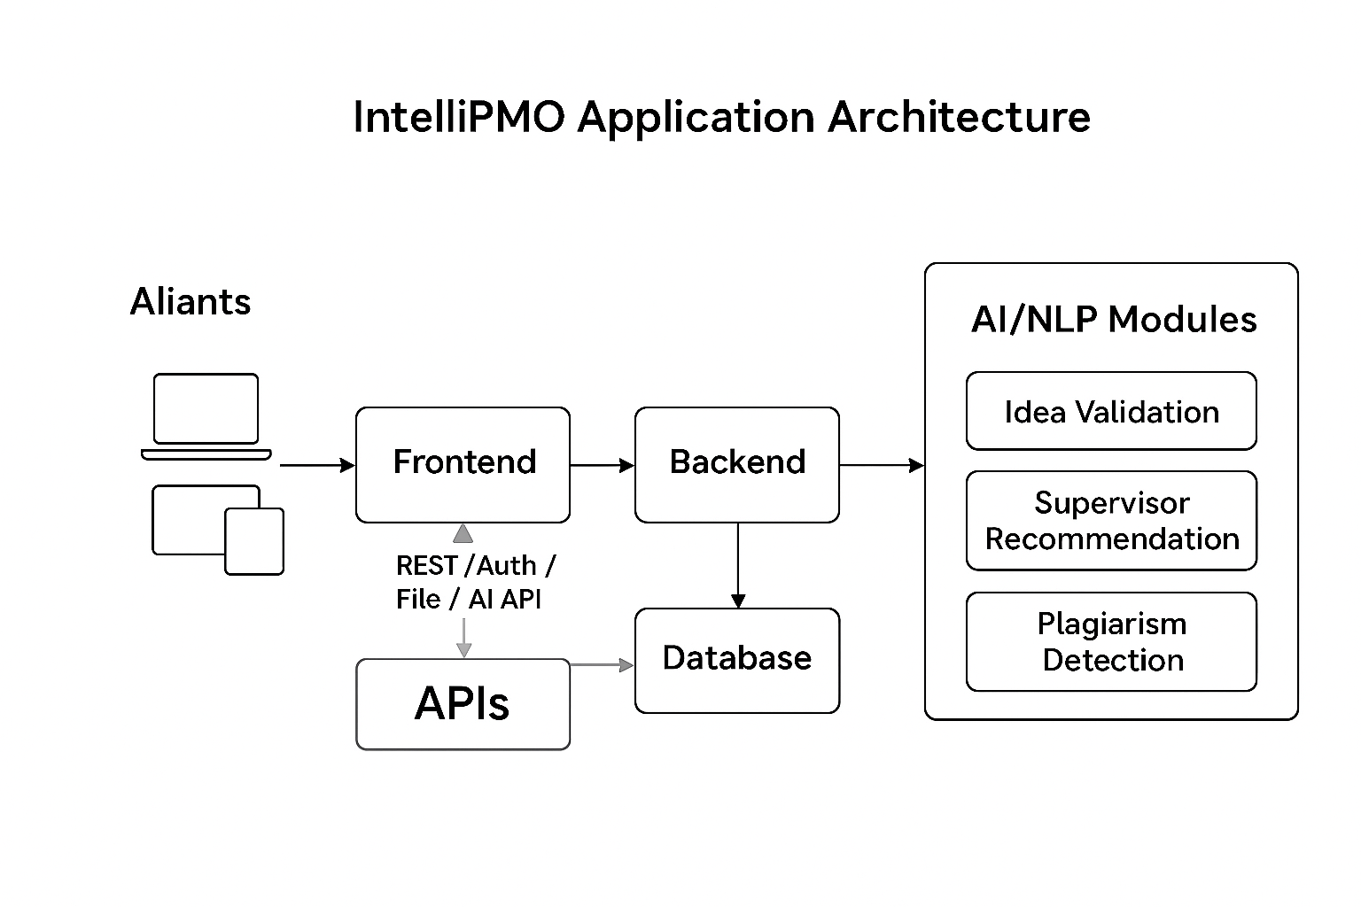
Clients

Hardware and Software Specification:

Hardware Requirements:
Component | Minimum Requirement | Recommended Requirement | Purpose
Processor (CPU) | Intel i3 / AMD Ryzen 3 | Intel i5 / Ryzen 5 or higher | To run backend, AI modules, and development tools smoothly
RAM | 8 GB | 16 GB | To handle multi-user operations, AI computations, and testing
Storage | 256 GB HDD | 512 GB SSD | For storing database, project documents, and AI model files
Network | 1 Mbps Internet | 10 Mbps or higher | Required for web-based access, cloud APIs, and online research
Display | 13-inch monitor | 15-inch or higher | Comfortable UI interaction and development

Software Requirements:
Component | Recommended Tool / Technology | Purpose
Operating System | Windows 10/11 or Linux (Ubuntu 20.04+) | Platform for development and deployment
Frontend | React.js, Node.js, npm | UI development, interactive dashboards
Backend | FastAPI (Python 3.9+), Uvicorn | API development, business logic, AI integration
Database | MySQL 8.0 | Data storage and management
AI / NLP Libraries | spaCy, Transformers (BERT), Scikit-learn | Idea validation, supervisor recommendation, plagiarism check
Development IDEs | VS Code / PyCharm | Coding and debugging
Version Control | Git / GitHub | Code management and collaboration
Testing Tools | Postman | API testing
Containerization (Optional) | Docker | Environment consistency and deployment

Estimated Cost:
Category | Description | Estimated Cost (PKR)
UI/UX Design & Frontend | Web dashboard and user interface using React.js, responsive design | 15,000
Backend Development | FastAPI development, API integration, authentication, business logic | 20,000
AI / NLP Modules Development | Idea validation, supervisor recommendation, document verification, plagiarism checking using spaCy, BERT, Scikit-learn | 25,000
Database & Storage | MySQL setup, project and user data storage, secure database configuration | 5,000
Cloud Hosting & Domain | 1-year domain, hosting for portal, server setup | 10,000
Testing & Documentation | System testing, debugging, documentation, and presentation preparation | 5,000
Miscellaneous Expenses | Internet, utilities, backup storage, and unexpected costs | 5,000

Total Estimated Cost: PKR 85,000

Tools and technologies used with reasoning:

Development Process
- Need: The project will use an iterative development process, where features are developed, tested, and improved in cycles.
- Reasoning for Tools:
  - FastAPI and Python allow rapid prototyping of backend APIs.
  - React.js supports component-based development, enabling iterative UI improvements.
  - Automated testing tools like PyTest and Postman ensure repeated testing does not introduce errors.
- Constraint: Testing and deployment must be integrated efficiently due to time constraints.

Host / Development Platforms
- Development Platform:
  - Windows 10/11 or Linux (Ubuntu) as the main OS for development.
  - IDEs: VS Code or PyCharm for coding, debugging, and testing.
- Target Platform:
  - Web-based system accessible via any modern browser (Chrome, Edge, Firefox).
  - Cloud hosting (AWS, DigitalOcean, or university server) for production deployment.

Programming Languages
- Frontend: JavaScript (React.js) – for interactive, responsive web interface.
- Backend: Python (FastAPI) – for APIs, AI/NLP integration, business logic.
- Database: SQL (MySQL) – structured data storage.
- AI / NLP Modules: Python libraries (spaCy, BERT, Scikit-learn) – for idea validation, supervisor recommendation, and plagiarism checking.
Reasoning: Python is ideal for AI integration, while React.js ensures a modular and modern UI.

Existing Tools
- Evaluated tools like Flask or Django were considered.
  - Reason for choice: FastAPI is faster, lightweight, and easier to integrate with AI modules.
- React.js was chosen over alternatives like Angular for simplicity and component reusability.
- MySQL is a proven database widely used in academic systems and compatible with Python.

Distribution of Development Organization
- Development may be physically distributed among team members.
- Reasoning for Tools:
  - Git and GitHub provide version control and collaboration support for distributed teams.
  - Cloud IDE or shared development environments can help coordinate work.

Size of Development Effort
- The project involves multiple modules:
  - Frontend (UI/UX), Backend (APIs), AI/NLP modules, Database, Cloud Deployment.
- Reasoning for Tools:
  - FastAPI and React.js allow modular, parallel development, reducing bottlenecks.
  - AI libraries support rapid prototyping without building models from scratch.

Budget and Time Constraints
- Budget and timeline are limited.
- Reasoning for Tools:
  - Open-source tools (React.js, Python, MySQL, spaCy, Scikit-learn) minimize costs.
  - Lightweight frameworks like FastAPI reduce development time.
  - Cloud hosting is scalable and cost-effective.

Project milestones and deliverables
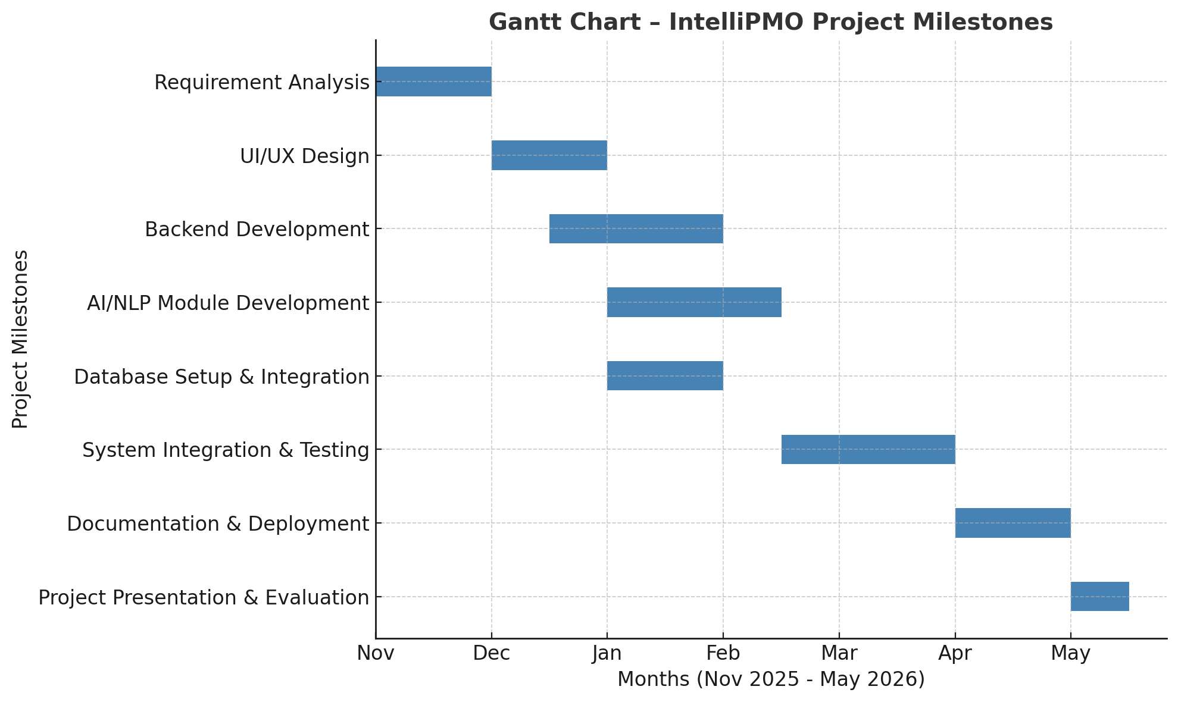

Work division among Group members
Group Member & Roll No. | Responsibilities
Nosheen  (22021519-004) | AI & NLP Module Development, Idea Validation System, Supervisor Selection Model, and Documentation Coordination
Laiba Javeed (22021519-074) | Backend Developer — FastAPI Development, Database Integration (MySQL), Authentication System, and API Connectivity
Samia Maheen (22021519-022) | Frontend Developer — React-based User Interface, UI/UX Design, User Dashboard, Proposal Upload & Feedback Modules

