3.

We used Lagrangian method to determine the dynamic model of the system which is given in the previous section. Now it is time to linearize the system.

The general state space model of the system is where, is the state variable, is the control vector and are controllable parameters.

By quadratic infinite-time cost function, the linear optimal feedback control solution is:



By implementing the above equation in the state space model we will have:



This equation is stable controlled system.

𝑹 is a weighting matrix and 𝑷 is a positive-definite Hermitian or real symmetric matrix. 𝑷 satisfies the algebraic Riccati equation:



To linearize the system we have to define a quiescent point. In the case of two inverted pendulum and cart system the quiescent point is when the inverted pendulums are kept in a small neighborhood of the vertical upright position. Therefore, and  are small. Thus:



 and 

Then the linearized state-space model can be simplified as:

 and 

And .

The linear models represent the systems adequately when the starting positions of the inverted pendulums are near the vertical upright positions. Because the linear optimal feedback controlled systems are stable at the equilibriums where 𝒙 = 0, the linear representations of the systems will always be valid as long as the initial positions are within a small neighborhood of the vertical upright position.

4.

Matlab:

First we obtained the state space form of the system by the use of ss function in Matlab. With state space variable the transfer function matrix can be derived. For the Jordan normal form we used Jordan function in matlab and the result are shown below. With the Jordan normal form, new state space variables are obtained.

In the figure below we can see eigenvalues of A in the form of 6×1 matrix.

The system is not stable. (isstable function in Matlab)

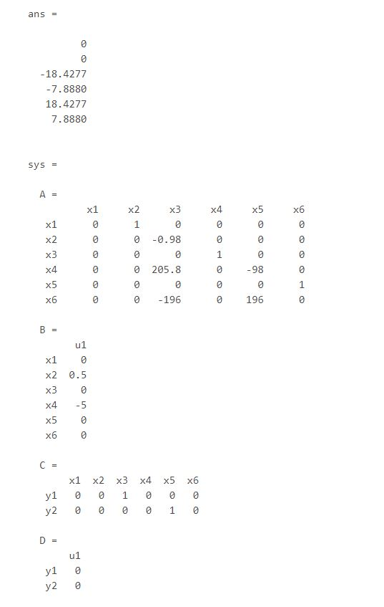

The transfer function matrix is:

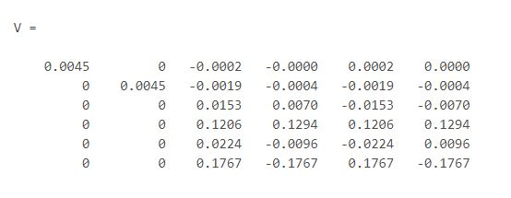

To obtain the Jordan normal form:

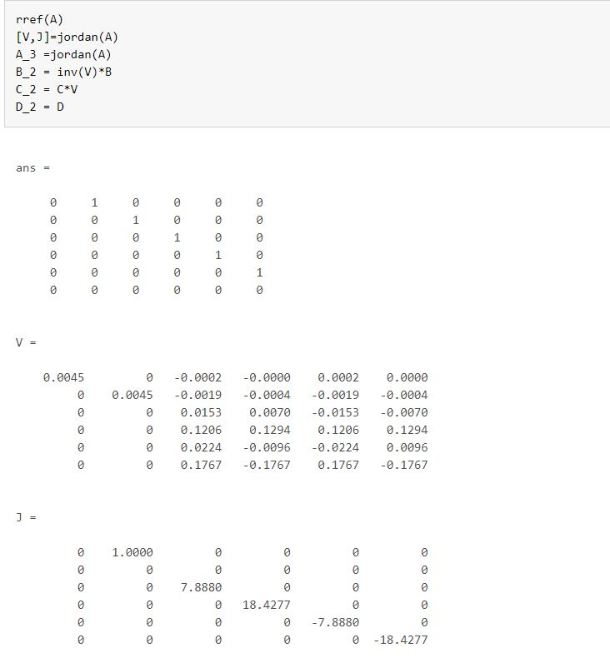

The new form of state space variables will be:

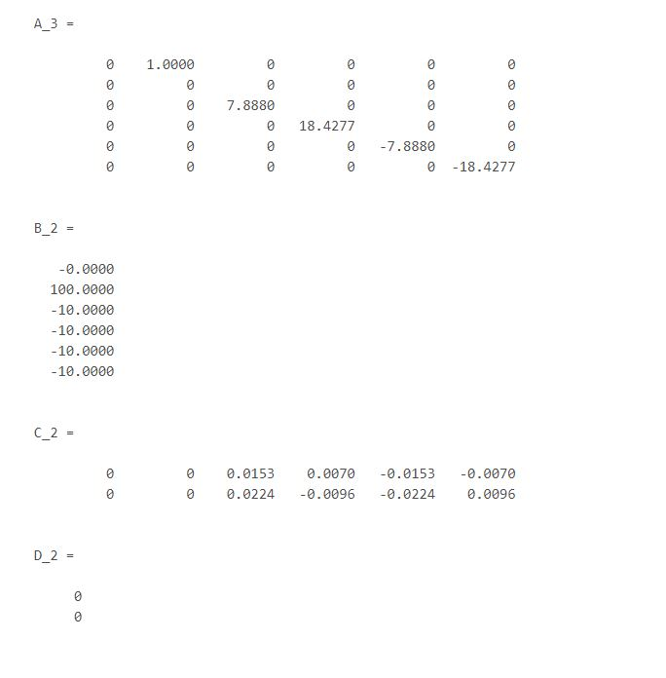

5.

The transfer function is:

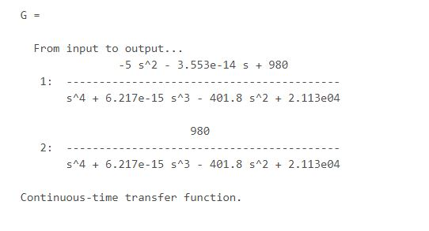

The pole zero map:

