[Skill Jobs E-learn Portal](https://training.skill.jobs)

* Categories  
  [Web Application Development](https://training.skill.jobs/courses/category/web-application-development) [Cisco Certifications](https://training.skill.jobs/courses/category/cisco-certifications) [Online Earning](https://training.skill.jobs/courses/category/online-earning) [Oracle Certification](https://training.skill.jobs/courses/category/oracle-certification) [Certification](https://training.skill.jobs/courses/category/certification) [Real-Life Advanced Digital Marketing](https://training.skill.jobs/courses/category/real-life-advanced-digital-marketing) [Project Based Real-Life Programs](https://training.skill.jobs/courses/category/project-based-real-life-programs) [Real Life](https://training.skill.jobs/courses/category/real-life) [Job Prepration](https://training.skill.jobs/courses/category/job-prepration) [Engineering Training Courses](https://training.skill.jobs/courses/category/engineering-training-courses)
* Home (current)
* [Courses](http://docs.google.com/)
* Online-Courses
* Workshop
* Events
* Free-class
* Contact Us

[Back to skill jobs](https://skill.jobs/)

Upcoming Course



[**Practical Accounts & Finance By Industry Expert (4th Batch)**](https://training.skill.jobs/courses/82/practical-accounts-&-finance-by-industry-expert)

Registration last date: 2021-03-28

Class start date: 2021-03-30

Total Hours: 32

TK 4500

Enroll Now



[**Online Live Training On Freelancing Career in Graphic Design (4th Batch)**](https://training.skill.jobs/courses/48/online-live-training-on-freelancing-career-in-graphic-design)

Registration last date: 2021-03-25

Class start date: 2021-03-28

Total Hours: 36

TK 3500

Enroll Now



[**Full Stack Web Development with Python Django & React JS (3rd Batch)**](https://training.skill.jobs/courses/80/full-stack-web-development-with-python-django-&-react-js)

Registration last date: 2021-03-23

Class start date: 2021-03-23

Total Hours: 75

TK 20000

Enroll Now

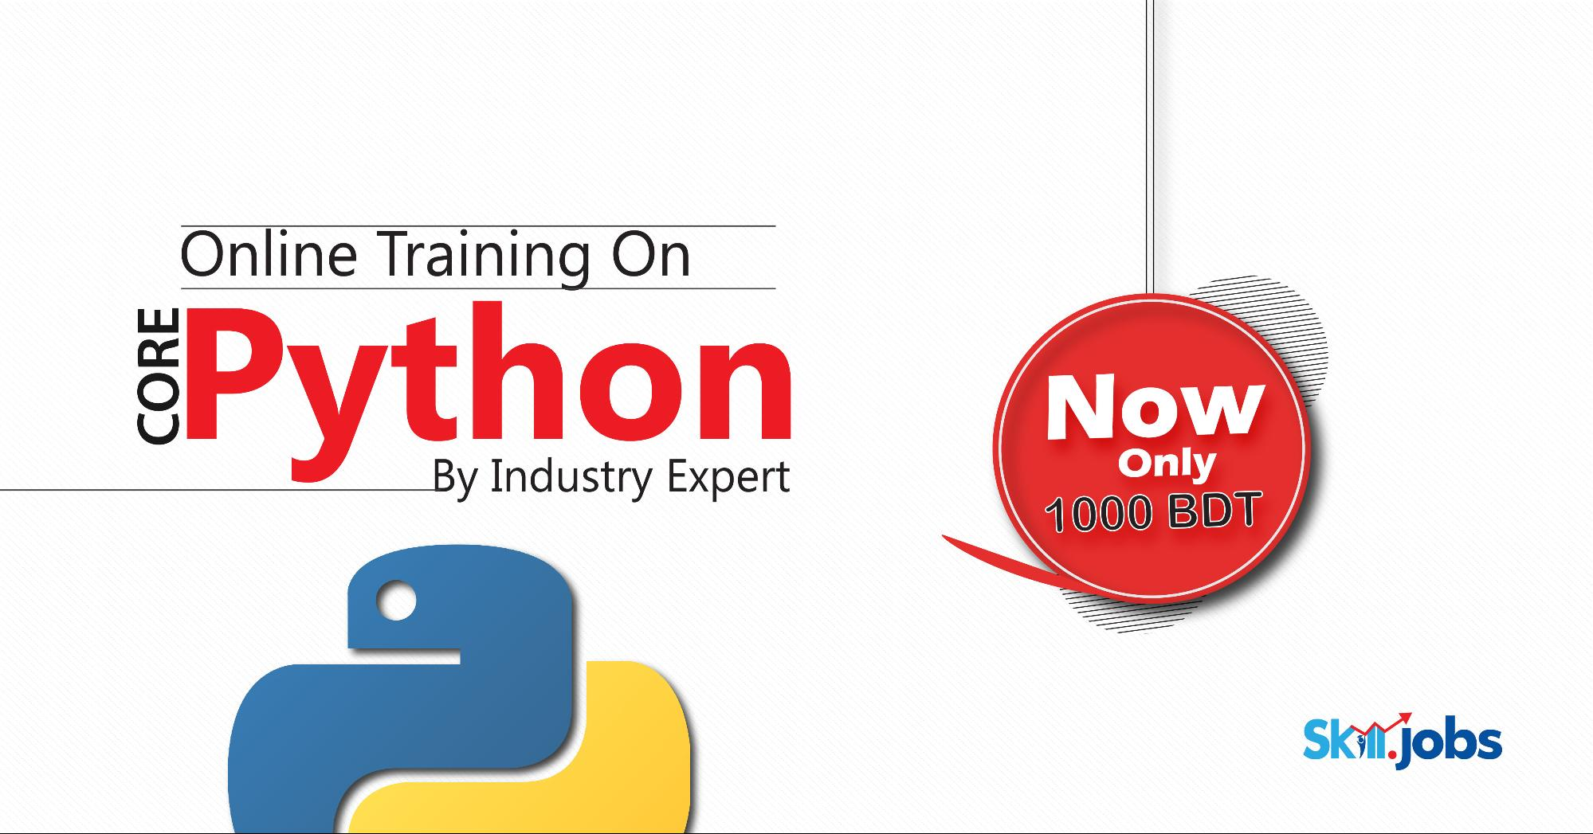

[**Online Live Training on Core Python**](https://training.skill.jobs/courses/81/online-live-training-on-core-python)

Registration last date: 2021-02-25

Class start date: 2021-02-28

Total Hours: 20

**~~TK 3000~~** TK 1000

Enroll Now



[**Communicative English for Professionals (3rd Batch)**](https://training.skill.jobs/courses/71/communicative-english-for-professionals)

Registration last date: 2021-01-25

Class start date: 2021-01-26

Total Hours: 25

TK 5000

Enroll Now



[**Data Science and Machine Learning (3rd Batch)**](https://training.skill.jobs/courses/69/data-science-and-machine-learning)

Registration last date: 2021-01-02

Class start date: 2021-01-03

Total Hours: 60

**~~TK 20000~~** TK 10000

Enroll Now



[**Real-Life Web Application Development on Python with Django (7th Batch)**](https://training.skill.jobs/courses/75/real-life-web-application-development-on-python-with-django)

Registration last date: 2020-11-23

Class start date: 2020-11-25

Total Hours: 60

TK 7000

Enroll Now



[**Microsoft Excel for Marketing & Sales Analytics (10th Batch)**](https://training.skill.jobs/courses/79/microsoft-excel-for-marketing-&-sales-analytics)

Registration last date: 2020-11-05

Class start date: 2020-11-06

Total Hours: 12

TK 3000

Enroll Now

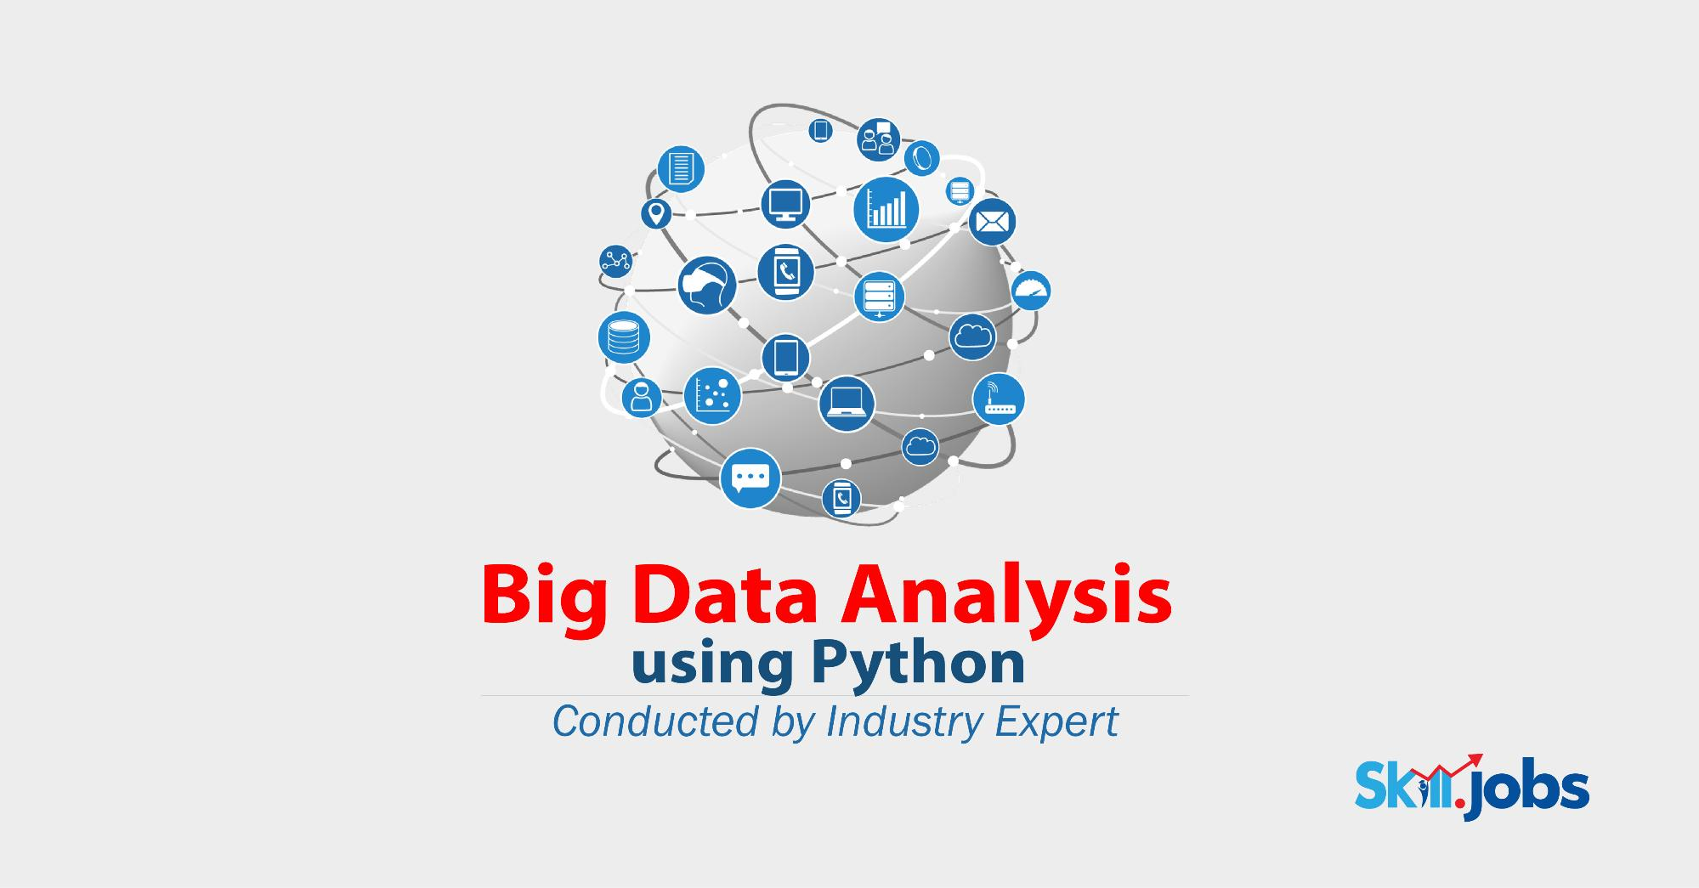

[**Big Data Analysis Using Python (1st Batch)**](https://training.skill.jobs/courses/72/big-data-analysis-using-python)

Registration last date: 2020-09-01

Class start date: 2020-09-07

Total Hours: 45

TK 5000

Enroll Now



[**Deep Learning AI with Python**](https://training.skill.jobs/courses/60/deep-learning-ai-with-python)

Registration last date: 2020-08-31

Class start date: 2020-09-05

Total Hours: 45

TK 5000

Enroll Now



[**Software testing with using Selenium and Python (1st Batch)**](https://training.skill.jobs/courses/59/software-testing-with-using-selenium-and-python)

Registration last date: 2020-08-22

Class start date: 2020-08-25

Total Hours: 50

TK 5000

Enroll Now