Software Design Document
<Medicine Management System with AI-Powered Suggestions>



Submitted by
<Muhammad Mahboob (S23BINFT1M01027>

Submitted to
<Dr Rizwan Ali Shah >

Department of Information Technology
Faculty of Computing
The Islamia University of Bahawalpur

Revision History

Name | Date | Reason for changes | Version

Document Approval
The following Software Requirements Specification has been accepted and approved by the following:
Signature | Printed Name | Title | Date

Table of Contents
- Introduction
  - Purpose
  - Scope
  - Overview
  - Reference Material
  - Definitions and Acronyms
- System Overview
- System Architecture
  - Architectural Design
  - Decomposition Description
  - Design Rationale
- Data Design
  - Data Description
  - Data Dictionary
- Component Design
- Human Interface Design
  - Overview of User Interface
  - Screen Images
  - Screen Objects and Actions
- Requirements Matrix
- Appendices

1. Introduction

1.1 Purpose
This Software Design Document (SDD) provides a comprehensive architectural and design overview of the Medicine Management System with AI-Powered Suggestions. The document serves as a blueprint for developers, testers, and project stakeholders, detailing the system's structure, components, interfaces, and data design. It bridges the gap between requirements specification and implementation, ensuring consistent understanding across the development team.

1.2 Scope
This document covers the design of:
- Three-tier web application architecture
- Database schema and data management
- Frontend components and user interfaces
- Backend services and API design
- AI suggestion engine integration
- Security and authentication mechanisms
- System integration points
Exclusions:
- Detailed algorithm implementations
- Third-party API specifications
- Hardware deployment configurations
- Network infrastructure design

1.3 Overview
The Medicine Management System follows a Model-View-Controller (MVC) architecture with Django framework. The system is organized into modular components: Inventory Management, Sales Processing, Return Management, Reporting System, and AI Suggestion Engine. The design emphasizes scalability, maintainability, and user experience.

1.4 Reference Material
- SRS Document - Medicine Management System v1.0
- Django Framework Documentation v4.2
- Python PEP 8 Style Guide
- OWASP Application Security Guidelines
- Medical Software Design Standards 1.5 Definitions and Acronyms
- MMS: Medicine Management System
- MVC: Model-View-Controller
- API: Application Programming Interface
- REST: Representational State Transfer
- ORM: Object-Relational Mapping
- NLP: Natural Language Processing
- UI: User Interface
- UX: User Experience
- JWT: JSON Web Token
- CSS: Cascading Style Sheets
- JS: JavaScript

2. System Overview
The Medicine Management System is a web-based application designed for pharmaceutical retailers. The system provides comprehensive medicine inventory management, sales tracking, return processing, and AI-powered medicine suggestions. The architecture follows a three-tier pattern:
Presentation Tier: Modern web interface built with HTML5, CSS3, and JavaScript
Application Tier: Django-based business logic and services
Data Tier: PostgreSQL database with Django ORM
Key Design Principles:
- Modularity: Independent, reusable components
- Scalability: Horizontal scaling capability
- Security: Role-based access control
- Usability: Intuitive, responsive interface
- Maintainability: Clean code separation
- Reliability: Transaction consistency and error handling

System Context
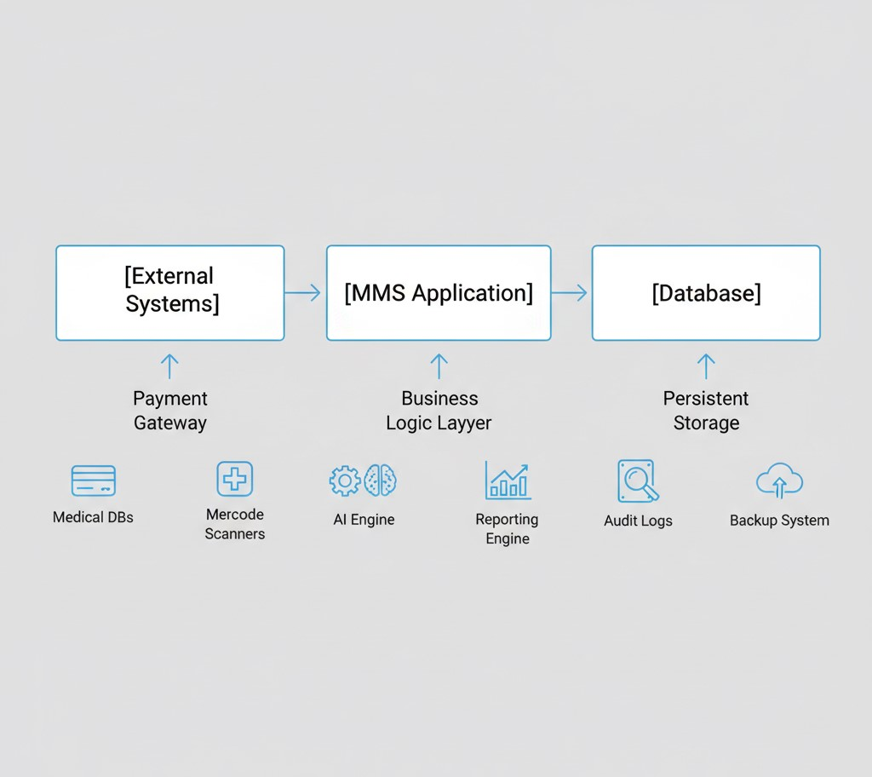

3. System Architecture

3.1 Architectural Design

High-Level Architecture Diagram
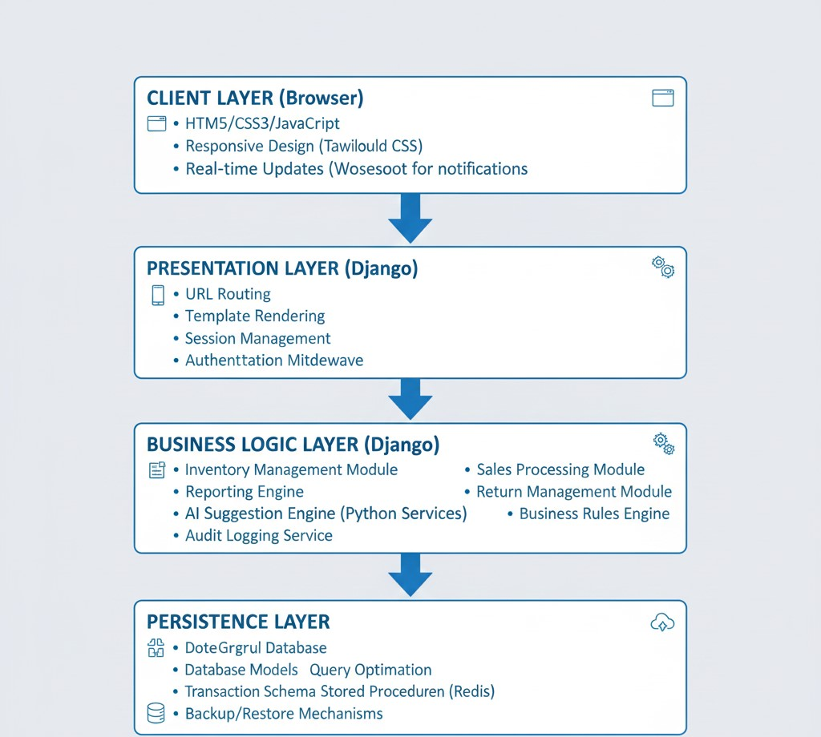

Deployment Architecture
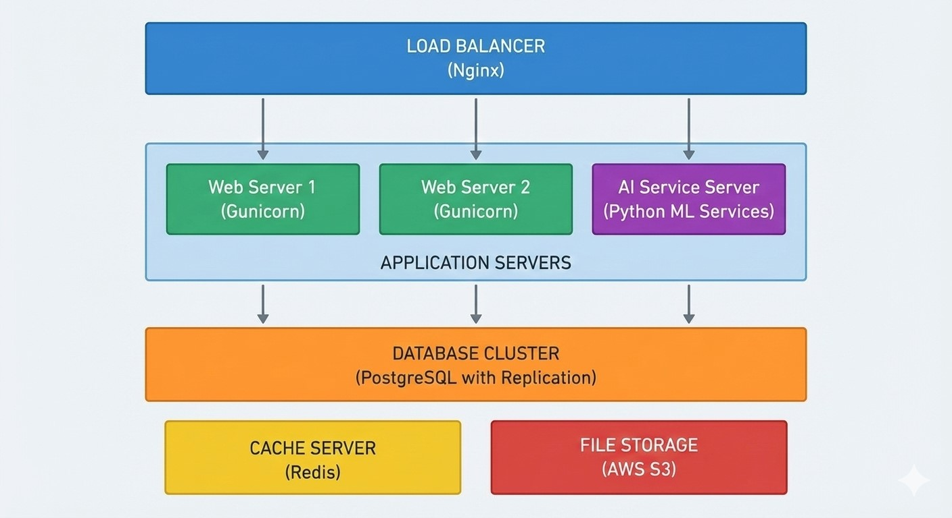

3.2 Decomposition Description
Module 1: Inventory Management Module
Components:
- MedicineController: Handles CRUD operations
- StockManager: Manages stock levels and updates
- ExpiryTracker: Monitors and alerts about expiring medicines
- SupplierManager: Manages supplier information
- BatchHandler: Processes batch-wise inventory
Responsibilities:
- Add/Edit/Delete medicine records
- Track stock movements
- Generate low stock alerts
- Manage expiry dates
- Handle supplier information

Module 2: Sales Processing Module
Components:
- SalesController: Manages sales transactions
- CartManager: Handles shopping cart operations
- PaymentProcessor: Integrates with payment gateways
- ReceiptGenerator: Creates printable receipts
- CustomerManager: Manages customer data
Responsibilities:
- Process sales transactions
- Calculate totals and taxes
- Generate invoices
- Manage customer history
- Handle payment processing
Module 3: AI Suggestion Module
Components:
- AIAnalyzer: Python-based symptom analysis
- SymptomParser: NLP processing of symptom descriptions
- MedicineMatcher: Matches symptoms with available medicines
- WarningGenerator: Creates safety warnings and disclaimers
- InteractionLogger: Logs all AI interactions
Responsibilities:
- Analyze user symptoms
- Suggest possible conditions
- Recommend appropriate medicines
- Generate safety warnings
- Log interactions for improvement
Module 4: Reporting Module
Components:
- ReportGenerator: Creates various reports
- DataAnalyzer: Processes data for analytics
- ChartRenderer: Generates visual charts
- ExportManager: Handles report exports
- Scheduler: Manages scheduled report generation
Responsibilities:
- Generate sales reports
- Create inventory reports
- Provide analytics dashboards
- Export reports in multiple formats
- Schedule automated reports Module 5: System Administration Module
Components:
- UserManager: Handles user accounts
- RoleManager: Manages role-based permissions
- AuditLogger: Logs system activities
- BackupManager: Handles data backups
- ConfigurationManager: Manages system settings
Responsibilities:
- User authentication and authorization
- System configuration
- Activity auditing
- Data backup and restore
- System monitoring

3.3 Design Rationale
Architectural Decisions:
- Choice of Django Framework:
  - Built-in admin interface for quick prototyping
○ Robust ORM for database operations
○ Excellent security features
○ Large community and extensive documentation
○ Python compatibility with AI/ML libraries
- Three-Tier Architecture:
  - Clear separation of concerns
○ Independent scalability of layers
○ Improved maintainability
○ Easier testing and debugging
- PostgreSQL Database:
  - ACID compliance for transaction safety
○ JSON support for flexible data structures
○ Excellent performance with large datasets
○ Strong community support
- RESTful API Design:
  - Stateless communication
○ Standardized interface
○ Easy integration with frontend
○ Scalable and cacheable
- AI Engine Integration:
  - Python-based for ML compatibility
○ Separate service for performance isolation
○ Async processing for better user experience
○ Comprehensive logging for continuous improvement
Design Patterns Used:
- MVC Pattern: Separation of data, presentation, and control logic
- Repository Pattern: Abstraction of data access layer
- Factory Pattern: Object creation for different report types
- Strategy Pattern: Different algorithms for AI analysis
- Observer Pattern: Event-driven notifications (alerts, updates)
- Singleton Pattern: Configuration management
- Decorator Pattern: Adding functionality to base components Performance Considerations:
- Database indexing for frequent queries
- Query optimization and caching
- Lazy loading for large datasets
- Async processing for AI operations
- CDN for static assets
- Gzip compression for API responses

4. Data Design

4.1 Data Description

Database Schema Overview
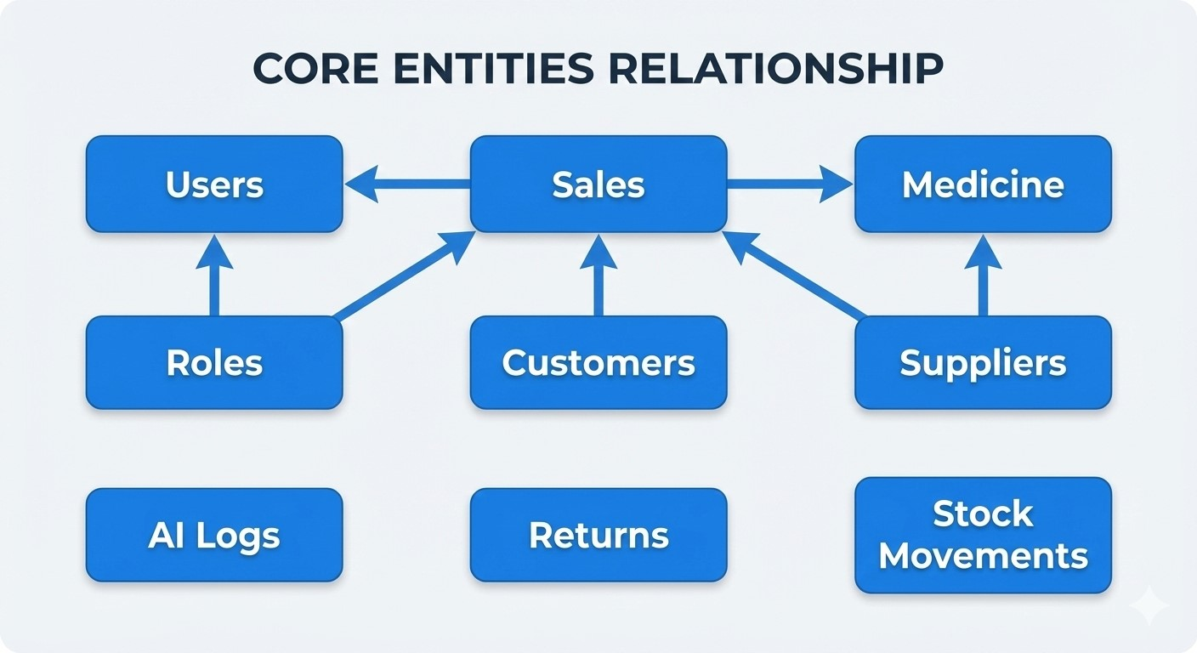

Entity Descriptions:
- Medicine Entity:
  - Stores information about all medicines in inventory
  - Includes batch tracking and expiry management
  - Links to suppliers and sales records ● Supports generic and brand name variations
- Sales Entity:
  - Records all sales transactions
  - Maintains relationship with customers and medicines
  - Tracks payment methods and discounts
  - Supports return reference

- User Entity:
  - Manages system users with role-based permissions
  - Tracks login history and activities
  - Supports password reset and profile management
- AI Logs Entity:
  - Stores all AI interaction data
  - Tracks symptoms, responses, and confidence scores
  - Used for model improvement and analytics

4.2 Data Dictionary
Core Tables Summary
Medicine Table
Stores all medicine inventory information
- medicine_id (PK): Unique identifier
- name: Brand name (e.g., "Paracetamol 500mg")
- generic_name: Chemical name
- manufacturer: Company name
- batch_number: Production batch identifier
- expiry_date: Expiration date ● quantity: Current stock level
- price: Selling price per unit
- category: Medicine category (e.g., Analgesic, Antibiotic)
- prescription_required: Boolean flag
- supplier_id: Reference to supplier
- created_at, updated_at: Timestamps
Sales Table
Records all sales transactions
- sale_id (PK): Unique transaction ID
- medicine_id (FK): Medicine sold ● quantity: Number of units sold
- unit_price: Price at time of sale
- total_amount: Calculated total
- customer_id: Reference to customer
- user_id: Staff who processed sale
- sale_date: Transaction timestamp
- payment_method: Cash/Card/Online
- receipt_number: Unique receipt ID
- created_at: Record creation time
Users Table
Manages system user accounts
- user_id (PK): Unique user identifier
- username: Login username
- password_hash: Encrypted password
- email: User email address
- first_name, last_name: User's name
- role: Admin/Pharmacist/Manager/Assistant
- is_active: Account status
- last_login: Last login timestamp
- created_at, updated_at: Timestamps
AI Interaction Logs Table
Tracks all AI suggestion requests
- log_id (PK): Unique log identifier
- user_id (FK): User who requested
- symptoms_text: User's symptom description
- ai_response: JSON structured AI response
- confidence_score: AI confidence level
- suggested_conditions: Possible diagnoses
- suggested_medicines: Recommended medicines
- created_at: Interaction timestamp
Inventory Movements Table
Audits all stock changes
- movement_id (PK): Unique movement ID
- medicine_id (FK): Medicine affected
- movement_type: Purchase/Sale/Return/Adjustment
- quantity_change: Positive/Negative quantity
- previous_quantity: Stock before change
- new_quantity: Stock after change
- reference_id: Related transaction ID
- user_id: User who made change
- created_at: Movement timestamp
Customers Table
Stores customer information
- customer_id (PK): Unique customer ID
- first_name, last_name: Customer name
- phone: Contact number
- email: Email address (optional)
- address: Delivery address
- allergies: Known allergies
- medical_history: Brief medical notes
- created_at: Record creation date
Suppliers Table
Manages medicine suppliers
- supplier_id (PK): Unique supplier ID
- name: Supplier company name
- contact_person: Primary contact
- phone: Contact number
- email: Email address
- address: Physical address
- payment_terms: Agreed terms
- created_at: Registration date
Returns Table
Handles product returns
- return_id (PK): Unique return ID
- sale_id (FK): Original sale reference
- medicine_id (FK): Returned medicine
- quantity: Number of units returned
- reason: Return reason code
- refund_amount: Calculated refund
- status: Pending/Approved/Rejected
- processed_by: Staff who handled return
- created_at: Return request date

Database Relationships:
- One-to-Many:
  - One Supplier → Many Medicines
○ One User → Many Sales Transactions
○ One Customer → Many Sales
- Many-to-Many:
  - Sales ↔ Medicines (through Sales_Details junction table)
- One-to-One:
  - User ↔ Profile (extended user information)
Data Integrity Rules:
- Cascade delete for dependent records
- Check constraints for valid data ranges
- Unique constraints for business keys
- Foreign key constraints for referential integrity
- Default values for common fields
- NOT NULL constraints for required fields Indexing Strategy:
1. Primary Indexes: Primary key columns 2. Foreign Key Indexes: All foreign key columns
3. Query Performance Indexes:
○ medicine(name) for search operations
○ sales(sale_date) for date-based queries
○ medicine(expiry_date) for expiry alerts
○ ai_logs(created_at) for time-based analysis

5. Component Design

Component 1: Medicine Management Component
Class Diagram:
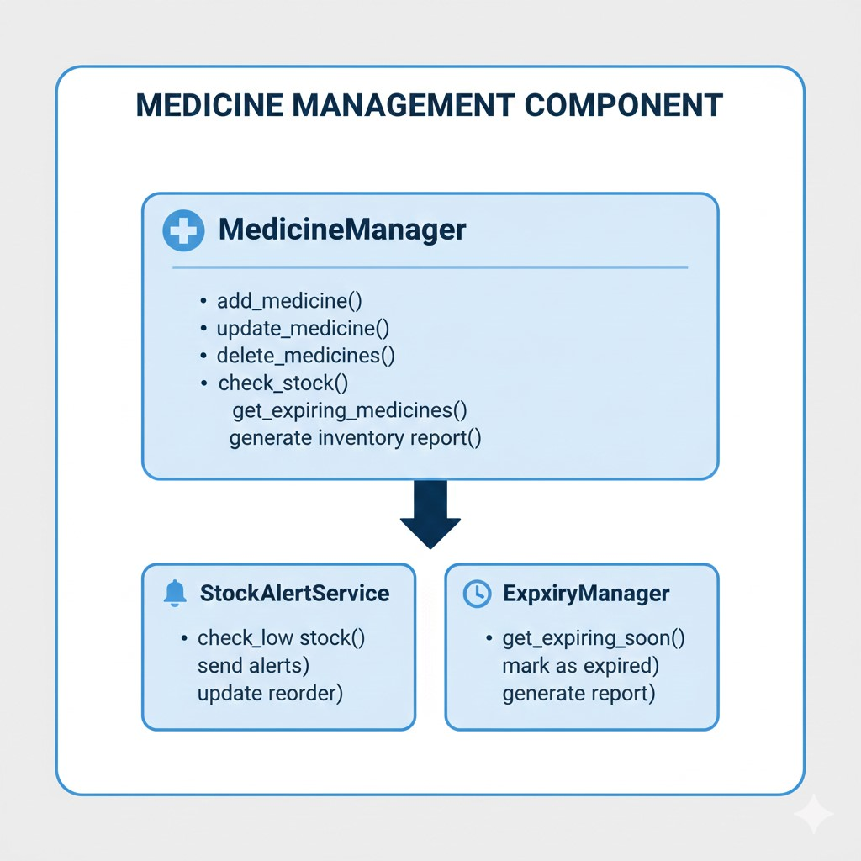

Sales Processing Component
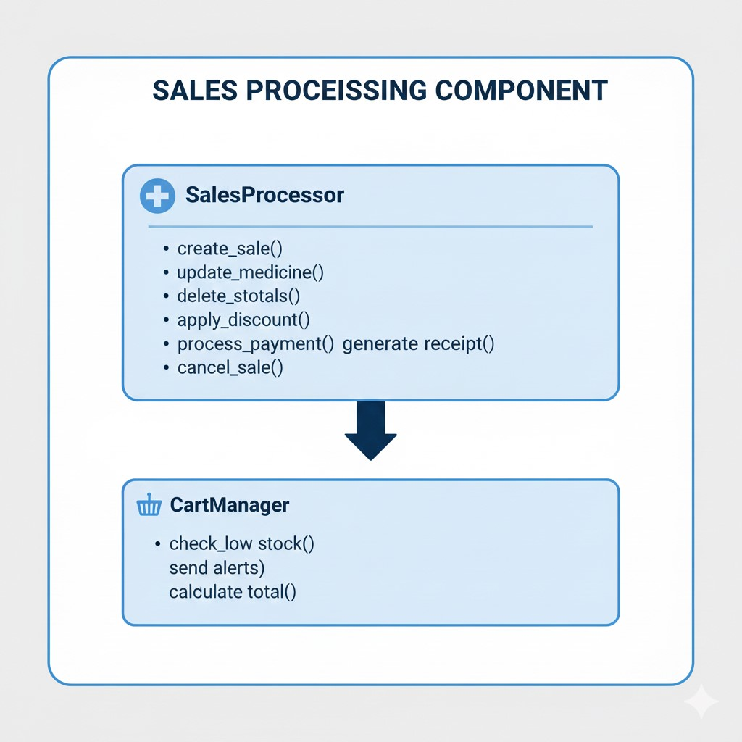

AI Suggestion Component
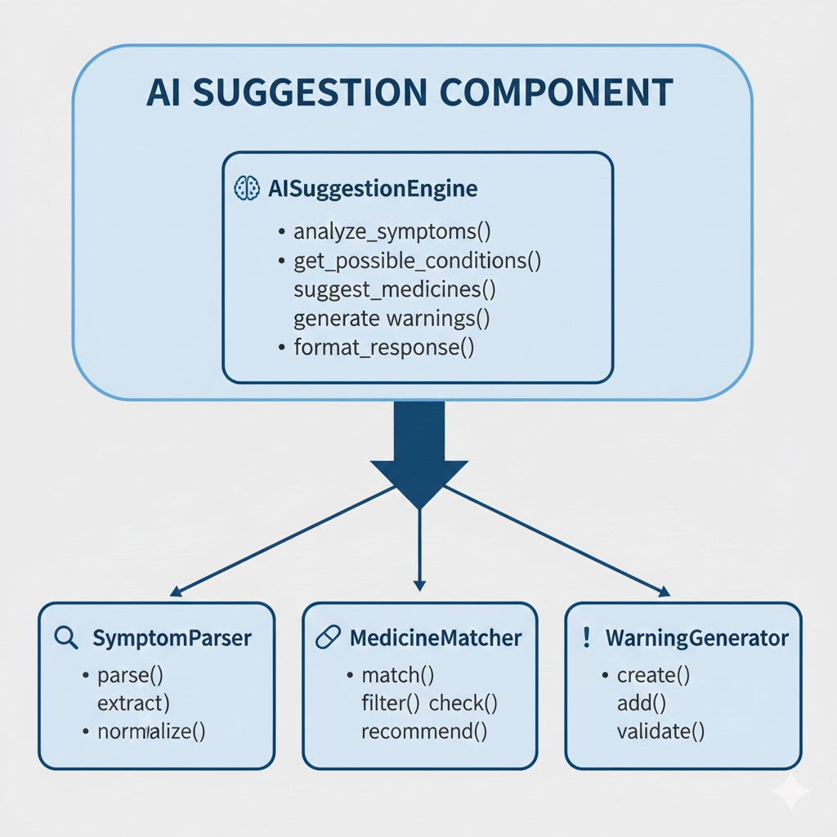

Reporting Component
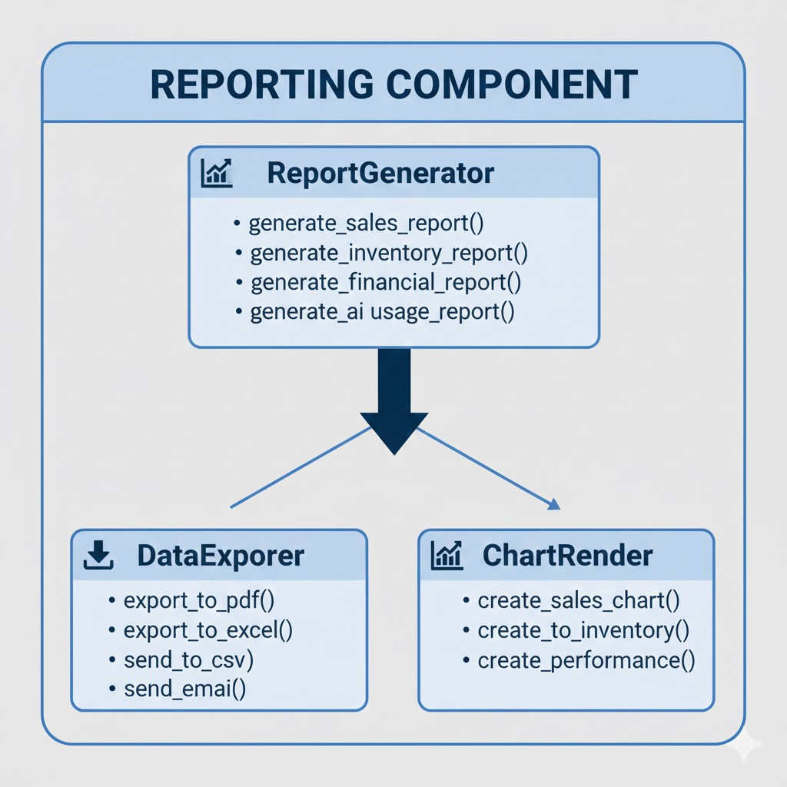

Authentication & Authorization Component
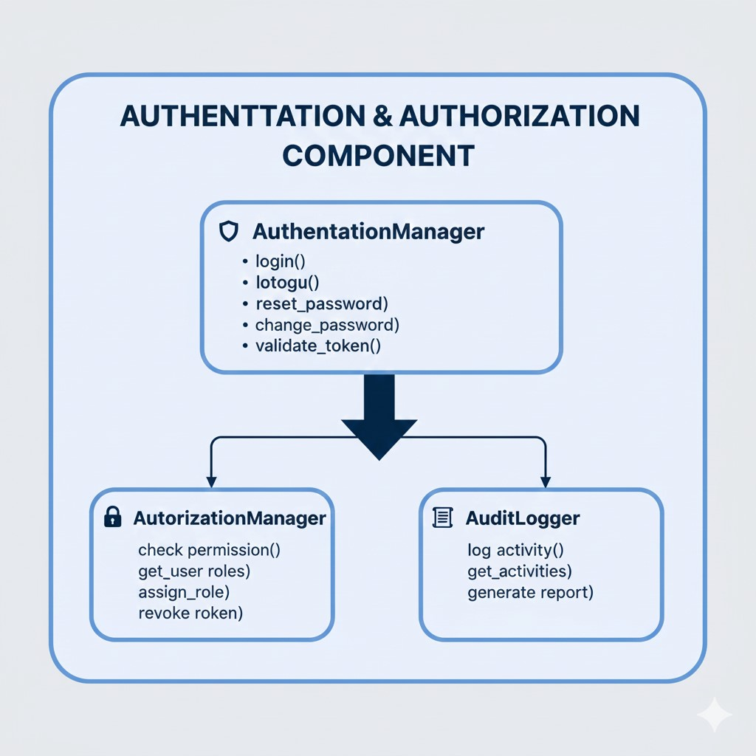

Interactions:
Scenario: Processing a Sale
- User → CartManager: Add items to cart
- CartManager → MedicineManager: Check stock availability
- MedicineManager → Database: Verify quantity
- Database → MedicineManager: Return stock status
- MedicineManager → CartManager: Confirm availability
- CartManager → SalesProcessor: Calculate totals
- SalesProcessor → PaymentGateway: Process payment
- PaymentGateway → SalesProcessor: Payment confirmation
- SalesProcessor → MedicineManager: Update stock
- MedicineManager → Database: Deduct sold quantity
- SalesProcessor → ReceiptGenerator: Create receipt
- ReceiptGenerator → Printer: Print receipt
Scenario: AI Medicine Suggestion
- User → AISuggestionEngine: Submit symptoms
- AISuggestionEngine → SymptomParser: Parse symptoms
- SymptomParser → AIModel: Get possible conditions
- AIModel → AISuggestionEngine: Return conditions
- AISuggestionEngine → MedicineMatcher: Find matching medicines
- MedicineMatcher → Database: Query available medicines
- Database → MedicineMatcher: Return medicine list
- MedicineMatcher → AISuggestionEngine: Filtered suggestions
- AISuggestionEngine → WarningGenerator: Create warnings
- WarningGenerator → User: Display results with disclaimers

6. Human Interface Design

6.1 Overview of User Interface
Design Philosophy:
- Simplicity: Clean, uncluttered interface
- Consistency: Uniform design patterns across modules
- Efficiency: Minimal clicks to complete tasks
- Accessibility: WCAG 2.1 AA compliant
- Responsiveness: Seamless experience across devices Color Scheme:
- Primary: Blue (#2563EB) - Trust, professionalism
- Secondary: Green (#10B981) - Health, safety ● Accent: Orange (#F59E0B) - Alerts, warnings
- Background: Gray (#F9FAFB) - Neutral, clean
- Text: Black (#111827) - High contrast readability Typography:
- Primary Font: Inter (Sans-serif) - Modern, readable
- Headings: Bold weights for hierarchy
- Body Text: Regular weight for comfortable reading
- Code/Monospace: Fira Code for technical text

Layout Structure:
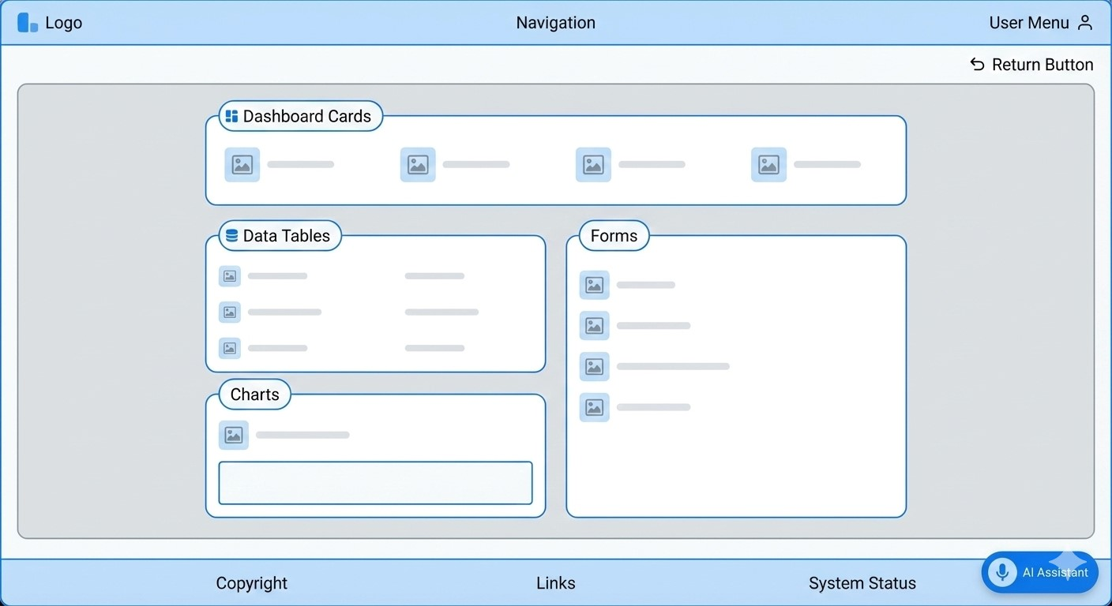

Screen 1: Dashboard Page
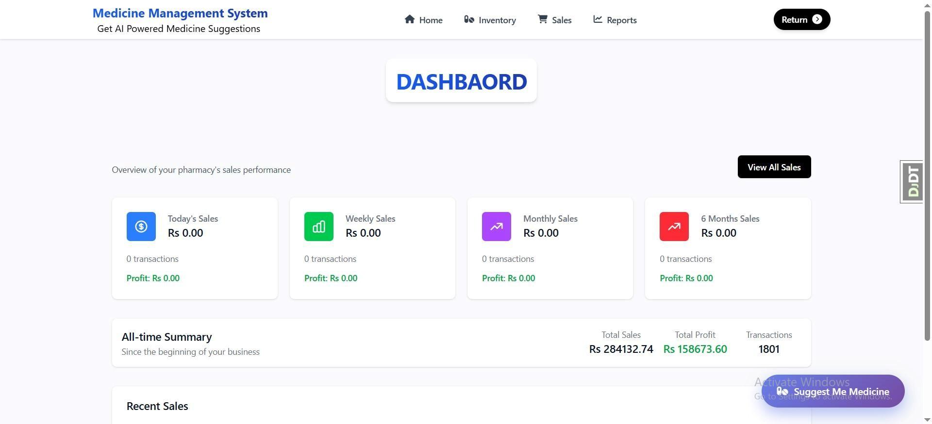

Screen 2: Inventory Management Page
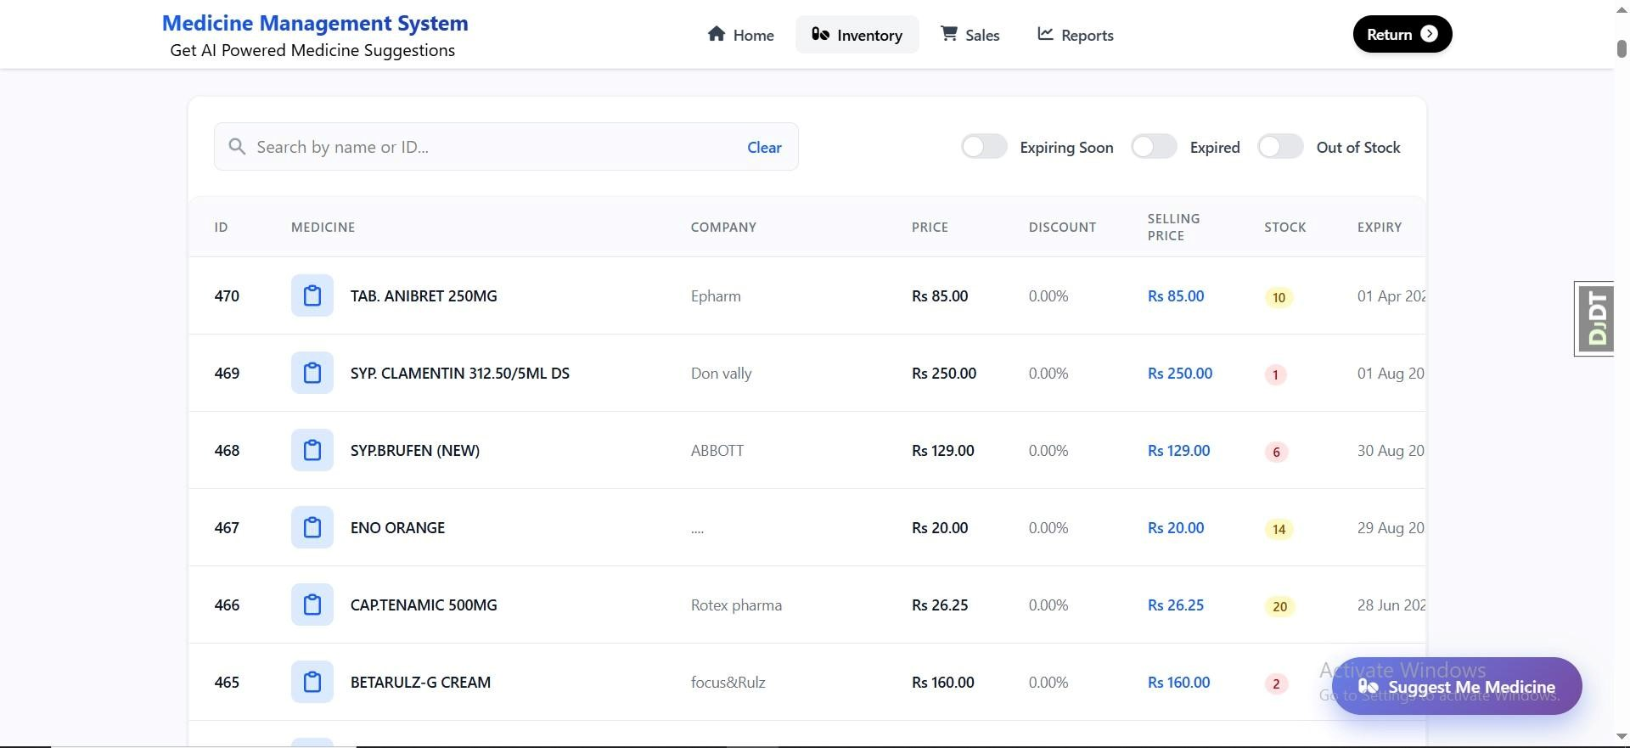

Screen 3: AI Assistant Modal
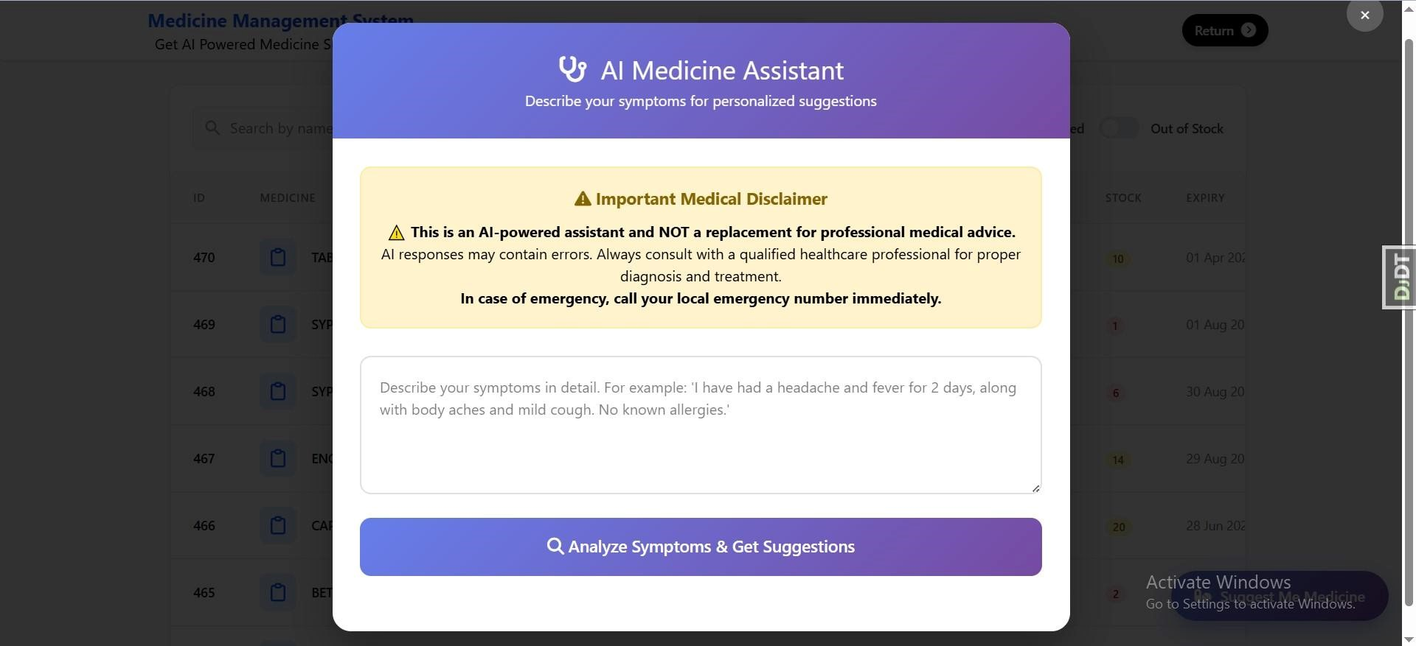

Writing symptoms
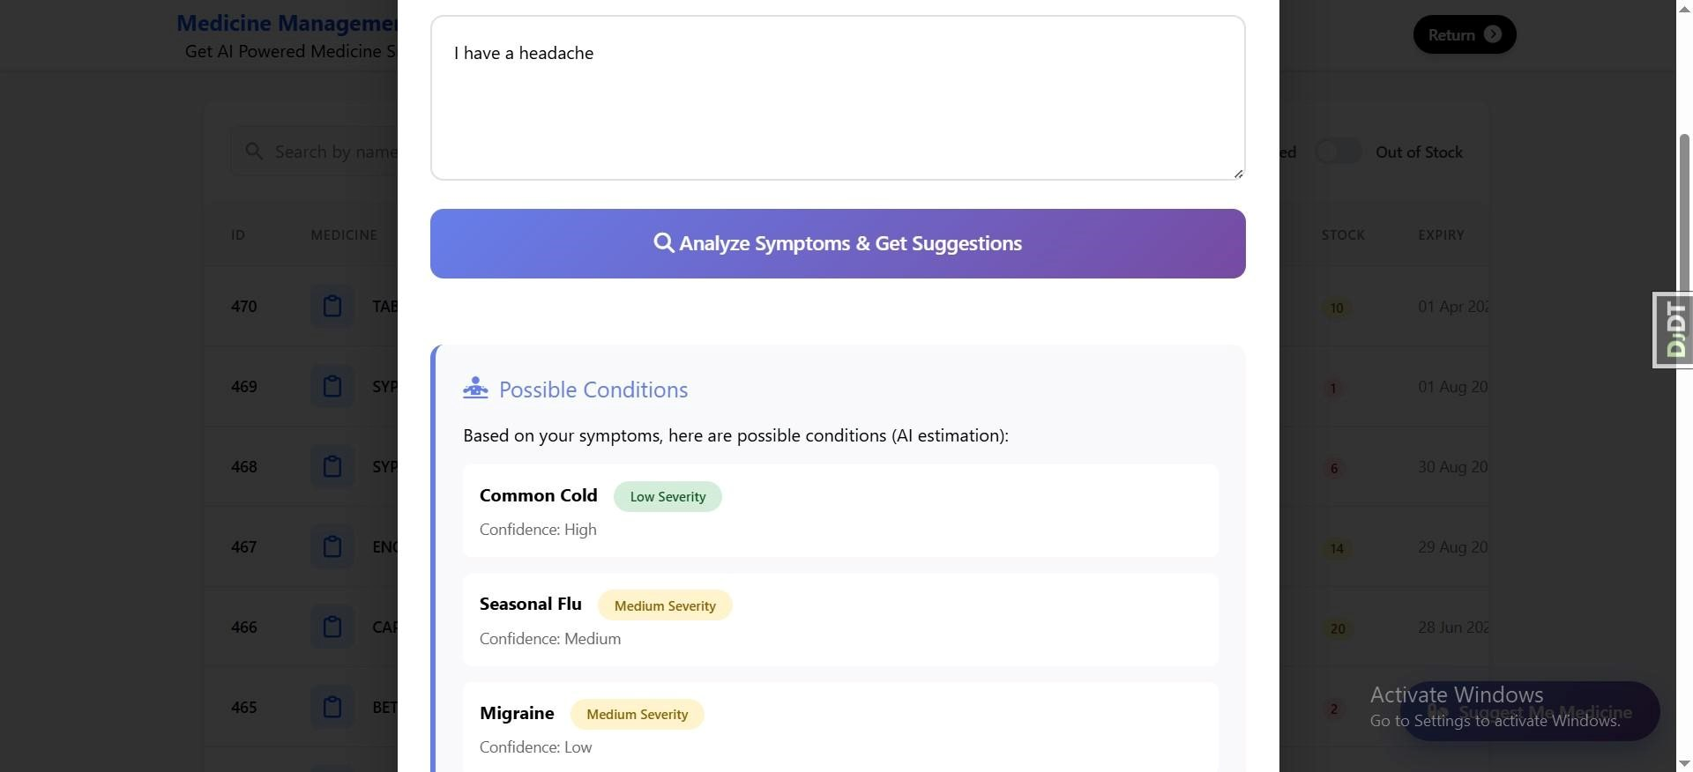
AI Powered Medicine Suggestions
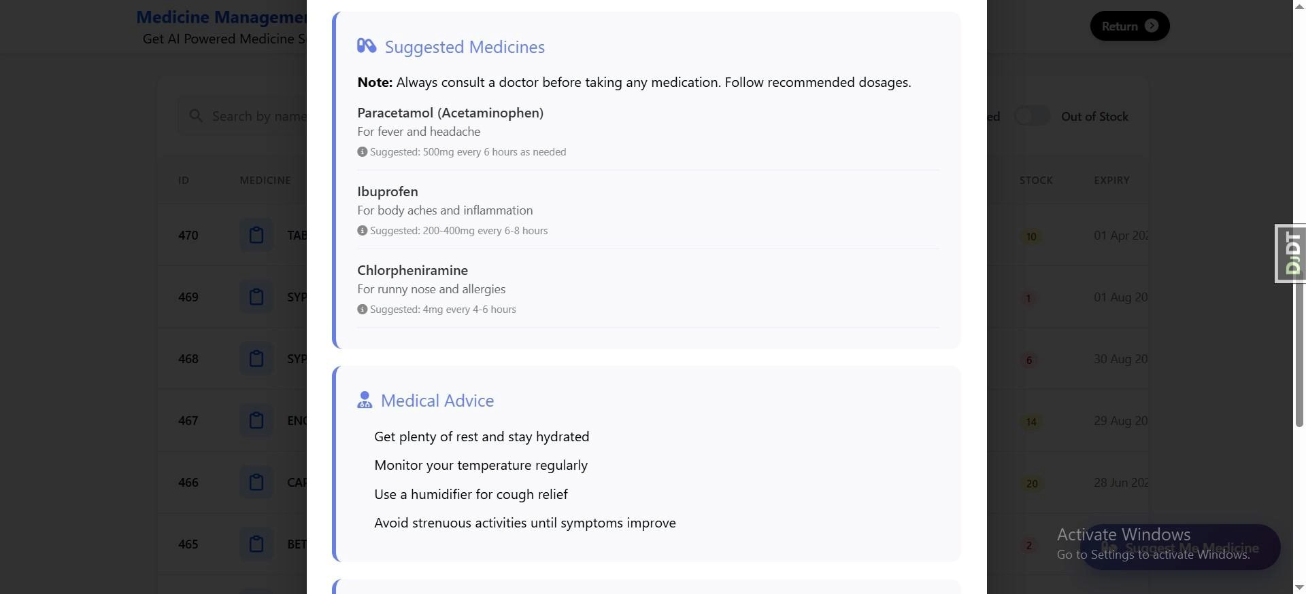
AI Powered Home Remedies Suggestions
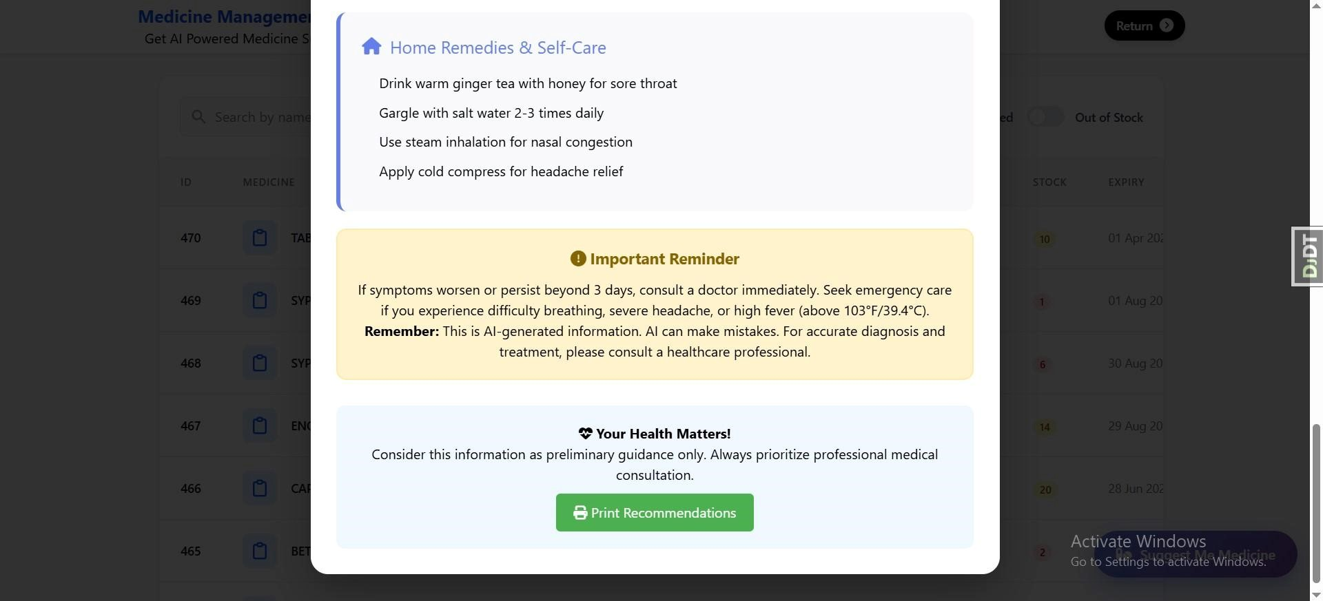
Screen 4: Sales Processing Page
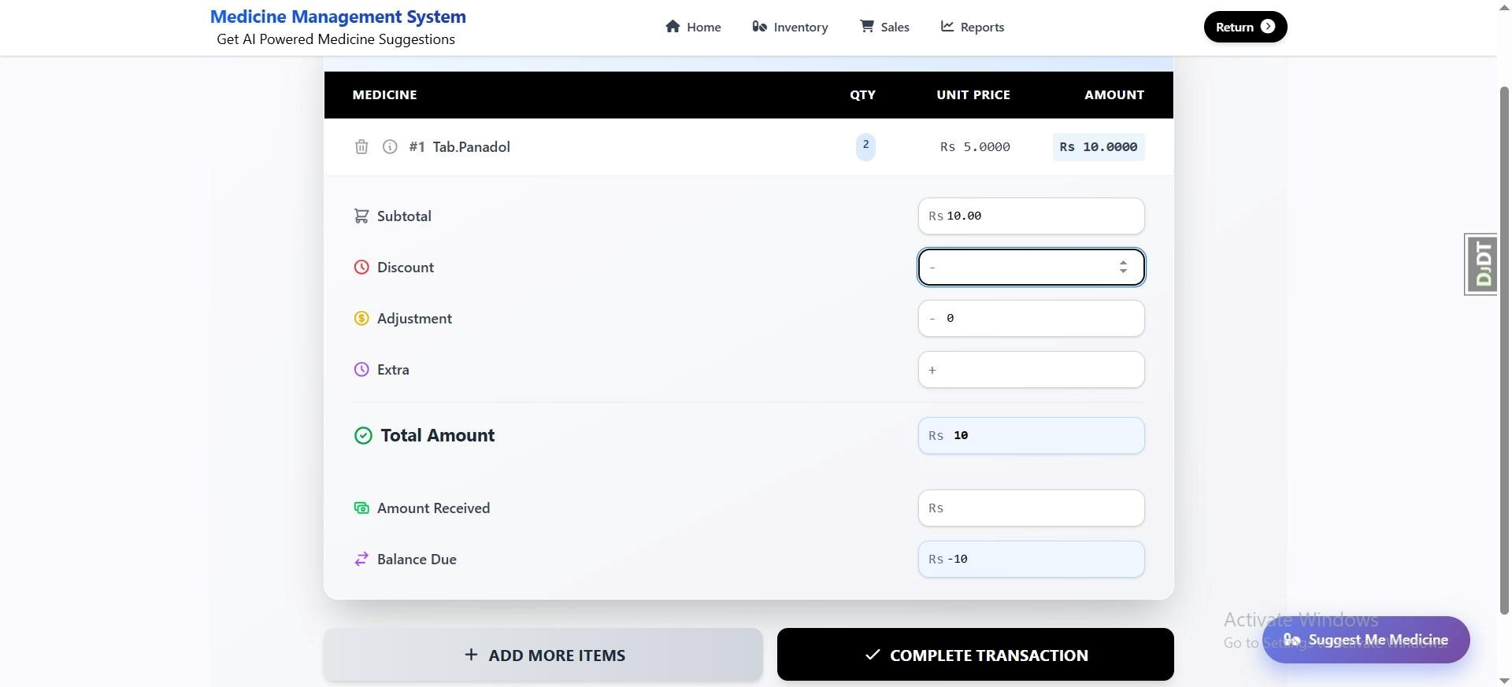

6.3 Screen Objects and Actions
Navigation Bar Components:
- Logo Section:
  - Object: div.logo-container
  - Elements:
    - Icon (medicine cross symbol)
○ System name "Medicine Management System"
○ Tagline "Get AI Powered Medicine Suggestions"
  - Actions: Click to return to dashboard
- Navigation Menu:
  - Object: nav.main-navigation
  - Menu Items:
    - Home (icon: fa-home)
○ Inventory (icon: fa-pills)
○ Sales (icon: fa-shopping-cart)
○ Reports (icon: fa-chart-line)
○ Return (icon: fa-undo)
  - Actions: Click to navigate to respective pages
  - Visual Feedback: Active page highlighted
- User Controls:
  - Object: div.user-controls
  - Elements:
    - User profile picture/initial
○ User name and role
○ Dropdown menu with: Profile, Settings, Logout
  - Actions: Click to show user menu AI Assistant Components:
- Floating Button:
  - Object: button#medicineHelperBtn
  - Position: Fixed bottom-right corner
  - Appearance: Green circular button with pill icon
  - Text: "Suggest Me Medicine"
  - Actions: Click opens AI modal
  - Animation: Subtle pulse animation to attract attention
- AI Modal:
  - Object: div#medicineModal
  - Structure:
○ Header with title and close button
○ Disclaimer section (prominent warning)
○ Symptoms textarea with placeholder
○ Analyze button
○ Results section (initially hidden) ● Actions:
○ Text input for symptoms
○ Button click triggers AI analysis
○ Close button dismisses modal
○ Print button for results
Data Table Components:
- Medicine Table:
  - Object: table.medicine-table
  - Columns:
    - Checkbox for selection
○ Medicine Name

Generic Name
Quantity
○ Expiry Date
○ Price ○ Actions (Edit/Delete) ● Features:
○ Sortable columns
○ Pagination
○ Search filter
○ Batch actions ○ Export options
- Sales Table:
  - Object: table.sales-table
  - Columns:
    - Sale ID
○ Customer Name
○ Total Amount
○ Date
○ Payment Method
○ Status ○ Actions (View/Print) ● Features:
○ Date range filtering
○ Status filters
○ Quick view modal
○ Receipt printing
Form Components:
- Medicine Entry Form:
  - Object: form.medicine-form
  - Fields:
    - Medicine Name (required)
○ Generic Name
○ Manufacturer
○ Batch Number (required)
○ Expiry Date (date picker)
○ Quantity (number)
○ Price (decimal)
○ Category (dropdown)
Prescription Required (checkbox)
Supplier (dropdown)
  - Validation: Real-time field validation
  - Actions: Submit saves to database
- Sales Form:
  - Object: form.sales-form
  - Sections:
    - Customer selection/creation
○ Medicine search and add
○ Cart display and management
○ Payment calculation ○ Payment method selection ● Features:
○ Auto-complete search
○ Real-time total calculation
○ Discount application
○ Tax calculation
Dashboard Widgets:
- Stat Cards:
  - Object: div.stat-card
  - Types:
    - Total Medicines
○ Low Stock Alerts
○ Expiring Soon
○ Today's Sales
○ Monthly Revenue
  - Design: Card with icon, number, label, and action button
  - Actions: Click to view detailed list
- Charts:
  - Object: div.chart-container
  - Types:
    - Sales trend line chart
○ Inventory category pie chart ○ Monthly performance bar chart ● Features:
○ Interactive tooltips
Zoom and pan
Export as image
○ Time period selector
Alert and Notification System:
- Toast Notifications:
  - Object: div.toast-notification
  - Types:
    - Success (green)
○ Error (red)
○ Warning (yellow)
○ Info (blue)
  - Position: Top-right corner
  - Duration: Auto-dismiss after 5 seconds ● Actions: Manual dismiss with close button
- System Alerts:
  - Object: div.system-alert
  - Triggers:
    - Low stock threshold reached
○ Medicine expiring soon
○ Sales target achieved
○ System maintenance
  - Display: Prominent banner or modal
  - Actions: Acknowledge or take action Interactive Elements:
- Buttons:
  - Primary: Solid color, used for main actions
  - Secondary: Outline, used for alternative actions
  - Danger: Red, used for destructive actions ● Success: Green, used for positive actions ● Disabled: Grayed out, non-interactive state
- Input Fields:
  - Text Input: Standard text entry
  - Textarea: Multi-line text entry

  - Select/Dropdown: Predefined options
  - Date Picker: Calendar for date selection
  - Number Input: Numeric values with steppers
  - Search: With magnifying glass icon
- Modal Dialogs:
  - Confirmation Modal: Yes/No decisions
  - Form Modal: Data entry forms
  - View Modal: Display detailed information
  - Alert Modal: Important system messages Responsive Design Breakpoints:
Mobile (< 768px):
  - Hamburger menu for navigation
  - Stacked card layout
  - Simplified tables with horizontal scroll
  - Larger touch targets
  - Bottom navigation for quick actions
Tablet (768px - 1024px):
  - Sidebar navigation
  - Two-column card layouts
  - Medium font sizes
  - Adaptive table layouts Desktop (> 1024px):
  - Top navigation bar
  - Multi-column layouts
  - Full data tables
  - Advanced dashboard widgets

7. Requirements Matrix

Requirement ID | SRS Section | Design Component | Implementation Status
FR-IM-001 | 3.2.1 | MedicineManager.a dd_medicine() | ✅ Implemented
FR-IM-002 | 3.2.1 | MedicineManager.c heck_stock() | ✅ Implemented
FR-ST-001 | 3.2.2 | SalesProcessor.cre ate_sale() | ✅ Implemented
FR-ST-002 | 3.2.2 | ReceiptGenerator.g enerate() | ✅ Implemented
FR-ST-003 | 3.2.2 | Customer.history tracking | ✅ Implemented
FR-RM-001 | 3.2.3 | ReturnProcessor.pr ocess_return() | ✅ Implemented
FR-AI-001 | 3.2.5 | AI Assistant floating button | ✅ Implemented
FR-AI-002 | 3.2.5 | Disclaimer modal display | ✅ Implemented
FR-AI-004 | 3.2.5 | AISuggestionEngin e.analyze_sympto ms() | ✅ Implemented
FR-AI-007 | 3.2.5 | Dosage recommendation  logic | ✅ Implemented
FR-AI-008 | 3.2.5 | Home remedies database | ⏳ Pending

Legend:
- ✅ Implemented: Fully designed and developed
- ⏳ Pending: Design complete, development in progress
- 📋 Planned: Design specified, to be developed
- ❌ Not Started: Requirement identified but not addressed

8. Appendices

Appendix A: Technology Stack
Backend:
- Framework: Django 4.2 (Python 3.10+)
- Database: PostgreSQL 14
- ORM: Django ORM
- REST API: Django REST Framework
- Authentication: Django Authentication + JWT
- Caching: Redis 7.0
- Task Queue: Celery with Redis broker
- AI/ML: Python (scikit-learn, TensorFlow/PyTorch for NLP)
- Medical Data: Trained models + medical APIs
Frontend:
- HTML5, CSS3, JavaScript (ES6+)
- CSS Framework: Tailwind CSS 3.3
- Icons: Font Awesome 6.0
- Charts: Chart.js 4.0
- UI Components: Custom components
- Build Tool: Vite (for production builds)
Development Tools:
- Version Control: Git with GitHub
- IDE: VS Code with Python/Django extensions
- Testing: pytest, Django Test Framework
- API Testing: Postman
- Database GUI: pgAdmin 4 / DBeaver
- Containerization: Docker & Docker Compose
- CI/CD: GitHub Actions Deployment:
- Web Server: Nginx 1.22
- WSGI Server: Gunicorn 20.1 ● Hosting: AWS EC2 / Heroku
- Database Hosting: AWS RDS / DigitalOcean
- Storage: AWS S3 for static files

SSL: Let's Encrypt certificates Monitoring: Sentry for error tracking

Appendix B: Security Considerations
Authentication & Authorization:
- Password Security:
  - BCrypt hashing algorithm
○ Minimum 8 characters with complexity
○ Account lockout after 5 failed attempts
○ Session timeout: 30 minutes inactivity
- Role-Based Access Control:
  - Admin: Full system access
○ Pharmacist: Inventory + Sales + AI
○ Manager: Reports + Analytics
○ Assistant: Sales only
- API Security:
  - JWT tokens for authentication ○ Rate limiting on API endpoints
○ Input validation and sanitization
○ SQL injection prevention via ORM
Data Protection:
- Encryption:
  - TLS 1.3 for data in transit
○ AES-256 for sensitive data at rest ○ Database column encryption for PII
- Audit Logging:
  - All user actions logged
○ Failed login attempts tracked
○ Data modification history
○ AI interaction logs
- Compliance:
  - Medical disclaimer requirements
○ Data retention policies
○ Privacy policy implementation
○ Regular security audits

Appendix C: Performance Optimization
Database Optimization:
- Indexing Strategy:
  - Primary keys on all tables
○ Foreign key indexes
○ Composite indexes for common queries
○ Partial indexes for filtered queries
- Query Optimization:
  - Select only required columns
○ Use Django's select_related/prefetch_related
○ Database connection pooling
○ Query caching with Redis
- Database Maintenance:
  - Regular vacuum and analyze
○ Index rebuilding
○ Query plan analysis
○ Performance monitoring
Application Optimization:
- Caching Strategy:
  - Page-level caching for static content
○ Query caching for frequent requests
○ Session caching in Redis
○ CDN for static assets
- Code Optimization:
  - Lazy loading of resources
○ Async processing for long operations
○ Connection pooling ○ Gzip compression for responses
- Frontend Optimization:
  - Minified CSS/JS files
○ Image optimization
○ Lazy loading of images ○ Browser caching headers Appendix D: Testing Strategy
Unit Testing:
- Test coverage target: 80%
- Django Test Framework
Mock external dependencies
Test business logic in isolation
Integration Testing:
- API endpoint testing
- Database integration tests
- Third-party service integration
- End-to-end workflow testing UI Testing:
- Selenium for browser automation
- Responsive design testing
- Cross-browser compatibility
- Accessibility testing
AI Model Testing:
- Accuracy testing with test datasets
- Performance benchmarking
- Edge case handling
- Safety and bias testing Security Testing:
- Penetration testing
- Vulnerability scanning
- OWASP compliance checking
- Data privacy verification

Appendix E: Deployment Checklist
Pre-Deployment:
- All tests passing
- Security scan completed
- Performance testing done
- Documentation updated
- Backup strategy verified
- Rollback plan prepared
Deployment Steps:
- Deploy to staging environment
- Run integration tests
- Verify database migrations
- Deploy to production
- Monitor system health
- Verify all services running
- Test critical user journeys
- Enable monitoring alerts Post-Deployment:
- Monitor error rates
- Track performance metrics
- Gather user feedback
- Schedule maintenance
- Plan next iteration

Appendix F: Maintenance Plan
Daily Tasks:
- Check system logs for errors
- Monitor server resource usage
- Verify backup completion
- Review security alerts Weekly Tasks:
- Generate system reports
- Review performance metrics
- Update AI training data
- Clean up temporary files Monthly Tasks:
- Security updates and patches
- Database optimization
- Performance tuning
- User access review
Quarterly Tasks:
- Comprehensive security audit System architecture review
Technology stack update assessment
- Disaster recovery testing Annual Tasks:
- Major version upgrades
- Compliance certification renewal
- Infrastructure capacity planning
- Strategic roadmap review

