Software Requirement Specification (SRS)

<Medicine Management System with AI-Powered Suggestions>



Department of Information Technology

Faculty of Computing
The Islamia University of Bahawalpur

<Submitted BY>
Student Name: Muhammad Mahboob
Roll No: S23BINFT1M01027
Section: 7th M1
Session: 2023 – 2027
<Submitted To>
Supervisor: Dr Rizwan Ali Shah
Meeting Details
Sr No | Details | Date | Supervisor Signature

Summary
The Medicine Management System with AI Powered Suggestions helps users manage their medicines, set reminders, and track usage. It uses AI to suggest medicines based on symptoms and provides alerts for dosage and drug interactions, improving patient safety and efficiency.

Table of Contents
- Introduction
  - Purpose
  - Scope
  - Overview
  - Reference Material
  - Definitions and Acronyms
- System Overview
- System Architecture
  - Architectural Design
  - Decomposition Description
  - Design Rationale
- Data Design
  - Data Description
  - Data Dictionary
- Component Design
- Human Interface Design
  - Overview of User Interface
  - Screen Images
  - Screen Objects and Actions
- Requirements Matrix
- Appendices

1. Introduction

1.1 Purpose
This Software Requirements Specification (SRS) document outlines the
comprehensive requirements for the Medicine Management System with AI-Powered Suggestions. The system is designed to serve pharmaceutical retailers and pharmacies by providing an integrated platform for inventory management, sales tracking, return processing, and AI-driven medical suggestion capabilities. This document serves as a contractual agreement between stakeholders and development team, ensuring all requirements are clearly defined and measurable.

1.2 Scope
The Medicine Management System is a web-based application that includes:
Core Management Features:
- Complete medicine inventory tracking with stock levels, expiry dates, and supplier information
- Sales transaction processing with receipt generation
- Return and refund management system
- Comprehensive reporting and analytics dashboard
Advanced AI Feature:
- AI-powered medicine suggestion system accessible via floating assistant
- Symptom analysis and preliminary medicine recommendations
- Integration with medical databases for accurate suggestions
- Professional medical disclaimers and safety warnings
Exclusions:
- The system will NOT serve as a diagnostic tool
- Will NOT replace professional medical consultation
- Does NOT process insurance claims
- NOT intended for hospital-level patient management

1.3 Definitions, Acronyms, and Abbreviations
- MMS: Medicine Management System
- AI: Artificial Intelligence
- SRS: Software Requirements Specification
- UI: User Interface
- UX: User Experience
- API: Application Programming Interface
- CRUD: Create, Read, Update, Delete
- HIPAA: Health Insurance Portability and Accountability Act (for reference only)
- DBMS: Database Management System
- NLP: Natural Language Processing
- Django: Python web framework used for backend
- HTML/CSS/JS: Frontend technologies
- SQL: Structured Query Language

1.4 References
- IEEE Standard 830-1998 for Software Requirements Specifications
- Django Documentation v4.2
- Medical Device Software Standards (IEC 62304)
- Healthcare Data Privacy Guidelines
- Python Programming Language Specification

1.5 Overview
This SRS is organized into five main sections. Section 1 introduces the document. Section 2 provides overall system description. Section 3 details specific requirements. Section 4 presents analysis models. Section 5 contains supporting information. The document follows a structured approach to ensure all functional and non-functional requirements are comprehensively covered.

2. The Overall Description

2.1 Product Perspective
The Medicine Management System operates as an independent web application designed for small to medium-sized pharmacies and pharmaceutical retailers. It interfaces with existing barcode scanners and receipt printers while maintaining standalone functionality.

2.1.1 Operations
- Daily Operations: Inventory updates, sales processing, customer management
- Weekly Operations: Stock reports, expiry alerts, sales summaries
- Monthly Operations: Financial reporting, inventory auditing, performance analytics
- AI Operations: Real-time symptom analysis, medicine suggestion generation

2.1.2 Site Adaptation Requirements
- Responsive design for desktop, tablet, and mobile devices
- Support for multiple pharmacy branches (scalable architecture)
- Localization support for different regions
- Configurable tax rates and currency formats

2.2 Product Functions
- Inventory Management System
  - Medicine CRUD operations
○ Stock level monitoring
○ Expiry date tracking and alerts
○ Supplier management
○ Batch tracking
- Sales Management
  - Point of Sale (POS) functionality
○ Invoice generation
○ Customer history tracking
○ Payment processing
○ Discount management
- Return Management
  - Return request processing
○ Refund calculation
○ Stock reconciliation
○ Return analytics
- Reporting System
  - Sales reports (daily, weekly, monthly)
○ Inventory reports
○ Financial summaries
○ Performance analytics
- AI Medicine Suggestion
  - Symptom input interface
○ AI analysis engine (Python-based)
○ Medicine recommendation generation
○ Safety disclaimers and warnings
○ Print functionality for suggestions

2.3 User Characteristics
- Pharmacist/Primary User
  - Education: Pharmacy degree or equivalent
○ Technical Skills: Basic computer literacy
○ Responsibilities: Inventory management, sales processing, customer consultation
○ Frequency: Daily usage, 8+ hours
- Store Manager
  - Education: Business management
○ Technical Skills: Intermediate computer skills
○ Responsibilities: Report analysis, inventory planning, staff management
○ Frequency: Daily usage, 2-4 hours
- Sales Assistant
  - Education: High school diploma
○ Technical Skills: Basic computer skills
○ Responsibilities: Sales processing, customer service
○ Frequency: Daily usage, 4-8 hours
- System Administrator
  - Education: IT-related degree
○ Technical Skills: Advanced technical skills
○ Responsibilities: System maintenance, user management, backups
○ Frequency: Weekly maintenance, 2-3 hours

2.4 General Constraints
- Regulatory Constraints: Must include medical disclaimers for AI suggestions
- Technical Constraints: Must support existing barcode scanners and receipt printers
- Performance Constraints: AI response time under 5 seconds
- Security Constraints: Customer data protection, access controls
- Legal Constraints: Compliance with data protection laws

2.5 Assumptions and Dependencies
Assumptions:
- Users have basic computer literacy
- Stable internet connection available
- Standard web browsers are used
- Medical database APIs are accessible
Dependencies:
- Django framework for backend
- Python AI libraries (TensorFlow/PyTorch for ML)
- PostgreSQL/MySQL database
- Web server (Apache/Nginx)
- Medical databases/APIs for AI training

3. Specific Requirements

3.1 External Interface Requirements

3.1.1 System Interfaces
- Operating System: Windows 10+, macOS 10.14+, Linux distributions
- Web Server: Apache 2.4+ or Nginx 1.18+
- Database: PostgreSQL 12+ or MySQL 8.0+
- Python: Version 3.8+

3.1.2 User Interfaces
- Primary Interface: Responsive web application
- Navigation: Fixed navbar with sections: Home, Inventory, Sales, Reports, Return
- AI Assistant: Fixed-position button (bottom-right corner)
- Color Scheme: Professional healthcare theme (blues, whites)
- Accessibility: WCAG 2.1 Level AA compliance

3.1.3 Hardware Interfaces
- Barcode Scanner: USB HID interface support
- Receipt Printer: ESC/POS command support
- Cash Drawer: Serial/USB interface
- Touch Screen: Capacitive touch support

3.1.4 Software Interfaces
- Backend Framework: Django 4.2
- Frontend: HTML5, CSS3, JavaScript (ES6+)
- AI Engine: Python with machine learning libraries
- Database ORM: Django ORM
- APIs: RESTful API for internal communication

3.1.5 Communications Interfaces
● Protocol: HTTPS with TLS 1.3
Ports: 80 (HTTP), 443 (HTTPS)
External APIs: Medical database APIs (secured connections)
Data Format: JSON for API communications

3.2 Functional Requirements

3.2.1 Medicine Inventory Management (FR-IM-001 to FR-IM-010)
- FR-IM-001: System shall allow adding new medicine with details (name, generic name, manufacturer, batch number, expiry date, quantity, price)
- FR-IM-002: System shall track stock levels in real-time
- FR-IM-003: System shall generate low-stock alerts (threshold configurable)
- FR-IM-004: System shall show expiry date warnings (30 days advance)
- FR-IM-005: System shall support batch-wise inventory tracking
- FR-IM-006: System shall allow inventory search by name, generic name, manufacturer
- FR-IM-007: System shall generate inventory reports (PDF/Excel)
- FR-IM-008: System shall maintain supplier information
- FR-IM-009: System shall track purchase history
- FR-IM-010: System shall support bulk import/export

3.2.2 Sales Tracking System (FR-ST-001 to FR-ST-008)
- FR-ST-001: System shall process sales transactions
- FR-ST-002: System shall generate receipts with QR codes
- FR-ST-003: System shall calculate taxes automatically
- FR-ST-004: System shall apply discounts (percentage/fixed)
- FR-ST-005: System shall maintain customer purchase history
- FR-ST-006: System shall support multiple payment methods
- FR-ST-007: System shall generate daily sales summaries
- FR-ST-008: System shall track salesperson performance

3.2.3 Return Management (FR-RM-001 to FR-RM-006)
- FR-RM-001: System shall process return requests with reason codes
- FR-RM-002: System shall calculate refund amounts automatically
- FR-RM-003: System shall update inventory upon return
- FR-RM-004: System shall generate return receipts
- FR-RM-005: System shall track return patterns
- FR-RM-006: System shall generate return reports

3.2.4 Reporting and Analytics (FR-RA-001 to FR-RA-007)
FR-RA-001: System shall generate sales reports (daily/weekly/monthly)
FR-RA-002: System shall generate inventory valuation reports
- FR-RA-003: System shall generate expiry reports
- FR-RA-004: System shall provide graphical analytics dashboard
- FR-RA-005: System shall export reports in multiple formats
- FR-RA-006: System shall show profit/loss statements
- FR-RA-007: System shall provide trend analysis

3.2.5 AI-Powered Medicine Suggestion (FR-AI-001 to FR-AI-012)
- FR-AI-001: System shall provide always-accessible AI assistant button
- FR-AI-002: System shall display medical disclaimer prominently
- FR-AI-003: System shall accept symptom descriptions via text input
- FR-AI-004: AI engine shall analyze symptoms using NLP (Python-based)
- FR-AI-005: System shall suggest possible conditions with confidence levels
- FR-AI-006: System shall recommend appropriate medicines from inventory
- FR-AI-007: System shall provide dosage recommendations
- FR-AI-008: System shall suggest home remedies and self-care tips
- FR-AI-009: System shall display safety warnings and when to see a doctor
- FR-AI-010: System shall allow printing of suggestions
- FR-AI-011: System shall maintain response time under 5 seconds
- FR-AI-012: System shall log all AI interactions for improvement

3.3 Use Cases

3.3.1 Use Case #1: Inventory Management
- Actor: Pharmacist
- Preconditions: User logged in, inventory module access ● Main Flow:
  - User navigates to Inventory section
  - System displays medicine list with stock levels
  - User adds new medicine item
  - System validates and saves medicine data
  - System updates stock levels
  - User receives confirmation
- Alternative Flow: Low stock alert generation
- Postconditions: Inventory updated, reports available

3.3.2 Use Case #2: AI Medicine Suggestion
Actor: Customer/Pharmacist
Preconditions: AI assistant available, user describes symptoms Main Flow:
- User clicks AI assistant button
- System displays disclaimer modal
- User accepts disclaimer and inputs symptoms
- System sends symptoms to Python AI engine
- AI analyzes symptoms using trained model
- System displays recommendations with warnings
- User can print or save suggestions
- Alternative Flow: Inconclusive analysis - suggests doctor visit
- Postconditions: Suggestions provided, interaction logged

3.4 Classes / Objects

3.4.1 Medicine Class
class Medicine:
Attributes:
- medicine_id (Primary Key)
- name
- generic_name
- manufacturer
- batch_number
- expiry_date
- quantity
- price
- category
- prescription_required (boolean) Methods:
- update_stock()
- check_expiry()
- calculate_profit()

3.4.2 User Class
class User:
Attributes:
- user_id (Primary Key)
- username
- password (hashed)
- email
- role (pharmacist/manager/assistant) - permissions Methods:

- authenticate()
- check_permission()
- log_activity()

3.4.3 Sales Class

class Sales:
Attributes:
- sale_id (Primary Key)
- medicine_id (Foreign Key)
- quantity
- price
- discount
- total
- customer_id
- sale_date - payment_method Methods:
- calculate_total()
- generate_receipt()
- apply_discount()

3.5 Non-Functional Requirements

3.5.1 Performance
- Response Time: Page load < 3 seconds, AI response < 5 seconds
- Throughput: Support 50 concurrent users
- Scalability: Handle up to 10,000 medicine records
- Resource Usage: Optimized database queries, efficient caching

3.5.2 Reliability
- Availability: 99.5% uptime
- Mean Time Between Failures (MTBF): 720 hours
- Mean Time To Repair (MTTR): 1 hour
- Data Integrity: Transaction consistency, automatic backups

3.5.3 Availability
- Operating Hours: 24/7 availability
- Maintenance Window: 2 hours weekly (off-peak hours)
Redundancy: Database replication, failover mechanisms

3.5.4 Security
- Authentication: Role-based access control
- Authorization: Permission-based feature access
- Data Encryption: AES-256 for sensitive data
- Audit Trail: All critical operations logged
- Session Management: Secure session handling, timeout after 30 minutes

3.5.5 Maintainability
- Code Documentation: Comprehensive inline comments
- Modular Design: Separation of concerns
- Testing: Unit tests covering 80% of codebase
- Version Control: Git with branching strategy

3.5.6 Portability
- Browser Compatibility: Chrome, Firefox, Safari, Edge (latest versions)
- Responsive Design: Mobile, tablet, desktop compatibility
- Database Portability: Support for PostgreSQL and MySQL

3.6 Inverse Requirements
- System shall NOT provide definitive medical diagnosis
- System shall NOT prescribe controlled substances
- System shall NOT share patient information without consent
- System shall NOT replace professional medical consultation
- System shall NOT operate without internet connectivity (for AI features)

3.7 Logical Database Requirements
- Database Schema: Normalized to 3NF
- Tables: Medicine, Sales, Users, Customers, Suppliers, Returns, AI_Logs
- Relationships: Proper foreign key constraints
- Indexing: Performance-optimized indexes on frequently queried columns
- Backup Strategy: Daily incremental, weekly full backups
- Data Retention: Sales data - 7 years, Logs - 1 year

3.8 Design Constraints

3.8.1 Standards Compliance
- Web Standards: HTML5, CSS3, WCAG 2.1 AA
- Security Standards: OWASP Top 10 compliance
- Medical Standards: Include proper disclaimers and warnings
- Coding Standards: PEP 8 (Python), ESLint (JavaScript)
- Database Standards: ANSI SQL compliance

4. Analysis Models

4.1 Sequence Diagrams
- Sequence diagram for medicine purchase
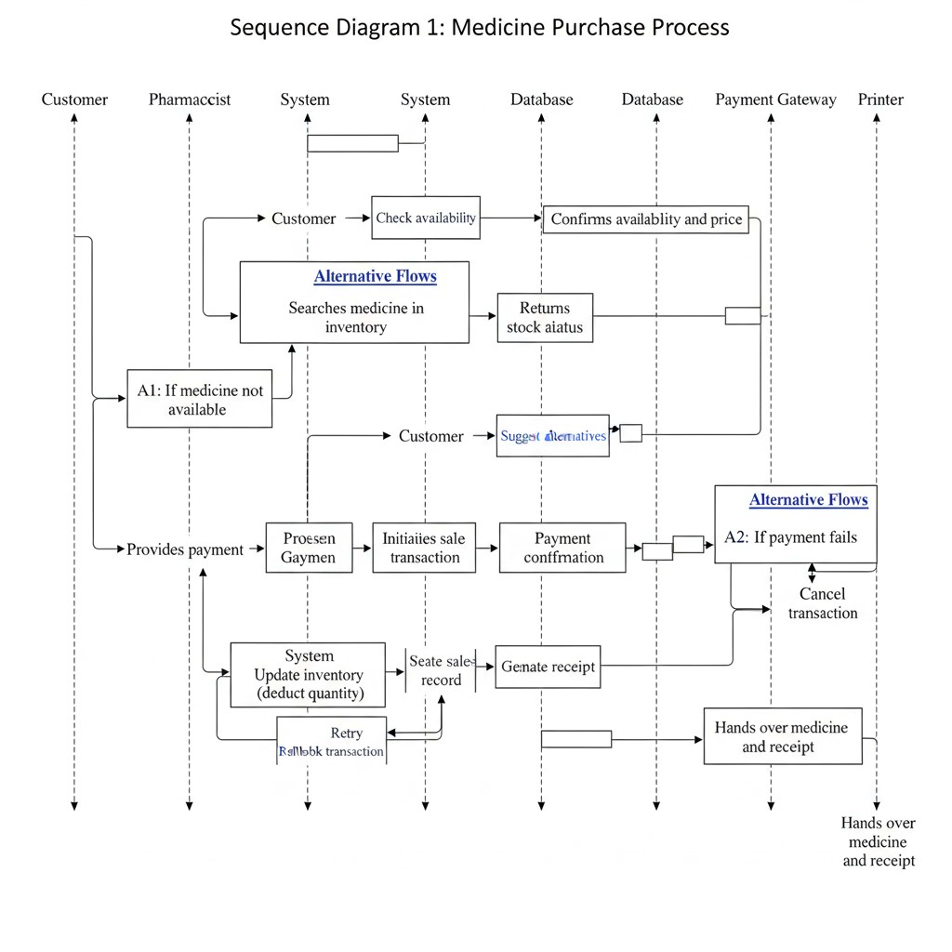
- Sequence diagram for AI suggestion process
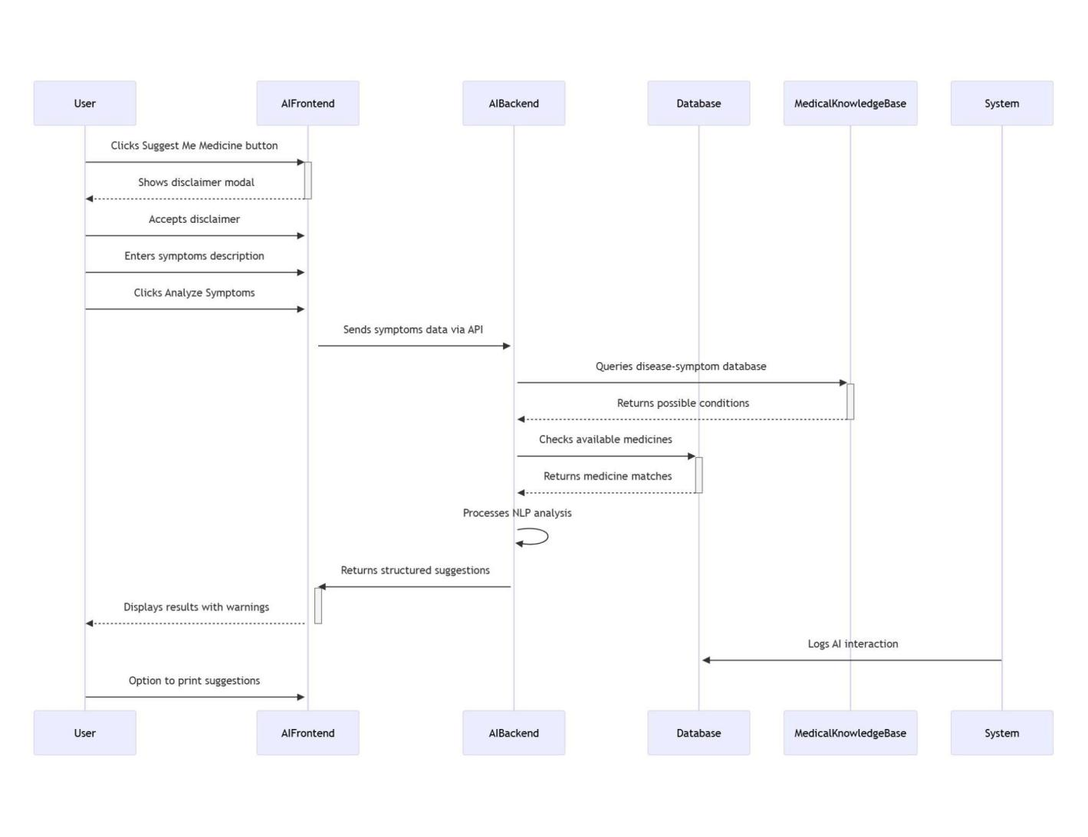

3. Sequence diagram for inventory update
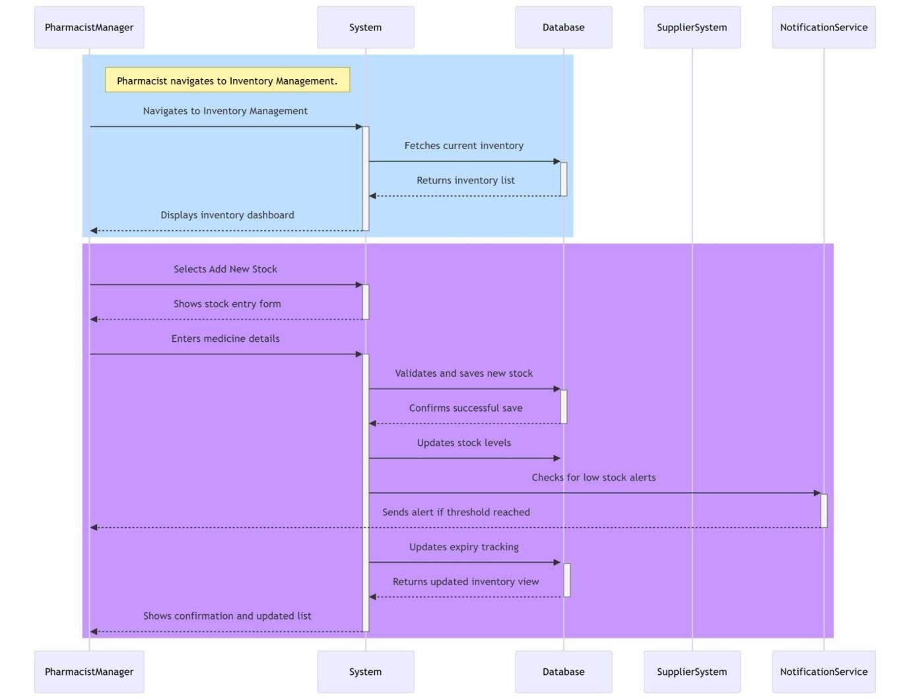

4.2 DATA FLOW DIAGRAMS (DFD)

Level 0: Context diagram
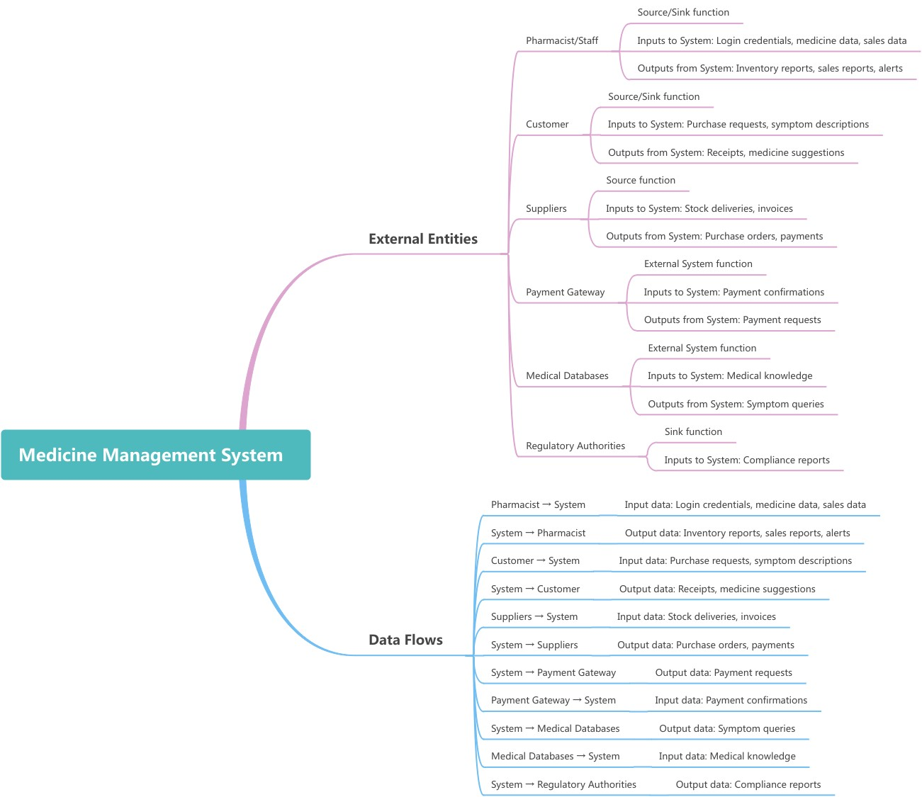

Level 1: Major process decomposition
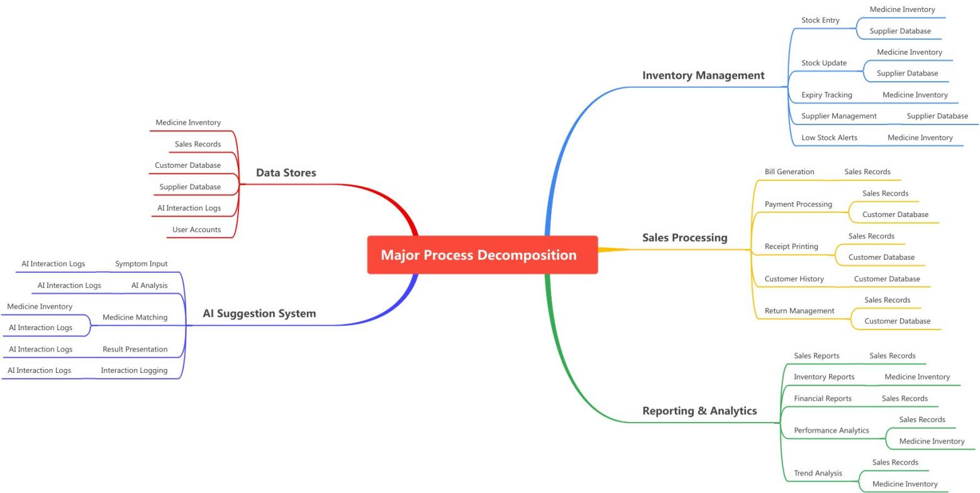

Level 2: Detailed process flows
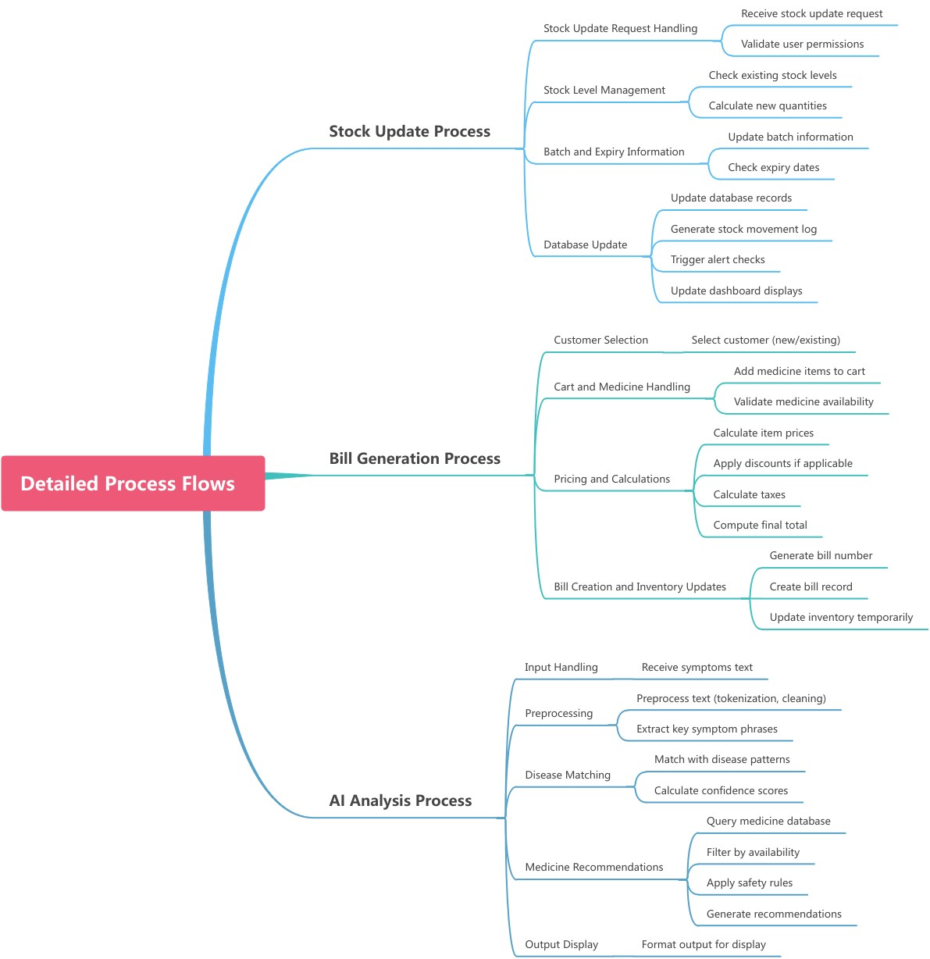

4.3 State-Transition Diagrams (STD)

Medicine stock state transitions
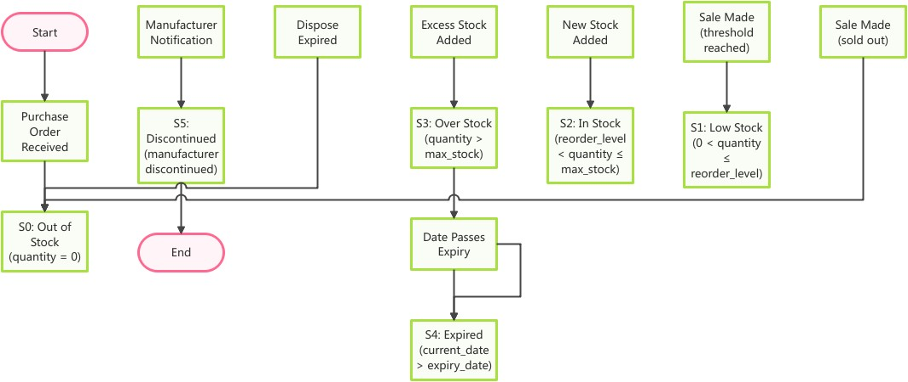

Sales transaction states

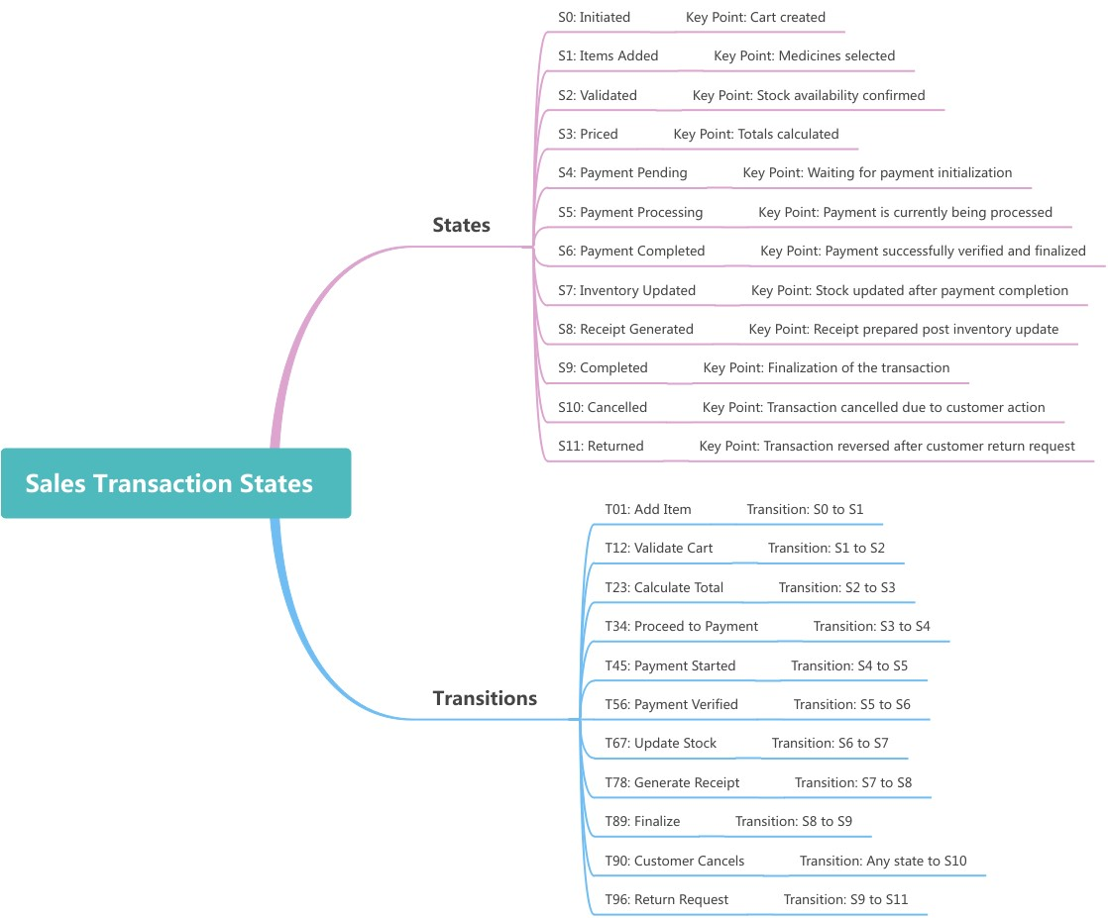

User session states
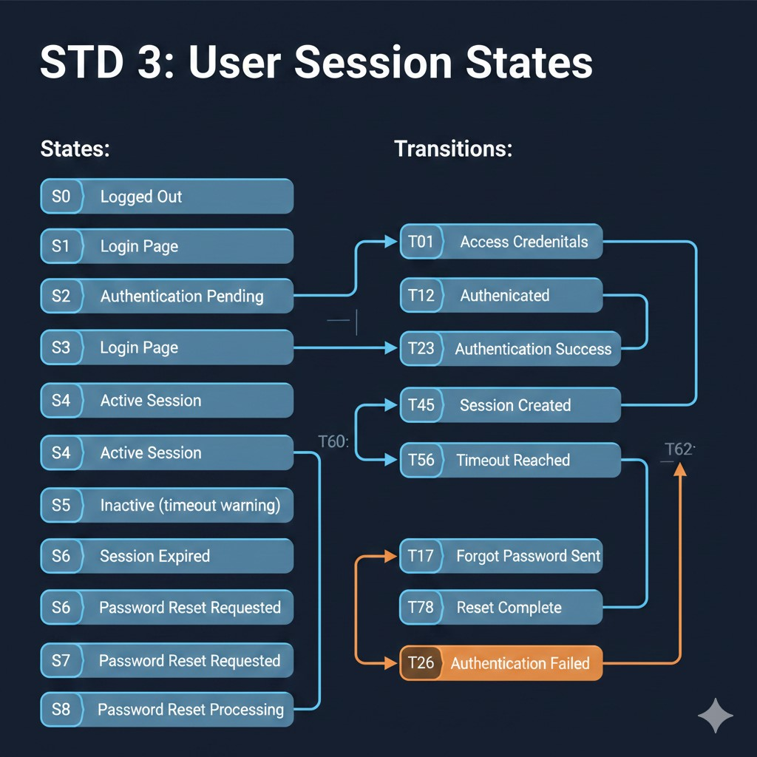

5. Supporting Information
Appendix A – Background Research on:
- AI in Healthcare: Review of existing medical suggestion systems
- Pharmacy Management Systems: Analysis of commercial solutions
- Machine Learning Models: Research on symptom-disease correlation models
- Data Privacy Regulations: Study of healthcare data protection laws
- User Interface Trends: Analysis of modern pharmacy software interfaces

Appendix B – Data Dictionary

Field Name | Table | Data Type | Description | Constraints
medicine_id | Medicine | INT | Unique  identifier | PRIMARY KEY,  AUTO_INCREM  ENT
medicine_nam  e | Medicine | VARCHAR(100) | Commercial name | NOT NULL
generic_name | Medicine | VARCHAR(100) | Generic chemical name
batch_no | Medicine | VARCHAR(20) | Manufacturing batch | NOT NULL
expiry_date | Medicine | DATE | Expiry date | NOT NULL
quantity | Medicine | INT | Current stock | DEFAULT 0
price | Medicine | DECIMAL(10,2) | Selling price | NOT NULL
user_id | Users | INT | User identifier | PRIMARY KEY
username | Users | VARCHAR(50) | Login username | UNIQUE, NOT NULL
role | Users | ENUM | User role | Pharmacist  Manager  Assistant
sale_id | Sales | INT | Sale identifier | PRIMARY KEY
symptoms | AI_Logs | TEXT | description
………………….END…………………..

