**Article information**

**FASTory power consumption data**

**Authors**

*Mahboob Elahi 1,* *Samuel Olaiya Afolaranmi 1,*, Wael M. Mohammed 1 and Jose Luis Martinez Lastra 1*

**Affiliations**

*FAST-Lab, Faculty of Engineering and Natural Sciences, Tampere University, Finland***Corresponding author’s email address and Twitter handle**

*Correspondence: samuel.afolaranmi@tuni.fi*

**Keywords**

*Power consumption-based prognostics model; predictive maintenance; power consumption; conveyor belt deterioration; belt tension; discrete manufacturing systems.*

**Abstract**

Machine learning (ML) techniques are widely adopted in manufacturing systems for discovering valuable patterns in sensor data. Machine learning models learn patterns in sensor data and can optimize process parameters, forecast equipment deterioration, and plant maintenance strategies. In this regard, this paper presents dataset collected from FASTory assembly line. This data contains more than 4K data samples of conveyor belt motor driver’s power consumption. FASTory assembly line is equipped with web-based industrial controllers and smart 3 phase energy monitoring modules as an expansion to these controllers. For collecting data, an application was developed. After every second application receives a new data sample as JavaScript Object Notation (JSON), application extracts energy data for relevant phase and inserts extracted data fields in a MySQL data base for processing data at later stage. Data is collected for two separate cases: static case and dynamic case. In the static case, power consumption data is collected under different loads and belt tension. This data is used by a prognostic model (Artificial Neural Network (ANN)) to learn the conveyor belt motor driver’s power consumption pattern under different belt tension and load condition. The data collected during the dynamic case is used to investigate how the belt tension affects the movement of pallet between conveyor zones. The knowledge obtained from the power consumption data of conveyor belt motor driver used to forecast gradual behavioural deterioration of conveyor belts used for the transportation of pallets between processing workstations of discrete manufacturing systems.

**Specifications table**

|  |  |
| --- | --- |
| **Subject** | Industrial Engineering, Manufacturing |
| **Specific subject area** | Energy data which includes power consumption of conveyor belt motor driver |
| **Type of data** | CSV, JSON, Table, Figure |
| **How the data were acquired** | The data is collected from FASTory assembly line which is equipped with web-based industrial controllers and smart 3-phase energy monitoring modules as an expansion to these controllers. An application was developed on premises which invokes REST energy services and subscribes to REST-formatted HTTP event notification for smart 3-phase energy monitoring module. After every second, application receives a new data sample as JavaScript Object Notation (JSON), application extracts energy data for relevant phase. The extracted data stored in a MySQL data base for processing at later stage [1,2]. |
| **Data format** | Raw, Unprocessed and Processed |
| **Description of data collection** | The collected data is intended to develop a machine learning (ML) model which takes power consumption of conveyor belt motor driver and load on conveyor and predicts a belt tension class. This model learns power consumption pattern of the conveyor belt motor driver for belt tension and load on conveyor (number of pallets), during data collection both tension of conveyor belt and load were varied from zero to maximum value [2].   1. The conveyor belt driver power consumption records retrieved from MySQL data base and saved as comma separated values in a csv file. This is unprocessed data with field: RMS Current, RMS Voltage, Load Combinations, %Belt Tension, Power (W), %Power/Nominal_Power. 2. The unprocessed data was processed with python data processing libraries like pandas and scikit-learn. This processed data saved in a new csv file. Processed data has all fields similar to un-processed data except following fields: Load, Class_3, Normalized_Power, Normalized_Load. 3. 500 test samples were extracted randomly from processed data and exposed to ML model once model trained, tested and validated on remaining data samples. 4. Separate Python jupyter notebooks were created for data visualization, data processing and training belt tension predictor ANN model[3]. |
| **Data source location** | FASTory Line  Future Automation Systems and Technologies Laboratory (FAST-Lab)  Tampere University Tampere,  Finland |
| **Data accessibility** | Dataset:<https://doi.org/10.23729/24df28ed-f7b4-482d-9458-b708485e7cb8> [2]  Software (jupyter notebooks for data visualization, processing and model training): <https://zenodo.org/badge/latestdoi/492717954> [3] |
| **Related research article** | Mahboob Elahi, Samuel Olaiya Afolaranmi, Wael M. Mohammed and Jose Luis Martinez Lastra, **Energy-Based Prognostics for Gradual Loss of Conveyor Belt Tension in Discrete Manufacturing Systems. In press** |

**Value of the data**

* The collected data includes more than 4K power consumption data samples of conveyor belt motor driver of FASTory assembly line. This data can be used to build an AI-powered model which monitor gradual behavioural deterioration of equipment, belt wear and tear, and gradual loss of belt tension of conveyor belts in discrete manufacturing system.
* The data can be utilized by researcher and data engineers for comparing equipment/sensor model-driven and data-driven models to shift plant maintenance strategy from Run-2-Failure and Preventive to Predictive maintenance strategy.
* The data can be used with the digital twin of a conveyor belt operated transportation system to get insight into the effect of insufficient, sufficient, and abundant belt tension on the required necessary traction force to overcome conveyance path friction, material transfer time between workstations, belt wear and tear, material slippage, and stress on driver motor shaft, etc. Furthermore, the data can be used to develop a data-driven prognostic model to predict equipment remaining useful life.

1. **Data description**
   1. **Data collection**

In this research work data is collected from FASTory assembly line, Figure 1 [4], located at FAST-LAB Tampere University, Finland. In late 19s FASTory line was used for assembling Nokia’s different cell phone models. Later this line was relocated to Tampere University and retro-fitted with smart web-based remote terminal units (RTUs) known as S1000 with E10 three phase smart energy monitoring modules as an expansion unit [1].

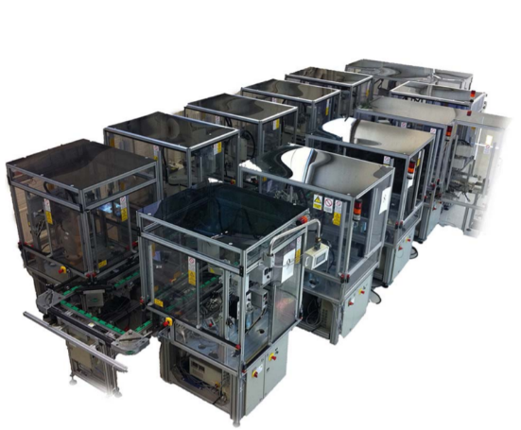

Figure 1. FASTory assembly line [4]

Figure 2 presents layout of FASTory line. The FASTory line consists of 10 identical workstations (numbered from 2 to 6 and 8 to 12) for executing the drawing processes, one workstation (numbered as 1) for loading and unloading the papers and one workstation (numbered as 7) for loading and unloading pallets. Each workstation is equipped with RFID for recognizing the incoming pallets. In addition, each workstation (2–6 and 8–12) include a main conveyor and bypass conveyor. The two conveyors split into different zones which are marked in Figure 2 as 1,2,3,4,5 and referred to as Z# in this paper. The entry and exit points of the workstations are located at Z1 and Z5 respectively. The main conveyor has 4 zones, (Z1, Z2, Z3, Z5), and for each zone, there is a stopper and presence sensor for stopping a pallet and checking the presence of a pallet respectively. Z3 is the production zone of each workstation. The Z1 of each workstation has a RFID tag reader which is used to read the pallet ID. The Z1 of the current workstation and Z5 of the next workstation are the same. The bypass conveyor has one zone (Z4) and one stopper.

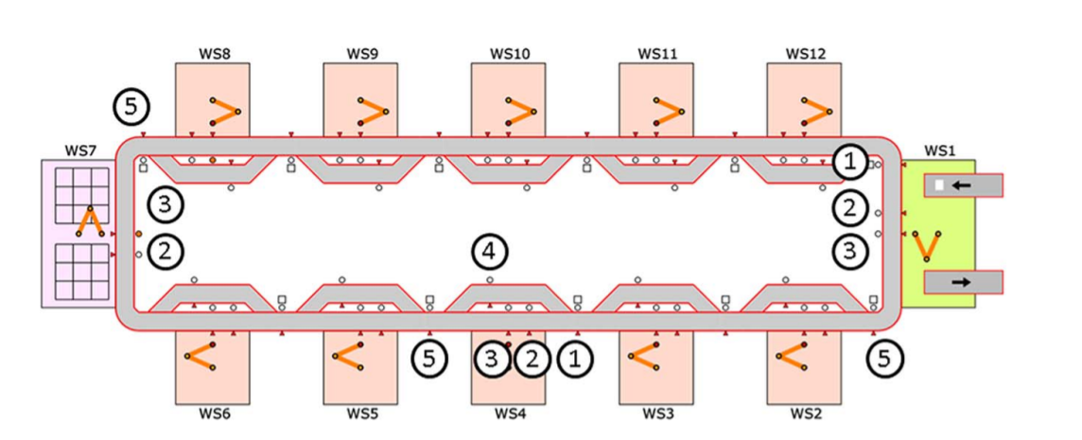

Figure 2. FASTory line layout [4]

In E10 smart 3-phase energy monitoring modules, Phase A is assigned to the robot, Phase B is allocated to the cabinet, I/Os and the controller, while Phase C is assigned to the conveyor system (including main and bypass). Power is measured by sampling current and voltage. The current sampled by a current transformer (CT) connected to +Ia-, +Ib- and +Ic- terminals and the voltage is measured by direct connection of the 3 phases (Va, Vb and Vc) and the neutral (Vn) terminals of the E10 expansion module [5]. The Phase C energy values are of interest in this paper (see Figure 3).

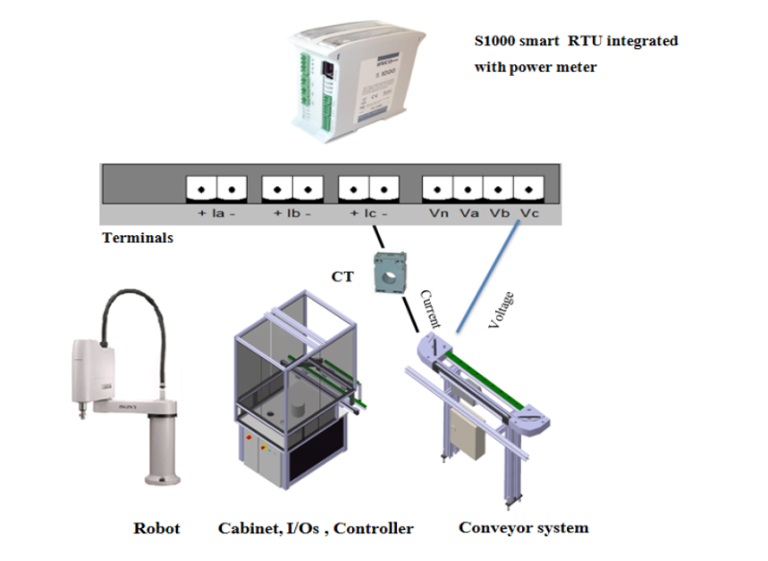

Figure 3. Power consumption monitoring in the testbench [5]

For collecting data an application was developed on premises which invokes REST energy services and subscribes to REST-formatted HTTP event notification. After every second, application receives a new data sample as JavaScript Object Notation (JSON), application extracts energy data for relevant phase (phase C) and inserts extracted data fields in a MySQL data base for processing at later stage [1,2]. Table 1 listed the event notification that RTUs exposed. These notifications provide information about about energy consumption (via S1000 energy meters) and CAMX state events (e.g., pallet input to a conveyor piece etc.).

Table 1. Event notification from testbench.

|  |  |  |
| --- | --- | --- |
| **S/N** | **Event Notification** | **Description** |
| 1 | EnergyMeter | Robot/conveyor/controller energy consumption, of each working cell published at a time interval of one second |
| 2 | DrawStart/DrawEnd | Cell ID, recipe number, pen colour, time stamp |
| 3 | EquipmentState | Cell ID, state of conveyor zones, pallet ID, time stamp |

During collecting data, both belt tension and load on conveyor are varied according to table 2 and table 3. The tension in belt was varied from 0 to maximum by changing head pully position from reference point. The head pully can move from 0 to 2.7cm (see Figure 4), tension decreases in upward direction and increases in downward direction.

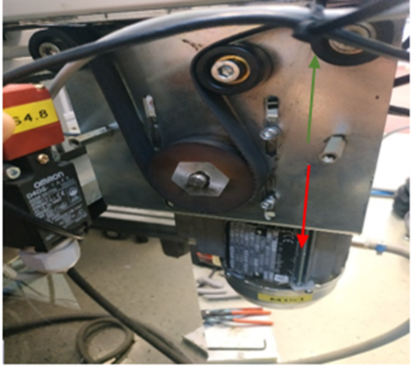

Figure 4. Motor driver with head pulley at main conveyor.

Table 2. Head pulley position and % belt tension.

|  |  |
| --- | --- |
| **Head pulley position (cm) from initial point** | **%Belt tension** |
| 0 | 0 |
| 0.4 | 15 |
| 0.81 | 30 |
| 1.22 | 45 |
| 1.62 | 60 |
| 1.89 | 70 |
| 2.02 | 75 |
| 2.29 | 85 |
| 2.43 | 90 |
| 2.57 | 95 |
| 2.7 | 100 |

Table 3. Pallet position on main conveyor’s zones with respect to load combinations.

|  |  |  |
| --- | --- | --- |
| **Load Combination** | **Active Zones** | **Description** |
| 0 | 0000 | No load |
| 1 | 1000 | 1 pallet at Z1 |
| 2 | 0100 | 1 pallet at Z2 |
| 3 | 1100 | 2 pallets; 1 pallet at each zone (Z1, Z2) |
| 4 | 0010 | 1 pallet at Z3 |
| 5 | 1010 | 2 pallets; 1 pallet at each zone (Z1, Z3) |
| 6 | 0110 | 2 pallets; 1 pallet at each zone (Z1, Z3) |
| 7 | 1110 | 3 pallets; 1 pallet at each zone (Z1, Z2, Z3) |
| 8 | 0001 | 1 pallet at Z5 |
| 9 | 1001 | 2 pallets; 1 pallet at each zone (Z1, Z5) |
| 10 | 0101 | 2 pallets; 1 pallet at each zone (Z1, Z5) |
| 11 | 1101 | 3 pallets; 1 pallet at each zone (Z1, Z2, Z5) |
| 12 | 0011 | 2 pallets; 1 pallet at each zone (Z3, Z5) |
| 13 | 1011 | 3 pallets; 1 pallet at each zone (Z1, Z3, Z5) |
| 14 | 0111 | 3 pallets; 1 pallet at each zone (Z2, Z3, Z5) |
| 15 | 1111 | 4 pallets; 1 pallet at each zone (Z1, Z2, Z3, Z5) |

The data was collected for two different cases named as static and dynamic.

1. In static case the conveyor belt is running continuously irrespective whether pallets are residing on conveyor belt were stopped via stoppers or not which increase the friction along conveyance path. This data used by ML model for learning power consumption pattern of conveyor belt motor driver for varying belt tension and load.
2. In dynamic case, belt tension kept constant, and pallet was moved between zones to investigate how the belt tension affects the movement of pallets between conveyor zones as well as the transportation of material/tool/equipment between workstations. This case is further divided into two cases: In case 1, a pallet can move from source to destination zone on main conveyor and no pallet is residing on remaining zones. In case 2, one or more pallets are residing on zone(s) when a pallet moves from source zone to destination zone. The “1” and “0” in “Active zone” column in table 3 represent the presence of a pallet on a zone on main conveyor.
3. Table 4 provide the description of fields of static case data (un-processed and processed data) and dynamic case data. Please be noted processed file has three new fields and the remaining are same as un-processed file.

Table 4. Description of fields of static and dynamic case data

|  |  |  |  |  |
| --- | --- | --- | --- | --- |
| **Field** | **Data type** | | | **Description** |
| **Un-processed Static Case Data** | | | | |
| RMS Current (A) | Float | Rms Current | | |
| RMS Voltage (V) | Float | Rms Voltage | | |
| Load Combinations | Int | A number between 0 and 15 when converted to binary gives zone numbers where pallet is residing (Active Zones) | | |
| %Belt Tension | Int | A number between 0 and 95, represent belt tension | | |
| Power (W) | Float | Power consumed by conveyor belt motor driver | | |
| %Power/Nominal_Power | Int |  | | |
| Load | Int | Gives number of pallets at a time on conveyor belt. It is a number between 0 and 4 | | |
| **Processed Static Case Data** | | | | |
| Class_3 | Int | | Represent belt tension class label. A number between 1 and 3 | |
| Normalized_Power | Float | | Normalized Power values, a value between 0 and 1 | |
| Normalized_Load | Float | | Normalized load combination values, a value between 0 and 1 | |
| **Dynamic Case Data** | | | | |
| Belt Tension (%) | Int | | A number between 75 and 95, represent belt tension | |
| Active Zone | String | | Gives zone number (in format Z#) which has a pallet and a “No” mean no pallet. | |
| From | Int | | A number represent source zone | |
| To | Int | | A number represent destination zone | |
| Avg. Time(s) | Float | | Time taken by a pallet to move from source to destination zone | |
| Distance(m) | Float | | Distance between zones of conveyor belt. It is fixed vale for zones | |
| Speed(m/s) | Float | | Conveyor belt speed calculated as: | |

**1.2 Data visualization**

In this section bar plots were presented using static case data to analyze trends in power consumption of conveyor belt motor driver. In this section the used data and python jupyter notebook file is listed in table 5

Table 5. Used Data and jupyter notebook file

|  |  |
| --- | --- |
| **File Name** | **Description** |
| FASToryPowerConsumptionData_UnProcessed.csv | Used for data visualization |
| FASToryPowerConsumptionDataVisulation.ipynb | Code for plotting data |

**1.2.1 Results and analysis for 0% to 70% belt tension**

Figure 5 shows the bar plot for belt tensions 0% to 70% for load combinations 0 and 1. It can be seen that with the increase in belt tension the power consumption on conveyor belt motor driver increased but as soon as there is a pallet on zone1 of conveyor, the power consumption drops. As mentioned above during static case stoppers at conveyor zones are active so with 70% belt tension the provided traction force by conveyor belt driver is not sufficient to overcome the path friction and slips from head pully.

Table 6 list the results from dynamic case and only for 70% belt tension because this the minimum belt tension for which belt starts moving with no load. Here stoppers are inactive, and pallet can move from source zone to destination zone. When a pallet moves from zone1 to zone5, due to jerky motion it takes 120s which is quite long time and can affects the working of other workstation also when pallet was instructed to move from zone3 to zone5, due to jerks it was stuck at the junction of main and bypass conveyor and never reach to destination zone (zone5).

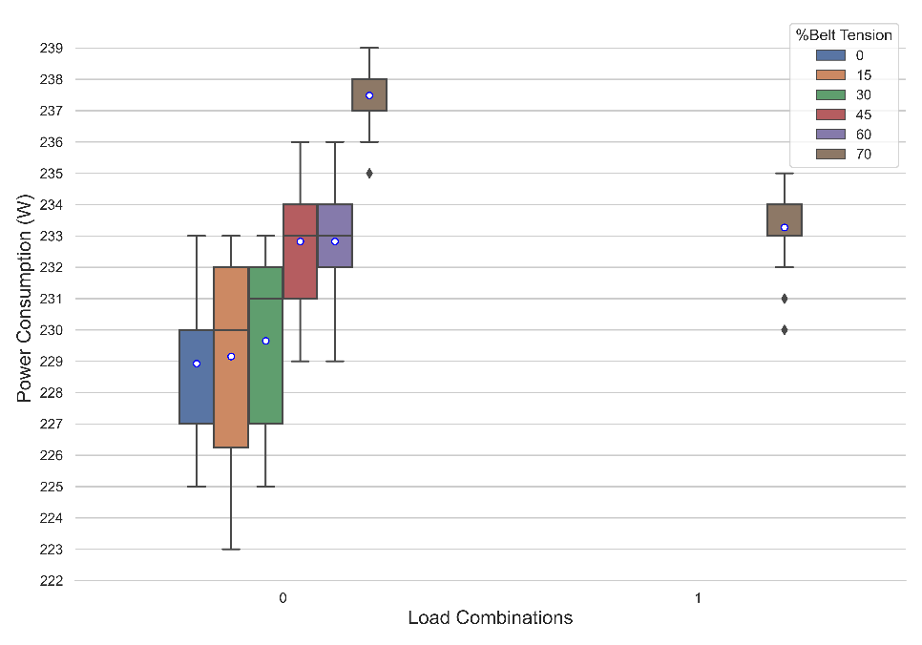

Figure 5. Effect of belt tensions (0%-70%) and load on conveyor motor driver power consumption.

Table 6. Dynamic case results for 70% belt tension.

|  |  |  |  |  |  |  |
| --- | --- | --- | --- | --- | --- | --- |
| **Belt Tension (%)** | **Active Zone** | **Source Zone** | **Destination Zone** | **Distance (m)** | **Time (s)** | **Speed (m/s)** |
| 70 | No | 1 | 5 | 1.61 | 120 | 0.013 |
| 70 | No | 1 | 2 | 0.61 | 80 | 0.008 |
| 70 | No | 1 | 3 | 0.835 | 86 | 0.01 |
| 70 | No | 3 | 5 | 0.773 | infinity | 0 |

**1.2.2 Results and analysis for 75% to 85% belt tension**

Figure 6 shows the bar plot for belt tensions 75% and 85% for all load combinations. It can be seen that with the increase in belt tension, the power consumption of conveyor belt motor driver also increased. The results obtained for 75% belt tension with the load combinations 6,7 and 14 (i.e., Z2 and Z3 are active for each combination) and 15 (all zones are active) are prominent. For these combinations, a reduction in belt traction force and an increase in belt slippage was observed. For 85% belt tension, either no reduction in belt traction force or an increase in belt slippage was observed.

Table 7 and Table 8 listed the results obtained during dynamic case for 75% and 85% belt tension. There is no significant difference observed. The arrival time to destination zone and speed is approximately same for both belt tensions.

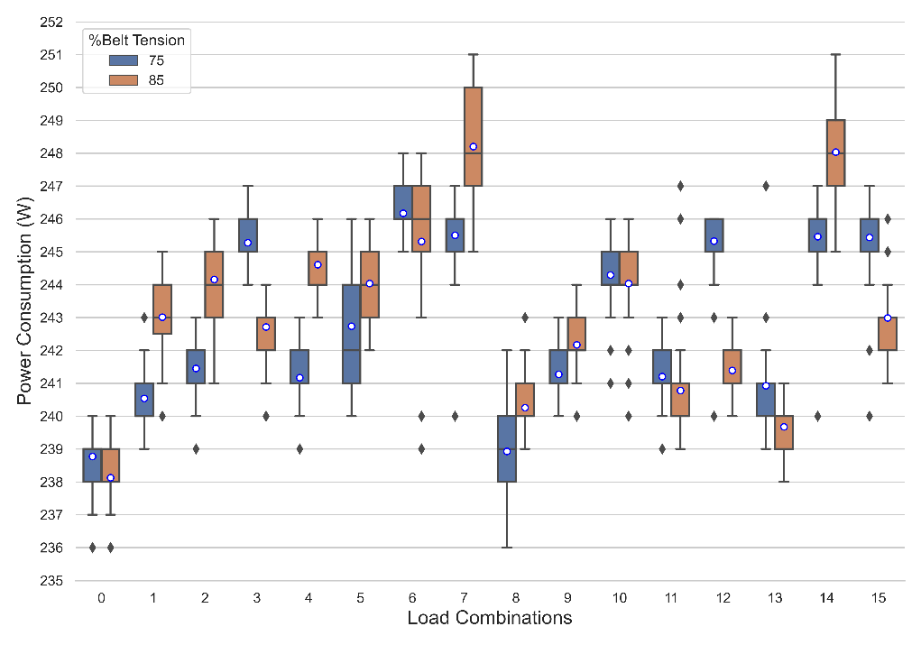

Figure 6. Effect of belt tension (75%-85%) and load on conveyor motor driver power consumption.

Table 7. Dynamic case results for 75%-85% belt tension with no active zones.

|  |  |  |  |  |  |  |
| --- | --- | --- | --- | --- | --- | --- |
| **Belt Tension (%)** | **Active Zone** | **Source Zone** | **Destination Zone** | **Distance (m)** | **Time (s)** | **Speed (m/s)** |
| 75 | No | 1 | 5 | 1.61 | 5.36 | 0.3 |
| 75 | No | 1 | 2 | 0.61 | 2.23 | 0.274 |
| 75 | No | 1 | 3 | 0.835 | 2.95 | 0.283 |
| 75 | No | 3 | 5 | 0.773 | 2.97 | 0.26 |
| 85 | No | 1 | 5 | 1.61 | 5 | 0.322 |
| 85 | No | 1 | 2 | 0.61 | 2.18 | 0.28 |
| 85 | No | 1 | 3 | 0.835 | 2.84 | 0.294 |
| 85 | No | 3 | 5 | 0.773 | 2.78 | 0.278 |

Table 8. Dynamic case results for 75%-85% belt tension with active zones.

|  |  |  |  |  |  |  |
| --- | --- | --- | --- | --- | --- | --- |
| **Belt Tension (%)** | **Active Zone** | **Source Zone** | **Destination Zone** | **Distance (m)** | **Time (s)** | **Speed (m/s)** |
| 75 | Z5 | 1 | 3 | 0.835 | 2.91 | 0.287 |
| 75 | Z5, Z3 | 1 | 2 | 0.61 | 2.29 | 0.266 |
| 75 | Z1, Z2 | 3 | 5 | 0.773 | 4.24 | 0.182 |
| 75 | Z1 | 2 | 3 | 0.223 | 1.2 | 0.186 |
| 85 | Z5 | 1 | 3 | 0.835 | 2.85 | 0.293 |
| 85 | Z5, Z3 | 1 | 2 | 0.61 | 2.07 | 0.295 |
| 85 | Z1, Z2 | 3 | 5 | 0.773 | 2.89 | 0.267 |
| 85 | Z1 | 2 | 3 |  | 1.02 | 0.219 |

**1.2.3 Results and analysis for 95% belt tension**

This is the maximum belt tension that can be achieved in conveyor belt. It can be seen in Figure 7, the power consumption of conveyor belt motor driver significantly increased for all load combinations. This is due to an extra stress on motor shaft which is induced due to belt tension. Table 9 and Table 10 lists the results obtained during dynamic case. Here an increase in speed and decrease in arrival time to destination zone was observed.

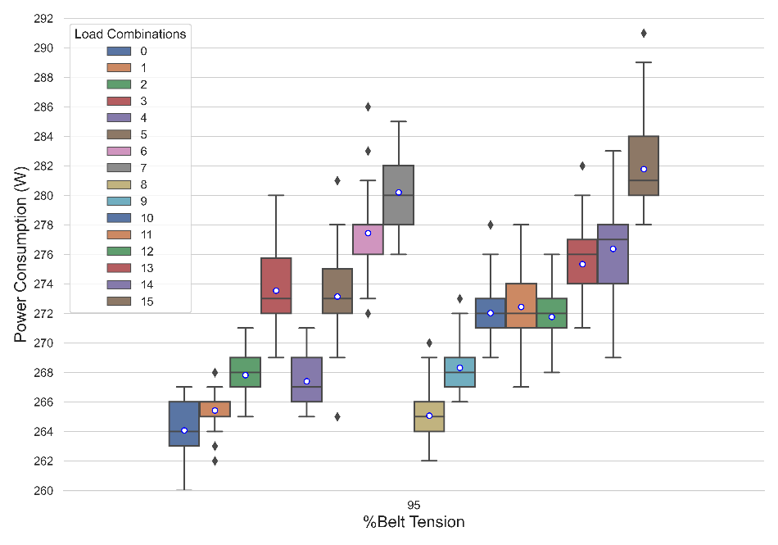

Figure 7. Effect of 95% belt tension and load on conveyor motor driver power consumption.

Table 9. Dynamic case results for 95% belt tension without active zones.

|  |  |  |  |  |  |  |
| --- | --- | --- | --- | --- | --- | --- |
| **Belt Tension (%)** | **Active Zone** | **Source Zone** | **Destination Zone** | **Distance (m)** | **Time (s)** | **Speed (m/s)** |
| 95 | No | 1 | 5 | 1.61 | 4.6 | 0.35 |
| 95 | No | 1 | 2 | 0.61 | 1.98 | 0.308 |
| 95 | No | 1 | 3 | 0.835 | 2.86 | 0.292 |
| 95 | No | 3 | 5 | 0.773 | 2.77 | 0.279 |

Table 10. Dynamic case results for 95% belt tension with active zones.

|  |  |  |  |  |  |  |
| --- | --- | --- | --- | --- | --- | --- |
| **Belt Tension (%)** | **Active Zone** | **Source Zone** | **Destination Zone** | **Distance (m)** | **Time (s)** | **Speed (m/s)** |
| 95 | Z5 | 1 | 3 | 0.835 | 2.85 | 0.293 |
| 95 | Z5, Z3 | 1 | 2 | 0.61 | 1.99 | 0.307 |
| 95 | Z1, Z2 | 3 | 5 | 0.773 | 2.8 | 0.276 |
| 95 | Z1 | 2 | 3 | 0.223 | 1.02 | 0.219 |

Figure 8 and Figure 9 shows the comparison box plots for belt tensions 75% to 95% and 0% to 85% respectively. It can be seen from Figure 8 approximately 20W of increase in power consumption was recorded for all load combination at 95% belt tension as compared to 75% and 85% belt tensions. Though 95% belt tension has showed good results for dynamic operations, but it is not advised to do transportations operations with 95% belt tension because it induces an excessive stress on the belt, motor bearings and shaft, so the motor draws more current to produce enough torque to maintain smooth belt motion. This is an unhealthy condition for operation and is harmful to the belt, motor shaft and bearings. On the other hand, belt tensions equal to or less than 70% are not useful as they lead to no motion (for 0% to 60% belt tension) and jerky motion (for 70% belt tension) which increase material transportation time, belt slippage and leads to belt wear and tear. The feasible belt tension range for this transportation system is from 75% to 85%. For these belt tensions power consumption of conveyor belt motor driver is moderate also there is no excessive stress on motor shaft.

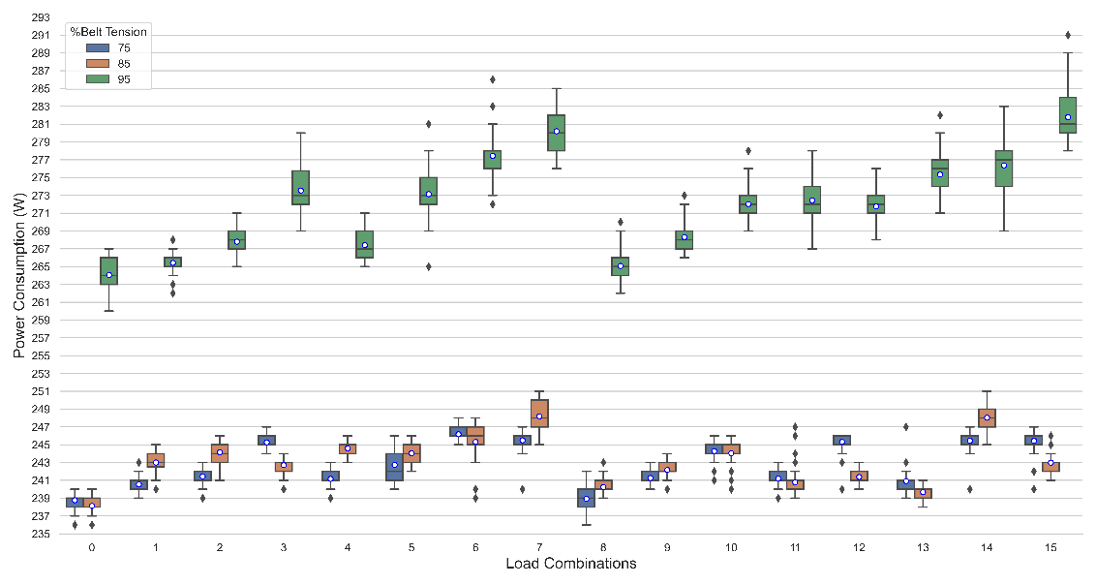

Figure 8. Comparison of 75%, 85% and 95% belt tensions.

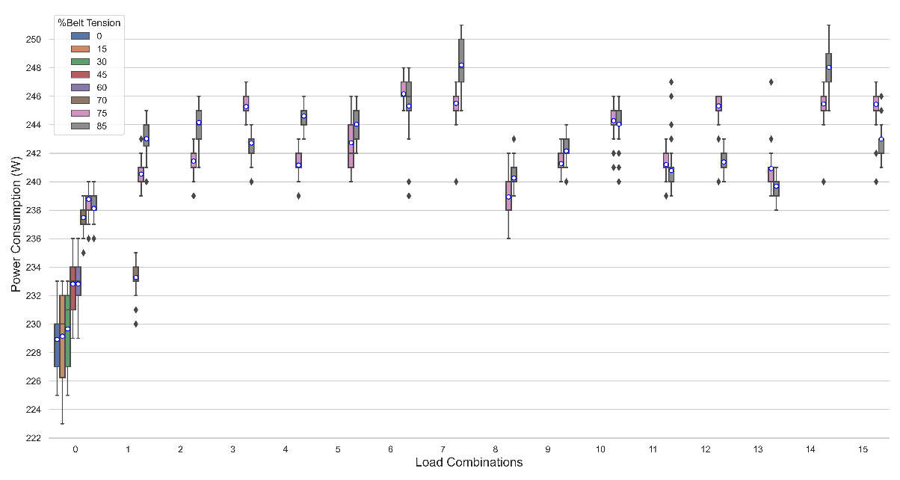

Figure 9. Comparison of 0%-85% belt tensions.

The collected data during static case can be classified into three distinct belt tension classes as shown in Figure 10. These classes are named as *“low”*, *“optimal”* and *“over-tensed”.* Figure 10 presents box plot for power consumed by conveyor belt motor driver. Each box plot shows power consumption for all load combinations against each belt tension. Box plots for optimal class highlighted with green. The low and over-tensed classes are highlighted with dark yellow and red colour respectively. Table 11 list the belt tension classes corelating to percentage belt tension values.

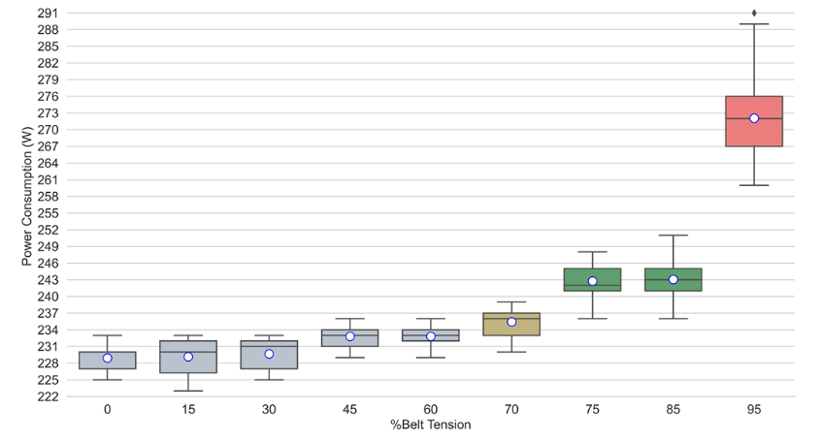

Figure 10. Power consumption of the conveyor belt motor driver for all load combinations corresponding to the belt tension.

Table 11. Belt tension classes correlating to %belt tension values.

|  |  |  |
| --- | --- | --- |
| **Class** | **Belt tension values in %** | **Description** |
| 1 | 0% to 70% | Not useful (low) |
| 2 | 75% to 85% | Useful (optimal) |
| 3 | Belt tension > 90% | Not useful (over-tensed) |

**1.3 Data Pre-Processing**

**13.1 Experimental design, materials and methods**

Table 12 lists the used data file and python jupyter notebooks used for data pre-processing and training ANN model setup.

Table 12. Used Data and jupyter notebook files.

|  |  |
| --- | --- |
| **File name** | **Description** |
| FASToryPowerConsumptionDataProcess.ipynb | Used for data pre-processing |
| FASToryANNbeltTensionPredictorModel.ipynb | Used for training ANN model |
| FASToryPowerConsumptionData_UnProcessed.csv | Contains data samples before data pre-processing |
| FASToryPowerConsumptionData_Processed.csv | Contains data samples after data pre-processing |
| FASToryPowerConsumptionData_TraningData.csv | Used for ANN training |
| FASToryPowerConsumptionData_TestData.csv | Unseen samples used for testing ANN model |

Figure 11 shows main steps for building an ANN belt tension class predictor model. Firstly, application receives data sample as JSON from FASTory line. Data for required phase was extracted from JSON object and stored to MySQL data base. Python jupyter notebook file named “FASToryPowerConsumptionDataProcess.ipynb” retrieve raw data from data base and stored this data as into a csv file named “FASToryPowerConsumptionData_UnProcessed.csv”. This file used for data pre-processing and processed data is stored in a new file named “FASToryPowerConsumptionData_Processed.csv”. This file splits into two files (last two entries of table 12), one file is used for model training, testing and validation and other file contains approximately 500 data samples which exposed to model once model training, testing and validation completed respectively. File named “FASToryANNbeltTensionPredictorModel.ipynb” uses “FASToryPowerConsumptionData_TraningData.csv” data file to train belt tension predictor model.

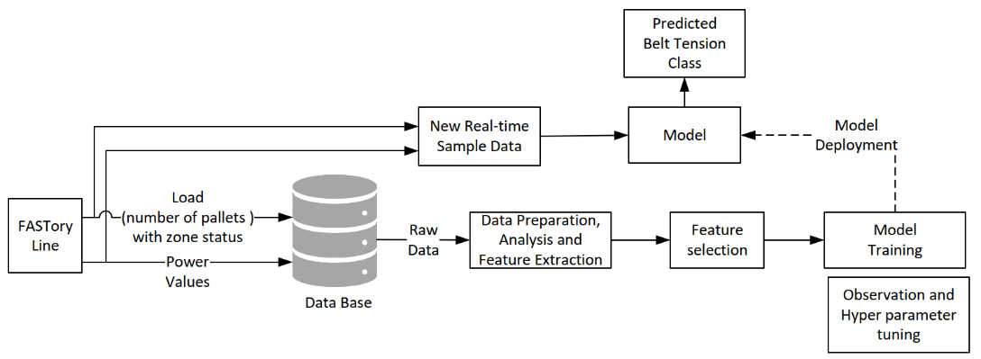

Figure 11. Main steps for development of the data-driven prognostic model.

Model training is an iterative process. During this process to achieve better results hyperparameters of model modified by updating corresponding code cell in python jupyter notebook file for model training. The computed loss/error i.e., the average percentage of the number of unsuccessful predicted classes is 3.2%. This misclassification error is observed for only those data samples that corresponds to “no-load” situation i.e., load combination 0 for belt tensions 70%, 75% and 85% due to data overlapping and low separation boundary. Another reason for this error is that the conveyor power consumption does not change instantly once the conveyor load is modified, but only after a short time delay. This delay is responsible for the few outliers and such occurrences may influence the value of the calculated error. Figure 12 illustrates the data overlapping by plotting box plots for load combinations 0 and 1 with belt tension range 0% to 85%.

Once model training and testing finished, real-time data samples at a frequency of 1Hz exposes to model. Figure 13 shows the confusion matrix for the developed ANN belt tension class prognostic model when real-time data samples expose to model. Table 13 lists the True Positive (TP), False Positive (FP), True Negative (TN) and False Negative (FN) values of model for model prediction on real-time data. These vales calculated from the model’s confusion matrix. It can be seen from confusion matrix and TP, FP, TN, and FN values for table 13, the developed model works well. Class1 has highest value for FN and its reason explained in previous paragraph.

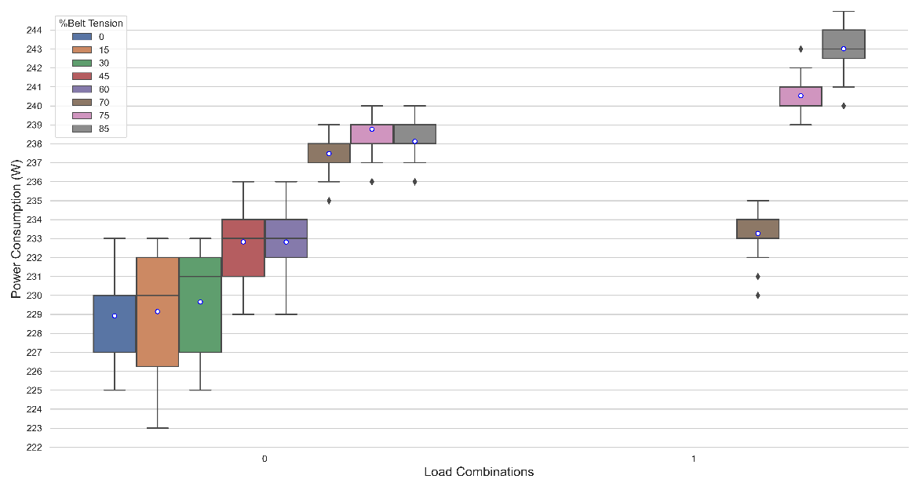

Figure 12. Data overlapping (misprediction).

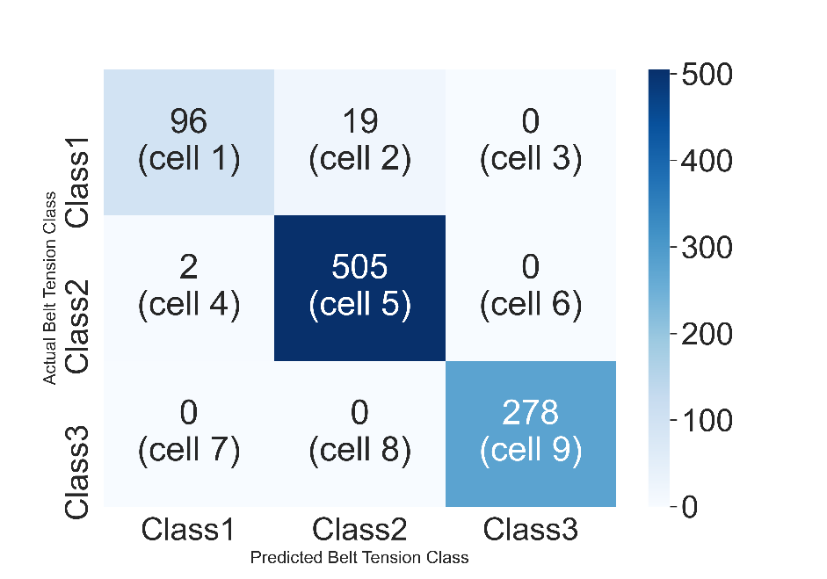

Figure 13. Confusion matrix of FASTory belt tension class predictor ANN model.

Table 13. TP, FP, TN, and FN values of ANN model.

|  |  |  |  |  |
| --- | --- | --- | --- | --- |
| **Belt Tension Class** | **True Positive** | **False Positive** | **True Negative** | **False Negative** |
| Class 1 | 96 (cell 1) | 2 (cell 4 + 7) | 783 (cell 5 + 6 + 8 + 9) | 19 (cell 2 + 3) |
| Class 2 | 505 (cell 5) | 19 (cell 2 + 8) | 374 (cell 1 + 3 + 7 + 9) | 2 (cell 4 + 6) |
| Class 3 | 278 (cell 9) | 0 (cell 3 + 6) | 622 (cell 1 + 2 + 4 + 5) | 0 (cell 7 + 8) |

**Ethics statements**

**N/A**

**CRediT author statement**

*CRediT*

*.*

**Acknowledgments**

*All contributors who do not meet the criteria for authorship should be listed in an acknowledgments section.*

**Declaration of interests**

*Please* ***tick*** *the appropriate statement below and declare any financial interests/personal relationships which may affect your work in the box below.*

☐ The authors declare that they have no known competing financial interests or personal relationships that could have appeared to influence the work reported in this paper.

☐ The authors declare the following financial interests/personal relationships which may be considered as potential competing interests:

*Please declare any financial interests/personal relationships which may be considered as potential competing interests here.*

**References**

*References are limited to a maximum of 20 and excessive self-citation is not allowed. Please cite any article you have referred to while collecting or analysing data and preparing your manuscript.* ***If your data article supports an original research article which is published or in press, please cite the associated article here; ideally, it should be the first citation****.* ***Please also make sure to cite the corresponding dataset.***

*Please review the References section in the* [*Guide for Authors*](https://www.elsevier.com/journals/data-in-brief/2352-3409/guide-for-authors#txt68000) *for a comprehensive guide to Data in Brief reference style and then list your references below, numbering each one as you go.*

- - - - - - - - - - - - - - - - - - - - - - - - - - - - - - - - - - - - - - - - - - - - - - - - - - - - - - - - - - - - - - - - - - - - - - - - - - - - - - - - - - - - - -