Week 12:

This week I mainly involved in two activities which are related to data collection of FASTory energy meters. A new data set was generated for power consumption monitoring application. This data will be uploaded to ZDMP server and will be utilized by our energy monitoring app. Currently we access the DAQ component through VPN and VPN connection is not consistent and interrupt publishing of the real-time data to Cumulocity and message bus that why real-time data from energy monitoring modules (S1000) is recorded in a csv file and will be uploaded to ZDMP server and our app continuously access this data 24/7, from ZDMP server without ant interruption, this good for demo purpose.

Second data collection is related power consumption of main conveyor for different belt tension and its effects on pallet processing.

## **Some Note about CNV data collection:**

1. Main conveyor has 4 zones which are labeled as Z1, Z2, Z3, Z5. This CNV can process up to 4 pallets.
2. These zones generate 16 different combinations for pallet(load) processing on main conveyor. Load is varied on CNV according to these combinations which helps us to capture the minute effect on power consumed by belt conveyor.
3. Figure 1 shows These Combinations:

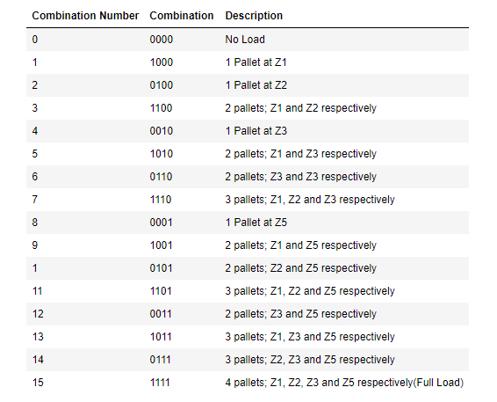

Figure : Zone Combinations for Pallet Processing

1. Belt tension is varied from 0% to 95% by adjusting the head pully between 0-2.7cm adjustable distance. Table 1 list the head pully position and corresponding percentage of belt tension

|  |  |
| --- | --- |
| Head Pully Position(cm) from initial point | % Belt Tension |
| 0 | 0 |
| 0.5 | 15 |
| 0.85 | 30 |
| 1 | 40 |
| 1.2 | 45 |
| 1.3 | 50 |
| 1.6 | 60 |
| 1.8 | 70 |
| 2 | 75 |
| 2.3 | 85 |
| 2.5 | 95 |

## **Observations for belt tension 0-60%:**

Here belt tension gradually increased from 0% to 60%.

1. This belt tension range is not suitable for any operation as with these belt tension values, there is too much slip in the belt hence there is no motion in the belt.
2. In the box plot (figure 2) of data each box shows the recorded value of power consumed by conveyor driver motor for each 15% increment in belt tension respectively.
3. this data is collected for no load condition (Combination 0: 0000)
4. Each box on the plot is plotted for 1 hundred data samples. Each recorded sample is an average of five data samples. The samples for average are collected with a sampling interval of 300ms.
5. For belt tension, 0 to 15 percent most of the data is centered about 230W.
6. For belt tension, 45 to 60 percent mostly power consumption data is centered about 233W. There is a 3-point increase in power consumption as compared to previous belt tensions.

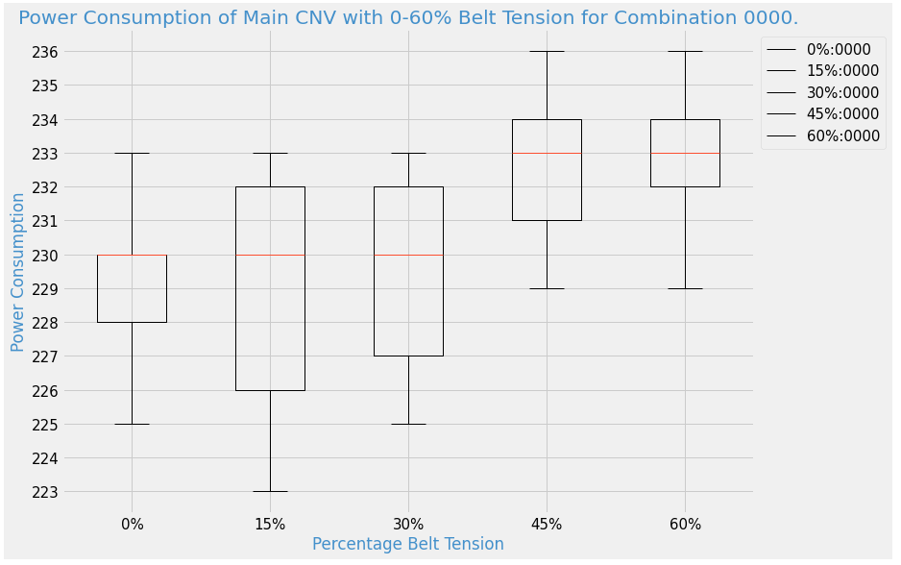

Figure :Power Consumption of Main CNV with 0-60% Belt Tension for Combination 0000.

## **Observations For belt Tension 70%:**

1. With this belt tension, the motor driver head pully is in contact with belt and conveyor belt starts moving. Only combinations 0 and 1 are used to collect power consumption data for this belt tension.
2. With no load, belt moves with a moderate slip and mostly data is centered about 237W.
3. As soon as there is a pallet on zone one (1:1000), belt speed significantly reduces, and a jerky motion is observed in belt. For this case data is centered about 233W which is similar to belt tensions 45% and 60%, please see figure 3.
4. This belt tension is enough to overcome the frictional forces and put the belt in motion but only under no load condition.
5. this belt tension is not good for pallet processing as with insertion of even 1pallet on conveyor, the friction between belt and conveyor path at the point of contact is much higher and this tension force cannot overcome the frictional force hence belt stops or move with jerks.
6. Dynamic case: Time taken by a pallet to travel from Z1 to Z5: infinity

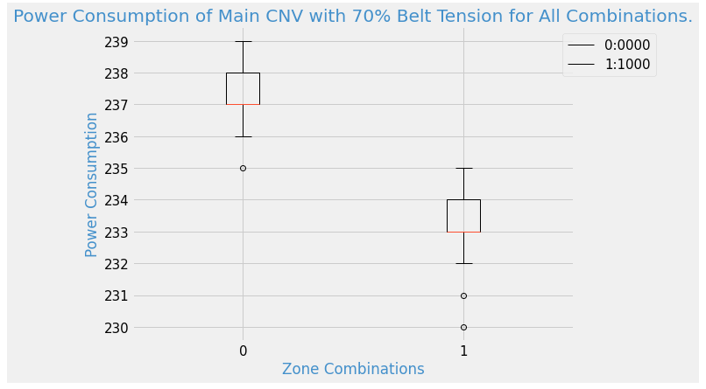

Figure :Power Consumption of Main CNV with 70% Belt Tension for All Combinations.

Currently I only analyze the results for belt tensions 0% to 70%. The remaining belt tension range, 75%-95% will be analyzed during next week because for these belt tensions data is for all pallet processing combinations.

For just a quick overview, to the see the effect of belt tension on CNV power consumption, please see the Figure 4 ,which show the plot for the average CNV power consumption for the entire belt tension range, 0%-95%, which is varied between 0% to 95% with an 15% increment in belt tension, for combination 0(0000) which is a no load condition i.e. no pallet is residing on any CNV zone. Similarly Figure 5, shows the plot for combination1 (1000) i.e. 1 pallet on Zone1 for 70%-95% belt tension.

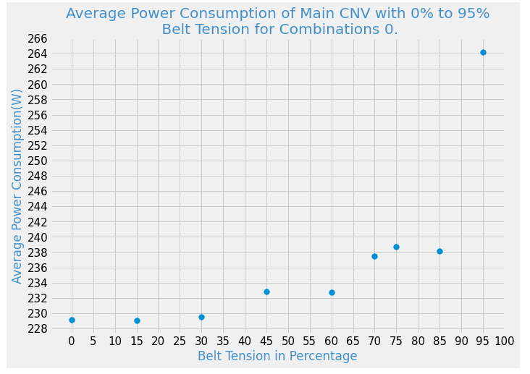

Figure :Average Power Consumption of Main CNV with 0% to 95% Belt Tension for Combinations 0.

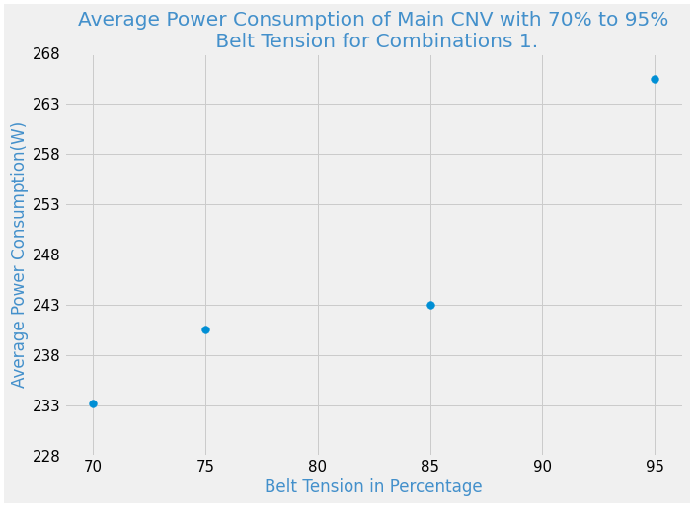

Figure :Average Power Consumption of Main CNV with 0% to 95% Belt Tension for Combinations 1.