Week_13-14:

I had been analyzing the results for remaining belt tensions (75%,85%,95%). For these belt tensions the experiment was conducted for all load combinations.

**NOTE:** I will be using the combined box plot for all load combinations rather than separate plots for each load combination for a given belt tension. You can find these plots in the “**Main CNV Static Data Analysis.html”** file which is attached with email.

## For belt Tension 75%

**Observations:**

1. Relative good and smoother belt motion is observed than 70% belt tension.
2. There is less slip in belt.
3. For this belt tension th experiment is conducted for all load configurations.

## Observations for 0,1,2,4 and 8 Combinations

| **Combination Number** | **Combination** | **Description** |
| --- | --- | --- |
| 0 | 0000 | No Load |
| 1 | 1000 | 1 Pallet at Z1 |
| 2 | 0100 | 1 Pallet at Z2 |
| 4 | 0010 | 1 Pallet at Z3 |
| 8 | 0001 | 1 Pallet at Z5 |

1. For **0 and 8** combinations the results are very similar and data mean is 239(W). The reason is that in '0' combination we have a no load condition wears for '8' combination we one pallet at zone 5 which is similar to having no load on conveyor due the fact that at zone 5 almost 75% of pallet reside on next workstation's conveyor.
2. Power consumption for combinations **'2 and 4'** is similar and the data mean for both combinations is 241. Here the power consumption is higher from other combinations due the fact that pallet is residing either on Zone 2 or Zone 3 due this there is increase in friction and motor supplies more power to overcome that frictional force to maintained a smooth motion in belt.
3. These combinations do not have any effect on belt slip and speed.

## Observations for 3, 5, 6, 9, 10, and 12 Combinations

There combinations co-relate the presence of two pallets at the same time on two different zones of main conveyor.

| **Combination Number** | **Combination** | **Description** |
| --- | --- | --- |
| 3 | 1100 | 2 pallets; Z1 and Z2 respectively |
| 5 | 1010 | 2 pallets; Z1 and Z3 respectively |
| 6 | 0110 | 2 pallets; Z3 and Z3 respectively |
| 9 | 1001 | 2 pallets; Z1 and Z5 respectively |
| 12 | 0011 | 2 pallets; Z3 and Z5 respectively |

1. For Combinations **3, 6 and 12** a relatively higher power consumption has been observed, also for combinations 3 and 12 data mean is same (245(W)). Though for combinations 3 and 12 the active zones are different, zone2 and zone3 are active zones respectively.
2. For combinations **9**, lowest power has been observed. Here the active zones are 1 and 5 they have very negligible effects on power consumptions, belt slip and speed.
3. Out of these combinations the most prominent combination is **6**, here both zone2 and zone3 are active at the same time and reviles some interesting effects. For this combination power consumption slightly increased but friction between belt and contact area significantly increased due which belt speed significantly reduced (apprx.40%).

## Observations for 7, 11, 13 and 14 Combinations

There combinations co-relate the presence of three pallets at the same time on three different zones of main conveyor.

| **Combination Number** | **Combination** | **Description** |
| --- | --- | --- |
| 7 | 1110 | 3 pallets; Z1, Z2 and Z3 respectively |
| 11 | 1101 | 3 pallets; Z1, Z2 and Z5 respectively |
| 13 | 1011 | 3 pallets; Z1, Z3 and Z5 respectively |
| 14 | 0111 | 3 pallets; Z2, Z3 and Z5 respectively |

1. Combination **7** is the most prominent and for this combination the active zones are zone1, zone2 and zone3. As far as concerned with power consumption, it is similar to combination 6(active zones are 2 and 3) but other parameters like slip and speed significantly affects. Belt speed significantly reduces as compared to other combinations and a jerky motion was observed. Belt slip significantly increased.
2. Combinations **11 and 13** both have same effect on parameters though the active zones are different in both combinations. the active zones for each combination are zone 1,2,5 and zone 1,3,5 respectively. For these combinations belt speed improves, slip decrees and jerky motion vanished and belt moves smoothly. In both combinations zone2 and zone3 affects conveyor parameters and affects from other active zones is negligible.
3. combination 14 has similar effect like combination 7.

## Observation for Combination 15 and Dynamic Case

| **Combination Number** | **Combination** | **Description** |
| --- | --- | --- |
| 15 | 1111 | 4 pallets; Z1, Z2, Z3 and Z5 respectively (Full Load) |

1. All zones are active in this combination. The power consumption is centered about a mean value of 246(W), similar like combinations 7 and 14 but belt speed significantly decreased and jerky motion started also, belt slip significantly increased.
2. Dynamic Case: It took 5.63 sec for a pallet to move from Zone 1 to Zone

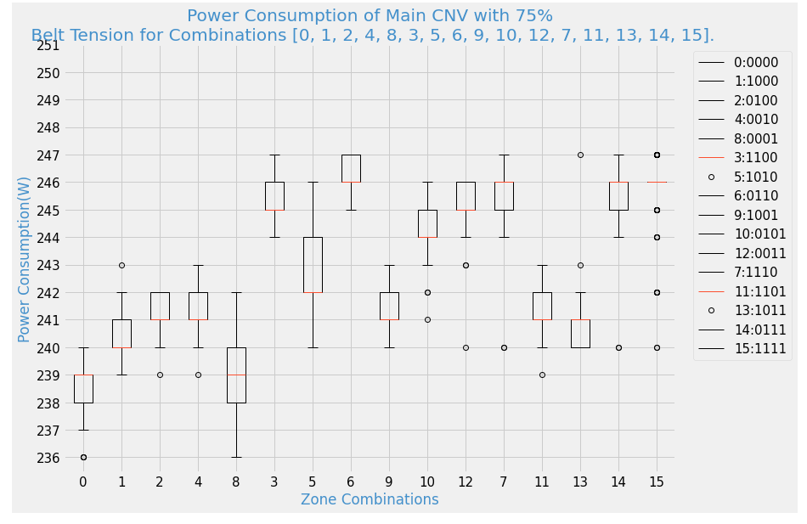

## For belt Tension 85%

**Observations:**

1. Good and smoother belt motion is observed than 75% belt tension.
2. There is no slip in belt.
3. For this belt tension this experiment is conducted for all load configurations.

## Observations for 0,1,2,4 and 8 Combinations

| **Combination Number** | **Combination** | **Description** |
| --- | --- | --- |
| 0 | 1000 | 0 Pallet, No load |
| 1 | 1000 | 1 Pallet at Z1 |
| 2 | 0100 | 1 Pallet at Z2 |
| 4 | 0010 | 1 Pallet at Z3 |
| 8 | 0001 | 1 Pallet at Z5 |

1. For theses combinations an overall increase in belt power consumption was observed and this increase in power consumption is mainly due to increase in belt tension, in this case belt tension is 15% higher than previous case.
2. For **0, 1 and 8** combinations the results are very similar i.e. theses combinations have no significant effect on belt speed and slip but belt power consumption for each combination increased respectively and out of these three combinations a relatively higher power consumption observed for combination 1.
3. For these combinations (0, 1 and 8) the belt slip and belt speed remains unaffected because we have a good belt tension and the presence of pallets on zone a and zone 5 can be neglected as at these zones pallet is not fully residing on conveyor belt of the under experiment workstation.
4. Power consumption for combinations **'2 and 4'** is similar and the data mean for both combinations is 245. Here the power consumption is higher from other combinations due the fact that pallet is residing either on Zone 2 or Zone 3 due this there is increase in friction and motor supplies more power to overcome that frictional force to maintained a smooth motion in belt.
5. These combinations do not have any effect on belt slip and speed.

## Observations for 3, 5, 6, 9, 10, and 12 Combinations

There combinations co-relate the presence of two pallets at the same time on two different zones of main conveyor.

| **Combination Number** | **Combination** | **Description** |
| --- | --- | --- |
| 3 | 1100 | 2 pallets; Z1 and Z2 respectively |
| 5 | 1010 | 2 pallets; Z1 and Z3 respectively |
| 6 | 0110 | 2 pallets; Z3 and Z3 respectively |
| 9 | 1001 | 2 pallets; Z1 and Z5 respectively |
| 12 | 0011 | 2 pallets; Z3 and Z5 respectively |

1. Theses combinations have no effect on belt speed and slip as the belt tension is good enough to overcome the frictional forces to maintain a steady and smooth belt motion.
2. An overall increase in power consumption had been observed for each combination, the maximum power(246W) consumption recorded for combination 6 and a minimum(241W) for combination 12. For these combinations the presence of pallets on different zones have direct effect on belt power consumption.

## Observations for 7, 11, 13 and 14 Combinations

There combinations co-relate the presence of three pallets at the same time on three different zones of main conveyor.

1. Combinations **7 and 14** are the most prominent and for this combination the active zones are zone1, zone2 and zone3 and zone2, zone3 and zone5 respectively. For both combinations the data mean is 248(W).
2. Combinations 11 and 13 both have same effect on parameters though the active zones are different in both combinations. the active zones for each combination are zone 1,2,5 and zone 1,3,5 respectively.
3. These combinations only affect conveyor belt power consumption and other parameters likes belt speed and slip remains same i.e. either no reduction in speed or increase in slip was observed

| **Combination Number** | **Combination** | **Description** |
| --- | --- | --- |
| 7 | 1110 | 3 pallets; Z1, Z2 and Z3 respectively |
| 11 | 1101 | 3 pallets; Z1, Z2 and Z5 respectively |
| 13 | 1011 | 3 pallets; Z1, Z3 and Z5 respectively |
| 14 | 0111 | 3 pallets; Z2, Z3 and Z5 respectively |

## Observation for Combination 15 and Dynamic Case

| **Combination Number** | **Combination** | **Description** |
| --- | --- | --- |
| 15 | 1111 | 4 pallets; Z1, Z2, Z3 and Z5 respectively (Full Load) |

1. All zones are active in this combination. The power consumption mean is 243(W), similar like combination 3, this is strange according to rule this power value must be like power consumption values of combinations 7 and 14. a very little reduction in belt speed was observed.
2. Dynamic Case: It took 5 sec for a pallet to move from Zone 1 to Zone 5.

## Plot for All Combinations with Belt tension 85%

This Belt tension is relatively good for processing almost any number of pallets at a time on any zone of conveyor. For this belt tension the belt power consumption for no load to maximum load is between 238(W) to 248(W). This can be an optimal belt tension.

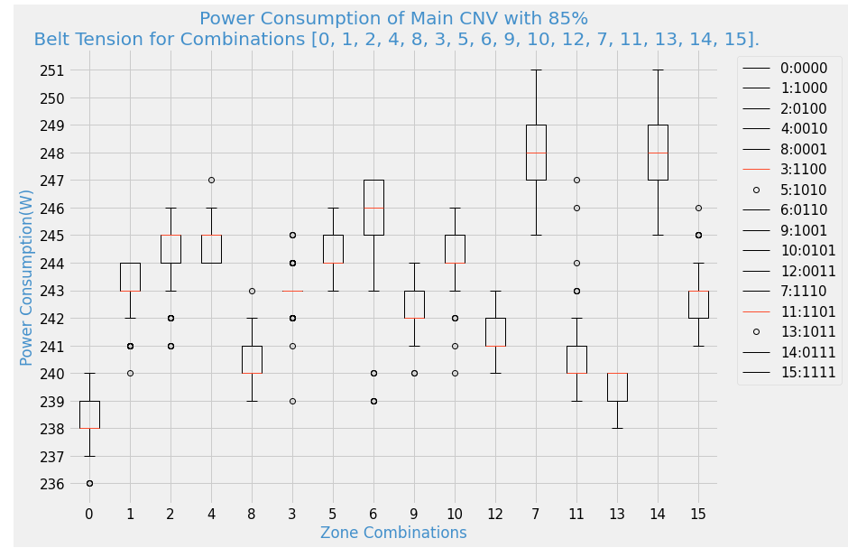

## For belt Tension 95%

**Observations:**

1. Good and smoother belt motion is observed.
2. There is no slip in belt.
3. For this belt tension a significant increase in power consumption observed for all combinations. This is the maximum belt tension in belt which induces and extra load on conveyor motor shaft so motor needs to supply more power to keep the smooth belt motion.
4. For this belt tension this experiment is conducted for all load configurations.

## Observations for 0,1,2,4 and 8 Combinations

| **Combination Number** | **Combination** | **Description** |
| --- | --- | --- |
| 1 | 1000 | 1 Pallet at Z1 |
| 2 | 0100 | 1 Pallet at Z2 |
| 4 | 0010 | 1 Pallet at Z3 |
| 8 | 0001 | 1 Pallet at Z5 |

1. For **0 and 8** combinations the results are very similar and data mean is 265(W). The reason is that in '0' combination we have a no load condition wears for '8' combination we one pallet at zone 5 which is similar to having no load due the fact that at zone 5 almost 75% of pallet reside on next workstation's conveyor.
2. Power consumption for combinations **'2 and 4'** is prominent data mean for both combinations is 268(W) and 267(W) respectively. Here the power consumption is higher from other combinations due the fact that pallet is residing either on Zone 2 or Zone 3 due this there is increase in friction and motor supplies more power to overcome that frictional force to maintained a smooth motion in belt.
3. These combinations do not have any effect on belt slip and speed.

## Observations for 3, 5, 6, 9, 10, and 12 Combinations

There combinations co-relate the presence of two pallets at the same time on two different zones of main conveyor.

| **Combination Number** | **Combination** | **Description** |
| --- | --- | --- |
| 3 | 1100 | 2 pallets; Z1 and Z2 respectively |
| 5 | 1010 | 2 pallets; Z1 and Z3 respectively |
| 6 | 0110 | 2 pallets; Z3 and Z3 respectively |
| 9 | 1001 | 2 pallets; Z1 and Z5 respectively |
| 12 | 0011 | 2 pallets; Z3 and Z5 respectively |

1. For Combinations **3, 5** have similar effects on belt parameters and only belt power consumption is affected. For these combinations a significant increase in belt power consumption had been observed, it due to pallet load and an extra belt tension. For both combinations the data mean is 273(W). For these combinations the active zones are zone1, zone2 and zone1, zone3 respectively.
2. For combinations **9** lowest power has been observed. Here the active zones are 1 and 5. Both combinations **10 and 12** have same data mean (272(W)) and similar effects like combinations 3 and 5.
3. Out of these combinations the most prominent combination is **6**, here both zone2 and zone3 are active at the same time and reviles some interesting effects. For this combination power consumption slightly increased than other combinations.
4. For these combinations there either no reduction in belt speed or no increase in belt slip.

## Observations for 7, 11, 13 and 14 Combinations

There combinations co-relate the presence of three pallets at the same time on three different zones of main conveyor.

1. Combination **7** is the most prominent and for this combination the active zones are zone1, zone2 and zone3. As far as concerned with power consumption, it is significantly higher to combination 6(active zones are 2 and 3), here the data mean is 280(W) but other parameters like slip and speed are not affected by this combination.
2. Combinations **11 and 13** both only affects conveyor power consumption and remaining parameters remains unaffected, though the active zones are different in both combinations. the active zones for each combination are zone 1,2,5 and zone 1,3,5 respectively.
3. combination **14** has similar effect like combination **7** but has relatively less power consumption. Here the data mean is 277(W).

| **Combination Number** | **Combination** | **Description** |
| --- | --- | --- |
| 7 | 1110 | 3 pallets; Z1, Z2 and Z3 respectively |
| 11 | 1101 | 3 pallets; Z1, Z2 and Z5 respectively |
| 13 | 1011 | 3 pallets; Z1, Z3 and Z5 respectively |
| 14 | 0111 | 3 pallets; Z2, Z3 and Z5 respectively |

## Observation for Combination 15 and Dynamic Case

| **Combination Number** | **Combination** | **Description** |
| --- | --- | --- |
| 15 | 1111 | 4 pallets; Z1, Z2, Z3 and Z5 respectively (Full Load) |

1. All zones are active in this combination. The power consumption mean is 281(W), slightly higher than combination 7. This combination has similar effects an all other parameters like combination 7.
2. Dynamic Case: It took 4.56 sec for a pallet to move from Zone 1 to Zone

**Plot for All Combinations with Belt tension 95%**

This Belt tension is not good for processing pallets as this is the maximum belt tension which puts an extra load on motor shaft so conveyor motor driver must supply enough power to maintain a steady motion in the belt hence motor heats up significantly which can harm conveyor motor driver at any time during a process. We can see that for this belt tension the power consumed by belt for combination 0 i.e. no-load condition is far more than the power consumed by belt for combination 7 with 85% belt tension. Furthermore, this tension causes the belt break during the process. For this belt tension the belt power consumption for no load to maximum load is between 238(W) to 248(W). This can be an optimal belt tension.

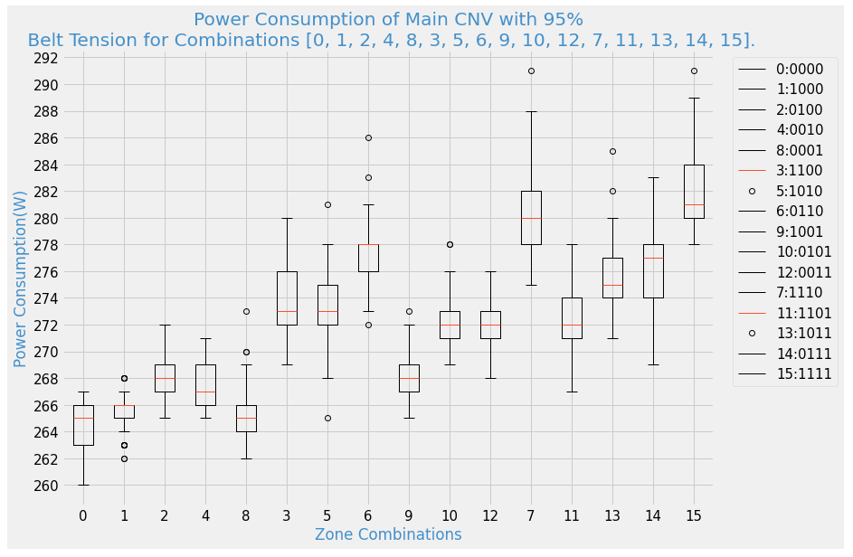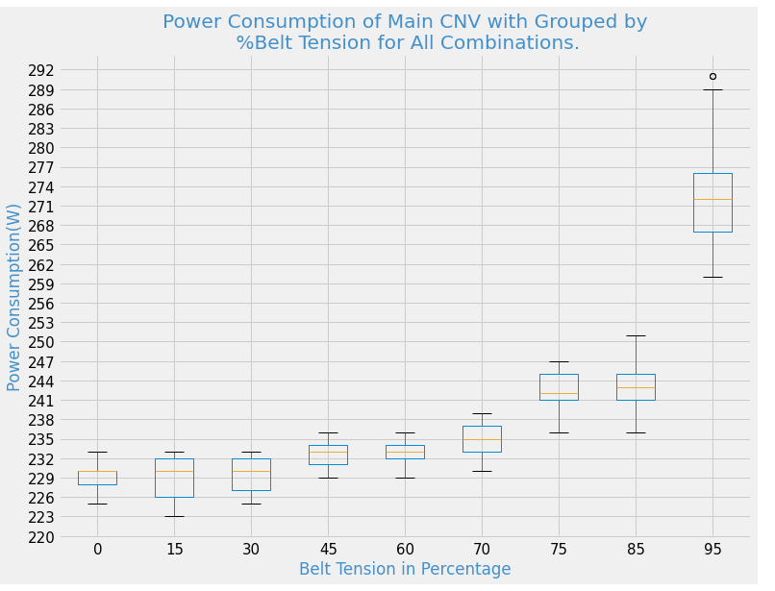

I was also working on Conveyor belt tension predictor. This predictor is a pattern recognizer which utilizes the historic power consumption data of conveyor belt and predict the current belt tension.

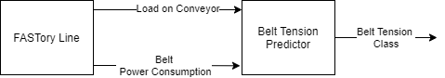

I am using Neural Net for this predictor and so far, I have achieved 72.5% accuracy. Below figures shows the accuracy and loss on train and test data.

