Two models (Model_4 and Model_3) have been trained for predicting the belt tension class. Both models have same input features (nodes) but have different number outputs nodes which is based on the data labialization. The data used for training the belt tension predictor model has been labeled according to belt tension values. As there are two different models for predicting the belt tension class so the data is labeled differently for each model.

As the data is collected for a range of belt tension i.e. from 0% to 95%, during this belt tension range the load on main conveyor had been changed according to load combinations (these combinations are explained in the previous report) which affects conveyor belt power consumption, slip and speed, each belt tension affects these parameters differently. Within this belt tension range there are lower and upper threshold to the belt tension values i.e. below a certain belt tension there is no motion in the conveyor belt and on the other hand there is too much belt tension which tightens the belt too much and induce an extra load on the driver motor shaft. So, the all tension values below lower threshold is marked as not useful belt tension (labeled as 1) and on the other hand the values greater than upper threshold are marked as over tense (labeled as 4 or 3 based on model). All belt tension values between these thresholds are marked as useful belt tensions (labeled as 3 or 2 based on model).

$$Not useful belt tension≤lower threshold \\ upper threshold≤Not useful belt tension (over tense) \\ lower threshold<useful belt tension>upper threshold$$

# **Predictor Model:**

This model uses the neural network for predicting the belt tension class. This model has two features (Load on Main conveyor and power consumption), some hidden layers and an output layer with 4 or 3 output nodes.

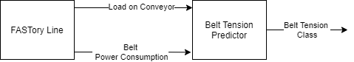

**Model_4:**

As mentioned above the two different models have been trained for predicting the belt tension class which is based on the data label. For this model the data has been labeled as follow:

| Belt Tension Class | %Belt Tension | Description |
| --- | --- | --- |
| 1 | 0 | Not Useful |
| 1 | 15 | Not Useful |
| 1 | 30 | Not Useful |
| 1 | 45 | Not Useful |
| 1 | 60 | Not Useful |
| 1 | 70 | Not Useful |
| 2 | 75 | Useful (compromise) |
| 3 | 85 | Useful (Optimal) |
| 4 | 95 | Over Tense |

1. All, “Not Useful” Belt tensions are combined in one class. The belt tension range: 0%-60% are not useful for us as with these belt tensions the is no motion in the conveyor belt and data mean is approximately same (0-30 and 45-60) for these combinations.
2. The belt tension 70% is also not useful though this belt tension creates motion in the belt but as soon as there is a pallet on zone1, belt moves with jerks. So, this belt tension belongs to the not useful belt tension class. Furthermore, the for these belt tensions the mean is almost same, see figure1 and the belt tension predictor mostly mis predict the belt tension class in that range so by grouping them in one class has huge effect on predictor accuracy. Any tension value which is less than or equal to 70% is not useful for our production system. Thus 70% is the lower threshold for belt tension.
3. Moderate and Useful (Optimal), belt tensions have sperate classes
4. Over Tense belt Tension has a huge power consumption margin among other belt tensions

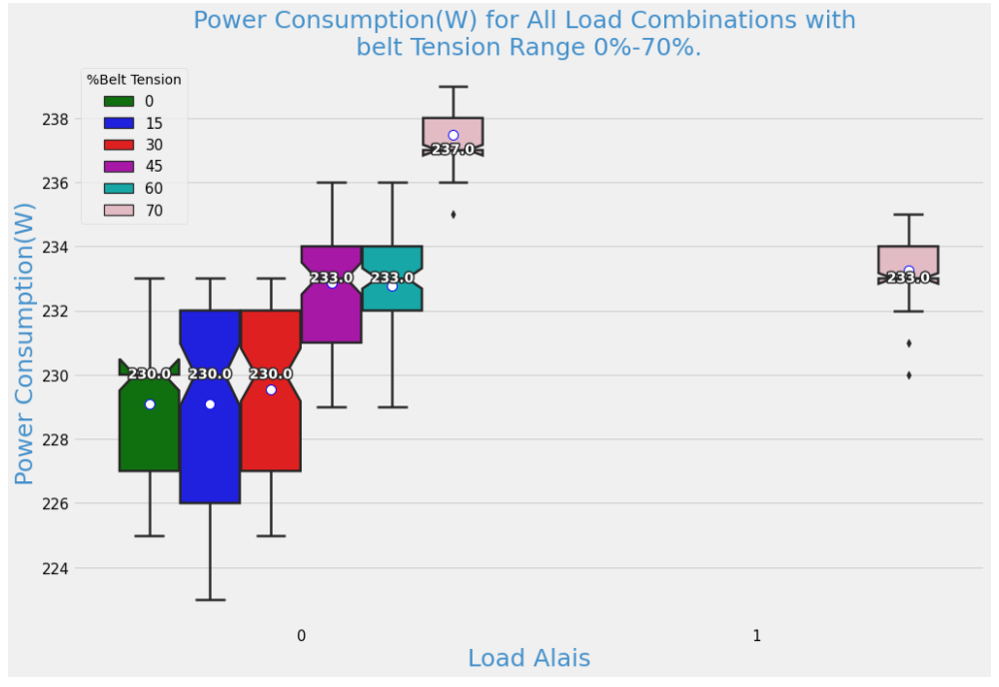

Figure 1: Not useful Belt Tensions

**Model_4 Statics:**

This model works well, and the following figures shows the model loss and accuracy on training and validation set.

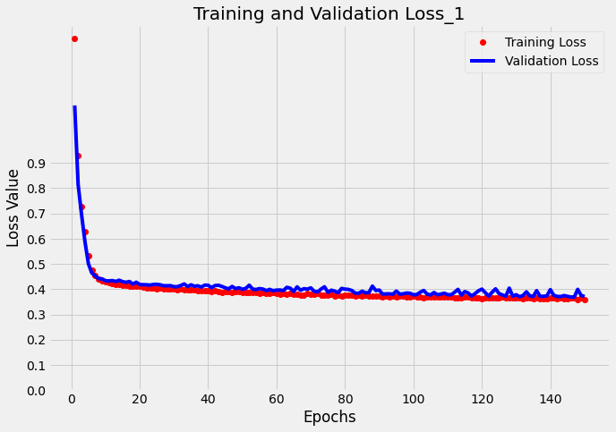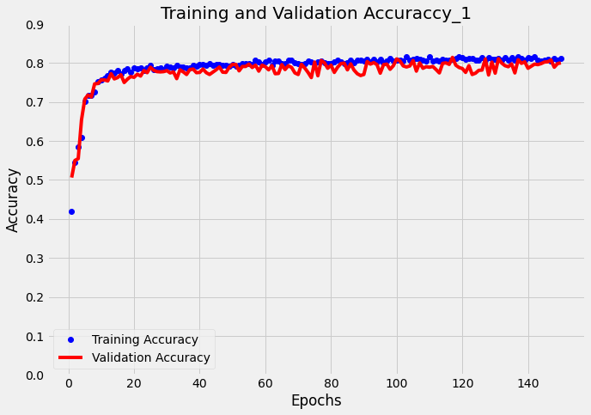

Model Average loss and accuracy on test data:

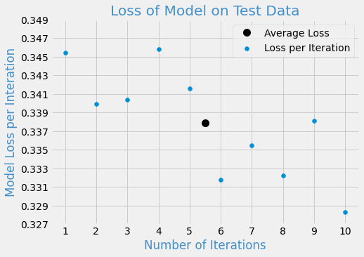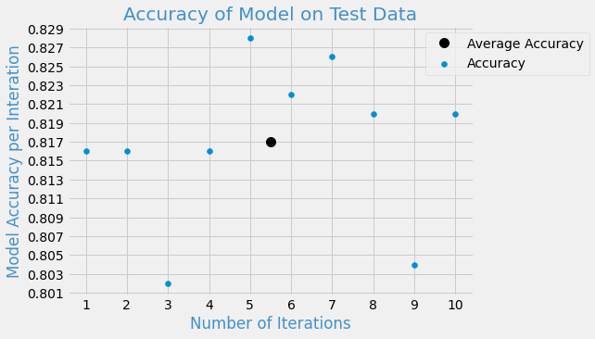

This model has an average accuracy greater than 80% which is good, but its loss is high. By close observation of mis prediction belt class it came to know that predictor mostly mis predict classes for certain load combinations for belt tensions 75% and 85% and it makes sense because the margin between the belt power consumption for different load combinations is very small and for some load combinations the power consumption values overlap with each other, though the belt tension is different see figure 2.

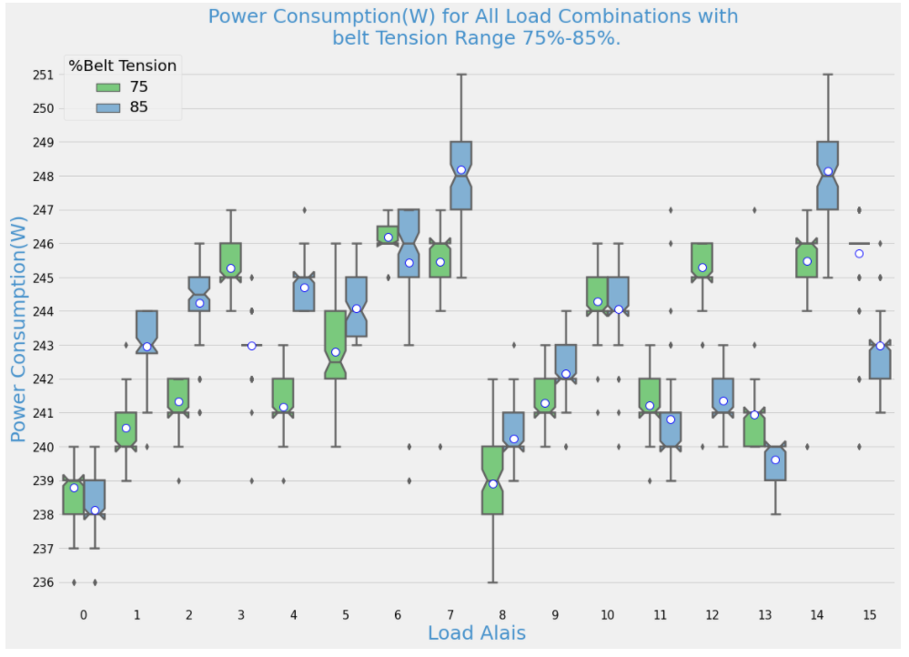

Figure 2: Comparison of 75% and 85% Belt Tension

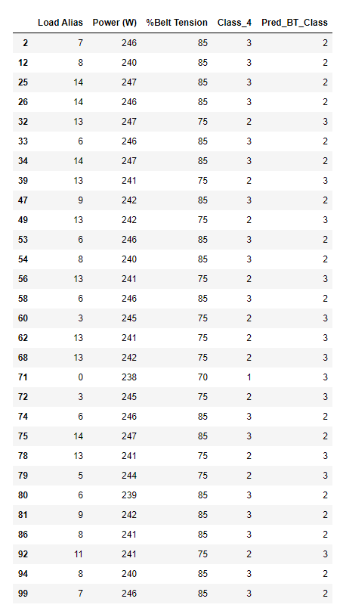

Figure 3: Mis Prediction

Mostly mis predictions occur for 6,7,8,9,14,13 load combinations.

|  |  |
| --- | --- |
| Load Combinations | Active Zones |
| 6 (0110) | Zone2 and Zone3 |
| 7 (1110) | Zone1, Zone2 and Zone3 |
| 8 (0001) | Zone5 |
| 9 (1001) | Zone1 and Zone5 |
| 13 (1011) | Zone1, Zone3 and Zone5 |
| 14 (0111) | Zone2, Zone3 and Zone5 |

These belt tensions (75 and 85) are grouped under one class, please see class_3 table. More detailed analysis of these belt tension can be found in **Main CNV Static Data Analysis** file.

**Model_3:**

**Class_3:**

1. All Not Useful Belt tensions are combined in a Class
2. Useful (Compromise) and Useful (Optimal), belt tensions are combined in a sperate class
3. Over Tense belt Tension has a huge power consumption margin among other belt tensions so it has its own class Please see the following table:

| **Belt Tension Class** | **%Belt Tension** | **Description** |
| --- | --- | --- |
| 1 | 0 | Not Useful |
| 1 | 15 | Not Useful |
| 1 | 30 | Not Useful |
| 1 | 45 | Not Useful |
| 1 | 60 | Not Useful |
| 1 | 70 | Not Useful |
| 2 | 75 | Useful (Compromise) |
| 2 | 85 | Useful (Optimal) |
| 3 | 95 | Over Tense |

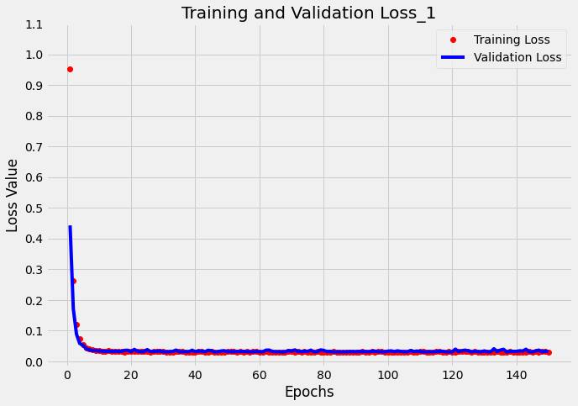

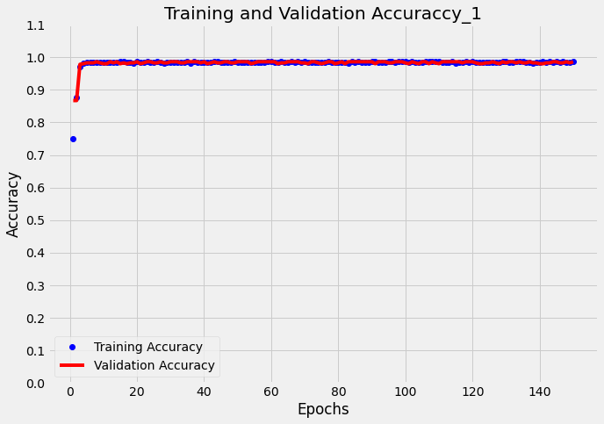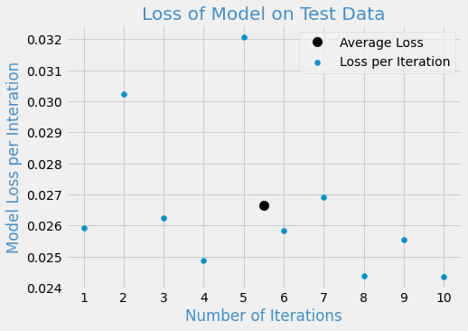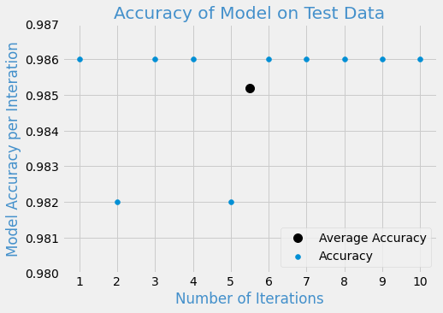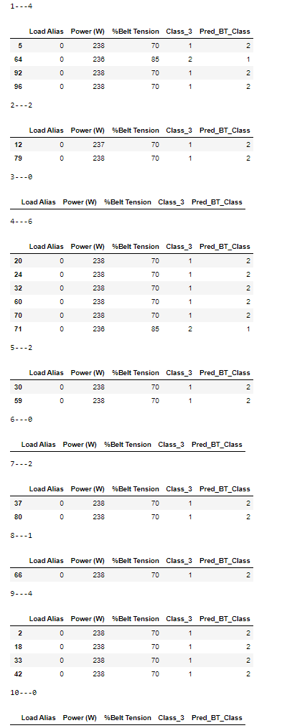

Figure 4: Mis Prediction Model_3

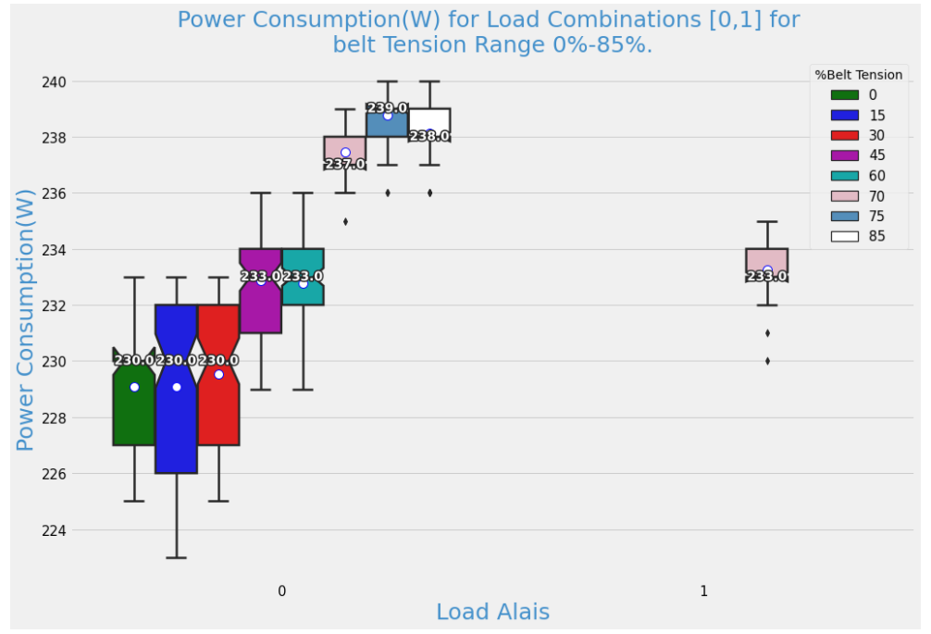

Figure 5: Mis Prediction Cause