Week_19:

ZDMP digital bus uses both AMQP and MQTT protocols for pushing data du to a bridge connection between them, both protocols use different topic naming conventions. Monitoring and alerting component uses AMQP as default communication protocol and follows different topic conventions due to this, the data published by our devices was not accessible at monitoring and alerting component for example our devices registered to DAQ and it automatically publishes data to message bus using MQTT protocol to topic

***T5_1-Data-Acquisition/DataSource: 24EM (topic generated by DAQ)***

*According to rule the kpis at M&A component must listen to the same topic but they need topic in the following convention*

***T5_1-Data-Acquisition.DataSource: 24EM (due to different protocol M&A listens to this topic).***

According to this all child topics must be separated by dots (.) not by forward slash (/). This topic mapping must be handled by M&A component.

I already informed Laura about this issue and soon she will fix the topic mapping for listing devices that uses MQTT for publishing data.

I have done the topic mapping on my side by hardcoding KPI topics for our devices.

**Pattern Recognizer and Monitoring and Alerting component:**

I have integrated M&A component and pattern recognizer. I used MQTT publisher to push the real-time to ZDMP digital bus without using DAQ component and this data published to topic “FAST…”, see the figure 1 for KPIs that are listing/monitoring to real-time data as well as predicted belt tension class by pattern recognizer, under topic “FAST…”. Figure to shows the alerts as an email to the user when any KPI deviates from its desire value.

Currently monitoring and alerting component does not integrated to Zstudio.

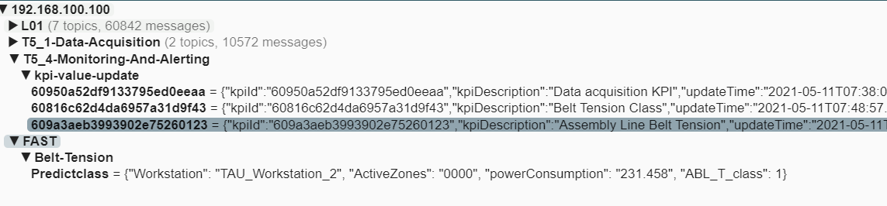

Figure 1: KPIs monitoring real-time data

