**Title of the project:**

The name of our project is **WAN based enterprise network with IoT service**. It is a secured computer networks system that enables our enterprise network to communicate with our different area of networks as well to share our resources like files, voice service and home appliance devices based IoT technology.

**Introduction:**

This project is intendent to plan and implement a good and secured computer network system. To deploy well-designed computer networks supporting converged applications of data, audio, and video. To support better performance, resilience, security, maintainability. This is to propose a network model that can be implemented in different network environments and also be used to implement MAN, LAN. Use of Voice over Internet Protocol technology allows to make a phone call using an Internet connection or a dedicated network that uses the IP protocol, rather than go through the normal telephone line. This save bandwidth used. Data packets, containing voice information are routed over the network, encoded in digital form. To filters & check unauthorized traffic that travels across the network. To allow only the genuine users to access the network and prevent the intruders from accessing it.

The four areas ( **Wireless area, IoT area, Pure VoIP with Lan area, Main server area** ) are not far away from each other. So we will just make use of concept named WAN ( Wide Area Network ) to connect them together all. There is also ISP ( Internet Service Provider ) which will provide an internet connection to all areas that we have connected together and each areas will have a secure internet.

**Objective:**

To simply the flow of information from one place to another place, that is to say area manager don’t need to go to the main server area physically.

* To make it easier to control IoT devices from different area and make IoT home appliance services to general people which is also a part of this enterprise network.
* To improve the security of information against the careless employees who might lose the information on the papers, so in this case the information will be running through cables.
* The major objective of this network design is to provide the secured IoT service as a part of the Enterprise Network.

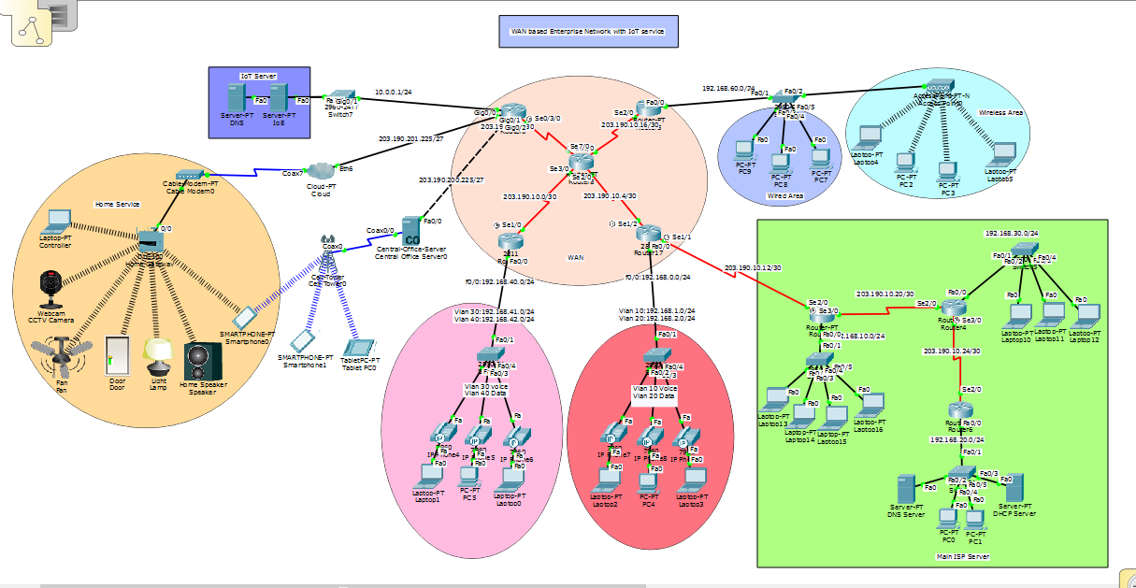**Implementation:**

Fig: WAN based Enterprise network.

DHCP:

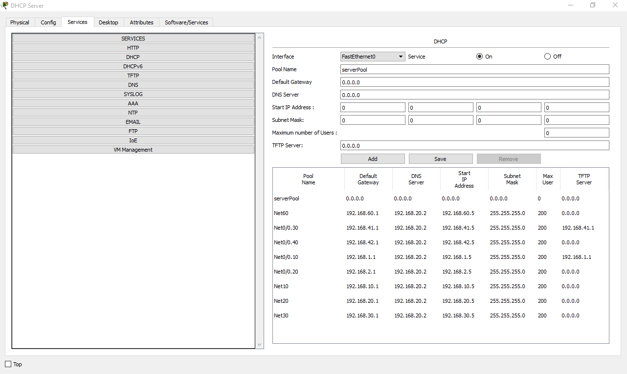

DNS:

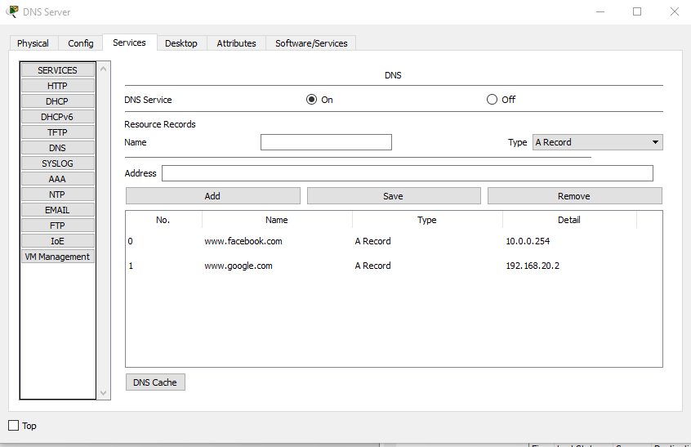

VoIP:

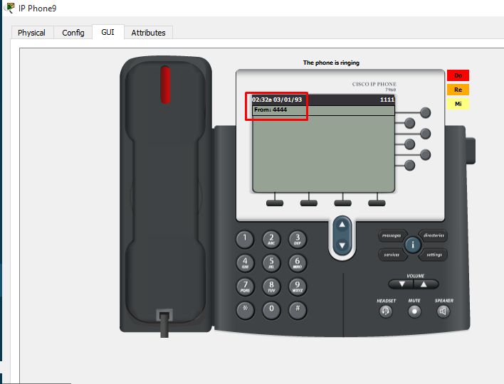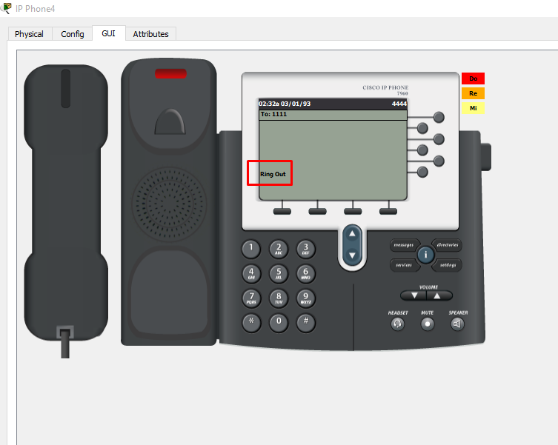

OSPF:

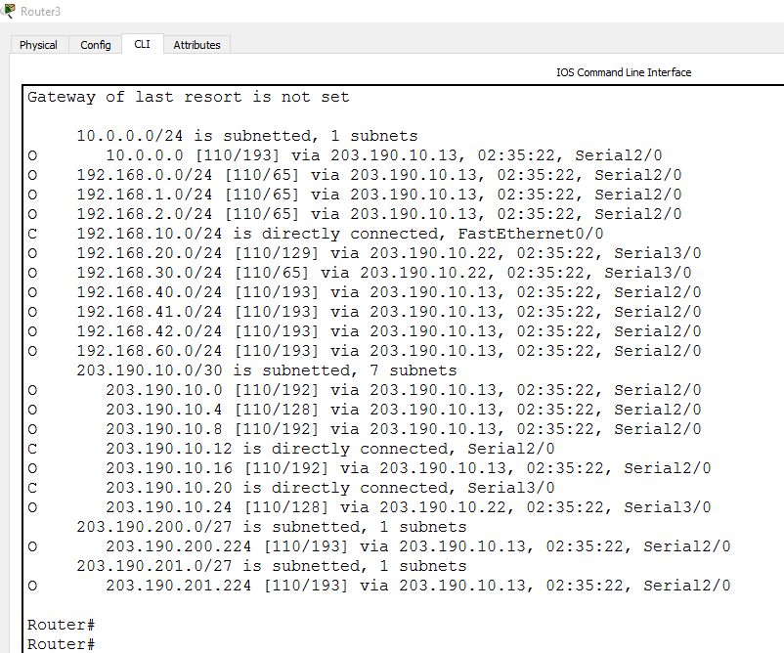

Inter-Vlan:

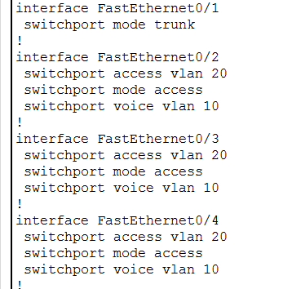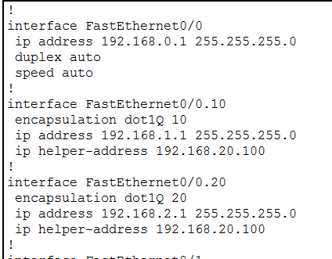

Security:

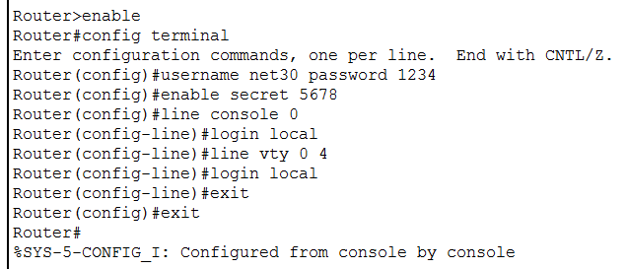

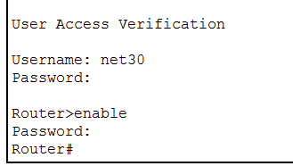

Telnet:

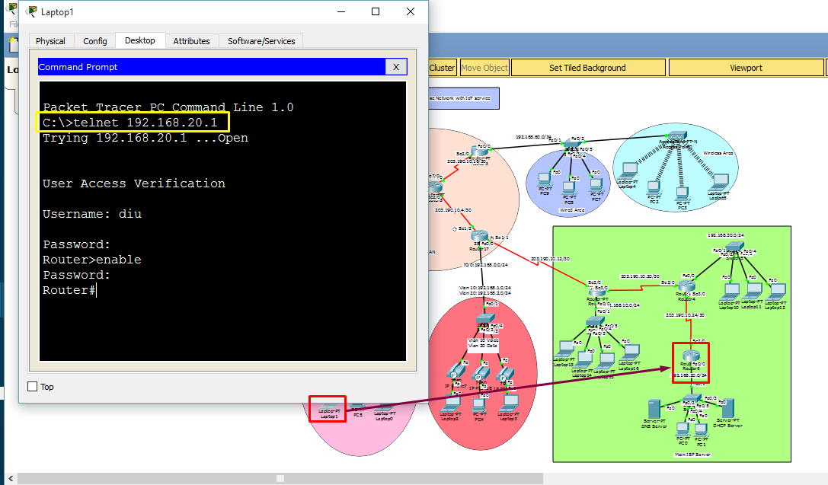

**Future Scope:**

With WAN based enterprise network ,our main aim is to:

* To establish a network which is free from any attacks by using weather firewalls or opened port number in systems of the company in case of receiving and sending vital information from one Area or even outside world (sending into another Area) through wired or wireless connection.
* Focusing to get more reliable connection (weather internet connection between areas or through internet to worldwide) are free from any error and also to get beneficial system that help the company more and more than the previous system were working.
* To ensure that there is no delay or wasting of time in case of sharing data and VoIP connection.
* To ensure that the rate of data transmission is very high.