This document contains the high level diagram and mockup screens of Warehouse Management System. The system will be used by two types of user. One is customer end and another one is Warehouse end.

# High Level Diagram

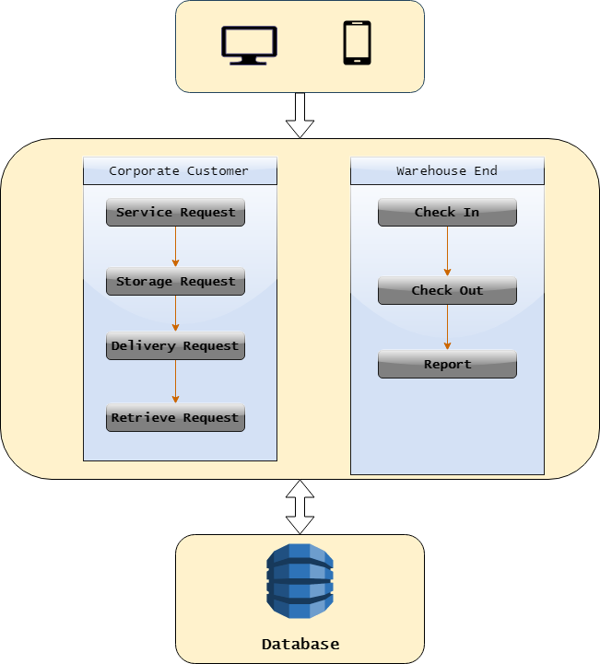

**Figure 1**- This is the high level diagram of Warehouse management system. This diagram shows that there will be two types of user who will use this system.

# Mockup

## Users Dashboard

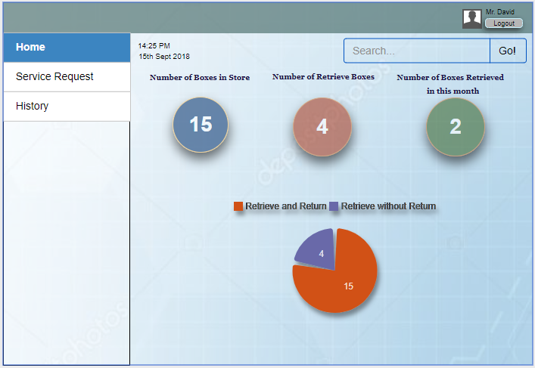

**Figure 2-** This dashboard will allow users to view their current status. Customer will be able to see number of boxes they have used and number of boxes they had retrieved.

## Service Request

Customers will be able to request for various types of services including storage request, delivery request and retrieve request. This part contains the UI of service requests.

### Storage Request

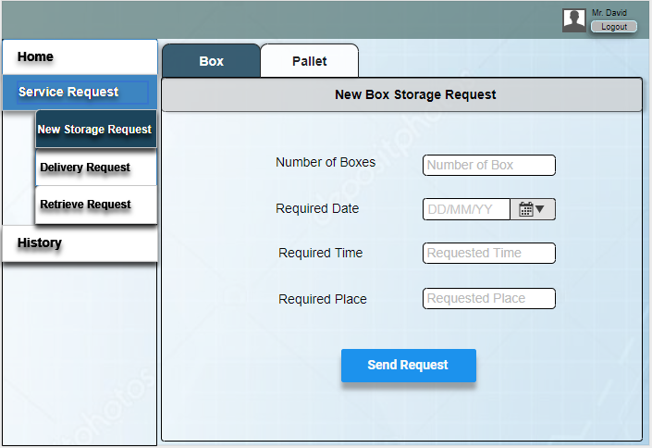

**Figure 3**- Customer will be able to request for new storage. They will provide all the necessary details to make a request.

### Delivery Request

Customer will be able to request for delivery. They can deliver their box, file or pallet. All this information is mandatory to send delivery request.

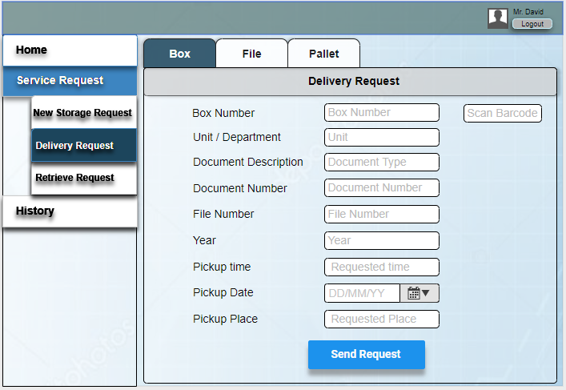

**Figure 4-** This UI shows that customer will be able to send their box to warehouse for store.

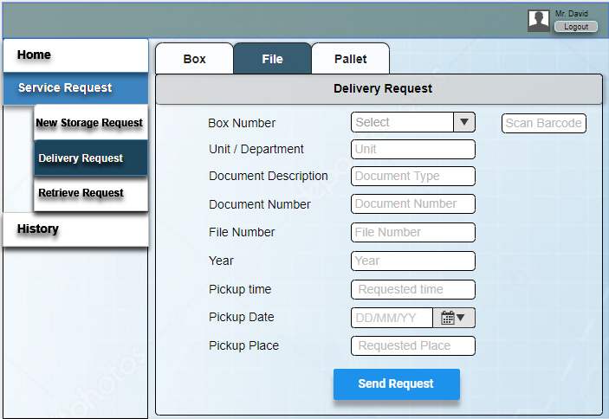

**Figure 5**- Customer will be able to send request for deliver any specific file in their stored box. They need to provide the file details to make the request.

## Retrieve Request

Customer will be able to make retrieve request for their files or boxes. They will be able to choose whether they want to retrieve the file or box permanently or temporarily.

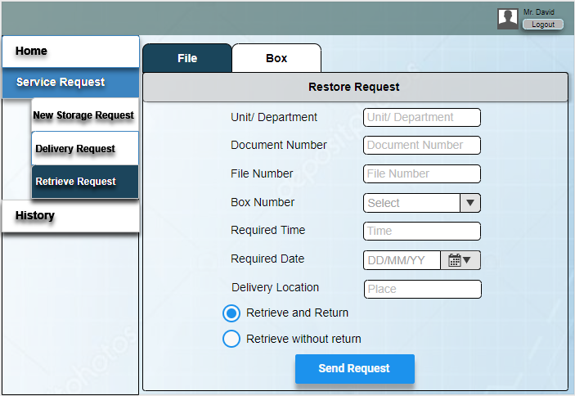

**Figure 6-** This UI is for File retrieve. Customer need to provide the details of targeted file to retrieve the quested file.

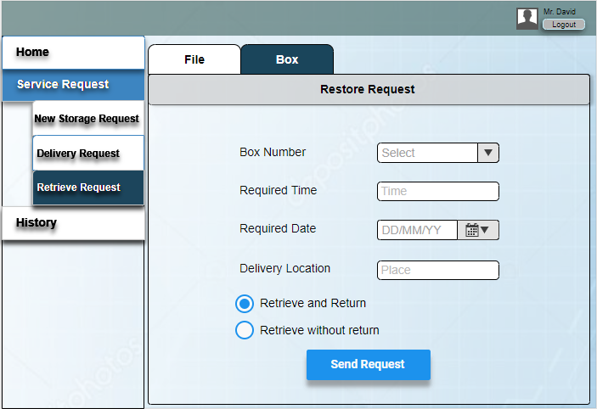

**Figure 7-** This UI is for Box retrieve. Customer need to select the box number to retrieve the quested box.

## History

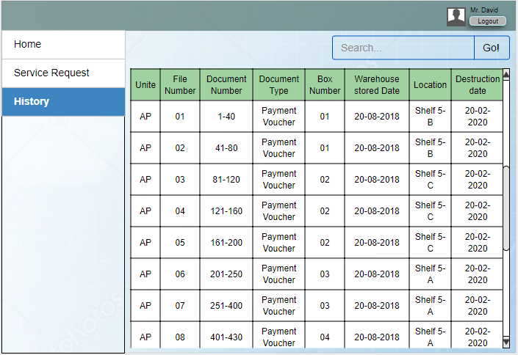

**Figure 8-** Customer will be able to see the details of their stored files and boxes. They will be able to see the current location of their property.

# Warehouse End

Users of warehouse end have to maintain this section for proper storage management.

## Dashboard

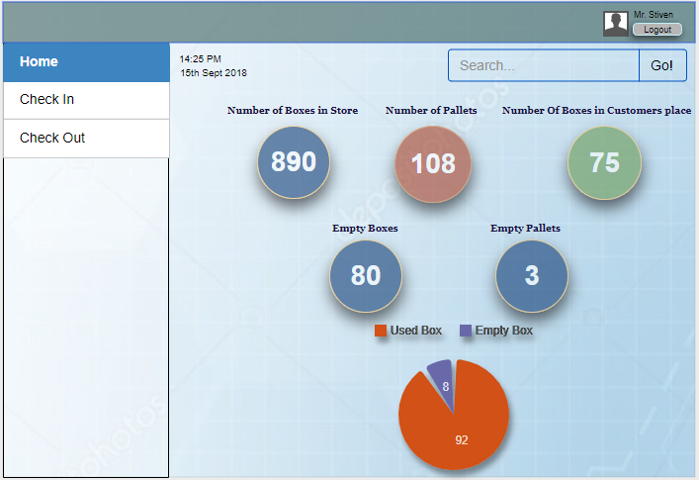

**Figure 9**- Warehouse admin will be able to see the current status in the dashboard. How many pallets they have in the warehouse. How many boxes are stored in the warehouse, how many boxes are in customers place, number of empty boxes, number of empty pallets and the ratio of empty and used boxes.

## Check In

Check In process start with the scanning of barcode which is attached with the box. After scanning the barcode a form will pop up with storage details.

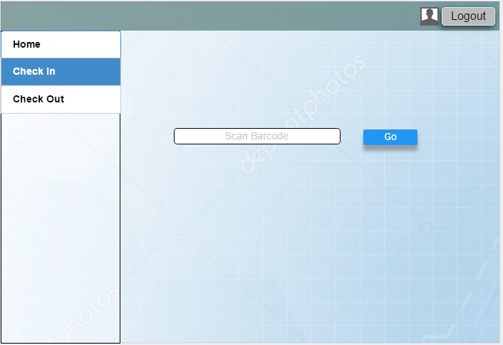

**Figure 10-** Check In process start with barcode scanning.

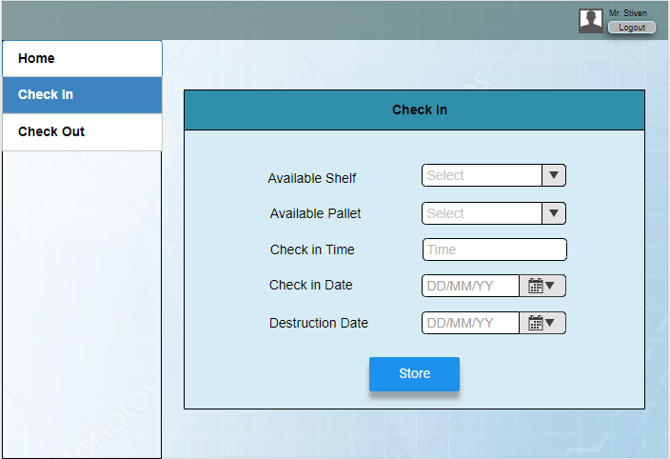

**Figure 11**- After scanning the barcode this form will pop up. This will show the available shelves and pallets. User have to select the specific shelf and pallet to store the property.

## Check Out

Check Out process star with barcode scanning. After scanning the barcode user need to provide some information to complete the check out process.

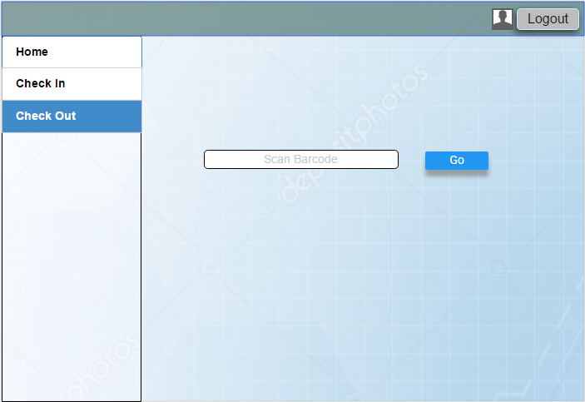

**Figure 12**- Check Out process start with barcode scanning.

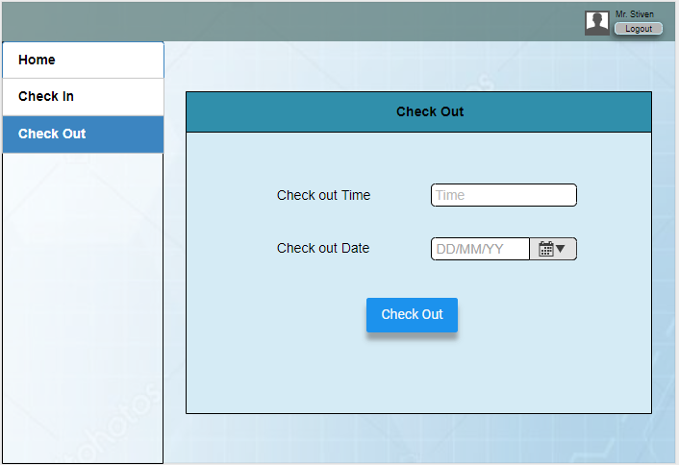

**Figure 13**- After scanning the barcode user need to input the checkout time and date.