TEAM 16

Fairuz Samiha Saeed

Homayra Alam

Mahbubur Rahman

QMST 5335 – Forecasting and Simulation

Texas State University

Term Project

05/07/2020

1. BANK SYSTEM

1.1 SYSTEM EXPLANATION

We have a bank system with three types of customers and four servers. Basic, Moderate, and Advanced customers all first go to the Sign In server and then redirected to ATM, Teller, or Manager. Basic customers go to the ATM or Teller, Moderate customers go to ATM, Teller or Manager, and Advanced customers go to Teller or Manager. This system is built on first come first served and Sign In server time depends on the customer type whereas the other three server execution time is independent on the customer type.

Currently, there are 1 Sign In, 3 ATMs, 4 Tellers, and 2 Managers in the system. The bank is planning to hire two additional employees and want to use simulation to decide which positions these two additional employees should be hired. Our team was assigned to compare three scenarios with the current status and against each other. Below is a diagram showing the flow in the bank.

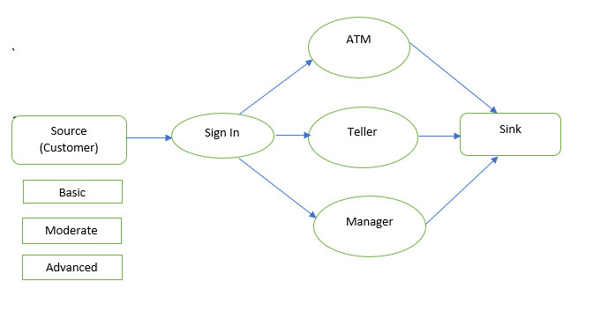

Figure 1: Flow Chart of the System

* 1. DATA ANALYSES

We had the data of Interarrival time, customer type, Sign In time, which server they are redirected (according to their type), and the service time for 5000 customers. According to our team data set, we calculated the percentage of the customer for each type. For simulation, we calculated the interarrival time distribution of customers using Stat: Fit and we also generated three fitted distributions for Sign In times. Then using the data files, we determined the percentage of each customer type being directed to each service option. Along with these we also went for the best distribution for service time at each service option.

Using this data set, we figured out the inter-arrival time of exponential distribution for three types of customers. The estimate was maximum likelihood estimates and we examined three significance of hypothesis test (Chi-Squared, Kolmogorov Smirnov and Anderson Darling). Each distribution was selected after performing goodness of fit according to their higher rank value, small distribution, and high p-value for each test. These conditional values prove that our data are perfectly fit with the selected distribution. For example, the following table shows the arrival distributions for interarrival time.

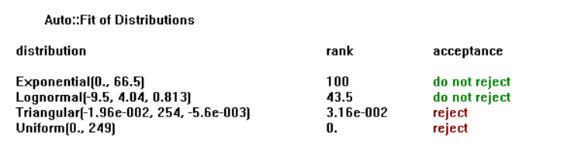

Table 1: Distribution Table of Inter arrival time

As interarrival time is continuous and takes only positive values, we tested four kinds of distributions shown in the table. We selected the auto fit for these data and the result gave us the best possible distributions (exponential & log-normal) based on the p-value of Chi-Squared, Kolmogorov Smirnov, and Anderson Darling. We selected exponential distribution as it has a higher rank. The distribution graph also confirms it to be exponential.

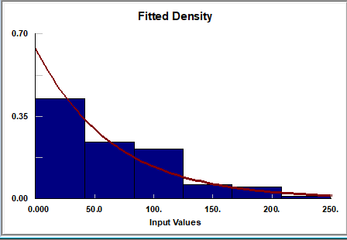

Figure 2. Histogram of Inter arrival time

The other distributions are as follows

|  |  |
| --- | --- |
| Interarrival | Random.Exponential(66.5) |
| Sign In 1 (Basic) | Random.Uniform(5,39) |
| Sign In 2(Moderate) | Random.Triangualr(0.629,58.2,77.6) |
| Sign In 3(Advance) | Random.Uniform(22.,97.) |
| ATM | Random.Exponential(58.8) |
| Teller | Random.Exponential(187) |
| Manager | Random.Exponential(273) |

Table 2: Distribution of Server Processing Time

we determined the sign In time distribution for three types of customers. The percentage of the customer is split up as, 19% Basic,51% Moderate, and 30% Advanced. Among them, the Basic customer only goes to ATM (79%) or Teller (21%), Moderate customer goes to ATM (23%), Teller (51%) or Manager (26%) and Advanced customer goes to Teller (19%) or Manager (81%).

* 1. SIMIO MODEL AND VERIFICATION

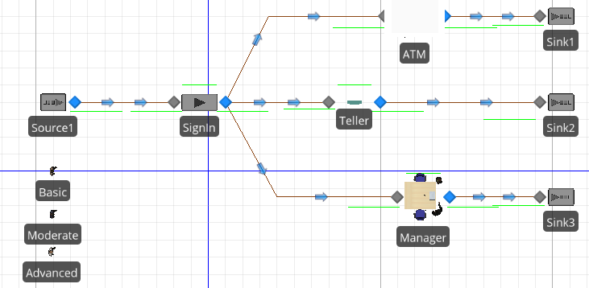

Figure 3: Basic 2D Simio Model

The above figure is our basic simio model. Here we have three customer entities (Basic, Moderate, Advanced) and four servers (Sign In, ATM, Teller, Manager). Every customer enters into the bank, they first go the Sign In server and are redirected to ATM, Teller, or Manager. After getting their service, they leave the system through the sink connected with the server.

The source server is entitled to choose a customer randomly according to their type and percentage mix. Sign In server has three separate processing time distribution for three types of customers and each server works according to their capacity. According to the design of this system, each customer is destined for a specified server and so we assigned each server according to their weight of customers. From the entrance server Sign In. three paths are divided into three servers and each path is assigned according to the weightage of servers.

As interarrival time, the service time of ATM, Teller & Manager is independent of customer type. We added the distribution from the data analysis into designated parts of their properties. We built a table for Sign In time because it depends on the customer type. We created the following from the simulation to distinguish between the different percentages of customer types (Type_Mix), Sign In distribution, and each server’s path weightage and linked it with our model by adding references. This table was made based on the result of data analysis.

Table 3: Data Table for Bank System Simulation

For validating the model, we made a Jackson Network and compared the network value with our model value. For computing the theoretical result, we chose one type of customer for the whole system and observe the value of the expected number of customers in the system (L)and expected waiting time (W) in the system. The following figure shows the Jackson Network for the Basic type of customer.

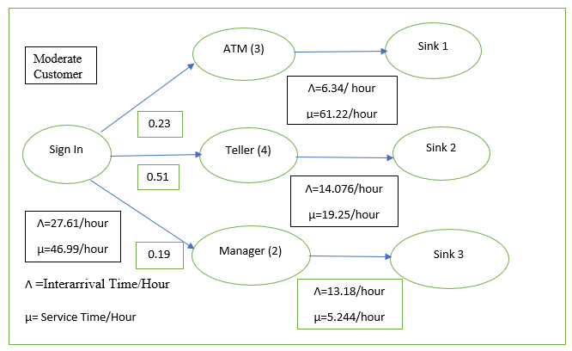Figure 4: Jackson Network for Moderate Type of Customer

The above Jackson Network is for the Basic type of customer. The basic customer only goes to the servers, ATM, and Teller. For calculating the theoretical value, we determined the mean of individual time and made it exponential. The following table shows that the theoretical and simulation results are close. We validated the model also for moderate and advanced customers.

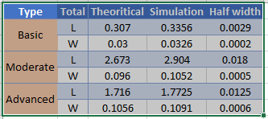 Table 4: Comparing Theoretical value with Simulated Value

* 1. SYSTEM ISSUES AND ALTERNATIVE ACTIONS

Based on the initial run of the current system, we observed that the expected number of customers in the system is very large. The waiting time of the customer in queue is comparatively high for sign in (0.0151 hours) and Manager (0.0743 hour) whereas ATM and Teller waiting queue time is close to 0. This is expected because Sign In server receives all the customers with one employee only. The utilization of Sign In server is 67% which means the server remains busy for 67% of the time. For ATM, the average service time is 60 seconds which is the lowest among the other three servers. It has a utilization factor of 8% with 3 Booths. This is expected because only basic customers who are 19% of the total customers are more likely to visit ATM. For Teller, the average service time is 187 seconds with a utilization factor of 25% with 4 capacity. This means tellers are busier than ATM. This is expected because Moderate customers are more likely to visit teller which is 51% of the total customers. Lastly, for Manager, the average service is highest among all (273 seconds) with a utilization factor of 76% with 2 Managers. Advanced customers mainly visit Managers which is 30% of the total customers. This makes sense because the service time is high with many customers.

From the above discussion, we can conclude that the Sign In server and Manager are the busiest. This makes sense because Sign in server deals with all the customers with just 1 employee and the Manager has long service time with almost 37% of the total customers. We also observed that the waiting time of a customer in the queue is comparatively high for these two servers. To overcome this problem, we need to employ more workforce in Manager and Sign In servers. We are going to simulate 4 different scenarios to find the best solution for this issue and validate it with our expected result.

Scenario 2 adds two more employees to the Teller. This will certainly not help to reduce pressure from Managers and Sign In. Otherwise, the utilization factor of Teller will reduce with the increase in some capacity. We do not want that as we already have a low utilization factor of 25%

Scenario 3 is based on adding one employee in Sign In and another employee in Manager. This scenario is expected to be the most useful for reducing pressure from these two engaged servers. In another way, it will reduce the utilization factor which decreases the number of expected customers in the system. Also, if a server can decrease its service time, then according to the equation of waiting time in queue Wq=W+1/μ(service time) will be decreased. This complies with the issues we are facing in our original model. In other words, additional employees should be added to the manager and sign in servers to reduce the waiting time of customers as well as utilization factors of the servers.

Scenario 4 works with Manger and Teller server, which means one employee is added to the manager and another one to the Teller. This will reduce the traffic intensity from the Teller and Manager. Though, the traffic load on Sign In cannot be solved using this scenario. We do not want this either because Sign In server is dealing with all the customers with just one employee (utilization factor 67%).

To select one of these options, we conduct a simulation experiment using the main Simio model presented above. This scenario will be completed based on the expected number of customers in the system and the waiting time of a customer in line. We will also look for a reduced traffic intensity for each server so that the customer load can be evenly distributed in the system.

1. SIMULATION STUDY
   1. EXPREMINET SETUP

To validate our expected result, we created an experimental model of our original model. We created scenarios by controlling the number of added new employees to different servers. 100 replications of each scenario are run, and each replication has 10 hours warmup and 103 hours run length. During this period 5040 customers enter into our system. Among them, around 489 customers entered in the system for 10 hours warm-up period. We used the warm-up period because establishing a suitable warm-up period for a simulation run is an interval that allows enough time for the dependent stochastic process of interest to reach a steady state. Also, the more replication we use, the more simulation value will be close to the theoretical value. We added these responses: How much time a customer spends in the bank (from the entrance until leaving) on average(W), How many customers are present inside the bank on average (L), How much time customers directed to each service option (ATM, Teller, Manager) spend in the corresponding queue on average(Wq).

2.2 SIMULATION OUTPUT AND DISCUSSION

Based on the initial run of the current system (1 Sign In, 3 ATM, 4 Teller, 2 Manager) we observed that the high queue length is faced by Manager and Sign In servers. An average number of waiting customers and service time in Manager and Sign In stations are comparatively high which results in the highest waiting time in the respective stations. ATM handles the smallest number of customers with low service time distribution and its waiting time is also lower. The number of waiting customer and service time of the Teller station is more than ATM and hence the waiting time in Teller is also higher than ATM. So, if we could increase the capacity of the Manager and Sign In stations, then the load distribution could be evenly distributed in the network.

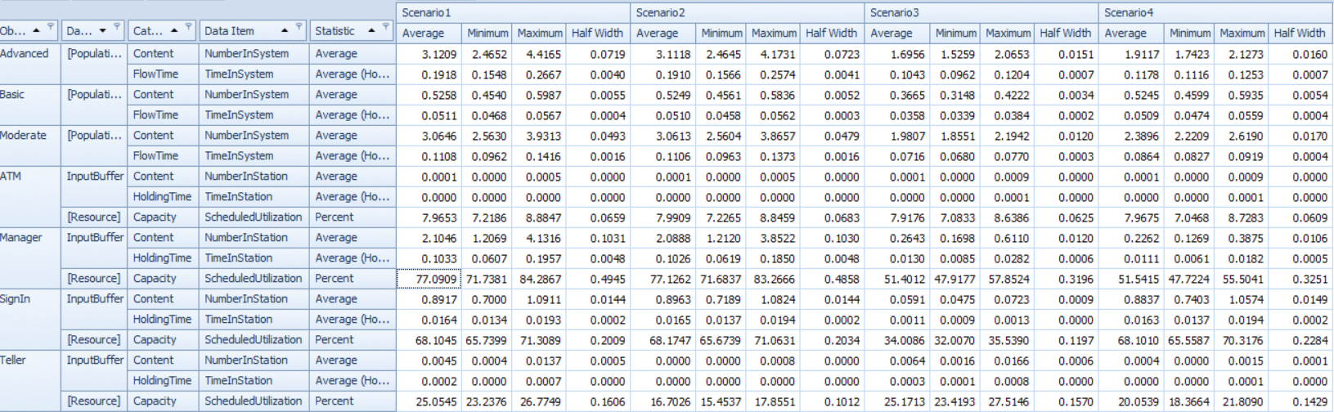

Table 5: Simulation Result of Four Scenarios

Scenario 2 is where extra 2 employees are hired for the Teller Stations. The expected result here is that the average busy time and the expected customer number will be less for the Teller server. After simulating this scenario, we can see that Teller and ATM have the lowest queue length along with the lowest waiting time, but the overall total waiting time and the total number of customers in the network did not decrease significantly. Whereas, the number of customer pressure and the waiting time in Manager rises. Also, the utilization factor of Manager is in this scenario is approximately 77%, Sign In is 68% and for the new recruitment, Teller remains less busy from the previous 25% to present 17%.

Scenario 3 is where an extra one employee is hired for Sign In position and another one for Manager position. We observed in the main scenario that, customer queue and waiting time were highest for Manager and Sign In Server. So, we added two employees at Teller, but the Manager server still faced the highest utilization factor. So, the expectation in this scenario is to equally distribute the customer over the network. Here, we get a balanced distribution for all the servers. The utilization factor is reduced for Manager and along with the total queue length and total waiting time. Sign In server also shows a reduced queue length and utilization factor. As there is one more employee for the Manager server, the number of customers in queue 0.2643 which is almost 87% less waiting customer when there is only 2 employees for the Manager server and also the average waiting time of the customer is 0.0130 which is also 87% less than the previous conditions. The number of customers in the queue in Sign In server is reduced by 93 percent and utilization factor is reduced from 68% to 34%.

Scenario 4 is where an extra one employee is hired for Teller and another one is for Manager position. In this condition average, busy time for Sign In server is highest, almost 68%. Also, the average waiting time in the system for Sign In server is highest among all. So, considering these numerical values, we can determine that, scenario 3 is best for this system.

The tables shown below describes the condition and response of the simulation experiment. The first table shows the scenarios and the second one shows responses for each scenario.

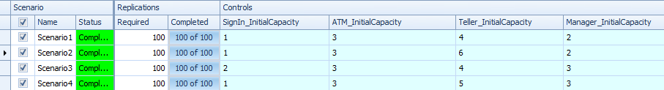

Table 6: Replication and Control of Experimental Setup

Table 7: Data of Responses for Four Scenarios

From the response table, we observed that the total average number of customers and the total average waiting time for the customers in the network is lowest for scenario 3 which are 4.04279 and 0.0746 (hours) respectively. We can also prove that using the SMORE plot. Scenario 3 provides the lowest mean with the lowest confidence intervals.

Figure 5: SMORE Plot of Average Waiting Time of Customer

When Scenario 1 and Scenario 2 are compared, scenario 2 has increased capacity in Teller station which had no significant effect on the overall network. For this reason, the total average waiting time is almost like these two scenarios. When Scenario 2 and Scenario 3 are compared, the capacity of Sign In and Manager is increased each by one which has a significant effect on the overall network. The total average waiting time for scenario 3 is the smallest and has a smaller confidence interval. When Scenario 3 and Scenario 4 are compared, one employee is moved from Sign In station to Teller station which causes the rise of total average waiting time in the network. This was obvious because Sign In station is much busier than Teller station. Hence compared to the above analysis, Scenario 3 is the best solution.

Figure 6: SMORE Plot of Total Average Customer in the System

Again, When Scenario 1 and Scenario 2 are compared, the capacity of Teller was increased by two in scenario 2. which had no significant effect on the overall network. For this reason, the total average number of customers is almost alike in these two scenarios. When Scenario 2 and Scenario 3 are compared, the capacity of Sign In and Manager were increased each by one which has a significant effect on the overall network. The total average number of customers for scenario 3 is the smallest and has a smaller confidence interval. When Scenario 3 and Scenario 4 are compared, one employee is moved from Sign In station to Teller station which causes the rise in the total average number of customers in the network. This was obvious because Sign In station is much busier than Teller station. Hence compared to the above analysis, Scenario 3 is the best solution.

Figure 7: SMORE Plot of average waiting time of Customers in ATM

From the above figure, we can observe that the average waiting time in ATM is similar for all the 4 scenarios. This is expected because ATM has the lowest waiting time and no new employees are assigned in the ATM server.

Figure 8: SMORE Plot of average waiting time of Customer in Teller

From figure 8, we can explain that the average waiting time of customers in Teller server is lower in scenario two and four. This is anticipated because 2 employees assigned in Teller for scenario 2 which causes the smallest average waiting of customer and one employee assigned in Teller for scenario 4 which causes 2nd lowest average waiting time of Customers.

Figure 9: SMORE Plot of average waiting time of Customer in Manager

From the above figure, we can see the average waiting time of customers in Manager server for scenario 1 & 2 is almost alike and scenario 3 & 4 is also the same. This is also likely because in scenarios 1 and 2 no additional employee appointed in this server. In scenarios 3 and 4, only one employee appointed each case.

1. CONCLUSIONS

In this project, we simulated a bank system. Here, we dealt with three types of customers and four servers. The bank wanted to hire two additional employees and we were directed to determine in which servers the new manpower will be suited to balance the system on the basis of the smallest number of customers in the network and smallest waiting time of a customer in the network. First, we established a simulation model, then we determined three Sign In time distributions for each type of customer. We referenced the source entity according to customer type and to the percentage of different customer types. Each server had its own system capacity and an exponential distribution of processing time with a different mean.

For the validation of the model in comparison to the theoretical value, we created separate Jackson Network for each type of customer. From that result, we observed that our simulation value is close to our theoretical value.

In the part of simulation analysis, we created three more scenarios, each scenario had different combinations of appointing two employees to different servers. Our determining factor was the average waiting time of a customer in a queue for each service option, the expected number of customers in the queue, expected time of a customer in the bank. We identified some issues regarding our main simulation scenario. For example, Sign In and Manager stations had the highest waiting time and the Manager station had high service time also. The utilization factor also resulted in a higher percentage of time of being engaged for Manager and Sign In server. Considering all these according to our data, the new recruitment should split up between these two servers.

Scenario two reduced pressure on Teller by adding two new employees to it, but it did not solve the traffic intensity on Manager and Sign In server. Scenario four was adding one person to Teller and another to Manager and it reduced pressure from Manager but not on from Sign In. Scenario three was the best scenario, according to our data. It added one to the Manager and another one to the Sign In. This one created a balanced scenario for this Bank system. The average waiting time of customers was reduced and the expected number of customers in the queue was also less for both Manager and Sign In. We also performed a similar plot, which indicated that scenario 3 is the most appropriate and efficient one for our data.

So, our recommendation will be to appoint one employee to the Manager station and another one to the Sign In station. Our focus for building the simulation model was visualizing the described experiment with different scenarios based on the total number of customers in the network and the average waiting time of customers. Our recommended scenario fulfills all the desired responses with the offered resources.

4 APENDIX

Input Data Analysis

* Sign In Distribution for Basic Customer

* A picture containing screenshot

  Description automatically generatedA screenshot of a cell phone

  Description automatically generatedSign In Distribution for Moderate Customer
* A screenshot of a video game

  Description automatically generatedA screenshot of a cell phone

  Description automatically generatedSign In distribution for Advanced Customer
* Service Time distribution for ATM

* A screenshot of a video game

  Description automatically generatedA screenshot of a cell phone

  Description automatically generatedService Time distribution for Teller
* Service Time distribution for Manager

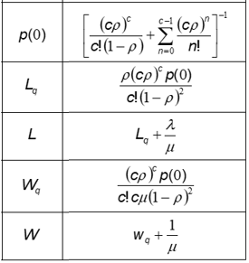Equations Used for data validation