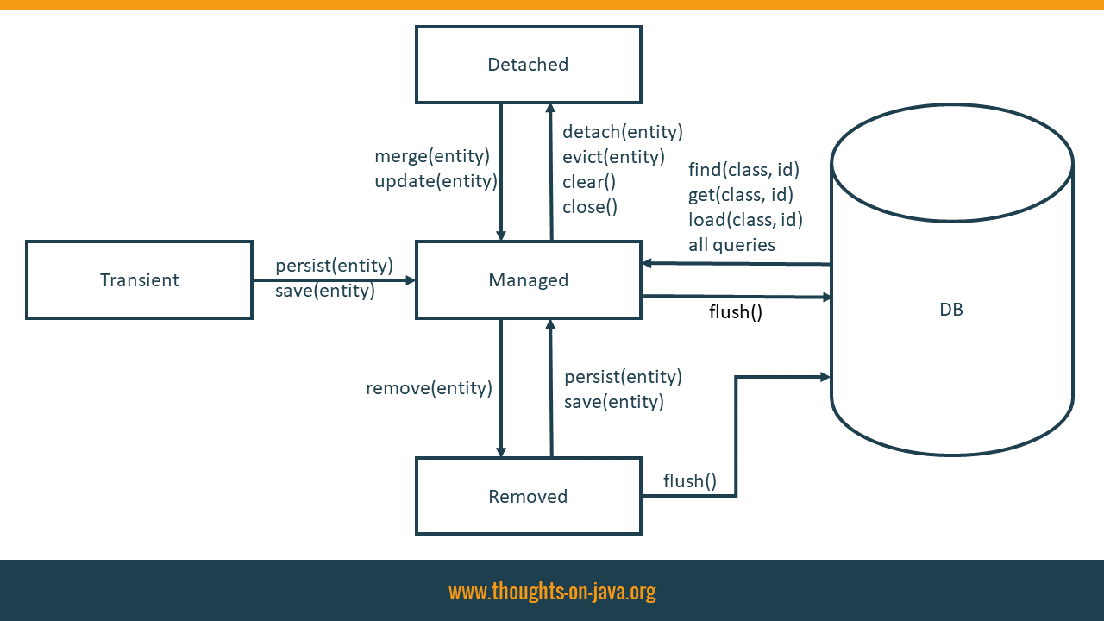https://www.thoughts-on-java.org/persist-save-merge-saveorupdate-whats-difference-one-use/

**The best way to map a @OneToMany relationship with JPA and Hibernate:**

<https://vladmihalcea.com/the-best-way-to-map-a-onetomany-association-with-jpa-and-hibernate/>

# [VLAD MIHALCEA](https://vladmihalcea.com/)

## **High-Performance Java Persistence and Hibernate**

https://vladmihalcea.com/