THE UNIVERSITY OF AZAD JAMMU AND KASHMIR, MUZAFFARABAD


COURSE TITLE | Database Systems
COURSE CODE | CS-2204
LAB TITLE | Open Ended Lab
STUDENT NAME | MAHDI ALI NAHVI
STUDENT ROLL NUMBER | 2024-SE-16
INSTRUCTOR NAME | Engr. Awais Rathore
SUBMISSION DATE | September 21, 2026
LAB NUMBER | 13

Task 1 — System Architecture & Entity-Relationship Design
CarGo Rentals needed to replace spreadsheet-based tracking of customers, vehicles, rentals, and payments with a relational database that prevents duplicate/inconsistent records and enforces the rule that a vehicle cannot be booked while it is already rented.

1.1 Entities Identified
- Customers — people who rent vehicles. Needs a unique identifier, contact details, and an identity document for verification.
- Vehicles — the fleet available for rent. Needs a plate number, model details, a daily rate, and a live availability status.
- Rentals — the transactional link between a customer and a vehicle for a period of time. This is the entity where the business rule (no double booking) must be enforced.
- Payments — money collected against a rental. Modeled separately from Rentals because a single rental may receive more than one payment (e.g., an advance and a final settlement).

1.2 Entity-Relationship Design
Relationships:
- Customers (1) — (N) Rentals: one customer can make many rentals over time.
- Vehicles (1) — (N) Rentals: one vehicle can be rented many times (at different, non-overlapping periods).
- Rentals (1) — (N) Payments: one rental can be settled through one or more payments.
Textual ER summary:
Customers (CustomerID PK)
|
| 1---N
v
Rentals (RentalID PK, CustomerID FK, VehicleID FK)
^
| N---1
|
Vehicles (VehicleID PK)
Rentals (1) ----N----> Payments (PaymentID PK, RentalID FK)

1.3 Key & Constraint Justification
Table | Primary Key | Foreign Key(s) | Key Constraints
Customers | CustomerID (surrogate, AUTO_INCREMENT) | — | Phone UNIQUE, CNIC UNIQUE, Email UNIQUE, NOT NULL on identifying fields
Vehicles | VehicleID (surrogate) | — | VehicleNumber UNIQUE, DailyRate CHECK (> 0), Status ENUM default 'Available'
Rentals | RentalID (surrogate) | CustomerID → Customers, VehicleID → Vehicles | CHECK (ScheduledReturnDate >= RentalDate); ON DELETE RESTRICT so a customer/vehicle with rental history cannot be silently deleted
Payments | PaymentID (surrogate) | RentalID → Rentals | AmountPaid CHECK (> 0); ON DELETE CASCADE so payments are cleaned up if a rental record is removed

A surrogate integer key (AUTO_INCREMENT) was used for every table instead of a natural key, because natural candidates such as phone number or vehicle number can change (a customer changes their number; a vehicle's plate can theoretically be reissued) — the surrogate key keeps foreign-key relationships stable. Natural keys are still protected using UNIQUE constraints so duplicate customers/vehicles cannot be inserted.
The core business rule — "a vehicle must not be available for another rental while it is currently rented" — is enforced redundantly at two levels for defense in depth: (1) a Vehicles.Status column that is only ever 'Available' or 'Rented' (or 'Maintenance'), and (2) a BEFORE INSERT trigger on Rentals (Task 5) that rejects any new rental row referencing a vehicle whose Status is not 'Available'. This means the rule holds even for direct SQL inserts that bypass application code.

Task 2 — Normalization (UNF → 1NF → 2NF → 3NF)
The company's original spreadsheet stored one flat record per rental:
RentalID | CustomerName | CustomerPhone | VehicleNumber | VehicleModel | DailyRate | RentalDate | ReturnDate | PaymentAmount
R001 | Ali Khan | 0300-1234567 | ABC-123 | Toyota Corolla | 5000 | 2026-09-01 | 2026-09-04 | 15000

2.1 Unnormalized Form (UNF)
This single-table structure mixes facts about four different real-world things — the rental event, the customer, the vehicle, and the payment — into one row. Every attribute is atomic here (no repeating groups), but the design is still unnormalized in the practical sense that it repeats customer and vehicle data across every rental row for the same customer/vehicle.

2.2 Functional Dependencies Identified
- RentalID → CustomerName, CustomerPhone, VehicleNumber, VehicleModel, DailyRate, RentalDate, ReturnDate, PaymentAmount
- CustomerPhone → CustomerName (a phone number identifies one customer)
- VehicleNumber → VehicleModel, DailyRate (a plate number identifies one vehicle and its rate)

2.3 First Normal Form (1NF)
Requirement: every attribute must hold a single atomic value, and rows must be uniquely identifiable — no repeating groups. The original structure already stores atomic values per column, so 1NF is satisfied by formally designating RentalID as the primary key of a single flat relation:
Rentals_1NF (RentalID PK, CustomerName, CustomerPhone, VehicleNumber,
VehicleModel, DailyRate, RentalDate, ReturnDate, PaymentAmount)
Anomalies still present at 1NF:
- Insertion anomaly: a new customer cannot be recorded until they actually make a rental (there is no rental-independent place to store customer data).
- Update anomaly: if Ali Khan's phone number changes, every historical rental row for Ali Khan must be updated, or the data becomes inconsistent.
- Deletion anomaly: deleting the only rental row for a customer erases all record that the customer ever existed.

2.4 Second Normal Form (2NF)
Requirement: the table must be in 1NF, and every non-key attribute must depend on the whole primary key, not part of it. Because RentalID here is a single-column key (not composite), there is no partial-dependency violation to remove mechanically — but CustomerPhone → CustomerName and VehicleNumber → VehicleModel, DailyRate are dependencies on non-key attributes, which is really a transitive-dependency problem carried into 2NF. To move meaningfully toward a well-structured design, we separate out the entities whose attributes depend on something other than RentalID:
Customers_2NF (CustomerPhone PK, CustomerName)
Vehicles_2NF (VehicleNumber PK, VehicleModel, DailyRate)
Rentals_2NF (RentalID PK, CustomerPhone FK, VehicleNumber FK,
RentalDate, ReturnDate, PaymentAmount)
Anomalies resolved at 2NF: customer and vehicle data can now be inserted independently of a rental (fixes the insertion anomaly), and each customer's name / each vehicle's rate is stored exactly once (fixes the earlier update anomaly for those attributes).
Anomalies still present: PaymentAmount is functionally dependent on the rental period and the vehicle's DailyRate (PaymentAmount ≈ DailyRate × number of days), not purely on RentalID as an independent fact — a transitive dependency that 3NF addresses, and using CustomerPhone as a natural key is fragile if a customer's number changes.

2.5 Third Normal Form (3NF)
Requirement: the table must be in 2NF, and no non-key attribute may depend transitively on the primary key through another non-key attribute. We finalize the design by (a) replacing natural keys with surrogate IDs for stability, and (b) separating Payments from Rentals, since PaymentAmount is a fact about a payment event, not an intrinsic attribute of the rental row itself:
Customers_3NF (CustomerID PK, CustomerName, CustomerPhone UNIQUE, ...)
Vehicles_3NF (VehicleID PK, VehicleNumber UNIQUE, VehicleModel, DailyRate, Status)
Rentals_3NF (RentalID PK, CustomerID FK, VehicleID FK,
RentalDate, ScheduledReturnDate, ActualReturnDate, TotalAmount)
Payments_3NF (PaymentID PK, RentalID FK, PaymentDate, AmountPaid, PaymentMethod)
Anomalies resolved at 3NF: TotalAmount is stored once per rental as a computed/recorded fact rather than being tangled with vehicle rate updates; a vehicle's DailyRate can change over time without corrupting historical rental charges, since Rentals stores the rate/amount that applied at the time; and payments can be added, refunded, or split across multiple transactions without touching the Rentals row. This 3NF structure is exactly what was implemented in car_rental.sql.

Task 3 — SQL JOIN Queries

Query 1 — INNER JOIN: Rental Details

Business question: customer name, vehicle number, vehicle model, rental date, and return date for every rental.
SELECT c.FullName AS CustomerName, v.VehicleNumber, v.Model AS VehicleModel,
r.RentalDate, r.ActualReturnDate AS ReturnDate
FROM Rentals r
INNER JOIN Customers c ON r.CustomerID = c.CustomerID
INNER JOIN Vehicles v ON r.VehicleID = v.VehicleID
ORDER BY r.RentalDate;
Expected result: one row per rental (5 rows in the sample data), with NULL in ReturnDate for rentals that are still active.
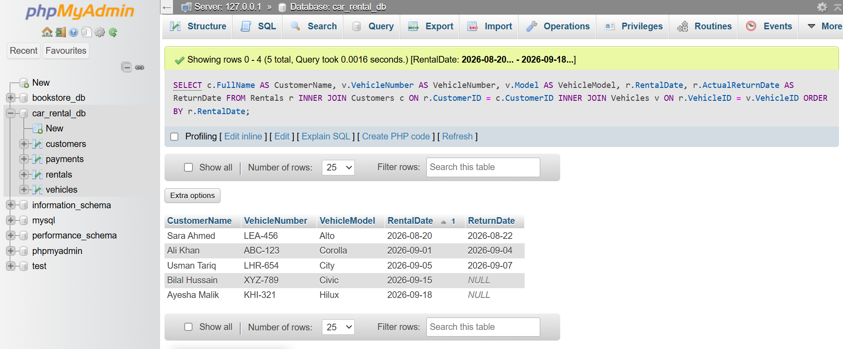

Query 2 — LEFT JOIN: Customers and Their Rentals
Business question: all customers and the vehicles they have rented, including customers who have never rented.
SELECT c.CustomerID, c.FullName, v.VehicleNumber, v.Model AS VehicleModel, r.RentalDate
FROM Customers c
LEFT JOIN Rentals r ON c.CustomerID = r.CustomerID
LEFT JOIN Vehicles v ON r.VehicleID = v.VehicleID
ORDER BY c.FullName;
Expected result: every customer appears at least once; a customer with no rentals would show NULLs for VehicleNumber, VehicleModel, and RentalDate.
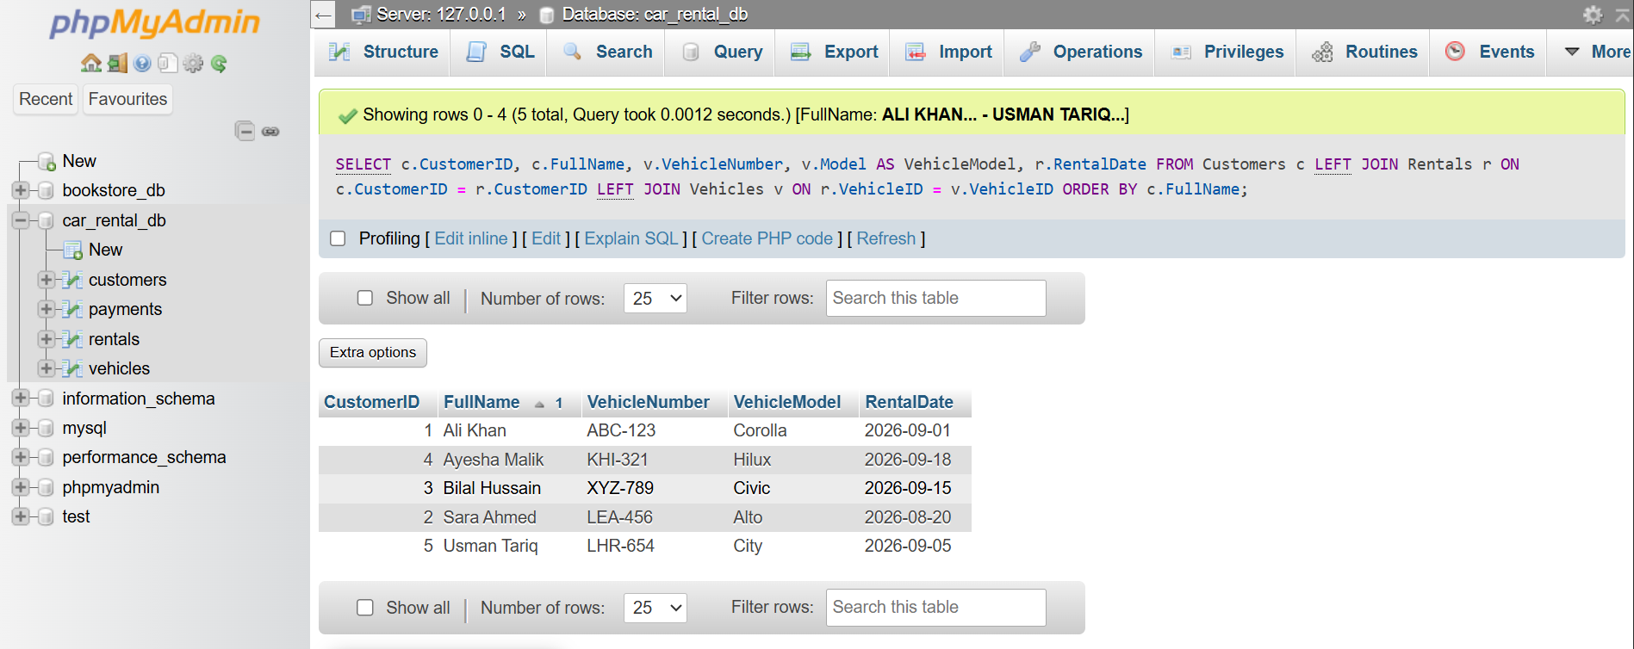

Query 3 — LEFT JOIN: Vehicles and Current Rental Info
Business question: all vehicles and their current rental info, including vehicles that are not currently rented.
SELECT v.VehicleID, v.VehicleNumber, v.Model AS VehicleModel, v.Status AS VehicleStatus,
c.FullName AS CurrentRenter, r.RentalDate, r.ScheduledReturnDate
FROM Vehicles v
LEFT JOIN Rentals r ON v.VehicleID = r.VehicleID AND r.RentalStatus = 'Active'
LEFT JOIN Customers c ON r.CustomerID = c.CustomerID
ORDER BY v.VehicleNumber;
Expected result: every vehicle appears; vehicles that are Available show NULL for CurrentRenter and the rental dates.
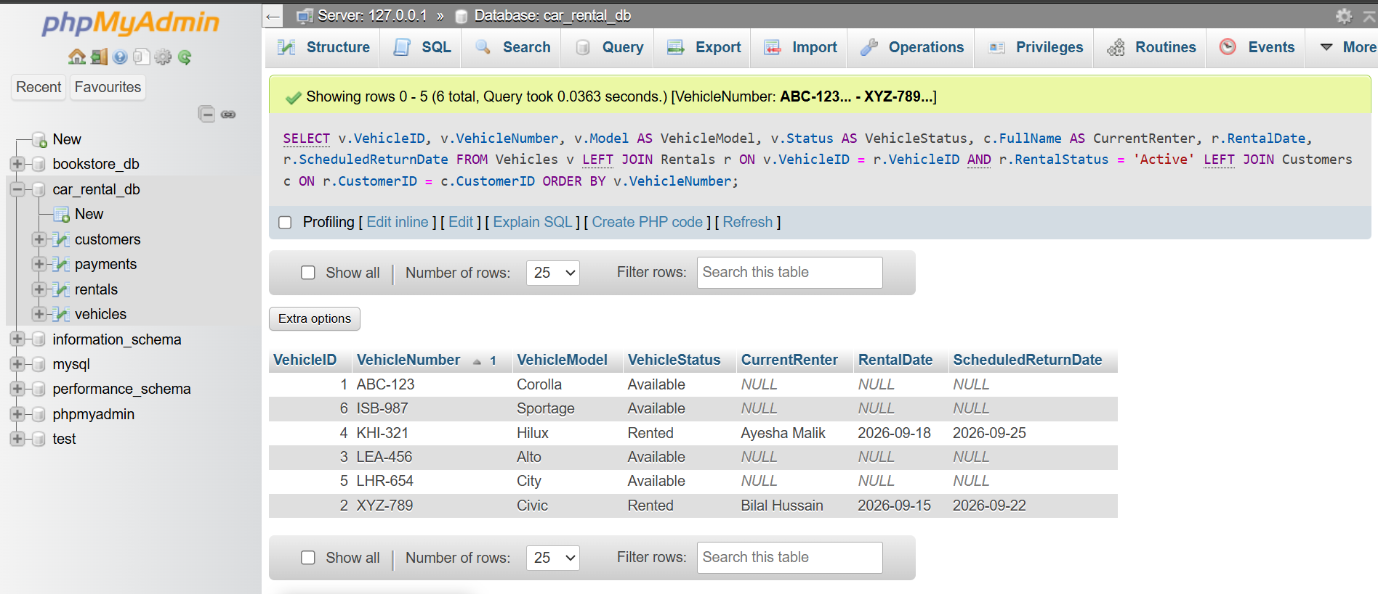

Query 4 — LEFT JOIN + GROUP BY + COUNT: Rentals per Customer
Business question: total number of rentals made by each customer, including customers with zero rentals.
SELECT c.CustomerID, c.FullName, COUNT(r.RentalID) AS TotalRentals
FROM Customers c
LEFT JOIN Rentals r ON c.CustomerID = r.CustomerID
GROUP BY c.CustomerID, c.FullName
ORDER BY TotalRentals DESC;
Expected result: every customer appears exactly once; COUNT(r.RentalID) (not COUNT(*)) correctly returns 0 for customers with no matching rental rows, since COUNT of a column ignores NULLs produced by the LEFT JOIN.
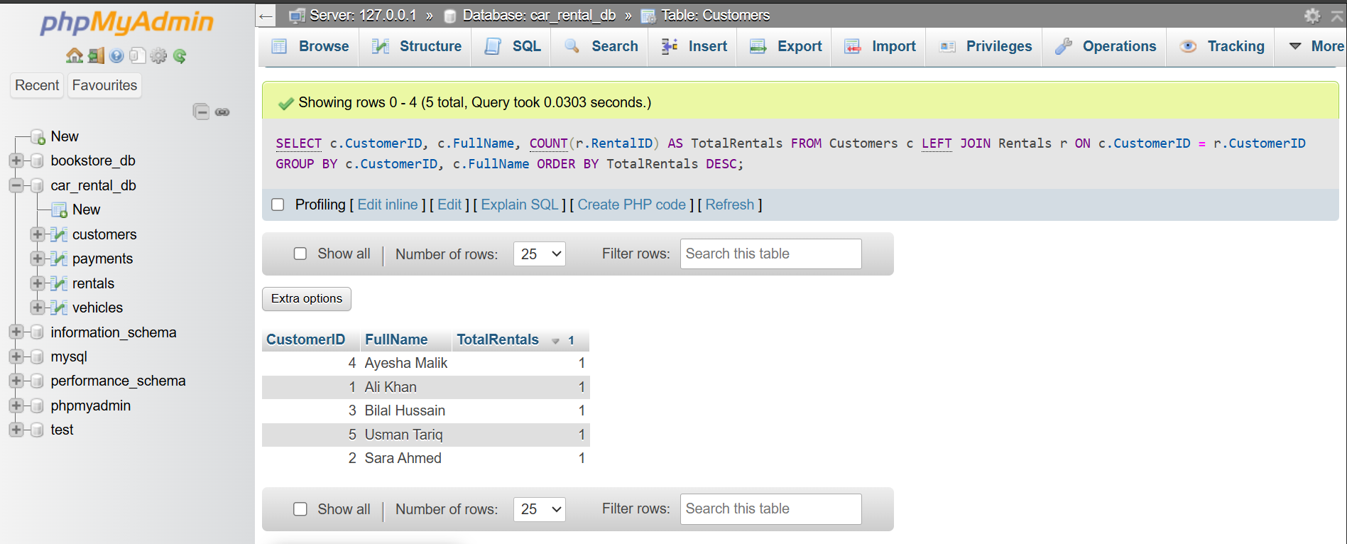

Task 4 — View: vw_consolidated_rental_report
CREATE OR REPLACE VIEW vw_consolidated_rental_report AS
SELECT r.RentalID, c.CustomerID, c.FullName AS CustomerName, c.Phone AS CustomerPhone,
v.VehicleID, v.VehicleNumber, v.Model AS VehicleModel, v.DailyRate,
r.RentalDate, r.ScheduledReturnDate, r.ActualReturnDate, r.RentalStatus,
r.TotalAmount, COALESCE(SUM(p.AmountPaid), 0) AS TotalPaid,
r.TotalAmount - COALESCE(SUM(p.AmountPaid), 0) AS BalanceDue
FROM Rentals r
JOIN Customers c ON r.CustomerID = c.CustomerID
JOIN Vehicles v ON r.VehicleID = v.VehicleID
LEFT JOIN Payments p ON r.RentalID = p.RentalID
GROUP BY r.RentalID, c.CustomerID, c.FullName, c.Phone, v.VehicleID,
v.VehicleNumber, v.Model, v.DailyRate, r.RentalDate,
r.ScheduledReturnDate, r.ActualReturnDate, r.RentalStatus, r.TotalAmount;
SELECT * FROM vw_consolidated_rental_report ORDER BY RentalID;

Business Justification
This view collapses a four-table join (Customers, Vehicles, Rentals, Payments) into one queryable object, so staff can pull a full rental summary — including how much has been paid and what balance is outstanding — without writing SQL each time. It is also safe to expose to a reporting/BI tool or a junior staff member's read-only account, since it hides the base-table structure while still surfacing exactly the fields management needs for customer history, vehicle usage, and outstanding-balance reports.
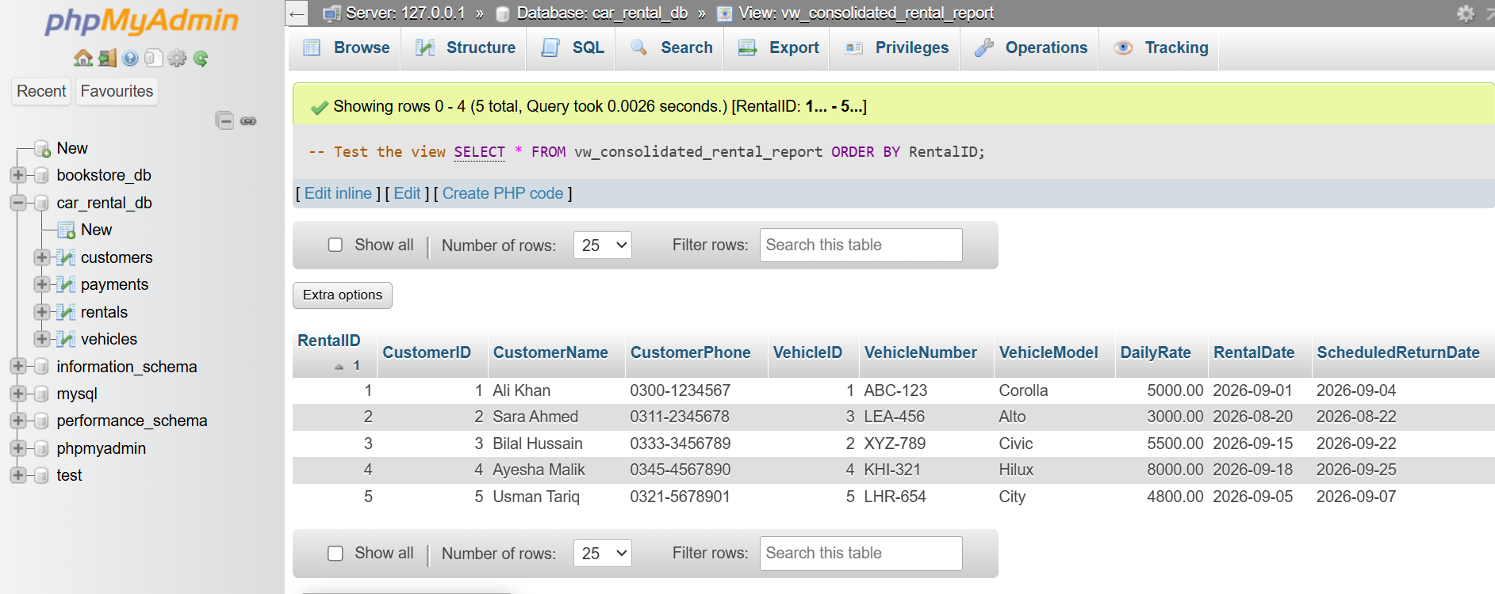

Task 5 — Trigger
Two complementary triggers enforce and automate the vehicle-availability rule.

trg_check_vehicle_availability (BEFORE INSERT)
CREATE TRIGGER trg_check_vehicle_availability
BEFORE INSERT ON Rentals
FOR EACH ROW
BEGIN
DECLARE v_status VARCHAR(20);
SELECT Status INTO v_status FROM Vehicles WHERE VehicleID = NEW.VehicleID;
IF v_status = 'Rented' THEN
SIGNAL SQLSTATE '45000'
SET MESSAGE_TEXT = 'Booking rejected: this vehicle is already rented.';
ELSEIF v_status = 'Maintenance' THEN
SIGNAL SQLSTATE '45000'
SET MESSAGE_TEXT = 'Booking rejected: this vehicle is under maintenance.';
END IF;
END;

trg_update_vehicle_status (AFTER INSERT / AFTER UPDATE)
A second pair of triggers keeps Vehicles.Status accurate automatically: AFTER INSERT ON Rentals sets the vehicle to 'Rented', and AFTER UPDATE ON Rentals detects when ActualReturnDate is newly filled in and flips the vehicle back to 'Available' while marking the rental 'Completed'.

Justification
Enforcing this rule as a database trigger (rather than only in application code) guarantees the no-double-booking rule holds no matter which client or script writes to the database, and keeps Vehicles.Status trustworthy for every other query and report without any manual bookkeeping.

Testing
Test 1 (should fail): attempting to insert a new rental for a vehicle whose Status is already 'Rented' raises a custom SQL error and the row is not inserted.
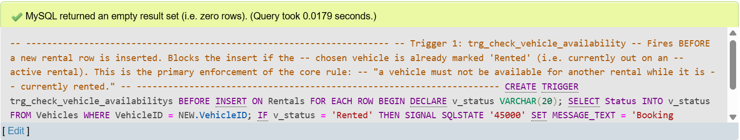
Test 2 (should succeed): inserting a rental for an 'Available' vehicle succeeds, and a follow-up SELECT on Vehicles shows Status has automatically changed to 'Rented'.
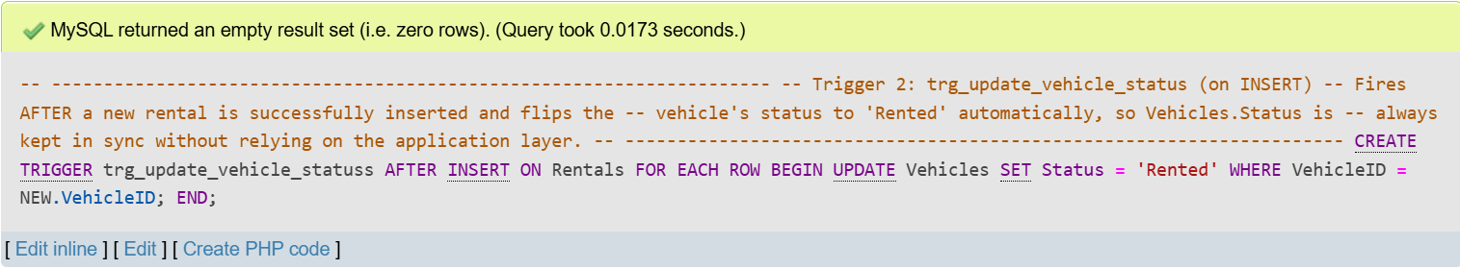

Test 3: updating ActualReturnDate on an active rental flips the vehicle's Status back to 'Available'.
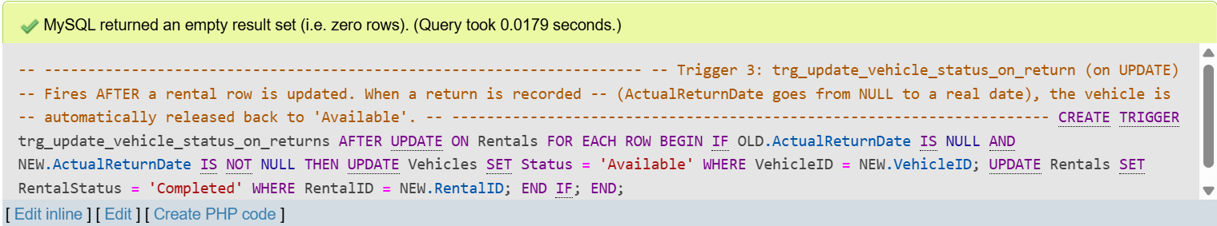

Task 6 — Stored Procedure: sp_register_rental
CREATE PROCEDURE sp_register_rental (
IN p_CustomerID INT, IN p_VehicleID INT,
IN p_RentalDate DATE, IN p_ScheduledReturnDate DATE,
IN p_PaymentMethod VARCHAR(20),
OUT p_RentalID INT, OUT p_TotalAmount DECIMAL(10,2)
)
sp_body: BEGIN
DECLARE v_status VARCHAR(20);
DECLARE v_dailyRate DECIMAL(10,2);
DECLARE v_days INT;
SELECT Status, DailyRate INTO v_status, v_dailyRate
FROM Vehicles WHERE VehicleID = p_VehicleID;
IF v_status IS NULL THEN
SIGNAL SQLSTATE '45000' SET MESSAGE_TEXT = 'Vehicle does not exist.';
END IF;
IF v_status <> 'Available' THEN
SIGNAL SQLSTATE '45000' SET MESSAGE_TEXT = 'Vehicle is not available for rental.';
END IF;
SET v_days = GREATEST(DATEDIFF(p_ScheduledReturnDate, p_RentalDate), 1);
SET p_TotalAmount = v_days * v_dailyRate;
INSERT INTO Rentals (CustomerID, VehicleID, RentalDate, ScheduledReturnDate,
DailyRateApplied, TotalAmount, RentalStatus)
VALUES (p_CustomerID, p_VehicleID, p_RentalDate, p_ScheduledReturnDate,
v_dailyRate, p_TotalAmount, 'Active');
SET p_RentalID = LAST_INSERT_ID();
INSERT INTO Payments (RentalID, PaymentDate, AmountPaid, PaymentMethod, PaymentStatus)
VALUES (p_RentalID, CURRENT_DATE, p_TotalAmount, p_PaymentMethod, 'Completed');
END;

Test Invocation
CALL sp_register_rental(1, 3, '2026-09-20', '2026-09-23', 'Card', @newRentalID, @newTotal);
SELECT @newRentalID AS NewRentalID, @newTotal AS TotalCharged;
With DailyRate = 3000.00 for Vehicle 3 (Suzuki Alto) and a 3-day rental (2026-09-20 to 2026-09-23), the procedure is expected to compute TotalAmount = 3 × 3000.00 = 9000.00, insert one Rentals row and one Payments row, and — because trg_check_vehicle_availability and trg_update_vehicle_status fire on that insert — automatically flip Vehicle 3's Status to 'Rented'.
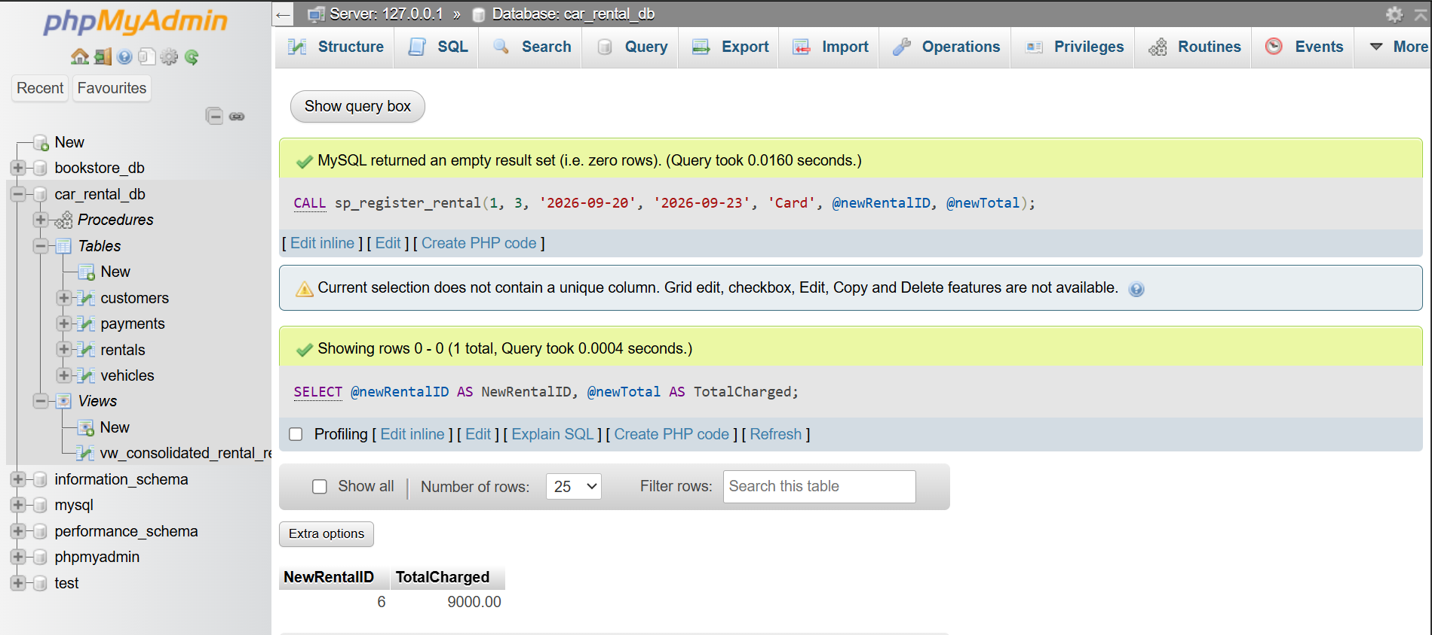
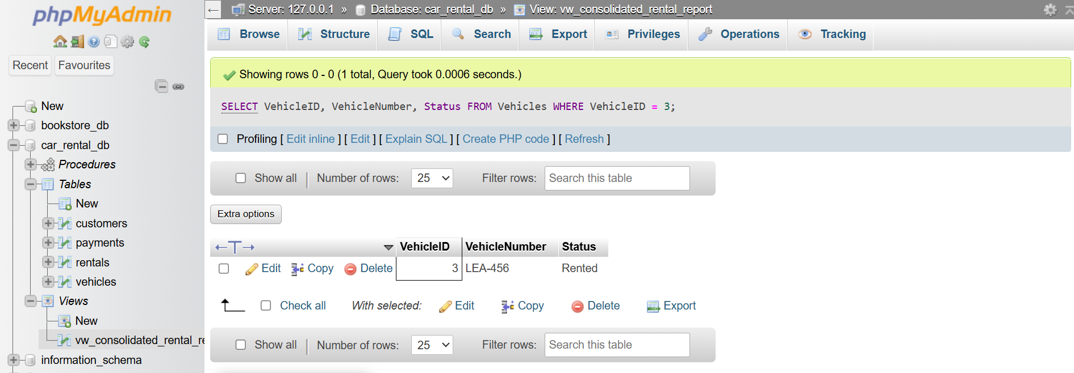

Task 7 — Optimization Analysis

7.1 Inefficiency Identified
Availability checks and reporting queries repeatedly filter Rentals by (VehicleID, RentalStatus) — for example, "is this vehicle currently active?" — and by date ranges on RentalDate. Beyond the automatic index MySQL/InnoDB places on a foreign key column itself, there was no composite index covering the (VehicleID, RentalStatus) pair, nor an index supporting date-range filtering or CustomerID lookups.

7.2 Performance / Consistency Impact
- Without a composite index, MySQL must scan every row of Rentals to find active rentals for a given vehicle, an operation that runs on every single Rentals INSERT via trg_check_vehicle_availability.
- As rental history grows into the thousands of rows, this scan cost grows linearly, slowing down bookings, JOIN Query 3, and the consolidated report view.
- A slower availability check also widens the time window in which two near-simultaneous booking requests could both read a stale 'Available' status before either write completes, increasing the practical risk of a double-booking race condition.

7.3 Proposed Improvement
Add a composite index on Rentals(VehicleID, RentalStatus) so the availability check becomes a direct index lookup instead of a full table scan, plus supporting indexes on CustomerID (customer-history queries) and RentalDate (date-range reports), and an index on Payments(RentalID) to speed up the view's join.
CREATE INDEX idx_rentals_vehicle_status ON Rentals (VehicleID, RentalStatus);
CREATE INDEX idx_rentals_customer ON Rentals (CustomerID);
CREATE INDEX idx_rentals_rentaldate ON Rentals (RentalDate);
CREATE INDEX idx_payments_rentalid ON Payments (RentalID);

7.4 EXPLAIN Analysis
Before the index existed, EXPLAIN on the availability check reported type = ALL against the Rentals table (a full table scan across all rows). After creating idx_rentals_vehicle_status, the same query is expected to report type = ref, using idx_rentals_vehicle_status as the key, examining only the small number of rows matching that VehicleID instead of the entire table.
EXPLAIN SELECT * FROM Rentals WHERE VehicleID = 2 AND RentalStatus = 'Active';

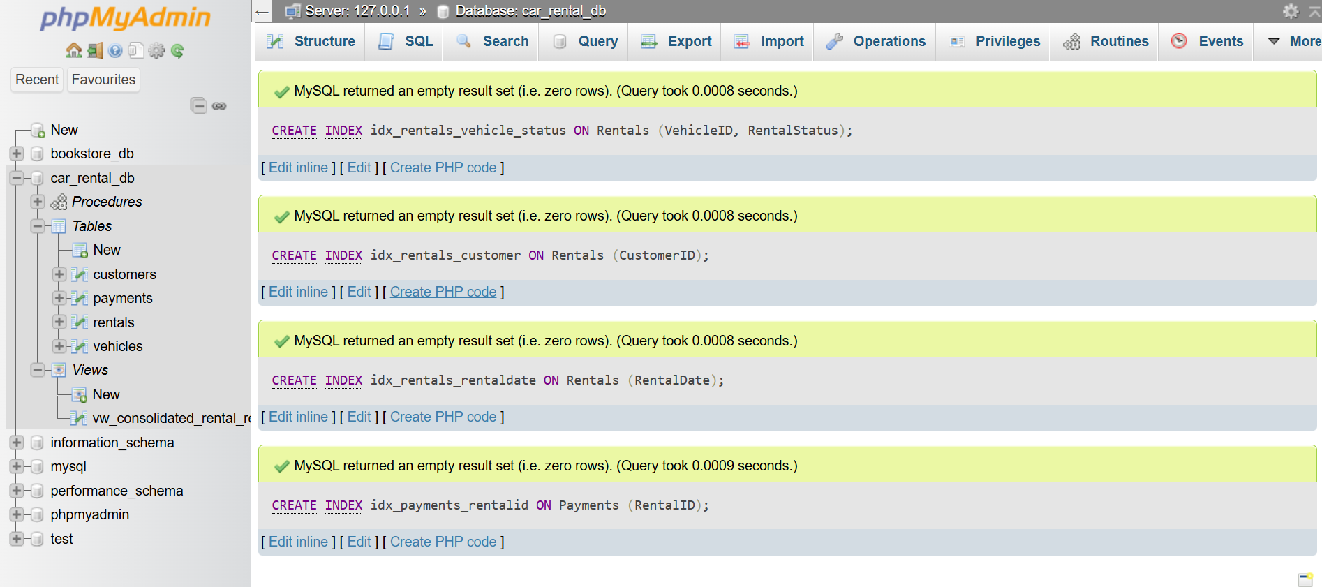

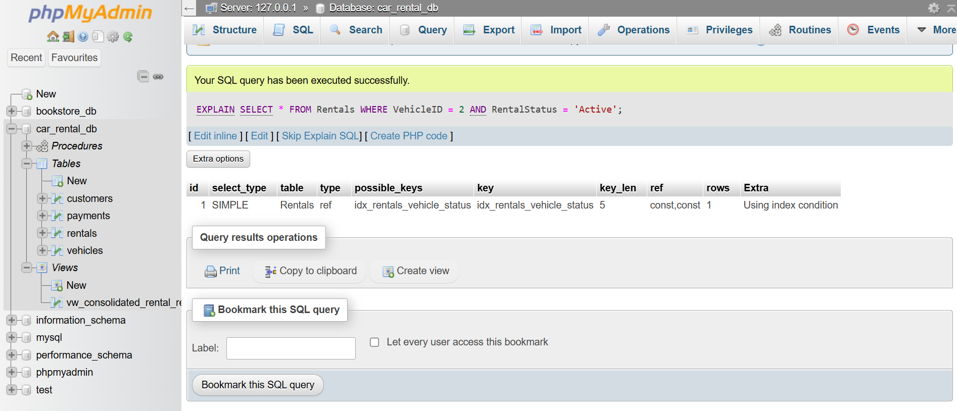

7.5 Conclusion
This targeted indexing strategy directly addresses the query patterns the application actually runs — the availability check enforced by the trigger, and the reporting joins used throughout the system — trading a small amount of extra storage and slightly slower writes for a much faster and more consistent read path, which matters most for a rule (no double-booking) that must be checked on every single rental insert.

