Home page:

Consult houses (landlord and student)

Receive requests (landlord)

Accept or deny (landlord)

house management:

consult his own houses (landlord)

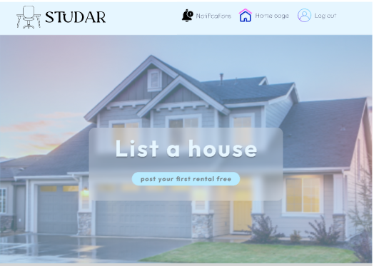(doesn’t have any listing)

(does have some listings)

Add a listing (landlord)

Consult details and delete (landlord)

Update (landlord)

searching roommates:

consult roommates and delete ad (student)

Add an ad (student)

Contact (student)

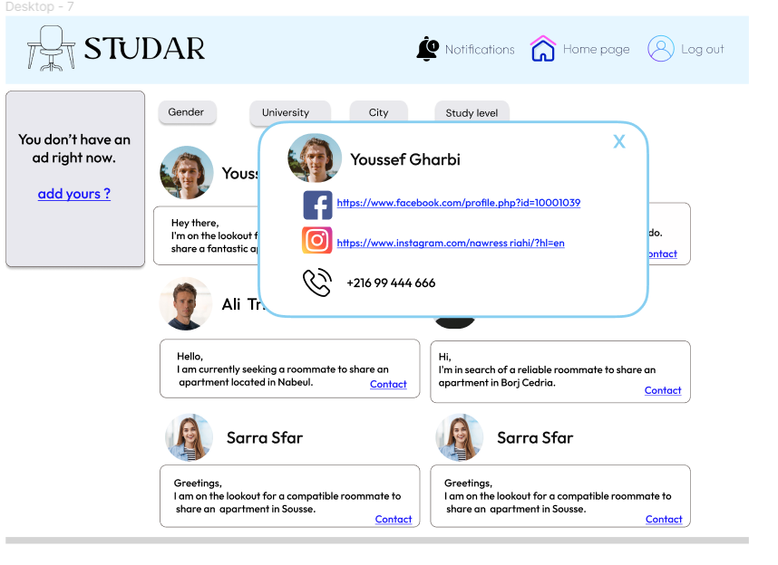

Consulting a house:

consult house details (student)

Send request (student)

