The CVIP Algorithm Test and Analysis Tool Manual and Program Layout

By; Wenjun (Evan) Bian (2006)
&
Seher Pelin Guvenc
Directed By; Dr. Scott E. Umbaugh

ECE Department
Southern Illinois University Edwardsville

Spring 2010
Table of Contents

1. Overview 2
1.1 Infrastructure 3
1.2 The GUI 3
2. Running CVIP-ATAT 11
3. Creating a New Project 12
4. Opening an Existing Project 14
5. Inserting Images 15
6. Inputting an Algorithm 21
7. Testing an Algorithm 24
8. Comparing Images 26
9. Feature Extraction (Under Construction) 30
10. Pattern Classification (Under Construction) 32
11. Saving the Project 34
12. Closing the Project 35
13. The Database 36
14. How to Add New Functions to the Project? (new section) 37
15. Adding and Testing Algorithm 2 from the Paper: “Comparison of Two Algorithms in the Automatic Segmentation of Blood Vessels in Fundus Images” (new section) 43

Overview
Image analysis is an important component for both Computer Vision and Image Processing; however, testing and analyzing images is a time-consuming and energy-consuming task. The tool, Automatic CVIP (Computer Vision and Image Processing) Algorithm Test and Analysis Tool (CVIP-ATAT), was designed to speed up the process of searching specific and/or generic algorithms for image processing and computer vision applications.
In Section 1.1, the infrastructure of the tool will be introduced followed by the description of the GUI (graphical user interface) in Section 1.2.

1.1 Infrastructure
CVIP-ATAT is composed of three layers. The top layer is the Graphical User Interface (GUI) which was developed using C# .NET 2005. The middle COM layer is a communication layer which was also developed using C++ .NET 2005. The bottom layer consists of the CVIPTools C Functions Libraries, which was developed using C++ .NET 2005（see Figure 1.). The GUI is in charge of the input and output images as well as the displaying of the analysis results. The COM layer is the connection between the GUI and CVIPTools C Function Libraries. The CVIPTools C Function Libraries consist of all image and data processing procedures and functions.

1.2 The GUI
The GUI of CVIP-ATAT is composed of seven interfaces: the main interface, the image input interface, the algorithm interface, the test interface, the image comparison interface, the image feature extraction interface and the pattern classification interface.
Top GUI Layer
(Input, Output and Result Display)
(Visual studio C# .NET 2005)
Middle COM Layer
(Communication Layer)
（Visual studio C++.NET 2005）

Bottom C Functions Libraries Layer
(Image Data Processing)
（Visual studio C++.NET 2005）

Input

Output

Figure 1. CVIP-ATAT Infrastructure

- The main interface is used to control all the other interfaces. It is located in the file named MDIMainForm.cs under the CVIP_ATAT project. Included under the file is the design and implementation of the main interface. Here the programmer can add or remove menu options to the menu toolbar if necessary using the designer view of the file and the user can start by selecting the options that are necessary. Figure 2. shows how the main interface GUI (graphical user interface) looks like.

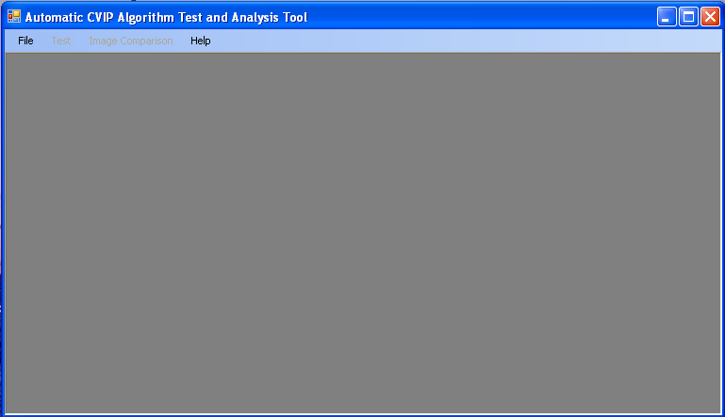
Figure 2. – The Main Interface

- The image interface is for the user to input the image(s). It is located under the file CVIPATATForm.cs along with the design and implementation parts. The interface is shown in Figure 3. In this interface the user can add images; they may be test or training images depending on the user. The user can also add ideal images corresponding to the original images. Deletion of selected and/or all images is also an option in the interface. The For Pattern Classification button allows the user to specify the type of image added, the class name of the object and the coordinates of the object to identify the position within the image. Though if not necessary this option may not be used at all.

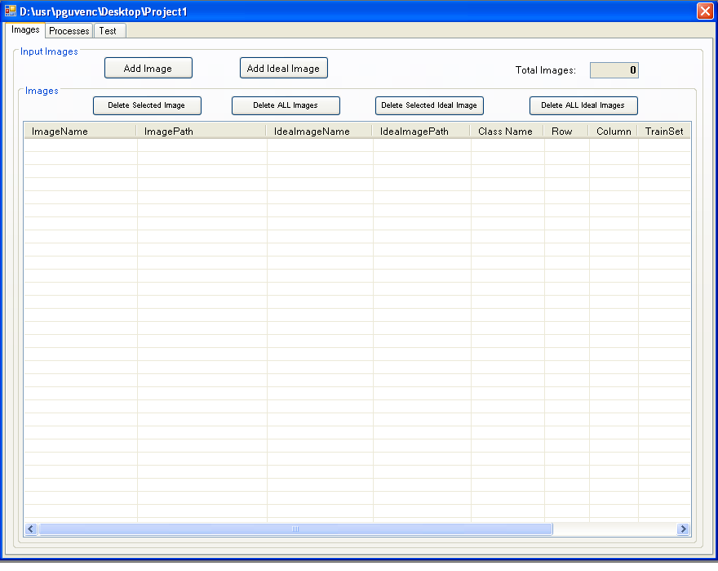
Figure 3. – The Image Interface

- The algorithm interface is for the user to define and insert the algorithms which will be tested. This interface is also located in the file CVIPATATForm.cs. The option for adding functions is located under the Processes tab of the window. Here the user can select functions to create his/her algorithm to test on the inserted images. More detail about inserting functions is explained in section 6 - Inputting an Algorithm. The user also has the chance of deleting selected processes or even all processes at once.
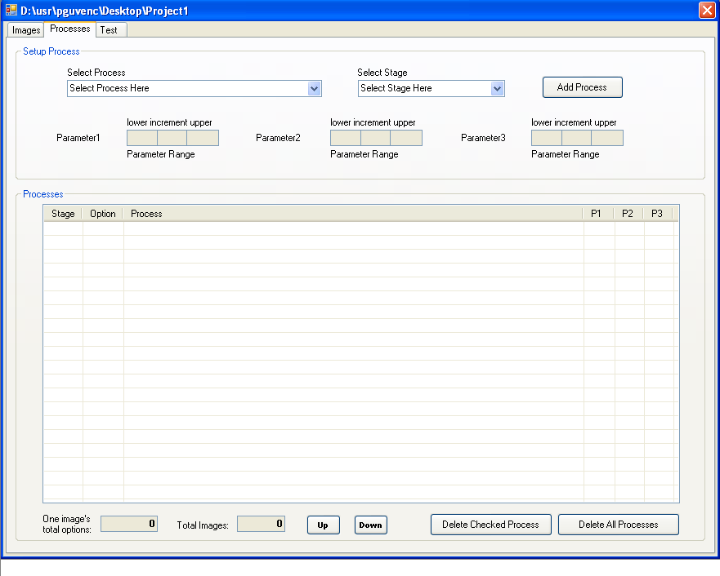
Figure 4. – The Algorithm Interface

- The test interface is for the user to run the test and display the test results. This interface can be found in the file CVIPATATForm.cs under the Test tab of the design view. Here the user can run the algorithm created in the algorithm interface and can also pause the running program at any time. The user also has the option of stopping the program which aborts the process. After the algorithm has finished running the resultant images are displayed in the table below. More detail will be explained in section 7 - Testing an Algorithm. The view of the test interface is shown in Figure 5.

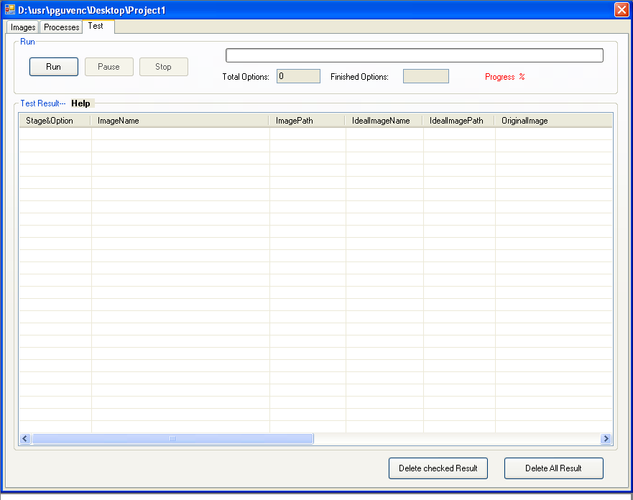
Figure 5. – The Test Interface

- The image comparison interface is for the user to compare images according to certain methods such as Root-Mean-Square (RMS) Error, Signal-to-Noise Ratio (SNR), Subtraction Energy and the Logical XOR. This interface is located under the file CompareForm.cs. The user can also view the analysis results after the comparison has been done in the table located below the comparison options. Figure 6 shows the layout of the image comparison GUI. The Comparison Interface also contains an Algorithm Comparison tab. This part of the tool compares algorithms according to the average numerical comparison results obtained from the Image Comparison Interface.

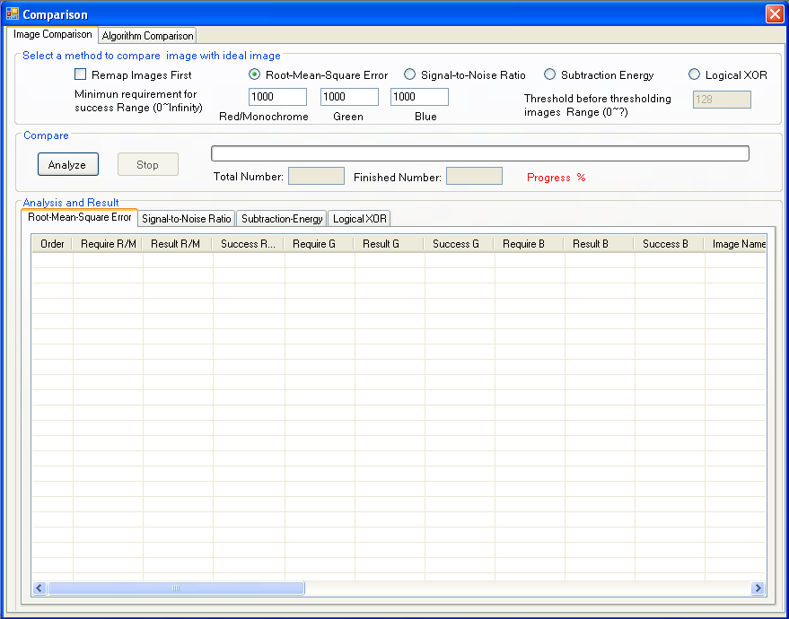
Figure 6. – The Image Comparison Interface
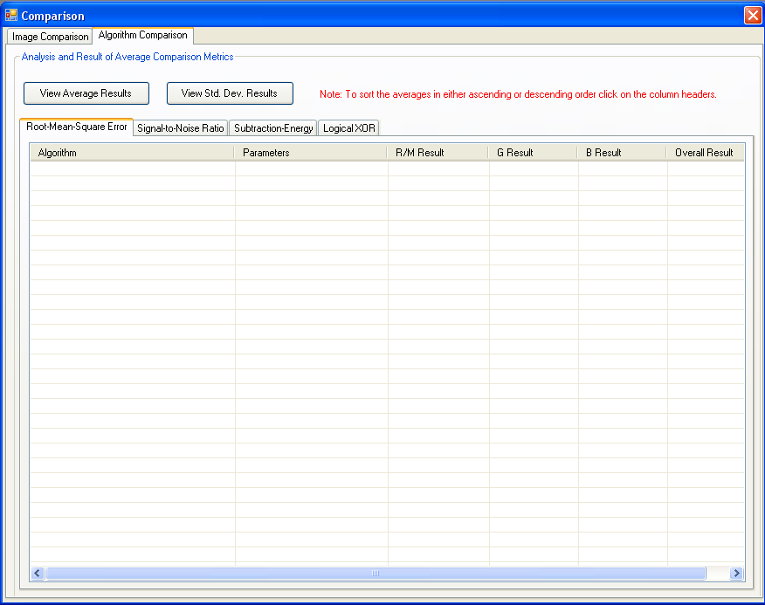
Figure 7. – The Algorithm Comparison Interface

(Under Construction)
- The image feature extraction interface is for the user to extract image features. These features are; binary object features, RST-invariant moment-based features, histogram features, texture features and spectral features. The results of feature extraction can be viewed in this window as well. This interface is located under the file FeatureForm.cs. The image feature extraction interface is shown in Figure 7.

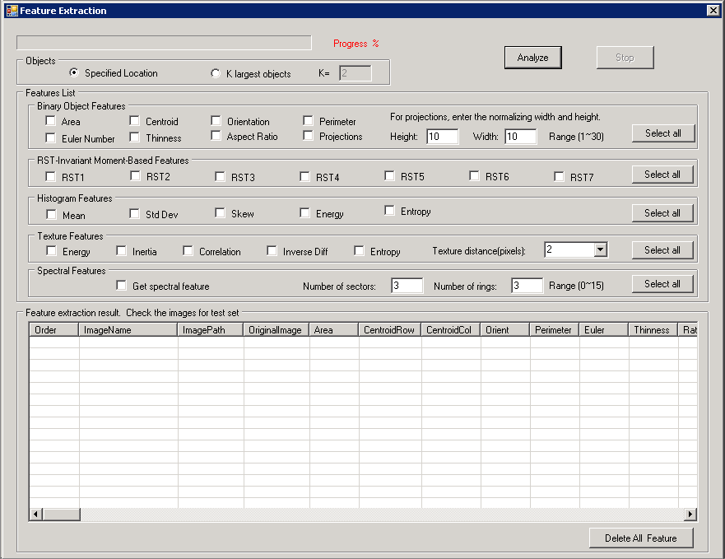
Figure 8. – The Feature Extraction Interface

(Under Construction)
- The pattern classification interface is for the user to classify patterns within the image. It contains options for data normalization, distance and similarity measures and classification algorithms. The user can also view the results of the pattern classification. This interface is located in the file PatternCForm.cs. Figure 8 shows the pattern classification interface.

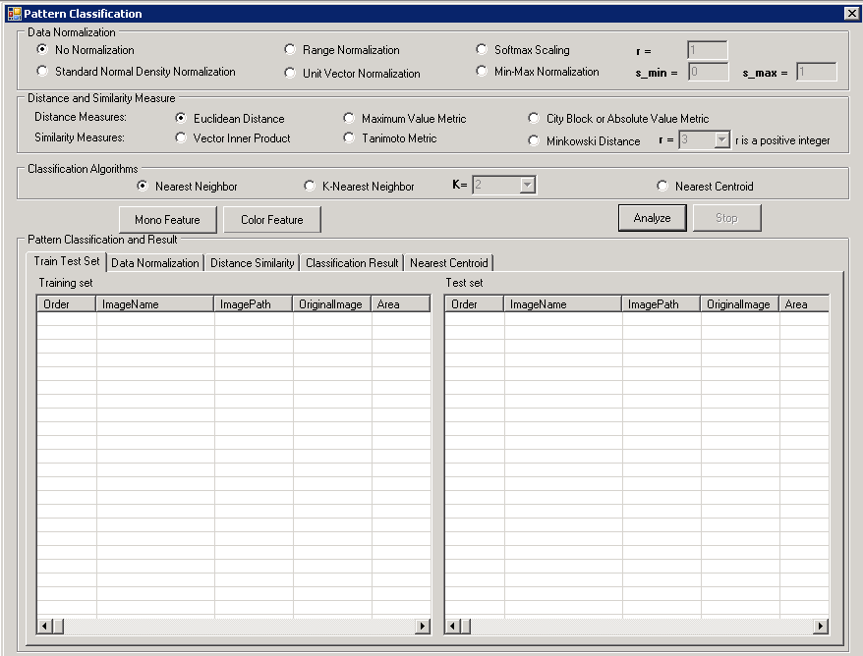
Figure 9. – The Pattern Classification Interface

2. Running CVIP-ATAT
In order to run CVIP-ATAT, two files are required: CVIP-ATAT.exe and CVIPtools.dll. The GUI is implemented in file CVIP-ATAT.exe. All C functions for image analysis and processing are implemented in file CVIPtools.dll, which is invoked by CVIP-ATAT.exe. These two files have to be in the same folder. In order to run the tool, you just need to simply double-click file CVIP-ATAT.exe.
Though the file path settings change each time you copy the directory of the project from one computer to another and the program does not work due to these changes. It gives an error about the SERVERLib. In order to get the program running again you need to register the .dll (dynamic link library) file again. In order to do so, the user needs to open a command prompt window and type in the line regsvr32 cvipxxx.dll where the .dll file is located at. Sometimes the user may need to remove the SERVERLib references from the project references and re-add it to make sure that it is referring to the correct .dll.

3. Creating a New Project
A new project should be created to hold the images that will be tested and analyzed. Different projects can be created to hold different types of images; however, just one project can be opened at one time. In order to create a new project, the following steps should be followed:
- Select File from the menu toolbar and then select New Project to open the New Project dialog box. See Figure 10 (first step) and Figure 11 (second step).
- In the New Project dialog box, type in a directory for your new project or use the Browse button to select a directory in which you wish your project to be.
- In the New Project dialog box, you should also provide a name for your new project. Note that the tool will create a new folder whose name will be identical with your project name and which will hold all of the files related to your new project.
- Press the OK button in the New Project dialog box to complete the creation of your new project. You still can cancel the creation simply by pressing the Cancel button.

The interface of your newly created project will look just like the one in Figure 3 which was mentioned above in the Image Interface section.

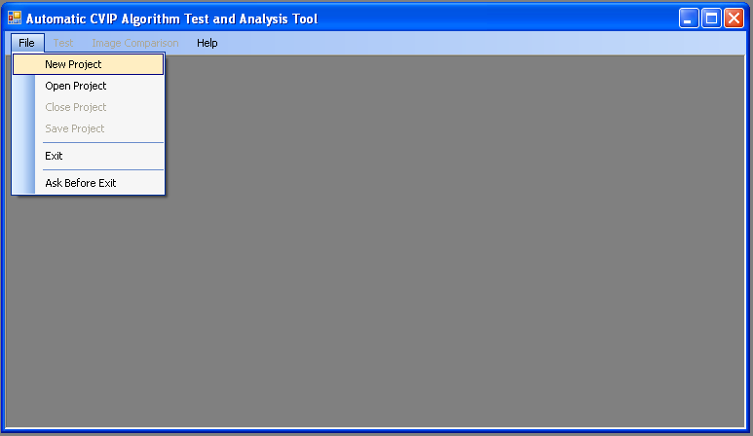
Figure 10. – Creating a new project (step one).

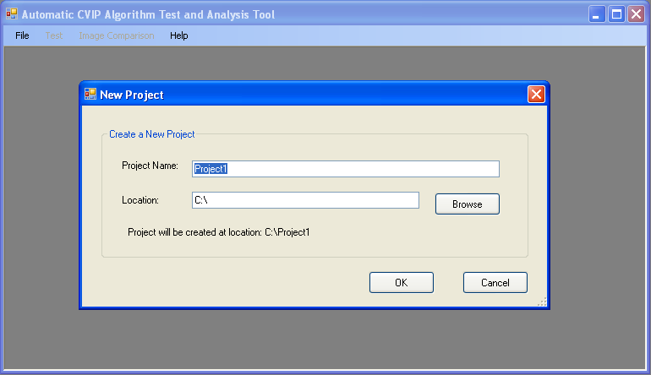
Figure 11. – Creating a new project (step two)

4. Opening an Existing Project
Apply the following steps in order to open an existing project;
- Select File from the menu toolbar and from there select Open Project from the main menu to open the Open Project dialog box. See Figure 12 (first step) and Figure 13 (second step). Note that if a project has been opened, then it must be closed before opening another project.

- Select the project you want to open. To open a project means opening its configuration file: CVIPconfg.cfg.

- Click the Open button in the Open Project dialog to open the project or you can double click on the CVIPconfg.cfg file as well. Click on the Cancel button to cancel the opening.

The interface of an opened file may look like the one in Figure 14. You should be able to see all of your images that you had added before and when you click on the Processes tab you should be able to see your algorithm that you created and in the Test tab you should be able to see your resultant images, unless you hadn’t deleted them before.

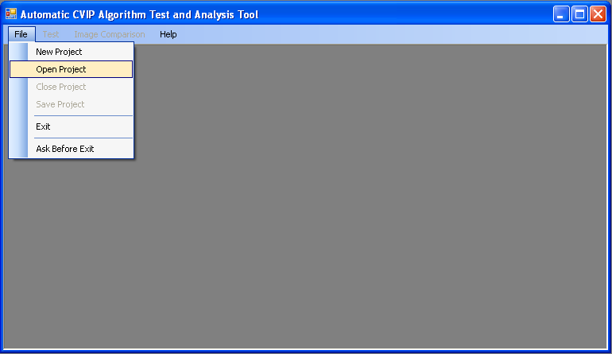
Figure 12. – Opening an existing project (step one)

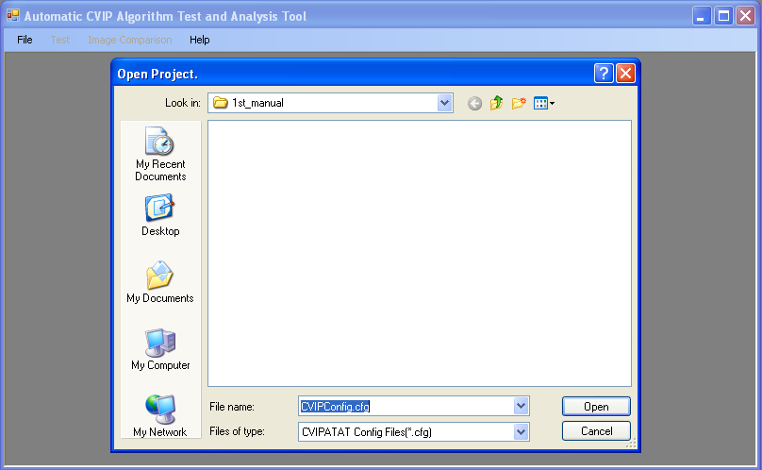
Figure 13. – Opening an existing project (step two)

5. Inserting Images
After creating a new project, the user can import images in the image interface. After opening an existing project, the user can add more images or delete some images for retesting. In order to add or delete images, the user should apply the following steps:
- The image input interface is one of the three tab pages shown in Figure 14. If the image interface has not been selected, click on the Images tab in Figure 14 to open it by clicking on the mouse left key.

- Click the Add Image button to add original images. After clicking the Add Image button, an Add Image dialog will appear as shown in Figure 14. The user can add a single original image or multiple original images at one time. If the user wants to add multiple original images, the Ctrl key should be held down, while using the mouse to select several images.

- Since ideal images should match the added original images, the user cannot add ideal images if no original images exist. So in order to add ideal images first of all the user should select the original images that need ideal images by using the Ctrl key and mouse left key to choose them from the original images list table. Then click the Add Ideal Image button to open the dialog for adding ideal images. At last, choose the ideal image. An ideal image can be matched to several original images at one time.

- The user can delete all of the original images (including the ideal images) by clicking the Delete ALL Images button or delete some of the original images by clicking the Delete Selected Image button. When the user wants to delete some of the original images, the original images that will be deleted should be selected first by holding down the Ctrl key and mouse left key.

- If user just wants to delete the ideal images only, the Delete Selected Ideal Image and the Delete ALL Ideal Images buttons can be used to do so.

Figure 15 illustrates how the image interface should look like after the insertion of the images is complete.

Notes:
The original images are used for testing and the resultant images (output images of the original images) are compared with the ideal images if there exists any; however, the ideal images must match the resultant images. It means that the ideal images and their corresponding resultant images must have the same bands and size with regard to the Logical XOR, Subtraction Energy, Signal-to-Noise Ratio (SNR) and Root-Mean-Square (RMS) Error comparisons.

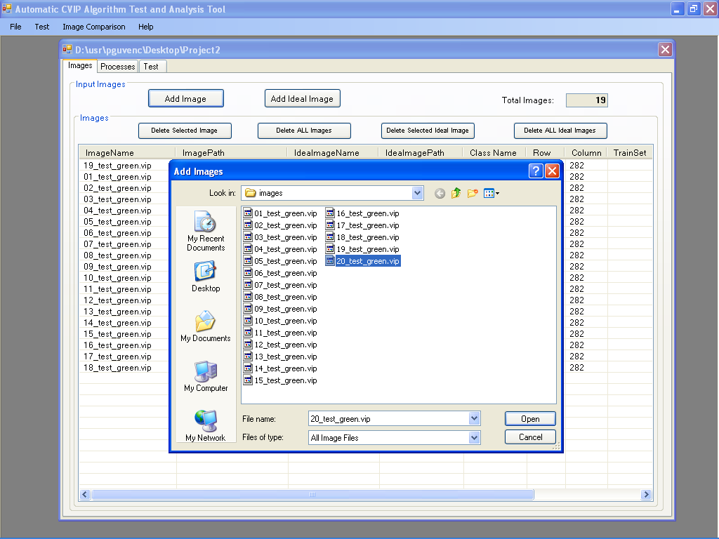
Figure 14. - Window for adding images.

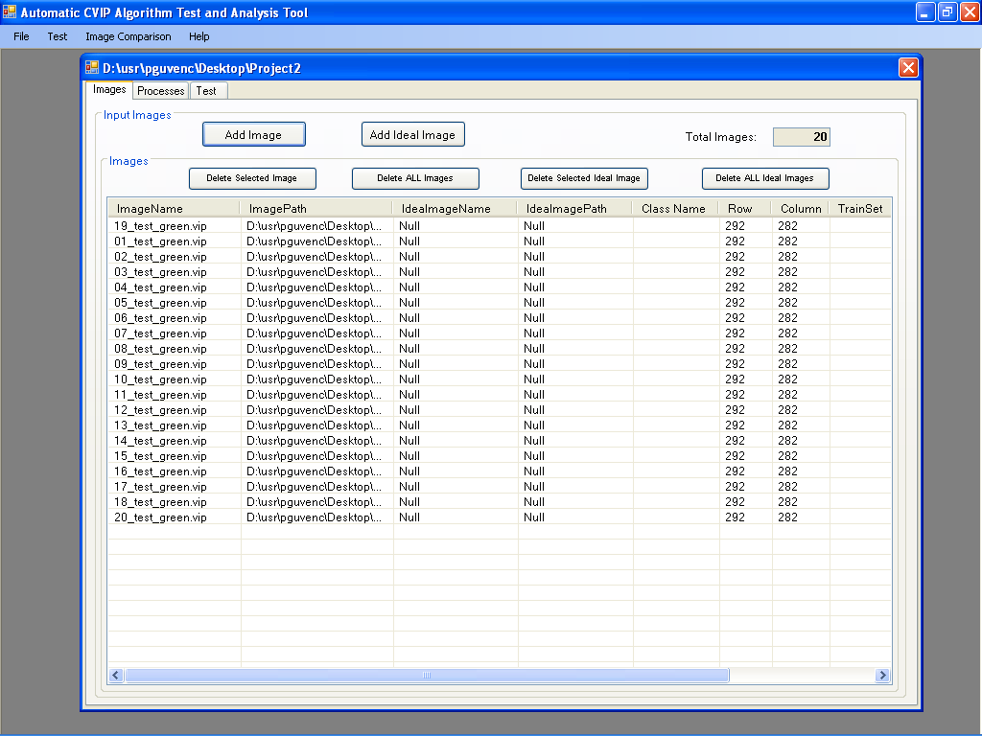
Figure 15. – After insertion of the images are complete.

- After the original images have been inserted in order for comparing the results at the end of the process the ideal images need to be inserted as well. In order to do so the user must click on an original image in the list in which he/she wants to add in the corresponding ideal image then click on the Add Ideal Image button. A window showing the image folders will appear and the user can select which image to insert as an ideal image to compare with the resultant images later on. This process is done one by one. The ideal images cannot be selected all at once like the original images. Each time the user should click on an original image and add the corresponding ideal image. This part of the software is being developed in such a way that it would be possible to add all corresponding ideal images at once.
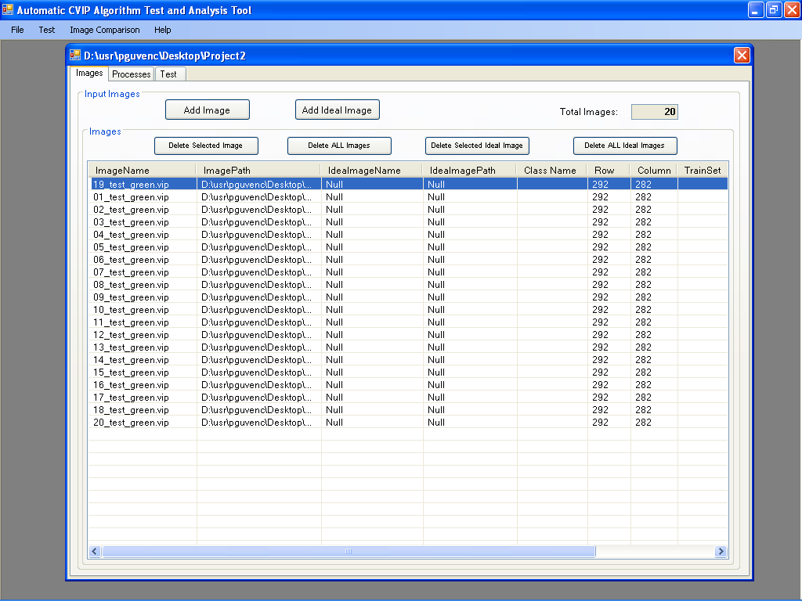
Figure 16. – Inserting Ideal Images.

- When inserting the “ideal” images one must not forget that the resultant images, obtained at the end of running the algorithm(s), must have the same number of bands as the ideal images do otherwise the comparison will not work since in order to compare 2 images the number of bands must match. This is also true for the image sizes, though since the CVIP – ATAT does not contain a resizing operator the size of the resultant image and the ideal images will be the same.
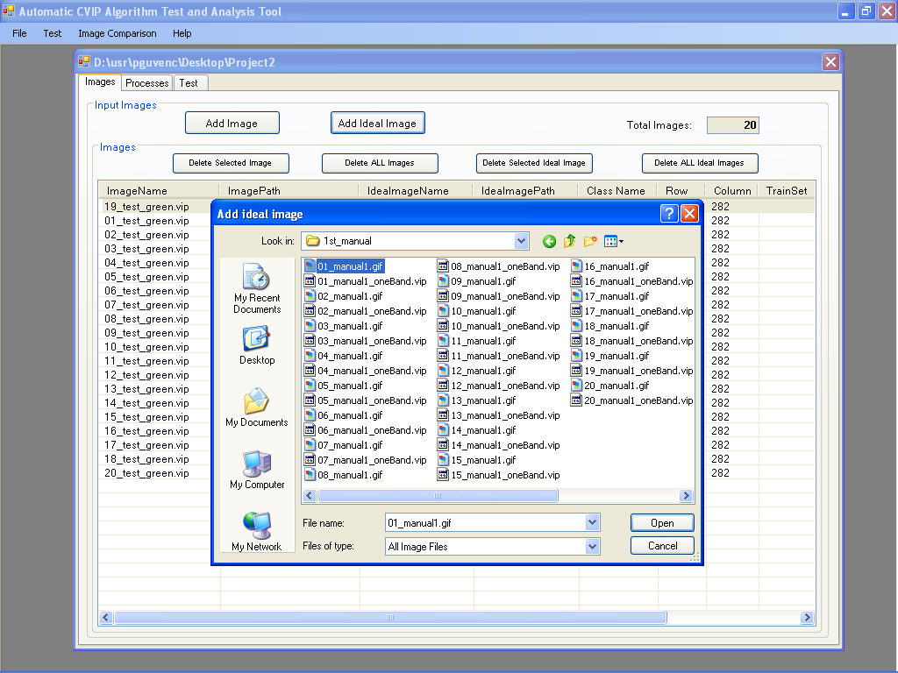
Figure 17. – Inserting ideal images.
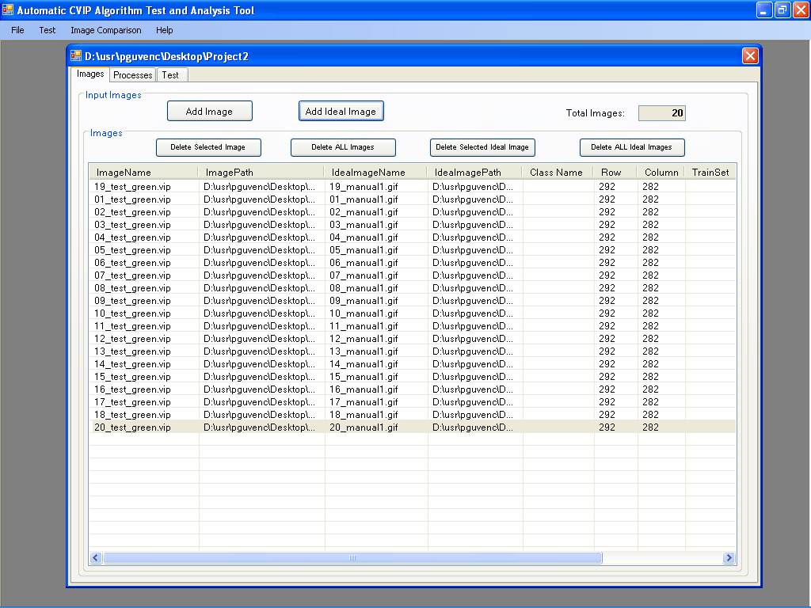
Figure 18. – After the insertion of the ideal images is complete.

6. Inputting an Algorithm
The user can input algorithms that will be tested on the images using the algorithm input interface. The algorithm input interface is shown in Figure 19. In order to input an algorithm, the user should apply the following steps:
- The algorithm input interface is one of the three tab pages shown in Figure 16. If the algorithm input interface has not been selected, click on the Processes tab shown in Figure 16 to open it clicking on the mouse left key.
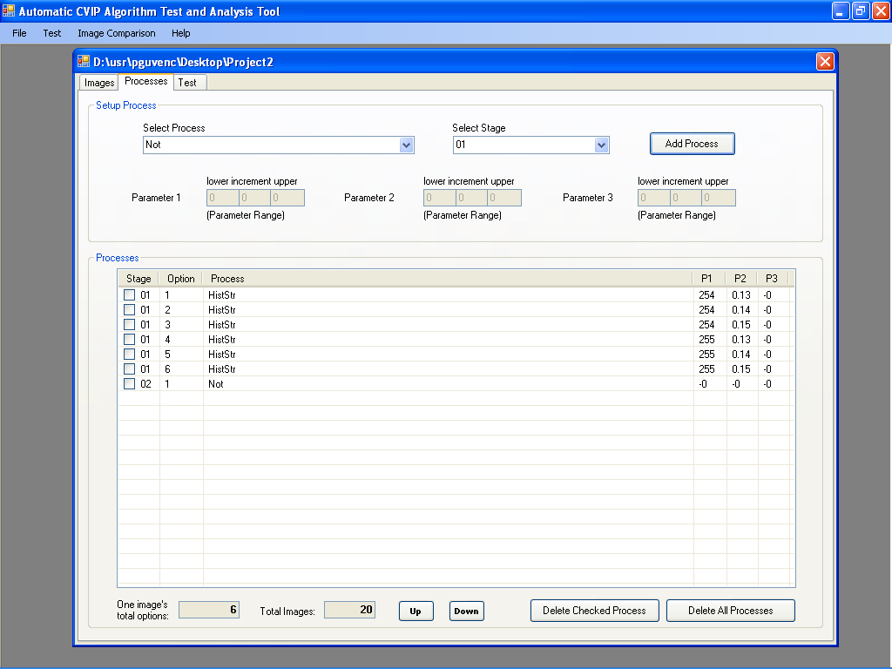
Figure 19. – The algorithm input interface after some functions have been added.

- The user can select an algorithm through the ComboBox named Select Processes. After an algorithm is selected, the user can adjust the parameters for that algorithm. Figure 17 displays how an algorithm can be selected.

- The user has to specify a stage for every algorithm through the ComboBox named Select Stage. Notice that the image testing process can be broken down into several stages and more than one algorithm can be applied for each stage. If the user tends to insert two processes into one stage, then when the program is run it goes through the processes in order. So if there are 4 options of one process and 5 options of another process and these two processes are inserted into one stage then the program runs 9 (5+4) options. But if the user tends to put the process with 4 options into stage 1 and the process with 5 options into stage 2 or vice versa then the program runs 20 (4x5) options. So it runs a combination of the processes. With this functionality the user is able to test all possible parameter combinations in one run.

- The user may need to adjust the parameters’ values of every process. If a parameter’s lower value is 1, increment value is 2 and upper value is 5, then the value for this parameter could be 1, 3 or 5. Because of this, there could be more than one option for each process. Or the user can use all of the possible parameter values by inserting the possible low and high values of that specific process.

- After selecting the process and its stage, the user needs to click on the Add Process button to add the selected process and its stage into the Processes list table. Though when inserting a process into a stage the user must be careful to put the stages into order without skipping any stage. For example without a stage 3 the user can not insert a process into stage 4.

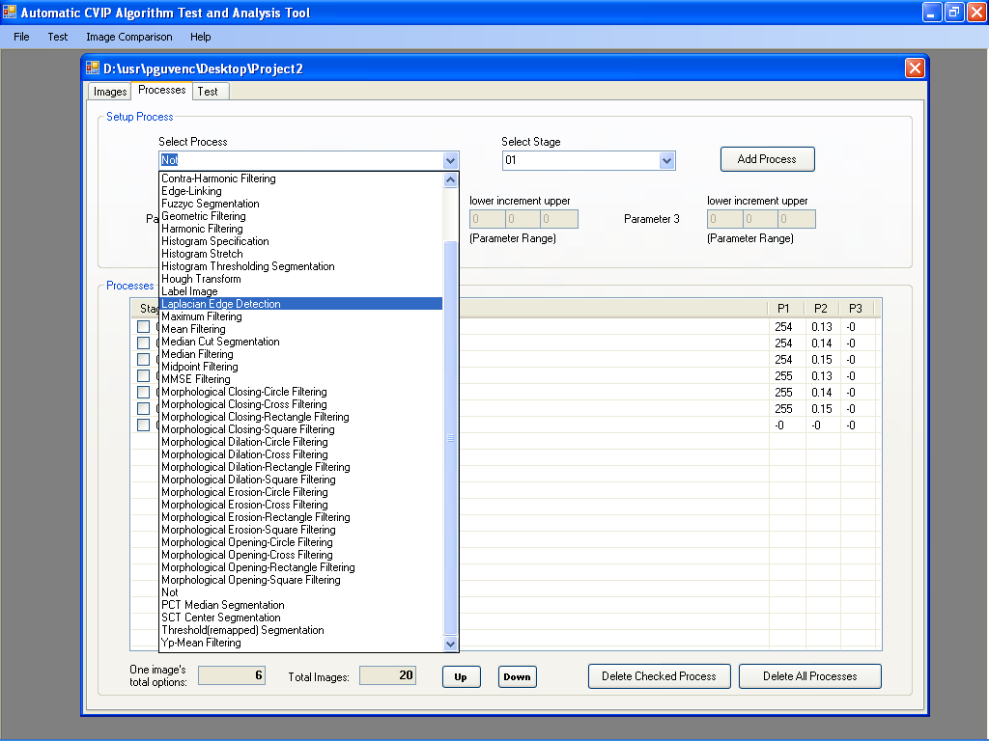
Figure 18. – Selecting an algorithm from the ComboBox.

- The user can repeat steps 3, 4 and 5 until all of the required processes have been selected.

- The user can delete one or multiple processes listed in the list table easily by checking them using the mouse left key, then by clicking on the Delete Checked Process button.

- If the user wants to delete all of the processes in the list table, he/she just needs to click on the Delete ALL Process button.

- The user can also adjust the order of the processes in the list table by selecting one of the processes and then moving it by clicking on the Up button or the Down button.

- The number of images which the algorithm will be tested on and the number of options for one image are displayed at the bottom of the algorithm input interface.

7. Testing an Algorithm
The test interface (see Figure 18) is used to test algorithms on images and display the test results. The following steps should be followed:
- The testing interface is one of the three tab pages shown in Figure 18. If the test interface is not selected, click the Test tab shown in Figure 18 to open it clicking on the mouse left key. Since the user has not yet ran the algorithm the list below, which holds the resultant images, is empty.

- In order to test the algorithm the user needs to click on the Run button. Then all of the selected algorithms will be tested on all of the selected images automatically. This process may take days or even weeks depending on the number of options there are to complete the task. Having the project compute the processes in parallel is an option in reducing the amount of time to complete the task. Though in order to have the project work in parallel modifications should be made in the implementation of the program which can be done in the future.

- During the test, a progress bar is used to display the progress and below it the percentage of the progress is displayed.

- Because of the multi-thread technique, the user can pause or stop the test process at any time by clicking on the Stop or Pause button. After the Pause button is clicked on if the user tends to continue he/she can resume the process by clicking on the Run button again.

- The test results are displayed in the result list table as shown in Figure 19. The resultant images can be viewed by double clicking on the image file in the list. One image can be viewed at once. In order to view another image the user must close the opened image/

- The user can delete part of the test result by checking the items in the list table, and then by clicking on the Delete Checked Result button.

- The user can also delete all of the test results by clicking on the Delete ALL Results button.

- The Add Coordinates button is used for adding coordinates on the selected image or opened image. These coordinates are used later on for feature extraction.

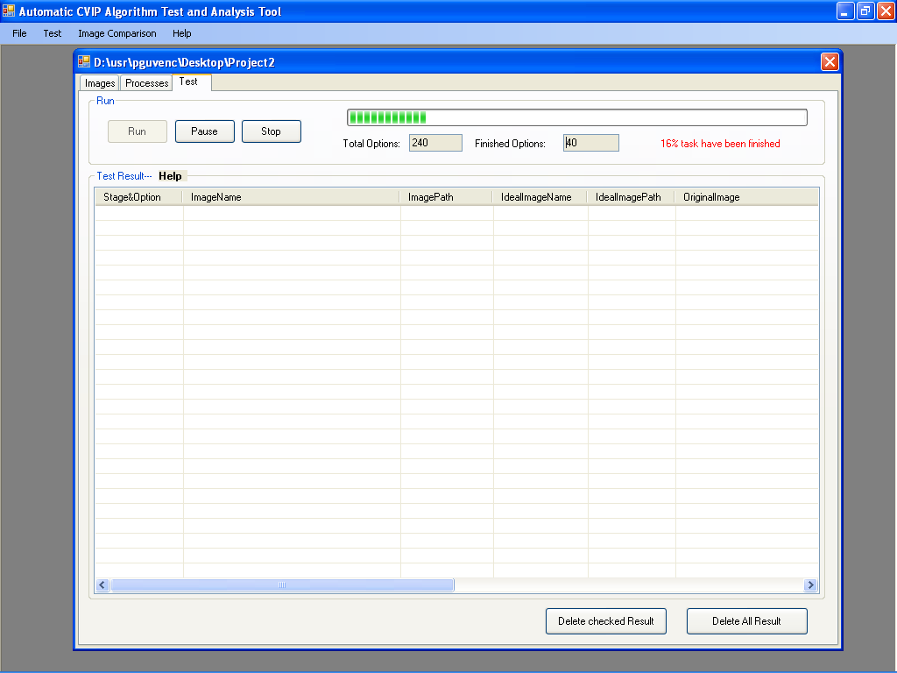
Figure 19. – The testing interface

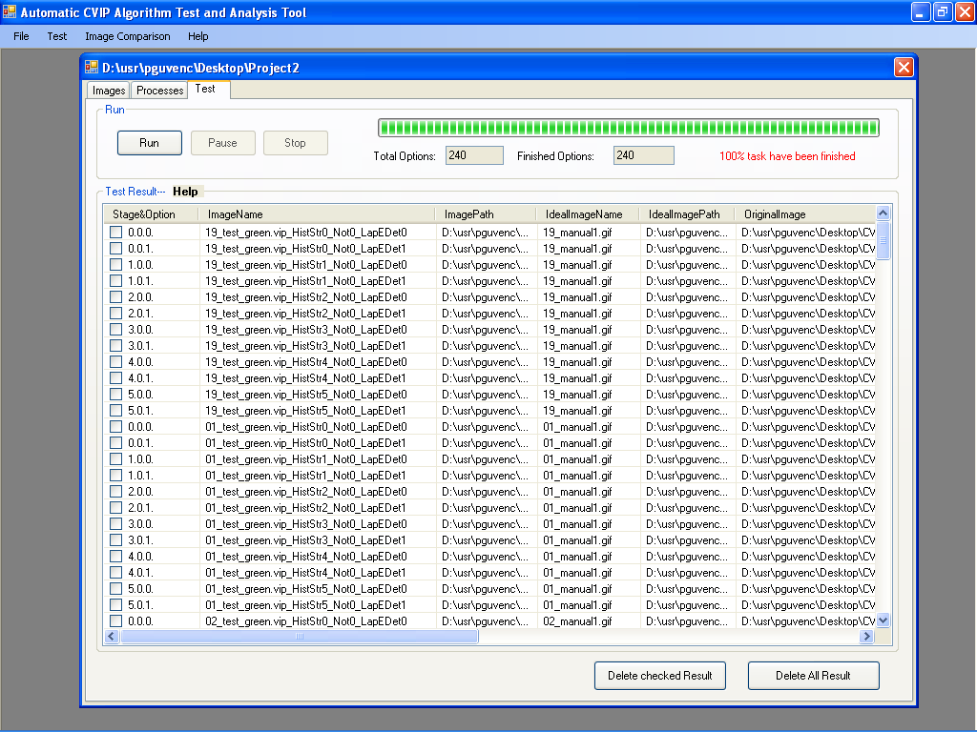
Figure 20. – After the running of the program has been completed.

8. Comparing Images
The comparison interface is used to compare images with their corresponding ideal images. The steps on how to compare the original images with their ideal images is given as follows:
- Select Comparison from menu toolbar to open the comparison interface, see Figure 20.

- Select one method to compare the images, from Root-Mean-Square (RMS) Error, Signal-to-Noise Ratio (SNR), Subtraction Energy or Logical XOR methods. The user can adjust the parameters of every comparison method easily if necessary.

- If remapping the image is necessary, then the Remap Image First box should be checked before proceeding to the comparison methods.

- After finishing steps 2 and 3, the user needs to click on the Analyze button for the selected method to do the calculation. Then the comparison will run automatically.

- Because of the multi-threaded technique, the user can stop the analyzing process at any time just by clicking on the Stop button. Though when the Stop button is clicked on the process aborts and it will not continue from where it left off instead it will start analyzing from the beginning if the Analyze button is clicked again. Figure 21 shows the comparison window right after the Analyze button has been clicked.

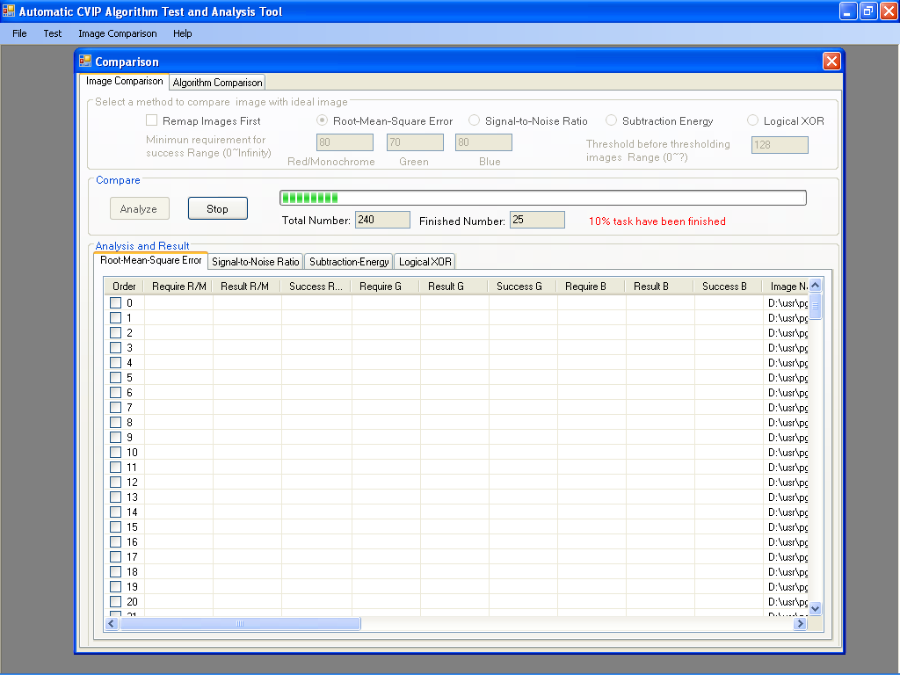
Figure 21. – Comparison window after the Analyze button has been clicked.

- The comparison results will be listed in the tab pages. Since there are four comparison methods, there are four tab pages respectively. So the user can see all of the results by going through the tabs. The figure below shows how the results are displayed after the Analyze button is clicked and the process is complete.

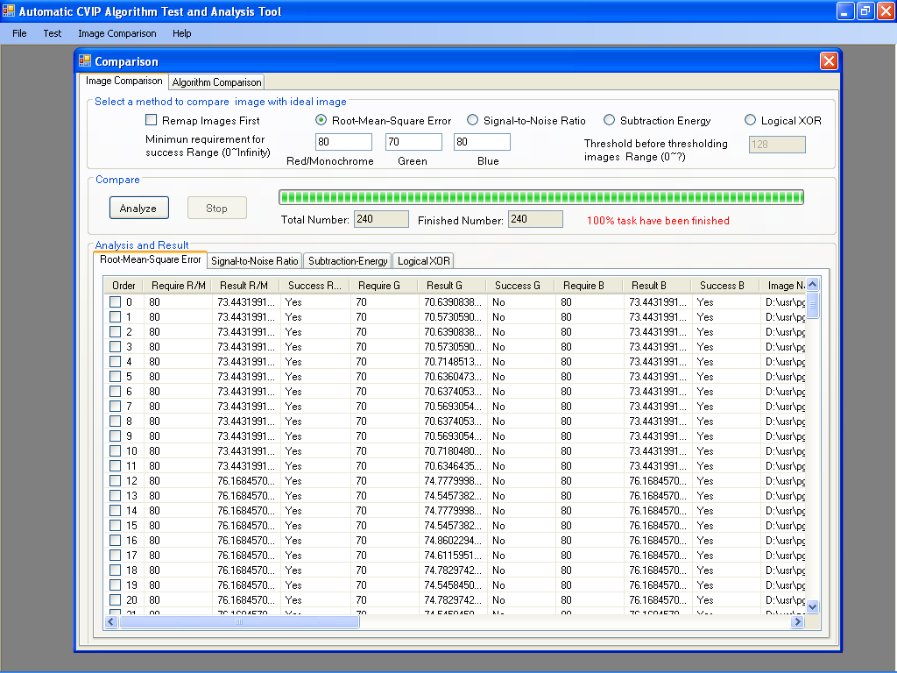
Figure 22. – The comparison window after the analyzing has been completed with the Root-Mean-Square Error selected.

8.1 Comparing Algorithms
After having compared the images the user can click on the Algorithm Comparison tab on the Comparison Interface and view the average comparison results listed according to the comparison type (RMS, SNR, Subtraction - Energy & XOR) selected. The figure below shows the average results listed for the RMS Error comparison metric.
As it is seen in the figure the algorithm along with the parameter values used are listed. This is easier to observe compared to individual image comparison results especially if the resultant images are a large amount. This way the user can automatically see which algorithm worked the best.
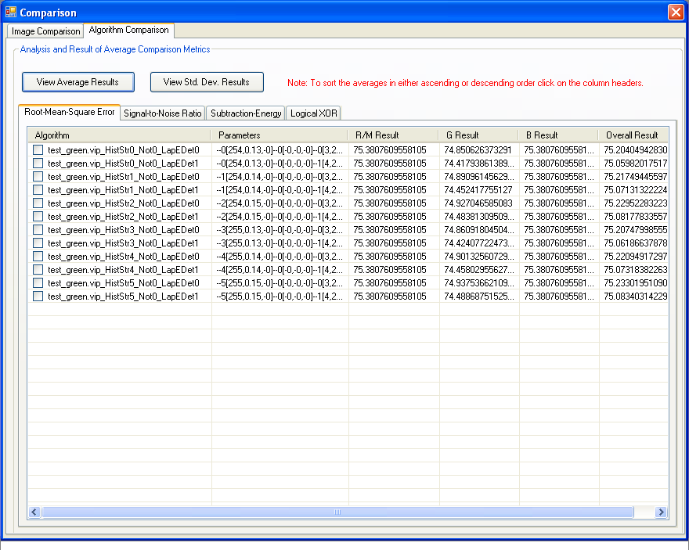
Figure 23. – Average Comparison results for each algorithm.

Another property of this window is that the user can sort the average results in either ascending order or descending order. In order to sort out the results the user must simply click on the column headers of any value he/she would like to sort. The rows can be sorted in a specific order according to the Average Red/Monochrome comparison value, the Green Band comparison value, the Blue Band comparison value or the Overall Comparison result.
The following figure shows the average results sorted in ascending order according to the final column which is the Overall Results column.

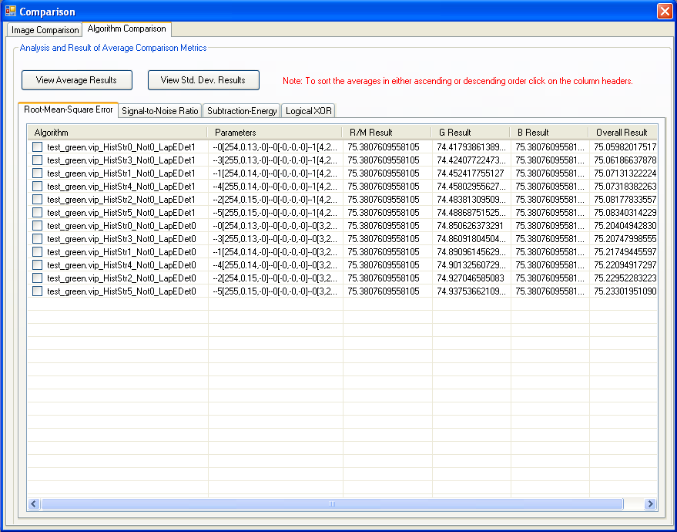
Figure 24. – The rows listed in ascending order according to the Overall Results column

9. Feature Extraction (Under Construction)
The feature extraction interface is used to extract features in an image. In order to do so, the following steps should be applied:
- Select Feature from the main menu toolbar to open the feature extraction interface (see Figure 21).

- Select an object. There are two types of objects: one located in the center of the image or specified location and the K largest object. If the user chooses the center of image or specified location, it means the object that the user is interested in is in the middle of the image or at the specified location. This is the easiest way for feature extraction. Currently, we use this way for image feature extraction. If the user chooses the K largest objects method, it means user wants to extract features for K largest objects in the images.

- Extracted features could be for Training Sets or Testing Sets, the user has to specify one set. This will be a benefit for pattern classification.

- The user also needs to specify the features that need to be extracted. In this software, there are five types of features: Binary Object features, RST-Invariant Moment based features, Histogram features, Texture features, and Spectral features. For each type of features, there are several different sub-features. The user can select part of the sub-features by checking the boxes near the sub-features or the user can select all of the sub-features by just clicking on the Select All button.

- After completing steps 2, 3 and 4, the user can continue by clicking on the Analyze button to extract the features automatically.

- Because of the multi-threaded technique, the user can stop the analyzing process at any time by just clicking on the Stop button. Though once the analyzing process has been stopped if the user decides to continue with the analyzing process by clicking on the Analyze button again the analyzing process will start from the beginning.

- The feature extraction results will be displayed in the list table shown in Figure 21.

Figure 25. – The feature extraction interface.

10. Pattern Classification (Under Construction)
The pattern classification interface is used to classify pattern in an image. In order to classify patterns the following steps should be applied:
- Select Pattern Classification from main menu toolbar to open the pattern classification interface (see Figure 22).

- Select the data normalization method. There are six methods for data normalization: No Normalization, Range-Normalize, Unit Vector Normalization, Standard Normal Density Normalization, Min-Max Normalization, and Softmax Scaling.

- Select the distance and similarity measures method. There are four methods for distance measures: Euclidean Distance, City Block or Absolute Value Metric, Maximum Value Metric, and the Minkowski distance. There are two methods for similarity measures: the Vector Inner Product and the Tanimoto Metric.

- Select classification algorithms. There are three classification algorithms: Nearest Neighbor, K-Nearest Neighbor, and Nearest Centroid.

- After completing steps 2, 3 and 4, the user can continue by clicking on the Analyze button to classify patterns in an image automatically.

- Because of the multi-threaded technique, the user can stop the analyzing process at any time. Though resuming the process is not possible, the process will start from the beginning once the Analyze button is clicked again.

Figure 26. – The pattern classification interface.

11. Saving the Project
There are two ways to save the project:
One way is to save the project is by selecting File->Save Project from the main menu toolbar to save the project directly. (See Figure 23)
Second way is to save the project by closing it. When the user closes the project window from the exit button at the top-right hand corner of the window or exits the software directly, the save project dialog will pop up. Click on the Yes button to save the project.

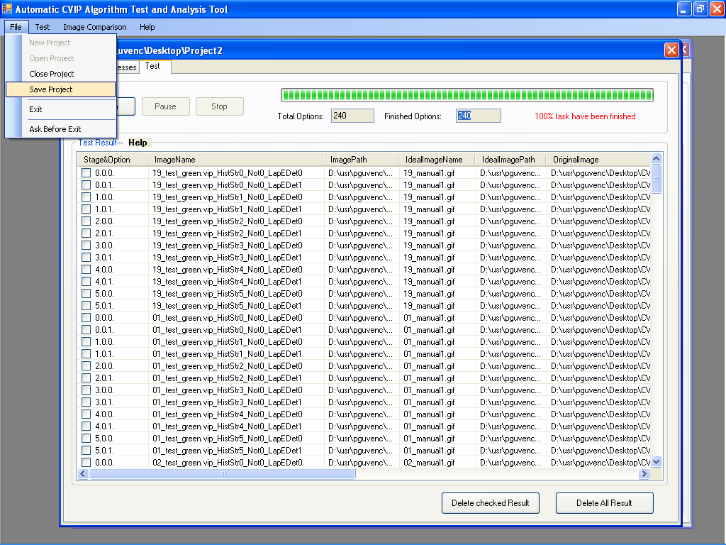
Figure 27. – Saving the project.

After the project has been saved the user can check the project folder he/she created at the beginning and see the results saved in that folder. The files in the folder will look like the ones in the following figure.
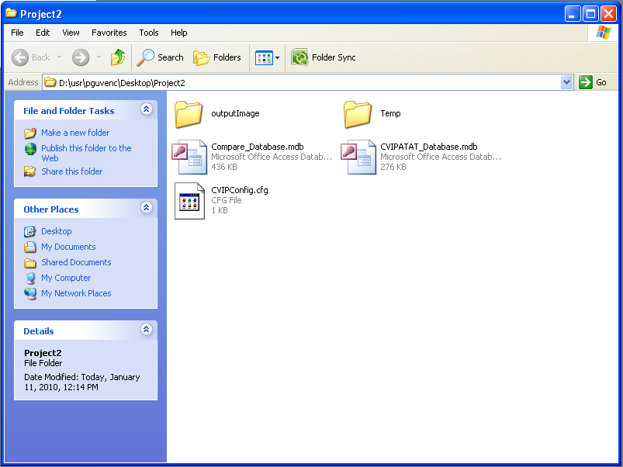
Figure 28. – Saved Project

12. Closing the Project
There are two ways to close the project:
First way to close the project is by using the main menu toolbar by selecting File->Close Project.
Second way is through the main interface. In the main interface, by using the mouse’s left key click on the close button at the top-right hand corner of the interface. This method will also will exit the software.

13. The Database
The database is used to store the input data, the output data, and the analysis results displayed on the GUI in the program. This software has four databases: CVIPATAT_database.mdb, feature_database.mdb, compare_database.mdb, and pattern_database.mdb. Figure 25 is an example for compare_database.mdb. The CVIPATAT_database.mdb is composed of 3 tables: Images table, Processes table, and TestResult table. The compare_database.mdb is composed of 4 tables: CompareRMS table, CompareSNR table, CompareSub table, and CompareXOR table. The feature_database.mdb just has one feature table. The pattern_database.mdb has also just one pattern table.
- The Images table is used to store all input images’ names, paths, their ideal images’ names and paths if ideal images exist.
- The Processes table is used to store the algorithms and their corresponding parameters.
- The TestResult table is used to store the output images’ names, paths, and their corresponding algorithms and parameters.
- The CompareRMS table is used to store the results of the Root-Mean-Square (RMS) Error comparison.
- The CompareSNR table is used to store the results of Signal-to-Noise Ratio (SNR) comparison.
- The CompareSub table is used to store the results of the Subtraction Energy comparison.
- The CompareXOR table is used to store the results of the Logical XOR comparison.
- The Features table is used to store the features after feature extraction.
- The Pattern table is used to store the result of pattern classification.
In order to open these databases, we need use Microsoft Office Access 2003. After opening these databases, we can explore, search and modify data in the databases easily.

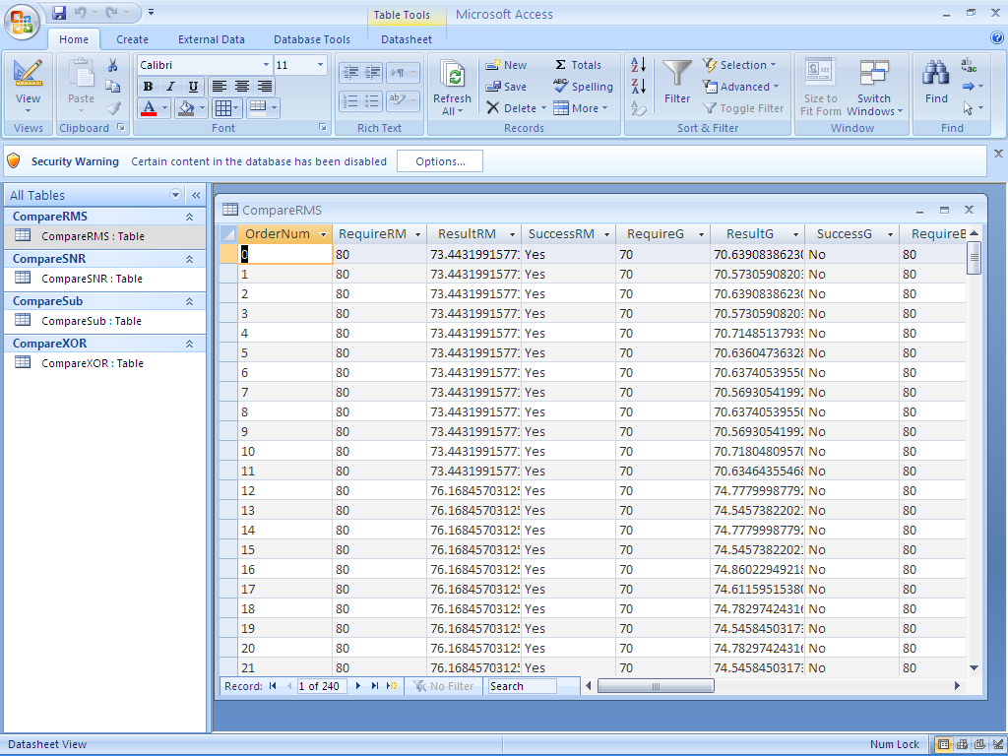
Figure 29. – Example of compare_database.mdb. The RMS values calculated before are displayed

14. How to Add New Functions to the Project? (new section)
As seen so far the software only contains a certain number of image processing and computer vision processes. In order to add new functions to the software there are several places within the project that need to be modified or in other words where the functions should be added. Though before explaining the process, the main structure of the implemented parts should be explained first.
Other then the interfaces the implementation of the processes are in separate files within the project. These C# files contain the implementation of the function calls of the image processing functions and also contain the information that is seen on the interfaces.
There are 5 of these files which are; CVIPConstant.cs, FileInputOutput.cs, Images.cs, Processes.cs, and Test.cs.
- The file CVIPConstant.cs contains all of the data type constants used for image compression, image color formats, and special CVIP data types and CVIP data formats (i.e. real, complex), Boolean types (constant CVIP Boolean types), kernel types used for filters in certain functions (i.e. circle, square, rectangle, cross) and Boolean types considering whether or not to threshold an image before performing a certain process.
- The file FileInputOutput.cs contains code that performs the file saving and database creating operations within the software.
- The Images.cs file is responsible for the addition and deletion of the images within the CVIPATAT GUI which was mentioned earlier. The processes there connect with the GUI.
- The Processes.cs file contains the image processing and computer vision function parameter settings and function abbreviations to make the usability of the functions easier since some functions have very long names. Here the default values for each function defined are set which were seen in the Processes tab in the algorithm interface mentioned before.
- The last file, Test.cs, is where the function calls are made and the processes are being executed.
The task now is to add a new function to the project. The main files that concern the programmer are; CVIPATATForm.Designer.cs, Processes.cs, and Test.cs. The following steps should be applied;
- In the file CVIPATATForm.Designer.cs, the programmer needs to add the name of the function within the variable this.cbBoxSelectProcess.Items.AddRange this variable holds all the functions listed in the dropdown list seen before in the algorithm interface. The insertion of the new function should be in the exact format as the other functions. Figure 26 shows the location in which the name of the function should be added. When the project is built and compiled the compiler automatically arranges the functions in the list according to their alphabetical order. After having completed this task when the project is compiled the programmer will be able to see the function within the dropdown list of the algorithm interface.

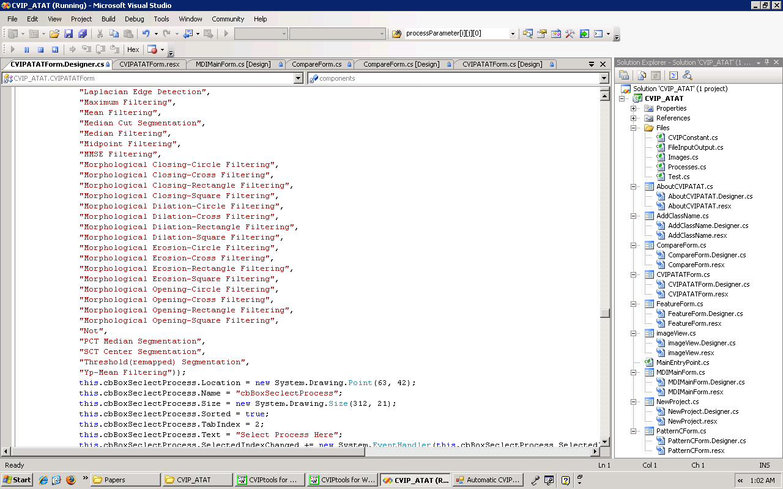
Function Names
Figure 30. – Adding the name of the function (CVIPATATForm.Designer.cs)

- After adding the name of the function the next step is to add the default parameters that show up under the Processes tab in the algorithm interface. The location is the Processes.cs file. First step is to add the parameters as strings (since the program works by passing strings since it is much easier then converting data types due to some functions taking floats or doubles and some functions taking integers). The default parameters are added and their ranges are added within the function public void process_cbBoxSelectProcess_SelectedIndexChange. The location of the function is shown in figure 27. The variables CProcessRef.tbParameter11.Enabled, CProcessRef.tbParameter22.Enabled and CProcessRef.tbParameter33.Enabled are the variables that determine the status of the first textbox (low value) of parameter1, parameter2 and parameter3 respectively. The status may be either false meaning that the textbox is disabled and cannot be used or true meaning that the textbox is enabled and a value can be entered.
The CProcessRef.labelParamterXY.Text variable determines the string written before the textbox and below the textbox. As shown before in the algorithm interface in figure 4, if the function does not take any parameters besides the image itself then the text written for the definition of the textbox is ParameterX. Otherwise the name of the parameter is written. And below the textbox the range of the parameter is written. The variable CProcessRef.tbParameterXY.text determines the default value the low value, increment value and maximum value of the parameter respectively. These processes are repeated for the next 2 parameters as well. In case the function takes more than 3 parameters the programmer can add a fourth parameter as well. Though in order to do so the programmer must modify the algorithm test GUI for the specific function since the GUI contains only 3 textboxes for 3 parameters as default. This modification must take place within the CVIPATAT.cs file.

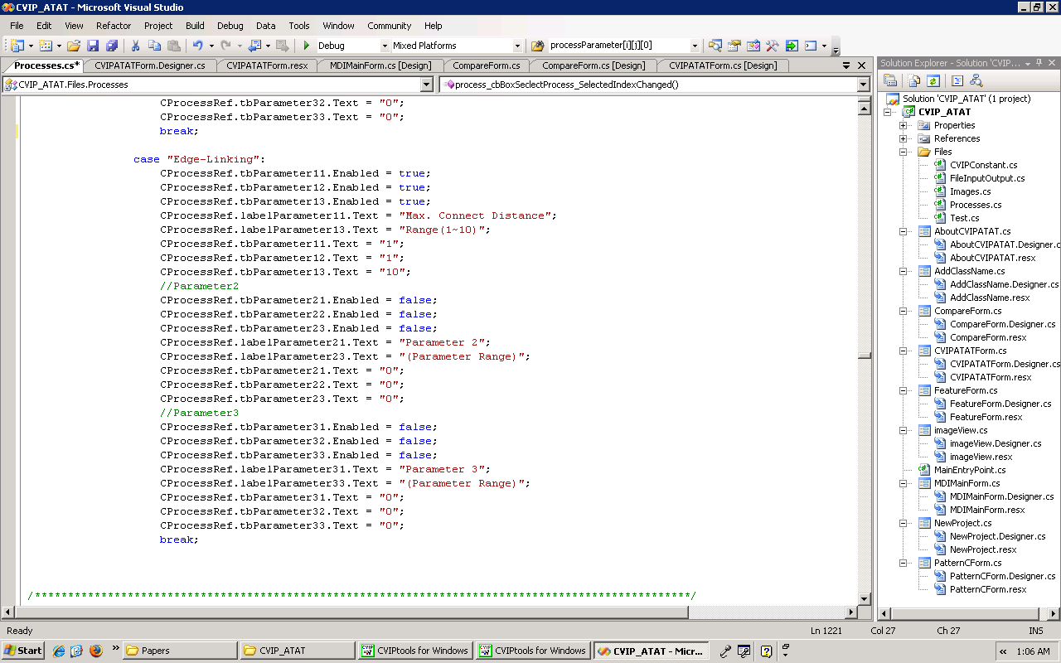
The next function parameters can be added here.
Figure 31. – Setting the default values of the function parameters and determining the status of the textboxes which contain the parameter values.

- Next the abbreviations are added in the same file (Processes.cs). The abbreviations help the programmer to deal with shorter function names later on since some functions tend to have very long names. These abbreviations are just used as references to the actual functions they are not seen within the GUI of the software.
The part where the abbreviations are set the parameter range checks are also made. The location is under the function public void process_btAddProcess_Click(). (The definition and parameter ranges of the functions were looked-up from the Help section in CVIPTools). The variable pXL refers to the lower value of either parameter1, 2 or 3 (The X stands for the number). And the variable pXU refers to the maximum value that the parameter can take. This prevents the user from entering false parameters for certain functions. An example could be; the user entering a negative integer for a function that takes only positive integers. Figure 28 shows where the parameter ranges and function abbreviations are added. (Note that some functions might not need parameter range adjustments, it depends on the definition of the function.)

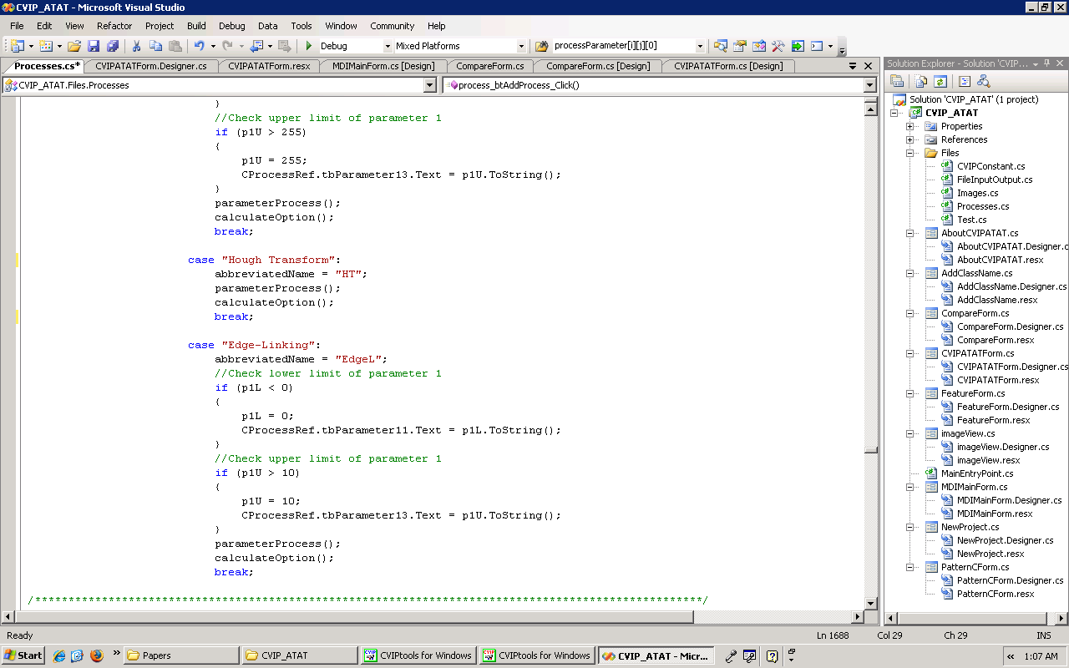
The next case can be added at the end of the last case.
Figure 32. – Creating abbreviations for the functions and checking the parameter values.

- The last step is to add the function call. This is done in the file Test.cs under the function private void TestRun(…). The function can be added after the last case in the switch-case structure within the function. Figure 29 shows the location of the function calls.
The variable CVIPToolsTestRef is an object that is used to invoke the COM function of the image processing function which is defined within the COM library in CVIPTools. Then the COM function automatically invokes the C function which is defined in CVIPTools. Since the code is implemented using C# .NET 2005 it wouldn’t be convenient to use the C function. The COM function can be used in any project which is implemented using any programming language.
The parameter[X] array refers to the parameter which was set in the Processes.cs file. Since there are three parameters the array size is three and the indices are 0, 1, and 2 respectively.
Some CVIP constants can also be used which were defined in the CVIPConstant.cs file. This is done by typing in the enum object and then selecting the necessary value.

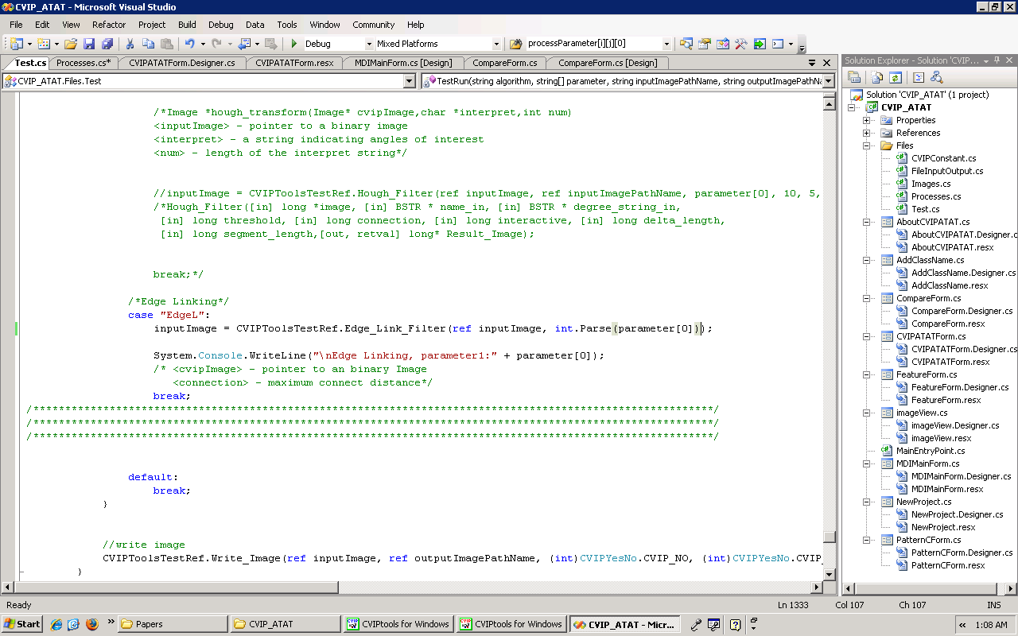
Figure 33. – Inserting the function call for the new image processing function.

As seen in the figure the parameter[0] array is casted to an integer. As mentioned before since the parameters are passed as strings to make the manipulation of functions easier each parameter should be casted to the desired parameter data type. The data types of the functions can be looked-up from the Help section in CVIPTools.

15. Adding and Testing Algorithm 2 from the Paper: “Comparison of Two Algorithms in the Automatic Segmentation of Blood Vessels in Fundus Images” (new section)
In this section the addition of an algorithm from the paper; “Comparison of Two Algorithms in the Automatic Segmentation of Blood Vessels in Fundus Images” will be used with the help of the steps mentioned in the previous section. The algorithm which will be added is algorithm 2.
Algorithm 2 contains the following functions:
- The Yp Mean Filtering (to remove the noise),
- The Laplacian Edge Detection,
- The Arithmetic Mean Filtering (used to reduce the noise),
- The Color-to-Gray Conversion,
- The Binary Threshold function,
- The Not Operation
- And the Edge-Linking function.
The functions which were already present within the first version of the CVIPATAT software were the Yp Mean Filtering function, the Arithmetic Mean filtering function and the Not operation. So the rest were needed to be added.
The steps mentioned in the previous section were followed. The parameter values were determined as follows;
- For the Laplacian Edge Detection function (Edge_Detect_Filter(…)), the parameter values were; (as mentioned before the COM functions were used when implementing the function calls. COM functions are noticed from the initial letters of each word being a capital letter.)
- Mask Choice (there are four types of Laplacian masks (parameter range: 1 through 4) (see CVIPTools Help))
- Mask Size (there are two types of mask sizes (parameter range: 1 through 2)).
- And a Boolean variable that determines whether to keep the image as DC or not. (parameter range: 0 (No) or 1 (Yes)).
- For the Color-to-Gray Conversion function there were no parameters which needed to be set so the textboxes corresponding to the parameters were set to disabled since they were not used. The COM function which was used was Lum_Average(…).
- For the Binary Threshold function there were two parameters but only one parameter had a data range. This parameter was the threshold value parameter. Its range is from 0 to 255. The rest of the parameters defined in the project were set to disabled. The second parameter was directly set to CVIP_NO (from the defined constants in the file CVIPConstant.cs) in the function call located in the Test.cs file. This parameter determines whether the binary threshold should be applied to the image directly or to the remapped version of the image (remapping to CVIP_BYTE). In this study it was applied directly to the original image.
Another option could be add the second parameter into the GUI and have the user define the parameter value according to the algorithm ran. But this algorithm only required the binary threshold to be done on the original image which is why it was automatically inserted in the function call.
The COM function used for binary thresholding was Threshold_Segment(…).
- For the Edge-Linking function the COM function Edge_Link_Filter(…) was used. This function contains only one parameter which is the maximum connect distance between two lines or edges. The rest of the parameters were disabled in the default parameter list. The range of the parameter is determined by the user as long as the parameter is a positive integer.
After having set all of the parameters for all of the functions, the function calls were inserted into the Test.cs file. And the project was built and compiled.
The algorithm was tested on 20 retinal fundus images. These images were inserted in the image interface under the Images tab in the CVIPATAT window. There ideal images were also inserted. These images were the hand drawn blood vessel images. They were used to compare with the resultant images after the algorithm ran. The algorithm was inserted in the algorithm interface under the Processes tab. Each function was inserted in a separate stage. The flow chart of algorithm two is as follows;

Original Image
Resize
Green Band Extraction
Yp Mean Filtering
Laplacian Edge Detection
Arithmetic Mean Filtering
Color-to-Gray Conversion
Binary Thresholding
Not Operation
Edge-Linking Operation
Final Image

As seen in the algorithm, at the beginning there is a resizing operation and green band extraction operation. In this study the resizing operation was left out and the algorithm was applied to the original size of the images. The green band was extracted using CVIPTools and the images were saved in a folder to be used in the algorithm. So the images which were inserted in the image interface were the green band extracted version of the images.
There were a total of 491520 options to calculate. This included every single parameter of every function. The process took a week to run on a normal PC. After the results were obtained the images with the best results were selected and the parameters used for those images were determined so as to get an idea of the parameters that worked the best for the algorithm. The total number of images was also 491520. This selection took a lot of time to complete. After the parameters were determined the algorithm was tested again on the 20 retinal fundus images though this time the parameter ranges were narrowed down to the ranges that worked the best in the previous test.
The same process was repeated each time the resultant images were obtained. This way the best parameters were found for the algorithm to work best. The comparison was made using the compare interface. Since in the beginning the ideal images were added, they were compared to the resultant images according to Root-Mean-Square (RMS) Error, Signal-to-Noise Ratio (SNR), Subtraction Energy and the Logical XOR. Though the problem about the comparison is that is has been designed so that the user can calculate the RMS Error and the SNR value according to the bands of the image. So it calculates the RMS and SNR values for each band separately. The general RMS and SNR values cannot be found with the current version of the software. Modifications need to be made.
The reason this algorithm was tested using this software was because the parameter values that had been used in the paper were not written. This way the exact parameter values were found in a much faster way. Plus the algorithm was tested using every possible parameter combination. In the previous study this was not possible since the parameters were entered by hand using CVIPTools. This made it impossible to try every single combination of parameters.
As a result the software was tested on a real problem and certain changes that needed to be made were determined. The structure of the whole project (software) is not suitable for running very many options. It is very slow though when compared to applying the same process by hand it is very fast. Though still structural changes must be made. This study also showed that the software’s layout is not very convenient for making changes, such as adding a new function. Many changes and addition need to be made in many places. These can be combined into one main structure instead.
The locations of the declaration of variables are not very convenient. They should be gathered in one main file or one main class since most of the variables are commonly used. This way when the programmer needs to make a change in the data type of the variables he/she would only have to make the changes in one place.
These observations will be dealt with in future studies.

