


University of Sousse | Higher Institute of Management of Sousse (ISGS)

FINAL YEAR PROJECT
Submitted in partial fulfillment of the requirements for the Bachelor's degree in Management Information Systems, specializing in Business Intelligence


DesignFlow
Design and Development of
a Web-Based Project Management and Business Intelligence Application
for a Graphic Design Agency

Prepared by
Mahdi Mlika
Academic Supervisor | Mr. Trigui Omar
Professional Supervisor | Mr. Jawhar Letaief
Host Organisation | Creative Media - Digital Technology & Multimedia Agency
Academic Year | 2025 – 2026

Acknowledgements
I would like to thank everyone who helped me finish this final year project.

First of all, I want to thank my academic advisor, Mr. Trigui Omar, for all of his help, advice, and support during this project. His knowledge and careful suggestions have been very helpful in deciding the direction and quality of this work.

I also want to thank Mr. Jawhar Letaief, my professional supervisor at Creative Media, for welcoming me into the company, giving me access to the operational context that made this project relevant, and having interesting conversations that helped me understand the real-world problems the system is meant to solve.

I am grateful to the faculty and staff of the Higher Institute of Management of Sousse for providing the academic framework that made this project possible.

Finally, I want to thank my family and friends for always being there for me and being patient with me along the way.
List of Abbreviations and Acronyms
Acronym | Signification
API | Application Programming Interface
BI | Business Intelligence
CRUD | Create, Read, Update, Delete
DRF | Django REST Framework
EHR | Effective Hourly Rate
ERD | Entity-Relationship Diagram
FK | Foreign Key
ISGS | Institut Supérieur de Gestion de Sousse
JWT | JSON Web Token
KPI | Key Performance Indicator
MVC | Model-View-Controller
ORM | Object-Relational Mapping
PDF | Portable Document Format
PFE | Projet de Fin d’Études
PMIS | Project Management Information System
RBAC | Role-Based Access Control
REST | Representational State Transfer
SPA | Single-Page Application
SWOT | Strengths, Weaknesses, Opportunities, Threats
UML | Unified Modeling Language
UUID | Universally Unique Identifier

Abstract
This report documents the design and development of a web-based project management and business intelligence system, built during a three-month internship at Creative Media, a digital technology and multimedia agency based in Sousse, Tunisia. The project addresses a well-documented gap in small creative and digital agencies: the absence of integrated tools for tracking project hours, measuring profitability in real time, and controlling unplanned scope growth.

The system developed here addresses this directly. It provides a Django REST API backend, a React/TypeScript single-page application for the frontend, and a PostgreSQL database. Three user roles are supported: a Manager who oversees all projects and accesses analytical dashboards, Designers who log time against tasks, and Clients who submit feedback and track their project status.

Key metrics implemented include the Effective Hourly Rate, Budget Utilisation, Scope Creep Index, Designer Utilisation, and Revision-to-Approval Ratio. All are computed in real time via PostgreSQL aggregate queries. The system also supports file uploads, an internal messaging board per project, and PDF/Excel export of reports.

Development followed five two-week Agile sprints, progressing from authentication and data modelling through to BI dashboards and report export.

Future development may extend the system to a multi-tenant architecture, enabling independent design agencies to work on the same platform with completely separate data environments.

Keywords: Business Intelligence, Project Management, Django REST Framework, React, TypeScript, PostgreSQL, Profitability Analytics, Scope Creep, Agile Development, Graphic Design Agency.

Résumé
Ce rapport documente la conception et le développement d'un système web de gestion de projets et d'intelligence d'affaires, réalisé lors d'un stage de trois mois chez Creative Media, une agence tunisienne spécialisée dans le développement numérique et les solutions multimédias, basée à Sousse. Le projet répond à une problématique bien documentée dans les agences créatives et numériques de taille réduite : l'absence d'outils intégrés pour le suivi des heures, la mesure de la rentabilité en temps réel et le contrôle des dérives de périmètre.

Le système développé répond directement à cette problématique. Il repose sur une API REST Django en backend, une application monopage React/TypeScript en frontend, et une base de données PostgreSQL. Trois rôles utilisateurs sont pris en charge : un Responsable supervisant l'ensemble des projets et accédant aux tableaux de bord analytiques, des Designers saisissant leurs heures sur les tâches, et des Clients soumettant des retours et suivant l'avancement de leurs projets.

Les indicateurs clés implémentés comprennent le Taux Horaire Effectif, le Taux d'Utilisation du Budget, l'Indice de Dérive du Périmètre, le Taux d'Utilisation des Designers et le Ratio Révisions/Validation. Tous sont calculés en temps réel via des requêtes d'agrégation PostgreSQL. Le système prend également en charge l'envoi de fichiers, un tableau de messagerie interne par projet, ainsi que l'export des rapports en PDF et Excel.

Le développement a suivi cinq sprints agiles de deux semaines, progressant de l'authentification et de la modélisation des données jusqu'aux tableaux de bord de BI, à l'exportation des rapports.

Les perspectives futures envisagent une extension vers une architecture multi-tenant, permettant à plusieurs agences indépendantes de travailler sur la même plateforme avec des environnements de données totalement distincts.

Mots-clés : Business Intelligence, Gestion de Projet, Django REST Framework, React, TypeScript, PostgreSQL, Analyse de Rentabilité, Scope Creep, Développement Agile, Agence de Design Graphique.
Table of Contents
General Introduction 1
1. Context and Justification 1
2. Problem Statement and Objectives 1
3. Methodology 2
4. Report Structure 2
Chapter 1 — Project Presentation and Framing 3
1. Presentation of the Host Organisation 3
1.1 About Creative Media 3
1.2 Team Functional Roles 3
1.3 Technical Fact Sheet 4
1.4 Internship Context and Tasks Performed 5
1.5 SWOT Analysis 5
2. Project Context and Problem Statement 6
2.1 The Problem Being Solved 6
2.2 Scope Boundaries 6
3. Development Methodology 7
3.1 Classical vs. Agile Approaches — Comparative Overview 7
3.2 Justification for the Chosen Methodology 7
3.3 Agile Sprint-Based Approach 7
3.4 Vertical Slice Development 8
3.5 Modelling Languages and Tools 8
4. Chapter Conclusion 9
Chapter 2 — Literature Review and Technical Framework 10
1. Introduction 10
2. Business Intelligence in Service Industries 10
2.1 Definition and Role of Business Intelligence 10
2.2 Key Performance Indicators for Creative Agencies 10
3. Project Management Information Systems 11
3.1 Characteristics of an Effective PMIS 11
3.2 Analysis of Existing Tools 11
4. Technical Framework and Technology Justification 12
4.1 System Architecture Pattern 12
4.2 Technology Stack Justification 12
4.3 Authentication Strategy 13
5. Synthesis and Working Hypotheses 13
6. Chapter Conclusion 14
Chapter 3 — Sprint 0: Requirements Specification and System Design 15
1. Introduction 15
2. Requirements Capture 15
2.1 Identification of Actors 15
2.2 Functional Requirements 15
2.3 Non-Functional Requirements 17
2.4 Roles and Permissions Matrix 17
3. Global Use Case Diagram 18
4. Scrum Project Planning 20
4.1 Scrum Roles and Responsibilities 20
4.2 Product Backlog 20
4.3 Sprint Planning Overview 22
4.4 Project Gantt Chart 23
5. Development Environment 23
5.1 Hardware Environment 23
5.2 Software and Development Tools 24
6. System Architecture 24
6.1 Physical Architecture 24
6.2 Logical / Software Architecture 26
6.3 Architecture Rationale 27
6.4 Deployment Diagram 28
7. Global Data Model 28
7.1 Global Class Diagram 28
7.2 Entity-Relationship Diagram 30
7.3 Relational Schema 31
8. Chapter Conclusion 31
Chapter 4 — Sprint 1: Foundation and Authentication 32
1. Introduction 32
2. Sprint 1 Backlog 32
3. Functional Specification 32
3.1 Sprint 1 Use Case Diagram 32
3.2 Textual Description of Use Cases 33
4. Conception 36
4.1 Sequence Diagrams 36
4.2 Class Diagram 37
5. Interface Realisation 38
5.1 Django Admin Panel & User Management 38
5.2 Login Interface 40
5.3 Account Activation Interface 40
5.4 Role-Based Dashboard Stubs 41
6. Testing 42
7. Sprint Tracking 43
7.1 Scrum Board 43
7.2 Burndown Chart 43
Chapter Conclusion 44
Chapter 5 — Sprint 2: Project and Task Management 45
1. Introduction 45
2. Sprint 2 Backlog 45
3. Functional Specification 45
3.1 Sprint 2 Use Case Diagram 45
3.2 Textual Description of Use Cases 46
4. Conception 49
4.1 Sequence Diagrams 49
4.2 Class Diagram 51
5. Interface Realisation 52
5.1 Project Card 52
5.2 Project List Interface (Manager View) 53
5.3 Project Detail and Task Management Interface 53
5.4 Task Creation Interface 53
5.5 Project List Interface (Designer View) 54
6. Testing 54
7. Sprint Tracking 55
7.1 Scrum Board 55
7.2 Burndown Chart 55
Chapter Conclusion 56
Chapter 6 — Sprint 3: Time Tracking and Deliverables 57
1. Introduction 57
2. Sprint 3 Backlog 57
3. Functional Specification 57
3.1 Sprint 3 Use Case Diagram 57
3.2 Textual Description of Use Cases 58
4. Conception 60
4.1 Sequence Diagrams 60
4.2 Class Diagram 62
5. Interface Realisation 63
5.1 Time Logging Interface (Designer View) 63
5.2 Kanban Board 64
5.3 File Upload Interface 64
5.4 Feedback View Interface (Designer View) 65
6. Testing 65
7. Sprint Tracking 66
7.1 Scrum Board 66
7.2 Burndown Chart 66
Chapter Conclusion 67
Chapter 7 — Sprint 4: Client Portal and Feedback 68
1. Introduction 68
2. Sprint 4 Backlog 68
3. Functional Specification 68
3.1 Sprint 2 Use Case Diagram 68
3.2 Textual Description of Use Cases 69
References 70

List of Figures
Figure 1: Creative Media — Company Logo 3
Figure 2: Creative Media — Team Functional Roles 4
Figure 3: Agile Sprint Cycle 8
Figure 4: Per-Sprint Development Workflow 8
Figure 5: Use Case Diagram — Global View 19
Figure 6: Gantt Chart — Five-Sprint Development Timeline 23
Figure 7: Three-Tier System Architecture 25
Figure 8: Backend Directory Structure 26
Figure 9: Frontend Directory Structure 27
Figure 10: Deployment Diagram 28
Figure 11: Global Class Diagram 29
Figure 12: Entity-Relationship Diagram 30
Figure 13: Sprint 1 Use Case Diagram 33
Figure 14: Sequence Diagram — Authenticate 36
Figure 15: Sequence Diagram — User Onboarding 37
Figure 16: Sprint 1 Class Diagram 38
Figure 17: Django Admin Panel 39
Figure 18: Account Creation 40
Figure 19: User Management 40
Figure 20: Login Interface 40
Figure 21: Activation Email 41
Figure 22: Account Activation Interface 41
Figure 23: Manager Dashboard 42
Figure 24: Designer Dashboard 42
Figure 25: Client Dashboard 42
Figure 26: Sprint 1 Scrum Board 43
Figure 27: Sprint 1 Burndown Chart 44
Figure 28: Sprint 2 Use Case Diagram 46
Figure 29: Sequence Diagram — Manage Projects 50
Figure 30: Sequence Diagram — Manage Tasks 51
Figure 31: Sprint 2 Class Diagram 52
Figure 32: Project Card 53
Figure 33: Project List Interface (Manager View) 53
Figure 34: Project Detail and Task Management Interface 53
Figure 35: Task Creation Interface 54
Figure 36: Project List Interface (Designer View) 54
Figure 37: Sprint 2 Scrum Board 55
Figure 38: Sprint 2 Burndown Chart 56
Figure 39: Sprint 3 Use Case Diagram 58
Figure 40: Sequence Diagram — Track Time 61
Figure 41: Sequence Diagram — Upload Deliverable 62
Figure 42: Sprint 3 Class Diagram 63
Figure 43: Time Logging Interface (Designer View) 64
Figure 44: Task Status Toggle 64
Figure 45: File Upload Interface 65
Figure 46: Feedback View Interface (Designer View) 65
Figure 47: Sprint 3 Scrum Board 66
Figure 48: Sprint 3 Burndown Chart 67
Figure 49: Sprint 2 Use Case Diagram 69

List of Tables
Table 1: Technical Fact Sheet: Creative Media 4
Table 2: SWOT Analysis of Creative Media 6
Table 3: Classical vs. Agile: Comparative Overview 7
Table 4: Analytical Metrics Implemented in the System 10
Table 5: Comparison of Existing Project Management Tools 11
Table 6: Technology Stack with Justifications 12
Table 7: Identified Actors and Their Roles 15
Table 8: Functional Requirements by Role 16
Table 9: Non-Functional Requirements 17
Table 10: User Roles and Permissions Matrix 17
Table 11: Global Product Backlog 20
Table 12: Sprint Planning Overview 22
Table 13: Hardware Development Environment 23
Table 14: Software and Development Environment 24
Table 15: Sprint 1 Backlog 32
Table 16: Textual Description of Use Case: Authenticate 34
Table 17: Textual Description of Use Case: Set Password 34
Table 18: Textual Description of Use Case: Create User Account 34
Table 19: Textual Description of Use Case: Manage Users 35
Table 20: Sprint 1 Test Results 43
Table 21: Sprint 2 Backlog 45
Table 22: Textual Description of Use Case: Manage Projects 46
Table 23: Textual Description of Use Case: Assign Designer 47
Table 24: Textual Description of Use Case: Manage Tasks 48
Table 25: Textual Description of Use Case: View Assigned Projects 48
Table 26: Textual Description of Use Case: AI Estimate Task Hours 49
Table 27: Sprint 2 Test Results 54
Table 28: Sprint 3 Backlog 57
Table 29: Textual Description of Use Case: Track Time 58
Table 30: Textual Description of Use Case: Update Task Status 59
Table 31: Textual Description of Use Case: Upload Deliverable 59
Table 32: Textual Description of Use Case: View Client Feedback 59
Table 33: Sprint 3 Test Results 65
Table 34: Sprint 4 Backlog 68

General Introduction

1. Context and Justification
Digital technology and creative agencies operate in a highly competitive environment where the quality of deliverables must be balanced against strict budget and deadline constraints. Unlike product-based businesses, design agencies generate their entire revenue by selling designer time, yet most agencies have no system to track how that time is spent relative to what was budgeted. Project tracking, if done at all, relies on spreadsheets, verbal agreements, or generic task management tools that lack financial visibility.

Without real-time data on hours logged against a project budget, a manager cannot know whether a project is profitable until it is complete. By then, it's usually too late to make changes. Scope creep, defined as the accumulation of tasks added after a project's initial specification, is particularly damaging in creative work, where revision cycles are frequent and the boundary between contracted and extra work is easily blurred.

These challenges are well-documented across small creative and digital agencies [1, 14]. Creative Media, the host organisation for this internship, operates in exactly this profile: a multidisciplinary digital agency delivering web, mobile, and multimedia projects under fixed timelines and client-driven requirements. The professional supervisor confirmed the relevance of these operational challenges to the agency's context, and the project was proposed and approved on that basis.

2. Problem Statement and Objectives
The core question this project addresses is: How can a graphic design agency gain real-time, data-driven visibility into the profitability of its projects, the utilisation of its designers, and the extent of unplanned scope growth then use that information to make better operational and financial decisions?

The project was scoped to the following objectives:
- Design and develop a full-stack web application covering the complete project lifecycle, from creation to delivery.
- Implement a granular time-tracking system linking logged hours to specific tasks and project budgets.
- Build analytical dashboards exposing key profitability metrics: Effective Hourly Rate, Budget Utilisation, Scope Creep Index, Designer Utilisation, and Revision-to-Approval Ratio.
- Enforce role-based access control for three user types (Manager, Designer, Client) ensuring data confidentiality and appropriate functionality per role.
- Support PDF and Excel report exports for offline management reporting.

3. Methodology
This project adopts an Agile development methodology adapted for a solo developer context, organised into five two-week sprints, each delivering a vertical slice of working functionality, from the database layer through the API to the user interface. This approach produces demonstrable progress at each supervisor review and limits integration risk by ensuring every feature is complete before the next is started.

4. Report Structure
Chapters 1 and 2 establish the organisational context and technical framework. Chapters 3 through 8 follow the five-sprint cycle. The General Conclusion evaluates the working hypotheses and proposes future development directions.

Chapter 1 — Project Presentation and Framing

1. Presentation of the Host Organisation

1.1 About Creative Media
Creative Media is a Tunisian limited liability company (SARL) founded in 2002 and headquartered at Rue Colonel Hedi EL Garnaoui, Khézama Est 4051, Sousse, Tunisia. The agency operates as a digital and technology company specialising in web and mobile development, digital technologies, and multimedia solutions. Its core areas of expertise include software development, UX/UI design, digital branding, computer-generated imagery (CGI), motion design, and artificial intelligence integration.
The company’s main activities encompass the design and development of web and mobile applications, SaaS platforms, ERP systems, AI integration, digital automation, graphic design, and audiovisual production. It offers services including custom software development, visual identity creation, application maintenance, cloud hosting, IT consulting, digital marketing, and interactive solutions.
Creative Media serves a diverse client portfolio spanning startups, SMEs, technology companies, agencies, institutions, and innovative projects across Tunisia, North Africa, and international markets. The company follows Agile and Scrum methodologies with a collaborative, client-centered approach, and maintains a technical infrastructure built on dedicated VPS servers, Linux cloud infrastructure, network security systems, CI/CD deployment pipelines, and multi-tenant architecture.

Figure 1: Creative Media — Company Logo

1.2 Team Functional Roles
Creative Media operates with a multidisciplinary team structured around three functional areas: Technical, Management, and Creative & Design. The technical team comprises full-stack developers and AI integrators responsible for web, mobile, and intelligent systems development. Project management is handled by dedicated project managers who oversee delivery using Agile and Scrum methodologies. The creative and design team consists of UX/UI designers and multimedia specialists covering interface design, motion graphics, CGI, and branding. Figure 2 illustrates the functional role distribution across these areas.
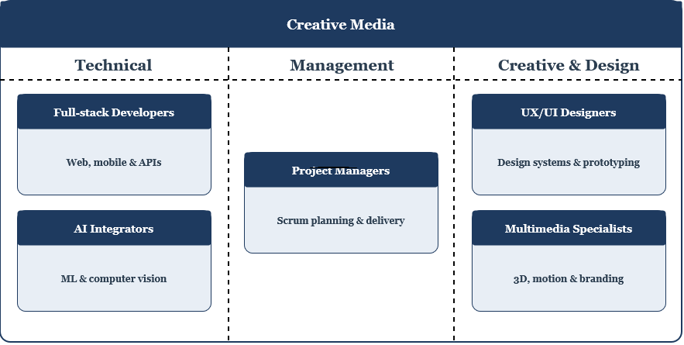
Figure 2: Creative Media — Team Functional Roles

1.3 Technical Fact Sheet
Table 1: Technical Fact Sheet: Creative Media
Attribute | Detail
Organisation | Creative Media
Legal Form | SARL
Founded | 2002
Head Office | Rue Colonel Hedi EL Garnaoui, Khézama Est 4051, Sousse, Tunisia
Business Sector | Web and mobile development, digital technologies, and multimedia solutions
Areas of Expertise | Software development, UX/UI Design, digital branding, CGI, motion design, and AI integration
Main Activities | Web and mobile application development, SaaS platforms, ERP systems, AI integration, digital automation, graphic design, and audiovisual production
Services Offered | Custom software development, visual identity creation, application maintenance, cloud hosting, IT consulting, digital marketing, and interactive solutions
Technologies Used | React.js, Next.js, React Native, Kotlin, Swift, Node.js, Fastify, PostgreSQL, MongoDB, Rust, WebAssembly, Redis, Docker, Nginx, REST APIs, AI, Computer Vision, 3D tools
Work Methodology | Agile and Scrum — collaborative, client-centred approach
Technical Infrastructure | Dedicated VPS servers, Linux cloud infrastructure, network security systems, CI/CD pipelines, multi-tenant architecture
Team | Multidisciplinary: full-stack developers, UX/UI designers, AI integrators, multimedia specialists, and project managers
Target Clients | Startups, SMEs, technology companies, agencies, institutions, and innovative projects
Operational Area | Tunisia, North Africa, and international market
Website | www.creativemedia.tn
Email | info@creativemedia.tn
Phone | +216 98 457 122
Internship Duration | 3 months (12 weeks)

1.4 Internship Context and Tasks Performed
During my internship at Creative Media, I proposed and developed a project management and business intelligence system designed to address common operational gaps in agencies of this profile. The professional supervisor validated the project scope and relevance. The tasks undertaken are directly aligned with the software engineering and BI activities documented in this report, and include:
- Project scoping: initial discussions with the professional supervisor to validate the system concept, define user roles, and agree on the functional perimeter.
- UML modelling: development of use case diagrams, class diagrams, and sequence diagrams to formalise system requirements.
- System architecture and data model design: three-tier architecture definition and full entity-relationship design.
- Backend and frontend development: progressive full-stack implementation covering all Django models, JWT authentication, user onboarding, project and task management, time tracking, client feedback, BI dashboards, file management and PDF/Excel report exports.
- Iterative review: regular progress presentations to the professional supervisor with adjustments incorporated based on his feedback.

1.5 SWOT Analysis
Table 2 frames the typical operational profile of small digital and creative agencies such as Creative Media, and contextualises the opportunities this project aims to exploit.

Table 2: SWOT Analysis of Creative Media
Strengths  - Established company with 20+ years of market presence.  - Multidisciplinary team covering development, AI, UX/UI, and multimedia.  - Broad, modern technical stack.  - Strong portfolio in web, mobile, AI, and multimedia production. | Weaknesses  - Limited adoption of dedicated project tracking and time-logging tools.  - Profitability visibility relies on post-project estimation rather than real-time measurement.  - Scope change management is handled through informal client communication channels.  - Reporting and performance review depend on manual data consolidation.
Opportunities  - Growing demand for data-driven agency management.  - BI adoption as a competitive differentiator.  - Scalable analytics platform for future growth.  - Potential to expand services using performance data. | Threats  - Competitive pressure from freelance platforms.  - Client budget constraints reducing project margins.  - Scope creep risk on fixed-price contracts.  - Talent retention challenges in the creative sector.

2. Project Context and Problem Statement

2.1 The Problem Being Solved
The fundamental problem this system addresses is the absence of financial transparency in creative project management. Research on service-based organisations consistently shows that agencies operating on fixed-price contracts struggle to measure profitability in real time: costs are estimated rather than tracked, and margin erosion is only visible after a project concludes [1, 14]. Creative Media operates in exactly this context, a digital agency delivering fixed-scope projects, and the professional supervisor confirmed that a system providing real-time project visibility would be a relevant and valuable tool for the organisation.
Two structural causes are documented in the literature:
- Scope creep: in client-driven creative work, revisions and additions requested after the initial specification are frequently absorbed into the workload without formal change control, distorting the relationship between effort and invoice value [1].
- Absence of real-time budget visibility: without systematic hour logging against project budgets, managers cannot intervene while a project is still in progress [14].
Secondary consequences include difficulty identifying which clients or project types generate disproportionate revision cycles, and the inability to plan team capacity against objective utilisation data.

2.2 Scope Boundaries
The system covers the complete project lifecycle for Managers, Designers, and Clients, including a BI analytics layer. Invoicing, payroll, real-time collaborative editing, and third-party design-tool integrations are out of scope.

3. Development Methodology

3.1 Classical vs. Agile Approaches — Comparative Overview
Two broad methodological families exist for software development projects: classical (sequential/waterfall) approaches and Agile iterative approaches. Table 3 summarises the key differences.
Table 3: Classical vs. Agile: Comparative Overview
Criterion | Classical (Waterfall) | Agile (Scrum)
Requirements | • Fixed upfront | • Evolve iteratively
Delivery | • Single release at end | • Working increment each sprint
Feedback | • End of project | • After every sprint
Risk Management | • Late defect discovery | • Early detection per cycle
Documentation | • Extensive upfront | • Lean, just-in-time
Adaptation | • Costly, requires phase restart | • Built into sprint cycle

3.2 Justification for the Chosen Methodology
Agile was selected for three reasons specific to the internship context. First, the system's requirements were partially emergent: the problem domain (agency profitability and scope tracking) is well understood in the literature, but the precise metrics, workflows, and interface decisions that would best serve a small digital agency required progressive refinement through working software rather than upfront specification. Second, the twelve-week constraint demanded working software at every milestone for supervisor review. A waterfall approach would have produced nothing demonstrable for the first eight weeks. Third, as a solo developer, the cost of context-switching between large phases (all models, then all APIs, then all UI) is high. Vertical slices within each sprint keep cognitive load manageable.

3.3 Agile Sprint-Based Approach
The project adopts the Scrum framework, which organises development into fixed-length iterations called sprints, each producing a usable software increment [13]. While Scrum is designed for teams, its core mechanics such as sprint planning, backlog management, and retrospective review adapt naturally to a supervised solo project. Five two-week sprints structure the work, each with a clearly defined goal and deliverable. This produces working, demonstrable software at the end of every sprint that can be reviewed by a supervisor. It also limits the scope of each development cycle, reducing the risk of losing context across a large codebase.
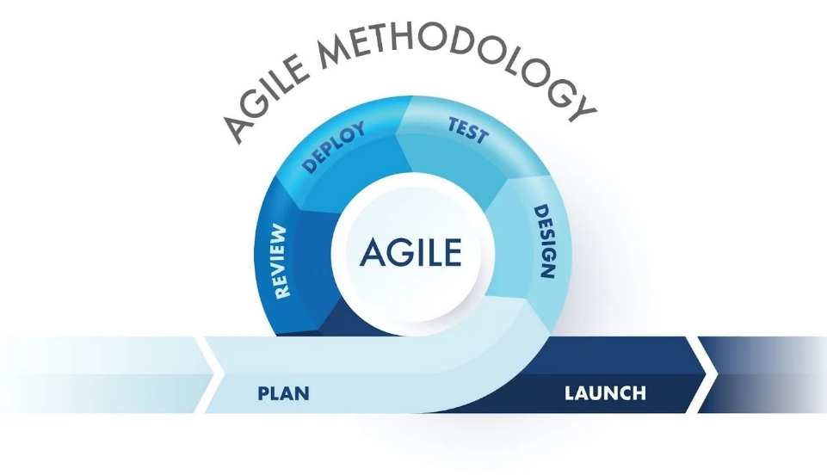
Figure 3: Agile Sprint Cycle

3.4 Vertical Slice Development
As part of each sprint, features are built in vertical slices. This means that each user story is fully implemented, from the database model to the serialiser to the API view to the React component, before the next story starts. This contrasts with a horizontal approach where all models come first, then all APIs, then all UI. The horizontal approach produces nothing testable for extended periods and makes early requirement validation impossible.
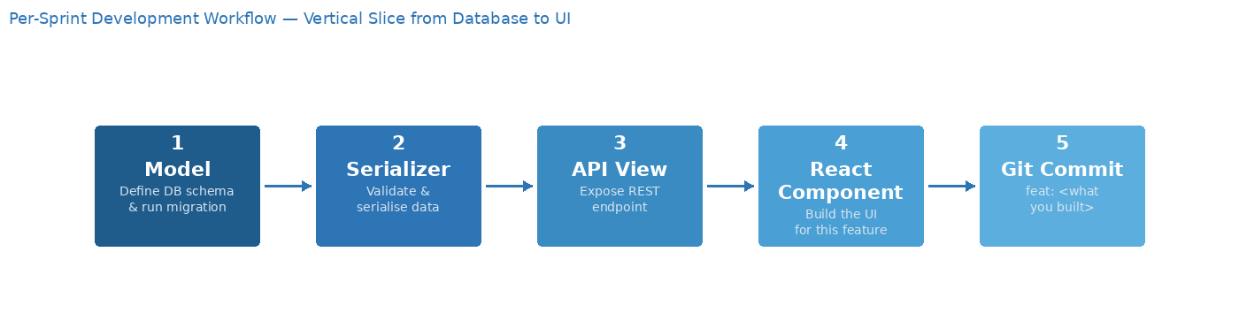
Figure 4: Per-Sprint Development Workflow

3.5 Modelling Languages and Tools
This report uses the Unified Modelling Language (UML) for all structural and behavioural diagrams. UML was chosen because it is the standard notation for object-oriented software design and provides a shared vocabulary between the academic context and professional practice. The following UML diagram types are used throughout the report: Use Case Diagrams (system scope and actor interactions), Class Diagrams (static domain model), Sequence Diagrams (dynamic interaction flows), and Deployment Diagrams (physical infrastructure topology). All UML diagrams were produced using draw.io.

4. Chapter Conclusion
The absence of integrated project tracking and profitability analytics is a well-documented operational gap in small creative and digital agencies [1, 14], and it defines a well-bounded engineering problem that is directly addressable by a custom full-stack system. The Agile sprint methodology provides the structure needed to deliver that solution within twelve weeks. Chapter 2 establishes the theoretical and technical framework that grounds the design decisions made throughout implementation.

Chapter 2 — Literature Review and Technical Framework

1. Introduction
This chapter reviews BI practice in service industries, evaluates existing tools, justifies the technology stack, and states the working hypotheses evaluated in the General Conclusion.

2. Business Intelligence in Service Industries

2.1 Definition and Role of Business Intelligence
Business Intelligence (BI) refers to the set of technologies, processes, and practices that transform raw operational data into meaningful, actionable information for decision-makers [1]. In a service industry context, where revenue is generated by selling time and expertise rather than tangible goods, BI plays a particularly important role in understanding the relationship between inputs (designer hours) and outputs (project value delivered to clients).
This system covers both layers: operational views (time logs per project, feedback per task) and analytical metrics (EHR, budget variance, scope creep index) that let a manager understand not just what happened but why.

2.2 Key Performance Indicators for Creative Agencies
Based on the operational challenges documented in the literature for agencies of this profile [1, 14] and confirmed as relevant by the professional supervisor, six metrics were selected as the core analytical layer. The Effective Hourly Rate is the central profitability indicator: it expresses how much monetary value the agency generates per designer hour logged. A high EHR indicates an efficiently managed project and a low EHR indicates underpricing or overconsumption of hours. The Scope Creep Index complements this by revealing whether a low EHR is driven by poor estimation or uncontrolled scope expansion.
Table 4: Analytical Metrics Implemented in the System
Metric | Formula | Business Meaning
Effective Hourly Rate | $$budget_amount ÷ SUM(hours_spent)$$ | Revenue earned per hour of designer time invested.
Budget Utilisation % | $$SUM(hours_spent) ÷ budget_hours × 100$$ | Proportion of the allocated hour budget consumed to date.
Estimation Variance % | $$(SUM(actual) - SUM(estimated)) ÷ SUM(estimated) × 100$$ | Accuracy of the original task hour estimates.
Scope Creep Index | $$COUNT(is_unplanned=True) ÷ COUNT(*) × 100$$ | Percentage of tasks added after project kick-off.
Designer Utilisation % | $$SUM(hours_this_week) ÷ available_hours_per_week × 100$$ | Proportion of contracted capacity actually billed.
Revision-to-Approval Ratio | $$COUNT(category='Revision') ÷ COUNT(category='Approval')$$ | Client feedback quality.  High values signal rework-intensive clients.

3. Project Management Information Systems

3.1 Characteristics of an Effective PMIS
A Project Management Information System (PMIS) is a software system that supports the planning, execution, monitoring, and control of projects [2]. For a creative agency, an effective PMIS must balance the structured task tracking of traditional project management with the flexibility required in creative workflows, where scope is often iterative and client-driven.
In this case, an effective PMIS should have role-based access (so that clients can only see their own projects, designers can only see their own assignments, and managers can see everything), real-time status updates (like task status and hours logged against budget), and direct integration between task management and financial tracking (so that logged hours immediately show up as budget consumption data without having to be manually combined).

3.2 Analysis of Existing Tools
Table 5 compares five commercial tools against the agency's requirements.
Table 5: Comparison of Existing Project Management Tools
Tool | Strengths | Gaps for Creative Media
  Harvest | • Strong time tracking and invoicing  • Team reporting | • No custom scope creep tracking  • Requires integration with separate PM tools  • No client profitability analytics
  Toggl Track | • Excellent timer-based tracking  • Good team dashboards | • No project budget management  • No client-facing portal or BI metrics
FunctionFox | • Designed for creative agencies  • Project costing | • Proprietary SaaS with per-seat pricing  • No customisable analytical layer  • Cannot adapt KPIs to agency needs
Monday.com | • Powerful general-purpose  • PM Highly configurable | • No financial analytics, EHR or scope creep concept  • Requires significant setup for basic time tracking
  Asana | • Mature task management  • Good workflow automation | • No time tracking or budget tracking natively  • No analytical layer or client portal

The gap common to all these tools is the absence of customisable, agency-specific profitability analytics integrated directly into the project management workflow. None expose a Scope Creep Index, an EHR per client, or a client profitability ranking weighted by revision, the three metrics identified in the literature and confirmed by the supervisor as most relevant to this system's analytical objectives.

4. Technical Framework and Technology Justification

4.1 System Architecture Pattern
The system follows a three-tier client-server architecture: a React single-page application communicates exclusively with a Django REST API via JSON over HTTPS. The API communicates with a PostgreSQL database. This separation provides several advantages: the frontend and backend can be developed, tested, and deployed independently. The API can be consumed by future clients without changes. Authentication and authorisation logic is enforced centrally at the API boundary rather than on the client side, preventing data leakage through URL manipulation.

4.2 Technology Stack Justification
Table 6: Technology Stack with Justifications
Layer | Technology | Justification
Backend | Django 5 + DRF 3.15 | Mature Python framework. ORM enables complex multi-table aggregate queries [3]. DRF provides battle-tested serialisation and viewset patterns with very little extra code [4].
Authentication | Simple JWT library | Stateless JWT tokens. No server-side session storage. Role embedded in payload enables role-based routing without secondary API call [10].
Database | PostgreSQL 16 | Advanced aggregation capabilities required for the BI layer [8].
Frontend | React 19 + TypeScript | Component-based SPA. TypeScript enforces consistency between API data shapes and component props [5, 6].
Build tool | Vite | Fast dev server with HMR. Significantly faster than CRA for TypeScript projects. Production build is optimised and small [11].
Data fetching | TanStack React Query | Declarative server-state management with automatic cache invalidation on mutation [7].
Styling | Tailwind CSS | Utility-first CSS with consistent design tokens. Avoids style conflicts in component-heavy Uis [12].
Charts | Recharts | React-native charting library built on D3. Declarative and composable [9].
Forms | React Hook Form + Zod | Performant uncontrolled forms with schema-based validation. Zod schemas mirror backend serialiser validation.
AI Inference | Groq API | Provides low-latency hosted LLM inference. The llama-3.3-70b-versatile model offers strong contextual reasoning.
PDF export | ReportLab | Standard Python library for programmatic PDF generation, widely used in Django projects.
Excel export | openpyxl | Python library for .xlsx generation with formatting and multi-sheet support.

4.3 Authentication Strategy
The system uses JSON Web Token (JWT) authentication implemented via the Simple JWT library. JWTs are stateless: the server does not maintain a session store, and authorisation decisions are made by decoding the token on each request. The payload includes the user's ID, email, and role, enabling role-based filtering without an additional database query per request.
A short-lived access token (60 minutes) paired with a longer-lived refresh token (7 days) is used. The React frontend's Axios interceptor automatically detects when a request is rejected due to an expired session, requests a new access token using the refresh token, and retries the failed request all while making token expiry invisible to the user in normal usage.
New user onboarding uses a separate invitation token mechanism: a UUID token with a 48-hour expiry is generated and emailed to new users by the Manager. Users must activate their account by setting a password through this token before JWT login becomes available. This prevents self-registration and ensures only Manager-approved users access the system.

5. Synthesis and Working Hypotheses
The literature review and comparative analysis confirm that the system being built fills a genuine gap in available tooling for small-to-medium creative agencies. The following working hypotheses guide the design and implementation. Each is evaluated against the completed system in the General Conclusion.
H1: Systematic time logging against project tasks, when integrated with budget data, will enable managers to identify unprofitable projects in real time rather than retrospectively.
H2: A formal Scope Creep Index will make the volume and frequency of unplanned work visible, enabling the agency to adjust contract terms or pricing models for repeat clients.
H3: Role-scoped access will ensure that client-facing views do not expose sensitive financial data (EHR, profitability rankings) while still providing clients with meaningful project status visibility.
H4: Server-side computation of all metrics via PostgreSQL aggregations will ensure dashboards reflect live data without requiring a separate data warehouse or ETL process.

6. Chapter Conclusion
There is no tool that combines role-based project management, designer time tracking, structured client feedback, and customizable agency-specific profitability analytics into one platform. This shows that a custom solution is needed. The chosen technology stack has all the features needed to create both the operational management layer and the analytical layer within the project's limits. Chapter 3 translates this into concrete requirements and a global system design.

Chapter 3 — Sprint 0: Requirements Specification and System Design

1. Introduction
This chapter documents Sprint 0 in full. It begins with a structured requirements capture, then presents the Scrum planning artefacts (product backlog, use case diagrams, Gantt chart), the interface wireframes, the hardware and software development environment, the system architecture, and the global data model.

2. Requirements Capture

2.1 Identification of Actors
Functional requirements were elicited through structured discussions with the professional supervisor and organised by user role. The system defines four actors: three internal users interacting directly with the platform, and one external technical actor.
Table 7: Identified Actors and Their Roles
Actor | Type | Role Description
Manager | Internal | The primary platform administrator. Creates and manages user accounts, projects, tasks, and designers. Has full visibility of all projects, analytics dashboards, and profitability reports. The only role authorised to generate and export PDF/Excel reports.
Designer | Internal | A team member assigned to one or more projects by the Manager. Views only their assigned projects and tasks, logs time against tasks, updates task status, uploads deliverable files, and views and responds to client feedback.
Client | Internal | A customer of the agency who is associated with one or more projects. Authenticated access limited to their own projects. Views project status, uploads reference materials and brand guidelines, submits feedback on deliverables, and participates in the project message board.
Email System | External | An external actor representing the SMTP or transactional email service. Triggered automatically by the system when a Manager creates a new user account. Responsible for delivering invitation emails containing secure and time-limited password-creation links.
Groq API | External | An external actor representing the hosted LLM inference service provided by Groq. Triggered server-side by the backend when the Manager requests an AI-generated project health narrative or an AI task hour estimate.

2.2 Functional Requirements
Table 8 presents 21 functional requirements derived directly from the use case diagram and structured discussions with the professional supervisor. They are organised by system module and cover all three internal roles as well as the Email System external actor.
Table 8: Functional Requirements by Role
ID | Module | Description
FR-01 | Authentication | The system shall allow all users (Manager, Designer, Client) to log in using an email address and password.
FR-02 | Authentication | The system shall provide a 'Set Password' flow triggered by an email invitation link sent by the Email System.
FR-03 | Authentication | The system shall enforce session management and secure logout for all users.
FR-04 | User Management | Managers shall be able to create, view, update, and deactivate/delete user accounts.
FR-05 | User Management | The system shall automatically trigger a 'Send Email Invitation' notification via the Email System when a new user account is created.
FR-06 | Project Management | Managers shall be able to create, view, edit, archive, and delete projects.
FR-07 | Project Management | Managers shall be able to create tasks within a project and assign one or more Designers to the project.
FR-08 | Project Management | Designers shall be able to view only the projects and tasks assigned to them.
FR-09 | Task Tracking | Designers shall be able to log time spent on a specific task with a description.
FR-10 | Task Tracking | Designers shall be able to update task status (Todo, In Progress, Completed) independently at any time.
FR-11 | Deliverables | Designers shall be able to upload deliverable files to a project.
FR-12 | Feedback | Managers and Designers shall be able to view feedback submitted by Clients on deliverables.
FR-13 | Feedback | Managers and Designers shall be able to reply to Client feedback from within the platform.
FR-14 | Messaging | Managers, Designers, and Clients shall be able to send direct messages to other users on the platform within a project context.
FR-15 | Client Portal | Clients shall be able to view the current status of their project(s) in real time after authenticating.
FR-16 | Client Portal | Clients shall be able to upload reference materials (images, documents) to their project.
FR-17 | Client Portal | Clients shall be able to submit written feedback on deliverables.
FR-18 | Reporting | Managers shall be able to view dashboards showing project profitability KPIs (EHR, budget utilisation, scope creep index, designer utilisation).
FR-19 | Reporting | Managers shall be able to generate detailed profitability and performance reports.
FR-20 | Reporting | Managers shall be able to export generated reports in standard formats (PDF, Excel).
FR-21 | Email System | The Email System shall send email invitations when triggered by user account creation.

2.3 Non-Functional Requirements
Table 9 lists 12 non-functional requirements which govern the quality attributes of the system. They are organised by category and constrain the technical implementation across all five sprints.
Table 9: Non-Functional Requirements
ID | Category | Description
NFR-01 | Security | All communications between client and server shall use HTTPS/TLS 1.2+.
NFR-02 | Security | Passwords shall be stored using a strong one-way hashing algorithm with salting.
NFR-03 | Security | The system shall implement role-based access control (RBAC): Manager, Designer, and Client roles with distinct permissions enforced at every API endpoint.
NFR-04 | Security | JWT access tokens shall expire after 1 hour. The Axios HTTP client shall silently refresh expired tokens and retry the original request without logging the user out. Refresh tokens shall be rotated on every use.
NFR-05 | Performance | Dashboard and report pages shall load within 3 seconds under normal load (≤ 100 concurrent users).
NFR-06 | Performance | File uploads (deliverables, reference materials) shall support files up to 50 MB.
NFR-07 | Scalability | The system architecture shall support horizontal scaling to accommodate growth in users and projects.
NFR-08 | Usability | The UI shall be responsive and usable on desktop browsers (Chrome, Firefox, Edge).
NFR-09 | Usability | Error messages shall be human-readable and provide actionable guidance.
NFR-10 | Reliability | All computed metrics (EHR, budget utilisation, scope creep index) shall be derived from live database aggregations and shall never be persisted as model fields, ensuring results are always current.
NFR-11 | Maintainability | Source code shall follow consistent style conventions and include inline documentation for all modules.
NFR-12 | Integration | Email delivery shall be handled through a configurable external SMTP provider or email API.

2.4 Roles and Permissions Matrix
Table 10: User Roles and Permissions Matrix
Capability | Manager | Designer | Client
All BI dashboards and analytics | ✓ | ✗ | ✗
Create / edit / delete projects | ✓ | ✗ | ✗
Assign designers to projects | ✓ | ✗ | ✗
View all projects | ✓ | ✗ | ✗
View assigned projects | ✓ | ✓ | ✗
Log time and update task status | ✓ | ✓ | ✗
Upload deliverables | ✓ | ✓ | ✗
View client feedback | ✓ | ✓ | ✗
View own projects | ✓ | ✗ | ✓
Submit feedback and revisions | ✓ | ✗ | ✓
Upload reference materials | ✓ | ✗ | ✓
Send and receive messages | ✓ | ✓ | ✓
Generate and export reports | ✓ | ✗ | ✗
Create user accounts | ✓ | ✗ | ✗
AI task hour estimation | ✓ | ✗ | ✗
AI project summary | ✓ | ✗ | ✗

3. Global Use Case Diagram
Figure 5 presents the global use case diagram capturing all three roles and their interactions with the system.
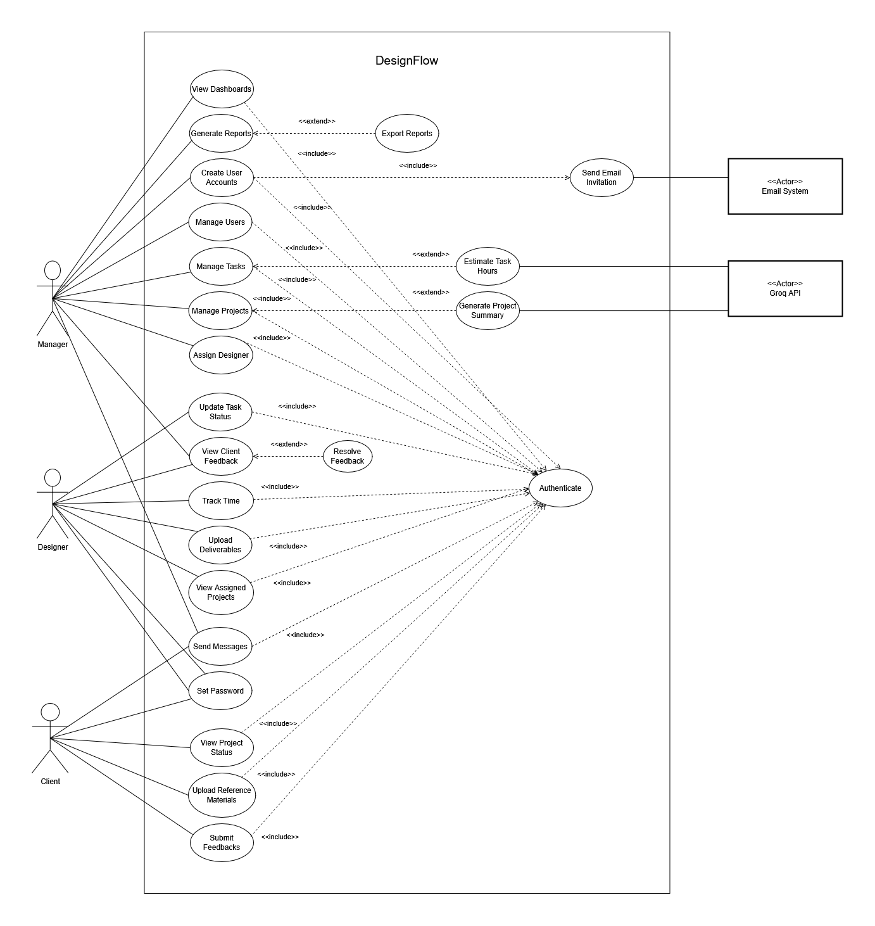
Figure 5: Use Case Diagram — Global View

4. Scrum Project Planning

4.1 Scrum Roles and Responsibilities
Product Owner: Mr. Jawhar Letaief defines and prioritizes the product backlog and business requirements.
Scrum Master: Mr. Trigui Omar manages the sprint cycle, helps with ceremonies, and fixes problems.
Developer: Mahdi Mlika implements all technical deliverables across the five sprints.

4.2 Product Backlog
The Product Backlog contains all 21 user stories for the project, organised by Epic and priority. Estimation is expressed in person-days. Stories are ordered by priority (Must Have → Should Have → Could Have) and dependency.
Table 11: Global Product Backlog
ID | Epic | User Story | Priority | Complexity | Est. (days)
US-01 | Authentication | As a Manager/Designer/Client, I want to authenticate so that I can access the platform. | 1 | Medium | 3
US-02 | Authentication | As a Designer/Client, I want to create my password so that I can secure my account after receiving an invitation. | 1 | Low | 2
US-03 | User Management | As a Manager, I want to create user accounts so that new members can access the platform. | 1 | Medium | 4
US-04 | User Management | As a Manager, I want to manage users so that I can view, edit, and deactivate accounts. | 1 | Medium | 5
US-05 | User Management | As a Manager, I want the system to send an email invitation when a user account is created. | 1 | Low | 2
US-06 | Project Management | As a Manager, I want to create a project with budget, deadline, and category, and edit or delete it at any time. | 1 | High | 5
US-07 | Project Management | As a Manager, I want to list all projects, view a detail page, assign designers, and filter results by status. | 1 | High | 6
US-08 | Project Management | As a Manager, I want to create, edit, and delete tasks linked to a project, with estimated hours, subtask support, and an unplanned-task flag to track scope creep. | 1 | Medium | 5
US-09 | Project Management | As a Designer, I want to see only the projects I am assigned to, with a budget progress bar showing hours used versus budget. | 1 | Low | 3
US-10 | Task & Deliverables | As a Designer, I want to log time on a task so that my effort is accurately tracked against the project budget. | 2 | Medium | 4
US-11 | Task & Deliverables | As a Designer, I want to update the task status so that the team knows the current progress without having to ask. | 2 | Low | 2
US-12 | Task & Deliverables | As a Designer, I want to upload deliverables so that clients and managers can review the completed outputs directly on the platform. | 2 | Medium | 4
US-13 | Feedback & Messaging | As a Manager/Designer, I want to view client feedback so that I can understand and act on client comments on my deliverables. | 2 | Low | 3
US-14 | Feedback & Messaging | As a Manager/Designer, I want to reply to feedback so that I can communicate directly with the client. | 3 | Medium | 3
US-15 | Feedback & Messaging | As a Manager/Designer/Client, I want to send messages so that I can communicate with other platform users. | 2 | High | 6
US-16 | Client Portal | As a Client, I want to view the project status so that I can monitor progress without contacting the team. | 2 | Medium | 4
US-17 | Client Portal | As a Client, I want to upload reference materials so that the design team has the context they need. | 3 | Medium | 3
US-18 | Client Portal | As a Client, I want to submit feedback so that I can share my opinions on the delivered work. | 2 | Medium | 4
US-19 | Reporting & Analytics | As a Manager, I want to view dashboards so that I can monitor project profitability at a glance. | 1 | High | 8
US-20 | Reporting & Analytics | As a Manager, I want to generate reports so that I can analyse detailed performance and financial data. | 1 | High | 7
US-21 | Reporting & Analytics | As a Manager, I want to export reports so that I can share or archive results outside the platform. | 3 | Medium | 3

4.3 Sprint Planning Overview
The 21 user stories are distributed across five 2-week sprints, ordered by priority and inter-sprint dependency. Table 12 provides a high-level view of each sprint's goal, included stories, and estimated effort. Detailed sprint checklists are presented in Chapters 4 through 9.
Table 12: Sprint Planning Overview
Sprint | Sprint Goal | User Stories | Duration | Est. (days)
Sprint 1 — Foundation & Auth | Authentication, password creation, and user management are fully operational. | US-01, US-02, US-03, US-04, US-05 | 2 weeks | 16
Sprint 2 — Project & Task Management | Managers can create and manage projects and tasks.  Designers can view their assigned projects. | US-06, US-07, US-08, US-09 | 2 weeks | 19
Sprint 3 — Time Tracking & Deliverables | Designers can log time, update task status, upload deliverables, and view client feedback. | US-10, US-11, US-12, US-13 | 2 weeks | 13
Sprint 4 — Client Portal & Feedback | Clients can view project status, upload reference materials, and submit feedback.  Designers and Managers can view, respond to, and resolve all feedback items. | US-14, US-15, US-16, US-17, US-18 | 2 weeks | 20
Sprint 5 — BI Dashboards & Reports | Manager BI dashboards are operational with KPI cards, budget vs. actual charts, EHR, client profitability, designer utilisation, and scope creep index.  Report generation with filters, PDF and Excel export. | US-19, US-20, US-21 | 2 weeks | 18

4.4 Project Gantt Chart
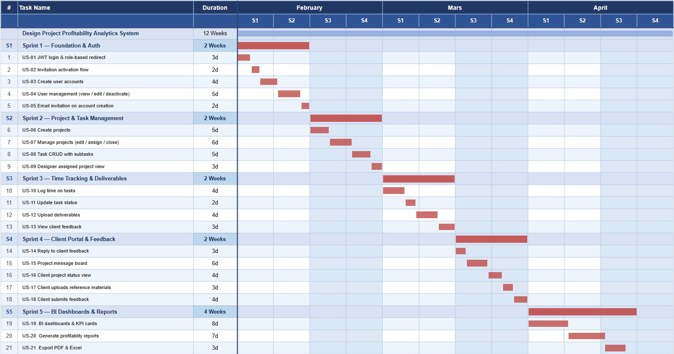
Figure 6 provides a temporal view of the five-sprint development timeline. Each sprint block covers two weeks.
Figure 6: Gantt Chart — Five-Sprint Development Timeline

5. Development Environment

5.1 Hardware Environment
Table 13: Hardware Development Environment
Component | Specification
Development Machine | Personal laptop — Windows 11 Pro
System Type | 64-bit Operating System, x64-Based Processor
Processor | AMD Ryzen 7 7735HS with Radeon Graphics
RAM | 16.0 GB
Storage | 512 GB SSD
Browser |   Mozilla Firefox

5.2 Software and Development Tools
Table 14: Software and Development Environment
Category | Tool / Version | Purpose
Backend Runtime |   Python 3.12 | Server-side language
Web Framework |   Django 5.0 | Backend framework and ORM
API Layer | 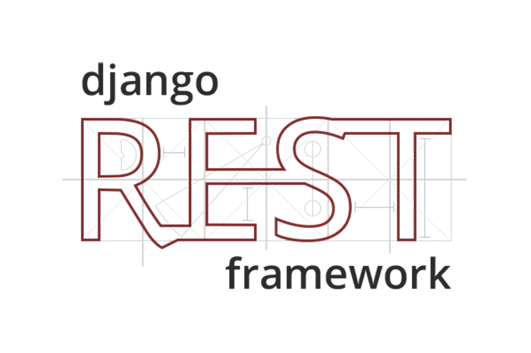  Django REST Framework 3.15 | REST API serialisation and views
Database |   PostgreSQL 16 | Primary data store
Frontend Runtime |   Node.js 20 (npm) | Frontend package management
Build Tool |   Vite 5 | Frontend dev server and build
Frontend Framework |   React 19 +  TypeScript | SPA and type-safe components
IDE |   Visual Studio Code | Code editing, extensions, debugging
API Testing |   Thunder Client (VS Code extension) | Manual endpoint testing
Diagramming |   draw.io | All UML diagrams
Scrum |   Trello | Scrum boards
Version Control |     Git + GitHub | Source code management
Virtualenv |   Python venv | Python dependency isolation

6. System Architecture

6.1 Physical Architecture
The system follows a three-component deployment topology: a static host serving the compiled React SPA, a Python WSGI host running the Django REST API, and a managed PostgreSQL instance. All communication between the SPA and the API occurs over HTTPS. The database is accessible only from the API host and is not exposed to the public internet.
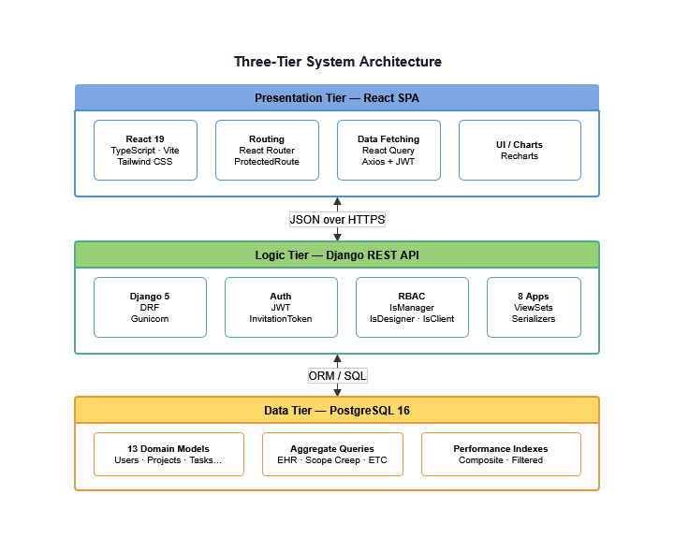
Figure 7: Three-Tier System Architecture

6.2 Logical / Software Architecture
The Django backend is organised into eight domain apps: users, projects, tasks, timelog, feedback, messages, files, and analytics. The analytics app is different from the others because it doesn't have any models, it only has views that run aggregate queries across the other apps. Not having models in the analytics app keeps aggregate query logic from mixing with domain models.
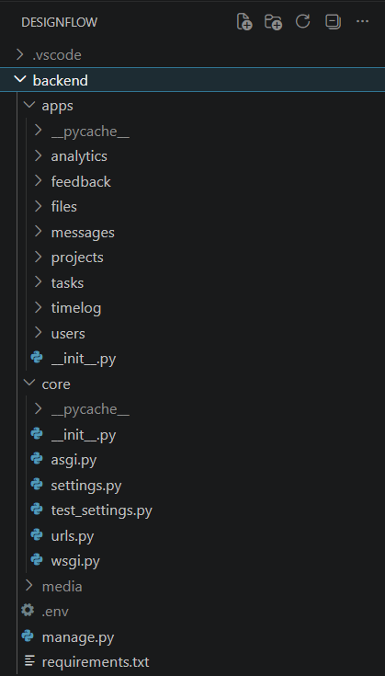
Figure 8: Backend Directory Structure

The React frontend has separate api/, hooks/, types/, pages/, and components/ folders that are similar to this structure. Each resource has its own typed API functions, React Query hooks, and TypeScript interfaces. This makes sure that the type contract between the backend and frontend is clear.
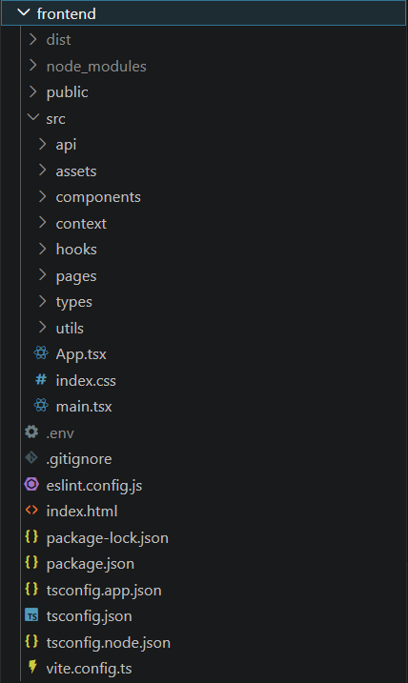
Figure 9: Frontend Directory Structure

6.3 Architecture Rationale
The choice of a strict three-tier separation with all business logic in the API layer (rather than partly in the frontend) is a security decision as much as a structural one. The system makes sure that a client who changes URL parameters or intercepts API responses can't get to other clients' data by enforcing RBAC at the API boundary with both permission classes and query-level filtering. The frontend's role is presentation only.

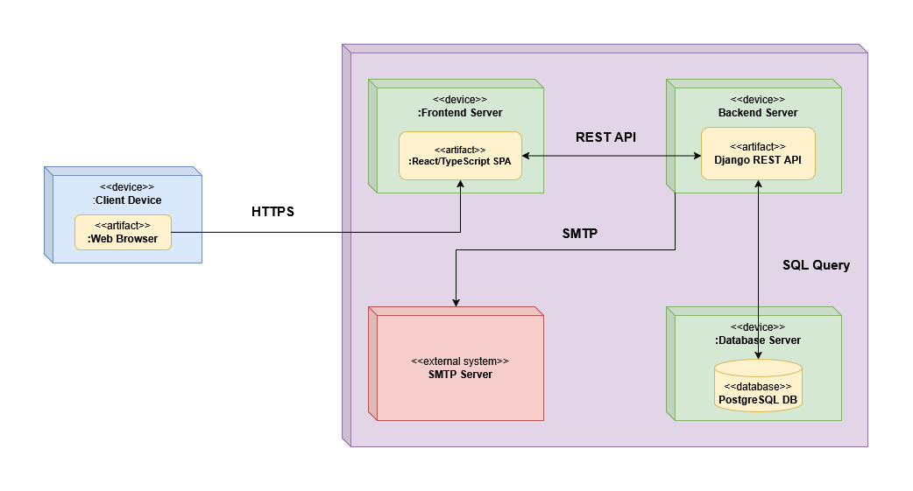
6.4 Deployment Diagram

Figure 10: Deployment Diagram

7. Global Data Model

7.1 Global Class Diagram
The class diagram models all thirteen domain objects and their relationships. The central entity is Project, which aggregates Tasks (with optional subtask nesting via a self-referential foreign key), time-logged by Designers through time logs, and feedback submitted by Clients. The User entity drives authentication. Role-differentiated profiles (Designer and Client) are attached via one-to-one relationships
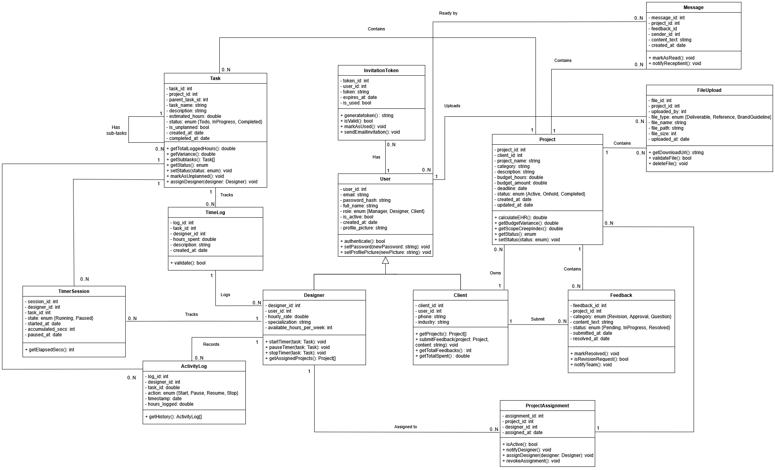
Figure 11: Global Class Diagram

7.2 Entity-Relationship Diagram
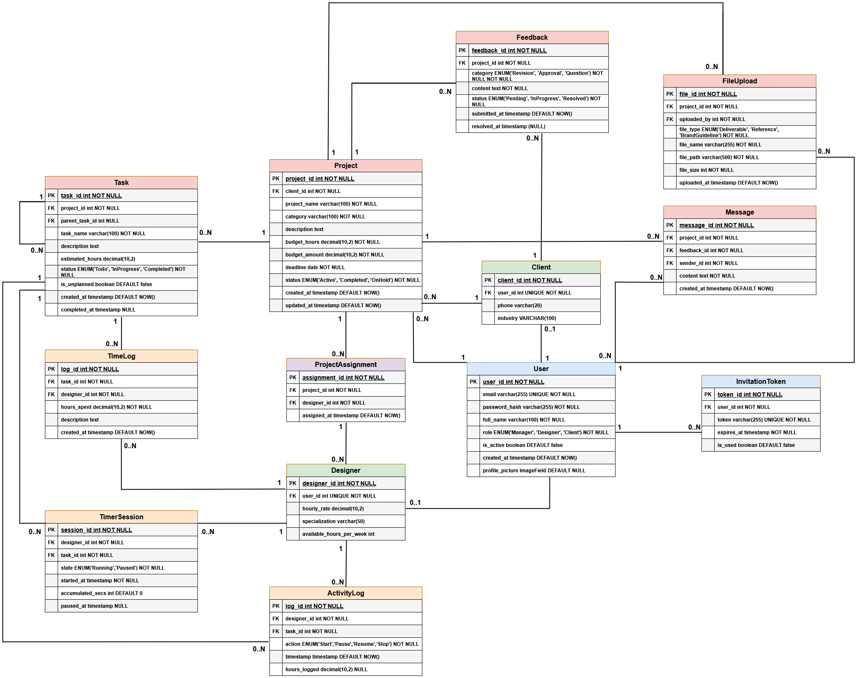
Figure 12: Entity-Relationship Diagram

7.3 Relational Schema
The relational schema below presents all thirteen entities with their attributes. Foreign keys are denoted with the # symbol.
User (user_id, email, full_name, password, role, is_active, is_staff, created_at, profile_picture).
Designer (designer_id, #user_id, hourly_rate, specialization, available_hours_per_week).
Client (client_id, #user_id, phone, industry).
InvitationToken (token_id, #user_id, token, expires_at, is_used).
Project (project_id, #client_id, project_name, description, budget_hours, budget_amount, deadline, status, category, created_at, updated_at).
ProjectAssignment (assignment_id, #project_id, #designer_id, assigned_at).
Task (task_id, #project_id, #parent_task_id, task_name, description, estimated_hours, status, is_unplanned, created_at, completed_at).
TimeLog (log_id, #task_id, #designer_id, hours_spent, description, created_at).
TimerSession (session_id, #designer_id, #task_id, state, started_at, accumulated_secs, paused_at).
ActivityLog (log_id, #designer_id, #task_id, action, timestamp, hours_logged).
Feedback (feedback_id, #project_id, category, content_text, status, submitted_at, resolved_at).
Message (message_id, #project_id, #feedback_id, #sender_id, content_text, created_at).
FileUpload (file_id, #project_id, #uploaded_by, file_type, file_name, file_path, file_size, uploaded_at).

8. Chapter Conclusion
Sprint 0 produced the complete artefact set required before development begins: a prioritised backlog of 21 user stories, a three-tier architecture with deployment diagram, and a global data model covering all thirteen entities. Chapter 4 documents Sprint 1, in which the Django and React scaffolds are built, all models are migrated, and the full authentication and onboarding flow is delivered.

Chapter 4 — Sprint 1: Foundation and Authentication

1. Introduction
Sprint 1 covers five user stories (US-01 through US-05), estimated at 16 person-days. The goal is to have authentication, password creation, and user management fully working by the end of the sprint, nothing else in the system can be tested without them.

2. Sprint 1 Backlog
Table 15 lists all user stories included in Sprint 1, their module, complexity, and estimated effort in person-days.
Table 15: Sprint 1 Backlog
ID | Epic | User Story | Priority | Complexity | Est.
US-01 | Authentication | As a Manager/Designer/Client, I want to authenticate so that I can access the platform. | 1 | Medium | 3
US-02 | Authentication | As a Designer/Client, I want to create my password so that I can secure my account after receiving an invitation. | 1 | Low | 2
US-03 | User Management | As a Manager, I want to create user accounts so that new members can access the platform. | 1 | Medium | 4
US-04 | User Management | As a Manager, I want to manage users so that I can view, edit, and deactivate accounts. | 1 | Medium | 5
US-05 | User Management | As a Manager, I want the system to send an email invitation when a user account is created. | 1 | Low | 2

3. Functional Specification

3.1 Sprint 1 Use Case Diagram
Figure 13 presents the use cases addressed in Sprint 1. All three internal actors interact with the Authenticate use case. The Manager additionally triggers the Send Email Invitation use case through the Create User Account action, which involves the external Email System actor.
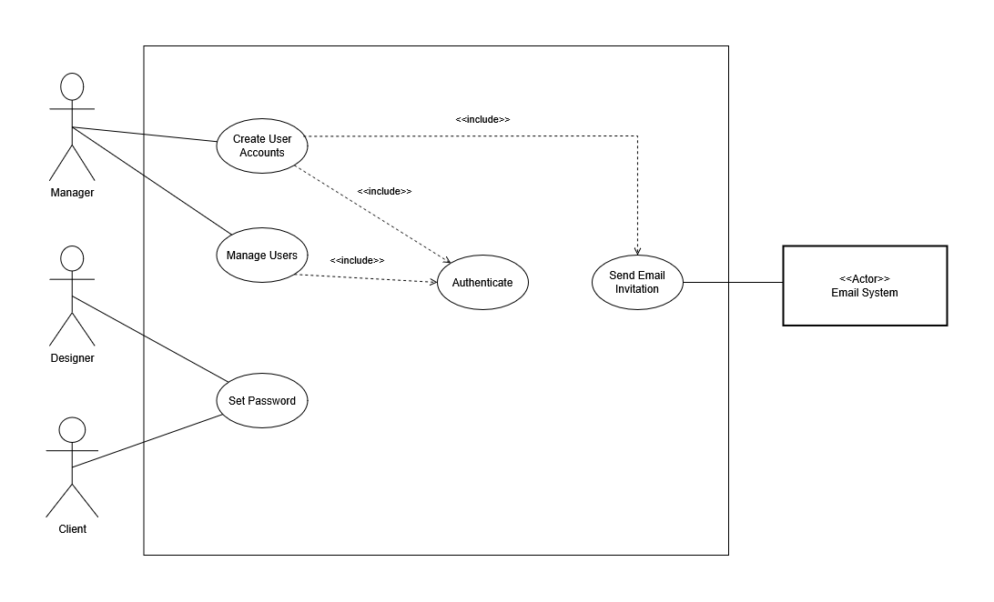
Figure 13: Sprint 1 Use Case Diagram

3.2 Textual Description of Use Cases

3.2.1 Use Case: Authenticate
Table 16: Textual Description of Use Case: Authenticate
Use Case: Authenticate
Actor(s) | Manager, Designer, Client
Description | Allows any registered user to sign in to the platform using their email address and password, and to access their role-specific workspace.
Pre-condition(s) | The user account exists and has been activated.
Post-condition(s) | The user is signed in and redirected to their personal dashboard (Manager, Designer, or Client view depending on their role).
Base Scenario | 1. The user opens the login page.  2. The user enters their email address and password, then clicks Sign In.  3. The system verifies the credentials.  4. The system identifies the user's role.  5. The user is redirected to their role-specific dashboard.
Other Scenarios | 3.a Wrong email or password:  1. The system displays the message "Invalid email or password."  3.b Deactivated account:  1. The system rejects the sign-in attempt and displays an appropriate message.

3.2.2 Use Case: Set Password
Table 17: Textual Description of Use Case: Set Password
Use Case: Set Password
Actor(s) | Manager, Designer, Client
Description | Allows a newly invited user to set their own password by clicking the activation link received by email.
Pre-condition(s) | The Manager has created the user account.  The user has received the invitation email containing a unique activation link.  The link has not yet been used and has not expired.
Post-condition(s) | The account is activated and the user can sign in.
Base Scenario | 1. The user clicks the activation link in the invitation email.  2. The system displays a password creation form.  3. The user enters and confirms their new password.  4. The system validates the password and activates the account.  5. The user is directed to the login page with a confirmation message.
Other Scenarios | 4.a Activation link has expired (48-hour limit reached):  1. The system displays the message "This invitation link has expired."  2. The Manager must send a new invitation.  4.b Activation link has already been used:  1. The system displays the message "This link has already been used."  2. The user is directed to the login page.

3.2.3 Use Case: Create User Account
Table 18: Textual Description of Use Case: Create User Account
Use Case: Create User Account
Actor(s) | Manager
Description | Allows the Manager to register a new user on the platform by providing their name, email address, and role. The system automatically sends the new user an invitation email with an activation link.
Pre-condition(s) | The Manager is signed in.  The email address provided does not already belong to an existing account.
Post-condition(s) | The user account is created in an inactive state.  An invitation email has been sent to the new user.  The account becomes active once the user sets their password.
Base Scenario | 1. The Manager opens the Django Admin Panel.  2. The Manager fills in the new user's full name, email address, and role (Designer or Client).  3. The Manager confirms the creation.  4. The system creates the account and generates a secure, time-limited activation link.  5. The system automatically sends an invitation email to the new user containing the activation link.
Other Scenarios | 3.a Email address already in use:  1. The system displays an error message and the account is not created.

3.2.4 Use Case: Manage Users
Table 19: Textual Description of Use Case: Manage Users
Use Case: Manage Users
Actor(s) | Manager
Description | Allows the Manager to view the list of all platform users, edit their details, and deactivate accounts when necessary.
Pre-condition(s) | The Manager is signed in.
Post-condition(s) | The selected user's account reflects the changes made.  A deactivated user can no longer sign in to the platform.
Base Scenario | 1. The Manager opens the user management section.  2. The system displays the full list of users with their role and account status.  3. The Manager selects a user to view or edit their details.  4. The Manager updates the relevant information (name, role, or account status) and saves the changes.

4. Conception

4.1 Sequence Diagrams
Figure 14 and Figure 15 model the primary dynamic flows implemented in Sprint 1.

4.1.1 Sequence Diagram: Authenticate
The authentication sequence models the JWT login flow and the Axios interceptor token-refresh path.
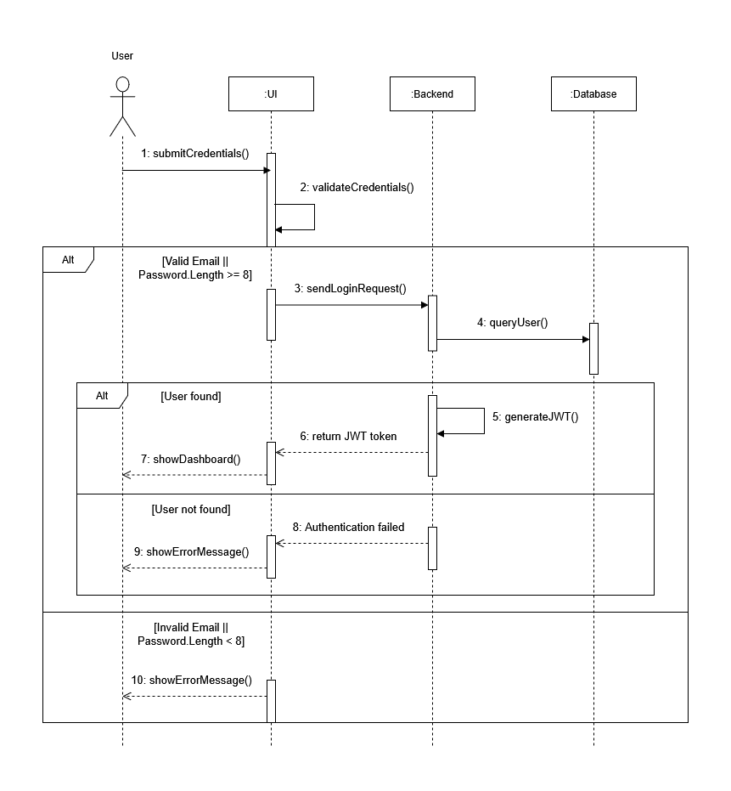
Figure 14: Sequence Diagram — Authenticate

4.1.2 Sequence Diagram: User Onboarding — Create & Activate Account
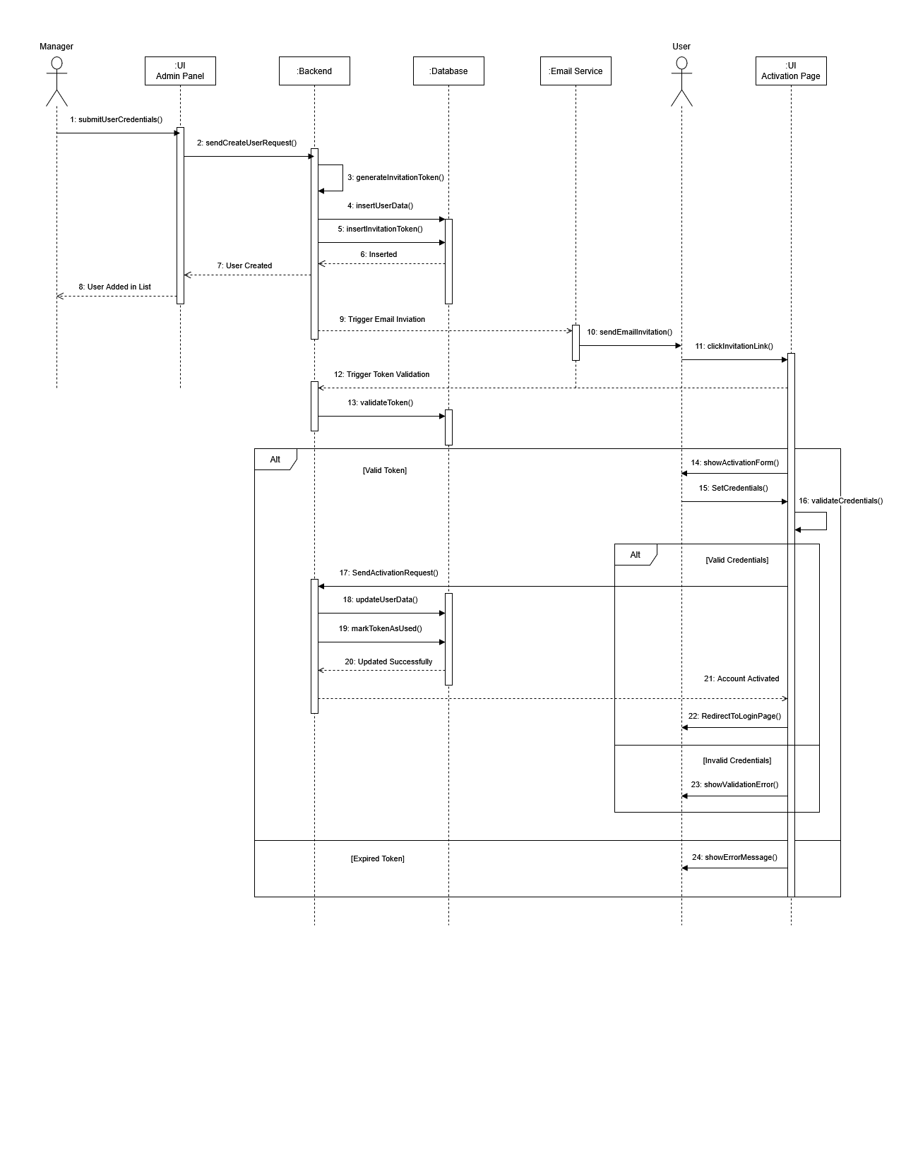
This sequence covers the invitation-based onboarding flow: account creation, token generation, email dispatch, and activation.

Figure 15: Sequence Diagram — User Onboarding

4.2 Class Diagram
Figure 16 presents the four domain models introduced in Sprint 1. User is the central auth model. Designer and Client each extend it via a one-to-one link, separating role-specific fields from auth data.
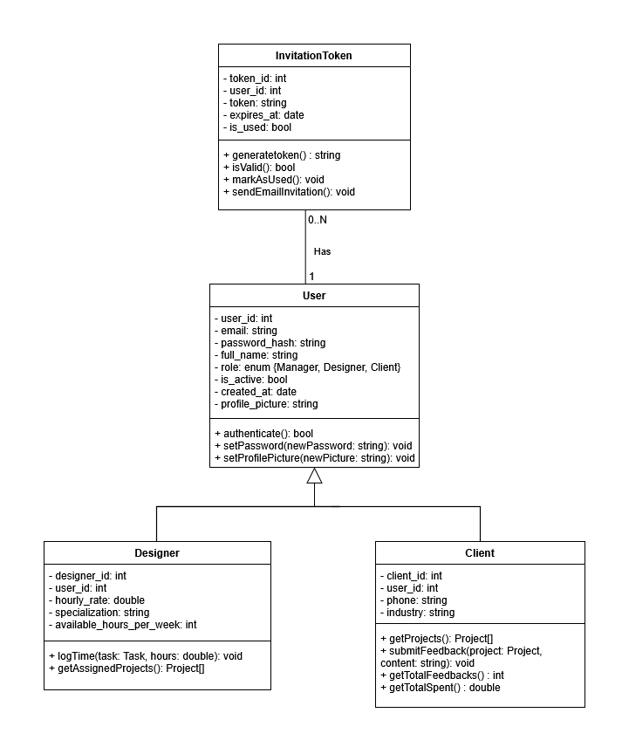
Figure 16: Sprint 1 Class Diagram

5. Interface Realisation
Figure 17–Figure 25 present the Sprint 1 deliverables.

5.1 Django Admin Panel & User Management
Figure 17 shows the Django administration panel used by the Manager. Figure 18 illustrates the account creation form, and Figure 19 shows the resulting user management list with role and status visible per entry.
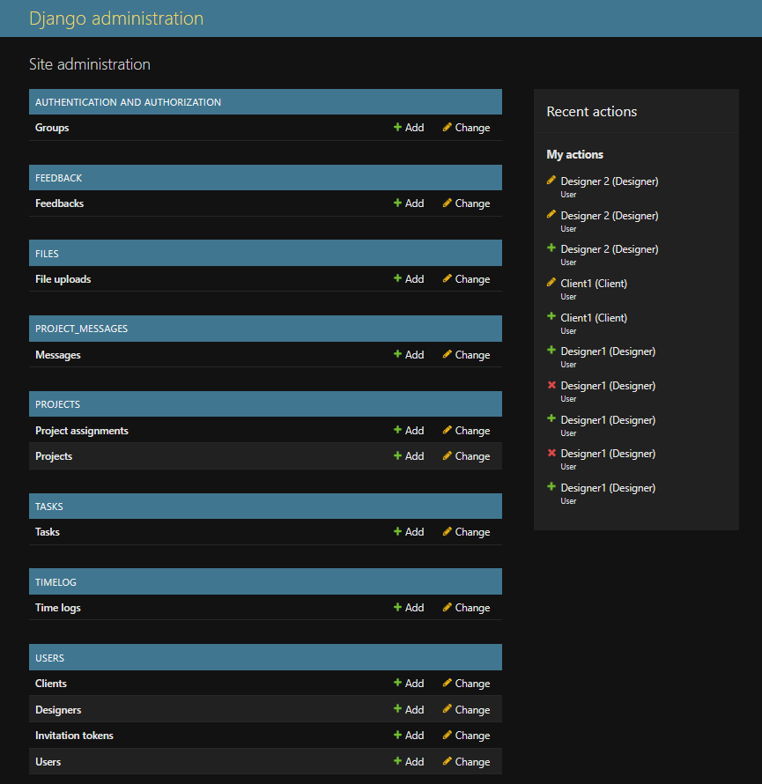
Figure 17: Django Admin Panel
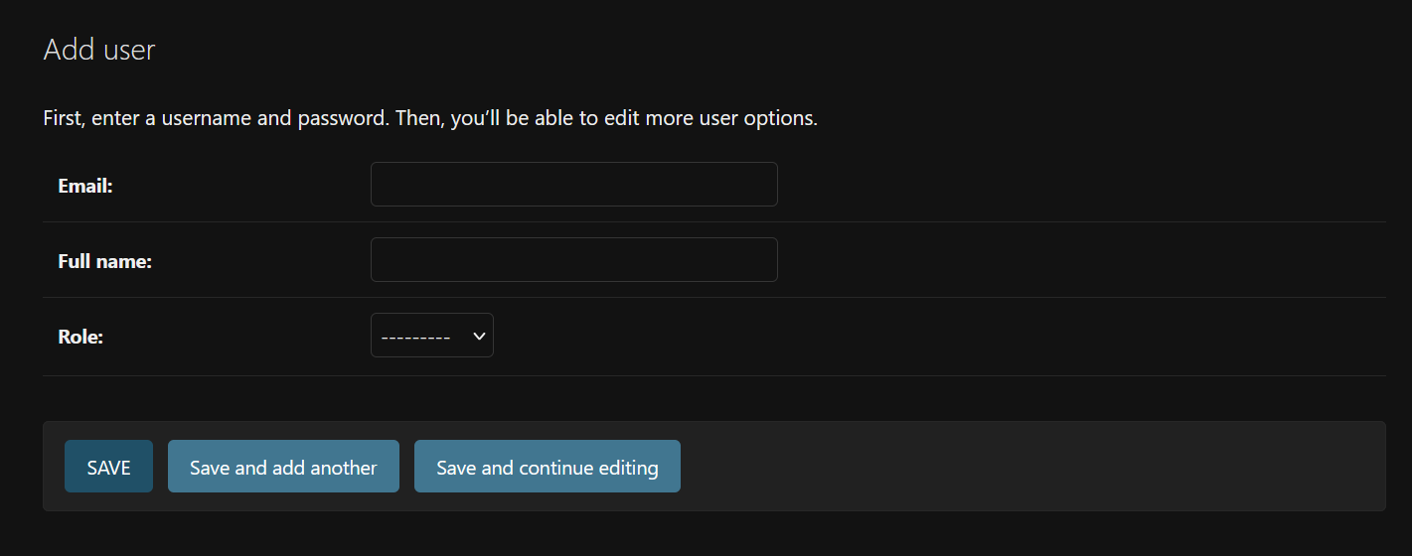
Figure 18: Account Creation
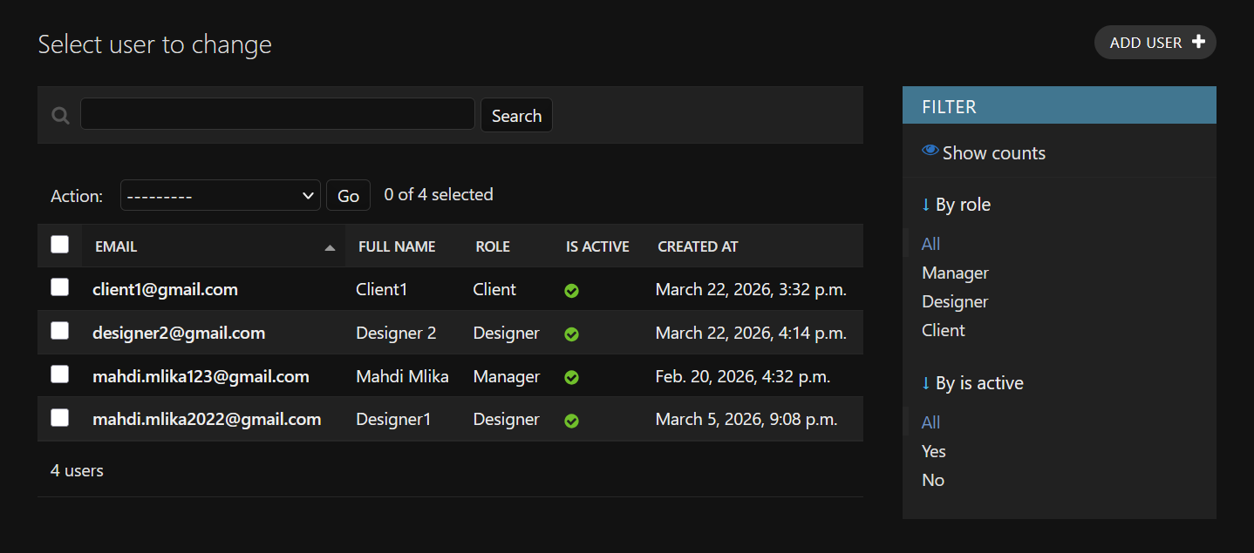
Figure 19: User Management

5.2 Login Interface
Figure 20 shows the login interface, a centred card with email and password fields. On success, the user is redirected to their role-specific dashboard.

Figure 20: Login Interface

5.3 Account Activation Interface
Figure 21 shows the invitation email received by a newly created user. Figure 22 shows the password creation form reached via the activation link.
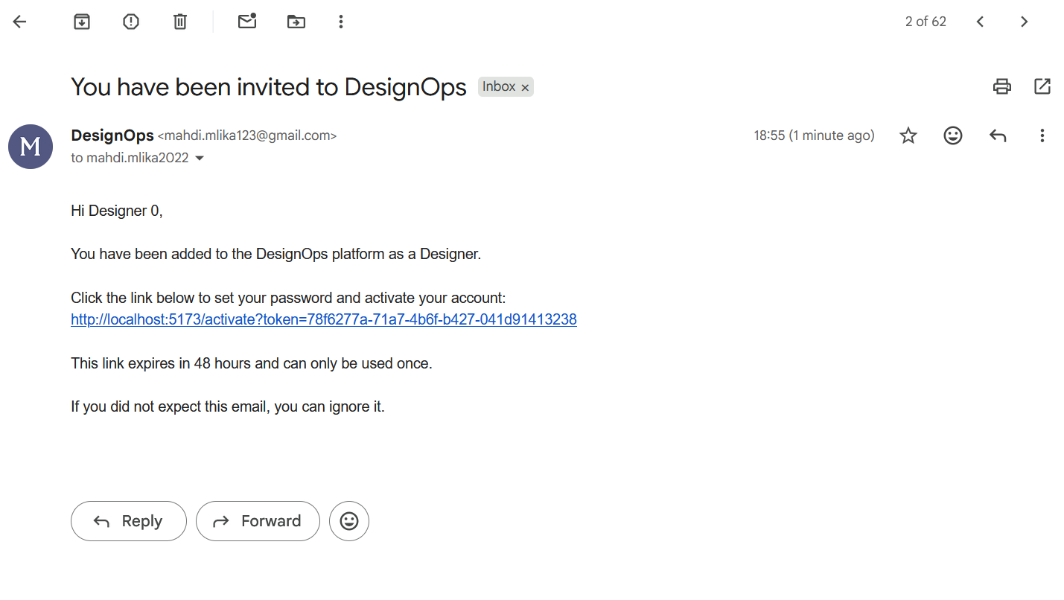
Figure 21: Activation Email
Figure 22: Account Activation Interface

5.4 Role-Based Dashboard Stubs
Figure 23, Figure 24, and Figure 25 show the three role-specific dashboard stubs: Manager, Designer, and Client respectively.
Figure 23: Manager Dashboard
Figure 24: Designer Dashboard
Figure 25: Client Dashboard

6. Testing
Table 20 shows a representative sample of the Thunder Client API test results. Each row corresponds to one test scenario.
Table 20: Sprint 1 Test Results
Endpoint / Action | Method | Scenario | Expected result | Outcome
/api/auth/token/ | POST | Valid credentials | Access & refresh tokens returned | ✔ Pass
/api/auth/token/ | POST | Incorrect password or inactive account | Error message | ✔ Pass
/api/auth/token/refresh/ | POST | Valid refresh token | New access token generated | ✔ Pass
/api/auth/activate/ | POST | Valid token, unused, not expired | Account activated | ✔ Pass
/api/auth/activate/ | POST | Expired or already-used token | Error message | ✔ Pass
Post-login redirect | UI | Login with Manager role | Redirect to Manager dashboard (/manager) | ✔ Pass
Post-login redirect | UI | Login with Designer role | Redirect to Designer dashboard (/designer) | ✔ Pass
Full invitation flow | UI | Click invitation link received by e-mail | Password set → account activated → redirect to /login | ✔ Pass

7. Sprint Tracking

7.1 Scrum Board
Figure 26 shows the Sprint 1 Scrum board at sprint close, all five user stories have been accomplished.
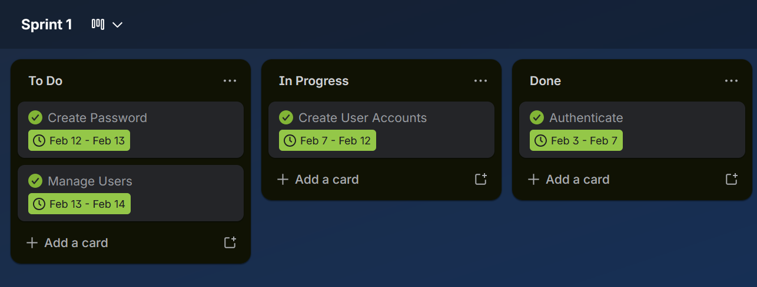
Figure 26: Sprint 1 Scrum Board

7.2 Burndown Chart
Figure 27 plots actual remaining effort against the ideal burndown.
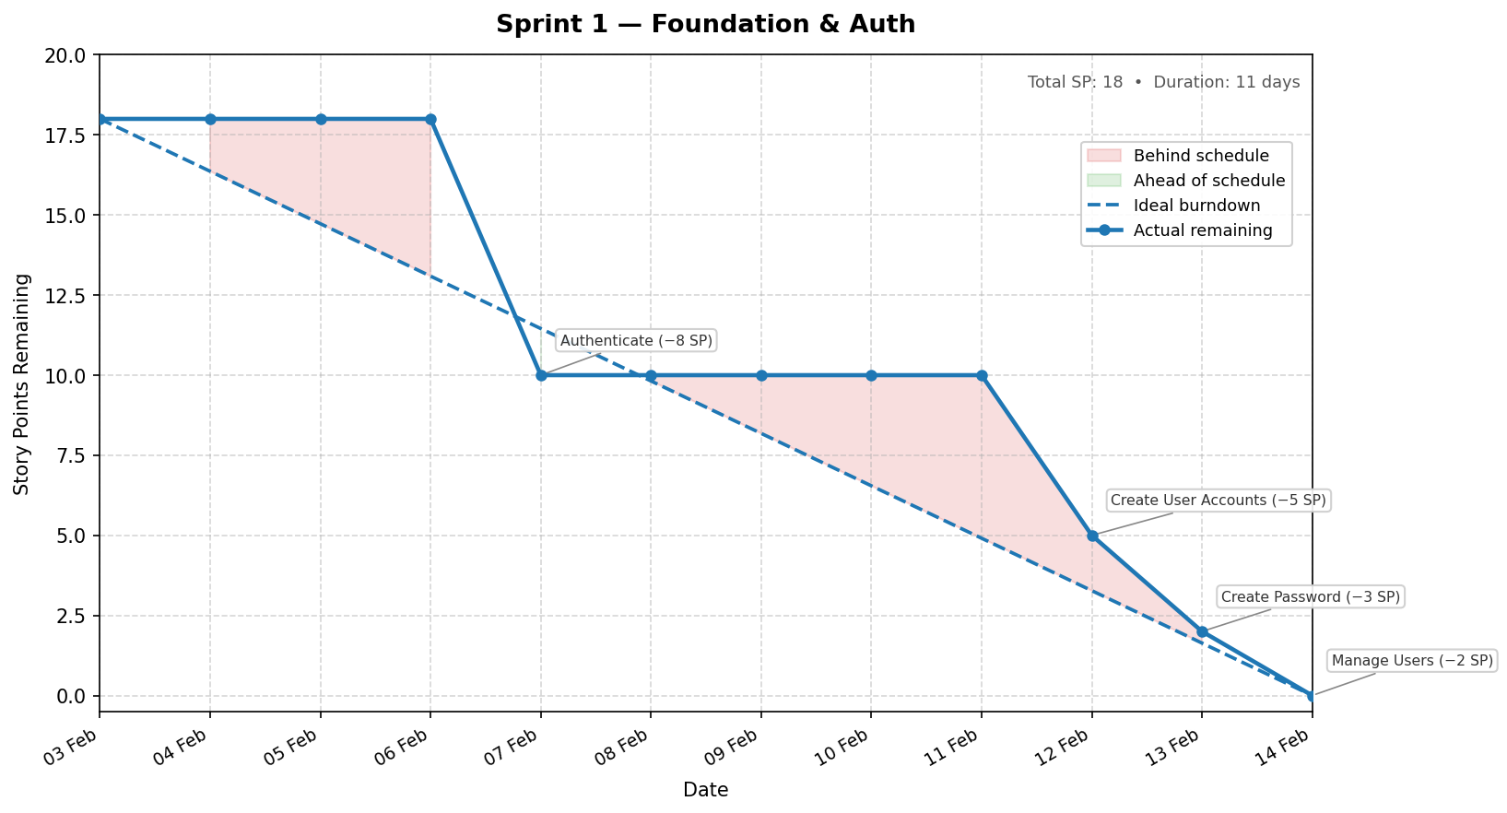
Figure 27: Sprint 1 Burndown Chart

Chapter Conclusion
Authentication and onboarding are complete, and all thirteen models are migrated. Sprint 2 builds the project and task management layer on top of this foundation.

Chapter 5 — Sprint 2: Project and Task Management

1. Introduction
Sprint 2 covers five user stories — US-06 through US-09, estimated at 15 person-days. The goal is to make the application usable for end-to-end project management: a Manager must be able to create a project, assign designers, break it into tasks with estimates, and monitor budget utilization. a Designer must be able to see the projects they are responsible for.

2. Sprint 2 Backlog
Table 21 lists all user stories included in Sprint 2, their assigned role, complexity, and estimated effort in person-days.
Table 21: Sprint 2 Backlog
ID | Epic | User Story | Priority | Complexity | Est.
US-06 | Project Management | As a Manager, I want to create a project with budget, deadline, and category, and edit or delete it at any time. | 1 | Medium | 5
US-07 | Project Management | As a Manager, I want to list all projects, view a detail page, assign designers, and filter results by status. | 1 | Medium | 6
US-08 | Project Management | As a Manager, I want to create, edit, and delete tasks linked to a project, with estimated hours, subtask support, and an unplanned-task flag to track scope creep. | 1 | Medium | 5
US-09 | Project Management | As a Designer, I want to see only the projects I am assigned to, with a budget progress bar showing hours used versus budget. | 2 | Low | 3

3. Functional Specification

3.1 Sprint 2 Use Case Diagram
Figure 28 presents the use cases addressed in Sprint 2. The Manager is the primary actor with create, edit, delete, and assignment capabilities. The Designer participates with a read-only view of assigned projects. The Estimate Task Hours use case is initiated by the Manager and delegates to the Groq API as an external system.
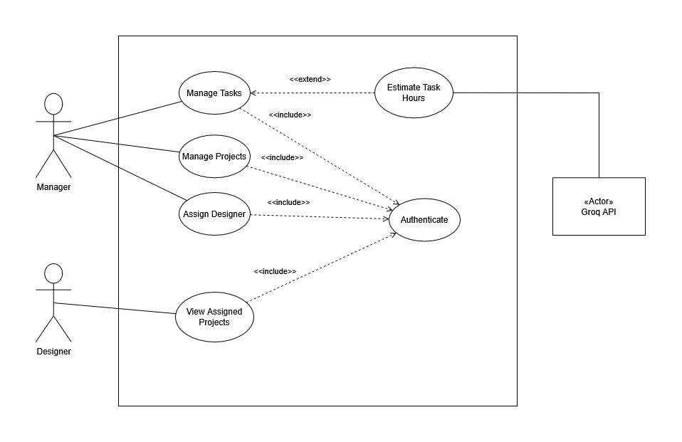
Figure 28: Sprint 2 Use Case Diagram

3.2 Textual Description of Use Cases

3.2.1 Use Case: Manage Projects
Table 22: Textual Description of Use Case: Manage Projects
Use Case: Manage Projects
Actor(s) | Manager
Description | Allows the Manager to create new projects by specifying client, budget, deadline, and category, and to subsequently edit, update the status of, or delete any project.
Pre-condition(s) | The Manager is signed in.  At least one Client account exists in the system.
Post-condition(s) | A Project record exists in the database and appears in the Manager's project list.
Base Scenario | 1. The Manager navigates to the Projects section.  2. The Manager selects Create Project.  3. The Manager fills in the project details.  4. The system validates the input and persists the record with status Active.
Other Scenarios | 3.a Missing required fields:  1. The system returns field-level error messages.

3.2.2 Use Case: Assign Designer
Table 23: Textual Description of Use Case: Assign Designer
Use Case: Assign Designer
Actor(s) | Manager
Description | Allows the Manager to assign one or more Designers to an existing project, granting them access to its detail page and task list.
Pre-condition(s) | The Manager is signed in.  The project exists.  The target user has role Designer and an associated Designer profile.
Post-condition(s) | The designer gains access to the project and its task list.
Base Scenario | 1. The Manager opens the project detail page.  2. The Manager selects a Designer from the assignment panel.  3. The system creates a project assignment record linking the Designer to the project.  4. The Designer's project list is updated on their next request.
Other Scenarios | 4.a Designer already assigned:  1. The system displays the message "This designer is already assigned to this project." and no duplicate record is created.

3.2.3 Use Case: Manage Tasks
Table 24: Textual Description of Use Case: Manage Tasks
Use Case: Manage Tasks
Actor(s) | Manager
Description | Allows the Manager to create, edit, and delete tasks linked to a project, with estimated hours, optional subtask nesting via a parent task, and an unplanned flag to identify scope creep.
Pre-condition(s) | The Manager is signed in.  A Project exists.
Post-condition(s) | Task records are linked to the project.  Estimated hours feed into budget variance calculations.  Tasks flagged as unplanned are counted in the Scope Creep Index.
Base Scenario | 1. The Manager opens the task list for a project.  2. The Manager selects Create Task.  3. The Manager fills the task details.  4. The system persists the Task record with status Todo.
Other Scenarios | 3.a Unplanned flag set:  1. The task is marked with a scope-creep badge in the UI and is counted in the Scope Creep Index metric.  3.b Parent task specified:  1. The task is created as a subtask nested under the selected parent task.

3.2.4 Use Case: View Assigned Projects
Table 25: Textual Description of Use Case: View Assigned Projects
Use Case: View Assigned Projects
Actor(s) | Designer
Description | Allows the Designer to view the list of projects they are assigned to, each showing its status, deadline, and a budget progress bar.
Pre-condition(s) | The Designer is signed in.  At least one project assignment links this Designer to a project.
Post-condition(s) | The Designer can navigate to any assigned project detail page.
Base Scenario | 1. The Designer navigates to their dashboard.  2. The system returns only the projects they are assigned to.  3. The Designer selects a project to access its detail page.
Other Scenarios | 2.a No assignments exist:  1. The list is empty and the UI displays an informational message.

3.2.5 Use Case: Estimate Task Hours
Table 26: Textual Description of Use Case: Estimate Task Hours
Use Case: Estimate Task Hours
Actor(s) | Manager
Description | Allows the Manager to request an AI-generated hour estimate for a new task. The system retrieves relevant historical time logs from the same project and submits them as context to the Groq API, which returns a suggested estimate with plain-English reasoning.
Pre-condition(s) | The Manager is signed in.  A project exists.
Post-condition(s) | A suggested estimate is displayed as advisory content.
Base Scenario | 1. The Manager fills in the task name and description.  2. The Manager clicks Estimate Hours.  3. The system queries up to 10 recent time log records from the same project.  4. The system constructs a prompt embedding the retrieved context and sends it to the Groq API.  5. The AI service returns a suggested estimate and a plain-English justification.  6. The system displays the suggestion in an advisory card below the Estimated Hours field.  7. The Manager accepts the suggestion or dismisses it.
Other Scenarios | 4.a Groq API timeout or error:  1. The system returns an error message.  3.b No historical data in project:  1. The system sends the prompt without context.  2. The model returns a generic estimate based on the task description alone.

4. Conception

4.1 Sequence Diagrams
Figure 29 and Figure 30 model the two primary dynamic flows implemented in Sprint 2.

4.1.1 Sequence Diagram: Manage Projects & Assign Designer
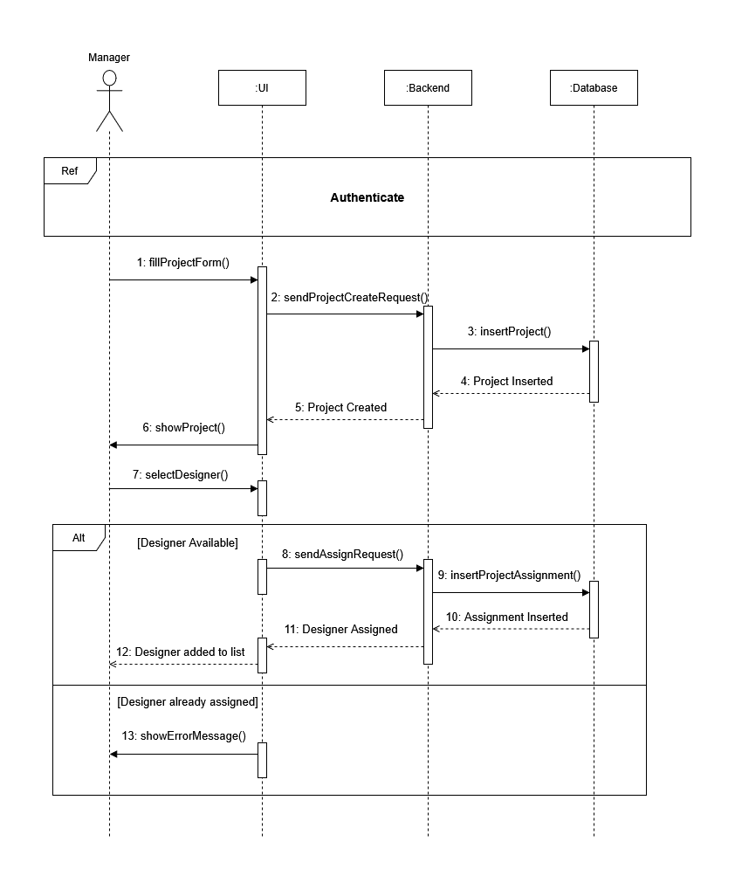
Figure 29: Sequence Diagram — Manage Projects & Assign Designer

4.1.2 Sequence Diagram: Manage Tasks & Estimate Task Hours
The task management feature allows the Manager to decompose each project into tasks and subtasks, each carrying a name, an estimated duration and a status (To Do, In Progress, Completed).
To assist the Manager during task creation, an AI-powered hour estimator is available. On demand, the system queries the project’s historical time logs, filters entries with similar task names, and forwards this contextual data to the language model, which returns a suggested duration along with a brief justification.
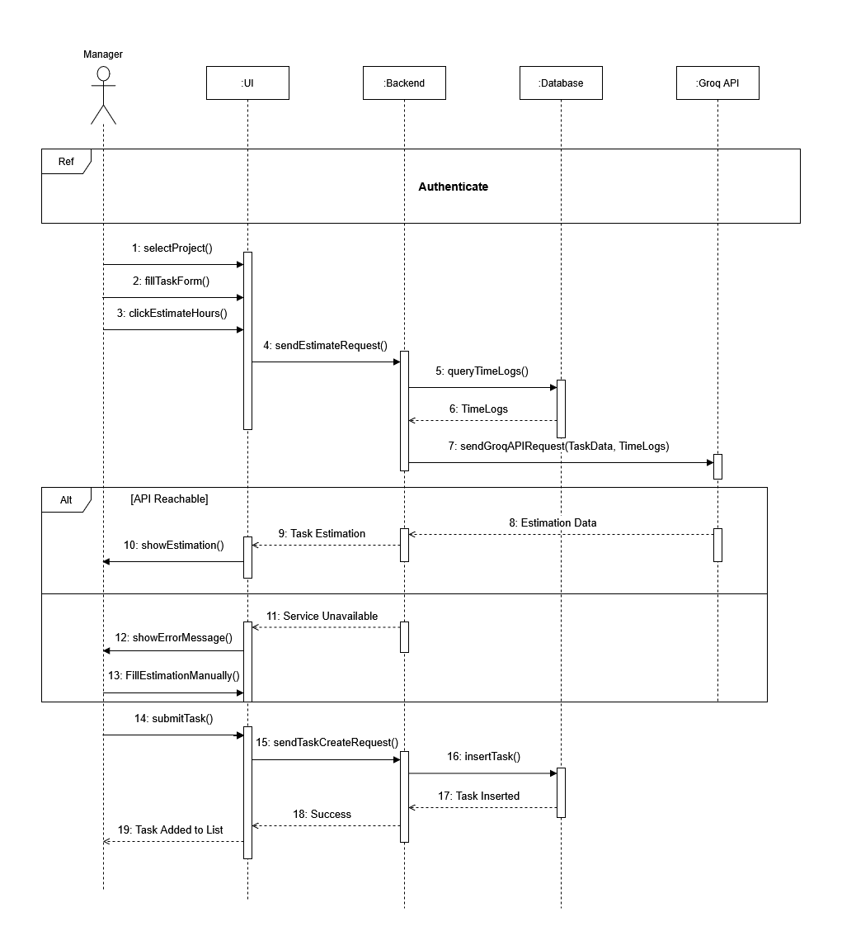
Figure 30: Sequence Diagram — Manage Tasks

4.2 Class Diagram
Figure 31 presents the three domain models introduced in Sprint 2. Project links the Client to its tasks and assignments. Task adds a self-referential parent link for subtask nesting and an unplanned flag that feeds the Scope Creep Index in Sprint 5.
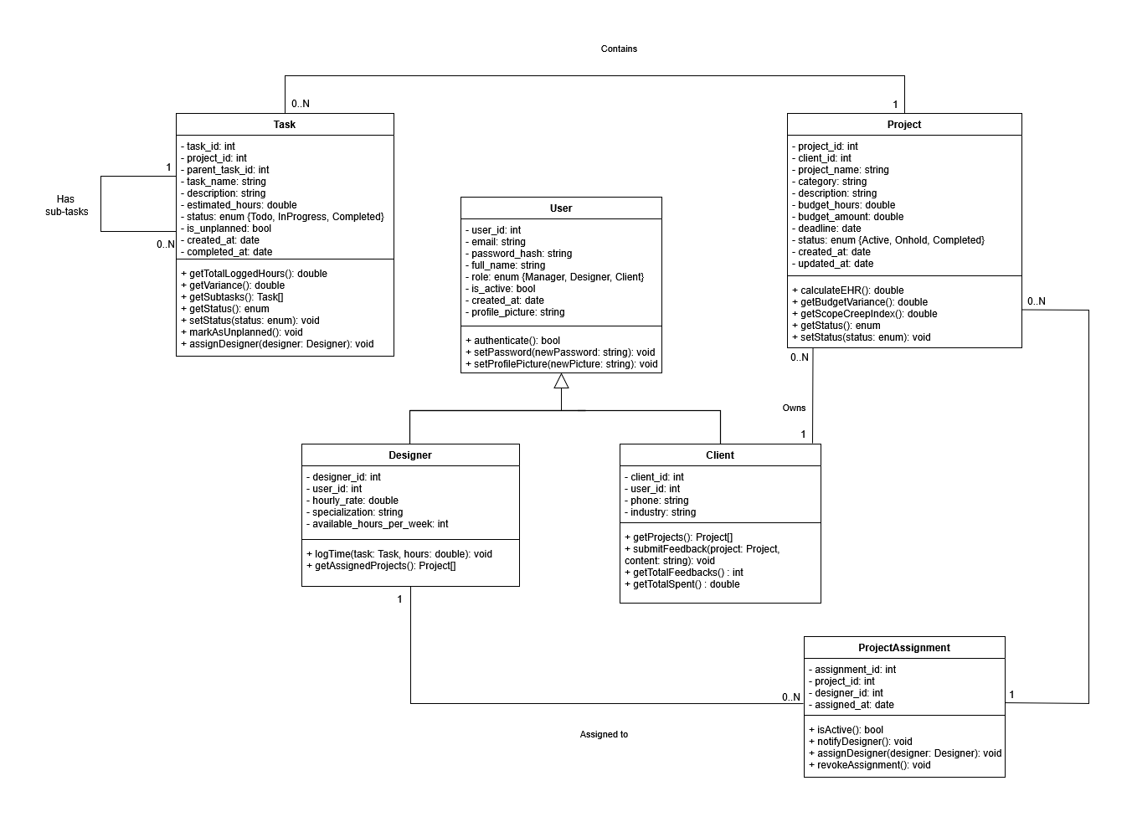
Figure 31: Sprint 2 Class Diagram

5. Interface Realisation
Figure 32–Figure 36 present the Sprint 2 deliverables.

5.1 Project Card
Figure 32 shows the project card component used across list and detail views.
Figure 32: Project Card

5.2 Project List Interface (Manager View)
Figure 33 shows the Manager's project list with status badges and filter controls.
Figure 33: Project List Interface (Manager View)

5.3 Project Detail and Task Management Interface
Figure 34 shows the project detail page with the task management panel and budget progress bar.
Figure 34: Project Detail and Task Management Interface

5.4 Task Creation Interface
Figure 35 shows the task creation side panel with the AI hour estimator advisory card.
Figure 35: Task Creation Interface

5.5 Project List Interface (Designer View)
Figure 36 shows the Designer's read-only assigned project list.
Figure 36: Project List Interface (Designer View)

6. Testing
Table 27 shows a representative sample of the Thunder Client API test results. Each row corresponds to one test scenario.

Table 27: Sprint 2 Test Results
Endpoint / Action | Method | Scenario | Expected result | Outcome
/api/projects/ | POST | Manager role, valid project data | Project created | ✔ Pass
/api/projects/ | POST | Request with Designer role (not authorised) | Access denied | ✔ Pass
/api/projects/{id}/ | GET | Designer role, project not assigned to that designer | Resource not found | ✔ Pass
/api/projects/{id}/ | PATCH | Update project status (Active → OnHold) | Status updated | ✔ Pass
/api/tasks/ | POST | Manager role, unplanned flag set | Task created with scope-creep flag | ✔ Pass
/api/tasks/ (subtask) | POST | Task with parent task set | Parent relationship persisted correctly | ✔ Pass
/api/tasks/estimate-hours/ | POST | Valid task data, similar time logs available | Suggested hours and justification returned | ✔ Pass

7. Sprint Tracking

7.1 Scrum Board
Figure 37 shows the Sprint 2 Scrum board at close. AI integration entered In Progress on day 14 as a post-planning addition, after the core task CRUD was confirmed working.
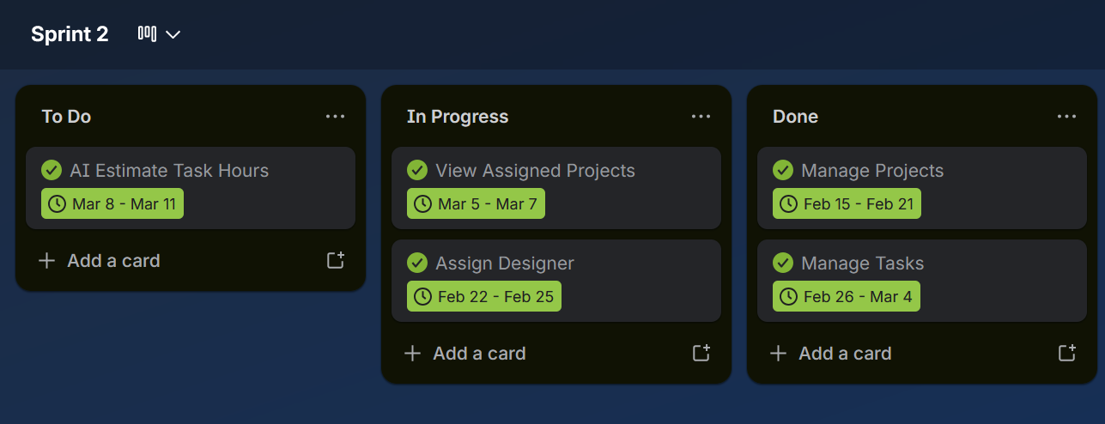
Figure 37: Sprint 2 Scrum Board

7.2 Burndown Chart
Figure 38 plots actual effort against ideal burndown. The deviation between days 14 and 15 corresponds to the Groq API integration work.
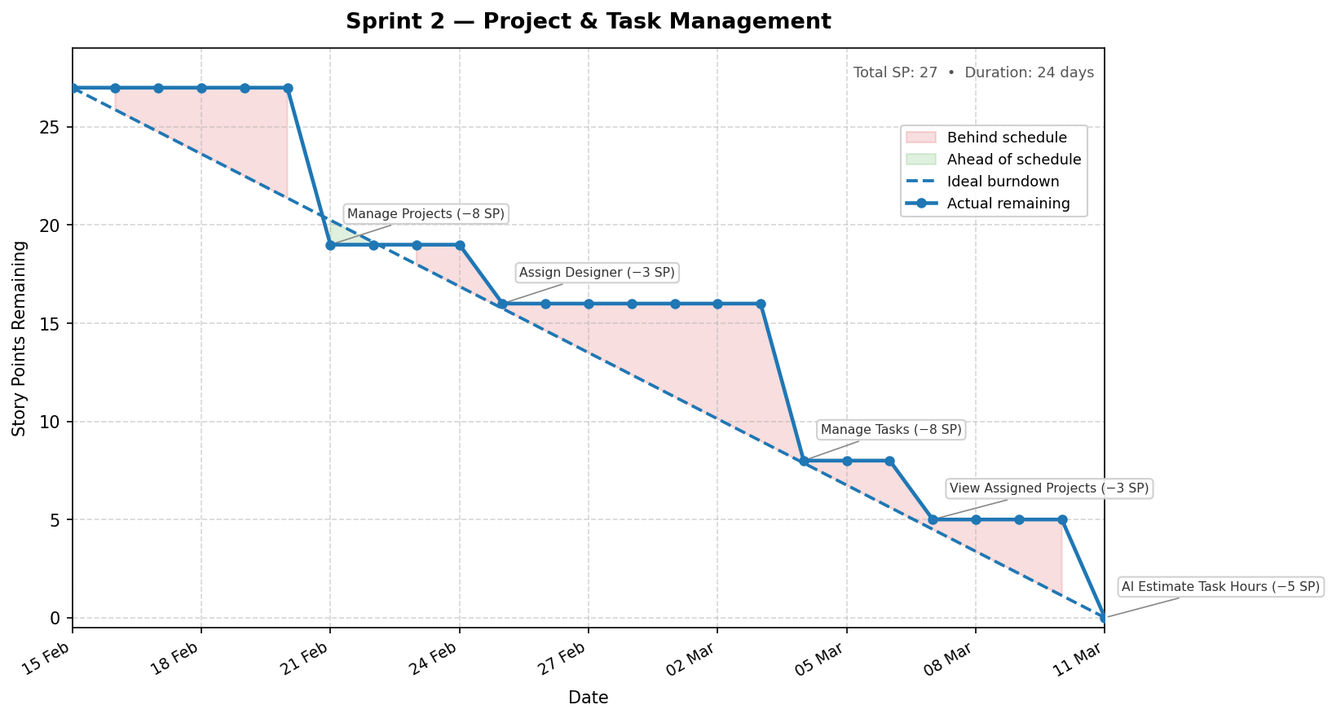
Figure 38: Sprint 2 Burndown Chart

Chapter Conclusion
Sprint 2 delivered the full project and task management layer, with all five user stories completed. Two decisions carry forward to Sprint 5: the unplanned task flag and the compound uniqueness constraint on assignments. Sprint 3 follows with time tracking and deliverable management.

Chapter 6 — Sprint 3: Time Tracking and Deliverables

1. Introduction
Sprint 3 covers four user stories (US-10 through US-13), estimated at 13 person-days. The goal is to make the application useful to Designers in their day-to-day work: a Designer must be able to track time against tasks using the built-in timer, manage task progress through a Kanban board, upload the resulting deliverable file for the client to review, and access any feedback the client has left against the project.

2. Sprint 3 Backlog
Table 28 lists all user stories included in Sprint 3, their assigned role, complexity, and estimated effort in person-days.
Table 28: Sprint 3 Backlog
ID | Epic | User Story | Priority | Complexity | Est.
US-10 | Task & Deliverables | As a Designer, I want to log time on a task so that my effort is accurately tracked against the project budget. | 2 | Medium | 4
US-11 | Task & Deliverables | As a Designer, I want to update the task status so that the team knows the current progress without having to ask. | 2 | Low | 2
US-12 | Task & Deliverables | As a Designer, I want to upload deliverables so that clients and managers can review the completed outputs directly on the platform. | 2 | Medium | 4
US-13 | Feedback & Messaging | As a Designer, I want to view client feedback so that I can understand and act on client comments on my deliverables. | 2 | Low | 3

3. Functional Specification

3.1 Sprint 3 Use Case Diagram
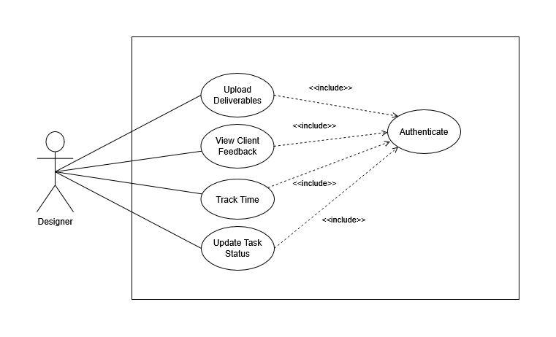
Figure 39: Sprint 3 Use Case Diagram

3.2 Textual Description of Use Cases

3.2.1 Use Case: Track Time
Table 29: Textual Description of Use Case: Track Time
Use Case: Track Time
Actor(s) | Designer, Manager
Description | Allows a Designer to track time spent on a task using a built-in timer. The Designer starts the timer when beginning work. The timer can be paused and resumed across sessions. Stopping the timer automatically creates a time log record and logs the elapsed duration. The Manager can view all time log entries across all projects.
Pre-condition(s) | The Designer is signed in.  The Designer is assigned to the project containing the target task.  The task exists and belongs to the Designer's assigned project.
Post-condition(s) | A time log record is created and linked to the task and the Designer.  Budget utilisation metrics are immediately updated to reflect the new entry.
Base Scenario | 1. The Designer drags a task card to the In Progress column on the task board.  2. The system begins the time counter.  3. The Designer may pause and resume the timer across sessions.  4. When the work is done, the Designer drags the task to Completed (or clicks Stop).  5. The system calculates total elapsed time and creates a time log record.  6. The project's budget progress bar reflects the updated total.

3.2.2 Use Case: Update Task Status
Table 30: Textual Description of Use Case: Update Task Status
Use Case: Update Task Status
Actor(s) | Designer, Manager
Description | Allows a Designer or Manager to update the status of a task to reflect its current stage of completion.
Pre-condition(s) | The Designer or Manager is signed in.  A Designer may only update the status of tasks belonging to their assigned projects.
Post-condition(s) | The task record reflects the new status, visible to all users with access to the project.
Base Scenario | 1. The Designer opens the task list for a project.  2. The Designer drags a task card to the target column.  3. The system sends a partial update request and saves the new status.  4. The task list reflects the new status immediately.  5. If the task is dragged to In Progress, the timer starts automatically for that task.  6. If the task is dragged to Completed, the timer stops and a time log record is created automatically.

3.2.3 Use Case: Upload Deliverable
Table 31: Textual Description of Use Case: Upload Deliverable
Use Case: Upload Deliverable
Actor(s) | Designer, Manager
Description | Allows a Designer to upload a completed output file (a deliverable) to the project. The file is stored on the cloud storage layer and a file upload record is created linking the file to the project.
Pre-condition(s) | The Designer is signed in and assigned to the project.  The file size does not exceed 50 MB.  The file type is supported.
Post-condition(s) | A file upload record exists with file type set to deliverable.  The file is stored at the configured storage path.  The file appears in the project's file list, accessible to the Manager and Client.
Base Scenario | 1. The Designer opens the project detail page.  2. The Designer selects Upload Deliverable and chooses a file.  3. The system validates the file type and size, stores the file, and creates a file upload record.  4. The uploaded file appears in the project file list with a download link.
Other Scenarios | 3.a File exceeds 50 MB:  1. The system rejects the upload and returns a validation error.  3.b Client attempts to upload a file classified as a deliverable:  1. The system enforces type-scoping and returns an error message.

3.2.4 Use Case: View Client Feedback
Table 32: Textual Description of Use Case: View Client Feedback
Use Case: View Client Feedback
Actor(s) | Designer, Manager
Description | Allows a Designer to read all feedback items submitted by the Client against a project, filtered by category and status. This enables the Designer to understand what revisions or approvals are pending before the next work session.
Pre-condition(s) | The Designer is signed in and assigned to the project.  The Client has previously submitted at least one feedback item.
Post-condition(s) | The Designer can view the full list of feedback items with their category, content, status, and submission date.
Base Scenario | 1. The Designer navigates to the project detail page.  2. The Designer selects the Feedback tab.  3. The system returns all Feedback records for the project, ordered by submission date.  4. The Designer reads the feedback items and can filter by category or status.
Other Scenarios | 3.a No feedback items exist for the project:  1. The list is empty and the UI displays an informational message.

4. Conception

4.1 Sequence Diagrams
Figure 40 and Figure 41 model the primary dynamic flows in Sprint 3.

4.1.1 Sequence Diagram: Track Time
This sequence models the timer-based time tracking flow. The Designer starts the timer by dragging a task to the In Progress column. Once the task is completed, the Designer drags it to the Completed column, causing the system to calculate total elapsed seconds and creating a time log record with the computed hours. An activity log entry is appended for each action (start, pause, resume, stop).
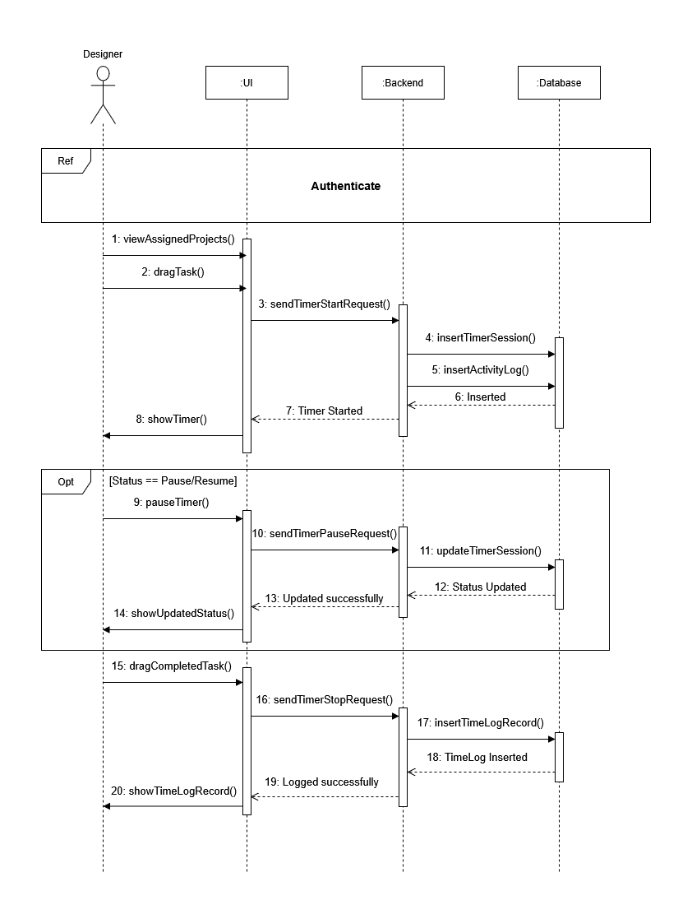
Figure 40: Sequence Diagram — Track Time

4.1.2 Sequence Diagram: Upload Deliverable
This sequence models the file upload flow. The frontend encodes the file as a standard multipart upload. Designers may only upload deliverables, not reference materials or brand guidelines, then stores the file on the server's configured media storage and creates a file upload record in the database containing the metadata (file name, path, size, and type).
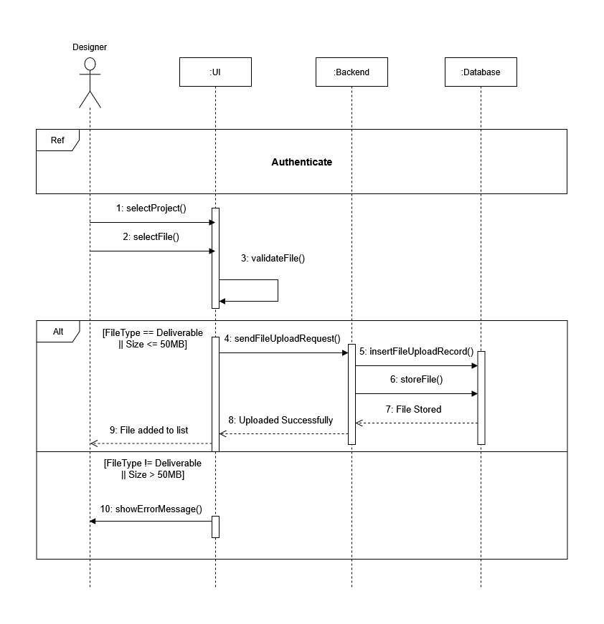
Figure 41: Sequence Diagram — Upload Deliverable

4.2 Class Diagram
The time log table links a Designer to a Task and stores logged hours. It is the source of all budget and utilisation metrics in Sprint 5. The timer session table persists the live state of a running or paused timer. Activity log table is an append-only audit trail recording every start, pause, resume, and stop action with a timestamp. The file upload table links a project to its uploader and carries a file type that enforces role-scoped upload rules at the API layer.
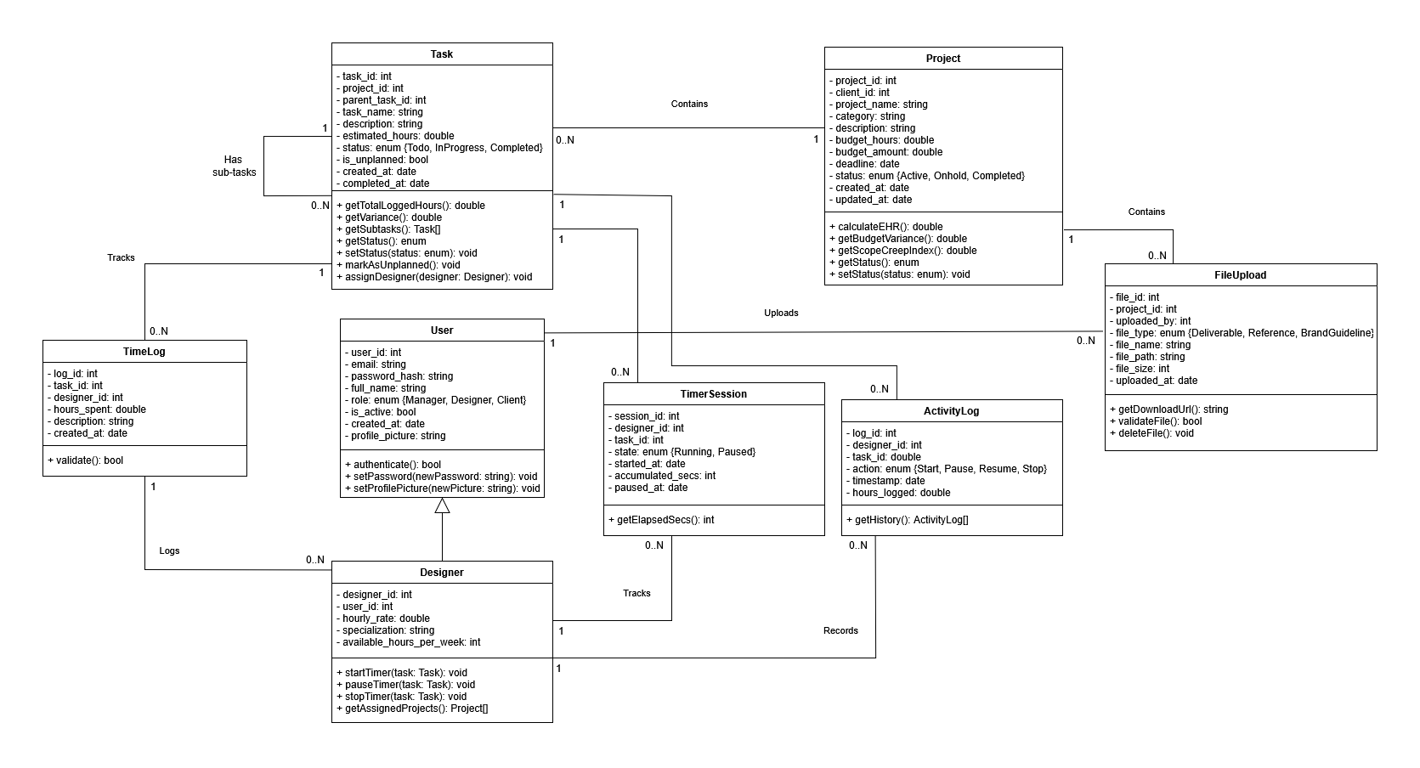
Figure 42: Sprint 3 Class Diagram

5. Interface Realisation
Figure 43–Figure 46 present the Sprint 3 deliverables.

5.1 Time Logging Interface (Designer View)
Figure 43 shows the Kanban board on the project detail page. Task cards are displayed across three columns (To Do, In Progress, Completed). The budget progress bar updates after each submission.
Figure 43: Time Logging Interface (Designer View)

5.2 Kanban Board
Figure 44 shows the Kanban board with three droppable columns. Task cards carry the task name, estimated hours, and scope-creep badge when applicable.
Figure 44: Task Status Toggle

5.3 File Upload Interface
Figure 45 shows the files uploaded on the project detail page.
Figure 45: File Upload Interface

5.4 Feedback View Interface (Designer View)
Figure 46 shows the feedback panel with items grouped by status. Category badges (Revision, Approval, Question) and dropdown filters for category and status are visible.
Figure 46: Feedback View Interface (Designer View)

6. Testing
Table 33 shows a representative sample of the Thunder Client API test results. Each row corresponds to one test scenario.

Table 33: Sprint 3 Test Results
Endpoint | Method | Scenario | Expected result | Outcome
/api/timelogs/timer/start/ | POST | Designer, valid assigned task | Timer session created | ✔ Pass
/api/timelogs/timer/pause/ | POST | Timer in running state | State set to paused, elapsed time preserved | ✔ Pass
/api/timelogs/timer/stop/ | POST | Timer running or paused | Time log record created | ✔ Pass
/api/timelogs/ | GET | Designer role | Only logs authored by that Designer returned | ✔ Pass
/api/files/ | POST | Designer uploads a deliverable file | File upload record created | ✔ Pass
/api/files/ | POST | Designer uploads with reference file type (scoping violation) | Type-scope error | ✔ Pass
/api/files/ | POST | File size exceeds 50 MB | Validation error | ✔ Pass

7. Sprint Tracking

7.1 Scrum Board
Figure 47 shows the Sprint 3 Scrum board.
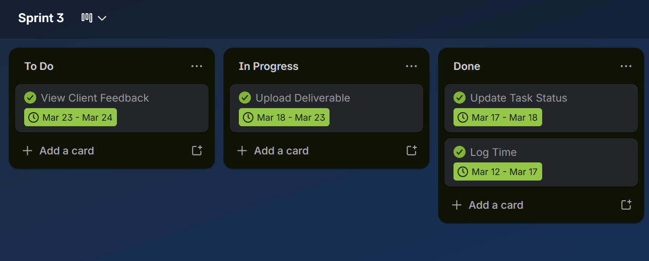
Figure 47: Sprint 3 Scrum Board

7.2 Burndown Chart
Figure 48 plots actual effort against ideal burndown.
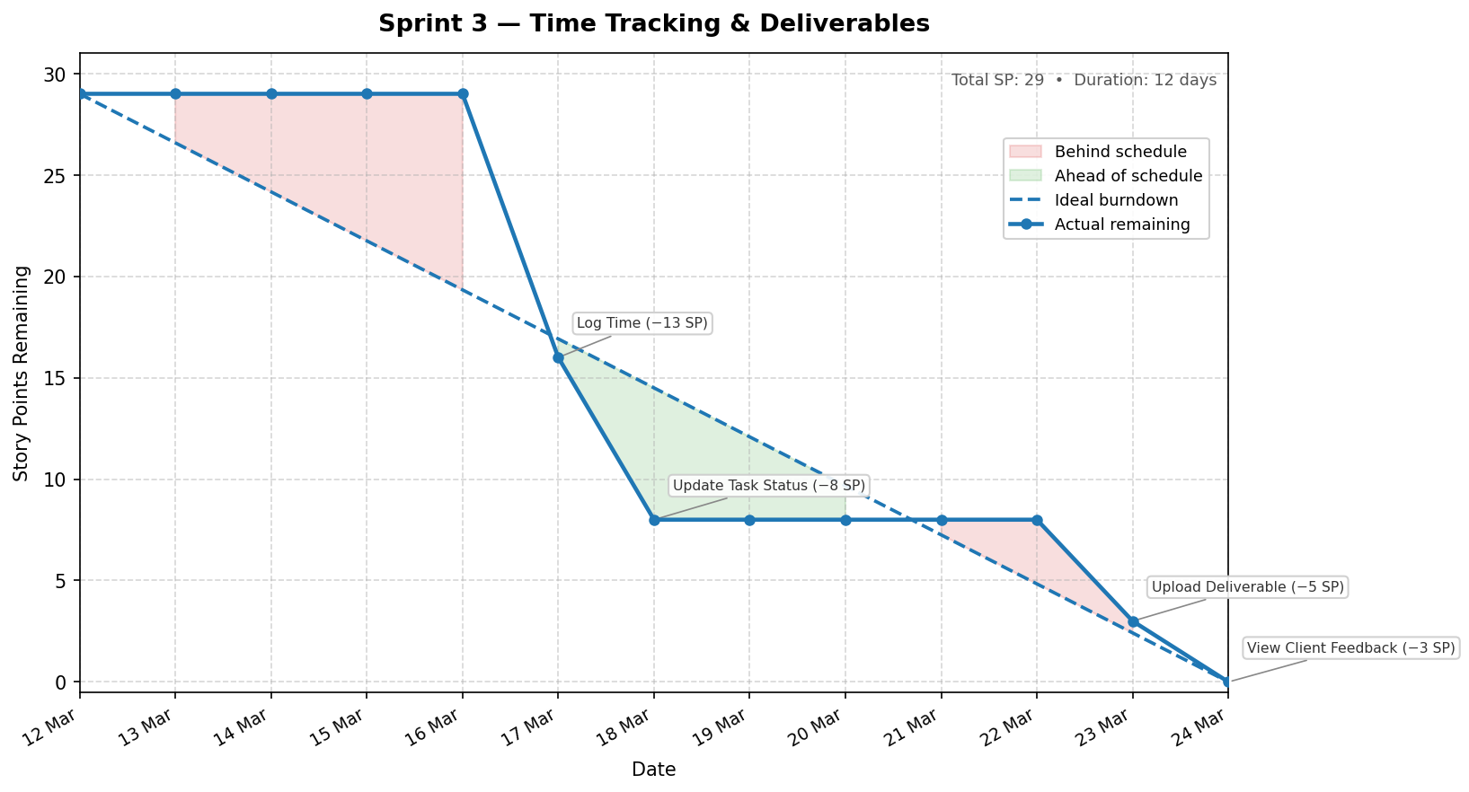
Figure 48: Sprint 3 Burndown Chart

Chapter Conclusion
Sprint 3 delivered the timer-based time tracking system, the Kanban task board, file upload, and the feedback view, with all user stories completed. Time log records are the source of truth for all budget and EHR metrics in Sprint 5. Sprint 4 follows with the client portal, feedback submission, and project messaging.

Chapter 7 — Sprint 4: Client Portal and Feedback

1. Introduction
Sprint 4 covers weeks seven and eight of the project. Its goal is to deliver the client-facing portal together with the full feedback and messaging workflow, completing the collaborative layer that connects clients, designers, and the manager within a single project context. Five user stories are addressed in this sprint (US-14 through US-18), estimated at 20 person-days.

2. Sprint 4 Backlog
Table 34 lists all user stories included in Sprint 4, their assigned role, complexity, and estimated effort in person-days.
Table 34: Sprint 4 Backlog
ID | Epic | User Story | Priority | Complexity | Est.
US-14 | Feedback & Messaging | As a Manager/Designer, I want to reply to feedback so that I can communicate directly with the client. | 3 | Medium | 3
US-15 | Feedback & Messaging | As a Manager/Designer/Client, I want to send messages so that I can communicate with other platform users. | 2 | High | 6
US-16 | Client Portal | As a Client, I want to view the project status so that I can monitor progress without contacting the team. | 2 | Medium | 4
US-17 | Client Portal | As a Client, I want to upload reference materials so that the design team has the context they need. | 3 | Medium | 3
US-18 | Client Portal | As a Client, I want to submit feedback so that I can share my opinions on the delivered work. | 2 | Medium | 4

3. Functional Specification

3.1 Sprint 4 Use Case Diagram
Figure 49 presents the Sprint 4 use case diagram. The Client is the central actor for this sprint, gaining access to the project portal, the feedback submission form, the reference file upload, and the shared message board. The Manager and Designer gain the ability to reply to feedback items and to transition feedback status through its lifecycle.
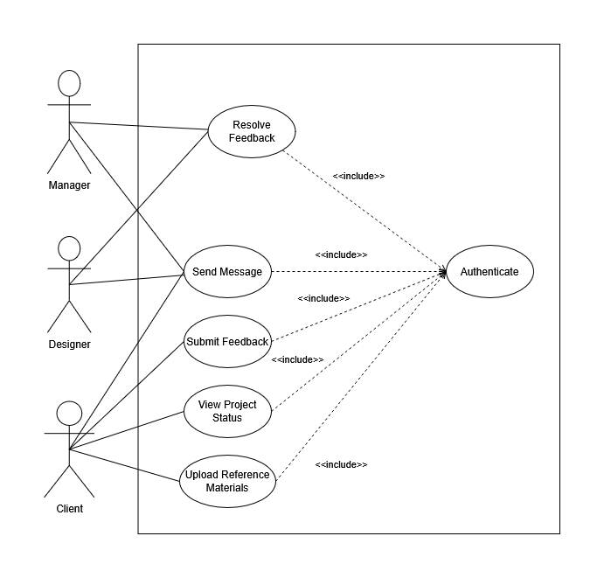
Figure 49: Sprint 4 Use Case Diagram

3.2 Textual Description of Use Cases

3.2.1 Use Case: View Project Status
Table 35: Textual Description of Use Case: View Project Status
Use Case: View Project Status
Actor(s) | Client
Description | Allows the Client to view the list of their own projects and to open a project detail page showing status, budget progress, deadline, uploaded files, and the message thread.
Pre-condition(s) | The Client is authenticated.  At least one project is associated with their account.
Post-condition(s) | The project detail page is displayed with current status information.
Base Scenario | 1. The Client navigates to their project list.  2. The system returns only projects belonging to that client.  3. The Client selects a project.  4. The system displays status, budget utilisation, deadline, files, and messages.
Other Scenarios | 1.a No project exists:  1. The system displays an empty-state message.

3.2.2 Use Case: Submit Feedback
Table 36: Textual Description of Use Case: Submit Feedback
Use Case: Submit Feedback
Actor(s) | Client
Description | Allows the Client to submit a feedback item on one of their projects, categorised as Revision, Approval, or Question.
Pre-condition(s) | The Client is authenticated and has at least one active project.
Post-condition(s) | A new Feedback record is created with status Pending and a submission timestamp recorded automatically.
Base Scenario | 1. The Client opens the project detail page and selects the feedback form.  2. The Client selects a category and enters a description.  3. The Client submits the form.  4. The system validates the input and creates the Feedback record.  5. The feedback appears in the project feedback list for the Manager and Designer.
Other Scenarios | 3.a Description field is empty:  1. The system returns a validation error and does not save the record.

3.2.3 Use Case: Resolve Feedback
Table 37: Textual Description of Use Case: Resolve Feedback
Use Case: Resolve Feedback
Actor(s) | Designer, Manager
Description | Allows the Manager or Designer to progress a feedback item through its lifecycle: Pending, InProgress, and Resolved. Resolving an item automatically records the resolution timestamp.
Pre-condition(s) | The user is authenticated as Manager or Designer.  At least one Feedback record exists for the project.
Post-condition(s) | The feedback status is updated.  If the new status is Resolved, the resolution time is recorded automatically.
Base Scenario | 1. The Manager or Designer opens the project feedback list.  2. The user selects a feedback item and chooses a new status.  3. The system sends a partial update request.  4. The system saves the new status and, where applicable, records the resolution time.  5. The feedback list reflects the updated status.

3.2.4 Use Case: Send Message
Table 38: Textual Description of Use Case: Send Message
Use Case: Send Message
Actor(s) | Client, Designer, Manager
Description | Allows any project member to post a message in the shared project message board. All members of the project can view the full thread.
Pre-condition(s) | The user is authenticated and is assigned to or owns the project.
Post-condition(s) | A new Message record is created and marked as unread for all other project members.
Base Scenario | 1. The user navigates to the project message board.  2. The user types a message and submits.  3. The system creates a Message record linked to the project and the sender.  4. The message appears in the thread for all project members.
Other Scenarios | 2.a Message text is empty:  1. The system returns a validation error.

3.2.5 Use Case: Upload Reference Materials
Table 39: Textual Description of Use Case: Upload Reference Materials
Use Case: Upload Reference Materials
Actor(s) | Client
Description | Allows the Client to upload reference or brand guideline files to a project. These files are accessible to the Manager and Designer and are stored as file upload records with the appropriate file type.
Pre-condition(s) | The Client is authenticated and has an active project.
Post-condition(s) | A file upload record is created with the appropriate type (Reference or Brand Guideline).  The file is stored in the project media directory.
Base Scenario | 1. The Client opens the project detail page and selects the file upload area.  2. The Client selects a file and a type (Reference or Brand Guideline).  3. The Client submits the form as multipart data.  4. The system validates the file and stores it in a file upload record.  5. The file appears in the project file list for all project members.
Other Scenarios | 4.a File size exceeds the configured limit:  1. The system returns an error and does not create the record.

4. Conception

4.1 Sequence Diagrams

4.1.1 Sequence Diagram: Submit & Resolve Feedback
Figure 50 models the full feedback lifecycle. The Client submits a feedback item through the project portal, which creates a Feedback record in Pending status. The Manager or Designer then transitions the item to InProgress and finally to Resolved, at which point the system automatically records the resolution timestamp.
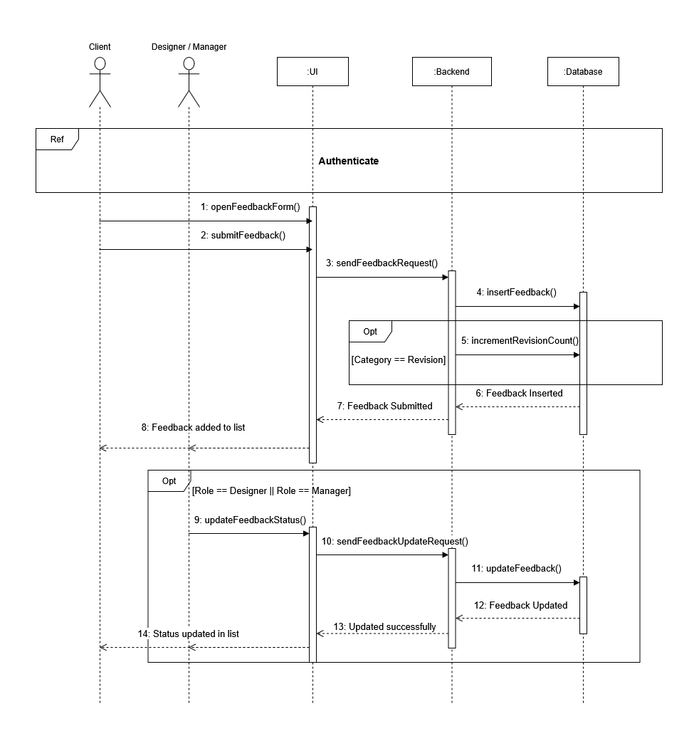
Figure 50: Sequence Diagram — Submit & Resolve Feedback

4.1.2 Sequence Diagram: Send Message
Figure 51 models the message sending flow. Any authenticated project member navigates to the project message board, composes a message, and submits it. The backend creates a Message record, marks it as unread, and returns the created record, which the frontend appends to the displayed thread immediately.
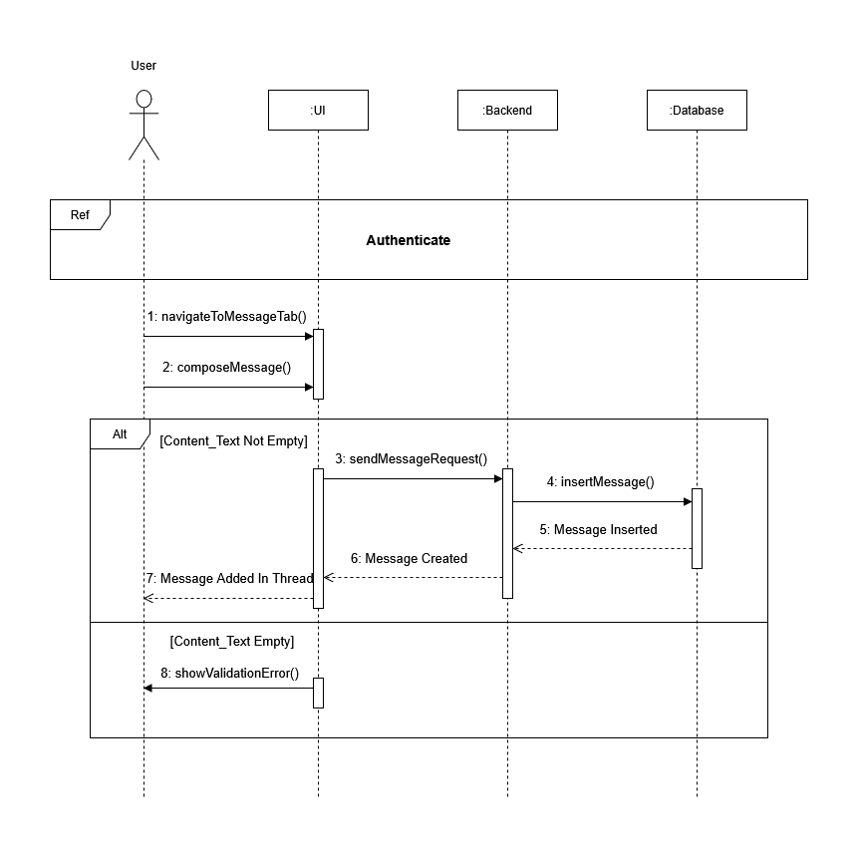
Figure 51: Sequence Diagram — Send Message

4.2 Class Diagram
Figure 52 shows the Sprint 4 class diagram. Two models are central to this sprint: Feedback and Message. The Feedback model belongs to a Project and carries a category attribute (Revision, Approval, or Question), a status lifecycle attribute, and an optional resolution timestamp that is recorded automatically when the status transitions to Resolved. The Message model also belongs to a Project and records the sender as a User reference, supporting all three roles on the same thread. The FileUpload model, introduced in Sprint 3 for designer deliverables, is extended in this sprint to accept client uploads categorised as Reference or Brand Guideline.
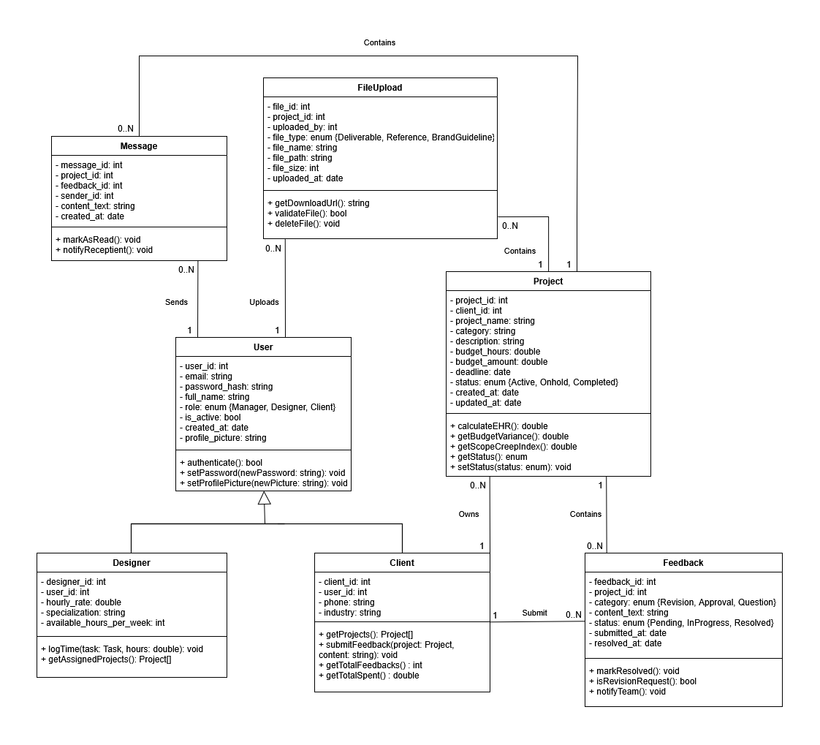
Figure 52: Sprint 4 Class Diagram

5. Interface Realisation

5.1 Client Project List
Figure X shows the client-facing project list page. Only projects associated with the authenticated client are returned, each displaying the project name, current status badge, and deadline.

5.2 Client Project Detail
Figure X shows the client project detail page, presenting budget utilisation, deadline, the uploaded file list, and the message thread in a single scrollable view.

5.3 Feedback Submission Form
Figure X shows the feedback form available to the client. The category selector limits input to Revision, Approval, or Question. Submitting the form creates the record and immediately updates the feedback list visible to the project team.

5.4 Feedback Management View
Figure X shows the feedback list as seen by the Manager or Designer. Each item shows the category, submission date, current status, and a status update control allowing the team to move the item through Pending, InProgress, and Resolved.

5.5 Project Message Board
Figure X shows the shared message board within a project. Messages from all roles appear in chronological order. The composer at the bottom is available to all project members regardless of role.

6. Testing
Table 40 records the functional tests carried out at the end of Sprint 4, covering the feedback, message, and file upload endpoints together with role-based access controls.
Table 40: Sprint 4 Test Results
Endpoint | Method | Scenario | Expected result | Outcome
/api/feedback/ | POST | Client role, valid project, all fields provided | Feedback created, status = Pending | ✔ Pass
/api/feedback/ | POST | Client role, empty description field | Validation error returned | ✔ Pass
/api/feedback/ | PATCH | Designer sets status to Resolved | Status updated, resolved timestamp set automatically | ✔ Pass
/api/messages/ | POST | Manager/Designer/Client roles, valid project | Message created, marked as unread | ✔ Pass
/api/files/ | POST | Client uploads reference file, valid project | File upload record created | ✔ Pass
/api/projects/ | GET | Client role | Only that client's projects returned | ✔ Pass

7. Sprint Tracking

7.1 Scrum Board
Figure X shows the Sprint 4 Scrum board.
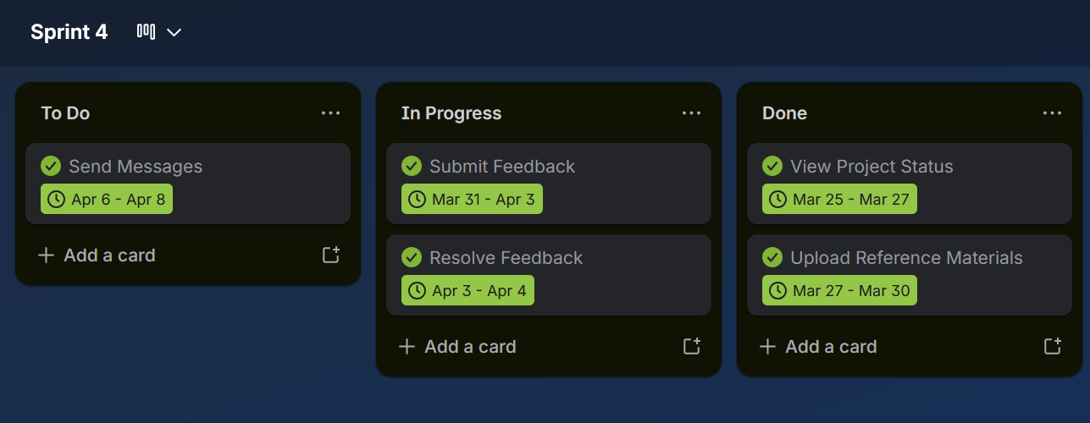

7.2 Burndown Chart
Figure X plots actual effort against ideal burndown.
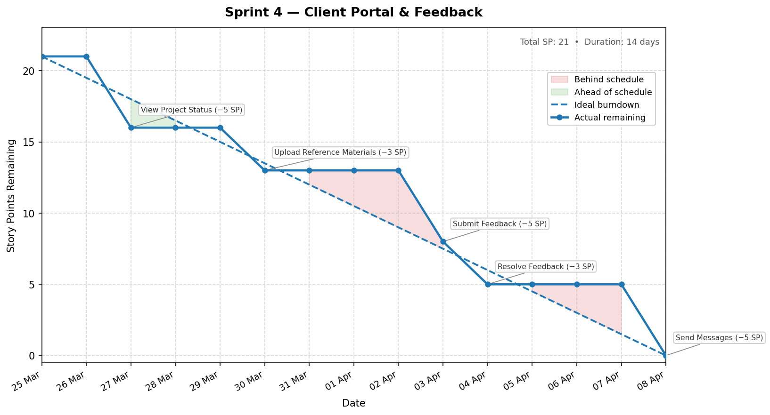

Chapter Conclusion
Sprint 4 delivered the complete client portal and the feedback lifecycle workflow. Clients can now view their projects, upload reference materials, submit categorised feedback, and communicate with the project team through a shared message board. The Manager and Designer can reply to feedback items, transition them through their status lifecycle. The Feedback and Message models, together with the extended use of FileUpload for client uploads, provide the data foundation on which the Sprint 5 analytics layer will compute revision-to-approval ratios and client profitability rankings.

Chapter 8 — Sprint 5: BI Dashboards and Reports

1. Introduction
Sprint 5 covers three user stories (US-19 through US-21), estimated at 18 person-days and spanning weeks 9 through 12. The goal is to deliver the complete business intelligence layer: KPI summary cards, budget variance and profitability charts, scope creep and designer utilisation metrics, an AI-generated project summary, and PDF and Excel report exports. All analytics endpoints are read-only views running database aggregate queries over the operational data accumulated in the preceding sprints.

2. Sprint 5 Backlog
Table 41 lists all user stories included in Sprint 5, their assigned role, complexity, and estimated effort in person-days.
Table 41: Sprint 5 Backlog
ID | Epic | User Story | Priority | Complexity | Est.
US-19 | Reporting & Analytics | As a Manager, I want to view dashboards so that I can monitor project profitability at a glance. | 1 | High | 8
US-20 | Reporting & Analytics | As a Manager, I want to generate reports so that I can analyse detailed performance and financial data. | 1 | High | 7
US-21 | Reporting & Analytics | As a Manager, I want to export reports so that I can share or archive results outside the platform. | 3 | Medium | 3

3. Functional Specification

3.1 Sprint 5 Use Case Diagram
Figure 53 presents the Sprint 5 use case diagram. The Manager is the sole internal actor. Three use cases are defined: View Dashboards, Generate Reports, and Export Reports. The Export Reports use case extends Generate Reports, reflecting that it is triggered only after report data has been assembled. The AI summary feature is an integral part of the View Dashboards use case, activated on demand from the project detail analytics panel.
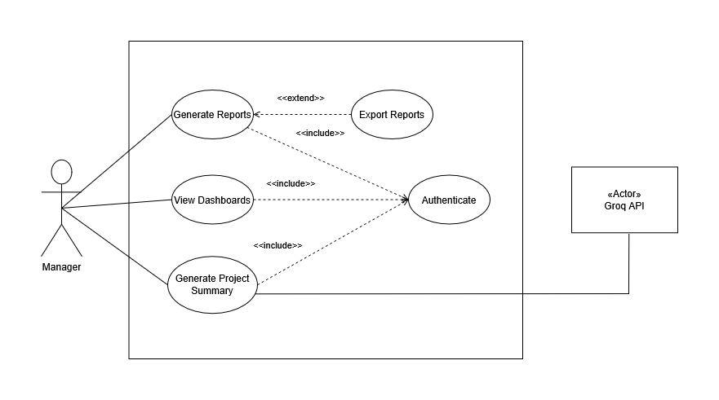
Figure 53: Sprint 5 Use Case Diagram

3.2 Textual Description of Use Cases

3.2.1 Use Case: View Dashboards
Table 42: : Textual Description of Use Case: View Dashboards
Use Case: View Dashboards
Actor(s) | Manager
Description | Allows the Manager to view KPI summary cards and interactive charts showing project profitability, budget variance, designer utilisation, and client performance.
Pre-condition(s) | The Manager is authenticated.  At least one project with time log records exists in the system.
Post-condition(s) | KPI cards and charts are rendered with live aggregated data.
Base Scenario | 1. The Manager navigates to the Analytics section.  2. The system fires parallel requests to all analytics endpoints, applying any active date, client, or project filters.  3. The dashboard renders the KPI summary cards: Effective Hourly Rate, budget utilisation, active project count, and pending feedback count.  4. Charts are drawn: budget vs. actual bar chart, cumulative hours line chart, revenue by client pie chart, and designer utilisation panel.
Other Scenarios | 2.a No project exists:  1. The system displays an empty-state message.

3.2.2 Use Case: Generate Reports
Table 43: Textual Description of Use Case: Generate Reports
Use Case: Generate Reports
Actor(s) | Manager
Description | Allows the Manager to compile a profitability summary report for a selected project, drawing on budget variance, Effective Hourly Rate, scope creep index, and revision-to-approval ratio data.
Pre-condition(s) | The Manager is authenticated.  At least one project with time log records exists in the system.
Post-condition(s) | Report data is assembled from the analytics layer.
Base Scenario | 1. The Manager navigates to the Reports section.  2. The Manager selects a project and an optional date range.  3. The system fetches profitability data from the analytics endpoints.  4. A structured report view is rendered with the computed figures.
Other Scenarios | 2.a No timelog data for the project:  1. The report is generated with zero-value figures and a note indicating no hours have been logged.

3.2.3 Use Case: Export Reports
Table 44: Textual Description of Use Case: Export Reports
Use Case: Export Reports
Actor(s) | Manager
Description | Allows the Manager to download the generated report as a PDF document or an Excel workbook.
Pre-condition(s) | The Manager is authenticated.  Report data has been assembled.
Post-condition(s) | A file is streamed from the server and saved to the local machine.
Base Scenario | 1. The Manager selects PDF or Excel from the export controls.  2. The system sends a request to the export endpoint with the selected format and project filter.  3. The backend fetches the relevant project data from the database.  4. The backend generates the file depending on the selected type.  5. The file is returned as an attachment in the response.  6. The browser triggers a download dialog.
Other Scenarios | 4.a Generation error:  1. The system returns an error message.

3.2.4 Use Case: Generate Project Summary
Table 45: Textual Description of Use Case: Generate Project Summary
Use Case: Generate Project Summary
Actor(s) | Manager
Description | Allows the Manager to request an AI-generated plain-English health summary for a specific project. The system retrieves all computed BI metrics for the project and submits them to the Groq API, which synthesises them into a 3–4 sentence narrative flagging risks and recommending one concrete action.
Pre-condition(s) | The Manager is authenticated.  The Groq API key is configured server-side in the environment settings.
Post-condition(s) | A narrative card is displayed on the project detail page reflecting the current state of the project's BI metrics.
Base Scenario | 1. The Manager opens a project detail page and clicks the Generate AI Summary button.  2. The system retrieves all BI metrics for the project: budget utilisation, EHR vs target rate, scope creep index, revision-to-approval ratio, and days until deadline.  3. The system submits the metrics as a structured prompt to the Groq API.  4. The Groq API returns a 3–4 sentence narrative identifying risks and suggesting one concrete action.  5. The system displays the narrative as a card on the project detail page.
Other Scenarios | 3.a Groq API is unreachable or returns an error:  1. The system returns an error message.
4. Conception
4.1 Sequence Diagrams
Figures 54 and 55 model the three primary dynamic flows implemented in Sprint 5.
4.1.1 Sequence Diagram: Export Report
The Manager selects an export format and the app issues a request to the reports export endpoint with the desired format and project filter. Django fetches the project, task, time log, and feedback records from the database, then generates a file depending on the chosen type. The completed file is returned as a file attachment and the browser triggers a download dialog.
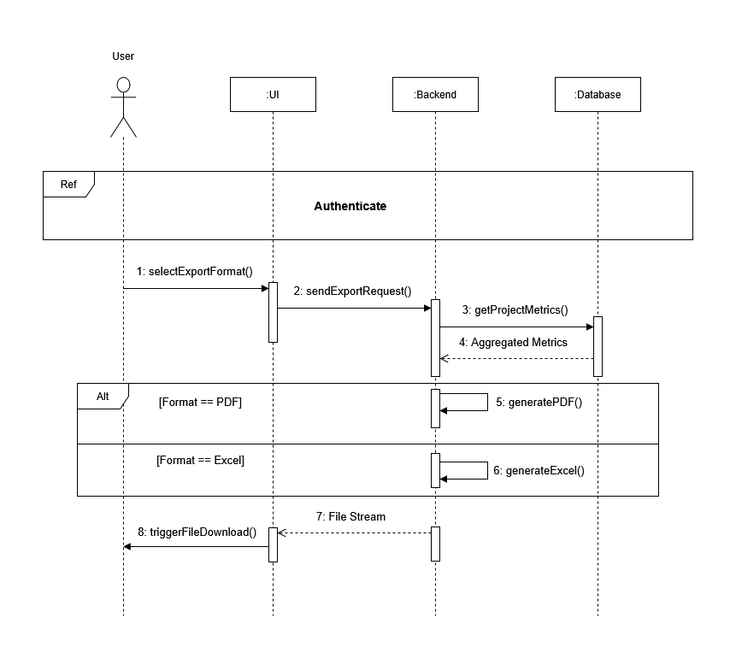
Figure 54: Sequence Diagram — Export Report
4.1.2 Sequence Diagram: Generate Project Summary
On demand, the Manager requests an AI summary for a specific project. The backend fetches the computed metrics from the database and constructs a contextual prompt embedding budget utilisation, Effective Hourly Rate, scope creep index, revision-to-approval ratio, and days remaining until the deadline. This prompt is forwarded to the Groq API, which returns a 3 to 4 sentence health narrative.
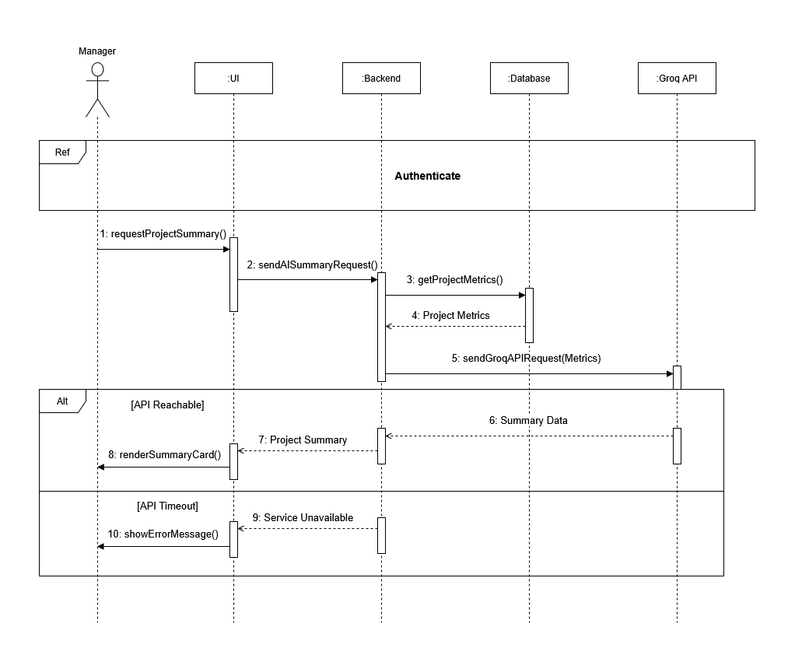
Figure 55: Sequence Diagram — Generate Project Summary
4.2 Class Diagram
Sprint 5 introduces no new domain models. The analytics and reports app contains only views that execute aggregate queries over the entities established in previous sprints: Project, Task, TimeLog, Designer, Client, and Feedback. Figure 56 shows the Sprint 5 class diagram, highlighting the subset of these entities consumed by the analytics layer.
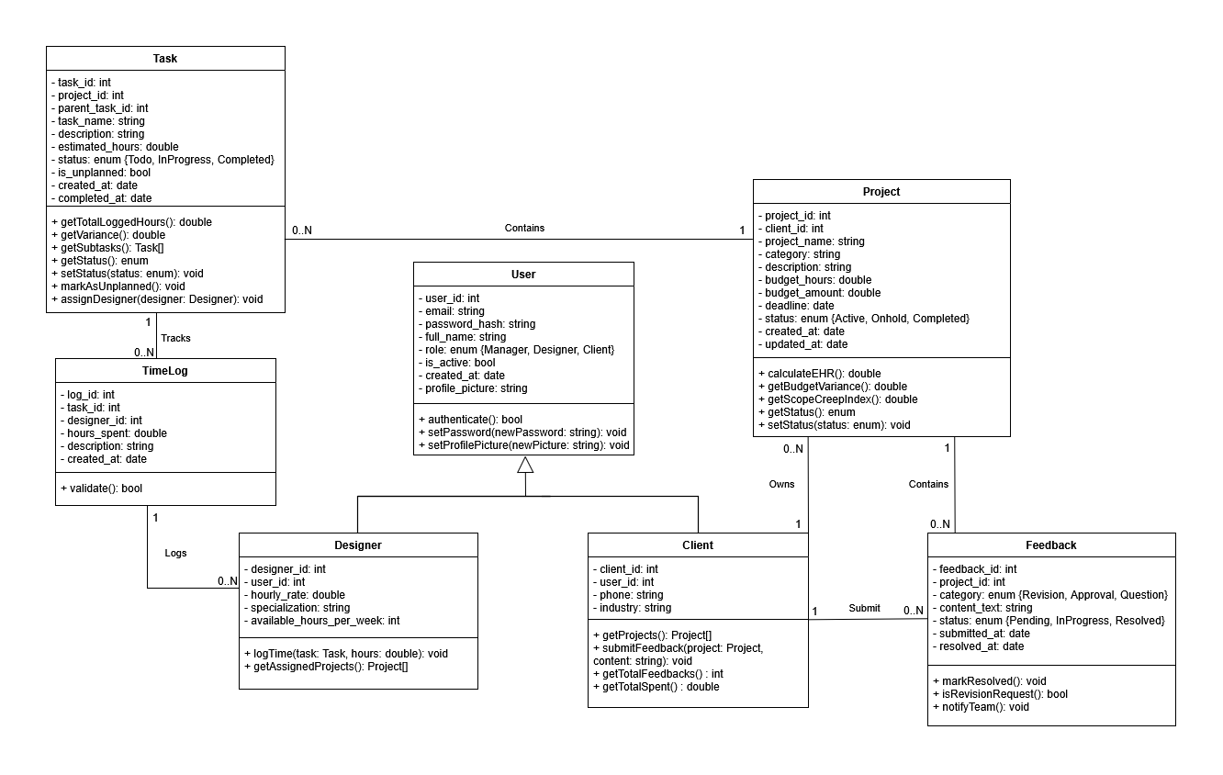
Figure 56: Sprint 5 Class Diagram
5. Interface Realisation
Figures 65 through 70 present the Sprint 5 deliverables.
5.1 KPI Summary Dashboard
Figure 65 shows the manager KPI dashboard. Four summary cards display the overall Effective Hourly Rate, aggregate budget utilisation, active project count, and pending feedback count, each computed live from the database at request time.

5.2 Budget vs. Actual Chart
Figure 66 shows the budget versus actual hours bar chart. Each project is represented by a pair of bars: one for budgeted hours and one for logged hours. Projects where actual hours exceed budgeted hours are rendered in red to make overruns immediately visible.

5.3 Client Profitability Ranking
Figure 67 shows the client profitability table. Clients are ranked by Effective Hourly Rate, weighted by revision count to surface clients who are profitable on paper but require disproportionate rework effort.

5.4 Designer Utilisation Panel
Figure 68 shows the designer utilisation panel. Each designer is shown with their logged hours for the selected period, their contracted weekly capacity, and the resulting utilisation percentage.

5.5 AI Health Narrative Card
Figure 69 shows the AI health narrative card on the project detail page. The card displays a plain-English paragraph synthesising all available metrics, flags the primary risk, and suggests one concrete action for the Manager.

5.6 Report Export Page
Figure 70 shows the report export page. The Manager selects a project and date range, and two export buttons generate either a PDF report using ReportLab or an Excel workbook using openpyxl.
6. Testing
Table 46 records the functional tests carried out at the end of Sprint 5, covering analytics endpoints, the AI summary endpoint, and report exports together with role-based access control.
Table 46: Sprint 5 Test Results
Endpoint | Method | Scenario | Expected result | Outcome
/api/analytics/kpi-summary/ | GET | Manager role | All KPI fields returned correctly | ✔ Pass
/api/analytics/budget-variance | GET | Manager role, with date filter | Filtered results returned | ✔ Pass
/api/analytics/profitability | GET | Manager role | Client profitability rankings returned | ✔ Pass
/api/analytics/scope-creep/ | GET | Project with unplanned tasks | Non-zero scope creep index returned | ✔ Pass
/api/analytics/ai-summary/ | GET | Valid project with time logs | 3 to 4 sentence narrative returned | ✔ Pass
/api/reports/export/ | GET | PDF format, valid project | PDF file streamed correctly | ✔ Pass
/api/reports/export/ | GET | Excel format, valid project | Excel workbook streamed correctly | ✔ Pass
7. Sprint Tracking
7.1 Scrum Board
Figure 71 shows the Sprint 5 Scrum board at close. Database index tasks were pulled into the sprint as a prerequisite work item before any analytics endpoint development began. The AI health narrative feature entered In Progress on day 16, after all analytics endpoints were confirmed working, as the narrative depends on a complete metrics context.
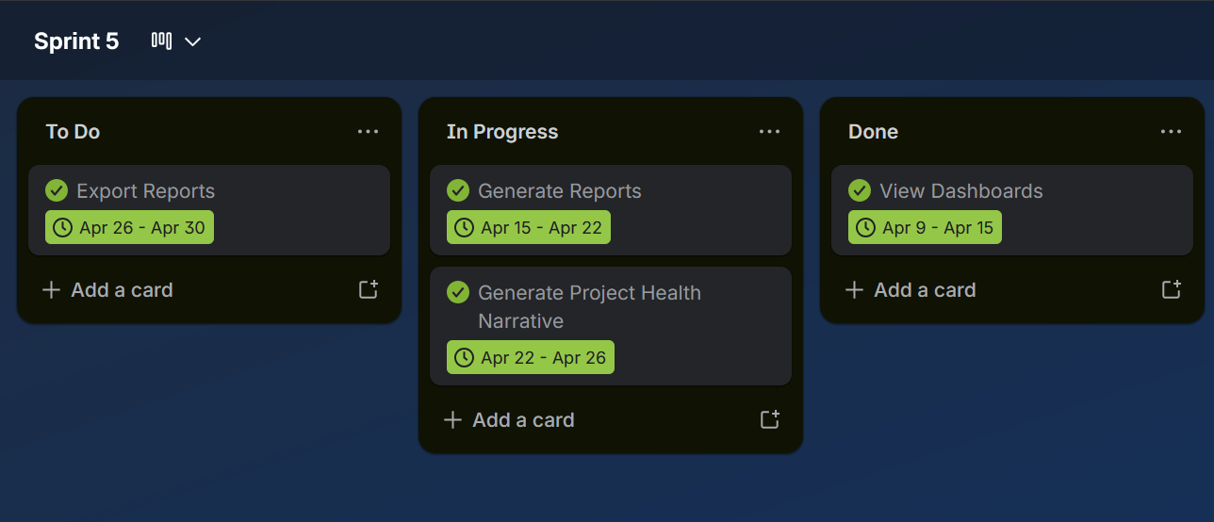
7.2 Burndown Chart
Figure 72 plots actual effort against ideal burndown for Sprint 5. A minor deviation between days 14 and 16 corresponds to the PDF generation work, which required more iteration than initially estimated. The sprint closed on target.
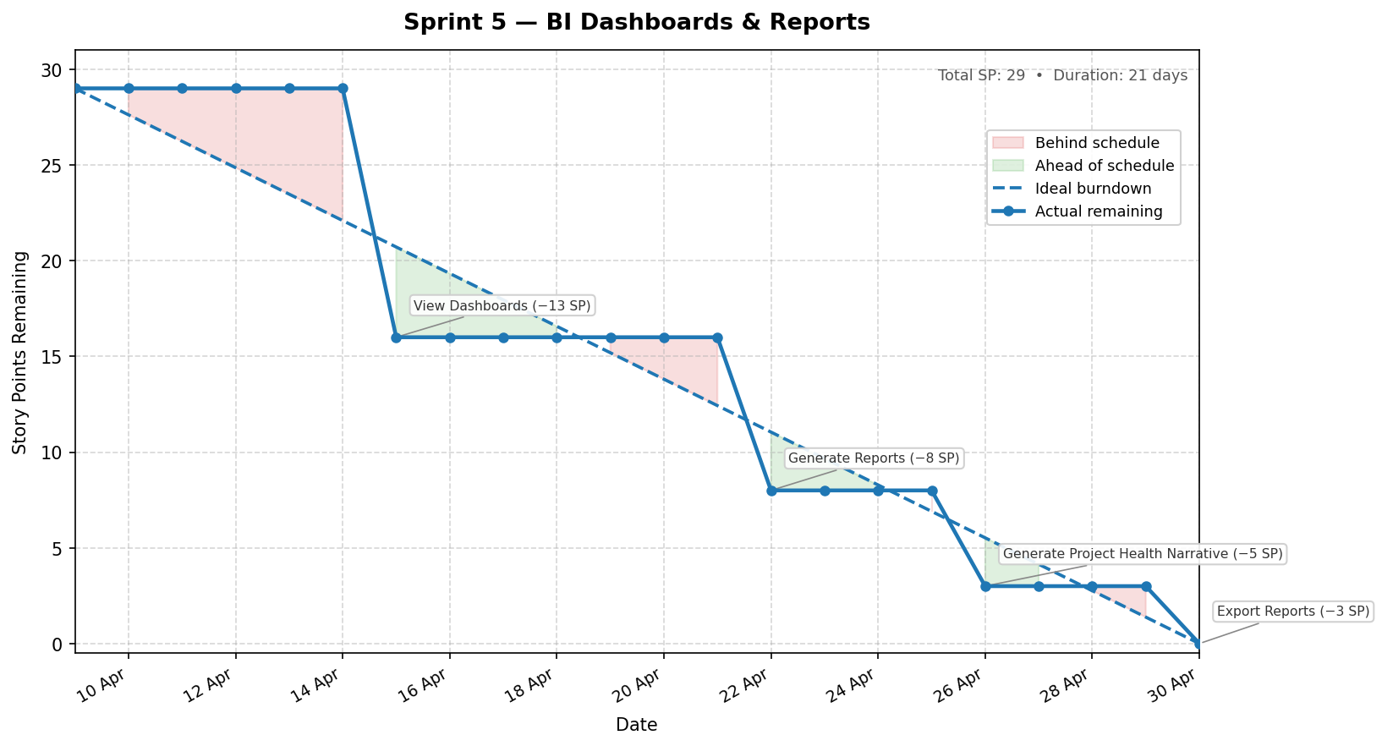
Chapter Conclusion
Sprint 5 delivered the complete business intelligence layer of DesignFlow. Multiple KPI metrics are now computed live from the accumulated operational data and surfaced on the manager analytics dashboard. The AI health narrative card provides the Manager with a synthesised risk assessment per project. PDF and Excel report exports make profitability data portable and shareable with stakeholders outside the platform. With Sprint 5 complete, all five working hypotheses stated in Chapter 2 can now be evaluated against the delivered system in the General Conclusion.

References
[1] Turban, E., Sharda, R., & Delen, D. (2014). Business Intelligence and Analytics: Systems for Decision Support (10th ed.). Pearson.
[2] PMI — Project Management Institute. (2021). A Guide to the Project Management Body of Knowledge (PMBOK® Guide) — 7th Edition. Project Management Institute.
[3] Django Software Foundation. (2024). Django 5.0 Documentation. https://docs.djangoproject.com
[4] Tom Christie. (2024). Django REST Framework Documentation. https://www.django-rest-framework.org
[5] Meta Open Source. (2024). React 19 Documentation. https://react.dev
[6] Microsoft. (2024). TypeScript Documentation. https://www.typescriptlang.org/docs
[7] TanStack. (2024). TanStack React Query v5 Documentation. https://tanstack.com/query
[8] PostgreSQL Global Development Group. (2024). PostgreSQL 16 Documentation. https://www.postgresql.org/docs/16
[9] Recharts Team. (2024). Recharts Documentation. https://recharts.org
[10] djangorestframework-simplejwt contributors. (2024). Simple JWT Documentation. https://django-rest-framework-simplejwt.readthedocs.io
[11] Vitejs. (2024). Vite — Next Generation Frontend Tooling. https://vitejs.dev
[12] Tailwind Labs. (2024). Tailwind CSS Documentation. https://tailwindcss.com/docs
[13] Schwaber, K., & Sutherland, J. (2020). The Scrum Guide. https://scrumguides.org
[14] Zwikael, O., & Smyrk, J. (2011). Project Management for the Creation of Organisational Value. Springer.

