University of Sousse | Institut Supérieur de Gestion de Sousse (ISGS)
Department of Information Technology — Business Intelligence Track

PROJET DE FIN D'ÉTUDES / FINAL YEAR PROJECT

Design Project Profitability Analytics System

Design and Development of
a Web-Based Project Management and Business Intelligence Application
for a Graphic Design Agency

Prepared by
Mahdi Mlika
Third-Year IT Student — Business Intelligence

Academic Supervisor | Mr. Trigui Omar
Professional Supervisor | Mr. Jawhar Letaief
Host Organisation | Creative Media — Graphic Design Agency
Academic Year | 2025 – 2026

Acknowledgements
I would like to express my sincere gratitude to all those who contributed to the successful completion of this final year project.

First and foremost, I thank my academic supervisor, Mr. Trigui Omar, for his guidance, constructive feedback, and continuous support throughout this project. His expertise and thoughtful recommendations have been invaluable in shaping the direction and quality of this work.

I also extend my thanks to my professional supervisor, Mr. Jawhar Letaief, at Creative Media, for welcoming me into the organisation, providing access to the operational context that made this project relevant, and for the insightful discussions that helped me understand the real-world challenges the system is designed to solve.

I am grateful to the faculty and staff of the Institut Supérieur de Gestion de Sousse (ISGS) and the University of Sousse for providing the academic framework that made this project possible.

Finally, I thank my family and friends for their unwavering encouragement and patience throughout this journey.

Abstract
This report documents the design and development of a web-based project management and business intelligence system, built during a three-month internship at Creative Media, a small graphic design agency in Tunisia. The agency currently has no digital system for tracking project hours or measuring profitability — costs are estimated informally, and it is only after a project closes that the manager can judge whether it was financially sound.

The system developed here addresses this directly. It provides a Django REST API backend, a React/TypeScript single-page application for the frontend, and a PostgreSQL database. Three user roles are supported: a Manager who oversees all projects and accesses analytical dashboards, Designers who log time against tasks, and Clients who submit feedback and track their project status.

Key metrics implemented include the Effective Hourly Rate, Budget Utilisation, Scope Creep Index, Designer Utilisation, and Revision-to-Approval Ratio. All are computed in real time via PostgreSQL aggregate queries. The system also supports file uploads, an internal messaging board per project, and PDF/Excel export of reports.

Development was organised as six two-week Agile sprints. Chapter 3 documents all six sprints in full detail, from the foundational data model and JWT authentication established in Sprint 1 through to the BI dashboards, report exports, and cloud deployment completed in Sprint 6.

Keywords: Business Intelligence, Project Management, Django REST Framework, React, TypeScript, PostgreSQL, Profitability Analytics, Scope Creep, Agile Development, Graphic Design Agency.

Résumé
Ce rapport documente la conception et le développement d'un système web de gestion de projets et d'intelligence d'affaires, réalisé lors d'un stage de trois mois chez Creative Media, une petite agence de design graphique en Tunisie. L'agence ne dispose actuellement d'aucun système numérique pour le suivi des heures de projet ou la mesure de la rentabilité — les coûts sont estimés de manière informelle, et ce n'est qu'à la clôture d'un projet que le responsable peut évaluer sa viabilité financière.

Le système développé répond directement à cette problématique. Il repose sur une API REST Django en backend, une application monopage React/TypeScript en frontend, et une base de données PostgreSQL. Trois rôles utilisateurs sont pris en charge : un Responsable supervisant l'ensemble des projets et accédant aux tableaux de bord analytiques, des Designers saisissant leurs heures sur les tâches, et des Clients soumettant des retours et suivant l'avancement de leurs projets.

Les indicateurs clés implémentés comprennent le Taux Horaire Effectif, le Taux d'Utilisation du Budget, l'Indice de Dérive du Périmètre, le Taux d'Utilisation des Designers et le Ratio Révisions/Validation. Tous sont calculés en temps réel via des requêtes d'agrégation PostgreSQL. Le système prend également en charge l'envoi de fichiers, un tableau de messagerie interne par projet, ainsi que l'export des rapports en PDF et Excel.

Le développement a été organisé en six sprints Agiles de deux semaines chacun. Le chapitre 3 documente l'intégralité de ces six sprints, depuis le modèle de données fondamental et l'authentification JWT mis en place lors du Sprint 1, jusqu'aux tableaux de bord BI, aux exports de rapports et au déploiement cloud finalisés au Sprint 6.

Mots-clés : Business Intelligence, Gestion de Projet, Django REST Framework, React, TypeScript, PostgreSQL, Analyse de Rentabilité, Scope Creep, Développement Agile, Agence de Design Graphique.

Liste des Acronymes
Acronyme | Signification
API | Application Programming Interface
BI | Business Intelligence
CRUD | Create, Read, Update, Delete
DRF | Django REST Framework
EHR | Effective Hourly Rate (Taux Horaire Effectif)
ERD | Entity-Relationship Diagram (Diagramme Entité-Relation)
FK | Foreign Key (Clé étrangère)
ISGS | Institut Supérieur de Gestion de Sousse
JWT | JSON Web Token
KPI | Key Performance Indicator (Indicateur Clé de Performance)
MVC | Model-View-Controller
ORM | Object-Relational Mapping
PDF | Portable Document Format
PFE | Projet de Fin d’Études
PMIS | Project Management Information System
RBAC | Role-Based Access Control (Contrôle d’Accès basé sur les Rôles)
REST | Representational State Transfer
SPA | Single-Page Application
SWOT | Strengths, Weaknesses, Opportunities, Threats
UML | Unified Modeling Language

Table of Contents
Acknowledgements i
Abstract ii
Résumé iii
Liste des Acronymes iv
Table of Contents v
List of Figures vii
List of Tables viii
General Introduction 1
I. Context and Justification 1
II. Problem Statement and Objectives 1
III. Methodology 2
IV. Report Structure 2
Chapter 1: Project Presentation and Framing 3
I. Presentation of the Host Organisation 3
1.1 About Creative Media 3
1.2 Organisational Structure 3
1.3 Internship Context and Tasks Performed 4
1.4 SWOT Analysis 4
II. Project Context and Problem Statement 5
2.1 The Problem Being Solved 5
2.2 Scope Boundaries 5
III. Development Methodology 5
3.1 Agile Sprint-Based Approach 5
3.2 Vertical Slice Development 6
3.3 Sprint Plan Overview 7
3.4 Gantt Chart 7
IV. Chapter Conclusion 7
Chapter 2: Theoretical Study and Literature Review 9
I. Business Intelligence in Service Industries 9
1.1 Definition and Role of Business Intelligence 9
1.2 Key Performance Indicators for Creative Agencies 9
II. Project Management Information Systems 10
2.1 Characteristics of an Effective PMIS 10
2.2 Analysis of Existing Tools 10
III. Technical Framework and Technology Justification 11
3.1 System Architecture Pattern 11
3.2 Technology Stack Justification 12
3.3 Authentication Strategy 13
IV. Synthesis and Working Hypotheses 13
V. Chapter Conclusion 14
Chapter 3: System Design and Implementation 15
I. Requirements Analysis 15
1.1 Functional Requirements 15
1.2 Non-Functional Requirements 15
II. Data Model 16
2.1 Entity Overview 16
2.2 Key Design Decisions 17
2.3 Database Indexes 17
III. System Architecture and UML Diagrams 17
3.1 Three-Tier Architecture 17
3.2 Application and Folder Structure 18
3.3 API Design 20
3.4 Use Case Diagrams 20
3.5 Class Diagram 22
3.6 Entity-Relationship Diagram 23
3.7 Deployment Diagram 23
3.8 Sequence Diagrams 24
IV. Sprint 1 — Foundation Implementation 27
4.1 Sprint Goal and Scope 27
4.2 Models and Migrations 28
4.3 JWT Authentication 29
4.4 Django Admin Configuration 30
4.5 React Application Scaffold 30
4.6 Roles and Permissions Matrix 31
V. Sprint 2 — Authentication and User Onboarding 31
VI. Sprint 3 — Project and Task Management 31
VII. Sprint 4 — Time Tracking and Client Feedback 32
VIII. Sprint 5 — BI Dashboards and File Uploads 32
IX. Sprint 6 — Reports, Testing, and Deployment 32
X. Chapter Conclusion 32
General Conclusion and Perspectives 33
I. Summary of Work Completed 33
II. Remaining Work and Timeline 33
III. Anticipated Contributions and Perspectives 33
References 35

List of Figures
Figure 1.1 — Creative Media: Company Logo
Figure 1.2 — Organisational Chart of Creative Media
Figure 1.3 — Agile Sprint Cycle Diagram
Figure 1.4 — Per-Sprint Development Workflow (Model → Serializer → API → UI → Git)
Figure 2.1 — Three-Tier System Architecture Diagram
Figure 2.2 — Backend Directory Structure
Figure 2.3 — Frontend Directory Structure
Figure 2.4 — Use Case Diagram: Global View
Figure 2.5 — Use Case Diagram: Manager Role
Figure 2.6 — Use Case Diagram: Designer Role
Figure 2.7 — Use Case Diagram: Client Role
Figure 2.8 — Class Diagram
Figure 2.9 — Entity-Relationship Diagram
Figure 2.10 — Deployment Diagram
Figure 2.11 — Sequence Diagram: JWT Login Flow
Figure 2.12 — Sequence Diagram: Invitation and Account Activation Flow
Figure 2.13 — Sequence Diagram: Project Creation Flow
Figure 2.14 — Sequence Diagram: Time Logging Flow
Figure 2.15 — Sequence Diagram: Client Feedback Submission Flow
Figure 3.1 — Database tables
Figure 3.2 — Django Admin Panel showing all registered models
Figure 3.3 — Thunder Client: JWT token response from POST /api/auth/token/
Figure 3.4 — React application running at localhost:5173

List of Tables
Table 1.1 — SWOT Analysis of Creative Media
Table 1.2 — Sprint Plan and Status Overview
Table 2.1 — Comparison of Existing Project Management Tools
Table 2.2 — Technology Stack with Justifications
Table 2.3 — Analytical Metrics: Definitions and Formulas
Table 3.1 — Data Model Entities
Table 3.2 — User Roles and Permissions Matrix
Table 3.3 — Core API Endpoints Reference

General Introduction

I. Context and Justification
Graphic design agencies operate in a highly competitive environment where the quality of creative output must be balanced against strict budget and deadline constraints. Unlike product-based businesses, design agencies generate their entire revenue by selling designer time — yet most agencies have no system to track how that time is spent relative to what was budgeted. Project tracking, if done at all, relies on spreadsheets, verbal agreements, or generic task management tools that lack financial visibility.

The consequences of this gap are significant. Without real-time data on hours logged against a project budget, a manager cannot know whether a project is profitable until it is complete — often too late to take corrective action. Scope creep, defined as the accumulation of tasks added after a project's initial specification, is particularly damaging in creative work, where revision cycles are frequent and the boundary between contracted and extra work is easily blurred.

Creative Media, the host organisation for this internship, faces precisely these challenges. Projects are currently tracked informally, profitability is estimated rather than measured, and designer capacity is managed by intuition rather than data. This project was initiated to address these gaps directly.

II. Problem Statement and Objectives
The central research question guiding this project is: How can a graphic design agency gain real-time, data-driven visibility into the profitability of its projects, the utilisation of its designers, and the extent of unplanned scope growth — and use that information to make better operational and financial decisions?

To answer this question, the following objectives were defined:
- Design and develop a full-stack web application covering the complete project lifecycle, from creation to delivery.
- Implement a granular time-tracking system linking logged hours to specific tasks and project budgets.
- Build analytical dashboards exposing key profitability metrics: Effective Hourly Rate, Budget Utilisation, Scope Creep Index, Designer Utilisation, and Revision-to-Approval Ratio.
- Enforce role-based access control for three user types (Manager, Designer, Client) ensuring data confidentiality and appropriate functionality per role.
- Support PDF and Excel report exports for offline management reporting.
- Deploy the complete system to a cloud environment accessible by the agency's team.

III. Methodology
This project adopts an Agile development methodology adapted for a solo developer context, organised into six two-week sprints, each delivering a vertical slice of working functionality — from the database layer through the API to the user interface. This approach produces demonstrable progress at each supervisor review and limits integration risk by ensuring every feature is complete before the next is started.

IV. Report Structure
This report is organised into three main chapters:
- Chapter 1 — Project Presentation and Framing: introduces Creative Media, defines the problem being addressed, and describes the Agile development methodology and sprint plan.
- Chapter 2 — Theoretical Study and Literature Review: establishes the conceptual framework by reviewing Business Intelligence principles, project management theory, existing tool analysis, and the technology stack selected for this system.
- Chapter 3 — System Design and Implementation: presents the complete data model, UML diagrams, system architecture, and the implementation results across all six sprints, from the foundational scaffold through to deployment.

Chapter 1: Project Presentation and Framing
This chapter introduces the organisational context of the project, defines the problem being addressed, and describes the development methodology. It serves as the foundation from which the technical and analytical work in subsequent chapters is motivated.

I. Presentation of the Host Organisation

1.1 About Creative Media
Creative Media is a Tunisian graphic design agency specialising in visual communication materials for a diverse client portfolio. Its core services include brand identity design (logos, typography, colour systems), print and digital advertising, social media content creation, and web graphic design. The agency serves clients across retail, hospitality, education, and professional services, primarily through referrals and recurring retainer engagements.

Figure 1.1: Creative Media — Company Logo

1.2 Organisational Structure
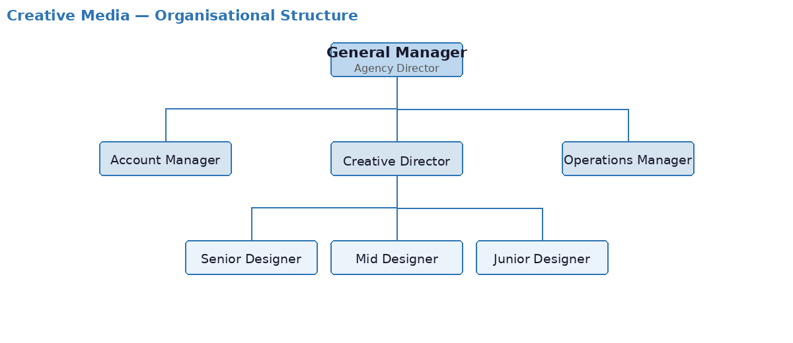
Figure 1.2: Organisational Chart of Creative Media

1.3 Internship Context and Tasks Performed
The student was placed at Creative Media to design and develop an internal project management and analytics system — a tool the agency currently lacks entirely. The internship tasks are directly aligned with the software engineering and BI activities documented in this report, and include:
- Requirements elicitation: structured discussions with the professional supervisor to identify operational pain points, define user roles, and establish system scope.
- UML modelling: development of use case diagrams, class diagrams, and sequence diagrams to formalise system requirements.
- System architecture and data model design: three-tier architecture definition and full entity-relationship design.
- Backend and frontend development (Sprints 1–6): progressive full-stack implementation covering all Django models, JWT authentication, user onboarding, project and task management, time tracking, client feedback, BI dashboards, file management, PDF/Excel report exports, and cloud deployment on Render.
- Iterative review: regular progress presentations to the professional supervisor with incorporation of feedback into subsequent development cycles.

1.4 SWOT Analysis
The following SWOT analysis frames Creative Media's current operational position and contextualises the opportunities this project aims to exploit.

Strengths  - Established and loyal client base  - Strong creative portfolio and expertise  - Flexible team structure adaptable to project needs  - Good market reputation within local sector | Weaknesses  - No digital time or project tracking system  - Project profitability is not measured  - Scope changes are managed informally  - Manual reporting is time-consuming and error-prone
Opportunities  - Growing demand for data-driven agency management  - BI adoption as a competitive differentiator  - Scalable analytics platform for future growth  - Potential to expand services using performance data | Threats  - Competitive pressure from freelance platforms  - Client budget constraints reducing project margins  - Scope creep risk on fixed-price contracts  - Talent retention challenges in the creative sector
Table 1.1: SWOT Analysis of Creative Media

II. Project Context and Problem Statement

2.1 The Problem Being Solved
The fundamental problem this system addresses is the absence of financial transparency in creative project management. At Creative Media, when a project concludes, it is often unclear whether it was profitable. A project invoiced at a fixed price may have required significantly more designer hours than estimated, eroding or eliminating the margin. This occurs for two primary reasons:
- Scope creep: clients frequently request revisions or additional elements after the project specification has been agreed upon. Without a formal tracking mechanism, these additions are absorbed into the workload without being reflected in the invoice.
- No real-time budget visibility: because hours are not logged systematically against budgets, the manager cannot intervene when a project is trending over budget before it is too late.

Secondary problems include the inability to identify which clients generate the most revision cycles and are therefore least profitable, and the difficulty of planning designer capacity when utilisation data is unavailable.

2.2 Scope Boundaries
The following is explicitly within scope: a web application accessible by Managers, Designers, and Clients; a backend REST API handling all CRUD operations and analytical queries; a frontend SPA with role-specific dashboards; a BI analytical layer computing six KPIs; PDF and Excel export; and cloud deployment on Render.

The following is explicitly out of scope: client invoicing and billing, payroll processing, real-time collaborative editing, and integration with third-party design tools (e.g., Adobe Creative Cloud).

III. Development Methodology

3.1 Agile Sprint-Based Approach
Development follows an Agile approach adapted for solo development, inspired by the Scrum framework. The project is divided into six two-week sprints, each with a clearly defined goal and deliverable. This structure produces working, demonstrable software at the end of every sprint — enabling regular supervisor review — and limits the scope of each development cycle, reducing the risk of losing context across a large codebase.

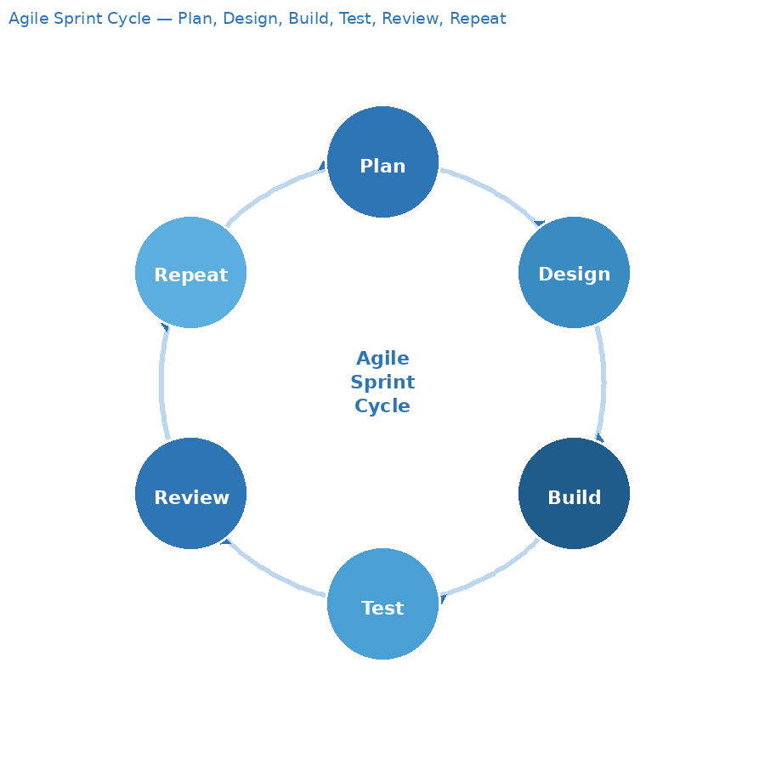
Figure 1.3: Agile Sprint Cycle — Plan, Design, Build, Test, Review, Repeat

3.2 Vertical Slice Development
Within each sprint, features are developed as vertical slices: each user story is implemented end-to-end — database model → serialiser → API view → React component — before the next story begins. This contrasts with a horizontal approach where all models come first, then all APIs, then all UI; the horizontal approach produces nothing testable for extended periods and makes early requirement validation impossible.

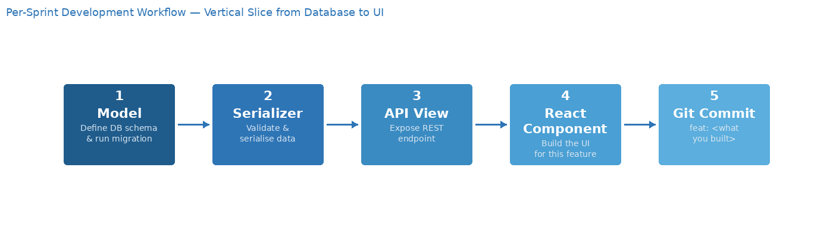
Figure 1.4: Per-Sprint Development Workflow — Model → Serializer → API View → React Component → Git Commit

3.3 Sprint Plan Overview

Sprint | Weeks | Goal | Points | Status
Sprint 1 | Weeks 1–2 | Foundation: Django + React scaffold, all models, JWT, Admin | 16 | ✔ Complete
Sprint 2 | Weeks 3–4 | Authentication & user onboarding (invitation flow, activation, login) | 15 | Upcoming
Sprint 3 | Weeks 5–6 | Project & task management (CRUD, designer assignment, role-scoped views) | 15 | Upcoming
Sprint 4 | Weeks 7–8 | Time tracking & feedback (logging, task status, client feedback) | 15 | Upcoming
Sprint 5 | Weeks 9–10 | BI dashboards & file uploads (KPI cards, charts, profitability table) | 22 | Upcoming
Sprint 6 | Weeks 11–12 | Charts, reports, QA, deployment (PDF/Excel, tests, Render deploy) | 26 | Upcoming
Table 1.2: Sprint Plan and Status Overview

3.4 Gantt Chart
The Gantt chart below provides a temporal view of the six-sprint development timeline, mapping each sprint’s goals to calendar weeks. It complements the sprint table above by making scheduling dependencies and delivery milestones explicit. Each sprint block covers two weeks; hatched cells indicate sprints not yet started at the time of this report.
[GANTT CHART PLACEHOLDER — Insert Figure 1.5: Gantt diagram illustrating the six-sprint timeline across 12 weeks, with sprint goals, deliverables, and milestones mapped to calendar dates.]
Figure 1.5: Gantt Chart — Six-Sprint Development Timeline (Weeks 1–12)

IV. Chapter Conclusion
This chapter has established the organisational and methodological context of the project. Creative Media's absence of digital project tracking represents a clear and well-defined business problem. The Agile sprint methodology provides the structure needed to deliver a complex full-stack system within a twelve-week academic internship. Chapter 2 will situate the project within its theoretical and technical framework, reviewing BI principles, project management theory, existing tools, and the technologies selected for implementation.

Chapter 2: Theoretical Study and Literature Review
Before writing any code, the project required a clear conceptual foundation: what does Business Intelligence actually mean in a service context, what tools already exist and why they fall short, and which technologies are the best fit for the constraints at hand. This chapter covers that groundwork. It also introduces the working hypotheses that guided the system design and that the final implementation will be evaluated against.

I. Business Intelligence in Service Industries

1.1 Definition and Role of Business Intelligence
Business Intelligence (BI) refers to the set of technologies, processes, and practices that transform raw operational data into meaningful, actionable information for decision-makers. In a service industry context — where revenue is generated by selling time and expertise rather than tangible goods — BI plays a particularly important role in understanding the relationship between inputs (designer hours) and outputs (project value delivered to clients).

A key distinction in BI is between operational reporting, which describes what happened, and analytical intelligence, which explains why it happened and enables prediction. This system implements both: operational views (time logs per project, feedback per task) and analytical metrics (EHR, budget variance, scope creep index) that provide explanatory power for management decisions.

1.2 Key Performance Indicators for Creative Agencies
Selecting the right KPIs is critical: too few and management lacks visibility; too many and decision-making is paralysed by noise. Based on industry practice and the specific pain points identified at Creative Media, six metrics were selected as the core analytical layer of this system. The Effective Hourly Rate is the central profitability indicator: it expresses how much monetary value the agency generates per designer hour logged. A high EHR indicates an efficiently managed project; a low EHR indicates underpricing or overconsumption of hours. The Scope Creep Index complements this by revealing whether a low EHR is driven by poor estimation or uncontrolled scope expansion.

Metric | Formula | Business Meaning
Effective Hourly Rate (EHR) | budget_currency ÷ SUM(hours_spent) | Revenue earned per hour of designer time invested
Budget Utilisation % | SUM(hours_spent) ÷ budget_hours × 100 | Proportion of the allocated hour budget consumed to date
Estimation Variance % | (SUM(actual) − SUM(estimated)) ÷ SUM(estimated) × 100 | Accuracy of the original task hour estimates
Scope Creep Index | COUNT(is_unplanned=True) ÷ COUNT(*) × 100 | Percentage of tasks added after project kick-off
Designer Utilisation % | SUM(hours this week) ÷ available_hours_per_week × 100 | Proportion of contracted capacity actually billed
Revision-to-Approval Ratio | COUNT(category='Revision') ÷ COUNT(category='Approval') | Client feedback quality; high values signal rework-intensive clients
Table 2.1: Analytical Metrics Implemented in the System

II. Project Management Information Systems

2.1 Characteristics of an Effective PMIS
A Project Management Information System (PMIS) is a software system that supports the planning, execution, monitoring, and control of projects. For a creative agency, an effective PMIS must balance the structured task tracking of traditional project management with the flexibility required in creative workflows, where scope is often iterative and client-driven.

Key characteristics of an effective PMIS in this context include: role-differentiated access (so that clients see only their own projects, designers see only their assignments, and managers have complete visibility); real-time status updates (task status, hours logged against budget); and direct integration between task management and financial tracking (so that logged hours translate immediately into budget consumption data without manual consolidation).

2.2 Analysis of Existing Tools
Several commercial tools address parts of the problem this system solves. A comparative analysis justifies the decision to build a bespoke solution rather than adopt an off-the-shelf product.

Tool | Strengths | Gaps for Creative Media
Harvest | Strong time tracking and invoicing; team reporting | No custom scope creep tracking; requires integration with separate PM tools; no client profitability analytics
Toggl Track | Excellent timer-based tracking; good team dashboards | No project budget management; no client-facing portal; no BI metrics
FunctionFox | Designed for creative agencies; project costing | Proprietary SaaS with per-seat pricing; no customisable analytical layer; cannot adapt KPIs to agency needs
Monday.com | Powerful general-purpose PM; highly configurable | No financial analytics; no EHR or scope creep concept; requires significant setup for basic time tracking
Asana | Mature task management; good workflow automation | No time tracking or budget tracking natively; no analytical layer; no client portal
Table 2.2: Comparison of Existing Project Management Tools

The gap common to all these tools is the absence of customisable, agency-specific profitability analytics integrated directly into the project management workflow. None expose a Scope Creep Index, an EHR per client, or a client profitability ranking weighted by revision frequency — the three metrics most relevant to Creative Media's decision-making.

III. Technical Framework and Technology Justification

3.1 System Architecture Pattern
The system follows a three-tier client-server architecture: a React single-page application communicates exclusively with a Django REST API via JSON over HTTPS; the API communicates with a PostgreSQL database. This separation provides several advantages: the frontend and backend can be developed, tested, and deployed independently; the API can be consumed by future clients (mobile apps, integrations) without changes; and authentication and authorisation logic is enforced centrally at the API boundary rather than on the client side, preventing data leakage through URL manipulation.

3.2 Technology Stack Justification
Layer | Technology | Justification
Backend | Django 5 + DRF 3.15 | Mature Python framework. ORM enables complex multi-table aggregate queries. DRF provides battle-tested serialisation and viewset patterns with minimal boilerplate.
Authentication | djangorestframework-simplejwt | Stateless JWT tokens. No server-side session storage. Role embedded in payload enables role-based routing without secondary API call.
Database | PostgreSQL 16 | Advanced aggregation capabilities (window functions, conditional COUNT, multi-level joins) required for the BI layer. ACID compliance critical for financial data.
Frontend | React 18 + TypeScript | Component-based SPA. TypeScript enforces consistency between API data shapes and component props, catching integration errors at compile time.
Build tool | Vite | Fast dev server with HMR. Significantly faster than CRA for TypeScript projects; production build is optimised and small.
Data fetching | TanStack React Query | Declarative server-state management with automatic cache invalidation on mutation — eliminates significant boilerplate vs. plain Redux.
Styling | Tailwind CSS | Utility-first CSS with consistent design tokens. Avoids style conflicts in component-heavy UIs.
Charts | Recharts | React-native charting library built on D3. Declarative and composable — well-suited for BI dashboards with dynamic data.
Forms | React Hook Form + Zod | Performant uncontrolled forms with schema-based validation. Zod schemas mirror backend serialiser validation.
PDF export | ReportLab | Standard Python library for programmatic PDF generation, widely used in Django projects.
Excel export | openpyxl | Python library for .xlsx generation with formatting and multi-sheet support.
Deployment | Render | Managed Web Service + Static Site + PostgreSQL. Simple environment variable management and automatic deploys from Git.
Table 2.3: Technology Stack with Justifications

3.3 Authentication Strategy
The system uses JSON Web Token (JWT) authentication implemented via djangorestframework-simplejwt. JWTs are stateless: the server does not maintain a session store, and authorisation decisions are made by decoding the token on each request. The payload includes the user's ID, email, and role, enabling role-based filtering without an additional database query per request.

A short-lived access token (60 minutes) paired with a longer-lived refresh token (7 days) is used. The React frontend's Axios interceptor automatically detects 401 responses, requests a new access token using the refresh token, and retries the failed request — making token expiry invisible to the user in normal usage.

New user onboarding uses a separate invitation token mechanism: a UUID token with a 48-hour expiry is generated and emailed to new users by the Manager. Users must activate their account by setting a password through this token before JWT login becomes available. This prevents self-registration and ensures only Manager-approved users access the system.

IV. Synthesis and Working Hypotheses
The literature review and comparative analysis confirm that the system being built fills a genuine gap in available tooling for small-to-medium creative agencies. The following working hypotheses guide the design and implementation, and will be evaluated against the completed system in the final conclusion:

H1: Systematic time logging against project tasks, when integrated with budget data, will enable managers to identify unprofitable projects in real time rather than retrospectively.

H2: A formal Scope Creep Index will make the volume and frequency of unplanned work visible, enabling the agency to adjust contract terms or pricing models for repeat clients.

H3: Role-scoped access will ensure that client-facing views do not expose sensitive financial data (EHR, profitability rankings) while still providing clients with meaningful project status visibility.

H4: Server-side computation of all metrics via PostgreSQL aggregations will ensure dashboards reflect live data without requiring a separate data warehouse or ETL process.

V. Chapter Conclusion
This chapter has established the theoretical and technical foundations of the project. Business Intelligence in service industries is a well-understood discipline, but existing tools do not adequately address the specific profitability tracking needs of boutique creative agencies. The comparative analysis of existing tools confirmed the absence of a solution combining role-scoped project management, designer time logging, structured client feedback, and customisable agency-specific profitability analytics. The technology stack — Django REST Framework, React/TypeScript, and PostgreSQL — provides the capabilities required to build both the operational management layer and the BI analytical layer within the twelve-week project constraint. Chapter 3 presents the concrete system design and the full implementation results across all six development sprints.

Chapter 3: System Design and Implementation
This chapter presents the concrete design of the system and documents the full implementation across all six sprints. The data model, architecture, and UML diagrams are presented first; each sprint section then records the deliverables completed, the technical decisions made, and the outcomes verified.

I. Requirements Analysis

1.1 Functional Requirements
Functional requirements were elicited through structured discussions with the professional supervisor and organised by user role. Use case diagrams in Section III formalise these requirements visually.

Manager: create/edit/delete projects; assign designers; manage tasks and subtasks with estimated hours and unplanned flags; view all time logs; access all BI dashboards; export PDF and Excel reports; create user accounts via invitation.
Designer: view assigned projects; log time against tasks with descriptions; update task status (Todo → InProgress → Completed); view and respond to client feedback; upload deliverable files; send messages.
Client: view own project status; submit feedback categorised as Revision, Approval, or Question; upload reference materials; send and receive messages on project message boards.

1.2 Non-Functional Requirements
- Security: all endpoints protected by JWT; role-based access enforced server-side on every request; file paths never exposed directly in API responses.
- Performance: database indexes on all frequently-queried columns; analytical queries executed via PostgreSQL aggregations rather than Python-level iteration.
- Scalability: stateless JWT authentication enables horizontal API scaling; Cloudinary or S3 integration for file storage eliminates ephemeral disk dependency on Render.
- Maintainability: strict separation between read serialisers (nested/computed fields) and write serialisers (writable fields only); consistent ViewSet pattern across all apps.
- Usability: role-based redirect after login; ProtectedRoute component blocks unauthorised page access; responsive UI built with Tailwind CSS.

II. Data Model

2.1 Entity Overview
The system's data model consists of eleven entities organised around the central Project entity. The table below describes each entity and its role in the system.

Model | Description
User | Core authentication entity. Stores email (login field), full_name, role (Manager/Designer/Client), is_active (False until invitation accepted).
Designer | One-to-one extension of User. Stores hourly_rate, specialization, available_hours_per_week. Created automatically via post_save signal.
Client | One-to-one extension of User. Stores phone and industry. Created automatically via post_save signal.
InvitationToken | UUID token with 48-hour expiry used for the invitation-based onboarding flow. is_used=True after activation.
Project | Central entity. Belongs to Client (PROTECT FK). Holds project_name, budget_hours, budget_currency, deadline, status (Active/Completed/OnHold), category.
ProjectAssignment | Many-to-many join between Project and Designer with unique_together constraint preventing duplicate assignments.
Task | Belongs to Project. Self-referencing parent_task FK supports subtask hierarchies. is_unplanned=True flags scope creep tasks added after kickoff.
TimeLog | Records hours_spent by a Designer on a Task. Primary source for all time-based analytics. One Designer logs many entries across many Tasks.
Feedback | Client-submitted feedback per project. Category: Revision / Approval / Question. Status: Pending / InProgress / Resolved. resolved_at set automatically on resolution.
Message | Project-scoped messages visible to all project participants (Manager, Designer, Client). Ordered by created_at.
FileUpload | Stores file metadata (name, path, type, size). Supports deliverable and reference material uploads. Files stored in MEDIA_ROOT/projects/{id}/.
Table 3.1: Data Model Entities

2.2 Key Design Decisions
Several non-obvious design decisions warrant explicit explanation:
- No separate Revision model: revisions are Feedback records with category='Revision'. This avoids model proliferation and keeps all client feedback queryable through a single interface.
- is_unplanned flag on Task: rather than a separate ScopeChange model, tasks added after project kickoff are flagged boolean. The Scope Creep Index is then a simple aggregate ratio requiring no extra joins.
- Designer and Client as profile tables: all authentication goes through the User model; profile tables add domain-specific fields (hourly_rate, industry) without polluting the auth system.
- budget_currency stores the monetary amount (e.g., 2000.00 for $2,000). Effective Hourly Rate = budget_currency ÷ SUM(hours_spent).
- on_delete=PROTECT on Project.client FK: prevents accidental deletion of a Client who owns active projects, preserving financial history.
- analytics app has no models: it contains only views executing aggregate queries across all other apps. Clean separation between operational and analytical layers.

2.3 Database Indexes
Composite indexes were defined on the most frequently filtered and joined columns to ensure analytical queries remain performant as data volume grows: (client, status) and (created_at) on Project; (project, status) and (is_unplanned) on Task; (task, designer) and (created_at) on TimeLog; (project, category, status) and (submitted_at) on Feedback; (project, created_at) on Message. All indexes were added before the first analytical query was written.

III. System Architecture and UML Diagrams

3.1 Three-Tier Architecture
The system is structured as a three-tier application: the React SPA (presentation tier) is served as a static site and communicates with the backend exclusively via API calls; the Django REST API (logic tier) handles all business logic, authorisation enforcement, and analytical computation; the managed PostgreSQL instance (data tier) handles all persistence including complex aggregation queries. The tiers are physically separated on Render, enabling independent scaling and deployment.
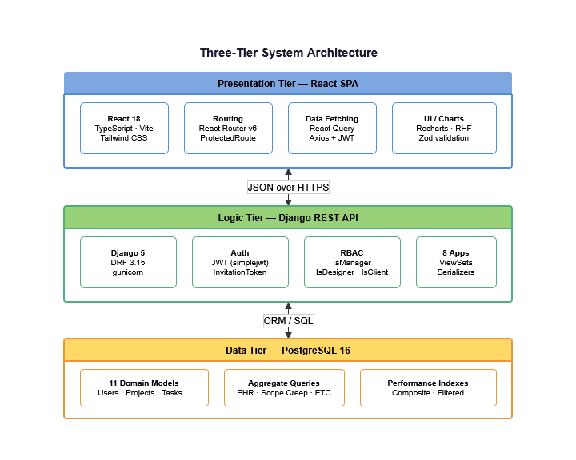
Figure 2.1: Three-Tier System Architecture — Presentation, Logic, and Data Layers

3.2 Application and Folder Structure
The Django backend is organised into eight domain apps: users, projects, tasks, timelog, feedback, messages, files, and analytics. The analytics app contains no models — only views executing aggregate queries across the other apps. The React frontend mirrors this with separate api/, hooks/, types/, pages/, and components/ directories, each resource having its own typed API functions, React Query hooks, and TypeScript interfaces.
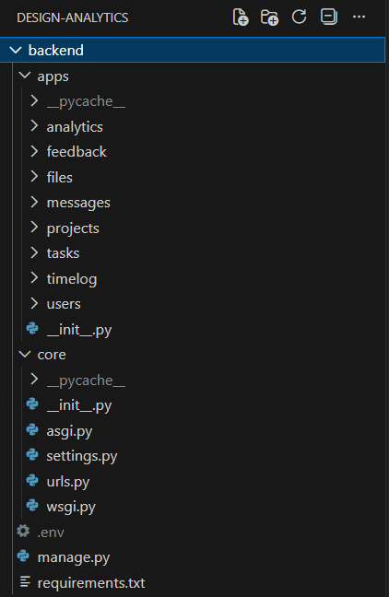
Figure 2.2: Backend Directory Structure
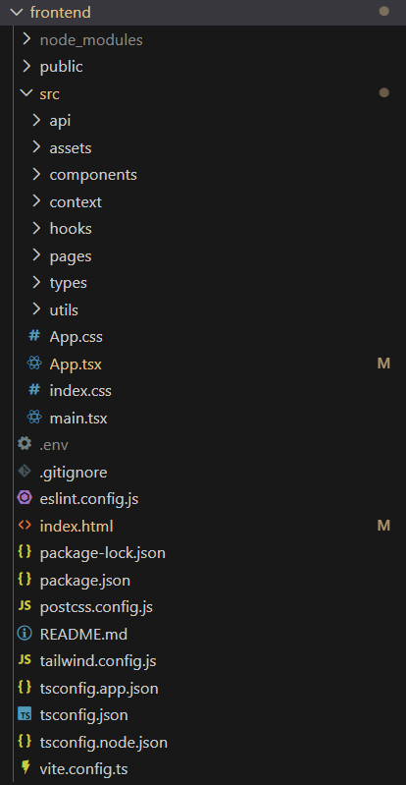
Figure 2.3: Frontend Directory

3.3 API Design
The API follows RESTful conventions with resource-based URL routing under /api/. Authentication is required on all endpoints except login and token refresh. Role-based access is enforced at the ViewSet level using custom permission classes (IsManager, IsDesigner, IsClient, IsManagerOrDesigner), and queryset filtering ensures that Designers see only assigned projects and Clients see only their own projects, regardless of the endpoint called.

3.4 Use Case Diagrams
The use case model was produced as a single global diagram capturing all three roles and their interactions with the system. For clarity in this report, the global diagram is presented first, followed by three cropped views — one per role — isolating each actor's specific use cases. A Manager controls the full system lifecycle: creating projects, assigning designers, and accessing all analytics. A Designer's scope is limited to assigned projects, where they log time and manage task status. A Client's scope is limited to their own projects, where they upload reference materials, submit feedback, and exchange messages.
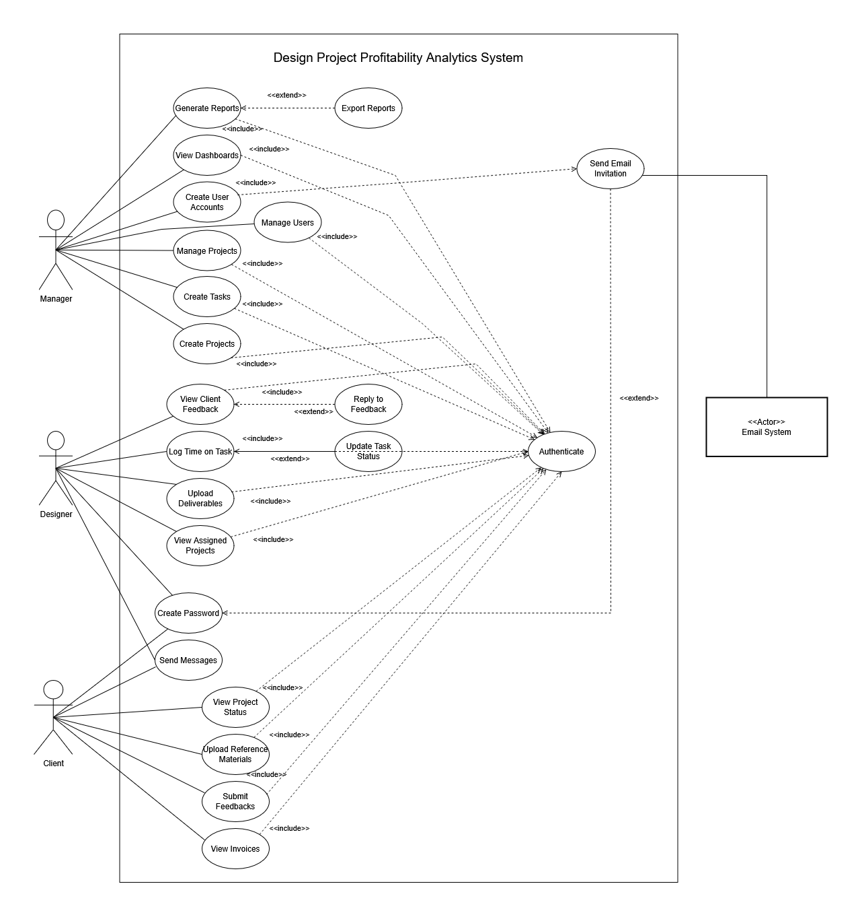
Figure 2.4: Use Case Diagram — Global View
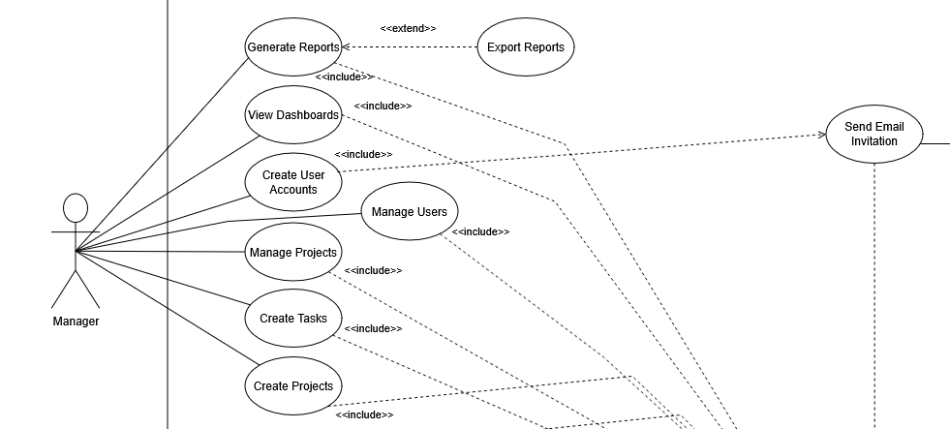Figure 2.5: Use Case Diagram — Manager Role
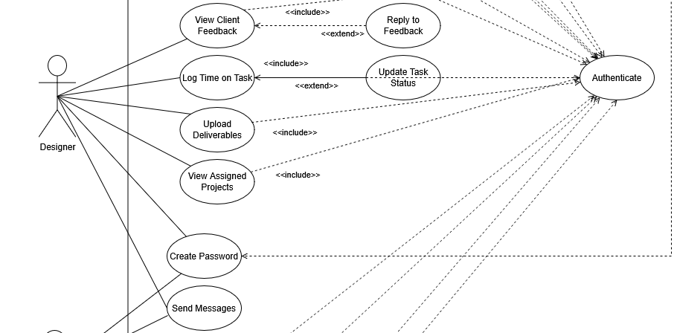
Figure 2.6: Use Case Diagram — Designer Role
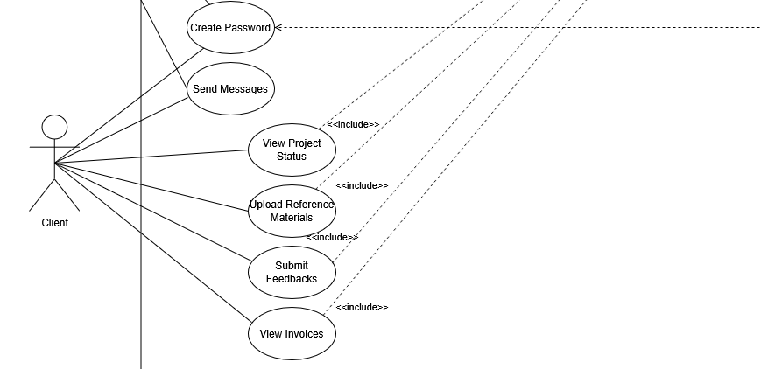
Figure 2.7: Use Case Diagram — Client Role

3.5 Class Diagram
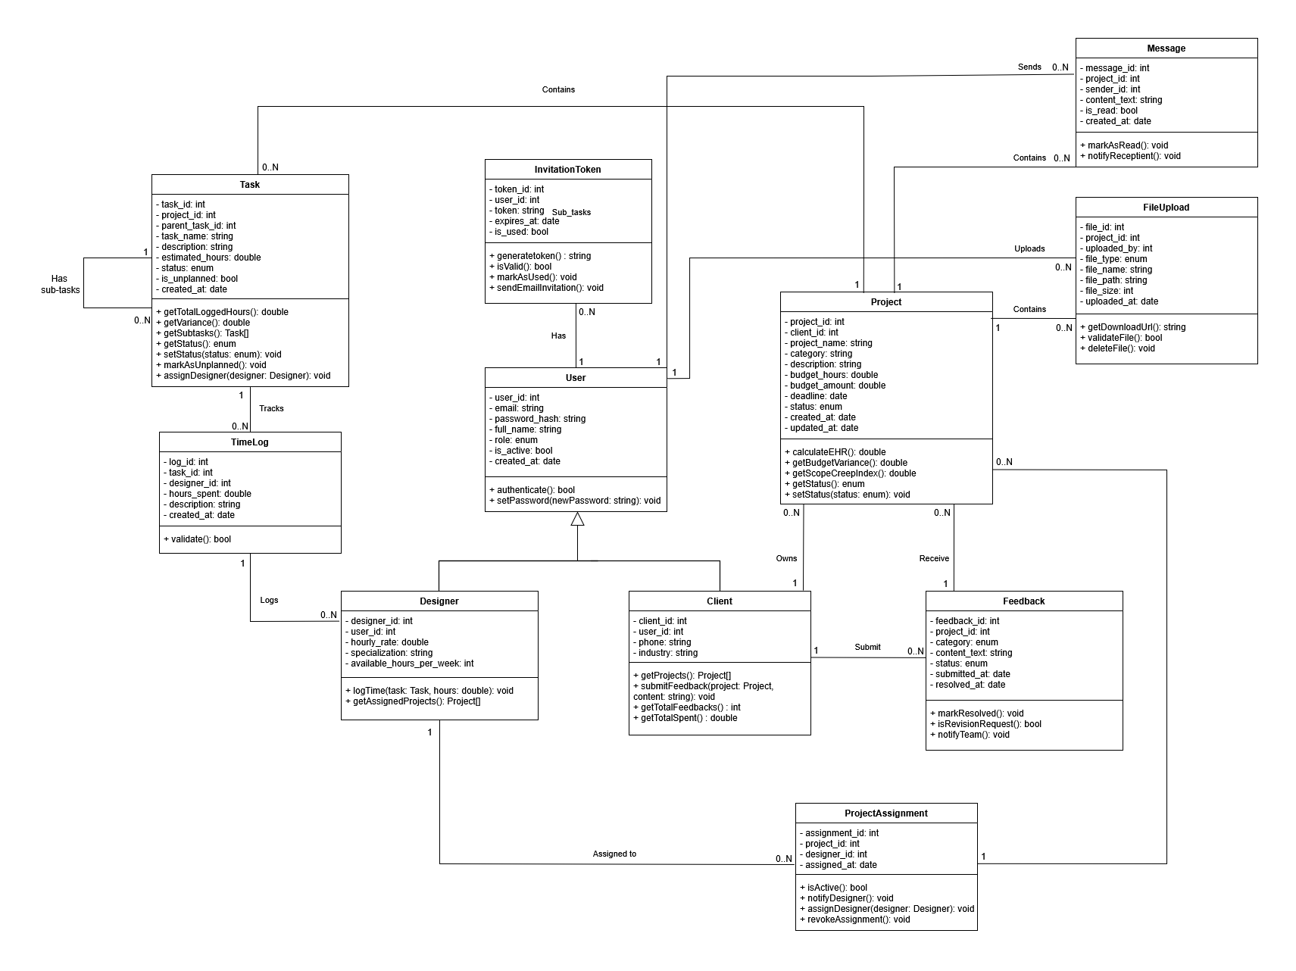
The class diagram models all eleven domain objects and their relationships. The central entity is Project, which aggregates Tasks (with optional subtask nesting via a self-referential foreign key), time-logged by Designers through TimeLogs, and feedback submitted by Clients. The User entity drives authentication; role-differentiated profiles (Designer and Client) are attached via one-to-one relationships.
Figure 2.8: Class Diagram

3.6 Entity-Relationship Diagram
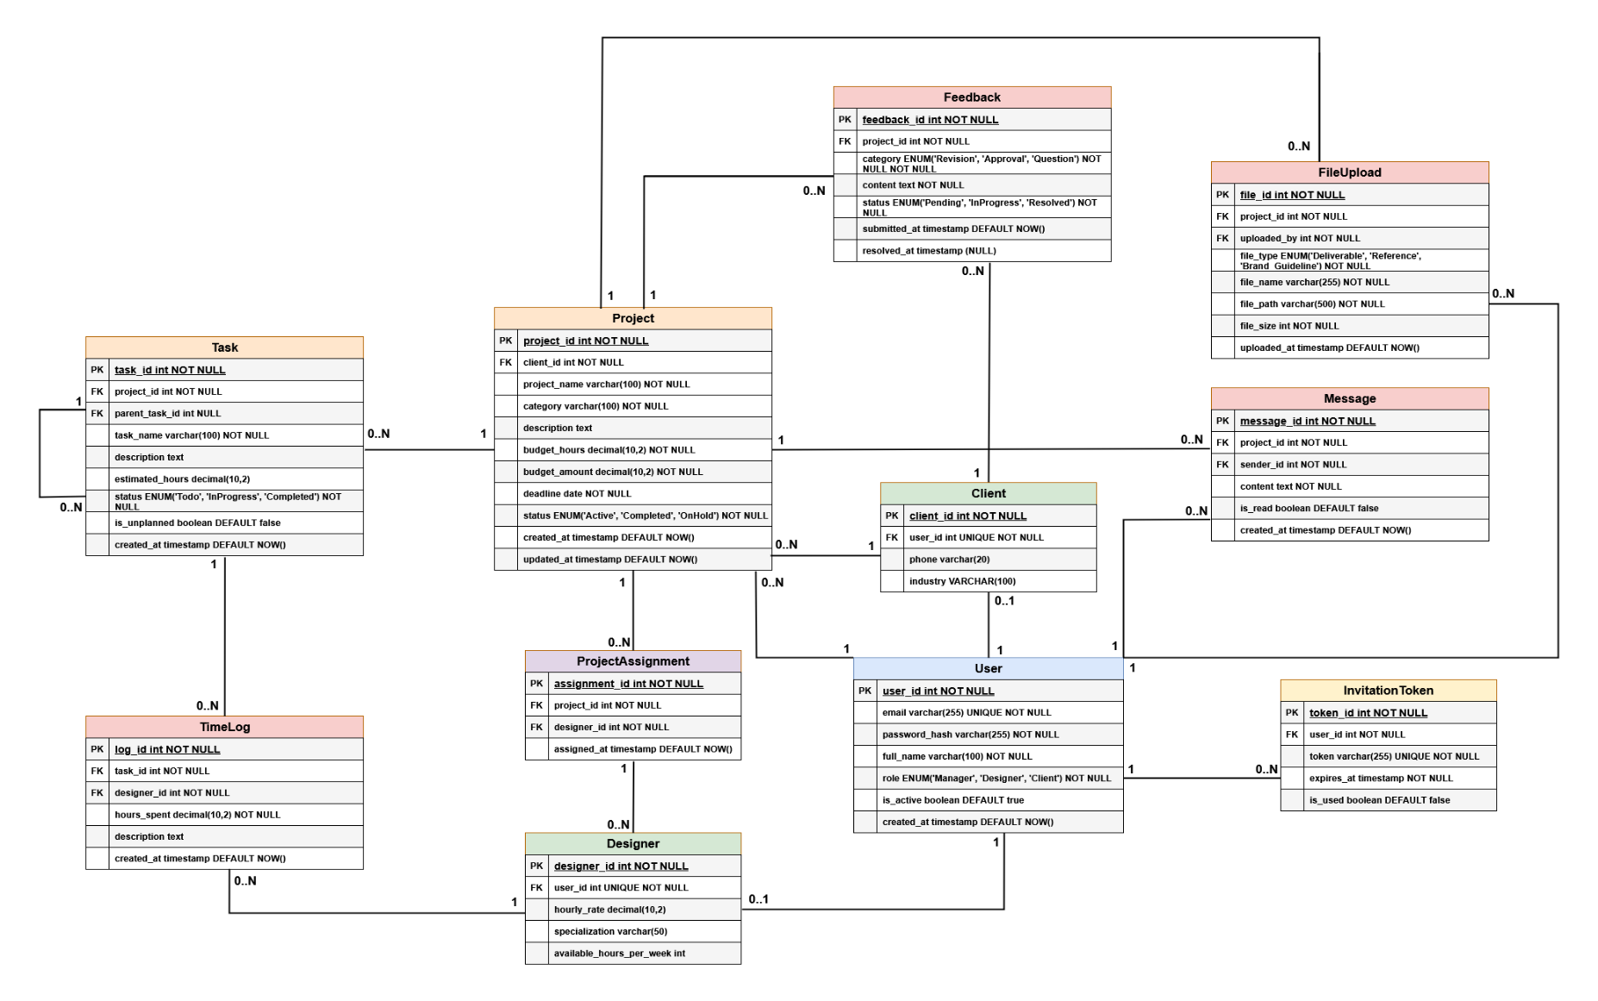
The ERD presents the physical database schema derived from the class diagram. Key constraints are visible: the PROTECT foreign key from Project to Client, the unique_together constraint on ProjectAssignment, and the self-referential foreign key on Task.
Figure 2.9: Entity-Relationship Diagram

3.7 Deployment Diagram
The deployment diagram shows how the system's components are physically distributed across infrastructure nodes on Render. The React SPA is served as a Static Site (a CDN-backed file server). The Django REST API runs as a Web Service (a containerised process). The PostgreSQL database is a managed instance isolated from the application tier. All communication between the SPA and the API occurs over HTTPS; the API communicates with the database over a private internal network, never exposed to the public internet.
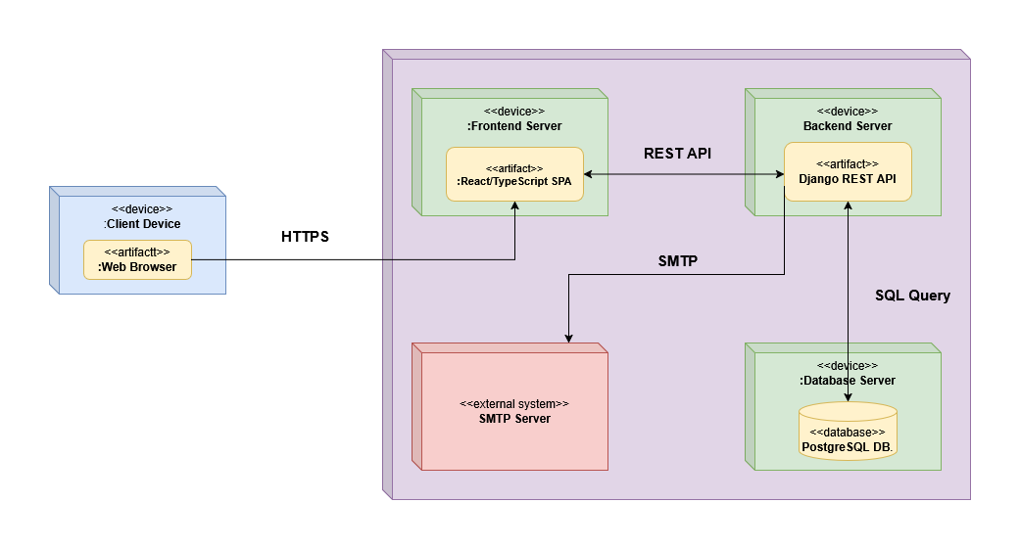
Figure 2.10: Deployment Diagram

3.8 Sequence Diagrams
Five sequence diagrams document the key interaction flows of the system. The first two cover the authentication flows implemented in Sprint 1. The remaining three cover the core operational flows which are implemented in Sprints 2 through 4.
JWT Login (Figure 2.11): User submits credentials → backend validates against User table → returns access/refresh token pair → Axios interceptor attaches access token to all subsequent requests → on 401, interceptor calls refresh endpoint and retries the original request transparently.

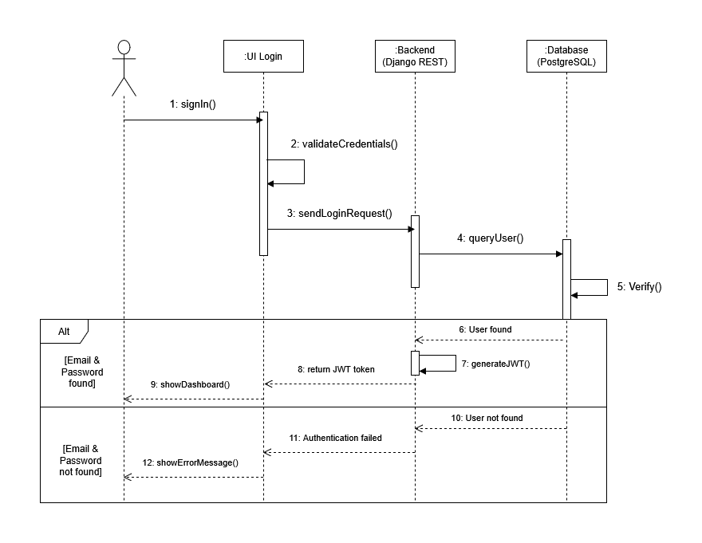Figure 2.11: Sequence Diagram — JWT Login Flow
Invitation & Account Activation (Figure 2.12): Manager creates user in Django Admin → post_save signal generates UUID InvitationToken (48h expiry) and sends activation email → user clicks link → /activate page → submits password → backend validates token (exists, is_used=False, not expired) → sets password, is_active=True, token.is_used=True → user can now log in via JWT.
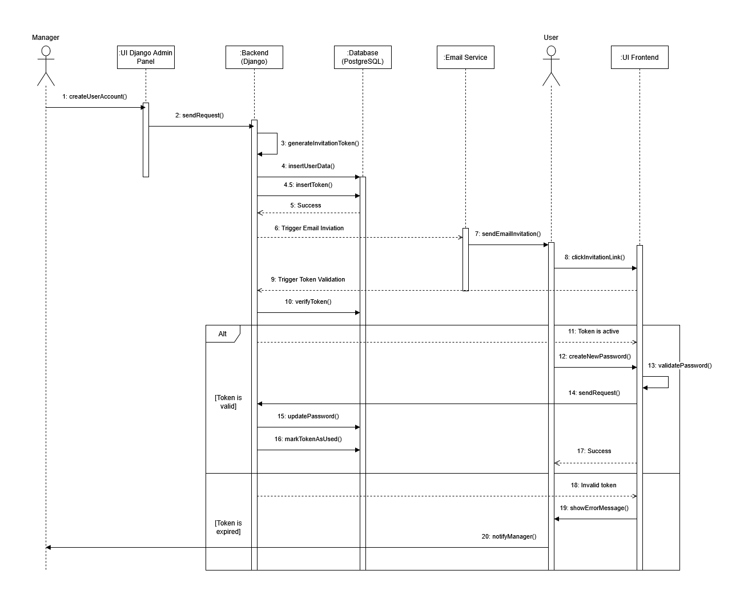
Figure 2.12: Sequence Diagram — Invitation and Account Activation Flow
Project Creation (Figure 2.13): Manager submits create project form → POST /api/projects/ → IsManager permission check → ProjectWriteSerializer validates payload → Project saved to DB → Designer assignment via POST /api/projects/{id}/assign/ → ProjectAssignment record created with unique_together enforcement → 201 response → React Query cache invalidated → project list refreshes.

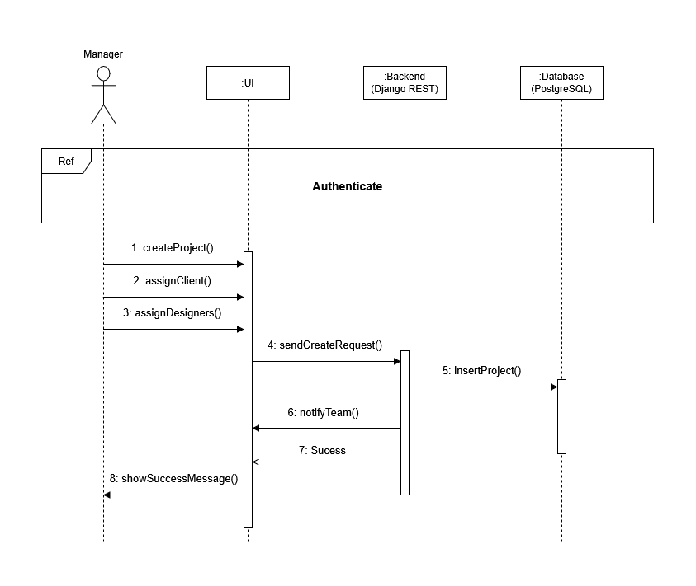Figure 2.13: Sequence Diagram — Project Creation and Designer Assignment Flow
Time Logging (Figure 2.14): Designer selects task from assigned project → submits time log form → POST /api/timelogs/ → IsDesigner permission check → TimeLogWriteSerializer validates hours_spent > 0 → TimeLog saved linking task + designer → budget utilisation and EHR metrics update automatically on next dashboard query → 201 response → React Query cache for project analytics invalidated.
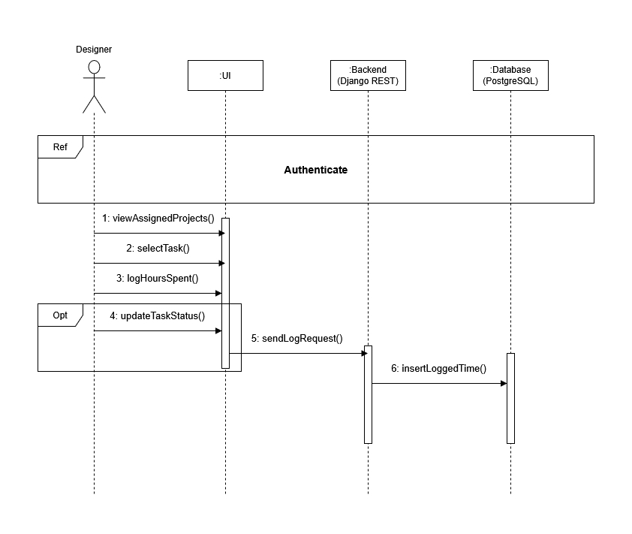
Figure 2.14: Sequence Diagram — Designer Time Logging Flow
Client Feedback Submission (Figure 2.15): Client submits feedback form (category: Revision/Approval/Question) → POST /api/feedback/ → IsClient permission check → FeedbackWriteSerializer validates → Feedback record saved with status=Pending → Manager/Designer see new item in feedback list → PATCH /api/feedback/{id}/ updates status → on transition to Resolved, serialiser update() automatically sets resolved_at = timezone.now().

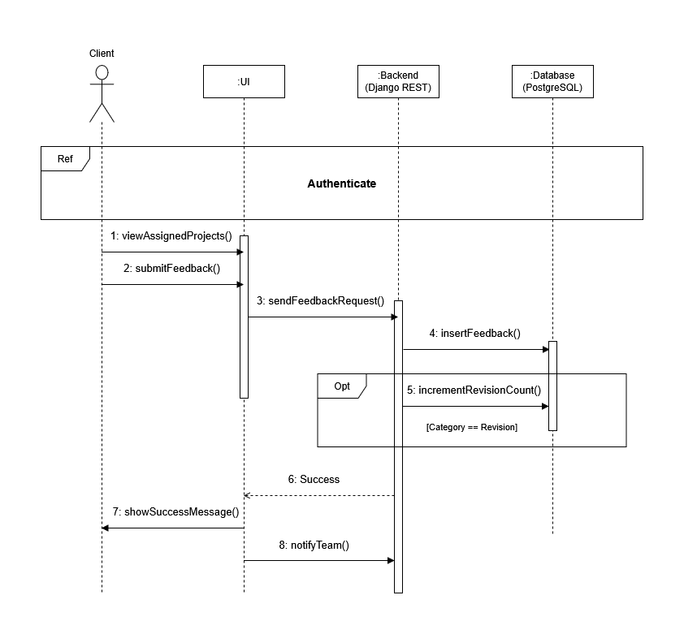Figure 2.15: Sequence Diagram — Client Feedback Submission and Resolution Flow

IV. Sprint 1 — Foundation Implementation

4.1 Sprint Goal and Scope
Sprint 1 covered the foundational layer of the entire system: scaffolding both the Django backend and the React frontend, implementing all eleven data models and running clean migrations to PostgreSQL, configuring the JWT authentication endpoints, and registering all models in the Django Admin interface. All Sprint 1 deliverables were completed successfully.

4.2 Models and Migrations
All eleven models were implemented in Django exactly as specified in the class diagram and ERD. The custom User model extends AbstractBaseUser using email as the login identifier — a deliberate departure from Django's default username-based authentication required by the multi-role system design. AUTH_USER_MODEL was configured before the initial migration to avoid the migration conflicts that arise from swapping the user model after the fact.

The Designer and Client profile models are created automatically via a post_save signal on User, triggered whenever a new user with the corresponding role is created. The Task model's self-referencing parent_task foreign key enables subtask hierarchies; the is_unplanned boolean is indexed separately to support efficient scope creep queries. All migrations were run and verified with zero errors; the resulting schema was inspected directly in PostgreSQL to confirm field types, constraints, and indexes.
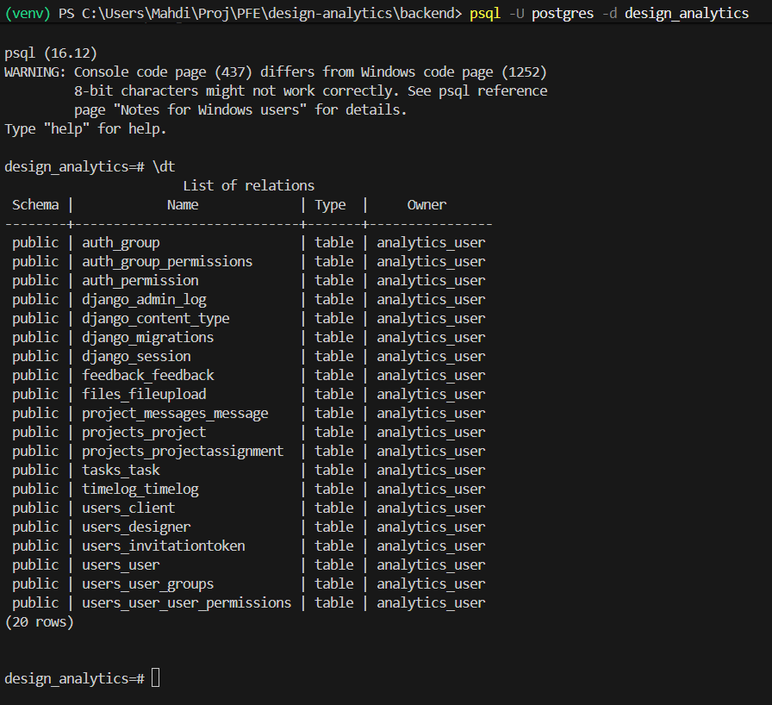
Figure 3.1: Database tables
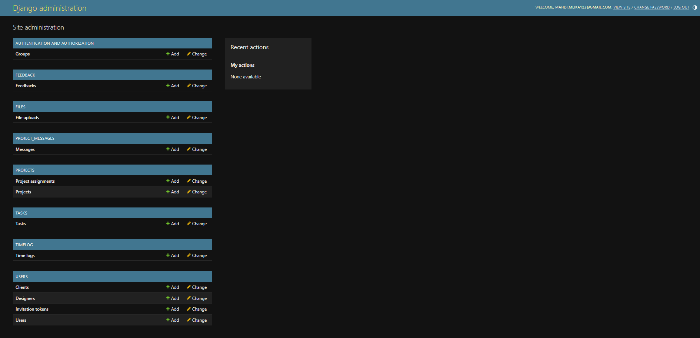
Figure 3.2: Django Admin Panel — All 11 Models Registered and Accessible

4.3 JWT Authentication
The JWT authentication layer was implemented using djangorestframework-simplejwt. Two endpoints are exposed: POST /api/auth/token/ accepts email and password credentials and returns an access/refresh token pair; POST /api/auth/token/refresh/ exchanges a valid refresh token for a new access token. The JWT payload was extended to include the user's role and full_name, enabling the frontend to make role-based routing decisions immediately upon login without an additional API call.

A protected test route was implemented and verified to return HTTP 401 without a valid token and HTTP 200 with a valid token. Permission class stubs (IsManager, IsDesigner, IsClient, IsManagerOrDesigner) were implemented in a shared permissions module, ready for use in subsequent sprints.

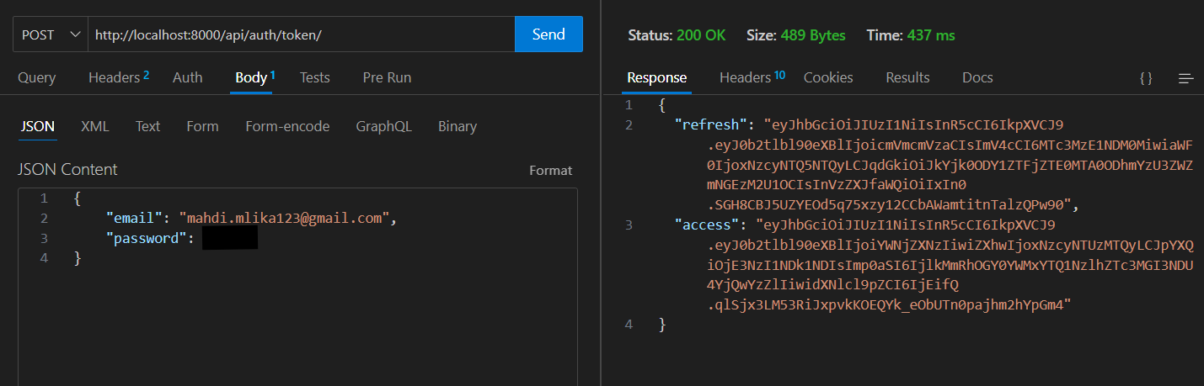Figure 3.3: Thunder Client Screenshot — JWT Token Response from POST /api/auth/token/

4.4 Django Admin Configuration
All eleven models were registered in the Django Admin interface, providing the Manager with a functional interface for user and data management from Sprint 1 onwards. The UserAdmin configuration reflects the custom User model (email as the search and list field rather than username). Inline admin configurations for Designer and Client profiles ensure that creating a user and their profile can be done on a single Admin page, avoiding the two-step creation that would otherwise be required with separate OneToOne records.

4.5 React Application Scaffold
The React frontend was scaffolded using Vite with the TypeScript template. React Router v6 was configured with stub routes for all three role dashboards (/manager, /designer, /client) and the public authentication routes (/login, /activate). The Axios API client was configured with the base URL from an environment variable, and the request interceptor for JWT attachment — along with the 401 auto-refresh and retry logic — was implemented and ready for Sprint 2. An AuthContext was created to store the decoded user object (parsed from the JWT payload) and expose the user's role to all components.
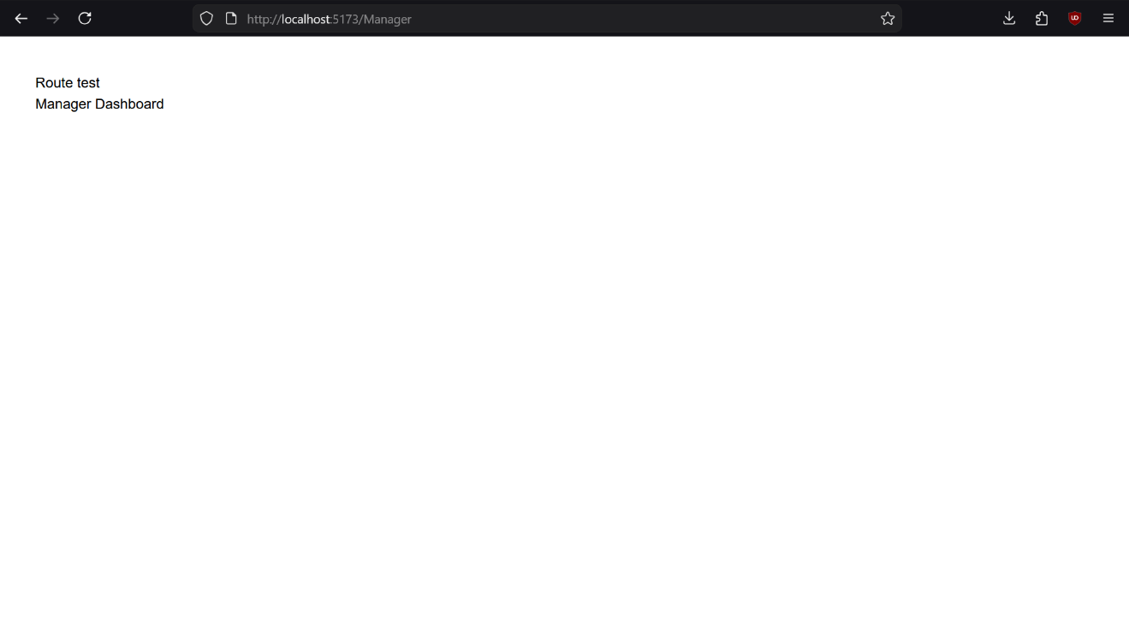
Figure 3.4: React Application Running at localhost:5173 — Vite Dev Server with Stub Routes Configured

4.6 Roles and Permissions Matrix

Capability | Manager | Designer | Client
All BI dashboards and analytics | ✓ | ✗ | ✗
Create / edit / delete projects | ✓ | ✗ | ✗
Assign designers to projects | ✓ | ✗ | ✗
View all projects | ✓ | ✗ | ✗
View assigned projects | ✓ | ✓ | ✗
Log time and update task status | ✓ | ✓ | ✗
Upload deliverables | ✓ | ✓ | ✗
View and resolve client feedback | ✓ | ✓ | ✗
View own projects | ✓ | ✗ | ✓
Submit feedback and revisions | ✓ | ✗ | ✓
Upload reference materials | ✓ | ✗ | ✓
Send and receive messages | ✓ | ✓ | ✓
Generate and export reports | ✓ | ✗ | ✗
Create user accounts | ✓ | ✗ | ✗
Table 3.2: User Roles and Permissions Matrix

V. Sprint 2 — Authentication and User Onboarding
[TO BE WRITTEN] Sprint 2 — Cover: post_save invitation token signal, email sending, POST /api/auth/activate/ endpoint, /activate React page (password form), login page, AuthContext, ProtectedRoute, role-based redirect. Test full flow: create user in Admin → receive email → click link → set password → login → reach correct dashboard.

VI. Sprint 3 — Project and Task Management
[TO BE WRITTEN] Sprint 3 — Cover: Project and Task CRUD endpoints (Manager-only create/delete; Designer/Manager patch), designer assignment endpoint, role-scoped queryset filtering, and frontend pages for all three roles.

VII. Sprint 4 — Time Tracking and Client Feedback
[TO BE WRITTEN] Sprint 4 — Cover: TimeLog CRUD, task status toggle (Todo → InProgress → Completed), client feedback submission, Pending → InProgress → Resolved resolution flow including auto-setting of resolved_at in the serialiser update().

VIII. Sprint 5 — BI Dashboards and File Uploads
[TO BE WRITTEN] Sprint 5 — Cover: all analytics API endpoints (/ehr/, /budget-variance/, /profitability/, /scope-creep/, /kpi-summary/), Recharts dashboard (BarChart, KPI cards, profitability table), file upload endpoint (multipart/form-data), and the project message board.

IX. Sprint 6 — Reports, Testing, and Deployment
[TO BE WRITTEN] Sprint 6 — Cover: LineChart (cumulative hours), PieChart (revenue by client), PDF export (ReportLab), Excel export (openpyxl), dashboard filter controls, Django TestCase API tests, and full Render deployment (backend Web Service + frontend Static Site + managed PostgreSQL).

X. Chapter Conclusion
[TO BE WRITTEN] Chapter 3 Conclusion — Summarise the design decisions and Sprint 1 outcomes. State that the full data model, architecture, and authentication foundation are in place. Confirm readiness for Sprint 2.

General Conclusion and Perspectives

I. Summary of Work Completed
This report documents the first phase of the Design Project Profitability Analytics System — a full-stack web application developed for Creative Media to address the agency's lack of digital project management and financial analytics capabilities.

The work completed to date covers the full foundation of the system: a clearly articulated problem statement grounded in the agency's operational context; a comprehensive review of BI principles, relevant literature, and existing tool analysis; a complete system design including the data model, three-tier architecture, nine UML diagrams, and REST API structure; and the Sprint 1 implementation of all Django models, JWT authentication, Django Admin configuration, and the React application scaffold.

[TO BE WRITTEN] General Conclusion I (to complete at end of project) — Extend with a summary of all six sprints once implementation is complete. Confirm whether each of the working hypotheses H1–H4 was validated by the completed system.

II. Remaining Work and Timeline
Five sprints remain in the development timeline. Sprint 2 will complete the user onboarding flow. Sprints 3 and 4 will implement the project/task management layer and the time tracking and feedback systems. Sprint 5 will build the BI dashboards and file management features. Sprint 6 will complete the chart suite, add PDF/Excel exports, run API tests, and deploy the complete system to Render.

Upon completion, this report will be extended with a fourth chapter presenting the full system's results, test outcomes, deployment details, and a critical evaluation of the implemented metrics against the working hypotheses defined in Chapter 2.

III. Anticipated Contributions and Perspectives
The primary contribution of this project is a purpose-built, extensible analytics platform that provides Creative Media with visibility into dimensions of its business that were previously opaque: which projects are profitable, which clients generate the most revision cycles, how effectively each designer's capacity is being utilised, and how frequently scope creep occurs.

Beyond the immediate organisational impact, this system demonstrates how a Django REST API, a React frontend, and a managed PostgreSQL instance can be combined to deliver genuinely useful BI capabilities without requiring enterprise-scale infrastructure or proprietary SaaS subscriptions.

Future perspectives include: predictive analytics using historical time log data to automatically estimate task hours for similar future projects; mobile application support through the existing REST API; and a potential generalisation of the platform for use by other creative agencies beyond Creative Media.

References
[1] Turban, E., Sharda, R., & Delen, D. (2014). Business Intelligence and Analytics: Systems for Decision Support (10th ed.). Pearson.
[2] PMI — Project Management Institute. (2021). A Guide to the Project Management Body of Knowledge (PMBOK® Guide) — 7th Edition. Project Management Institute.
[3] Django Software Foundation. (2024). Django 5.0 Documentation. https://docs.djangoproject.com
[4] Tom Christie. (2024). Django REST Framework Documentation. https://www.django-rest-framework.org
[5] Meta Open Source. (2024). React 18 Documentation. https://react.dev
[6] Microsoft. (2024). TypeScript Documentation. https://www.typescriptlang.org/docs
[7] TanStack. (2024). TanStack React Query v5 Documentation. https://tanstack.com/query
[8] PostgreSQL Global Development Group. (2024). PostgreSQL 16 Documentation. https://www.postgresql.org/docs/16
[9] Recharts Team. (2024). Recharts Documentation. https://recharts.org
[10] djangorestframework-simplejwt contributors. (2024). Simple JWT Documentation. https://django-rest-framework-simplejwt.readthedocs.io
[11] Vitejs. (2024). Vite — Next Generation Frontend Tooling. https://vitejs.dev
[12] Tailwind Labs. (2024). Tailwind CSS Documentation. https://tailwindcss.com/docs
[13] Schwaber, K., & Sutherland, J. (2020). The Scrum Guide. https://scrumguides.org

