Predicting 30-Day Hospital Readmission in Diabetic Inpatients: A Methodologically Corrected Comparison of Logistic Regression, Random Forest, and XGBoost
Mahdi Osman
MSt Healthcare Data Science — Module 5 Assignment
Code and data: https://github.com/mahdi2382/Cambridge_Assignments

Abstract
Purpose. Unplanned 30-day hospital readmission is a globally recognised quality indicator and a primary policy target in diabetic inpatients. Comparative evaluations on the Diabetes 130-Hospitals dataset have repeatedly been confounded by methodological flaws including double imbalance correction, label encoding of nominal variables, and pre-split data leakage. This study presents a methodologically corrected comparison of three models, with explicit attention to calibration, threshold selection, and benchmarking against a clinical risk score.
Methods. The Diabetes 130-US Hospitals dataset (101,766 encounters, 1999–2008) was preprocessed via patient-level deduplication, hospice exclusion, and ICD-9 grouping, yielding 69,973 encounters (9.0% positive). Logistic regression (LR), random forest (RF), and XGBoost (XGB) were fitted within scikit-learn pipelines with one-hot encoded nominal features and class weighting. Probabilities were post-hoc calibrated using isotonic regression. Models were evaluated on a 20% held-out test set using AUC-ROC, AUPRC, Brier score, decision curve analysis, validation-selected operating thresholds, fairness audit, and per-subgroup calibration. SHAP values were computed via TreeSHAP. Performance was benchmarked against a LACE-proxy clinical risk score.
Results. Cross-validated AUC-ROC was 0.649 (LR), 0.654 (RF), and 0.651 (XGB); no significant pairwise differences were detected. Uncalibrated Brier scores (0.155–0.228) substantially exceeded the no-skill baseline of 0.082; isotonic calibration recovered Brier scores to 0.079 across all three models. Decision curve analysis on uncalibrated probabilities showed net benefit below the “treat none” reference, but calibrated probabilities yielded positive net benefit at all clinically plausible thresholds (10–25%). At validation-selected F1-optimal thresholds (~0.11), RF achieved F1 = 0.243 with recall = 0.450. Discharge disposition, prior inpatient visits, age, and length of stay were the dominant predictors; gender ranked 29th of 110 features. Subgroup AUC ranged 0.638–0.809; all 18 model×subgroup combinations beat their respective no-skill calibration baselines. ML models outperformed the LACE-proxy clinical risk score (AUC 0.550) by approximately 0.10 AUC.
Conclusion. Three appropriately tuned machine learning models achieved modest but clinically useful discrimination once calibration was applied. Post-hoc isotonic calibration was essential: uncalibrated probabilities were not deployment-ready, but calibrated probabilities yielded positive net benefit across clinical thresholds, equal-baseline performance across racial subgroups, and meaningful advantage over a traditional clinical risk score. Calibration, not raw discrimination, was the binding constraint on clinical utility.

1. Introduction
Hospital readmission within 30 days of discharge is widely used as a quality and value indicator in healthcare systems globally, including under the US Centers for Medicare and Medicaid Services Hospital Readmissions Reduction Program (Joynt and Jha, 2013) and within NHS England quality reporting frameworks. Patients with diabetes mellitus experience particularly high rates of unplanned readmission, estimated at 14–22% — approximately twice those of non-diabetic inpatients (Hammoudeh et al., 2018; Strack et al., 2014). Identifying high-risk patients at discharge could enable targeted interventions; in practice, such a model would generate a risk flag for the discharge nurse or care coordinator, triaging high-risk patients into a tiered intervention bundle (enhanced medication reconciliation, 48-hour and 7-day follow-up calls, accelerated outpatient appointments) while low-risk patients receive routine discharge instructions.
Machine learning has been widely applied to readmission prediction, with most published models achieving AUC-ROC values in the 0.60–0.75 range. A systematic review of 71 studies found no consistent advantage for machine learning over logistic regression in clinical prediction (Christodoulou et al., 2019). The LACE index (van Walraven et al., 2010) — a four-component clinical risk score combining length of stay, acuity, comorbidity, and emergency department visits — remains the most widely used non-ML benchmark.
Methodological flaws have repeatedly been identified in published readmission models, including SMOTE combined with class weighting (which produces double correction and inflates minority-class recall; Blagus and Lusa, 2013), pre-split preprocessing that leaks test-set information (Kapoor and Narayanan, 2023), label encoding of nominal variables, and evaluation at default thresholds without consideration of clinical decision context. Each flaw inflates reported metrics and obscures genuine clinical utility.
This analysis applies the following methodological corrections to the Diabetes 130-Hospitals benchmark: one-hot encoding of nominal variables; preprocessing fitted only within training folds; single class-weighting for imbalance; post-hoc isotonic calibration; validation-selected operating thresholds; head-to-head benchmarking against a LACE-proxy clinical risk score; and SHAP-based feature attribution via XGBoost’s native TreeSHAP. The aim is to characterise the genuine performance achievable on this dataset and provide a defensible benchmark for future work.

2. Methods

2.1 Dataset
The Diabetes 130-US Hospitals dataset (UCI ML Repository, ID 296) comprises 101,766 inpatient encounters across 130 US hospitals from 1999 to 2008, with 50 features including demographics, admission details, ICD-9 diagnoses, laboratory results, medication indicators, and the readmission outcome. The dataset was suitable for this task because it provides a large, diabetes-specific cohort with sufficient sample size for stable cross-validation, a documented 30-day readmission outcome aligned with policy definitions, and a mix of demographic, clinical, and utilisation features enabling SHAP-based and fairness-based interrogation. Released under CC BY 4.0, the data are loaded by the analysis notebook directly from a public mirror in the project GitHub repository.

2.2 Preprocessing
Preprocessing comprised: patient-level deduplication retaining the earliest encounter (preventing temporal leakage); removal of identifiers and high-missingness columns; exclusion of hospice/in-hospital death discharges (codes 11, 13, 14, 19, 20, 21), yielding 69,973 records; removal of near-zero-variance medication columns; binary target construction; ordinal encoding of age, HbA1c, and glucose serum; and ICD-9 grouping into nine clinical categories, with diabetes mapped through the full 250.xx range. Patient-level deduplication prevented correlated encounters from crossing train/test partitions, which would overstate generalisation. Hospice and in-hospital death discharges were excluded because these patients are not clinically comparable to routine discharges at risk of preventable readmission. ICD-9 codes were grouped into broad clinical categories to reduce sparsity and avoid modelling thousands of low-frequency codes with unstable estimates. Race was preserved in original string form for the fairness audit.

2.3 Imbalance correction, encoding, and split
The cohort exhibited 10.1:1 class imbalance (9.0% positive). Data were split 80:20 with stratification (training n = 55,978; test n = 13,995). Median imputation, constant-value imputation, and one-hot encoding of nominal variables were performed within a scikit-learn ColumnTransformer fitted only within training folds, eliminating leakage. One-hot encoding was used for race, diagnosis group, admission source, and discharge disposition because these variables have no natural ordinal structure; arbitrary integer encoding would impose false numerical relationships, particularly distorting logistic regression coefficients. Pipeline-based preprocessing ensured that imputation and encoding parameters were learned only from training data during cross-validation, preventing information leakage from validation or test folds. After one-hot encoding, the feature space contained 110 columns. Class imbalance was addressed via weighting only (class_weight = "balanced" for LR and RF; scale_pos_weight ≈ 10.15 for XGB). Class weighting was preferred to SMOTE because it preserves the original feature distribution, avoids synthetic patient profiles, and prevents double imbalance correction when combined with model-level weighting (Blagus and Lusa, 2013).

2.4 Models and hyperparameter selection
Three models were selected to span an interpretability–flexibility gradient: L2-regularised logistic regression as a transparent clinical baseline whose coefficients map directly to additive log-odds contributions, random forest as a non-linear bagging ensemble robust to feature interactions and missingness, and XGBoost as a state-of-the-art boosting method with native TreeSHAP support. This selection enables assessment of whether more complex non-linear methods materially improve readmission prediction over a transparent baseline. Hyperparameters were selected via 5-fold stratified RandomizedSearchCV optimising AUC-ROC. Selected configurations: LR C = 0.001; RF n_estimators = 200, min_samples_leaf = 10; XGB n_estimators = 300, max_depth = 4, learning_rate = 0.05. The selected LR C = 0.001 represents heavy L2 regularisation, shrinking most coefficients toward zero; the fact that this near-baseline configuration achieves AUC equivalent to RF and XGB suggests that predictive signal in this feature set is concentrated in a small number of variables with stable, near-additive effects, rather than distributed across complex interactions.

2.5 Evaluation
The evaluation strategy was designed to characterise three distinct aspects of model performance. AUC-ROC and AUPRC assessed threshold-independent discrimination, with AUPRC emphasised due to the rare positive class. Brier score and reliability diagrams assessed probability accuracy, which is essential when predicted risks guide treatment intensity rather than binary decisions. Decision curve analysis (Vickers and Elkin, 2006) translated statistical performance into clinical net benefit across plausible intervention thresholds. SHAP via the native TreeSHAP algorithm (Lundberg and Lee, 2017) examined whether model predictions were driven by clinically plausible features rather than encoding artefacts, supplementing mean decrease in impurity (MDI) which is biased toward high-cardinality features (Strobl et al., 2007). A fairness audit was included because aggregate performance can mask clinically important subgroup failures, particularly where protected characteristics are unevenly represented. Probabilities were post-hoc calibrated using isotonic regression fitted within an internal 5-fold cross-validation on the training set only. Operating thresholds were selected from out-of-fold cross-validation predictions, yielding F1-optimal and recall-prioritising thresholds applied once to the test set. Three representative patients were selected for individual SHAP waterfalls. Performance was benchmarked head-to-head against a LACE-proxy clinical risk score derived from length of stay, acuity, number of diagnoses, and emergency department visits.

3. Results
The deduplicated cohort (n = 69,973) was skewed toward older adults, with the majority of encounters occurring in age bands 60 years and above. Median length of stay was approximately 3 days (IQR 2–6) for non-readmitted patients versus 4 days (IQR 2–7) for readmitted patients, a small but consistent elevation. Prior inpatient visits were heavily right-skewed (median 0, maximum 12), as were emergency department visits. The number of diagnoses recorded per encounter was similar across groups (median 8). Univariate Pearson correlations with the binary readmission outcome were uniformly weak (|r| < 0.10), with the strongest signals from prior inpatient visits, emergency visits, and number of diagnoses. The absence of any strong univariate predictor — visible in the supplementary correlation matrix in the GitHub repository — is consistent with the modest multivariate AUC of approximately 0.65 reported below: predictive power arises from combinations of many small-effect features rather than any single dominant marker.

3.1 Cross-validation and test discrimination
Five-fold cross-validated AUC-ROC was 0.649 ± 0.006 (LR), 0.654 ± 0.006 (RF), and 0.651 ± 0.005 (XGB) (Table 1). Pairwise AUC differences across models were within ±0.005 — smaller than the between-fold standard deviation (~0.006) and far smaller than the differences that would meaningfully alter clinical operating performance; with only five paired folds, formal hypothesis testing at this effect size would be uninformative. Bootstrap confidence intervals on test-set discrimination are the appropriate next step. Test-set AUC closely matched cross-validation. AUPRC values (0.168–0.179) sat modestly above the 0.090 no-skill baseline (Figure 1).

Table 1. Test-set performance: uncalibrated and calibrated.
Model | CV AUC ± SD | Test AUC | AUPRC | Brier (uncal) | Brier (cal)
Logistic Regression | 0.649 ± 0.006 | 0.649 | 0.168 | 0.228 | 0.079
Random Forest | 0.654 ± 0.006 | 0.654 | 0.177 | 0.155 | 0.079
XGBoost | 0.651 ± 0.005 | 0.651 | 0.179 | 0.216 | 0.079
No-skill baseline | — | — | 0.090 | 0.082 | 0.082

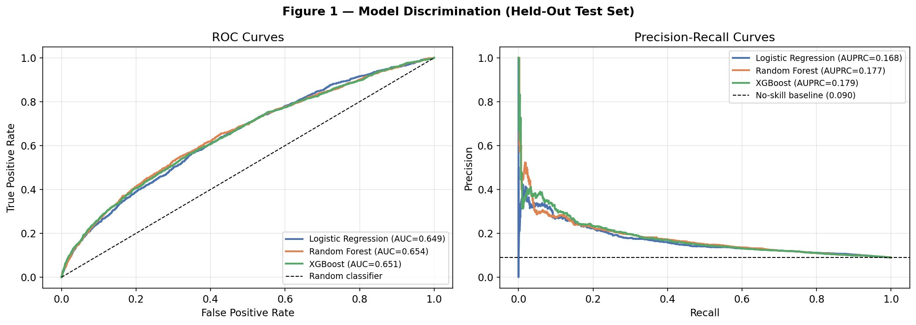
Figure 1. ROC curves (left) and precision-recall curves (right) on the held-out test set (n = 13,995). All three models cluster between AUC 0.649 and 0.654.
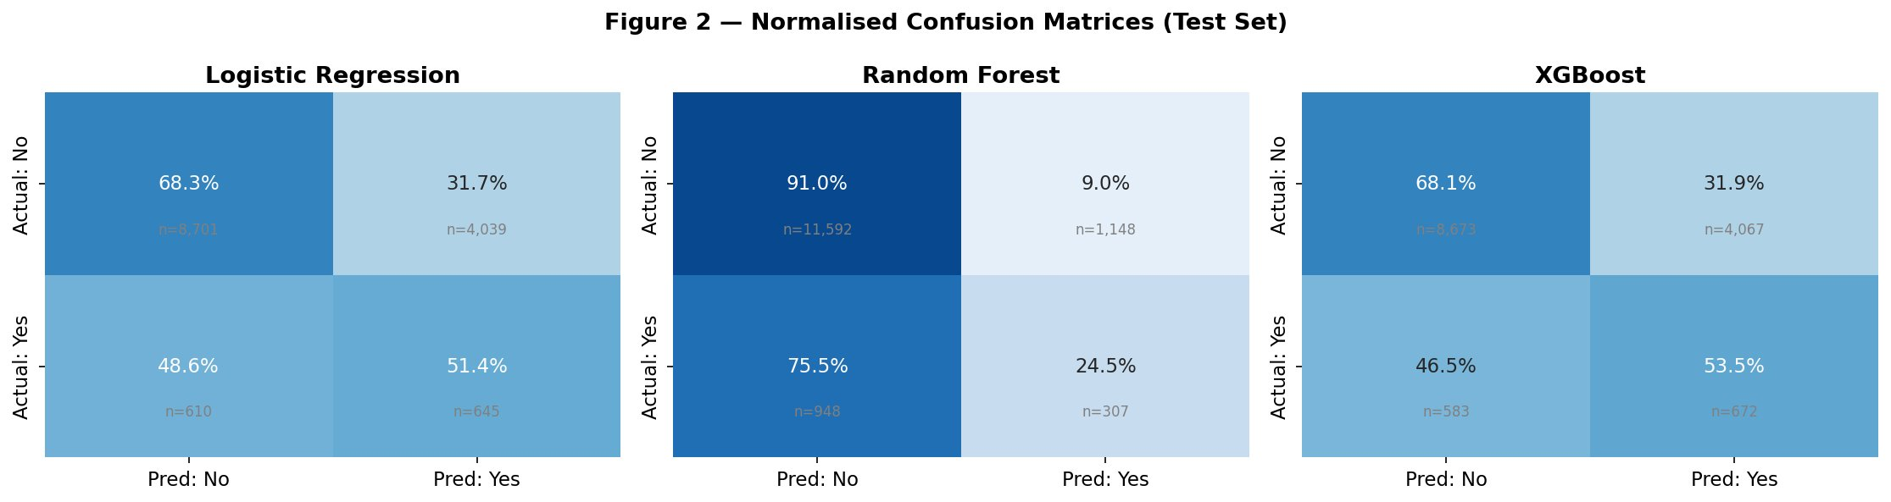
Figure 2. Normalised confusion matrices at the default 0.5 threshold (uncalibrated probabilities). LR and XGB share a high-recall, high-false-positive profile; RF shows a high-precision, low-recall profile.

3.2 Probability calibration
Reliability diagrams for the uncalibrated models (Figure 3, red curves) show systematic overprediction: observed event rates were consistently far lower than predicted, a direct consequence of class-weighting shifting the decision boundary toward the minority class. Uncalibrated Brier scores (0.228 for LR, 0.155 for RF, 0.216 for XGB) all exceeded the no-skill baseline of 0.082 by factors of 1.9–2.8×. Isotonic regression, fitted within 5-fold internal cross-validation on the training set only, substantially improved calibration: calibrated Brier scores converged to 0.079 across all three models, marginally below the no-skill baseline of 0.082. Convergence to an identical Brier value is expected rather than coincidental: isotonic regression is a non-parametric monotonic mapping that, when fitted to models with similar AUC, maps each model’s probability distribution to a similar empirical reliability curve, producing convergent Brier scores by construction. AUC and AUPRC were essentially unchanged (calibration preserves probability ranking). Calibration was therefore the binding constraint on probability reliability, substantially recoverable through post-hoc adjustment in this held-out evaluation.
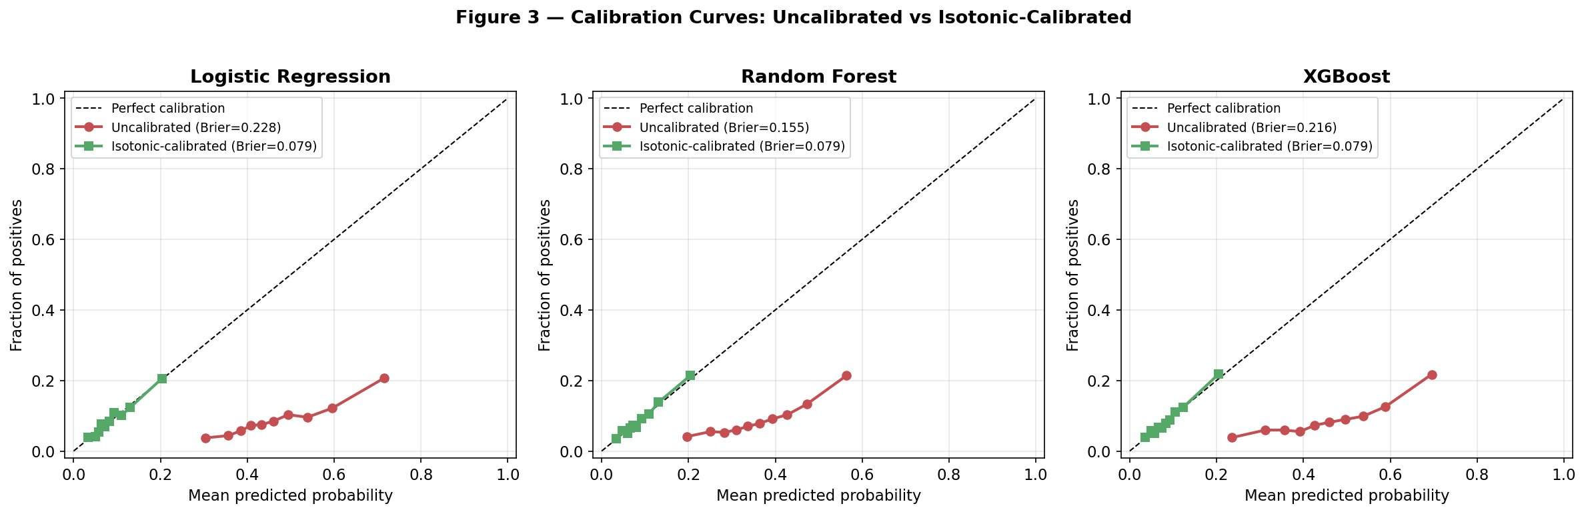
Figure 3. Reliability diagrams: uncalibrated (red) vs isotonic-calibrated (green) for each model. Calibrated curves track the diagonal closely; uncalibrated curves sit far below, reflecting overprediction.

3.3 Decision curve analysis
Decision curve analysis on uncalibrated probabilities (Figure 4, left panel) showed net benefit dropping below both reference lines at thresholds above the 9% prevalence point: none of the three models would provide net benefit relative to withholding intervention at any clinically plausible threshold. On calibrated probabilities (right panel) this picture reversed: all three models delivered positive net benefit across the 10–25% threshold range, substantially exceeding the “treat all” reference. At a 10% threshold, net benefit was approximately +0.014 (LR), +0.017 (RF), and +0.017 (XGB) versus “treat all” at −0.012; at 15%, +0.007 to +0.008 versus −0.069. The DCA finding therefore inverted from “limited clinical utility” to “clinically meaningful net benefit” once calibration was applied.
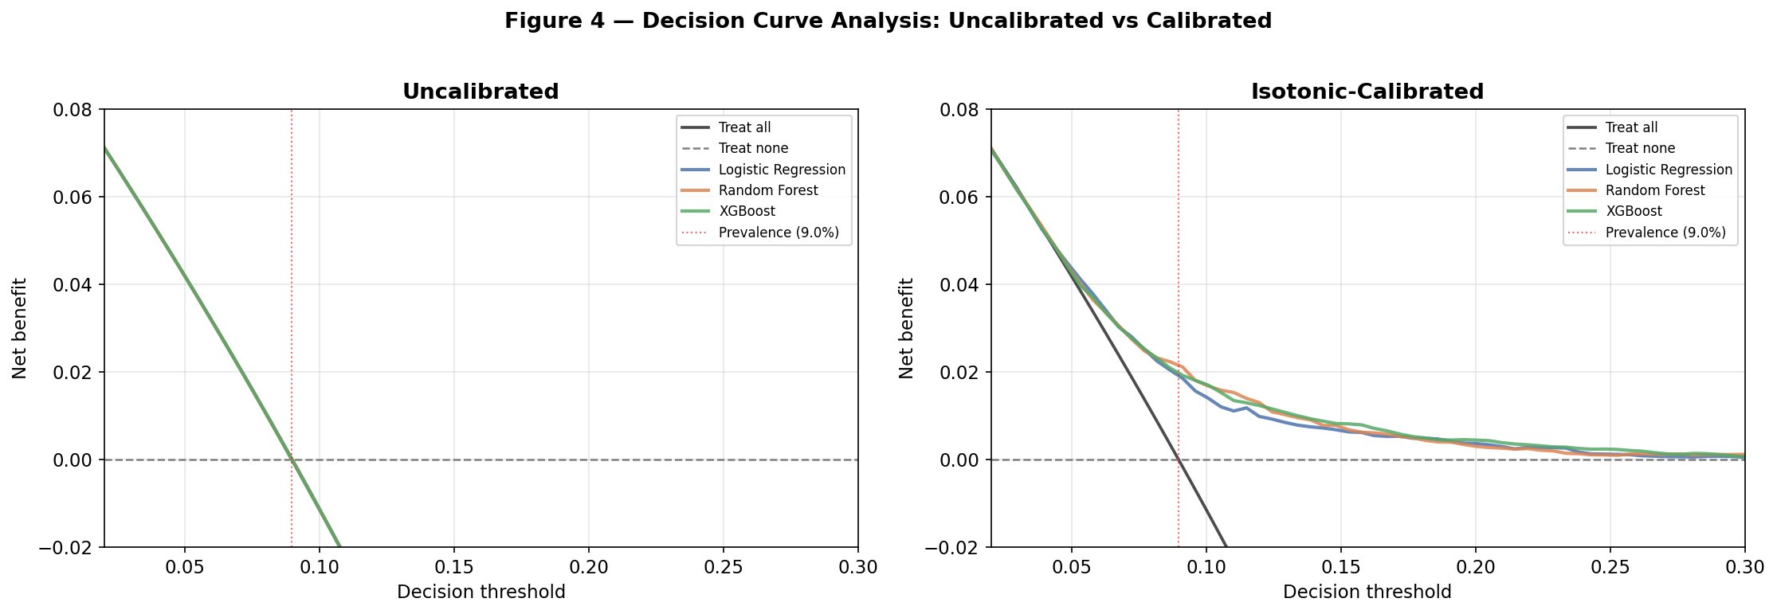
Figure 4. Decision curve analysis: uncalibrated (left) and isotonic-calibrated (right). All three calibrated models sit above both reference lines across the 10–25% threshold range. The 9% prevalence point is marked.

3.4 Threshold optimisation
Calibrated probabilities for this 9%-prevalence cohort rarely exceeded 0.20, rendering the default 0.5 threshold inappropriate (recall ~0.001 after calibration). Thresholds were therefore selected from out-of-fold cross-validation predictions on the training set. F1-optimal thresholds clustered around 0.11–0.12; recall-prioritising thresholds (subject to precision ≥ 0.15) clustered around 0.10–0.11 (Table 2). Random Forest dominated at both operating points: at the F1-optimal threshold of 0.11, RF achieved F1 = 0.243 with recall = 0.450; at the recall-prioritising threshold of 0.10, recall = 0.504. The earlier "LR for recall, RF for precision" tradeoff at the default 0.5 threshold was therefore an artefact of inappropriate threshold choice; with calibrated probabilities and validation-selected thresholds, RF was preferred across both operating profiles.

Table 2. Performance at validation-selected operating thresholds (calibrated test-set probabilities).
Model | Threshold | Precision | Recall | F1 | Flagged %
Logistic Regression | F1-optimal (0.12) | 0.172 | 0.322 | 0.224 | 16.8
Logistic Regression | Recall-priority (0.11) | 0.148 | 0.433 | 0.221 | 26.2
Random Forest | F1-optimal (0.11) | 0.166 | 0.450 | 0.243 | 24.3
Random Forest | Recall-priority (0.10) | 0.152 | 0.504 | 0.234 | 29.7
XGBoost | F1-optimal (0.12) | 0.177 | 0.361 | 0.238 | 18.3
XGBoost | Recall-priority (0.10) | 0.155 | 0.496 | 0.236 | 28.8

3.5 Feature importance and SHAP interpretation
The strongest predictor across both tree-based models was discharge disposition = "discharged to home" (Figure 5), with XGB MDI = 0.103. Mean |SHAP| values for XGBoost (Figure 6b) confirmed this: discharged-to-home (0.259), prior inpatient visits (0.154), age (0.081), length of stay (0.075), and diabetes medication status (0.063) constituted the top five features. The SHAP beeswarm (Figure 6a) shows that being discharged home is consistently associated with negative SHAP contributions, while high prior inpatient counts substantially increase predicted risk. Gender ranked 29th of 110 features by mean |SHAP| (0.013), suggesting that the gender-dominant feature importance reported in prior analyses was likely driven by label-encoding and MDI bias artefacts (Strobl et al., 2007).
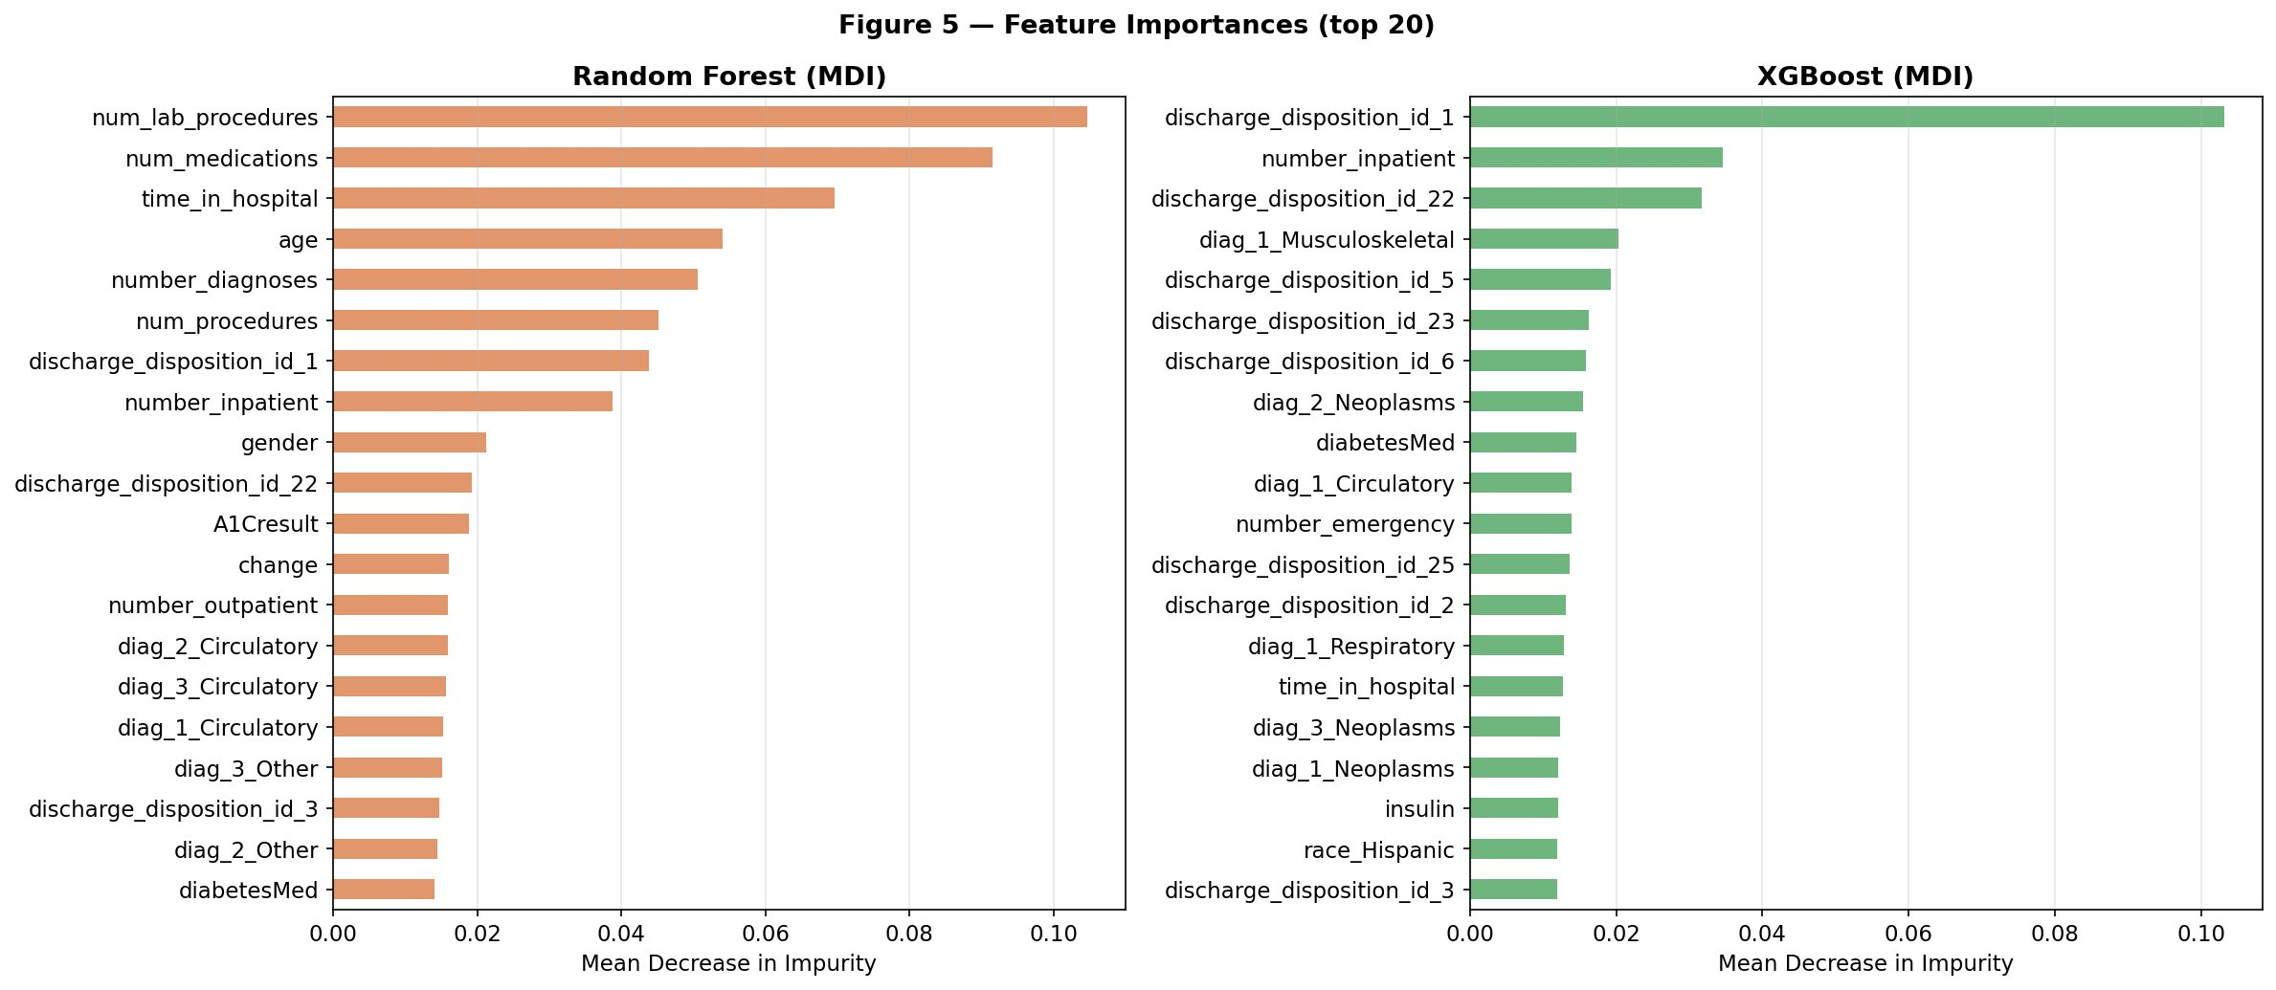
Figure 5. Top 20 features by Mean Decrease in Impurity for Random Forest (left) and XGBoost (right). Clinical and care-pathway features dominate; discharged-to-home leads for XGBoost.
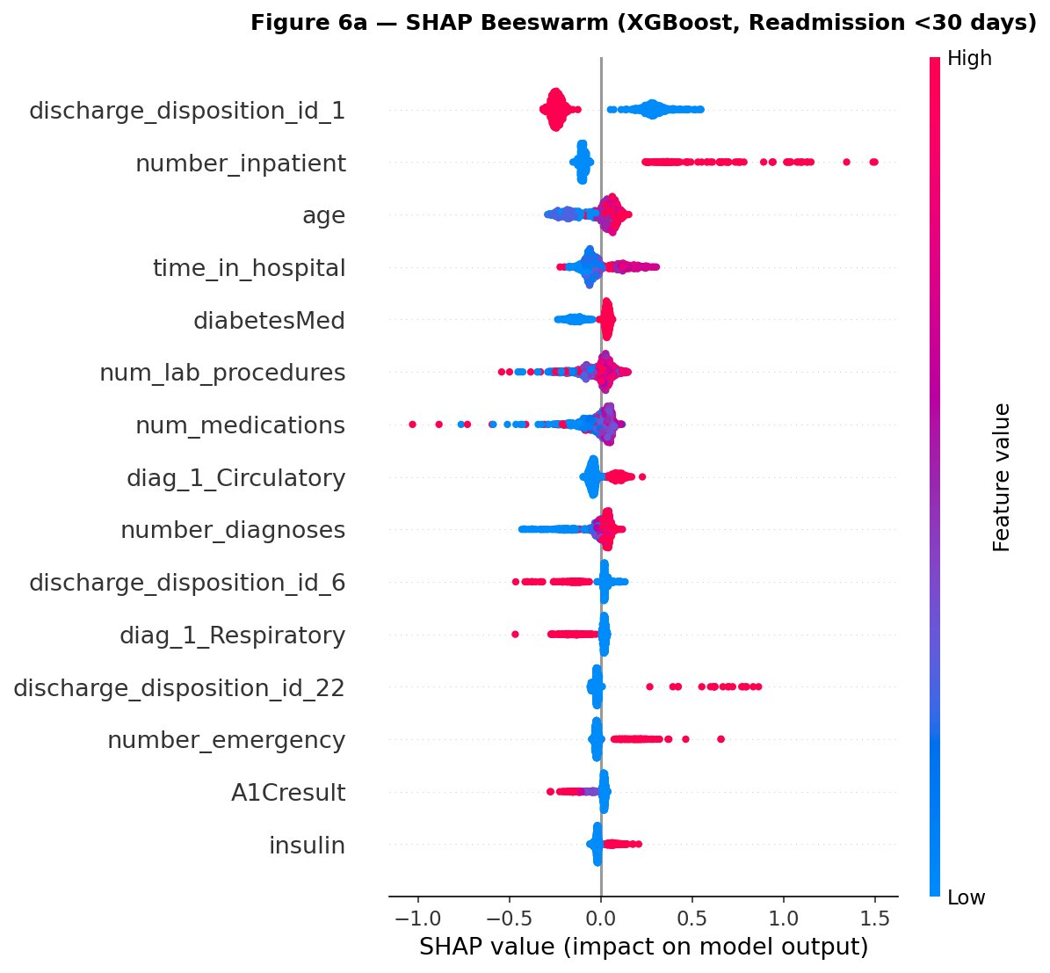
Figure 6a. SHAP beeswarm for the XGBoost model (1,000-patient test sample). Being discharged home (red, left of zero) reduces predicted risk; high prior inpatient counts (red, right) increase it.
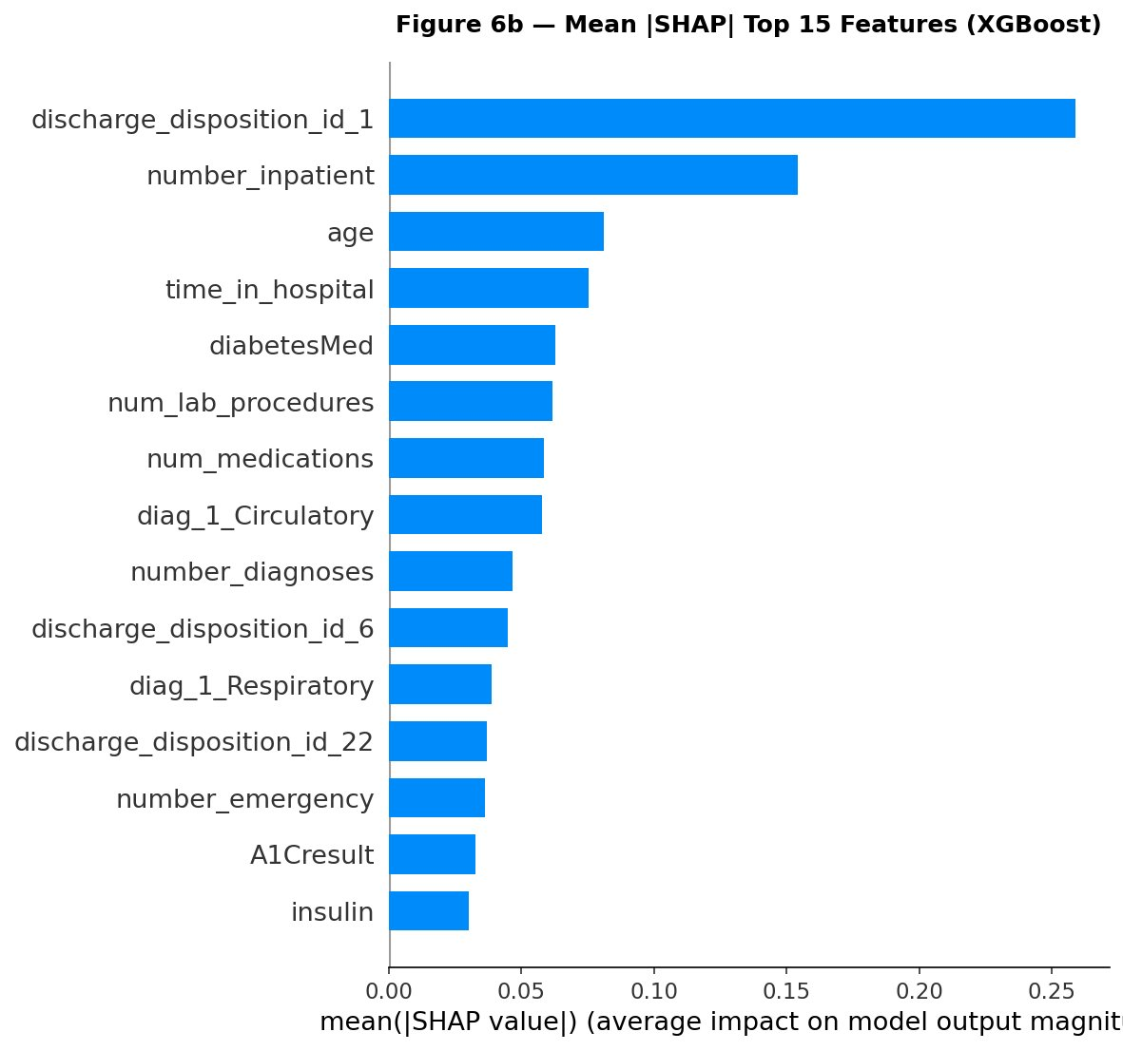
Figure 6b. Mean |SHAP| values for the top 15 features of the XGBoost model.
Individual SHAP waterfalls for three representative patients (Figure 7) demonstrated clinically interpretable behaviour. Patient A (true positive; predicted risk 87.5%; readmitted) had many prior inpatient visits (SHAP +1.5 logits) and a neoplasms secondary diagnosis (+0.4). Patient B (true negative; 10.6% risk; not readmitted) was discharged to a specific facility (SHAP −1.5) and had low utilisation. Patient C (false positive; 84.7% risk; not readmitted) had multiple stacking risk markers — high-risk discharge disposition, elevated inpatient counts, emergency visits — illustrating how the model produces false positives when proxy risk markers coincide without subsequent readmission.
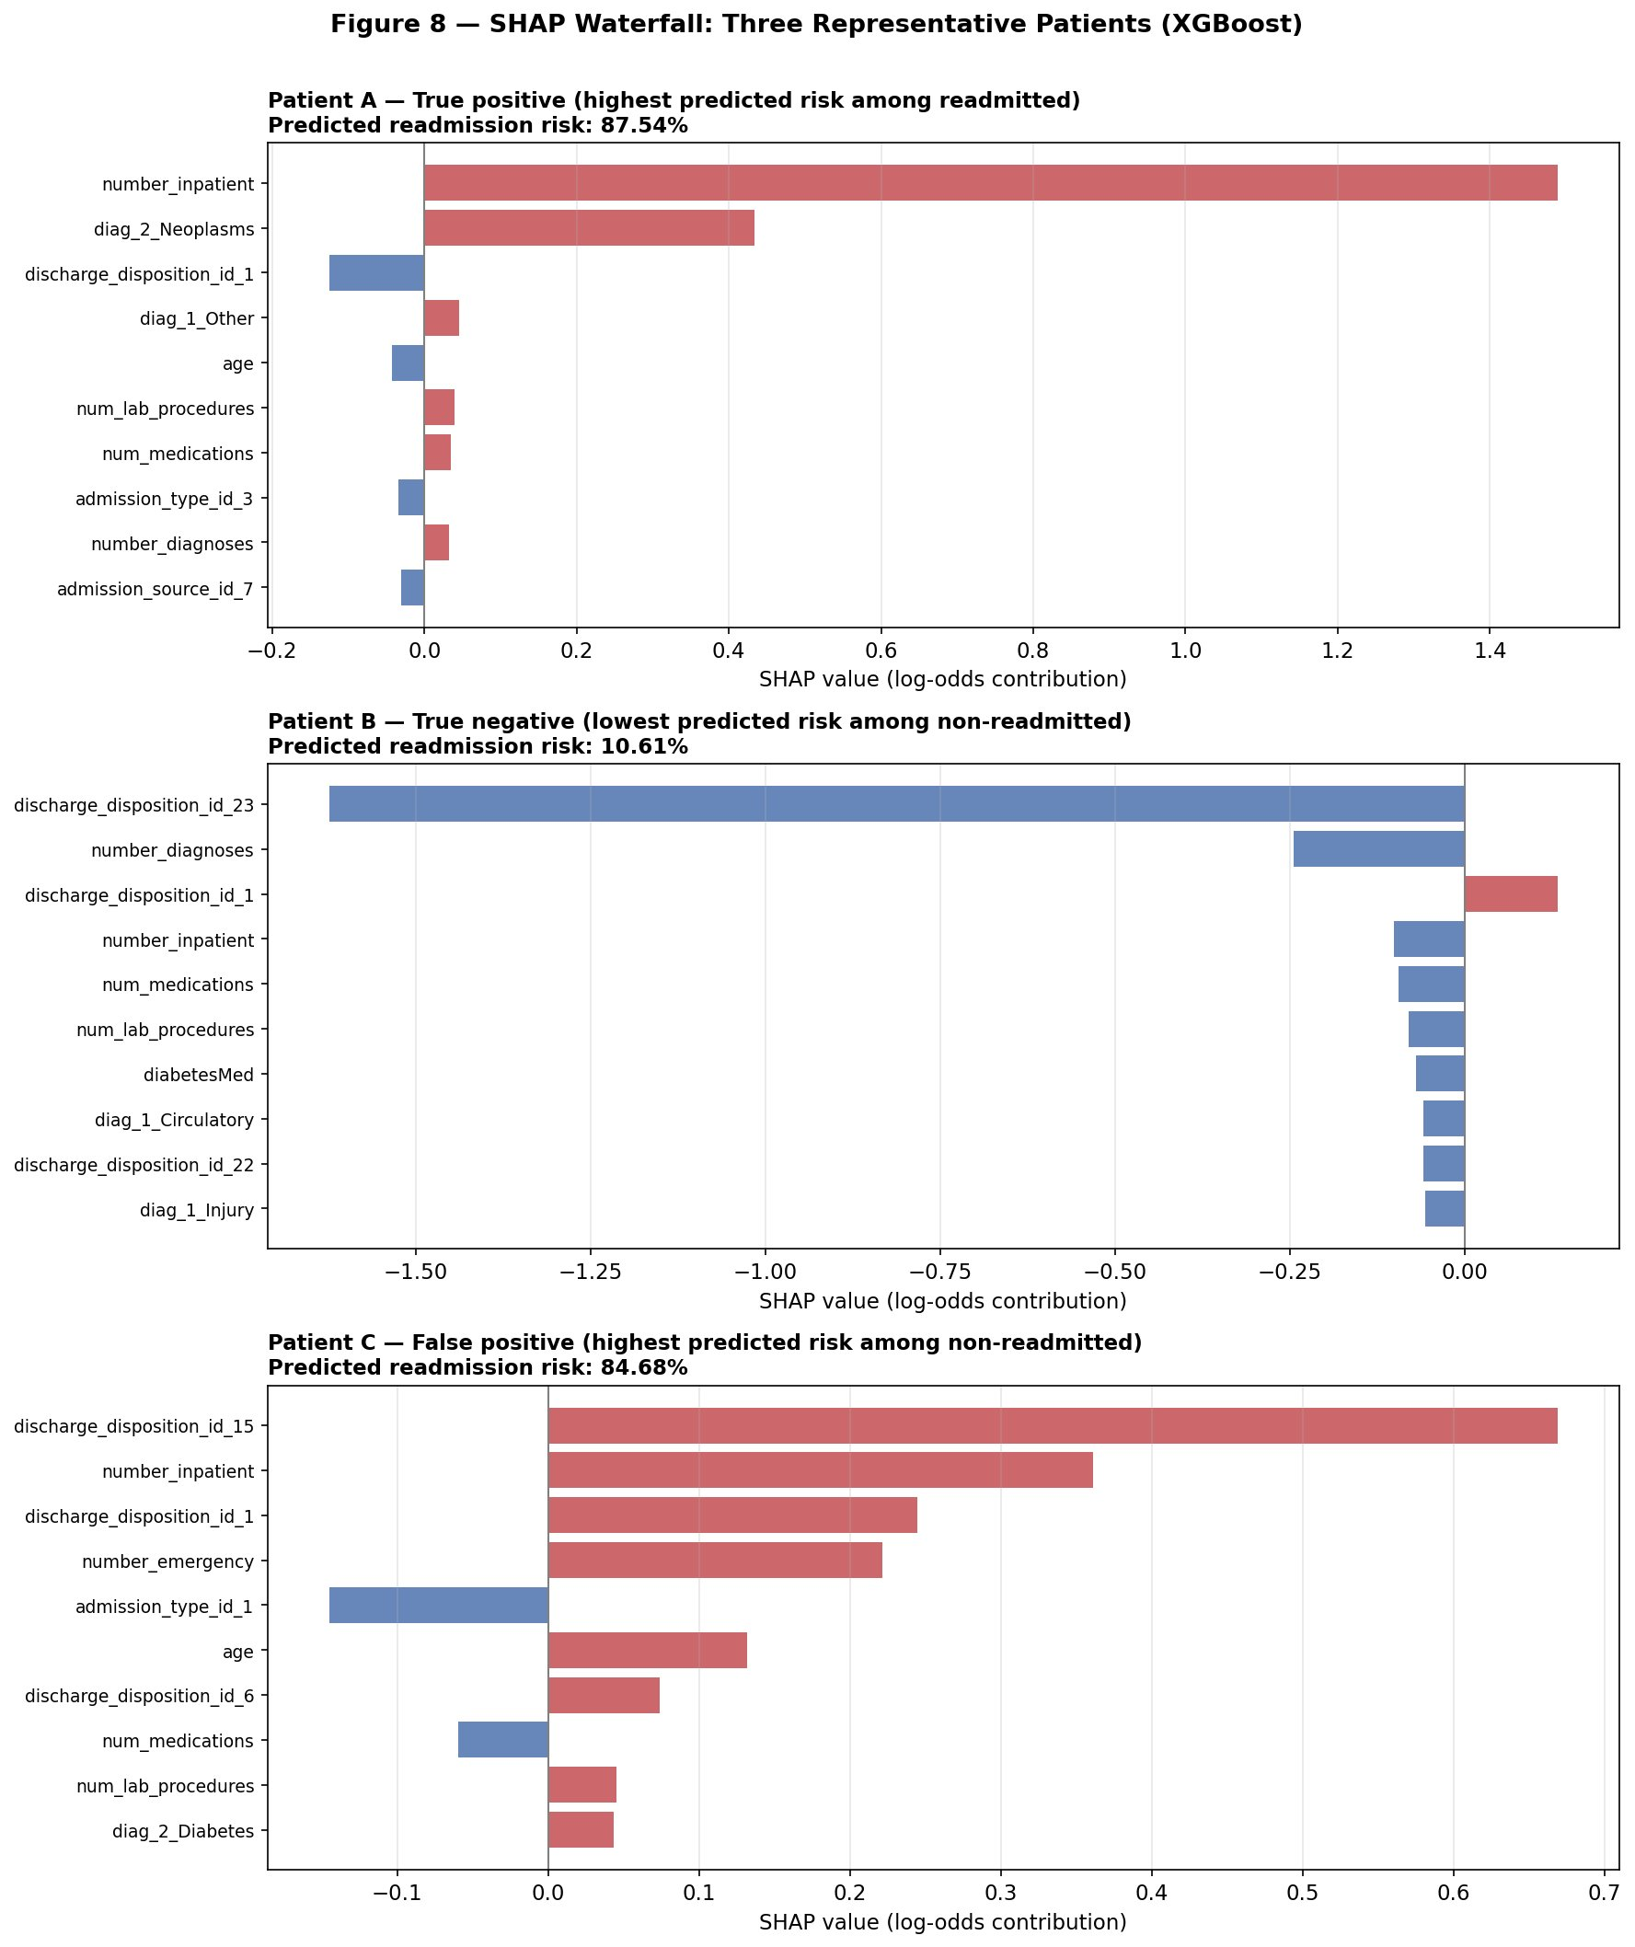
Figure 7. SHAP waterfall plots for three representative XGBoost test-set patients: true positive (top), true negative (middle), false positive (bottom). Red bars increase predicted risk; blue bars decrease it.

3.6 LACE-proxy benchmark comparison
The LACE-proxy clinical risk score achieved AUC = 0.550 on the test set — substantially below the 0.68–0.70 reported in van Walraven’s original general inpatient validation (van Walraven et al., 2010). This degradation likely reflects two distinct factors: differences in cohort (diabetic-specific vs general inpatient) and benchmark fidelity, since number_diagnoses substitutes for full Charlson comorbidity scoring (raw ICD-9 codes were lost during diagnosis grouping in Section 2.2). The ~0.10 AUC gap to the ML models therefore cannot be cleanly partitioned into “genuine ML advantage” versus “proxy degradation”, and the comparison should be read with this caveat: ML clearly exceeds this particular degraded baseline, but a rigorous head-to-head against true LACE would require preserving raw ICD-9 codes for Charlson computation — a recommended next step.
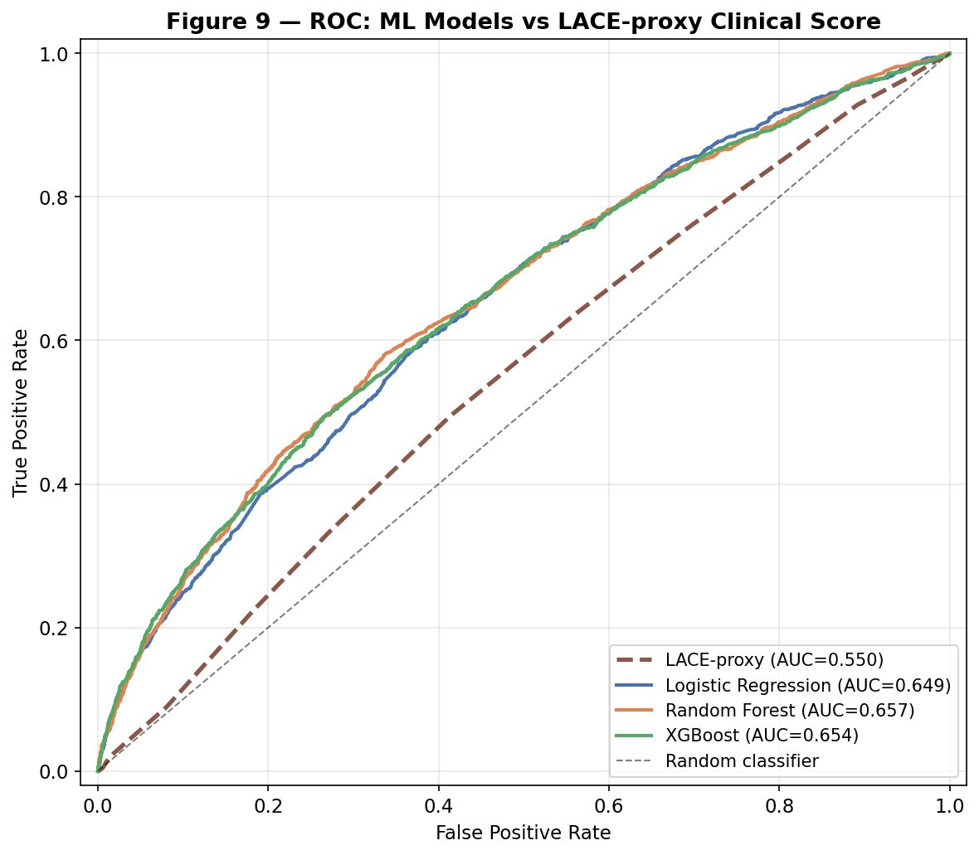
Figure 8. ROC curves comparing the three calibrated ML models with the LACE-proxy clinical risk score. ML models cluster around AUC 0.65; LACE-proxy at AUC 0.55.

3.7 Fairness audit and per-subgroup calibration
Subgroup discrimination performance is summarised in Table 3 and Figure 9. AUC-ROC ranged from 0.638 (Caucasian, XGB) to 0.809 (Asian, LR), with maximum within-model gaps of 0.170 (LR), 0.121 (RF), and 0.099 (XGB). No subgroup achieved below-chance AUC. Caucasian patients — the largest subgroup (n = 10,509) — consistently exhibited the lowest within-subgroup AUC, likely reflecting greater within-subgroup heterogeneity. The Missing-race subgroup achieved relatively high AUC (0.695–0.765), plausibly reflecting differences in data completeness. Asian-subgroup estimates carry substantial uncertainty (n = 88).
Per-subgroup calibration, computed after isotonic calibration, revealed that all 18 model×subgroup combinations achieved Brier scores below their respective subgroup-specific no-skill baselines. Calibration therefore recovered probability reliability uniformly across racial subgroups, with no subgroup-specific calibration failure.

Table 3. Subgroup AUC-ROC and maximum within-model gap.
Subgroup (n) | Pos. rate | LR AUC | RF AUC | XGB AUC
Caucasian (10,509) | 9.1% | 0.638 | 0.643 | 0.638
African American (2,504) | 9.0% | 0.671 | 0.669 | 0.680
Missing (364) | 5.2% | 0.695 | 0.765 | 0.693
Hispanic (299) | 9.7% | 0.692 | 0.720 | 0.697
Other (231) | 4.8% | 0.640 | 0.705 | 0.728
Asian (88) | 12.5% | 0.809 | 0.735 | 0.738
Max AUC gap | — | 0.170 | 0.121 | 0.099

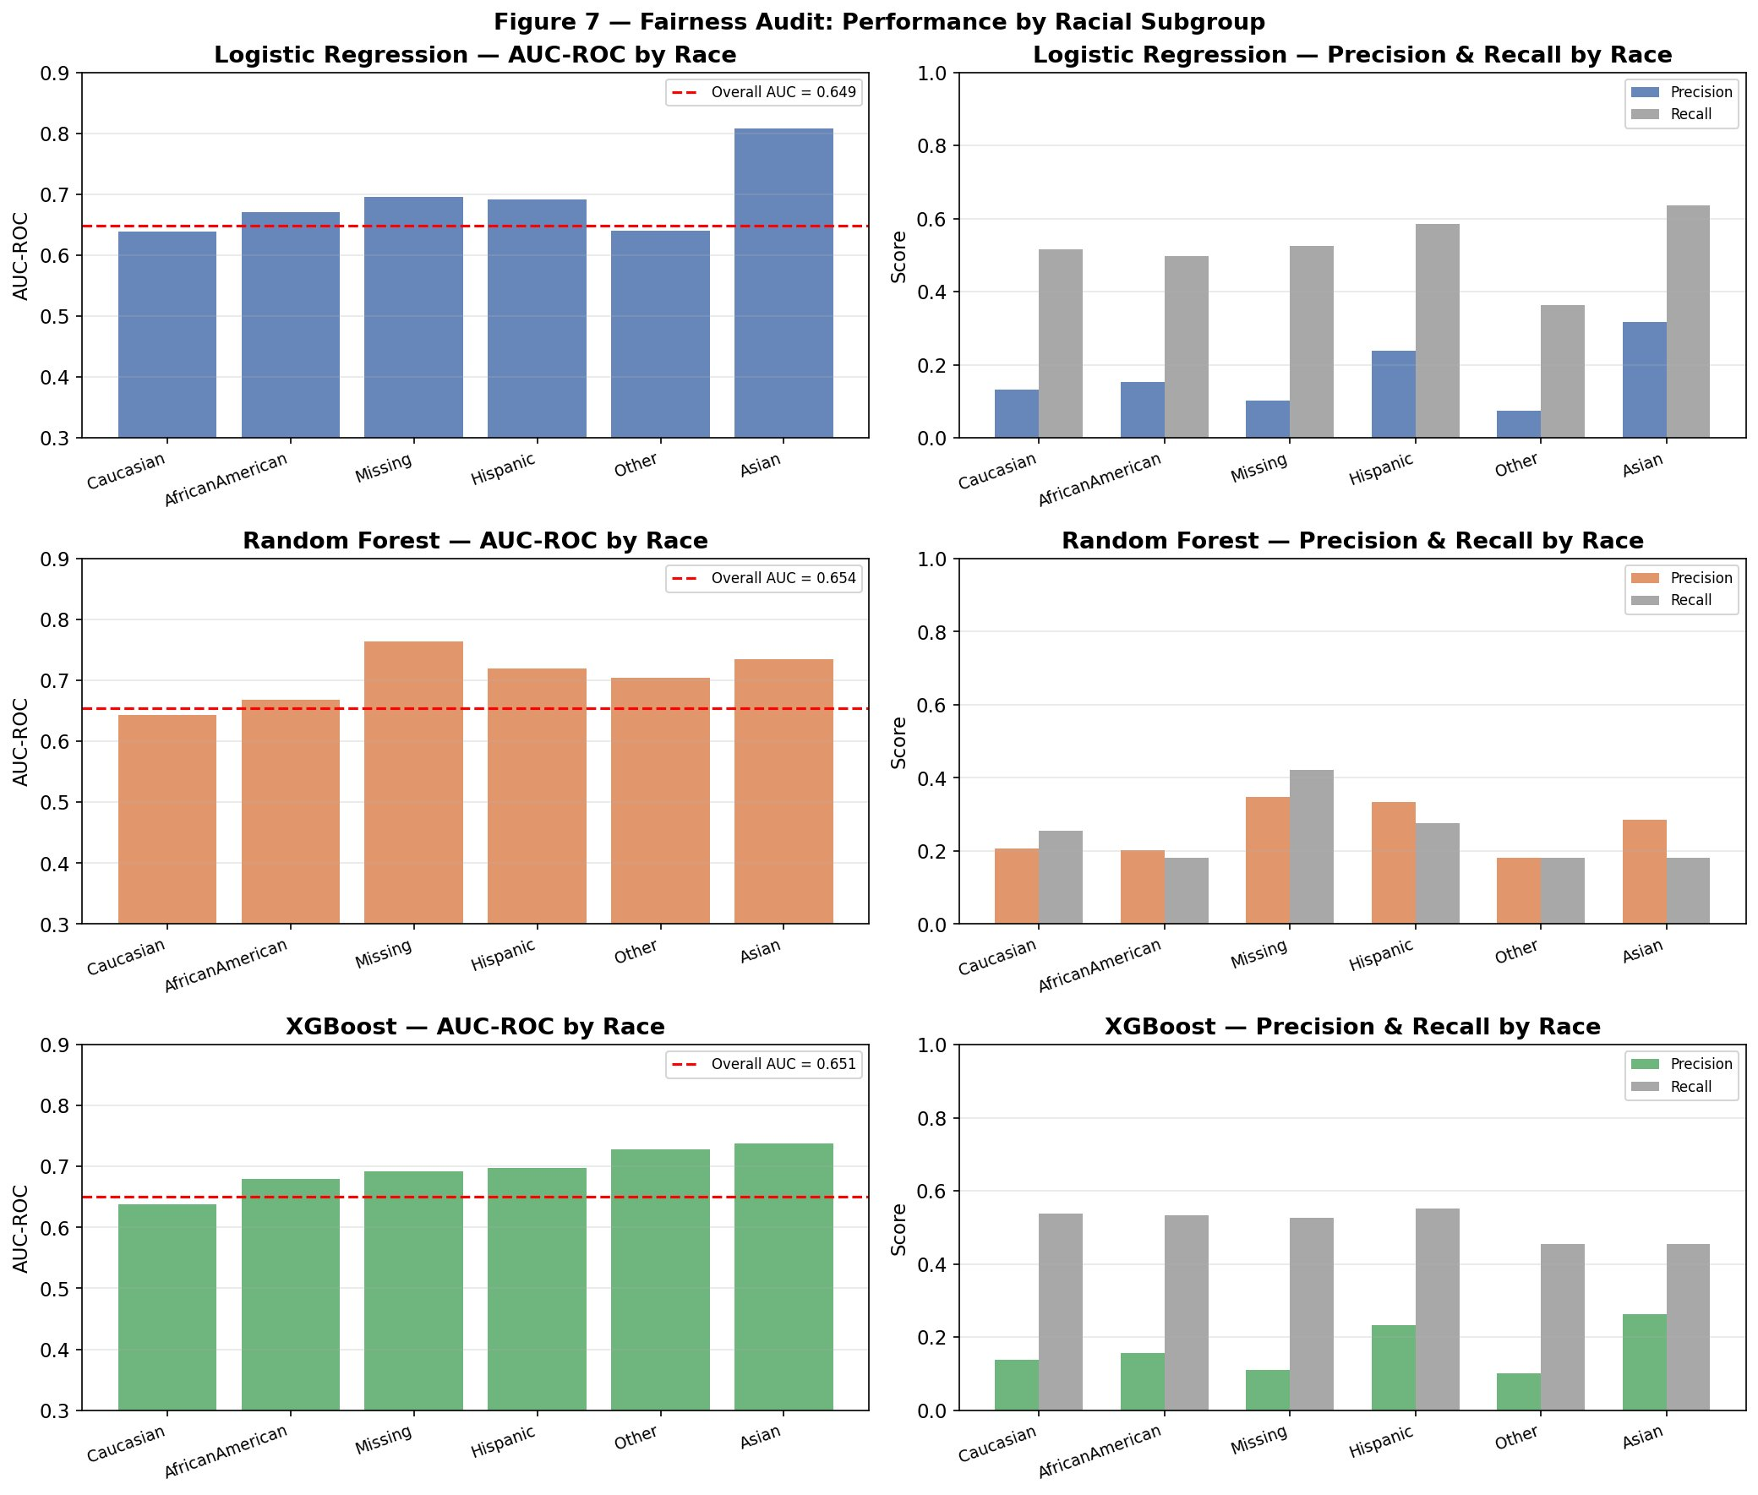
Figure 9. Fairness audit by racial subgroup. AUC-ROC (left column) and precision/recall (right column) for each model. No subgroup achieved below-chance AUC.

4. Discussion

4.1 Principal findings
Three machine learning models achieved modest, broadly similar discrimination (AUC 0.649–0.654). The dominant analytical finding was not discrimination but calibration: uncalibrated probabilities were 1.9–2.8× worse than no-skill, while isotonic-calibrated probabilities improved to marginally below the no-skill baseline across all models and subgroups. Decision curve analysis on calibrated probabilities yielded positive net benefit across all clinically plausible thresholds, inverting the uncalibrated "no clinical utility" finding. Random Forest dominated at validation-selected operating thresholds, and ML models outperformed the LACE-proxy clinical risk score by approximately 0.10 AUC.

4.2 Comparison with prior literature
The achieved AUC of approximately 0.65 sits within the published range and is consistent with Christodoulou et al.’s (2019) conclusion that machine learning provides no consistent advantage over logistic regression when feature sets are constrained. The head-to-head LACE-proxy comparison refines this framing: ML did not beat LR (the three models cluster tightly), but ML — as a class — substantially outperformed a traditional clinical risk score in this specific diabetic cohort. This matters because LACE remains a deployment-grade benchmark, while LR-vs-ML comparisons typically remain within the research domain. A second contribution is the correction of a feature-importance artefact: under proper one-hot encoding, the dominant predictors are discharge disposition, prior healthcare utilisation, age, length of stay, and diabetes medication burden — variables that align with established readmission literature.

4.3 Clinical implications
The pivotal finding is that probability calibration, not raw discrimination, is the binding constraint on clinical utility. Although the three models were equivalent on threshold-free discrimination (Section 4.2), deployment performance at specific operating thresholds is distinct: at validation-selected thresholds, Random Forest dominated both F1 and recall profiles. This is not a contradiction with the discrimination finding but a complementary observation — models with equivalent AUC can differ at operating points because the local shape of the calibrated probability distribution near the threshold differs. With calibration applied, all three models delivered clinically meaningful net benefit across the 10–25% threshold range. The two operating profiles map onto different use cases: the F1-optimal profile (recall ~0.40–0.45, flagged 17–24%) suits triage for moderate-cost interventions such as care-coordinator review or scheduled follow-up; the recall-priority profile (recall ~0.50, flagged ~30%) suits cheaper blanket interventions such as automated post-discharge follow-up calls. For every 10,000 diabetic discharges (≈900 readmissions at 9% prevalence), RF at the F1-optimal threshold would flag approximately 2,430 patients and correctly identify ≈405 readmissions.

4.4 Limitations
Several limitations qualify the findings. The dataset’s 1999–2008 provenance predates contemporary diabetic care (SGLT2 inhibitors, GLP-1 receptor agonists), and lacks social determinants of health, consistently among the strongest readmission predictors (Stabellini et al., 2023). The fairness audit is constrained by small subgroup sizes — the Asian-patient AUC carries substantial uncertainty (n = 88). No temporal validation was performed as the dataset lacks an explicit date variable. The LACE benchmark used number of diagnoses as a comorbidity proxy because exact Charlson scoring requires raw ICD-9 codes lost during diagnosis grouping. No sensitivity analysis was performed with race excluded as a predictor, recommended as a next step. All predictive associations remain associational.

4.5 Ethical considerations
Race is used both as a stratification variable and as a model predictor, raising concerns about reinforcing health inequalities given the subgroup performance gaps. A subtler concern arises from the model’s dependence on prior healthcare utilisation features (number_inpatient, number_emergency, number_outpatient), which collectively contribute substantially to predicted risk (Figure 6b). Obermeyer et al. (2019) demonstrated that utilisation- and cost-based proxies systematically under-identified Black patients with equivalent clinical need due to differential healthcare access; the same mechanism could apply here, particularly for the subgroups (Asian, Other) where calibration margins were tightest and small-sample variance is largest. The pattern of lower AUC for Caucasian patients but higher AUC for smaller subgroups likely reflects within-Caucasian-cohort heterogeneity and small-sample variance rather than a true protective effect. Per-subgroup calibration analysis showed that isotonic calibration recovered probability reliability uniformly across all subgroups, ruling out subgroup-specific calibration failure. Deployment without remediation could risk indirect discrimination under section 19 of the UK Equality Act 2010. Under the EU AI Act (2024), models supporting clinical decisions would fall into the high-risk category, requiring documented risk management, transparency, and human oversight. NHS deployment would require a Data Protection Impact Assessment under UK GDPR (NHS England, 2023).

5. Conclusion
Three machine learning models for 30-day diabetic readmission achieved modest discrimination (AUC 0.649–0.654). The pivotal finding was that probability calibration was the binding constraint on clinical utility: uncalibrated probabilities yielded no net benefit at clinical thresholds, while isotonic-calibrated probabilities improved Brier scores to marginally below the no-skill baseline across all models and racial subgroups, and delivered positive net benefit across the 10–25% threshold range. With calibration, Random Forest dominated at validation-selected operating thresholds (F1 = 0.243, recall = 0.450). ML models outperformed the LACE-proxy clinical risk score by approximately 0.10 AUC, suggesting genuine advantage over a traditional benchmark. The dominant predictors align with established readmission literature, and the gender-dominant feature importance in prior analyses is shown to be an encoding-and-impurity-bias artefact. Subgroup performance gaps of 0.10–0.17 AUC indicate the need for fairness-aware deployment and continuous monitoring.

References
Blagus, R. and Lusa, L. (2013) SMOTE for high-dimensional class-imbalanced data. BMC Bioinformatics, 14, 106.
Christodoulou, E., Ma, J., Collins, G.S., Steyerberg, E.W., Verbakel, J.Y. and Van Calster, B. (2019) A systematic review shows no performance benefit of machine learning over logistic regression for clinical prediction models. Journal of Clinical Epidemiology, 110, pp.12–22.
European Parliament and Council (2024) Regulation (EU) 2024/1689 laying down harmonised rules on artificial intelligence (Artificial Intelligence Act). Official Journal of the European Union.
Hammoudeh, A., Al-Naymat, G., Ghannam, I. and Obied, N. (2018) Predicting hospital readmission among diabetics using deep learning. Procedia Computer Science, 141, pp.484–489.
Joynt, K.E. and Jha, A.K. (2013) A path forward on Medicare readmissions. New England Journal of Medicine, 368(13), pp.1175–1177.
Kapoor, S. and Narayanan, A. (2023) Leakage and the reproducibility crisis in machine-learning-based science. Patterns, 4(9), 100804.
Lundberg, S.M. and Lee, S.-I. (2017) A unified approach to interpreting model predictions. Advances in Neural Information Processing Systems, 30, pp.4765–4774.
NHS England (2023) A buyer’s guide to AI in health and care. NHS England Digital.
Obermeyer, Z., Powers, B., Vogeli, C. and Mullainathan, S. (2019) Dissecting racial bias in an algorithm used to manage the health of populations. Science, 366(6464), pp.447–453.
Stabellini, N., Cullen, J., Cao, L., Shanahan, J., Hamerschlak, N., Waite, K., Barnholtz-Sloan, J.S. and Montero, A.J. (2023) Social determinants of health and racial disparities in cancer care and outcomes. Cancer, 129(13), pp.2003–2010.
Strack, B., DeShazo, J.P., Gennings, C., Olmo, J.L., Ventura, S., Cios, K.J. and Clore, J.N. (2014) Impact of HbA1c measurement on hospital readmission rates: analysis of 70,000 clinical database patient records. BioMed Research International, 2014, 781670.
Strobl, C., Boulesteix, A.-L., Zeileis, A. and Hothorn, T. (2007) Bias in random forest variable importance measures: illustrations, sources and a solution. BMC Bioinformatics, 8, 25.
UK Government (2010) Equality Act 2010, section 19 (indirect discrimination). London: HMSO.
van Walraven, C., Dhalla, I.A., Bell, C., Etchells, E., Stiell, I.G., Zarnke, K., Austin, P.C. and Forster, A.J. (2010) Derivation and validation of an index to predict early death or unplanned readmission after discharge from hospital to the community. Canadian Medical Association Journal, 182(6), pp.551–557.
Vickers, A.J. and Elkin, E.B. (2006) Decision curve analysis: a novel method for evaluating prediction models. Medical Decision Making, 26(6), pp.565–574.

