University of Liberal Arts Bangladesh (ULAB)
Department of Computer Science and Engineering
Fire and Smoke Image Classification Using Adaptive Digital Image Processing and MobileViT-XS
Open-Ended Lab Report
Course: CSE 4462 Digital Image Processing Lab
Submitted by: Mahdia Hossain
Student ID: [your student ID]
Submitted to: [course teacher's name]
Date: November 2026

Contents
1. Problem Statement
2. Dataset
3. Method
4. Implementation
5. Results
6. Comparison of Alternatives
7. Discussion with DIP Theory
8. Conclusion
9. Limitations
10. Future Work
11. References
This report has 28 figures and 17 tables. All numbers come from the saved result files of each run.

1. Problem Statement
Fires in homes, factories, streets and forests cause great damage when they are found late. Cameras are already in many places. A program that checks camera photos can raise an early alarm [1]. In this project we built such a program with digital image processing (DIP) and a small deep-learning model.

1.1 What we know at the start
- The input is one colour photo. It can be indoor or outdoor, and of any size.
- The output must be one of three classes: fire, smoke or normal, with a confidence.
- Public datasets of fire, smoke and normal photos exist. Some of them also have boxes drawn around the fire and smoke.
- Classic DIP tools exist for noise removal, contrast and colour segmentation [2].
- Small deep networks such as MobileViT-XS can classify photos and can run on small devices [3].

1.2 What we must find
- Which DIP steps help, and which ones only change the photo for no reason.
- How to make the system work on bad camera photos that are noisy, dark, blurred or heavily compressed.
- How to avoid false alarms on normal things that look like fire or smoke, such as sunsets, lamps, car lights and fog.
- Which classifier works best when it is chosen fairly, and how well it works on photos from a new source.
- How to give the finished system to other people in a form that is easy to run and that shows every step.

1.3 Why the problem is hard
Many normal things look like fire or smoke. Sunsets, lamps and car lights look like fire. Fog and steam look like smoke. Real camera photos are often noisy or dark, and deep networks lose accuracy on such photos [4], [5]. A model must also work on photos from places it did not see in training.

1.4 Earlier work
Early methods used colour rules. Chen et al. [6] used rules on the red, green and blue values. Töreyin et al. [7] added motion and flicker cues for video. Çelik and Demirel [8] gave a rule in the YCbCr colour space, which we use for our fire mask. Colour rules are fast and easy to explain, but they give false alarms on anything red or bright. Later work used deep networks. Muhammad et al. [1] used a CNN for surveillance cameras. De Venâncio et al. [9] built the D-Fire dataset, and Catargiu et al. [10] built the FireAndSmoke dataset. Our work joins the two lines: classic DIP cleans the photo, and a small transformer classifies it.

1.5 Our answer in short
Our final model is called CA. It first measures the noise in the photo. It applies a median filter and CLAHE only when the photo is noisy. Clean photos are not changed. A small vision transformer, MobileViT-XS, then gives the answer. Figure 1 shows the full pipeline. CA has the best validation score of all 16 classifiers we trained. It gives false alarms on only 2.2% of look-alike photos, and it stays strong on damaged photos.
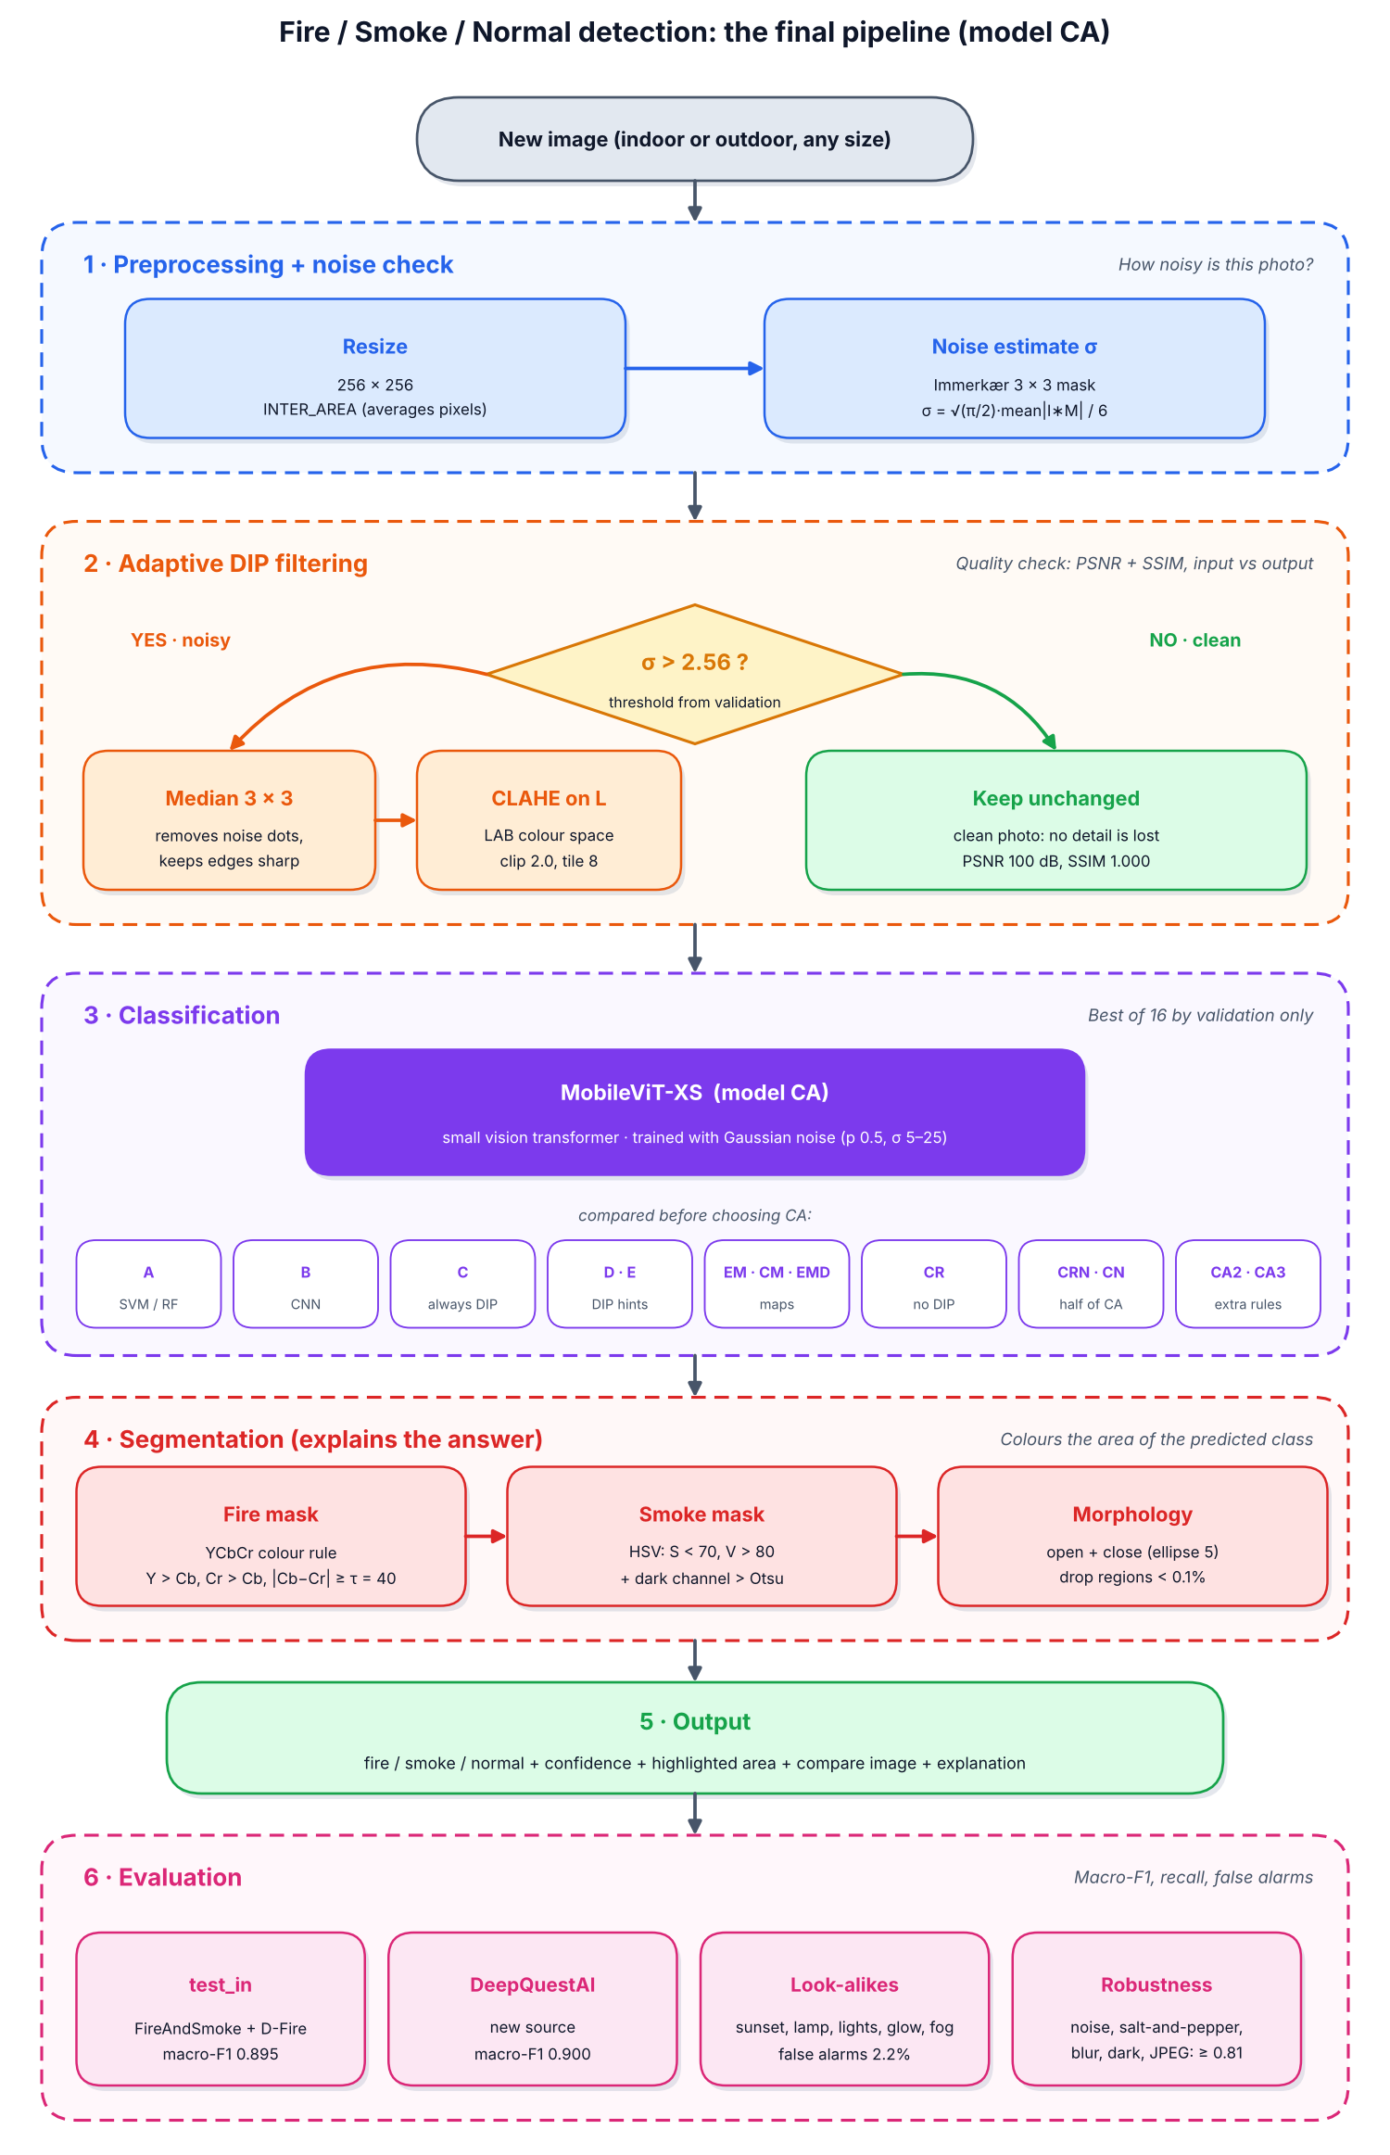
Figure 1. The final pipeline (model CA). A photo is filtered only when its measured noise σ is above 2.56. The colour masks are used only to explain the answer.

1.6 Key words used in this report
Table 1. Key words in simple language
Word | Simple meaning
DIP | Digital image processing: changing a picture with maths, for example to remove noise.
Noise | Random wrong pixels. Gaussian noise looks like grain. Salt-and-pepper noise looks like white and black dots.
Median filter | Replaces each pixel with the middle value of its neighbours. It removes dots and keeps edges sharp.
CLAHE | Contrast Limited Adaptive Histogram Equalisation. It improves contrast in small tiles of the picture.
L channel | The lightness part of the LAB colour space. Changing only L keeps the colours the same.
Noise level σ | A number that says how noisy a photo is. We measure it with the Immerkær method.
PSNR and SSIM | Two scores that say how alike two pictures are. Higher means more alike.
MobileViT-XS | A small and fast vision transformer, a deep-learning model for pictures.
Macro-F1 | The average F1 score of the three classes. 1.0 is perfect.
False alarm | The model says fire or smoke, but the photo is normal.
Validation set | Photos used to choose settings and the best model. Test photos are never used for choices.

2. Dataset

2.1 Sources
We used three public datasets. Table 2 lists them. FireAndSmoke [10] and D-Fire [9] were used for training, validation and in-domain testing. Both have boxes drawn around fire and smoke. A photo with a fire box is labelled fire. A photo with only smoke boxes is labelled smoke. A photo with no box is labelled normal. The DeepQuestAI dataset [11] was kept only for testing. It comes from a different source, so it shows how the model works on new places and cameras. We also used the D-Fire boxes to check our colour masks.
Table 2. Datasets used
Dataset | Photos scanned | How we used it
FireAndSmoke [10] | 27,294 | train, validation, in-domain test
D-Fire [9] | 21,527 | train, validation, in-domain test, mask check
DeepQuestAI [11] | 3,000 | test only (new source)

2.2 Cleaning
The same photo often appears more than once on the internet. If a copy of a test photo is in the training set, the model has already seen the exam answer, and the test score becomes too high. We removed 157 exact copies with a file hash. We removed 9,875 near-copies with a perceptual hash (distance of 4 or less). We also removed 8,119 training and validation photos that were copies of a test photo. Figure 2 shows examples. The final dataset has 41,789 photos.
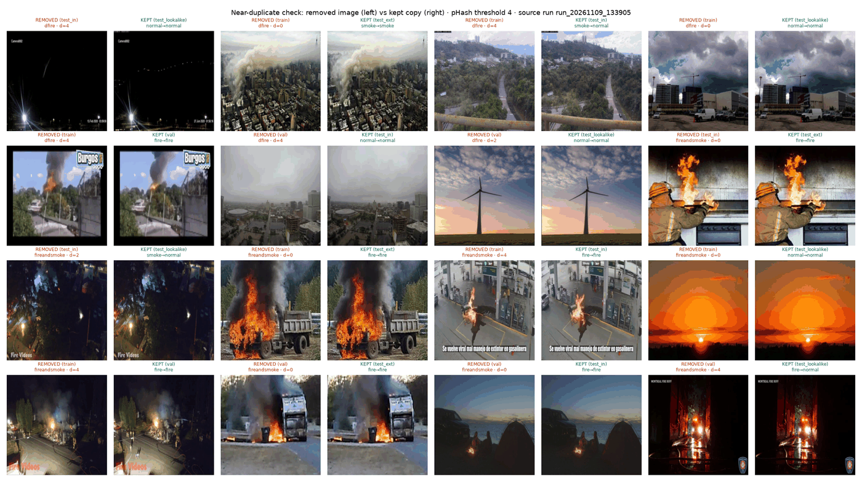
Figure 2. Examples of near-copy pairs found by the duplicate check. One photo of each pair was removed.

2.3 Splits
Table 3 shows the number of photos in each split. The validation set was used to choose thresholds and the best model. The test sets were never used for any choice.
Table 3. Photos per split after cleaning
Split | Fire | Smoke | Normal | Total
Train | 12,837 | 6,239 | 4,971 | 24,047
Validation | 4,805 | 1,922 | 598 | 7,325
Test in-domain | 2,858 | 1,930 | 2,022 | 6,810
Test DeepQuestAI | 940 | 993 | 998 | 2,931
Look-alike pool | 0 | 0 | 676 | 676

2.4 Look-alike set
We made a separate test set of normal photos that look like fire or smoke. The pool had 676 photos. We checked them by hand in a small labelling tool. We kept 451 photos in five types: sunset or sunrise (88), lamp or street light (52), vehicle light (185), reflection or glow (51) and cloud, fog or haze (75). We rejected 19 photos because they really showed fire or smoke. The other photos were skipped or left unlabelled and were not used. Figure 3 shows examples. A good model must call all of these photos normal.
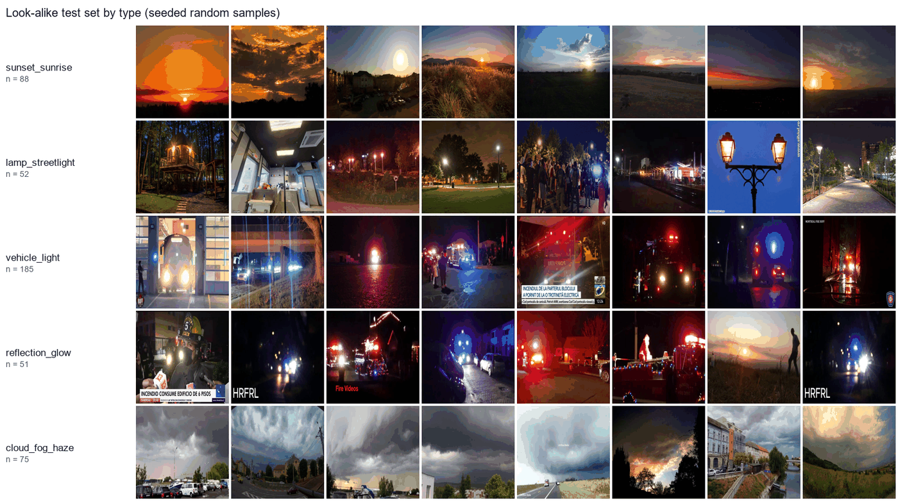
Figure 3. Examples of each look-alike type. A good model must call all of these normal.

2.5 Three ways we test
- Test in-domain: new photos from the same sources as training.
- Test DeepQuestAI: photos from a completely different source. This is the fairest test.
- Look-alikes: the 451 tricky normal photos, to count false alarms.

3. Method
This section explains each step of the final pipeline in Figure 1. For every DIP step we say what it does and why we chose it. The evidence for each choice is in Section 5.

3.1 Step 1: Resizing
Each photo is resized to 256 × 256 pixels with area interpolation (INTER_AREA in OpenCV [12]).
Why: the network needs a fixed input size. Area interpolation averages blocks of pixels, so it works like a low-pass filter [2]. It keeps small details better than nearest-neighbour resizing, and it also removes a little noise.

3.2 Step 2: Measuring the noise
We measure the noise with the method of Immerkær [13]. The grey image I is convolved with this 3 × 3 mask M:
M = [ 1 −2 1 ; −2 4 −2 ; 1 −2 1 ]
The noise level σ is then found with this formula, where W and H are the width and height of the image:
σ = √(π/2) × Σ |(I ∗ M)(x, y)| ÷ (6 × (W − 2) × (H − 2))
Why: the mask is the difference of two Laplacian masks. Its response is zero on flat areas and on straight edges, so what is left is mostly noise. The method needs only one convolution, so it is very fast. Section 5.6 shows that it finds noisy photos well.

3.3 Step 3: The adaptive decision
If σ is above 2.56, the photo is called noisy and is filtered. If σ is 2.56 or below, the photo is passed on unchanged.
Why: every filter removes some real detail. If we filter every photo, clean photos lose detail for no reason. The threshold 2.56 was chosen on validation photos only (Section 5.6).

3.4 Step 4: Median filter (only for noisy photos)
A 3 × 3 median filter replaces each pixel with the middle value of its 9 neighbours [14].
Why: the median is an order-statistic filter. A single wrong dot is never the middle value, so it is removed, and edges stay sharp. In our tests the median filter was clearly the best filter for salt-and-pepper noise (SSIM 0.923, against 0.750 for the Gaussian filter and 0.622 for the bilateral filter).

3.5 Step 5: CLAHE on the L channel (only for noisy photos)
The photo is changed to the LAB colour space. CLAHE [15] is applied to the L (lightness) channel with a clip limit of 2.0 and 8 × 8 tiles. Then the photo is changed back to RGB.
Why: CLAHE improves local contrast, and its clip limit stops it from making noise too strong. Working on L only keeps the colours the same. Colour is the strongest sign of fire. In our tests CLAHE on L shifted the colours by only 0.32, while histogram equalisation on RGB shifted them by 18.4.

3.6 Step 6: Classification with MobileViT-XS
The classifier is MobileViT-XS [3] from the timm library [16], pretrained on ImageNet. It has 1.93 million parameters. During training, half of the photos get extra Gaussian noise with a random σ between 5 and 25. The noise is added before the adaptive step, so the model sees filtered noisy photos during training.
Why: MobileViT-XS mixes small convolutions with a transformer, so it sees both local texture and the whole scene. It is small enough for a laptop or an edge device. It was better than the MobileNetV3 CNN in our tests. Noise training teaches the network to ignore the noise that the filter leaves behind.

3.7 Step 7: Colour segmentation (to explain the answer)
After the model gives its answer, a colour mask shows the area of the predicted class. The masks do not change the answer.
- Fire mask: the YCbCr rule of Çelik and Demirel [8]. A pixel is fire if Y > Cb, Cr > Cb and |Cb − Cr| ≥ τ, with τ = 40.
- Smoke mask: pixels with low saturation and enough brightness (S < 70 and V > 80 in HSV) whose dark channel [17] is above an Otsu threshold [18].
- Morphology: opening and then closing with a 5 × 5 ellipse, and removing regions smaller than 0.1% of the image [2].
Why: YCbCr separates brightness from colour, so the fire rule works in bright and dark scenes. Smoke is grey and hazy, so low saturation and the dark channel describe it. Opening removes small specks and closing fills small holes. We use the masks only as a picture, because the smoke mask gives too many false marks to be trusted for the answer (Section 5.4).

3.8 Hand-made features (for the baseline models)
For the baseline models we also turned each photo into 16 numbers: 4 colour features, 3 brightness features, 4 texture features from local binary patterns [19] and the grey-level co-occurrence matrix [20], 2 haze features from the dark channel and 3 edge features (Sobel).

3.9 Models we compared
We trained 16 classifiers to find out which design works best. Table 4 lists them.
Table 4. The 16 classifiers we compared
Model | What it is
A (SVM, RF) | Only the 16 hand-made numbers, with an SVM [21] or a Random Forest [22]
B | MobileNetV3-Small CNN [23] on photos
C | MobileViT-XS, always median filter + CLAHE
D | C + the 16 numbers joined at the end of the network
E | C + the 16 numbers given to the transformer as extra tokens
EM, CM, EMD | Extra branch that predicts fire and smoke maps (learned, or from the DIP masks)
CR | MobileViT-XS on raw photos, no DIP
CRN | CR + noise training
CN | C + noise training
CA (final) | Adaptive DIP (filter only noisy photos) + noise training
CA2 | CA + a brightness rule for dark photos
CA3 v1, v2 | Picks a different filter for each noise type

3.10 How we measure
The main score is macro-F1, the average F1 score of the three classes. We also report recall and the false alarm rate, which is the share of normal photos called fire or smoke. For CA we give 95% confidence intervals from 1,000 bootstrap samples [24]. We measure how much a DIP step changes a photo with PSNR and SSIM [25]:
PSNR = 10 × log10( 255² ÷ MSE )
MSE is the mean squared difference between two images. A higher PSNR or SSIM means that the two images are more alike. The final model was chosen by validation macro-F1 only, before we looked at the test sets.

4. Implementation

4.1 Tools
Table 5. Tools and libraries
Tool | What we used it for
Python 3 | All code
OpenCV [12], NumPy | Resizing, filters, CLAHE, colour spaces, morphology
scikit-image | PSNR and SSIM checks
scikit-learn | SVM, Random Forest, ANOVA feature ranking
PyTorch [26], timm [16] | Training MobileViT-XS and MobileNetV3
imagehash | Finding exact and near-copy photos
pandas, matplotlib | Tables and figures
Gradio | A small local demo website
Google Colab | Running the package on any computer
Git, GitHub Desktop | Saving every run and result

4.2 Hardware and training settings
All training was done on a laptop with an NVIDIA GeForce RTX 3050 GPU (6 GB). Table 6 lists the training settings of the final model. The model needs about 4.6 ms per photo on this GPU with a batch of 32.
Table 6. Training settings of model CA
Setting | Value
Input size | 256 × 256
Batch size | 32
Epochs | 15 (best epoch kept by validation macro-F1)
Optimiser | AdamW [27], weight decay 0.05
Learning rate | 0.0005, cosine schedule, 1 warm-up epoch
Loss | Cross-entropy with class weights and label smoothing 0.1
Noise training | Gaussian noise, probability 0.5, σ from 5 to 25
Random seed | 42

4.3 How the code is organised
Every experiment is started from one script, run.py. Each experiment reads its settings from a YAML file and saves its results in a new folder named with the date and time. Old results are never overwritten. A ledger file keeps one line per run. Long jobs save checkpoints, so they can continue after a crash. Table 7 shows the main folders.
Table 7. Main folders of the project
Folder | What it holds
src/data | Building the dataset: copies removed, splits made, look-alike labelling tool
src/dip | All DIP code and DIP experiments: filters, noise estimate, masks, features
src/classic | Model A (SVM and Random Forest)
src/deep | Data loading, network designs, training and the robustness test
src/app | Export of the final model, prediction code and demo website
firesmoke | The finished Python package
configs | YAML settings for every experiment
outputs | Every result, one dated folder per run, plus the ledger
release | The exported model file firesmoke_CA.pt

4.4 Problems we met and how we fixed them
Table 8. Problems during the work
Problem | Fix
Windows memory error (paging file error 1455) while training | Fewer data workers, a setting to control them, and a larger page file on drive E
The first filter study added noise after resizing | Corrected so noise is added before resizing, then model CA3 was trained again
A 68 MB result file was too big for GitHub | Compressed the file and kept the large original out of Git
The result folder of model CA2 was deleted by mistake | Its saved model was tested again without training (a new script, reeval.py). The validation score matched the original exactly (0.9078)

4.5 The firesmoke package
The final model is released as a small Python package named firesmoke. An export step packs the trained weights, the noise threshold, the filter settings and the class names into one file of about 8 MB. The package uses the same DIP code as the training, so a new photo is treated in the same way as the training photos. It can be used in three ways:
- Command line: firesmoke predict <folder> --weights firesmoke_CA.pt
- Python: FireSmokeDetector("firesmoke_CA.pt").predict("photo.jpg")
- A Google Colab notebook that keeps the model and every result in Google Drive, so it runs on any computer without a GPU.
For every photo the package saves the label, the confidence, the noise level σ, the decision (clean or noisy), an image of all steps (Figure 4), a short explanation in words, a file with all numbers, and an image that compares the input with the output of the DIP step (Figure 5).
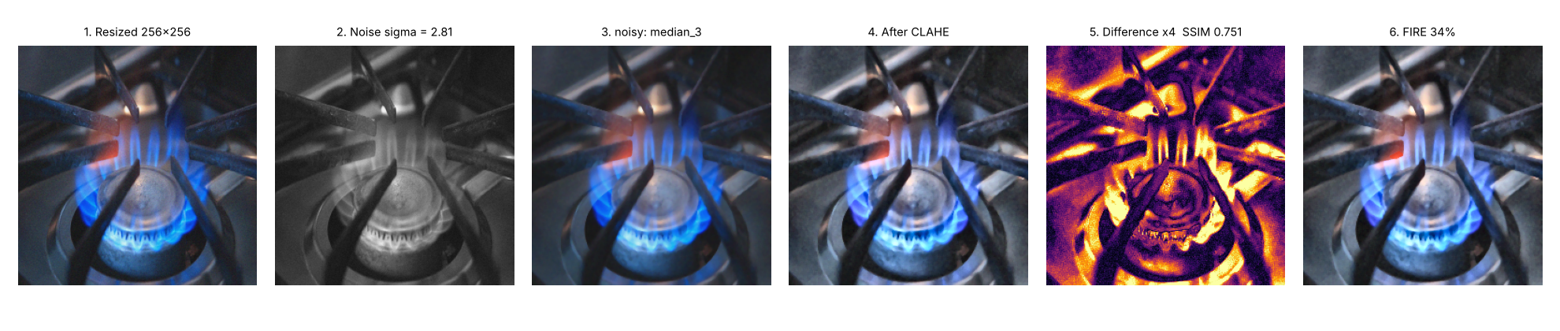
Figure 4. The step image saved by the package for a photo with added Gaussian noise: resized photo, grey photo used for the noise check, median filter, CLAHE, difference image and answer. This example was made with a test model to show the steps, so its label is not a real prediction.
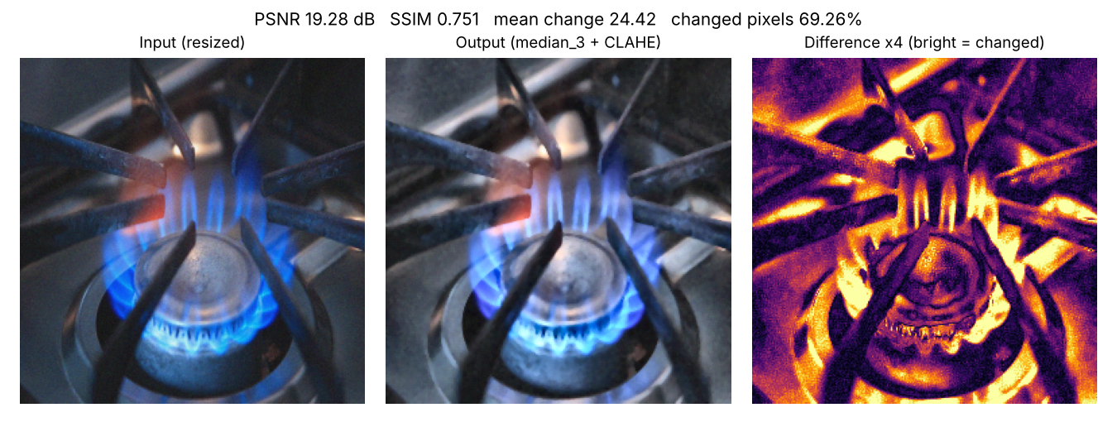
Figure 5. The input and output comparison saved by the package for the same photo. Bright areas in the difference image are the pixels that changed. For a clean photo the package reports PSNR 100 dB, SSIM 1.000 and 0% changed pixels.

5. Results
All numbers in this section come from the saved result files of each run. Each model was trained once with seed 42.

5.1 How much each DIP step changes a photo
We applied each preprocessing step to 1,300 photos and compared the output with the input. Table 9 shows the result. The median filter changes a photo only a little. CLAHE changes it more, because it spreads the brightness values. Entropy rose from 7.05 to 7.33 bits and RMS contrast rose from 53.8 to 56.2, so the processed photos show slightly more detail. Figure 6 shows each step and Figure 7 shows the histogram before and after CLAHE.
Table 9. Change caused by each step (1,300 photos, output compared with input)
Step | PSNR (dB) | SSIM
Median 3 × 3 | 32.32 | 0.925
CLAHE on L | 21.07 | 0.799
Both together | 20.83 | 0.786

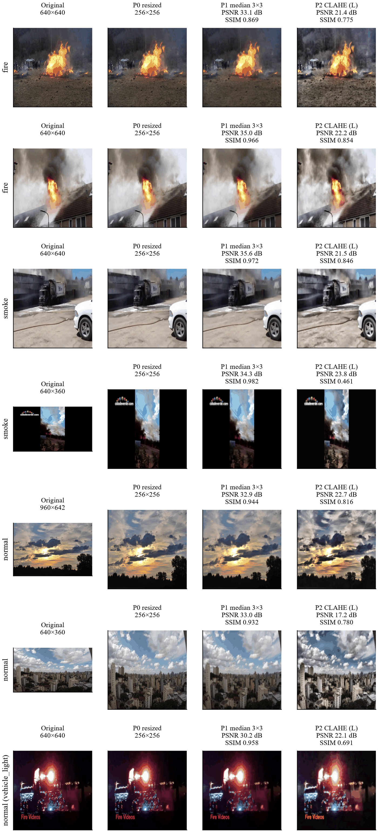
Figure 6. Each preprocessing step on example photos: original, resized, median filter, CLAHE on L, with PSNR and SSIM.
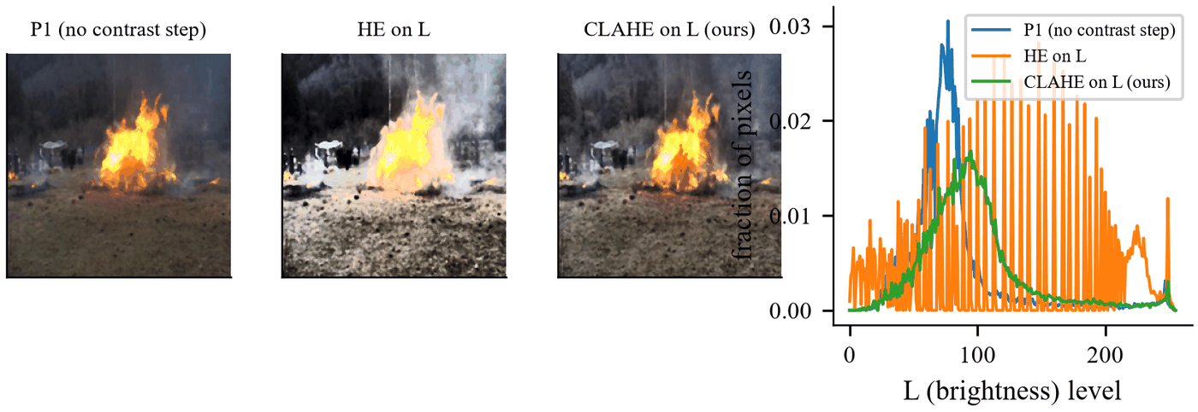
Figure 7. The brightness histogram spreads out after CLAHE.

5.2 Comparing filters
We added noise to photos on purpose and tested how well each filter brings the clean photo back. Table 10 shows the result. On salt-and-pepper noise the median filter is clearly the best. On Gaussian noise the bilateral filter [28] is the best. Figure 8 shows an example.
Table 10. Restoring a noisy photo (PSNR in dB / SSIM, compared with the clean photo)
Noise added | Median | Gaussian | Bilateral
Salt-and-pepper | 32.15 / 0.923 | 27.87 / 0.750 | 21.67 / 0.622
Gaussian | 29.97 / 0.819 | 31.10 / 0.848 | 34.56 / 0.894

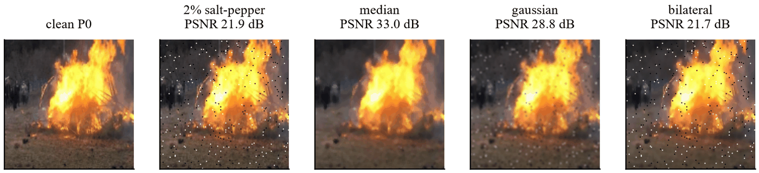
Figure 8. Median, Gaussian and bilateral filters compared on a noisy photo.

5.3 Comparing contrast methods
We compared three contrast methods by how much they shift the colours. Histogram equalisation on the RGB channels shifted the colours by 18.4. Histogram equalisation on L shifted them by 1.28. CLAHE on L shifted them by only 0.32. Figure 9 shows the difference.
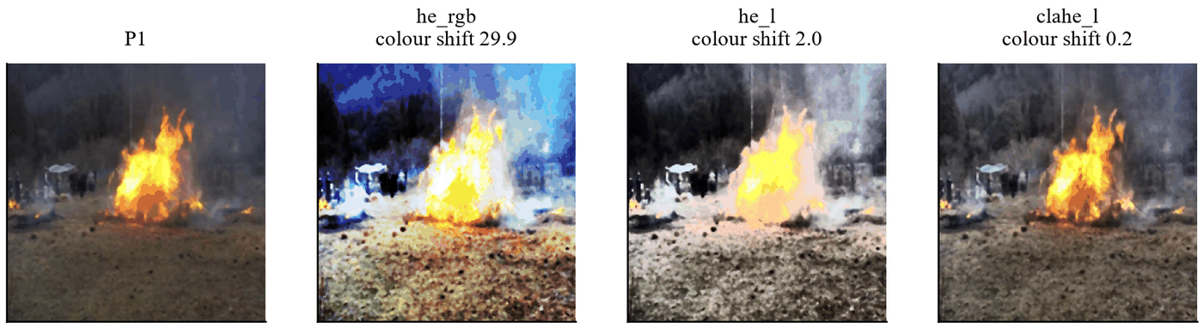
Figure 9. Histogram equalisation on RGB changes colours a lot. CLAHE on L keeps the fire colour correct.

5.4 Colour segmentation
We checked the colour masks against the dataset boxes. Figure 10 shows the steps and Figure 12 shows more examples. We tested five values of the fire threshold τ on validation photos, and τ = 40 was the best (Figure 11). Table 11 gives the result. The fire mask works fairly well. The smoke mask is weak. It marks almost 19% of the area of normal photos, because grey sky, roads and walls have the same colour as smoke.
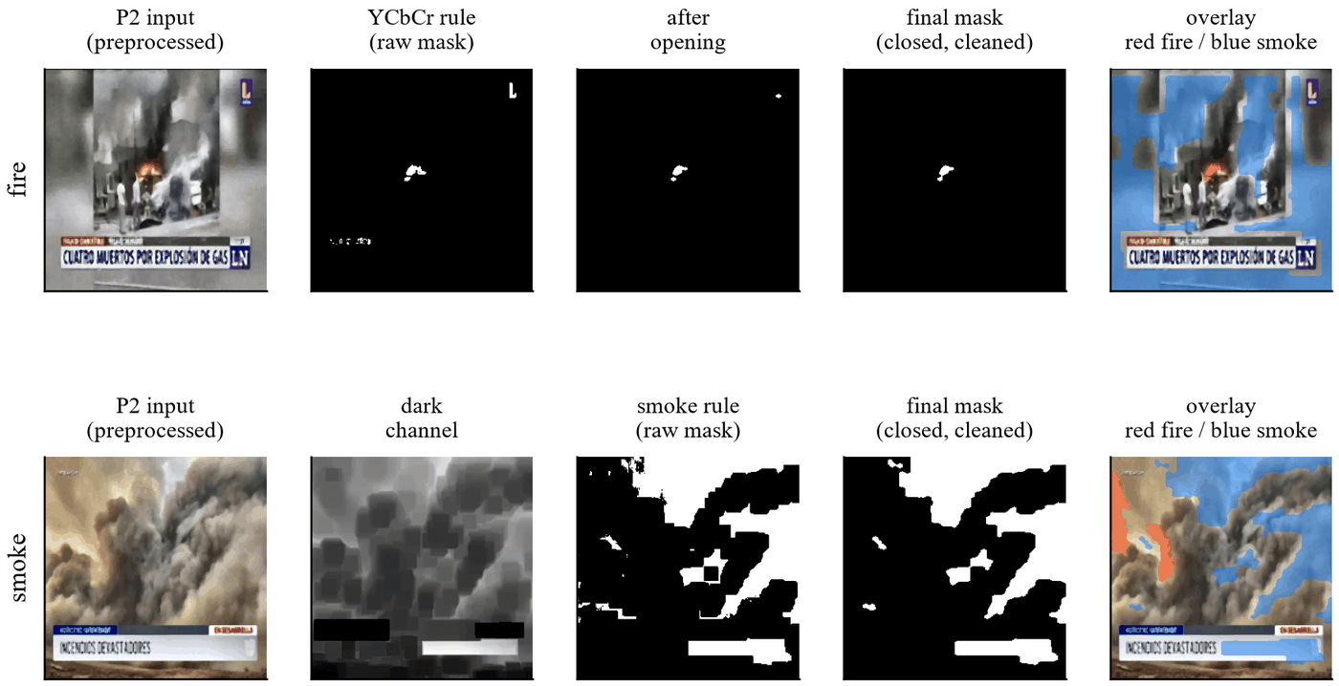
Figure 10. Segmentation step by step. Top: fire (YCbCr rule, opening, closing, overlay). Bottom: smoke (dark channel, smoke rule, cleaned mask, overlay).
Table 11. Colour masks checked on validation photos
Mask | Covers the box area | Area marked on normal photos | Score J
Fire (τ = 40) | 33% | 3.65% | 0.294
Smoke | 33.7% | 18.9% | 0.147

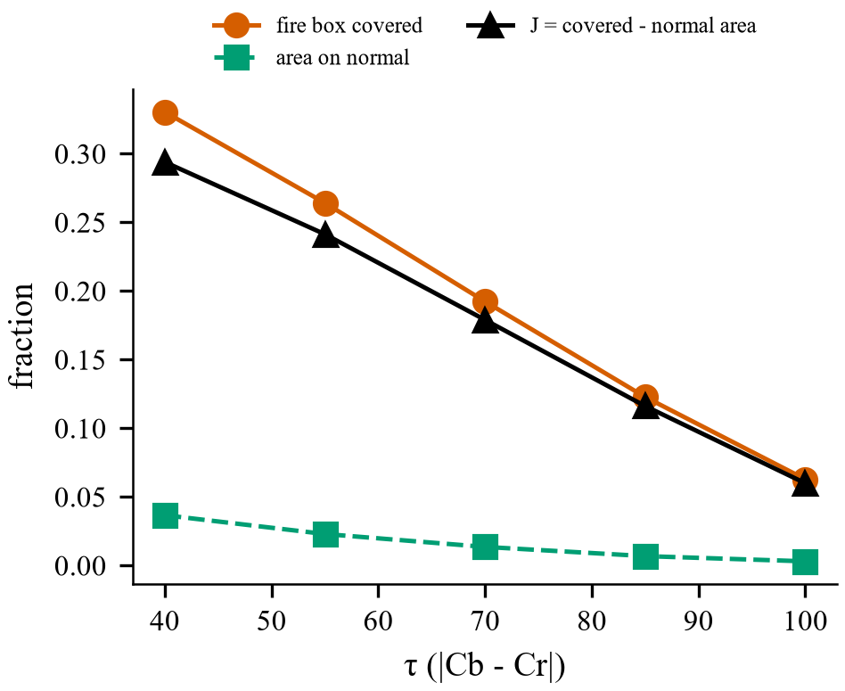
Figure 11. Choosing the fire threshold τ on validation photos. τ = 40 was the best.
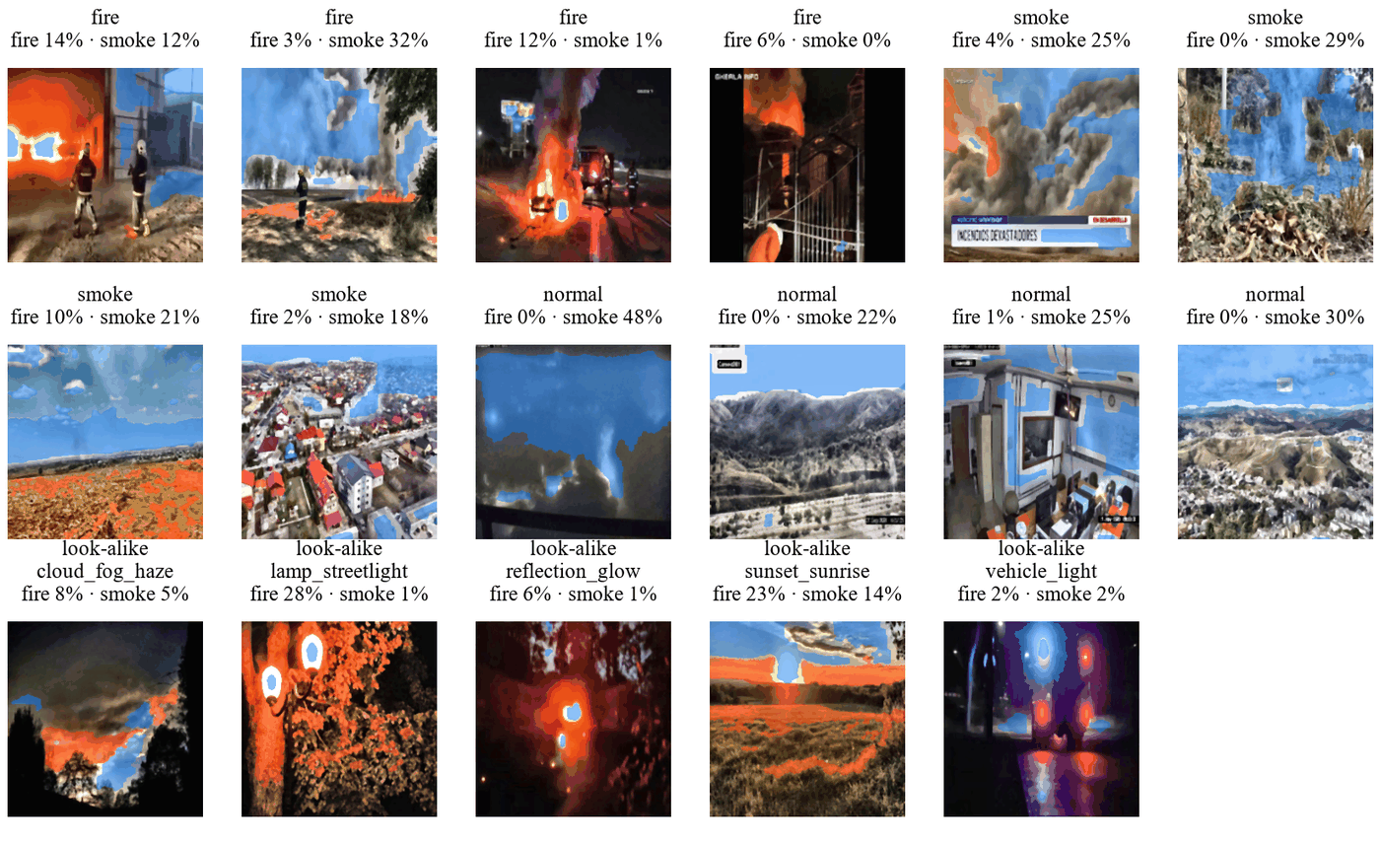
Figure 12. More mask examples. The smoke mask often also marks grey sky, roads and walls.

5.5 Hand-made features
The 16 features were computed for 41,564 photos with no failures. This took about 22 ms per photo. Figure 13 ranks them by the ANOVA F-score on training data. The strongest features are the edges of the fire mask (2568), redness (1452), fire area (1021) and the mean of the dark channel (999).
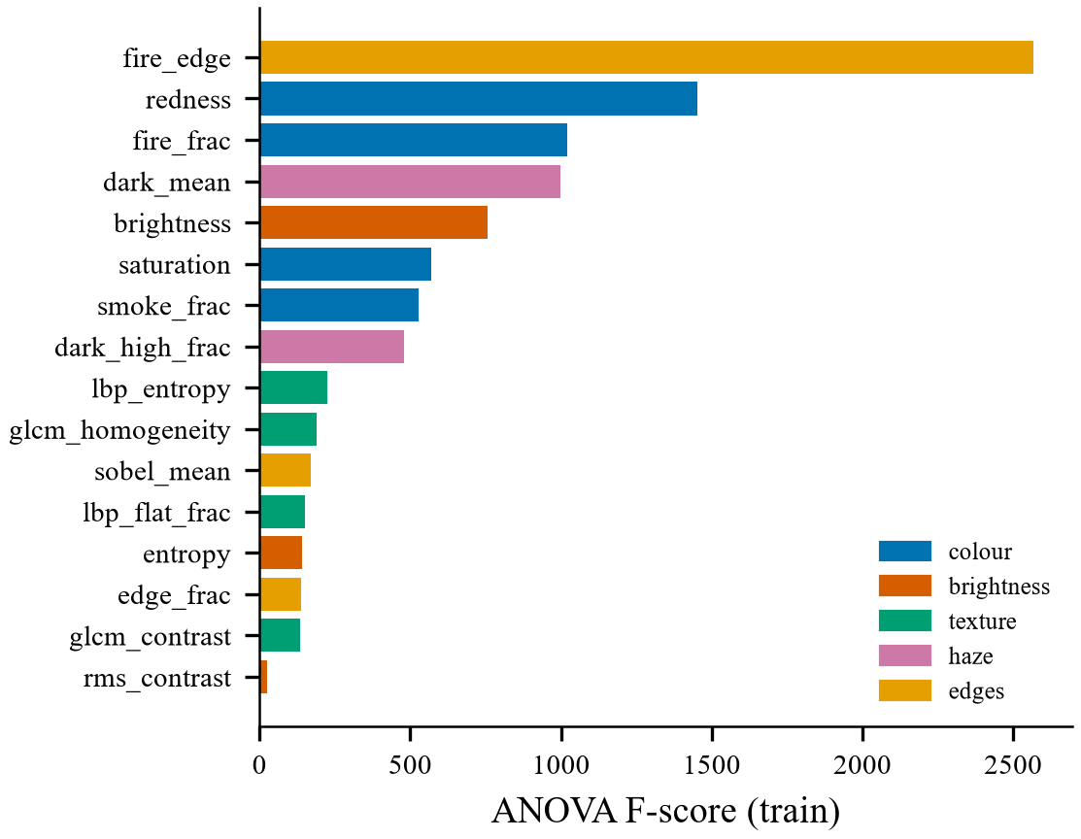
Figure 13. The 16 features ranked by ANOVA F-score on training data.

5.6 Choosing the noise threshold
We measured σ on original validation photos and on the same photos with added Gaussian noise. Figure 14 shows the two groups. The threshold σ = 2.56 separates them best, with a balanced accuracy of 0.784. It marks 97% of the photos with added noise of σ 15 and all photos with σ 25. It also marks 36% of the original photos. This is partly correct, because many camera photos already have some noise.
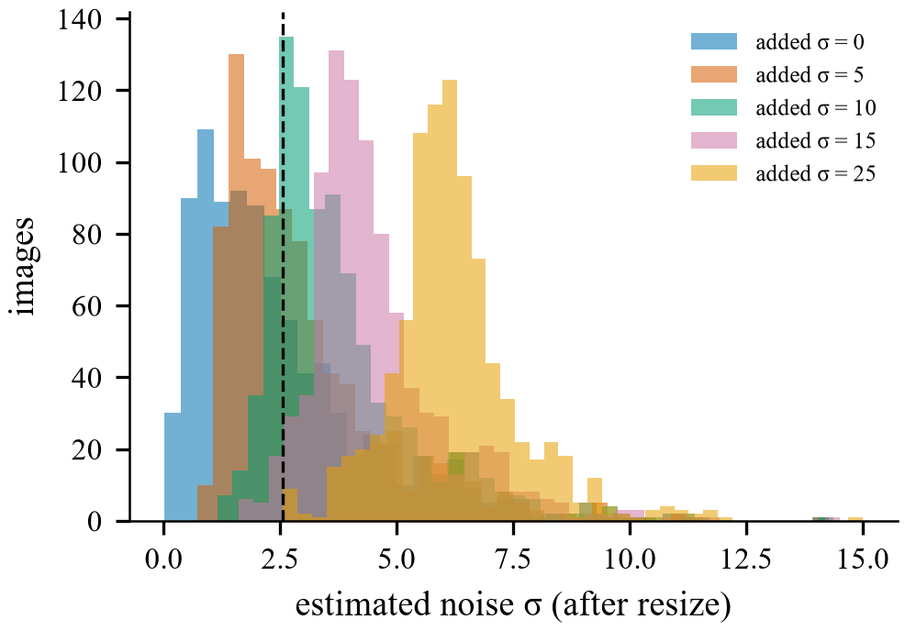
Figure 14. Noise level σ of original photos and photos with added noise. The chosen threshold is 2.56.

5.7 Testing a brightness threshold
We also tested a rule for dark photos. A mean brightness of 71.4 separates ordinary photos from darkened photos with a balanced accuracy of 0.87 (Figure 15). But it marks 21.9% of ordinary photos as dark. Model CA2 used this rule. Its validation score was lower than that of CA (0.908 against 0.917), and it gave more false alarms on look-alike photos (3.1% against 2.2%), so the rule is not in the final model.
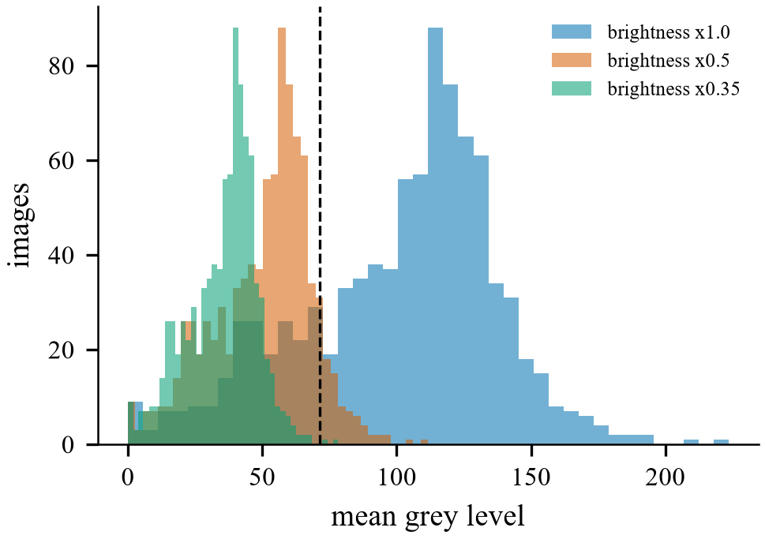
Figure 15. Mean brightness of ordinary and darkened photos. The tested threshold is 71.4.

5.8 Which filter for which noise
In a larger study we added noise to 150 validation photos and compared 15 filter settings and a no-filter baseline. The filters included median, Gaussian, average, bilateral and non-local means [29] filters. The first run added the noise after resizing. This was a mistake, because a real camera adds noise before the photo is resized. We corrected the study and report the corrected run. Table 12 shows the best filter for each noise type. Figure 16 shows examples and Figure 17 shows all SSIM values.
Table 12. Best filter for each noise type (noise added before resizing)
Noise added | Best filter | PSNR (dB) | SSIM
Gaussian σ 10 | Bilateral | 37.1 | 0.932
Gaussian σ 25 | Bilateral | 33.5 | 0.872
Salt-and-pepper 2% | Median 3 × 3 | 31.5 | 0.903
Salt-and-pepper 5% | Median 3 × 3 | 30.1 | 0.844

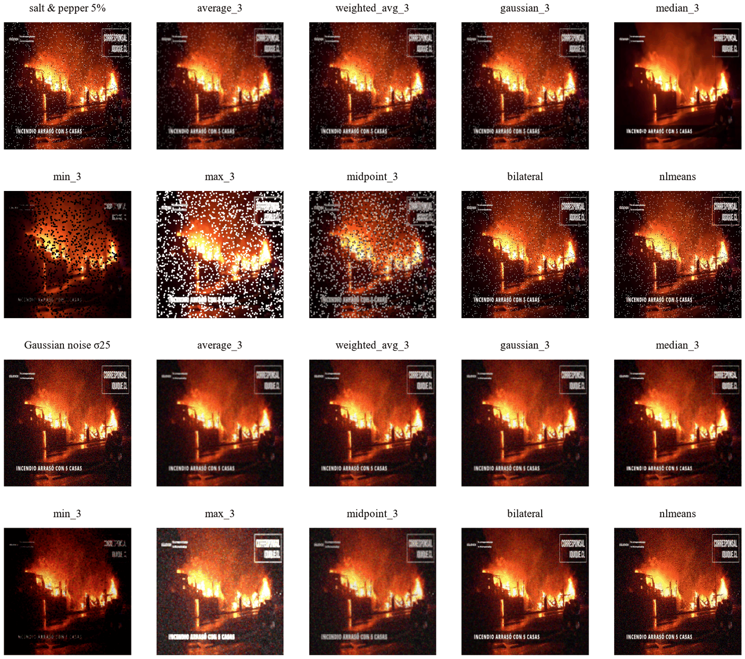
Figure 16. The same noisy photos restored by different filters.
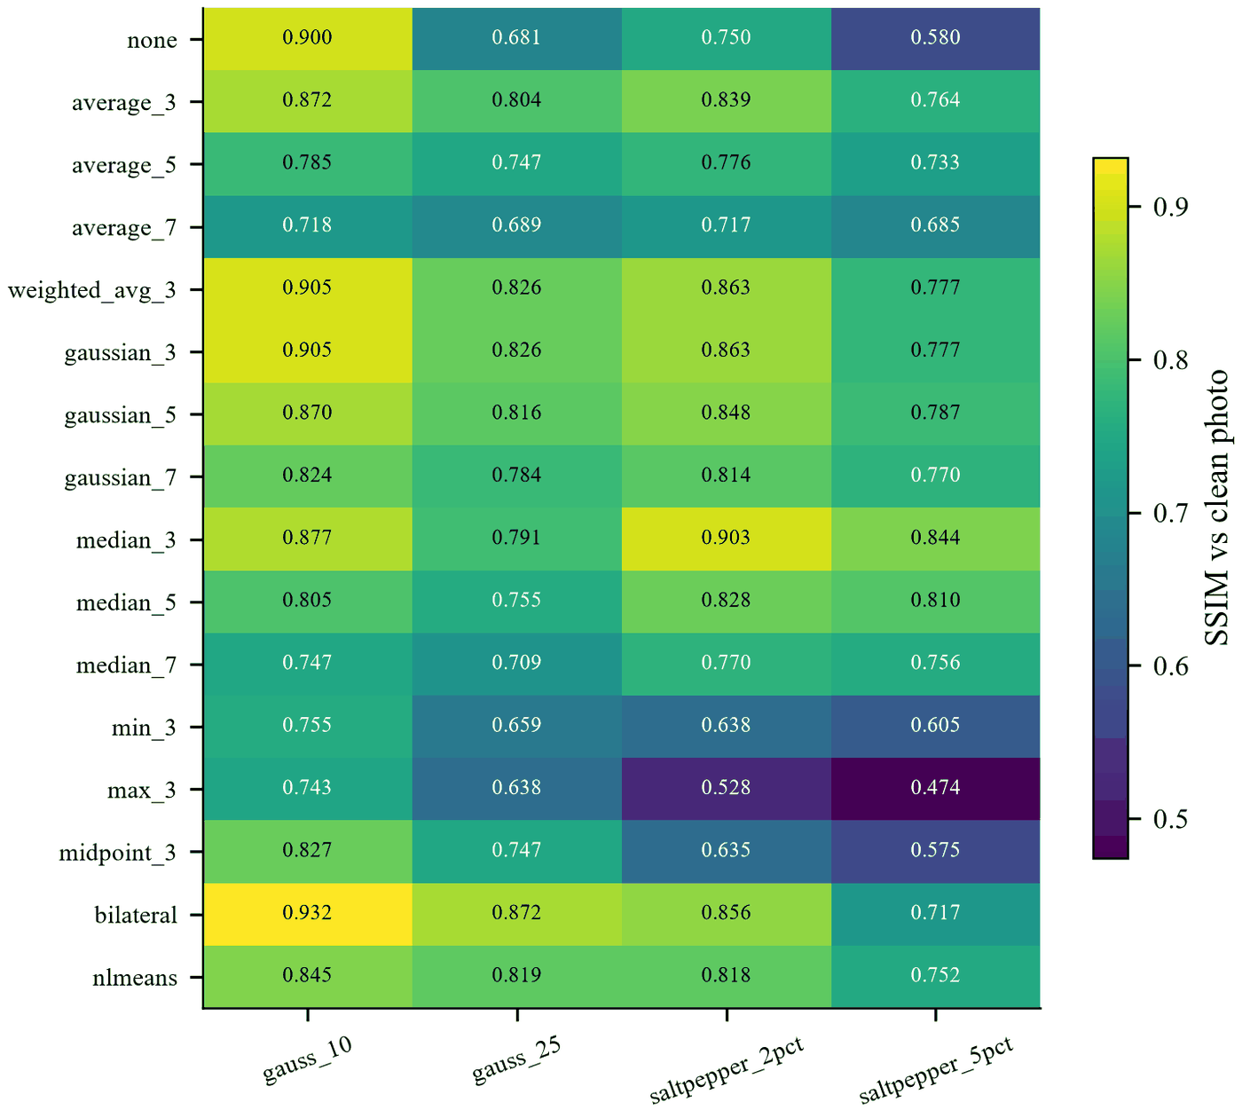
Figure 17. SSIM of each filter for each noise type.
We also tested how well two detectors find noisy photos (Figure 18). The noise estimate σ finds both noise types, with an AUC of 0.839 for Gaussian noise and 0.964 for salt-and-pepper noise. The isolated point count (a mask with 8 in the centre and −1 around it, which marks lonely dots) finds salt-and-pepper noise almost perfectly when the noise is added after resizing (AUC 0.999), but poorly when it is added before (AUC 0.621). Resizing shrinks the dots into small grey spots, so they are no longer lonely points.
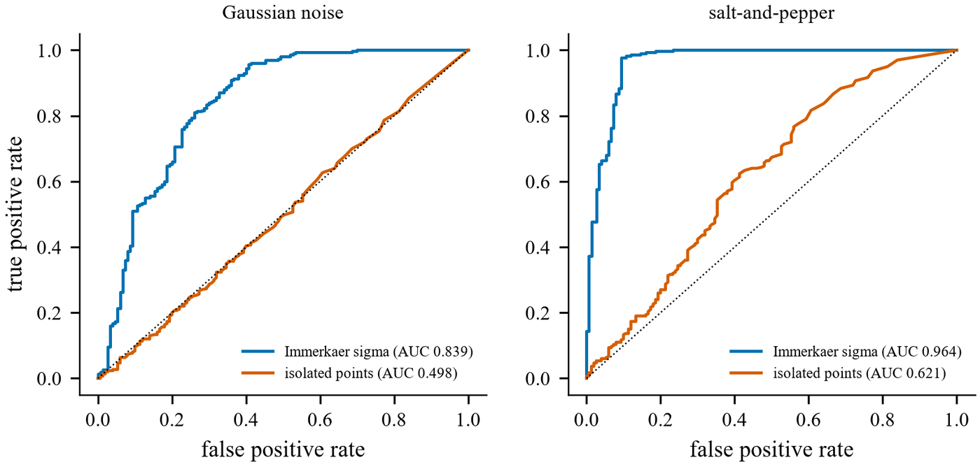
Figure 18. How well the noise estimate σ and the isolated point count find noisy photos.
Figure 19 shows the adaptive rule on example photos. Clean photos pass unchanged, with PSNR 100 dB and SSIM 1.000. The same photos with added noise are filtered.
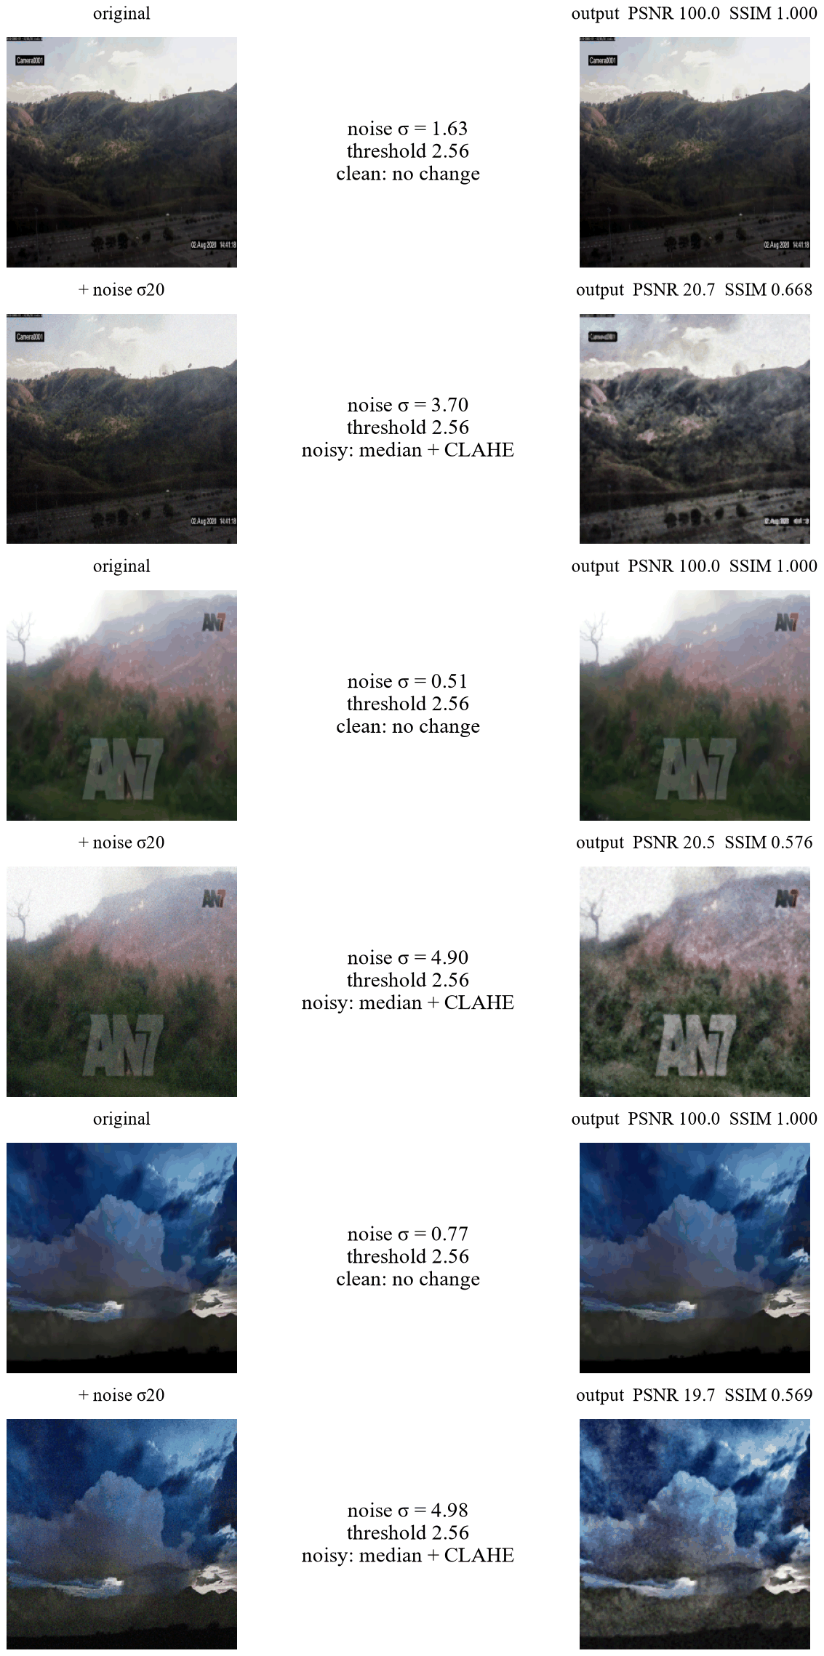
Figure 19. The adaptive rule in action. Clean photos pass unchanged. The same photos with added noise get the median filter and CLAHE.

5.9 All 16 classifiers
Table 13 gives the scores of all 16 classifiers. Figure 20 shows the validation scores and Figure 21 shows the false alarms on look-alike photos.
Table 13. All 16 classifiers. Scores are macro-F1. False alarms are the share of normal photos called fire or smoke.
Model | Idea | Validation | Test in-domain | Test DeepQuestAI | False alarms DeepQuestAI (%) | False alarms look-alikes (%)
CA (final) | adaptive DIP + noise training | 0.9174 | 0.8950 | 0.9002 | 12.4 | 2.22
CR | raw photos, no DIP | 0.9164 | 0.9017 | 0.8995 | 12.0 | 3.55
EM | feature tokens + learned maps | 0.9158 | 0.8888 | 0.8884 | 17.4 | 3.33
CA3 v2 | filter per noise type (corrected) | 0.9142 | 0.8910 | 0.8912 | 15.7 | 3.55
CM | learned maps | 0.9133 | 0.8944 | 0.8753 | 16.5 | 4.21
D | 16 features at the end | 0.9132 | 0.8912 | 0.8981 | 10.7 | 2.66
E | 16 features as tokens | 0.9130 | 0.8945 | 0.8781 | 18.7 | 3.55
EMD | tokens + maps from DIP masks | 0.9102 | 0.8871 | 0.8827 | 13.1 | 2.66
CRN | raw photos + noise training | 0.9092 | 0.8905 | 0.8974 | 13.2 | 3.55
CA3 v1 | filter per noise type (first run) | 0.9089 | 0.8883 | 0.9044 | 13.1 | 2.66
CA2 | adaptive DIP + brightness rule | 0.9078 | 0.8901 | 0.9010 | 10.5 | 3.10
C | always median + CLAHE | 0.9077 | 0.8897 | 0.8833 | 15.5 | 3.30
CN | always DIP + noise training | 0.8991 | 0.8868 | 0.8871 | 16.8 | 2.88
B | MobileNetV3-Small CNN | 0.8859 | 0.8776 | 0.8555 | 22.2 | 3.55
A (RF) | 16 features, Random Forest | 0.6955 | 0.7105 | 0.5078 | 81.6 | 40.8
A (SVM) | 16 features, SVM | 0.6416 | 0.6896 | 0.5243 | 76.8 | 35.7

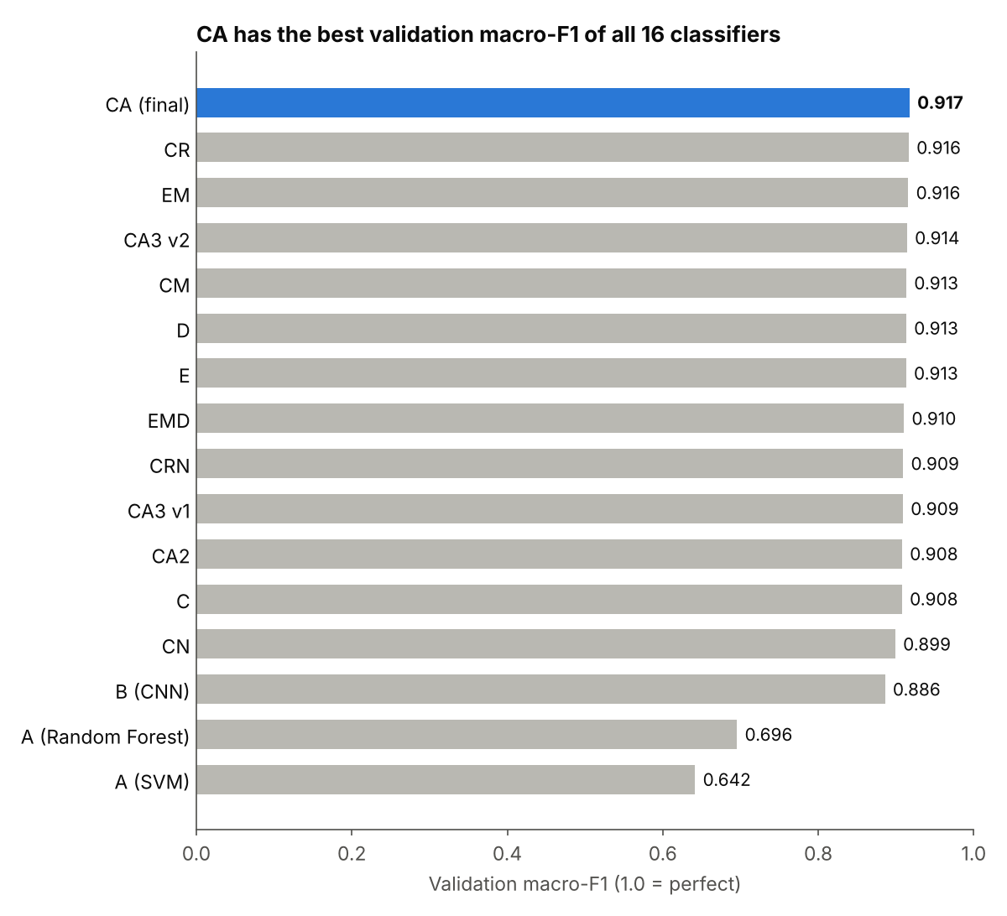
Figure 20. Validation macro-F1 of all 16 classifiers. Only this score was used to choose the final model.
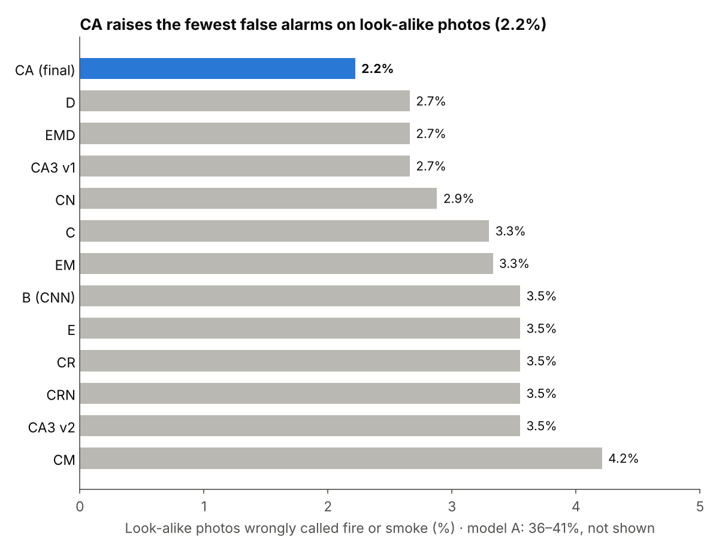
Figure 21. Share of look-alike photos wrongly called fire or smoke. Model A (36% to 41%) is not shown.

5.9.1 Baselines
Model A reaches only 0.70 on validation and about 0.51 on DeepQuestAI. It calls 77% to 82% of the normal DeepQuestAI photos fire or smoke (Figure 22). Sixteen numbers cannot describe a photo well enough. Model B, the CNN, reaches 0.886 on validation. Every MobileViT-XS model is better than B.
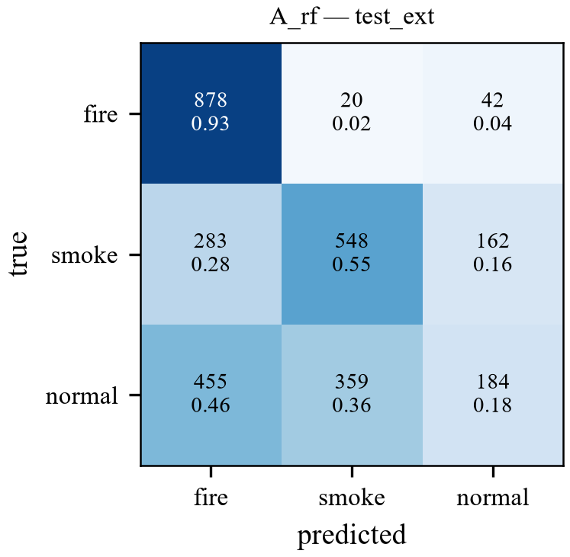
Figure 22. Confusion matrix of model A (Random Forest) on DeepQuestAI. Most normal photos are called fire or smoke.

5.9.2 Models with DIP features inside the network
Models D, E, EM, CM and EMD give DIP information to the network in different ways. Figure 23 shows maps learned by model EM. Their validation scores are between 0.910 and 0.916, and none of them is better than CA. To see if these models really use the features, we switched off one group of features at test time (Figure 24). For D and EM the macro-F1 changed by less than 0.5 points. Only model E lost a little on DeepQuestAI (0.013 for texture and 0.011 for edges). So the transformer learns almost everything from the photo itself. After this result we stopped adding features and worked on cleaning the photo instead.
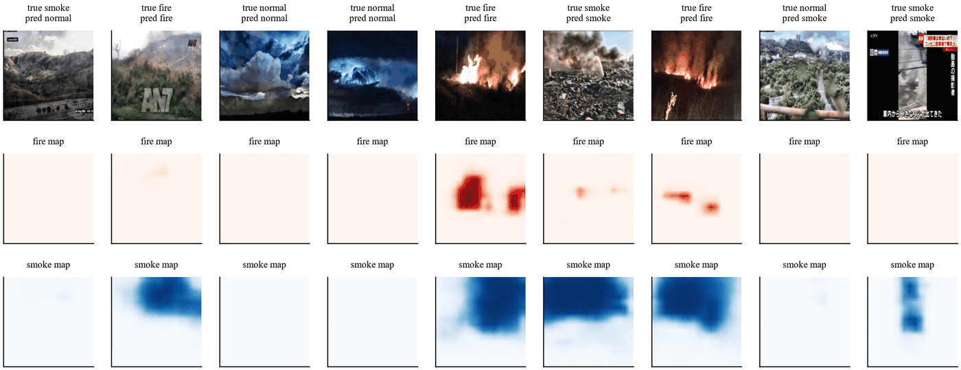
Figure 23. Fire and smoke maps learned by model EM.
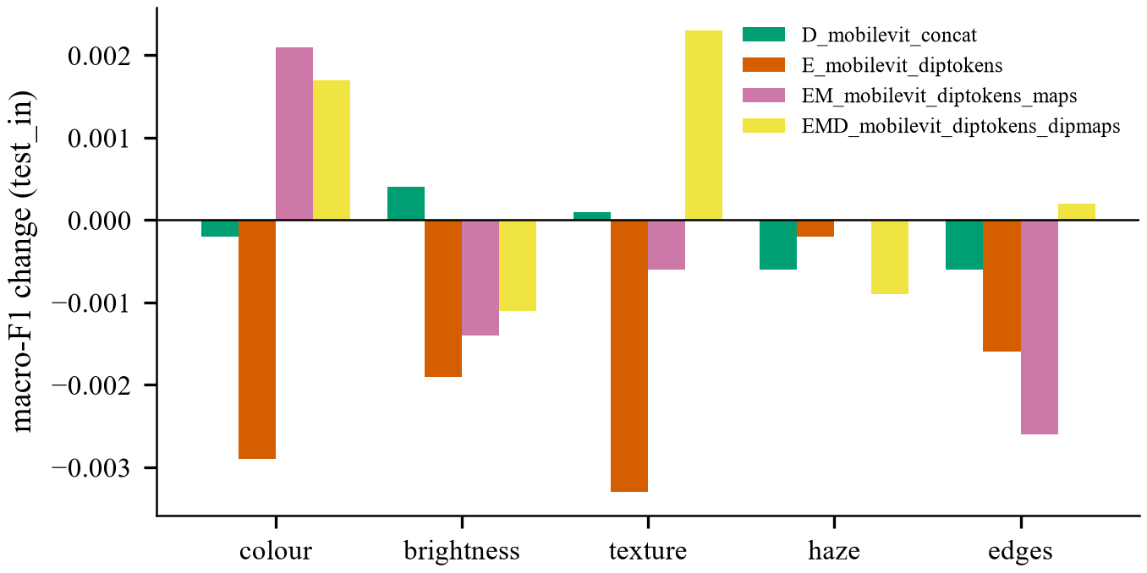
Figure 24. Change in macro-F1 on the in-domain test set when one group of features is switched off at test time.

5.9.3 Raw photos against DIP
Model CR uses raw photos. On clean photos it is very good, with the best in-domain test score (0.902). Model C, which filters every photo, is a little lower on all three sets. This shows that filtering clean photos does not help. But the robustness test below shows that CR breaks down on noisy photos.

5.9.4 The final model CA
Model CA has the best validation macro-F1 of all 16 classifiers (0.9174), so it was chosen as the final model. Table 14 gives its scores with 95% confidence intervals. Figure 25 shows the training curve and Figure 26 shows the confusion matrix on DeepQuestAI. On the in-domain test set, the fire recall is 0.955 and the smoke recall is 0.815. CA is not the best on every single test. CR is higher on the in-domain test, CA3 v1 and CA2 are a little higher on DeepQuestAI, and CA2 and D have fewer false alarms on DeepQuestAI. The macro-F1 differences are small and lie inside the confidence intervals of CA.
Table 14. Final model CA with 95% confidence intervals
Split | Photos | Accuracy | Macro-F1 | Macro-F1 95% interval | False alarms
Validation | 7,325 | 0.942 | 0.917 | 0.9085 to 0.9257 | 5.5%
Test in-domain | 6,810 | 0.904 | 0.895 | 0.8877 to 0.9024 | 8.3%
Test DeepQuestAI | 2,931 | 0.900 | 0.900 | 0.8898 to 0.9116 | 12.4%
Look-alikes | 451 | n/a | n/a | n/a | 2.2%

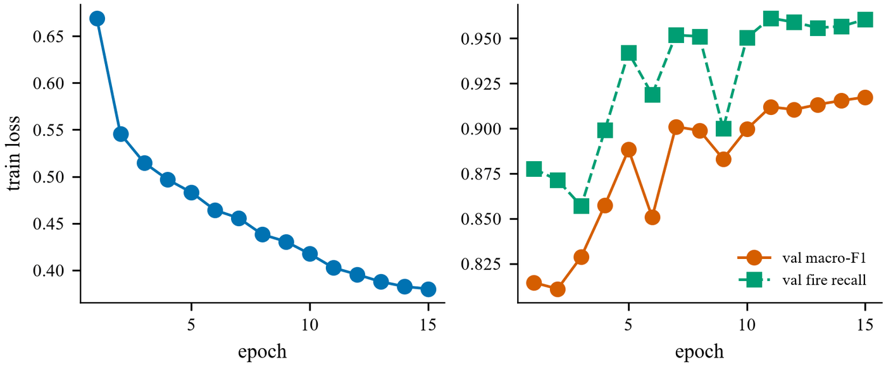
Figure 25. Training curve of model CA. The best epoch was the last one, epoch 15.
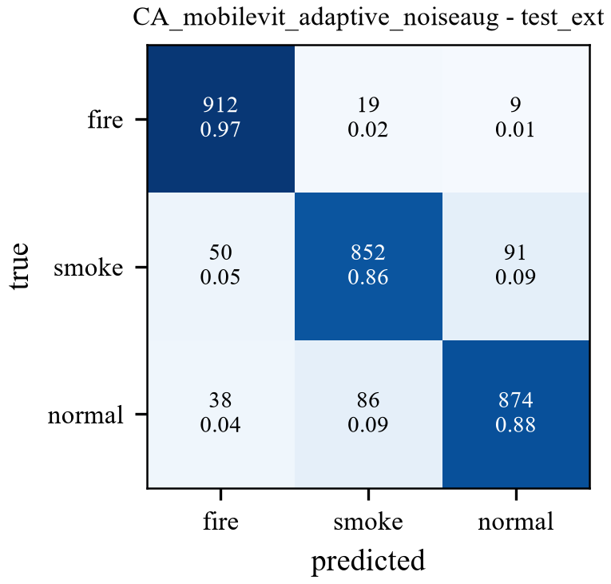
Figure 26. Confusion matrix of model CA on DeepQuestAI.
Table 15 shows the false alarms of CA on each look-alike type. Only 10 of the 451 photos were called fire or smoke. No fog photo was called smoke.
Table 15. False alarms of model CA on the look-alike set
Type | Photos | Called fire | Called smoke | False alarm rate
Cloud, fog, haze | 75 | 0 | 0 | 0.00%
Lamp, street light | 52 | 2 | 0 | 3.85%
Reflection, glow | 51 | 1 | 1 | 3.92%
Sunset, sunrise | 88 | 0 | 1 | 1.14%
Vehicle light | 185 | 0 | 5 | 2.70%
All | 451 | 3 | 7 | 2.22%

5.10 Robustness to damaged photos
We damaged the DeepQuestAI photos on purpose and measured macro-F1 again. Nothing was retrained. The damage was added to the full-size photo, before the pipeline. We used nine kinds of damage: darkening (brightness times 0.35), Gaussian blur (7 × 7 kernel), JPEG compression (quality 20), Gaussian noise with σ of 5, 10, 15 and 25, and salt-and-pepper noise on 2% and 5% of the pixels. Table 16 and Figure 27 show the result.
Table 16. Macro-F1 on DeepQuestAI photos with added damage (S&P = salt-and-pepper noise)
Model | Clean | Dark | Blur | JPEG | σ 5 | σ 10 | σ 15 | σ 25 | S&P 2% | S&P 5%
CA (final) | 0.900 | 0.868 | 0.889 | 0.877 | 0.894 | 0.876 | 0.860 | 0.815 | 0.863 | 0.820
CA2 | 0.901 | 0.877 | 0.881 | 0.887 | 0.894 | 0.884 | 0.868 | 0.837 | 0.861 | 0.819
CA3 v2 | 0.891 | 0.874 | 0.881 | 0.867 | 0.887 | 0.875 | 0.856 | 0.763 | 0.841 | 0.791
CN | 0.887 | 0.884 | 0.868 | 0.861 | 0.882 | 0.870 | 0.857 | 0.798 | 0.843 | 0.788
CRN | 0.897 | 0.878 | 0.886 | 0.886 | 0.898 | 0.888 | 0.870 | 0.806 | 0.686 | 0.441
CR | 0.900 | 0.890 | 0.906 | 0.873 | 0.879 | 0.797 | 0.661 | 0.396 | 0.636 | 0.434

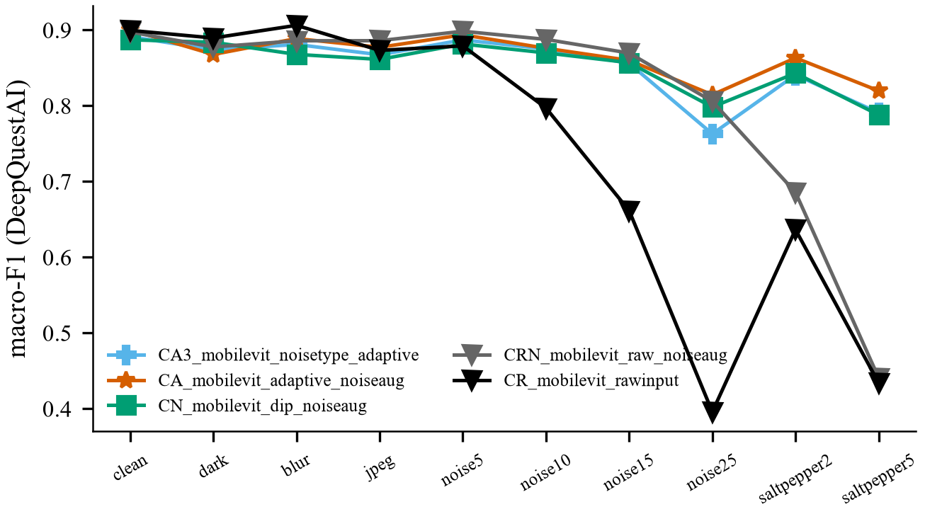
Figure 27. Macro-F1 on DeepQuestAI under each kind of damage. CA2 was tested later in a separate run with the same damage, so it is in Table 16 but not in this chart.
On clean, dark, blurred and JPEG photos the six models are close. The difference appears under noise. CR falls to 0.40 at Gaussian noise of σ 25 and to 0.43 at 5% salt-and-pepper noise. Its fire recall at σ 25 is only 0.38, so it misses most fires. CRN has noise training but no filter. It handles Gaussian noise but falls to 0.44 at 5% salt-and-pepper noise. CN has both the filter and noise training, but it filters clean photos too, and its validation score is the lowest of the MobileViT-XS models. CA and CA2 both stay at 0.81 or higher under every kind of damage. The fire recall at σ 25 is 0.91 for CA and 0.906 for CA2. CA2, which also brightens dark photos, is a little better than CA on dark photos (0.877 against 0.868), on JPEG photos and on strong Gaussian noise (0.837 against 0.815 at σ 25). The two are almost equal on salt-and-pepper noise. CA2 was still not chosen, because its validation score is lower and it gives more false alarms on look-alike photos. The final model was chosen by validation score only, before these tests were run. An earlier test of model C, which has the filter but no noise training, gave 0.546 at σ 25. So both parts are needed: the filter for noisy photos and the noise training.

5.11 Choosing a filter for each noise type
Model CA3 first decides the noise type. To find salt-and-pepper noise it counts isolated points with the point mask that has 8 in the centre and −1 around it [2]. A pixel with a response above 600 counts as a lonely dot. CA3 then uses the filter with the best SSIM from Table 12. This point detector works poorly once the photo is resized (Section 5.8), so the final pipeline does not use it. The corrected model CA3 v2 has a lower validation score than CA (0.914) and falls to 0.76 at σ 25. The filter that gives the best-looking image is not always the best filter for the classifier.

5.12 Package test on a new photo
We also ran the package on new photos that were not in any dataset. Figure 28 shows one of them, a gas stove with a blue flame. The package printed this result: noise level σ = 0.89, below the threshold 2.56, so the photo was clean and was not filtered. Scores: fire 1.7%, smoke 2.2%, normal 96.1%. The answer was normal with a confidence of 96.1%. This answer is useful for an alarm system, because a cooking flame is not a danger. It also shows a limit: the model learned fire as orange and yellow flames, so blue flames may be missed.
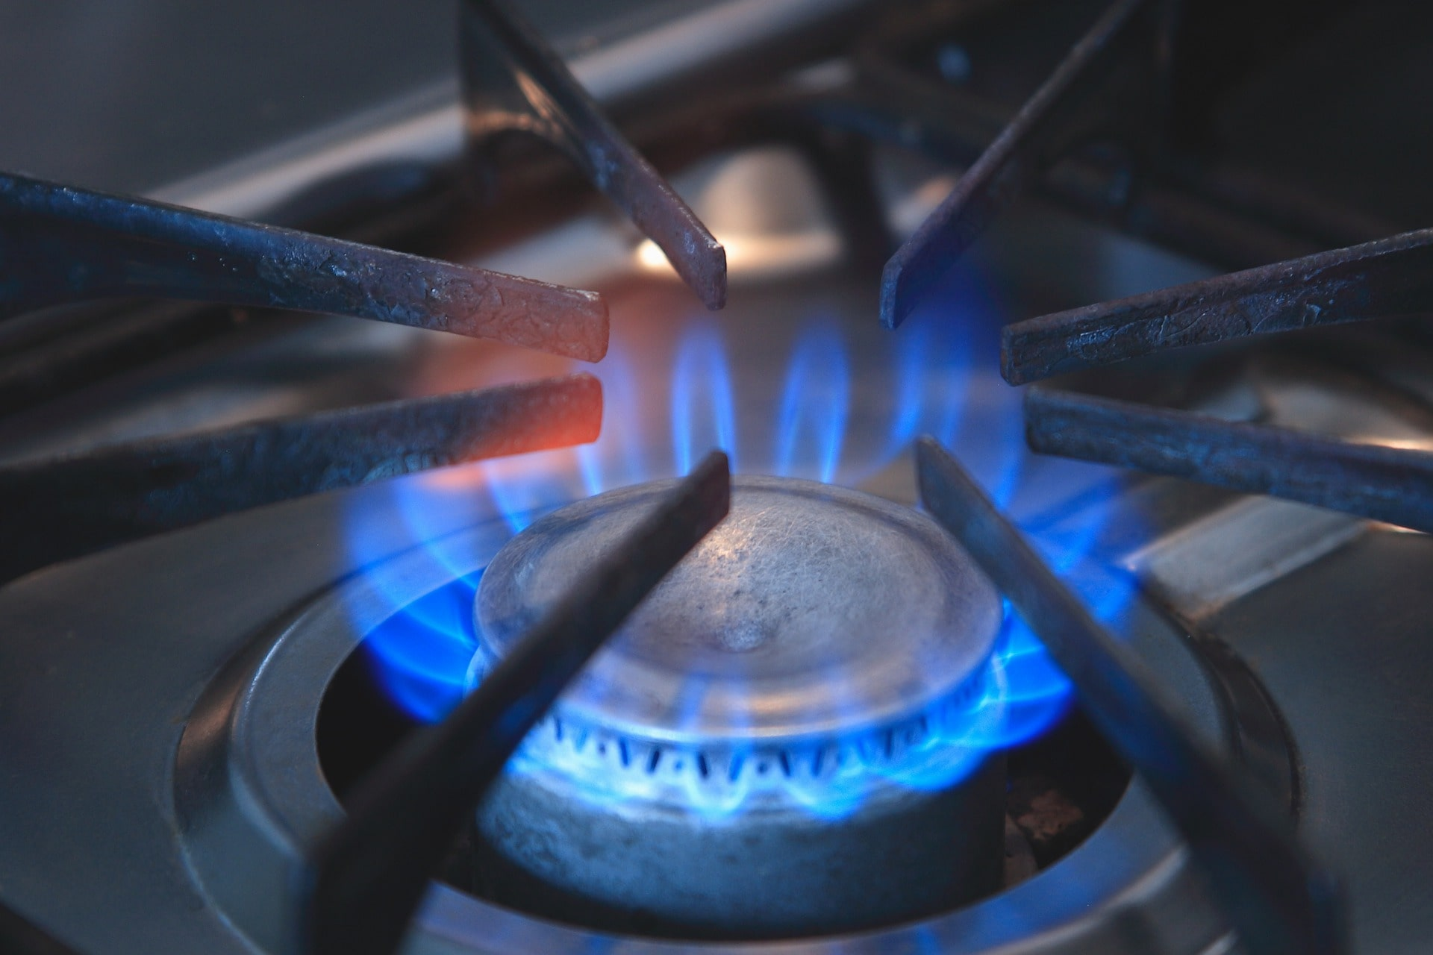
Figure 28. A new photo of a gas stove. The package called it normal (96.1%), with σ = 0.89 and no filter.

6. Comparison of Alternatives
We chose CA because it has the best validation score and the fewest look-alike false alarms, and it stays strong on every kind of damaged photo. Only CA2 is as strong on damaged photos, but it is lower on validation and gives more look-alike false alarms. Table 17 explains why each other option was not chosen.
Table 17. Why each alternative was not chosen
Alternative | What it does well | Why we did not choose it
A (SVM, Random Forest) | Fast and fully explainable; uses only DIP features | Fails on a new source (about 0.51); 77% to 82% false alarms on DeepQuestAI
B (MobileNetV3 CNN) | Small and fast | Lower than every MobileViT-XS model (0.886 on validation)
C (always median + CLAHE) | Simple and shows DIP clearly | Changes clean photos for no reason; breaks under strong noise (0.546 at σ 25)
D (features at the end) | Few DeepQuestAI false alarms (10.7%) | Lower validation score; the features are barely used
E, EM, CM, EMD (tokens and maps) | Put DIP inside the transformer | More complex but not better; CM has the most look-alike false alarms (4.2%)
CR (raw photos) | Best in-domain test score (0.902) | Breaks under noise: 0.40 at σ 25, 0.43 at 5% salt-and-pepper
CRN (raw + noise training) | Handles Gaussian noise | No median filter, so salt-and-pepper breaks it (0.44 at 5%)
CN (always DIP + noise training) | Steady under damage | Lowest validation score of the MobileViT-XS models (0.899)
CA2 (brightness rule) | Good on DeepQuestAI (0.901, 10.5% false alarms); a little better than CA on dark photos and strong noise | Lower validation score (0.908); more look-alike false alarms (3.1%); marked 22% of ordinary photos as dark
CA3 v1 and v2 (filter per noise type) | Best DeepQuestAI score in v1 (0.904) | Lower validation score; v2 falls to 0.76 at σ 25
CA (final) | Best validation score (0.917), fewest look-alike false alarms (2.2%), 0.81 or higher under all damage | Chosen

The choice was made by validation score only, before we looked at the test sets, so it is fair. On clean photos CA and CR are almost equal. The real difference is robustness.

7. Discussion with DIP Theory
The results agree with classic DIP theory [2]. Each filter works best on the kind of noise it was made for, and a filter should be used only when the photo needs it.
- Laplacian-type noise mask: the Immerkær mask cancels flat areas and straight edges, so what is left is mostly noise. This makes the noise estimate cheap (one convolution) and reliable (AUC 0.84 to 0.96).
- Median filter: it is an order-statistic filter. It throws away single wrong dots and keeps edges. This is why it won on salt-and-pepper noise, and why CA does not break on this noise while CR and CRN do.
- Filter only when needed: every filter also removes some real detail. The median filter alone changed clean photos to about 32 dB PSNR. The adaptive rule avoids this loss, which is why CA beats C and CN on clean photos.
- CLAHE on L: global histogram equalisation can stretch flat areas too much and make noise stronger. CLAHE works on small tiles and limits the stretch with a clip limit. Using only the L channel keeps the hue, so the fire colour stays correct.
- Area interpolation: it averages blocks of pixels, so it acts as a low-pass filter. It lowers Gaussian noise and shrinks salt-and-pepper dots into small grey spots. This explains why the isolated point count stopped working when the noise was added before resizing.
- Weak smoke mask: smoke is grey, with low saturation and medium brightness. Sky, fog, roads and walls look the same in HSV, so a colour rule alone cannot separate them. The trained network does much better, because it also uses shape and texture.
- DIP and learning together: filtering removes most of the noise, but not all of it. Noise training teaches the network to ignore the rest.

8. Conclusion
This project joined classic digital image processing with a small vision transformer for fire and smoke classification.
- We built a clean and fair dataset of 41,789 photos and a separate set of 451 look-alike photos.
- We studied each DIP step (filters, CLAHE, colour segmentation, morphology and noise estimation) and measured it with PSNR, SSIM and other scores.
- The final model CA measures the noise in each photo and filters only when needed. It has the best validation macro-F1 of 16 classifiers (0.917), reaches 0.900 on a test set from a new source, and gives false alarms on only 2.2% of look-alike photos.
- Under added noise, blur, darkness and JPEG damage, CA stays at 0.81 or higher, while the same network on raw photos falls to 0.40.
- The system is packaged as the firesmoke Python library, so anyone can run it on a new photo and see every step.

9. Limitations
- Each model was trained only once, with one random seed. Differences smaller than about one point may be due to chance.
- The first filter study added noise after resizing. We corrected it and trained CA3 again. Both results are reported.
- The filter with the best image quality (SSIM) was not the best filter for the classifier.
- The smoke mask marks about 19% of the area of normal photos.
- About 12% of the normal DeepQuestAI photos are still called fire or smoke.
- The brightness rule (CA2) helped only a little on dark photos (0.877 against 0.868 for CA), and it marked 22% of ordinary photos as dark.
- The result folder of model CA2 was deleted by mistake. We tested its saved model again without training and rebuilt its results. Its validation score matched the original run exactly (0.9078).
- The system uses single photos. It does not use motion, which is a strong sign of smoke in video.
- The model learned fire as orange and yellow flames. Blue flames may be missed.

10. Future Work
- Train every model with three or more seeds and use paired statistical tests.
- Extend the system to video and add motion features for smoke.
- Improve the smoke mask with texture, for example local binary patterns, instead of colour alone.
- Add more photos of blue and unusual flames, and more dark photos.
- Run the package on a small robot or edge device with a camera.

11. References
[1] K. Muhammad, J. Ahmad, and S. W. Baik, “Early fire detection using convolutional neural networks during surveillance for effective disaster management,” Neurocomputing, vol. 288, pp. 30–42, 2018.
[2] R. C. Gonzalez and R. E. Woods, Digital Image Processing, 4th ed. New York, NY, USA: Pearson, 2018.
[3] S. Mehta and M. Rastegari, “MobileViT: Light-weight, general-purpose, and mobile-friendly vision transformer,” in Proc. Int. Conf. Learn. Represent. (ICLR), 2022.
[4] S. Dodge and L. Karam, “Understanding how image quality affects deep neural networks,” in Proc. 8th Int. Conf. Quality of Multimedia Experience (QoMEX), 2016, pp. 1–6.
[5] D. Hendrycks and T. Dietterich, “Benchmarking neural network robustness to common corruptions and perturbations,” in Proc. Int. Conf. Learn. Represent. (ICLR), 2019.
[6] T.-H. Chen, P.-H. Wu, and Y.-C. Chiou, “An early fire-detection method based on image processing,” in Proc. IEEE Int. Conf. Image Process. (ICIP), 2004, pp. 1707–1710.
[7] B. U. Töreyin, Y. Dedeoğlu, U. Güdükbay, and A. E. Çetin, “Computer vision based method for real-time fire and flame detection,” Pattern Recognit. Lett., vol. 27, no. 1, pp. 49–58, 2006.
[8] T. Çelik and H. Demirel, “Fire detection in video sequences using a generic color model,” Fire Safety J., vol. 44, no. 2, pp. 147–158, 2009, doi: 10.1016/j.firesaf.2008.05.005.
[9] P. V. A. B. de Venâncio, A. C. Lisboa, and A. V. Barbosa, “An automatic fire detection system based on deep convolutional neural networks for low-power, resource-constrained devices,” Neural Comput. Appl., vol. 34, pp. 15349–15368, 2022, doi: 10.1007/s00521-022-07467-z.
[10] C. Catargiu, N. Cleju, and I. B. Ciocoiu, “A comparative performance evaluation of YOLO-type detectors on a new open fire and smoke dataset,” Sensors, vol. 24, no. 17, Art. no. 5597, 2024, doi: 10.3390/s24175597.
[11] DeepQuestAI, “Fire-Smoke-Dataset,” GitHub repository. [Online]. Available: https://github.com/DeepQuestAI/Fire-Smoke-Dataset (accessed Nov. 2026).
[12] G. Bradski, “The OpenCV library,” Dr. Dobb’s J. Softw. Tools, 2000.
[13] J. Immerkær, “Fast noise variance estimation,” Comput. Vis. Image Understand., vol. 64, no. 2, pp. 300–302, 1996, doi: 10.1006/cviu.1996.0060.
[14] T. S. Huang, G. J. Yang, and G. Y. Tang, “A fast two-dimensional median filtering algorithm,” IEEE Trans. Acoust., Speech, Signal Process., vol. 27, no. 1, pp. 13–18, 1979.
[15] K. Zuiderveld, “Contrast limited adaptive histogram equalization,” in Graphics Gems IV, P. S. Heckbert, Ed. San Diego, CA, USA: Academic Press, 1994, pp. 474–485.
[16] R. Wightman, “PyTorch image models,” GitHub repository, 2019, doi: 10.5281/zenodo.4414861.
[17] K. He, J. Sun, and X. Tang, “Single image haze removal using dark channel prior,” IEEE Trans. Pattern Anal. Mach. Intell., vol. 33, no. 12, pp. 2341–2353, 2011.
[18] N. Otsu, “A threshold selection method from gray-level histograms,” IEEE Trans. Syst., Man, Cybern., vol. 9, no. 1, pp. 62–66, 1979.
[19] T. Ojala, M. Pietikäinen, and T. Mäenpää, “Multiresolution gray-scale and rotation invariant texture classification with local binary patterns,” IEEE Trans. Pattern Anal. Mach. Intell., vol. 24, no. 7, pp. 971–987, 2002.
[20] R. M. Haralick, K. Shanmugam, and I. Dinstein, “Textural features for image classification,” IEEE Trans. Syst., Man, Cybern., vol. SMC-3, no. 6, pp. 610–621, 1973.
[21] C. Cortes and V. Vapnik, “Support-vector networks,” Mach. Learn., vol. 20, no. 3, pp. 273–297, 1995.
[22] L. Breiman, “Random forests,” Mach. Learn., vol. 45, no. 1, pp. 5–32, 2001.
[23] A. Howard et al., “Searching for MobileNetV3,” in Proc. IEEE/CVF Int. Conf. Comput. Vis. (ICCV), 2019, pp. 1314–1324.
[24] B. Efron and R. J. Tibshirani, An Introduction to the Bootstrap. New York, NY, USA: Chapman & Hall, 1993.
[25] Z. Wang, A. C. Bovik, H. R. Sheikh, and E. P. Simoncelli, “Image quality assessment: From error visibility to structural similarity,” IEEE Trans. Image Process., vol. 13, no. 4, pp. 600–612, 2004.
[26] A. Paszke et al., “PyTorch: An imperative style, high-performance deep learning library,” in Adv. Neural Inf. Process. Syst., vol. 32, 2019, pp. 8024–8035.
[27] I. Loshchilov and F. Hutter, “Decoupled weight decay regularization,” in Proc. Int. Conf. Learn. Represent. (ICLR), 2019.
[28] C. Tomasi and R. Manduchi, “Bilateral filtering for gray and color images,” in Proc. IEEE Int. Conf. Comput. Vis. (ICCV), 1998, pp. 839–846.
[29] A. Buades, B. Coll, and J.-M. Morel, “A non-local algorithm for image denoising,” in Proc. IEEE Conf. Comput. Vis. Pattern Recognit. (CVPR), 2005, pp. 60–65.

