Theoretical Questions

Mohammad Mahdi Abdollahpour - 9531057

1.

$${\hat{F}}_{n}\left(x\right)= \sum_{i=1}^{n}{\frac{I\left(X_{i}≤x\right)}{n}}=\sum_{i=1}^{n}{\frac{Y_{i}}{n}}$$

$$Y_{i} \sim Bernouli\left(F\left(x\right)\right) \\ E\left({\hat{F}}_{n}\left(x\right)\right)=\frac{1}{n}\left(n*E\left(Y_{i}\right)\right)=F\left(x\right) \\ V\left({\hat{F}}_{n}\left(x\right)\right)=\frac{1}{n^{2}}\left(n*V\left(Y_{i}\right)\right)=\frac{\left(F\left(x\right)*\left(1-F\left(x\right)\right)\right)}{n} \\ MSE=bias^{2}({\hat{F}}_{n}\left(x\right))+V({\hat{F}}_{n}\left(x\right)) \\ bias= E\left({\hat{F}}_{n}\left(x\right)\right)-F\left(x\right) =0, So MSE=V\left({\hat{F}}_{n}\left(x\right)\right), V\left({\hat{F}}_{n}\left(x\right)\right) goes to 0 as n goes to ∞, so MSE goes to zero as n goes to ∞ \\ MSE=E{\left({\hat{F}}_{n}\left(x\right)-F\left(x\right)\right)}^{2}, so if MSE →0 , then {\hat{F}}_{n}\left(x\right) →\left(qm\right) F\left(x\right), so {\hat{F}}_{n}\left(x\right)→ \left(p\right) F\left(x\right)$$

2.

$${\hat{P}}_{n}=\frac{1}{n}*\sum_{i=1}^{n}{X_{i}} , se= \sqrt{V\left({\hat{P}}_{n}\right)}=\sqrt{\left({\hat{P}}_{n}*\frac{\left(1-{\hat{P}}_{n}\right)}{n}\right)} \\ {\hat{P}}_{n}±z_{0.05}*se= {\hat{P}}_{n}±2*se \\ {\hat{q}}_{n}=\frac{1}{n}*\sum_{i=1}^{n}{Y_{i}} \\ estimator for p-q : {\hat{p}}_{n}-{\hat{q}}_{n} \\ se= \sqrt{V\left({\hat{p}}_{n}- {\hat{q}}_{n}\right)}=\sqrt{\frac{\left({\hat{p}}_{n}- {\hat{q}}_{n}\right)\left(1-\left({\hat{p}}_{n}+ {\hat{q}}_{n}\right)\right)}{n} } \\ 90 confidence interval : \left({\hat{p}}_{n}- {\hat{q}}_{n}\right)±2*\sqrt{\frac{\left({\hat{p}}_{n}- {\hat{q}}_{n}\right)\left(1-\left({\hat{p}}_{n}+ {\hat{q}}_{n}\right)\right)}{n} }$$ 3.

$${\hat{F}}_{n}\left(x\right)=\frac{1}{n}\sum_{i=1}^{n}{X_{i}} \\ by CLT,\frac{\sqrt{n}\left({\overline{F}}_{n}(x)-μ\right)}{V\left({\overline{F}}_{n}(x)\right)} →Z \\ \lim_{n→∞}\left({\overline{F}}_{n}\left(x\right)- F\left(x\right)\right)=N(0,\frac{F\left(x\right)\left(1-F\left(x\right)\right)}{2} )$$ 4.

$$se\left(\hat{θ}\right)= \sqrt{V\left(\hat{θ}\right)}=\sqrt{V\left(\hat{F_{n}}\left(b\right)\right)+ V\left(\hat{F_{n}}\left(a\right)\right)-2*COV\left(\hat{F_{n}}\left(b\right),\hat{F_{n}}\left(a\right)\right)}$$

$$computing COV\left(\hat{F_{n}}\left(b\right),\hat{F_{n}}\left(a\right)\right) as done in excercise 5 of chapter 8 \\ V\left(\hat{F_{n}}\left(b\right)\right)= \hat{F_{n}}\left(b\right)*\frac{\left(1-\hat{F_{n}}\left(b\right)\right)}{n}$$

$$V\left(\hat{F_{n}}\left(a\right)\right)= \hat{F_{n}}\left(a\right)*\frac{\left(1-\hat{F_{n}}\left(a\right)\right)}{n}$$

Confidence interval will be $\hat{(F_{n}}\left(b\right)- \hat{F_{n}}\left(a\right))±z_{\frac{α}{2}}*se$

5.

$$CDF\left(θ\right)= \prod_{i}{P\left(X_{i}≤c \right)}=P{\left(X_{i}≤c\right)}^{n}={\left(\frac{c}{θ}\right)}^{n}$$

$$PDF\left(θ\right)=n c^{n-1} , θ=1$$

$$\hat{θ} \sim Beta\left(n,1\right)$$

$$in parametric bootstrap \hat{θ} \sim Unif\left(0,\hat{θ}\right) so P\left(\hat{θ}=c\right)=0$$

$$in nonparametric we have \hat{θ}= \hat{θ^{*}} any time X_{i}s include the max,$$

$$so probability of omitting the\max{is {\left(1-\left(\frac{1}{n}\right)\right)}^{n}=e^{-1} , chance of having the\max{is 1-e^{-1}=0.63 } }$$

**Codes Report**

Question 1

A and b

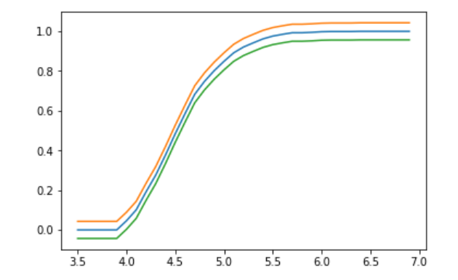

Blue line is estimated CDF and orange and green lines are 95 percent confidence envelope for *F*.

C.

Point estimated would be $\hat{F}\left(4.9\right)- \hat{F}\left(4.3\right)$

And standard error is $se= \sqrt{V\left(F\left(4.9\right)-F\left(4.3\right)\right)}=\sqrt{V\left(\hat{F}\left(4.9\right)\right)+ V\left(\hat{F}\left(4.9\right)\right)}$

The interval is $\hat{F}\left(4.9\right)- \hat{F}\left(4.3\right)±2*se$

95%

-0.584178140300015 , 1.636178140300015

93%

-0.5044730430477062 , 1.5564730430477063

Question 2

Estimated Lambda 1.006595871904141

97% confidence interval ( 0.9349665290299697 , 1.0782252147783125 )

the interval contains the param 0.975 % of times

Question 3

Estimated lambda 1.0212193328795964

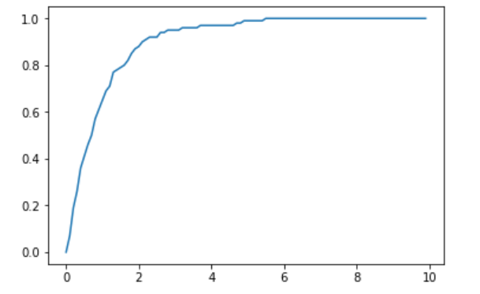

Empirical Distribution Function

Plugin Estimators

Mean: 0.989556249796454

Sigma: 1.0241083502783939

the other way (defined in course book): 1.029267618952513

skewness: 2.1584672388251156

Question 4

A and B

vboot 179.73283867041596

se 13.406447652917455

95% confidence interval( 103.36720117089159 , 155.92047597032803 )

C

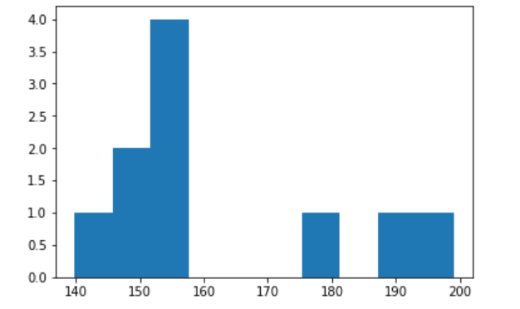

Histogram of Bootstrap Replications

And the True sampling distribution of $\hat{θ}$ is N(~148,se) which quite looks like the histogram

Question 5

A and B

Plot of Posterior

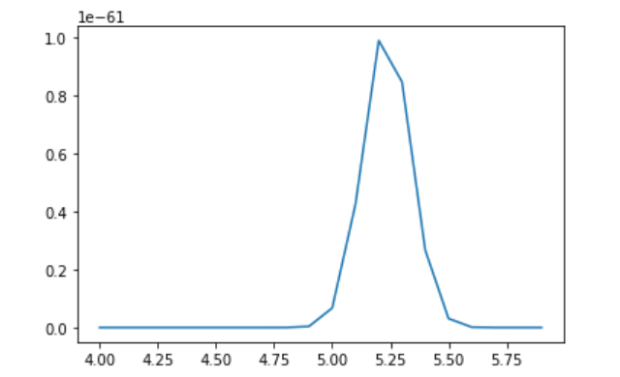

Plot of simualted posterior

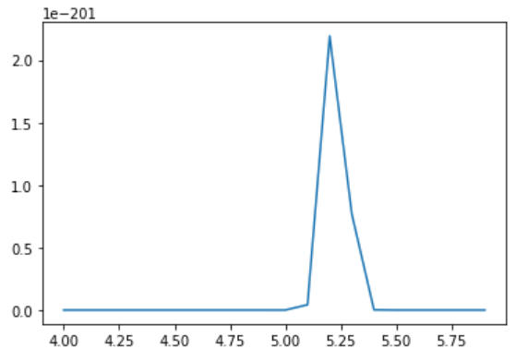

D

Analytically

$CDF\left(θ\right)= \int_{A}^{ }{f\left(μ | x^{n}\right) dμ},A=\{μ:e^{μ}≤ θ\}$

By simulation

Using the guide on page 212 of course book we have:

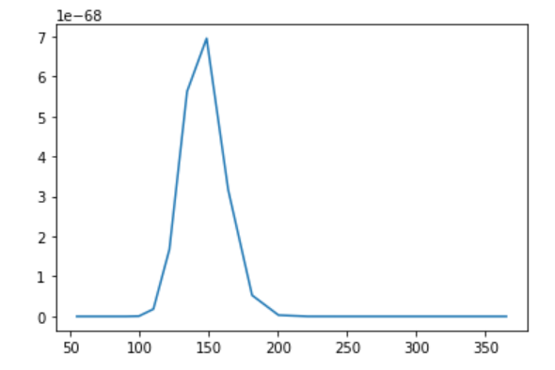

E

97% confidence interval ( -61.88483753233056 , 76.84934247091029 )

93% confidence interval ( -50.37453361005844 , 65.33903854863817 )

Question 6

In 0.0637 of times we reject the null, which is the error rate for type-1 error and is close to 0.05

Question 7

A

Delta 0.022175

97% confidence interval ( -0.013458074389523171 , 0.05780807438952317 )

P-Value 0.17686214169208325

Since both negative and positive values are in confidence interval, we can not judge to which author it belongs to.

B

Based on permutation test, P-value is 0.00062

So, the two distributions are the same.

Question 8

test accuracy 0.72

test confusion matrix

[[31. 14. 0.]

[ 9. 30. 3.]

[10. 6. 47.]]

train accuracy 0.78

train confusion matrix

[[33. 6. 1.]

[10. 38. 3.]

[ 7. 6. 46.]]

Question 9

theta_hat -0.07130609590256017

se: 0.10018298605515501

95% confidence interval ( -0.2716720680128702 , 0.12905987620774984 )