PROJECT REPORT
FaceLock for Windows

Facial Recognition-Based PC Security System

Author | Mahdi Dakhli / Roua Ben Jemaa
Supervisor | Makrem Baldi
Institution | TEK-UP University
Field | Cyber Security Engineering
Language | Python 3
Platform | Windows 10 / 11
GitHub | github.com/mahdidkh/facelock_for_windows
Date | 4 April 2026

Academic Year 2025 – 2026

Abstract
FaceLock for Windows is a Python 3 desktop security application that automatically locks and unlocks a Windows workstation using real-time facial recognition.
Built on a clean modular architecture, the system continuously captures webcam frames, detects and aligns faces, generates 128-dimensional biometric vectors using the SFace ONNX model, and compares them against identities stored in a secure SQLite database.
When the authorized user leaves the camera field of view for more than 3 seconds, the Windows session is immediately locked. Upon return, the system recognizes the user and automatically unlocks the session — providing seamless, frictionless protection.
This report presents the project's conception, technical architecture, module breakdown, implementation details with real test screenshots, security analysis, and a roadmap of recommended improvements.

Table of Contents
Abstract 2
Chapter 1 — Introduction and Context 3
1.1 Problem Statement 3
1.2 Project Objectives 3
1.3 Scope and Constraints 4
Chapter 2 — Analysis and Design 5
2.1 General Architecture 5
2.2 Data Flow 5
2.3 Data Model 6
2.4 Project Structure (VS Code) 6
Chapter 3 — Technical Implementation 7
3.1 Developed Modules 7
3.2 Technology Stack 10
Chapter 4 — Testing and Results 11
4.1 Application Launch 11
4.2 User Enrollment 11
4.3 Protection Mode — Status OK 12
4.4 Protection Mode — ABSENT Detection 12
4.5 SQLite Database 13
Chapter 5 — Security Analysis 14
5.1 Strengths 14
5.2 Limitations and Risks 14
5.3 Recommendations 15
Conclusion and Perspectives 16
Bibliography 17

Chapter 1 Introduction and Context

1.1 Problem Statement
Workstation security is an increasing concern in both professional and personal environments.
A session left unlocked for even a few seconds can expose sensitive data to unauthorized parties. Existing solutions
- manual lock
- inactivity timers
- Windows Hello
Suffer either from high user friction or limited hardware compatibility.
This project addresses the following question:
How can a Windows session be protected automatically and transparently for the legitimate user, without requiring manual action, while also unlocking the session upon their return without any effort?

1.2 Project Objectives
- Detect the authorized user's presence in real time via the webcam.
- Automatically lock the Windows session after absence exceeding 3 seconds.
- Recognize the returning user and automatically unlock the session.
- Provide a simple enrollment mechanism to register authorized faces.
- Store biometric data securely using a SQLite database with binary embeddings.

1.3 Scope and Constraints
The project targets Windows 10 and 11 systems exclusively.
It requires a functional webcam and a Python 3 environment with the required dependencies.
The solution is designed for single-machine use and does not support network synchronization or centralized identity management.
The primary technical constraint is real-time performance: detection and recognition must run fast enough to ensure a seamless user experience.

Chapter 2 Analysis and Design

2.1 General Architecture
The application follows an MVC-inspired pattern adapted to a video signal processing pipeline.
Each processing step is encapsulated in an independent Python module, promoting reusability, testability, and maintainability.

Module | File | Responsibility
CameraHandler | camera_handler.py | Video acquisition, brightness analysis
FaceDetector | face_detector.py | Face detection and geometric alignment
FaceEncoder | face_encoder.py | 128D embedding extraction via SFace ONNX
DatabaseManager | database.py | SQLite persistence of biometric vectors
FaceAuthenticator | face_authenticator.py | Authentication via cosine similarity
SystemController | system_controller.py | Native Windows lock/unlock control
FaceLockApp | main.py | Orchestrator: enrollment and protection modes

2.2 Data Flow
The protection loop pipeline runs on every webcam frame:
capture → face detection → alignment → encoding → cosine similarity authentication → decision (lock / unlock / keep awake).

Frame Capture (CameraHandler)
Face Detection & Alignment (FaceDetector)
Embedding Generation (FaceEncoder)
Cosine Similarity Authentication (FaceAuthenticator)
Decision: Lock / Unlock / Keep Awake

2.3 Data Model
The SQLite database contains one table «authorized_faces» storing the auto-incremented ID, unique username, biometric BLOB (NumPy .npy serialized), and enrollment timestamp.
Field | Type | Constraint | Description
id | INTEGER | PRIMARY KEY | Auto-increment
username | TEXT | UNIQUE NOT NULL | Username
embedding | BLOB | NOT NULL | 128D vector
created_at | TIMESTAMP | DEFAULT NOW | Enrollment date

2.4 Project Structure (VS Code)
The project contains 7 Python source files:
- the SFace ONNX model
- the SQLite database
- and the virtual environment
all visible in the VS Code file explorer:
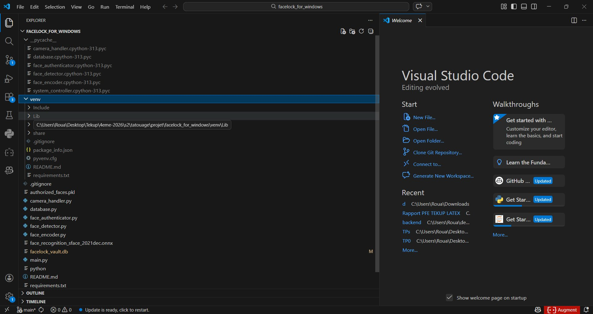
Figure 1 — Project file structure in VS Code

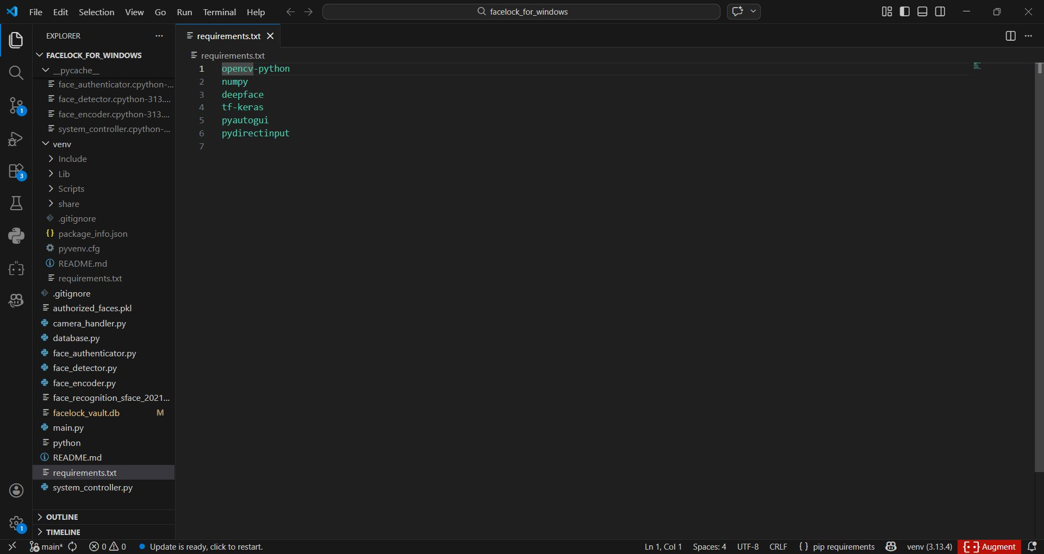
Figure 2 — requirements.txt listing all 6 dependencies

Chapter 3 Technical Implementation

3.1 Developed Modules

CameraHandler — camera_handler.py
Manages the webcam lifecycle via cv2.VideoCapture at 640×480. A horizontal mirror flip is applied to each frame.
Brightness is checked in the range 50–220 to reject overexposed or underlit frames before further processing.

FaceDetector — face_detector.py
Wraps DeepFace.extract_faces() using the 'opencv' backend for speed.
Only detections with confidence > 0.4 are accepted.
The align_face() method returns a 224×224 BGR image with eyes geometrically aligned, ready for the encoder.

FaceEncoder — face_encoder.py
Loads the SFace ONNX model via cv2.FaceRecognizerSF. Faces are resized to 112×112 before inference.
The output is a flattened, L2-normalized 128-dimensional vector guaranteeing stable cosine similarity computation.

DatabaseManager — database.py
Provides SQLite-backed storage using INSERT OR REPLACE to enforce username uniqueness.
NumPy float32 arrays are serialized losslessly to binary BLOBs via np.save() / io.BytesIO, replacing the less secure .pkl pickle approach.

FaceAuthenticator — face_authenticator.py
Loads all embeddings at startup and computes cosine similarity scores for each registered identity. The best match above threshold 0.40 is returned as the authenticated user.
refresh_identities() re-syncs after new enrollments.

SystemController — system_controller.py
Calls user32.LockWorkStation() directly via ctypes for native, instant locking.
Unlocking simulates the Windows lock screen interaction:
Enter → type password via pyautogui.write() → Enter.
SetThreadExecutionState prevents sleep while the user is present.

FaceLockApp — main.py
Orchestrates two modes: Enrollment (capture face on 's', register in DB) and Protection (continuous surveillance loop collecting the Windows password once via getpass at startup).

3.2 Technology Stack
Library | Version | Role
opencv-python | 4.x | Video capture, image processing, SFace ONNX inference
numpy | 1.x | Vector computation, embedding serialization
deepface | 0.0.9x | Face detection and alignment (opencv/ssd backend)
tf-keras | latest | Backend dependency for DeepFace
pyautogui | 0.9.x | Keyboard simulation for password entry on unlock
pydirectinput | 1.0.x | Low-level Windows input complement
sqlite3 | stdlib | Local persistent database (Python standard library)

Chapter 4 Testing and Results
The following screenshots were captured during real execution of the application on a Windows 11 machine, demonstrating each key step of the workflow.

4.1 Application Launch
Running python main.py displays the main console menu with the three available options.
The user selects option 1 to enroll or option 2 to activate protection.
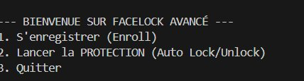
Figure 3 — Main console menu on launch

4.2 User Enrollment
In enrollment mode, the webcam opens and a green bounding rectangle appears around the detected face.
The user presses 's' to capture, then types a username. The embedding is computed and saved to the SQLite database.
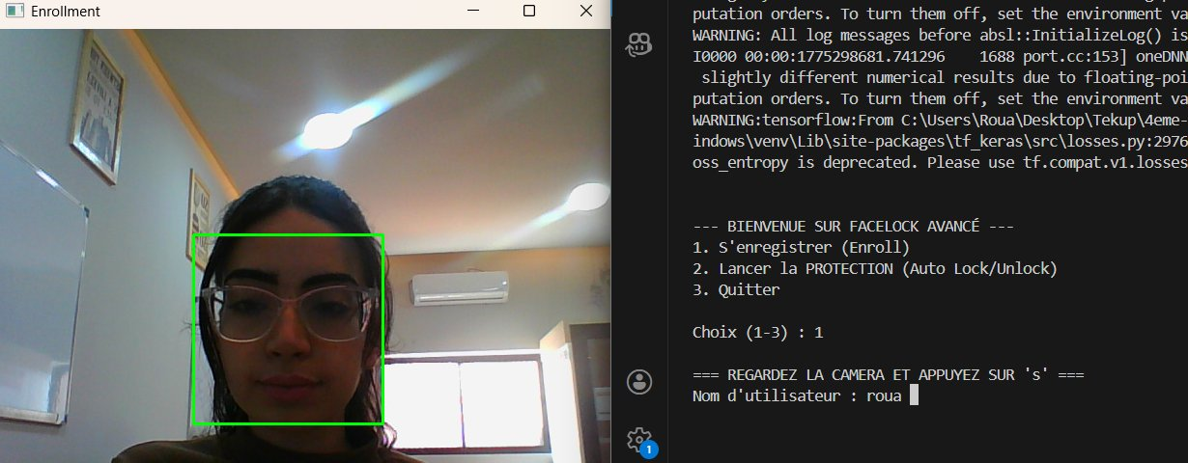
Figure 4 — Enrollment mode: face detected with green bounding box, username entry in console
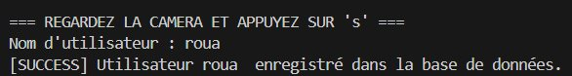
Figure 5 — Enrollment success confirmation: user 'roua' registered in the database

4.3 Protection Mode — Status OK
Once protection mode is activated (option 2), the system asks for the Windows password once, then opens the FaceLock Active window.
When the authorized face is recognized, the status banner displays 'Statut: OK' in green.

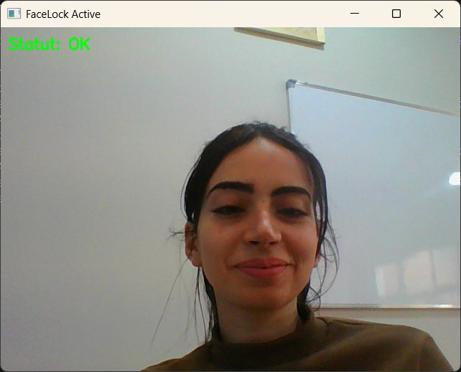
Figure 6 — FaceLock Active: authorized user recognized, Status OK (green)
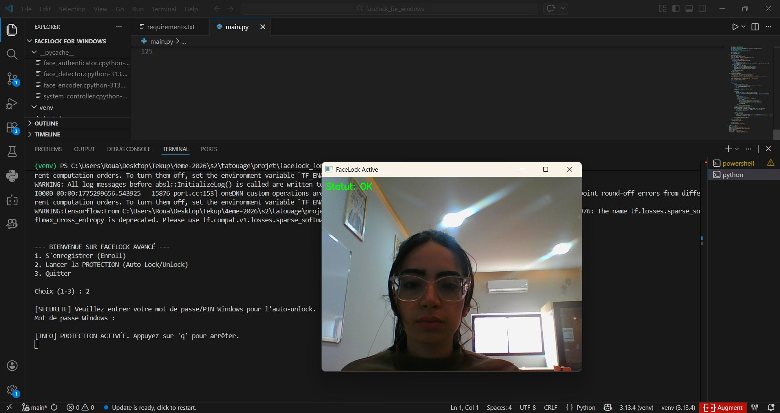
Figure 7 — Full view: FaceLock Active window alongside VS Code terminal showing protection activated

4.4 Protection Mode — ABSENT Detection
When the authorized face disappears from the camera for more than the grace period (3 seconds), the status changes to 'ABSENT' in red, displaying the elapsed time.
After the grace period, the Windows session is locked automatically.
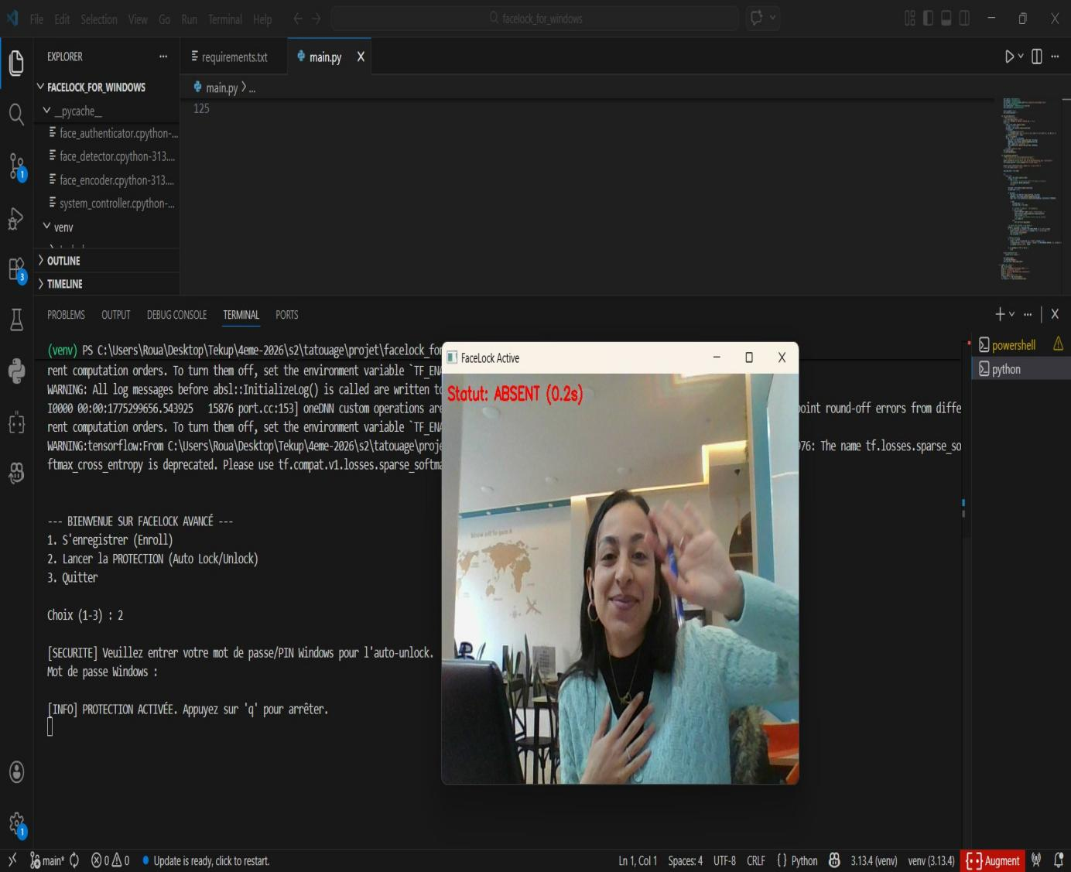
Figure 8 — ABSENT status (0.2s): countdown before automatic Windows lock

4.5 SQLite Database
The facelock_vault.db database was inspected with DB Browser for SQLite, confirming the table structure and the stored biometric embeddings as binary BLOBs.
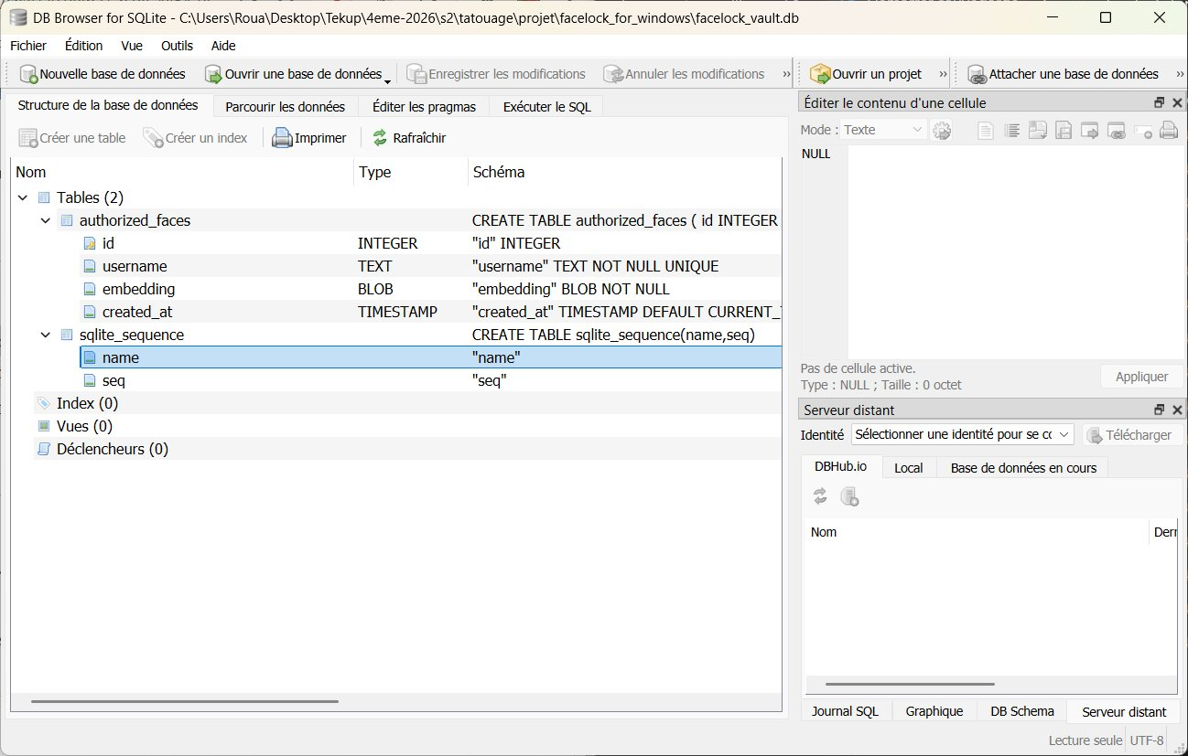
Figure 9 — DB Browser: authorized_faces table schema (id, username, embedding BLOB, created_at)
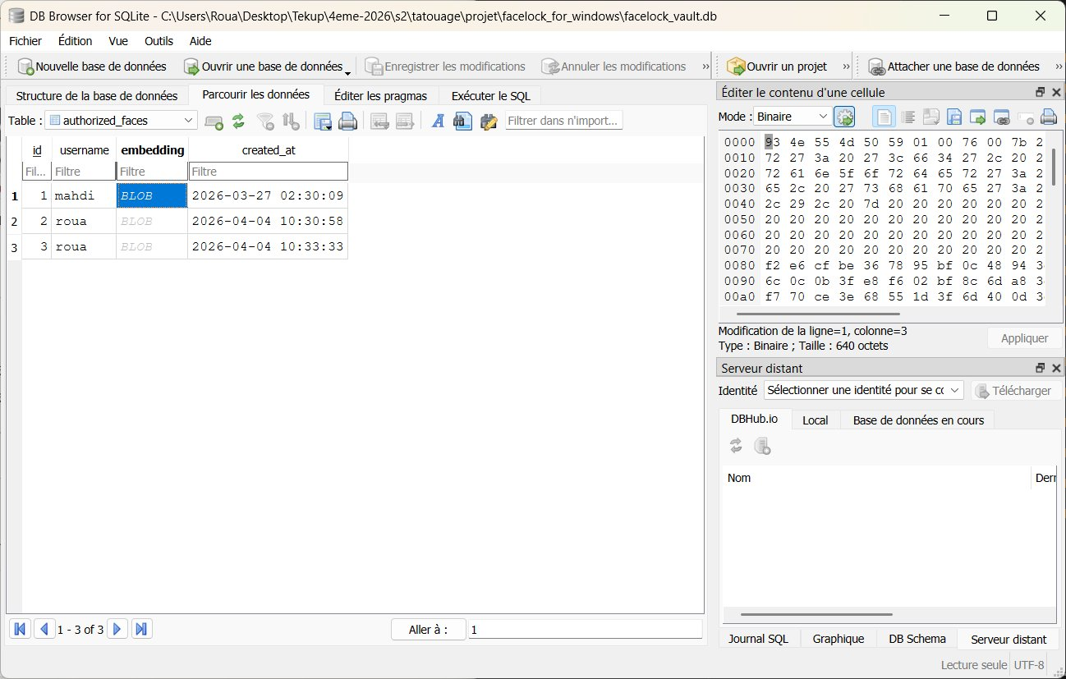
Figure 10 — DB Browser: table data showing 3 enrolled users (mahdi, roua×2) with binary BLOB embeddings

Chapter 5 Security Analysis and Recommendations

5.1 Strengths
- Biometric embeddings stored as binary SQLite BLOBs : inaccessible without explicit decoding.
- Windows password collected via getpass (no echo) and held only in RAM: never written to disk.
- SFace model produces robust 128D representations : more resistant to lighting and angle variations than Haar/HOG classifiers.
- Migration from .pkl files to SQLite eliminates arbitrary deserialization attack surface.
- Modular architecture allows easy component replacement (e.g., swap SFace for a newer model).

5.2 Limitations and Risks
- Unlock via keyboard simulation (pyautogui) exposes the password to any active keylogger on the session.
- No liveness detection: a printed photo or video replay could potentially bypass the face detector.
- The similarity threshold (0.40) is not adaptive requires manual tuning per webcam quality.
- The ONNX model (37 MB) is committed to Git, significantly increasing repository clone size.
- Windows-exclusive: ctypes.windll.user32 calls will fail on Linux or macOS.

5.3 Recommendations
- Implement liveness detection (blink detection, depth map) to counter photo/video spoofing attacks.
- Replace keyboard simulation with Windows Credential Manager API or token-based authentication.
- Externalize ONNX model download to first launch to keep the repository lightweight.
- Add automated test suite (pytest) with mock embeddings for DatabaseManager and FaceAuthenticator.
- Build a graphical UI (PyQt5 or Tkinter) to replace the console menu for better UX.
- Introduce a config file (config.yaml) to externalize THRESHOLD, GRACE_PERIOD, and camera index.

Conclusion and Perspectives
FaceLock for Windows is a well-rounded project that successfully demonstrates biometric workstation security using only a standard webcam and Python.
The screenshots captured during real testing confirm all core functionalities work as intended: face enrollment with a bounding-box UI, real-time status feedback (OK / ABSENT), automatic session locking, and secure SQLite storage of biometric vectors as binary BLOBs.
The modular architecture ensures clean separation of concerns , each of the six modules handles one responsibility, making the codebase maintainable and extensible.
The migration from .pkl to SQLite and the use of the SFace ONNX model are sound engineering decisions that strengthen both security and accuracy.
The main areas requiring improvement are the unlock mechanism (keylogger exposure via pyautogui), the absence of liveness detection (spoofing risk), and the lack of an automated test suite.
Addressing these three points would bring the project to a production-ready level, competitive with existing commercial solutions.
Future perspectives include multi-factor authentication (face + PIN), a graphical dashboard for activity logs, and an enterprise deployment mode with centralized identity management.

Bibliography
[1] Serengil, S. I., & Ozpinar, A. (2020). LightFace: A Hybrid Deep Face Recognition Framework. ASYU 2020. — DeepFace library.
[2] Yu, Y., et al. (2022). SFace: Sigmoid-Constrained Hypersphere Loss for Face Recognition. IEEE Transactions on Image Processing.
[3] OpenCV Model Zoo — Face Recognition SFace. https://github.com/opencv/opencv_zoo
[4] Python Software Foundation — sqlite3 module. https://docs.python.org/3/library/sqlite3.html
[5] Microsoft Docs — LockWorkStation (WinAPI). https://learn.microsoft.com/windows/win32/api/winuser/nf-winuser-lockworkstation
[6] PyAutoGUI Documentation. https://pyautogui.readthedocs.io
[7] Dakhli, M. — GitHub Repository: facelock_for_windows. https://github.com/mahdidkh/facelock_for_windows

