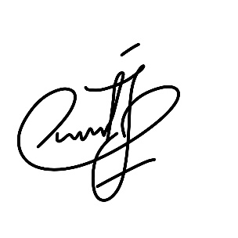**Declaration of interests**  
   
☒ The authors declare that they have no known competing financial interests or personal relationships that could have appeared to influence the work reported in this paper.  
   
☐ The authors declare the following financial interests/personal relationships which may be considered as potential competing interests:

   
   
 