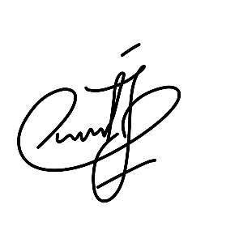Author Agreement Statement  
We the undersigned declare that this manuscript is original, has not been published before and is  
not currently being considered for publication elsewhere.  
We confirm that the manuscript has been read and approved by all named authors and that there  
are no other persons who satisfied the criteria for authorship but are not listed. We further  
confirm that the order of authors listed in the manuscript has been approved by all of us.  
We understand that the Corresponding Author is the sole contact for the Editorial process.  
He/she is responsible for communicating with the other authors about progress, submissions of  
revisions and final approval of proofs  
Signed by all authors as follows: