**Classification of brain tumors using MRI images based on pre-trained models**

**ABSTRACT**

Brain tumors can have fatal consequences and are often diagnosed as malignant and are a significant threat if not diagnosed quickly. In general, it is very important to diagnose tumors in the early stages to start treatment. It is very important to diagnose and classify the affected areas using MRI. We urgently need a reliable solution to ensure correct diagnosis.

There are different tumors such as glioma, meningioma, pituitary and benign tumors.

In this article, we examine and compare the CNN method and four pre-trained Mbilenet inception Densnet models.

**.1INTRODUCTION**

Cancer ranks among the primary factors contributing to global mortality, posing a substantial obstacle to enhancing life expectancy. Brain tumors develop due to the proliferation of irregular cells within the brain, resulting in harm to crucial brain tissues and potentially leading to cancerous growth [1]. Human brain tumors encompass approximately 150 diverse types, classified into (i) noncancerous tumors and (ii) cancerous tumors [2]. According to relevant literature [3], brain tumors are typically classified into two stages: primary and secondary. In the primary stage, tumors are characterized by small sizes and are termed benign in biological parlance. Conversely, in the secondary stage, tumors originate from other body parts, are larger than benign tumors, and are referred to as malignant [4] While benign tumors progress slowly and remain localized, malignant tumors grow rapidly and have invasive properties [5]. Among malignant tumors, gliomas, meningiomas, and pituitary tumors are the most prevalent types [6]. Gliomas stem from glial cells in the brain, whereas meningioma tumors typically arise from the protective membrane covering the brain and spinal cord [7]. Pituitary brain tumors, which develop in the pituitary glands—a crucial layer of the brain responsible for producing essential hormones—are generally benign. Various techniques are employed in clinical settings for brain tumor treatment [8]. In the benign stage, radiotherapy is often effective, and patients may avoid surgery while still achieving survival [9]. Conversely, the cancerous stage poses significant risks and typically requires a combination of chemotherapy and radiotherapy for treatment [10]. Consequently, benign tumors tend to spread more slowly than malignant ones. Nevertheless, prompt and accurate diagnosis is paramount, necessitating the expertise of radiologists [11].

1.Each of the four pre-trained deep learning models—, Dense Net, Mobile Net, and Inception was fine-tuned using a deep transfer learning approach. Training was performed on imbalanced data while incorporating data augmentation techniques. From the trained models, features were extracted from the global average pooling layer, capturing comprehensive information for each tumor type. This methodology aims to deliver dependable and accurate tumor classification, assisting radiologists in forming precise diagnostic opinions.

2.All four models underwent training, validation, evaluation, and comparison using both Adam and Adamax optimization techniques. Static and dynamic learning rate methods were applied during the training of each pretrained model. Both learning rate techniques were tested with both optimizers utilized in this study, and the outcomes were juxtaposed for analysis.

3.The performances of the four pretrained models were compared across four stages to determine the model with superior performance. The results show that the proposed model outperforms certain previous methodologies, achieving higher accuracy levels on benchmark datasets.

**.2RELATED WORKS**

Early identification of the type of brain tumor and rapid initiation of treatment is necessary for intervention. Automation of classification with computerized systems reduces the workload of specialist doctors.

Recent research has introduced numerous machine learning-based methods for brain tumor classification (BTC), aiming to assist radiologists in conducting more precise diagnostic evaluations . Machine learning and deep learning are the primary techniques employed for this purpose [12]. Within machine learning, various approaches such as k-nearest neighbor (KNN), support vector machines (SVM), decision trees, and genetic algorithms have been utilized in different studies [13]. While many techniques in the literature focus on binary class classification, distinguishing between benign and malignant tumors, this task is relatively straightforward due to the clear interpretation of tumor shape and texture [14]. In contrast, multiclass classification poses greater difficulty due to the high similarity among different tumor types.

In their research, introduced an automated method for brain tumor detection using magnetic resonance imaging (MRI). Initially, brain MRI images undergo preprocessing to enhance their visual quality. Subsequently, two distinct pre-trained deep learning models are employed to extract robust features from the images. These resulting feature vectors are then amalgamated to create a hybrid feature vector utilizing the partial least squares (PLS) technique. Next, the primary tumor locations are identified via agglomerative clustering. Finally, these proposals are standardized to a predetermined size and forwarded to the head network for classification. Compared to existing methodologies, the proposed approach achieved an impressive classification accuracy of 98.95%.

The findings of [15] proposed a deep learning model for brain tumor detection in MRI images, aiming for increased accuracy. Their approach involves combining a Convolutional Neural Network (CNN) with a Long Short-Term Memory (LSTM). LSTMs enhance CNN’s feature extraction capabilities, particularly beneficial for image classification tasks. The proposed LSTM-CNN model outperformed standard CNN classification methods, achieving the highest accuracy of 92%.

The research of [16] introduced a method called Border Collie Firefly Algorithm-based Generative Adversarial Network (BCFA-based GAN) using the Spark framework to classify the severity level of brain tumors effectively. Their approach involves employing a set of slave nodes and a master node for severity classification. Pre-processing is conducted using a Laplacian filter to remove noise from the images. Feature extraction occurs on the slave nodes, and the extracted features are then inputted into a Support Vector Machine (SVM) for tumor classification on the master node. Finally, the results are fed into the BCFA- based GAN for severity level classification. The proposed BCFA-based GAN demonstrated superior performance, achieving high accuracy (97.515%), sensitivity (97.515%), and specificity (97.515%).

The study of [17] introduced a multi-grade brain tumor classification system based on a Convolutional Neural Network (CNN) model. Initially, deep learning techniques are utilized to segment tumor regions from MR images. Subsequently, extensive data augmentation is implemented to enhance the training of the system, addressing the challenge of limited data availability when dealing with MRI for multi-grade brain tumor classification. Finally, a pre-trained CNN model is fine-tuned using augmented data for classifying brain tumor grades. The proposed system undergoes experimental evaluation on both augmented and original data, demonstrating convincing performance compared to existing methods with an accuracy of 94.58%.

Reference [18] introduced a novel automated deep learning approach for multiclass brain tumor classification. The method involves fine-tuning the Densenet 201 Pre-Trained Deep Learning Model and training it using a deep transfer learning approach with imbalanced data. Two feature selection techniques are proposed: Entropy–Kurtosis-based High Feature Values (EKb HFV) and a Modified Genetic Algorithm (MGA) based on metaheuristics. The features selected by the genetic algorithm are further refined using a new threshold function proposed in the study. Subsequently, the features obtained from both EKbHFV and MGA approaches are combined using a non-redundant serial-based fusion method and classified using a multi class SVM cubic classifier. Experimental evaluations conducted on two datasets, BRATS 2018 and BRATS 2019, achieved an accuracy exceeding 95% without data augmentation.

Reference devised an efficient automated method for brain tumor classification to aid radiologists, reducing the time required for precise diagnosis. Their approach utilized 3064 T1-weighted contrast- enhanced brain MR images (T1W-CE MRI) from 233 patients. They employed five fine-tuned pre-trained models, including Google Net, Alex Net, Shuffle Net, Squeeze Net, and NAS Net-Mobile, to evaluate their performance in classifying various brain tumor categories. The proposed CNN models incorporated layers from pre-trained networks, with the last three layers replaced to accommodate the new image classes (meningioma, pituitary, and glioma). However, in the pretrained Squeeze Net, the 1-by-1 convolutional layer was substituted instead of the last learnable 1-by-1 convolutional learnable layer, maintaining the same number of filters as the number of classes. Finally, a majority voting technique was employed to combine the outputs of the five models, treating them as a decision-making committee. The proposed system exhibited significant improvement, achieving an overall accuracy of 99.31%.

The work of [19] introduced a precise and optimized system for brain tumor detection. The system encompasses preprocessing, segmentation, feature extraction, optimization, and detection stages. Preprocessing involves the utilization of a compound filter composed of Gaussian, mean, and median filters. Image segmentation is performed using threshold and histogram techniques. Feature extraction employs the Grey Level Co-occurrence Matrix (GLCM). Optimal feature selection is achieved through the application of whale optimization and grey wolf optimization methods. Brain tumor detection is accomplished using a CNN classifier, resulting in an accuracy of 98.9%.

The study of [20] proposed an MRI-based brain tumor detection approach using convolutional deep learning methods and selected machine learning techniques to enhance performance. Initially, preprocessing and augmentation algorithms were employed on MRI brain images. Subsequently, they introduced a new 2D Convolutional Neural Network (CNN) and a convolutional auto-encoder network, both pre-trained with their respective hyperparameters. The network architecture comprised eight convolutional and four pooling layers, with batch-normalization layers applied after all convolutional layers. The modified auto-encoder network consisted of a convolutional auto-encoder network followed by a convolutional network for classification, utilizing the last output encoder layer of the initial part. Additionally, six machine learning techniques were utilized for brain tumor classification, and their results were compared.

The research of developed a brain tumor diagnosis system based on deep learning, employing a CNN architecture known as Efficient Netv 2S. They enhanced this architecture with Ranger optimization and comprehensive preprocessing techniques. The system comprises four stages: (1) Pre-processing, (2) Data generation, (3) CNN framework or deep feature extraction for tumor detection, and (4) Diagnosis. Upon evaluating the model’s performance using the test dataset, it achieved an accuracy exceeding 98%.

**.3METHODS**

The Brain Tumor MRI image Dataset, available on Kaggle, was utilized for both training and evaluating the model in this study. This dataset consists of 2,611 images distributed among four classes: glioma tumors (741 images), no tumor (400 images), meningioma tumors (749 images), and pituitary tumors (721 images).

Each image was resized to 224 by 224 pixels to ensure compatibility with the proposed model. The dataset was divided into an 80:20 ratio for training and testing. Table 1 presents statistics for the images used in this study, and Figure 1 displays samples from the brain tumor images.

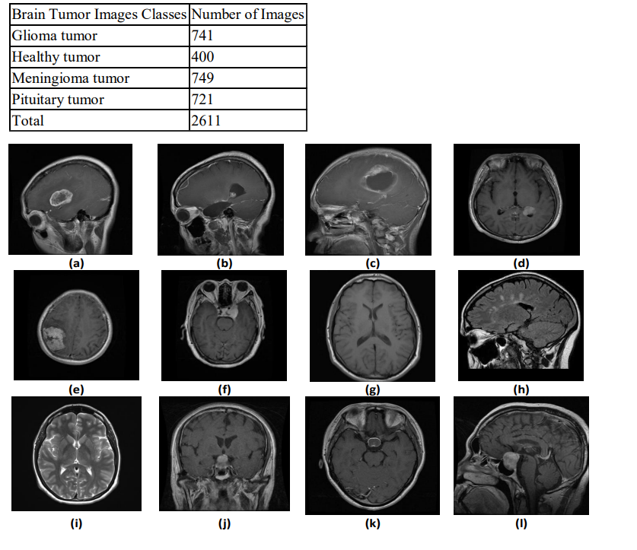**Table I**. Summary of the Brain Tumor Images Used in this Study

Figure 1. Sample images from brain tumor. Glioma tumor (a, b and c), Healthy tumor (d, e and f),

Meningioma tumor (g, h, and i), Pituitary tumor (j, k, and l

.**3-1**Pre-trained models are known as transfer learning (TL). These models work in such a way that they can be used to solve a different but related task using a transfer learning technique. These pretrained models serve as initial points for further fine-tuning on smaller datasets or as feature extractors in transfer learning. Transfer learning utilizes features already learned to address one problem as a starting point for solving other problems, leveraging previously acquired knowledge to learn new data.

transfer learning can be explained as:

1)Mobile Net: The Mobile Net model is specifically designed for mobile and embedded vision applications due to its lightweight deep neural network architecture. It employs depth-wise separable convolutions to construct compact networks, resulting in fewer parameters compared to standard convolutions. This architecture reduces computational costs and complexity, making it highly efficient for vision-related tasks with rapid processing [20].

2) Densenet-121: Dense Net-121 is a pretrained CNN model comprising 121layers, belonging to the Dense Net family of architectures. Reference [20] introduced this model, characterized by a unique connectivity pattern where each layer is connected to every other layer in a feed-forward manner. This connectivity facilitates feature reuse, promotes efficient information flow, and mitigates issues such as the vanishing- gradient problem. Dense Net architectures are renowned for their exceptional performance and efficiency, particularly in tasks such as image classification and object detection.

3) Inception: Inception itself is a module that uses filters with different dimensions in different ways, in such a way that it applies several filters with different dimensions to the input and puts the output next to each other. In general, each module contains several convolutional and parallel pooling operations. Inception includes several models: Inceotionv1, Inceptionv2, Inceotionv3,..

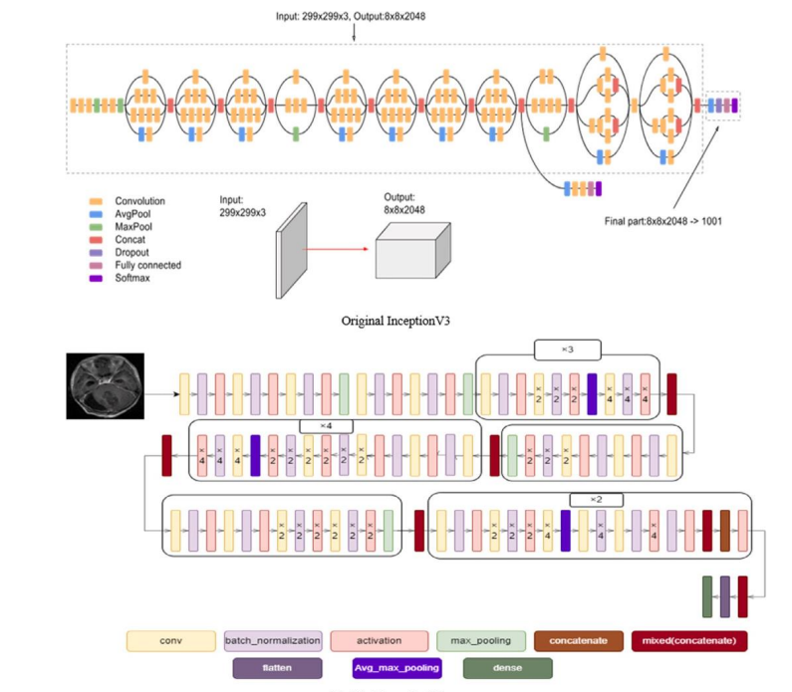

Figure 2. Inception architecture.

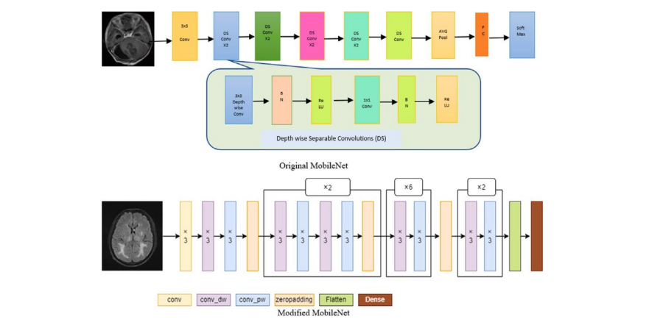

Figure 3 MobileNet & TL MobileNet architecture

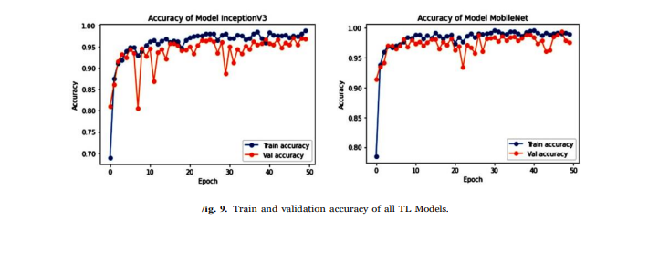

Figure 4. Train and validation accuracy of two TL Models

**Other Evaluations**

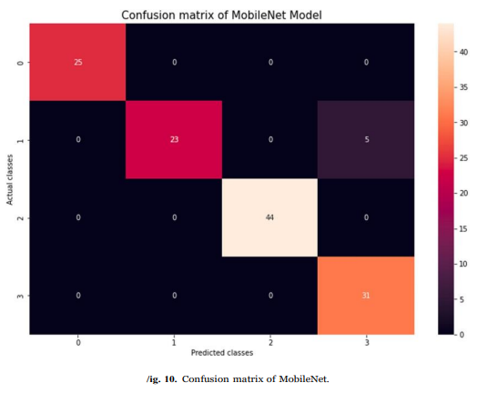 To further evaluate model performance, only the Inception and Mobile Net models were considered, as shown in Figure **5,** where their confusion matrices were analyzed to determine the number of correct and incorrect predictions. Additionally, to visualize the models’ performance throughout training, Figures **4** illustrates the training.

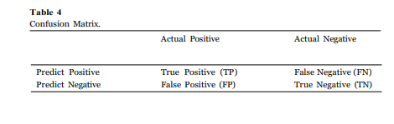

**Table 2**

Figure 5.Confusion matrix of MobileNet.

.**3-2**But a new framework for brain tumor classification using MRI is the use of multiple models with different transfer learning architectures and fine-tuning on three tumor datasets that are trained.

Convolutional neural networks (CNNs), a sub-branch of deep learning, have an architecture that can perform end-to-end learning. As we increase the depth and width dimensions in CNN architectures, we encounter overfitting and gradient vanishing problems in datasets with limited labeled data. The gradient vanishing problem is usually solved with residual connections. Complex models with more learning parameters than the amount of data show high performance in the training phase due to overfitting; however, they perform poorly on test data they have not seen before [21]. To avoid overfitting in these models, we usually use regularization techniques such as L2 regularization, dropout, batch normalization, and data augmentation [21-23]. In cases where these techniques are insufficient, ensemble learning techniques can be used, combining different features from the dataset using multiple models. The ensemble learning technique can solve the overfitting problem by combining features of different models with different properties from the available dataset. However, the issue of which models to combine and what weight to use still needs to be solved.

**3-2-1 .Dataset**

This study leveraged three datasets for its research purposes. To begin with, dataset 1 [24] is a publicly accessible Figshare brain tumor dataset containing a total of 3064 brain MRIs. This dataset has three distinct classes: glioma, meningioma, and pituitary tumors. Specifically, this dataset comprises 1426 glioma images, 708 meningioma images, and 930 pituitary tumor images. Moving to dataset 2, it is composed of four classes: glioma (926 images), meningioma (937 images), pituitary tumors (901 images), and a category denoting the absence of tumors (500 images). Finally, dataset 3 [25] is also an open-source brain tumor dataset that merges data from three sources: Figshare, SARTAJ [26], and Br35H, resulting in a total of 7023 brain MRIs. This dataset represents four categories: healthy brain images, meningioma, pituitary, and glioma tumors. Concretely, there are 2000 images of healthy individuals, 1621 glioma images, 1645 meningioma images, and 1757 of pituitary tumors. Figure 1 shows example MR images from the datasets. Diagnostics 2024, 14, x FOR PEER REVIEW 7 of 24 healthy brain images, meningioma, pituitary, and glioma tumors. Concretely, there are 2000 images of healthy individuals, 1621 glioma images, 1645 meningioma images, and 1757 of pituitary tumors. Figure 1 shows example MR images from the datasets.

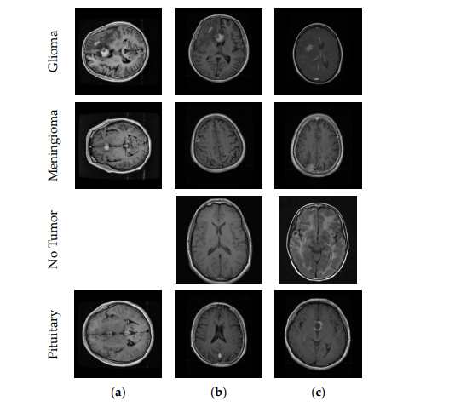

Figure 6. Sample MR images from the datasets. (a) Dataset 1; (b) Dataset 2; (c) Dataset 3.

We divided the datasets into train, validation, and test. First, we split the datasets into 80% train and 20% test. Then, we split 10% of the training datasets into validation. Figure 2 shows example MR images of brain tumor types and the process of the image segmentation algorithm.

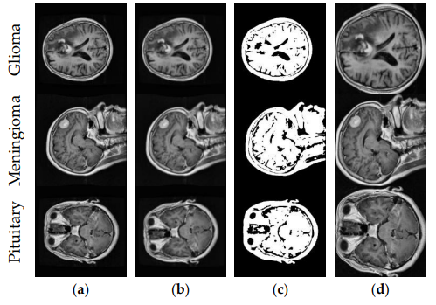

Figure 7. Brain tumor types and the process of the image segmentation algorithm. (a) Original image; (b) Gaussian blur with a 9 × 9 kernel; (c) binary image-otsu thresholding; (d)

The MRI images were first preprocessed. In Figure 2, a noise outside the brain region was removed. For CNN architectures to focus only on the brain region, we first applied Gaussian blur with the 9 × 9 kernel and then applied Otsu thresholding to extract the binary image. The brain region’s contours were detected in the binary image, and brain region segmentation was performed based on the extreme points of the largest contour in all directions. Thus, CNN architectures will only operate within the brain region in real-time applications.

**3-2-2. Proposed Framework**

Several CNN models with different architectures were retrained on the brain tumor dataset with transfer learning and fine-tuning (see Figure 3). In these models, various hyperparameters were optimized with grid search to determine the most successful models. Table 2 summarizes the optimized hyperparameters and their values. CNN models are constructed by preserving the previous parameter values until the last convolution layer. After the final convolution layer, global average pooling and flattening layers were analyzed separately. The last layer was added with three or four neurons using the Softmax activation function. CNN models were retrained for 50 epochs. The study employed a batch size of 16. During the training phase, all layers of the models in the study were retrained. Three datasets were used in this study. The five best-performing models on each dataset were identified, and their performance on the test dataset was found using ensemble learning. The PSO-based algorithm determined the weights of the five models for ensemble learning.

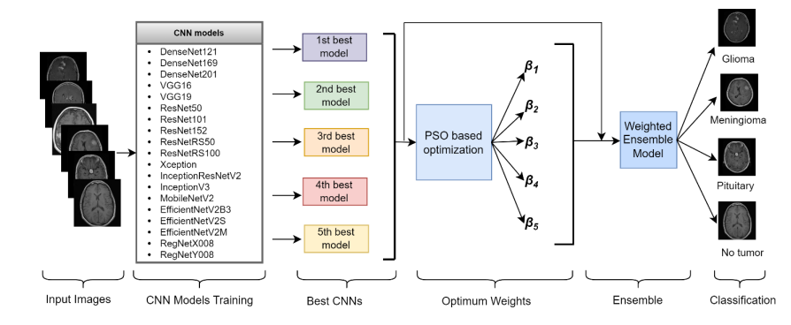

Figure 8. General structure of the proposed framework

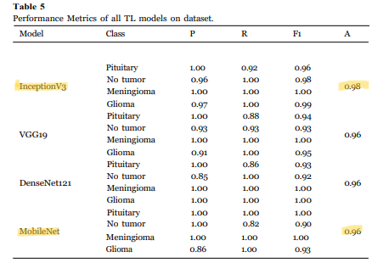**4. Results**

**Table 3** describes the performance metrics of every model. Various numbers of scores are set into the test dataset for separated experimental models. Among the models, InceptionV3 outperforms the accuracy. We took 50 epochs for InceptionV3, VGG19, DenseNet121, and MobileNet of the training set.

InceptionV3 beats all other models in using the terms of performance parameters by achieving an accuracy of 98% as well as MobileNet outperforms 99.60% in the case of experimenting on epochs experiments.

**Table 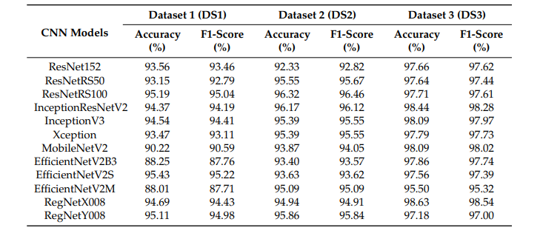4**

Detecting brain tumor types in MRI images using computer-aided systems and promptly initiating the appropriate treatment process is paramount. Although CNN models are widely used in disease detection from medical images, they often face the problem of overfitting when training on limited labeled data and data with high inter-class similarity. By employing diverse CNN models with varying architectures and utilizing transfer learning and the ensemble method, we enhance the breadth of feature extraction within the dataset, effectively addressing the overfitting issue. With the framework we developed in this study, we train the CNN models with different architectures on a dataset and determine the best-performing models. Combining these models with a PSO-based algorithm and ensemble method with optimum weights, we detected brain tumor types with high accuracy. We trained the framework on three brain tumor datasets, identified the best CNN models for each dataset, and determined their optimal weights. We obtained 99.92% accuracy and a 99.92% F1-score on the test data of the Dataset 3. The proposed model outperformed the existing studies. We achieved successful performances with our proposed framework on all three brain tumor datasets, which shows that the proposed framework is consistent in brain tumor classification. It contributes to the automatic detection of brain tumor types and doctors’ decision-making processes.

**References**

1. Aurna, N.F.; Yousuf, M.A.; Taher, K.A.; Azad, A.K.M.; Moni, M.A. A classification of MRI brain tumor based on two stage feature

level ensemble of deep CNN models. Comput. Biol. Med. 2022, 146, 105539. [CrossRef] [PubMed]

2. Mehnatkesh, H.; Jalali, S.M.J.; Khosravi, A.; Nahavandi, S. An intelligent driven deep residual learning framework for brain

tumor classification using MRI images. Expert Syst. Appl. 2023, 213, 119087. [CrossRef]

3. Gupta, R.K.; Bharti, S.; Kunhare, N.; Sahu, Y.; Pathik, N. Brain tumor detection and classification using cycle generative adversarial

networks. Interdiscip. Sci. Comput. Life Sci. 2022, 14, 485–502. [CrossRef] [PubMed]

4. Nayak, D.R.; Padhy, N.; Mallick, P.K.; Bagal, D.K.; Kumar, S. Brain tumor classification using noble deep learning approach with

parametric optimization through metaheuristics approaches. Computers 2022, 11, 10. [CrossRef]

5. Kaya, M.; Çetin-Kaya, Y. Seamless computation offloading for mobile applications using an online learning algorithm. Computing

2021, 103, 771–799. [CrossRef]

6. Nguyen, T.D.; Le, D.-T.; Bum, J.; Kim, S.; Song, S.J.; Choo, H. Retinal disease diagnosis using deep learning on ultra-wide-field

fundus images. Diagnostics 2024, 14, 105. [CrossRef] [PubMed]

7. Kaya, M. Feature fusion-based ensemble CNN learning optimization for automated detection of pediatric pneumonia. Biomed.

Signal Process. Control 2024, 87, 105472. [CrossRef]

8. Noor, M.B.T.; Zenia, N.Z.; Kaiser, M.S.; Mamun, S.A.; Mahmud, M. Application of deep learning in detecting neurological disorders from magnetic resonance images: A survey on the detection of Alzheimer’s disease, Parkinson’s disease and schizophrenia.

Brain Inform. 2020, 7, 11. [CrossRef]

9. Litjens, G.; Kooi, T.; Bejnordi, B.E.; Setio, A.A.A.; Ciompi, F.; Ghafoorian, M.; van der Laak, J.A.W.M.; van Ginneken, B.;

Sánchez, C.I. A survey on deep learning in medical image analysis. Med. Image Anal. 2017, 42, 60–88. [CrossRef]

10. He, K.; Zhang, X.; Ren, S.; Sun, J. Deep residual learning for image recognition. In Proceedings of the IEEE Conference on

Computer Vision and Pattern Recognition, Las Vegas, NV, USA, 26 June–1 July 2016; pp. 770–778. [CrossRef]

11. Zhang, C.; Bengio, S.; Hardt, M.; Recht, B.; Vinyals, O. Understanding deep learning (still) requires rethinking generalization.

Commun. ACM 2021, 64, 107–115. [CrossRef]

12. Krizhevsky, A.; Sutskever, I.; Hinton, G.E. Imagenet classification with deep convolutional neural networks. Commun. ACM 2017,

60, 84–90. [CrossRef]

13. Lecun, Y.; Bottou, L.; Bengio, Y.; Haffner, P. Gradient-based learning applied to document recognition. Proc. IEEE 1998,

86, 2278–2324. [CrossRef]

14. Ioffe, S.; Szegedy, C. Batch normalization: Accelerating deep network training by reducing internal covariate shift. In Proceedings

of the International Conference on Machine Learning, Lille, France, 6–11 July 2015; pp. 448–456.

15. Kumar, A.; Kim, J.; Lyndon, D.; Fulham, M.; Feng, D. An ensemble of fine-tuned convolutional neural networks for medical

image classification. IEEE J. Biomed. Health Inform. 2016, 21, 31–40. [CrossRef] [PubMed]

16. Kennedy, J.; Eberhart, R. Particle swarm optimization. In Proceedings of the ICNN’95-International Conference on Neural

Networks, Perth, Australia, 27 November–1 December 1995; pp. 1942–1948.

17. Mahmud, M.; Kaiser, M.S.; McGinnity, T.M.; Hussain, A. Deep learning in mining biological data. Cogn. Comput. 2021, 13, 1–33.

[CrossRef] [PubMed]

18. Mahmud, M.; Kaiser, M.S.; Hussain, A.; Vassanelli, S. Applications of deep learning and reinforcement learning to biological data.

IEEE Trans. Neural Netw. Learn. Syst. 2018, 29, 2063–2079. [CrossRef] [PubMed]

19. Ayadi, W.; Elhamzi, W.; Charfi, I.; Atri, M. Deep CNN for brain tumor classification. Neural Process. Lett. 2021, 53, 671–700.

[CrossRef]

20. Raza, A.; Ayub, H.; Khan, J.A.; Ahmad, I.; Salama, A.S.; Daradkeh, Y.I.; Javeed, D.; Ur Rehman, A.; Hamam, H. A hybrid deep

learning-based approach for brain tumor classification. Electronics 2022, 11, 1146. [CrossRef]

21. Khan, M.S.I.; Rahman, A.; Debnath, T.; Karim, M.R.; Nasir, M.K.; Band, S.S.; Mosavi, A.; Dehzangi, I. Accurate brain tumor

detection using deep convolutional neural network. Comput. Struct. Biotechnol. J. 2022, 20, 4733–4745. [CrossRef]

22. Rahman, T.; Islam, M.S. MRI brain tumor detection and classification using parallel deep convolutional neural networks. Meas.

Sens. 2023, 26, 100694. [CrossRef]

23. Asif, S.; Zhao, M.; Tang, F.; Zhu, Y. An enhanced deep learning method for multi-class brain tumor classification using deep

transfer learning. Multimed. Tools Appl. 2023, 82, 31709–31736. [CrossRef]

24. Saurav, S.; Sharma, A.; Saini, R.; Singh, S. An attention-guided convolutional neural network for automated classification of brain

tumor from MRI. Neural Comput. Appl. 2023, 35, 2541–2560. [CrossRef]

25. Akter, A.; Nosheen, N.; Ahmed, S.; Hossain, M.; Yousuf, M.A.; Almoyad, M.A.A.; Hasan, K.F.; Moni, M. A Robust clinical

applicable CNN and U-Net based algorithm for MRI classification and segmentation for brain tumor. Expert Syst. Appl. 2024,

238, 122347. [CrossRef]

26. Deepak, S.; Ameer, P.M. Brain tumor classification using deep CNN features via transfer learning. Comput. Biol. Med. 2019,

111, 103345. [CrossRef] [PubMed]

27. Swati, Z.N.K.; Zhao, Q.; Kabir, M.; Ali, F.; Ali, Z.; Ahmed, S.; Lu, J. Brain tumor classification for MR images using transfer

learning and fine-tuning. Comput. Med. Imaging Graph. 2019, 75, 34–46. [CrossRef] [PubMed]

28. Ismael, S.A.A.; Mohammed, A.; Hefny, H. An enhanced deep learning approach for brain cancer MRI images classification using

residual networks. Artif. Intell. Med. 2020, 102, 101779. [CrossRef] [PubMed]

29. Mehrotra, R.; Ansari, M.A.; Agrawal, R.; Anand, R.S. A transfer learning approach for AI-based classification of brain tumors.

Mach. Learn. Appl. 2020, 2, 100003. [CrossRef]

30. Rasool, M.; Ismail, N.A.; Boulila, W.; Ammar, A.; Samma, H.; Yafooz, W.M.; Emara, A.H.M. A hybrid deep learning model for

brain tumour classification. Entropy 2022, 24, 799. [CrossRef]

31. Badjie, B.; Ülker, E.D. A deep transfer learning based architecture for brain tumor classification using MR Images. Inf. Technol.

Control 2022, 51, 332–344. [CrossRef]

32. Alnowami, M.; Taha, E.; Alsebaeai, S.; Muhammad Anwar, S.; Alhawsawi, A. MR image normalization dilemma and the accuracy

of brain tumor classification model. J. Radiat. Res. Appl. Sci. 2022, 15, 33–39. [CrossRef]

33. Talukder, M.A.; Islam, M.M.; Uddin, M.A.; Akhter, A.; Pramanik, M.A.J.; Aryal, S.; Almoyad, M.A.A.; Hasan, K.F.; Moni, M.A. An

efficient deep learning model to categorize brain tumor using reconstruction and fine-tuning. Expert Syst. Appl. 2023, 230, 120534.

[CrossRef]

34. Zulfiqar, F.; Ijaz Bajwa, U.; Mehmood, Y. Multi-class classification of brain tumor types from MR images using EfficientNets.

Biomed. Signal Process. Control 2023, 84, 104777. [CrossRef]

35. Alanazi, M.F.; Ali, M.U.; Hussain, S.J.; Zafar, A.; Mohatram, M.; Irfan, M.; Albarrak, A.M. Brain tumor/mass classification

framework using magnetic-resonance-imaging-based isolated and developed transfer deep-learning model. Sensors 2022, 22, 372.

[CrossRef]

36. Gómez-Guzmán, M.A.; Jiménez-Beristain, L.; García-Guerrero, E.E.; López-Bonilla, O.R.; Tamayo-Pérez, U.J.; EsquedaElizondo, J.J.; Palomino-Vizcaino, K.; Inzunza-González, E. Classifying brain tumors on magnetic resonance imaging by using

convolutional neural networks. Electronics 2023, 12, 955. [CrossRef]

37. Rezaei, K.; Agahi, H.; Mahmoodzadeh, A. A weighted voting classifiers ensemble for the brain tumors classification in mr images.

IETE J. Res. 2020, 5, 3829–3842. [CrossRef]

38. Noreen, N.; Palaniappan, S.; Qayyum, A.; Ahmad, I.; Alassafi, M.O. Brain tumor classification based on fine-tuned models and

the ensemble method. Comput. Mater. Contin. 2021, 67, 3967–3982. [CrossRef]

39. Patil, S.; Kirange, D. Ensemble of deep learning models for brain tumor detection. Procedia Comput. Sci. 2023, 218, 2468–2479.

[CrossRef]

40. Khan, F.; Ayoub, S.; Gulzar, Y.; Majid, M.; Reegu, F.A.; Mir, M.S.; Soomro, A.B.; Elwasila, O. MRI-based effective ensemble

frameworks for predicting human brain tumor. J. Imaging 2023, 9, 163. [CrossRef] [PubMed]

41. Tandel, G.S.; Tiwari, A.; Kakde, O.G.; Gupta, N.; Saba, L.; Suri, J.S. Role of ensemble deep learning for brain tumor classification

in multiple magnetic resonance imaging sequence data. Diagnostics 2023, 13, 481. [CrossRef]

42. Kang, J.; Ullah, Z.; Gwak, J. Mri-based brain tumor classification using ensemble of deep features and machine learning classifiers.

Sensors 2021, 21, 2222. [CrossRef]

43. Ait Amou, M.; Xia, K.; Kamhi, S.; Mouhafid, M. A Novel MRI diagnosis method for brain tumor classification based on cnn and

Bayesian optimization. Healthcare 2022, 10, 494. [CrossRef]

44. Devi, R.L. Detection and automated classification of brain tumor types in MRI images using a convolutional neural network with

grid search optimization. In Proceedings of the Fifth International Conference on I-SMAC (IoT in Social, Mobile, Analytics and

Cloud) (I-SMAC), Palladam, India, 11–13 November 2021; pp. 1280–1284.

45. Dehkordi, A.A.; Hashemi, M.; Neshat, M.; Mirjalili, S.; Sadiq, A.S. Brain tumor detection and classification using a new

evolutionary convolutional neural network. arXiv 2022, arXiv:2204.12297. [CrossRef]

46. Bashkandi, A.H.; Sadoughi, K.; Aflaki, F.; Alkhazaleh, H.A.; Mohammadi, H.; Jimenez, G. Combination of political optimizer,

particle swarm optimizer, and convolutional neural network for brain tumor detection. Biomed. Signal Process. Control 2023,

81, 104434. [CrossRef]

47. Wu, P.; Shen, J. Brain tumor diagnosis based on convolutional neural network improved by a new version of political optimizer.

Biomed. Signal Process. Control 2023, 85, 104853. [CrossRef]

48. Anaraki, A.K.; Ayati, M.; Kazemi, F. Magnetic resonance imaging-based brain tumor grades classification and grading via

convolutional neural networks and genetic algorithms. Biocybern. Biomed. Eng. 2019, 39, 63–74. [CrossRef]

49. Bacanin, N.; Bezdan, T.; Venkatachalam, K.; Al-Turjman, F. Optimized convolutional neural network by firefly algorithm for

magnetic resonance image classification of glioma brain tumor grade. J. Real-Time Image Process. 2021, 18, 1085–1098. [CrossRef]

50. Bezdan, T.; Milosevic, S.; Venkatachalam, K.; Zivkovic, M.; Bacanin, N.; Strumberger, I. Optimizing convolutional neural network by

hybridized elephant herding optimization algorithm for magnetic resonance image classification of glioma brain tumor grade. In

Proceedings of the Zooming Innovation in Consumer Technologies Conference (ZINC), Novi Sad, Serbia, 26–27 May 2021; pp. 171–176.

51. Kothandaraman, V. Binary swallow swarm optimization with convolutional neural network brain tumor classifier for magnetic

resonance imaging images. Concurr. Comput. Pract. Exp. 2023, 35, e7661. [CrossRef]

52. Rammurthy, D.; Mahesh, P.K. Whale Harris hawks optimization based deep learning classifier for brain tumor detection using

MRI images. J. King Saud. Univ.-Comput. Inf. Sci. 2022, 34, 3259–3272. [CrossRef]

53. Chawla, R.; Beram, S.M.; Murthy, C.R.; Thiruvenkadam, T.; Bhavani, N.P.G.; Saravanakumar, R.; Sathishkumar, P.J. Brain tumor

recognition using an integrated bat algorithm with a convolutional neural network approach. Meas. Sens. 2022, 24, 100426.

[CrossRef]

54. Sharif, M.I.; Li, J.P.; Khan, M.A.; Kadry, S.; Tariq, U. M3BTCNet: Multi model brain tumor classification using metaheuristic deep

neural network features optimization. Neural Comput. Appl. 2022, 36, 95–110. [CrossRef]

55. Xu, L.; Mohammadi, M. Brain tumor diagnosis from MRI based on Mobilenetv2 optimized by contracted fox optimization

algorithm. Heliyon 2024, 10, e23866. [CrossRef]

56. Jun, C. Brain Tumor Dataset. 2017. Available online: https://figshare.com/articles/dataset/brain_tumor_dataset/1512427

(accessed on 5 May 2023).

57. Sartaj, B. Brain Tumor Classification (MRI). 2020. Available online: https://www.kaggle.com/datasets/sartajbhuvaji/braintumor-classification-mri (accessed on 5 May 2023).

58. Nickparvar, M. Brain Tumor MRI Dataset. Available online: https://www.kaggle.com/datasets/masoudnickparvar/braintumor-mri-dataset?select=Training (accessed on 5 May 2023).

59. Hamada, A. Br35H Brain Tumor Detection 2020 Dataset. 2020. Available online: https://www.kaggle.com/ahmedhamada0

/brain-tumor-detection/metadata (accessed on 5 May 2023).

60. LeCun, Y.; Bengio, Y.; Hinton, G. Deep learning. Nature 2015, 521, 436–444. [CrossRef]

61. Tajbakhsh, N.; Shin, J.Y.; Gurudu, S.R.; Hurst, R.T.; Kendall, C.B.; Gotway, M.B.; Liang, J. Convolutional neural networks for

medical image analysis: Full training or fine tuning? IEEE Trans. Med. Imaging 2016, 35, 1299–1312. [CrossRef] [PubMed]

62. Yosinski, J.; Clune, J.; Bengio, Y.; Lipson, H. How transferable are features in deep neural networks? In Proceedings of the

Advances in Neural Information Processing Systems 27: Annual Conference on Neural Information Processing Systems 2014,

Montreal, QC, Canada, 8–13 December 2014.

63. Fawcett, T. An introduction to ROC analysis. Pattern Recognit. Lett. 2006, 27, 861–874. [CrossRef]

64. Powers, D. Precision, Recall and F-Measure to ROC, Informedness, Markedness & Correlation. J. Mach. Learn. Technol. 2011, 2.1, 37–63.

65. Hassija, V.; Chamola, V.; Mahapatra, A.; Singal, A.; Goel, D.; Huang, K.; Scardapane, S.; Spinelli, I.; Mahmud, M.; Hussain, A.

Interpreting black-box models: A review on explainable artificial intelligence. Cogn. Comput. 2023, 16, 45–74. [CrossRef]

66. Jahan, S.; Taher, K.A.; Kaiser, M.S.; Mahmud, M.; Rahman, M.S.; Hosen, A.S.; Ra, I.H. Explainable AI-based Alzheimer’s prediction

and management using multimodal data. PLoS ONE 2022, 18, e0294253. [CrossRef] [PubMed]

67. Viswan, V.; Shaffi, N.; Mahmud, M.; Subramanian, K.; Hajamohideen, F. Explainable artificial intelligence in Alzheimer’s disease

classification: A systematic review. Cogn. Comput. 2024, 16, 1–44. [CrossRef]

68. Selvaraju, R.R.; Cogswell, M.; Das, A.; Vedantam, R.; Parikh, D.; Batra, D. Grad-cam: Visual explanations from deep networks via gradient-based localization. In Proceedings of the IEEE International Conference on Computer Vision, Venice, Italy,

22–29 October 2017; pp. 618–626.

69. Alyasseri, Z.A.A.; Al-Betar, M.A.; Doush, I.A.; Awadallah, M.A.; Abasi, A.K.; Makhadmeh, S.N.; Alomari, O.A.;

Abdulkareem, K.H.; Adam, A.; Damasevicius, R.; et al. Review on COVID-19 diagnosis models based on machine learning and

deep learning approaches. Expert Syst. 2022, 39, e12759. [CrossRef] [PubMed]

Disclaimer/Publisher’s Note: The statements, opinions and data contained in all publications are solely those of the individual

author(s) and contributor(s) and not of MDPI and/or the editor(s). MDPI and/or the editor(s) disclaim responsibility for any injury to

people or property resulting from any ideas, methods, instructions or products referred to in the content

70.S. Mockly, É. Houbron, H. Seitz, A rationalized definition of general tumor

suppressor micrornas excludes mir-34a, Nucleic Acids Res. 50 (8) (2022)

4703–4712.

71.A. Lauko, A. Lo, M.S. Ahluwalia, J.D. Lathia, Cancer cell heterogeneity &

plasticity in glioblastoma and brain tumors, in: Seminars in Cancer Biology, vol.

82, Elsevier, 2022, pp. 162–175.

73. F.-X. Wang, K. Chen, F.-Q. Huang, R.N. Alolga, J. Ma, Z.-X. Wu, Y. Fan, G. Ma,

M. Guan, Cerebrospinal fluid-based metabolomics to characterize different types

of brain tumors, J. Neurol. 267 (2020) 984–993.

74. Z.N.K. Swati, Q. Zhao, M. Kabir, F. Ali, Z. Ali, S. Ahmed, J. Lu, Content-based

brain tumor retrieval for MR images using transfer learning, IEEE Access 7 (2019)

17809–17822.

75. R. Chelghoum, A. Ikhlef, A. Hameurlaine, S. Jacquir, Transfer learning using convolutional neural network architectures for brain tumor classification from MRI

images, in: IFIP International Conference on Artificial Intelligence Applications

and Innovations, Springer, 2020, pp. 189–200.

76. H.A. Khan, W. Jue, M. Mushtaq, M.U. Mushtaq, Brain tumor classification in

MRI image using convolutional neural network, Math. Biosci. Eng 17 (5) (2020)

6203–6216.

77. S. Kumar, D.P. Mankame, Optimization driven deep convolution neural network

for brain tumor classification, Biocybern. Biomed. Eng. 40 (3) (2020) 1190–1204.

78. M. Sharif, J. Amin, M. Raza, M. Yasmin, S.C. Satapathy, An integrated design of

particle swarm optimization (PSO) with fusion of features for detection of brain

tumor, Pattern Recognit. Lett. 129 (2020) 150–157.

79. C.-J. Tseng, C. Tang, An optimized xgboost technique for accurate brain tumor

detection using feature selection and image segmentation, Healthc. Anal. (2023)

100217.

80. J. Amin, M. Sharif, M. Yasmin, S.L. Fernandes, A distinctive approach in brain

tumor detection and classification using MRI, Pattern Recognit. Lett. 139 (2020)

118–127.

81. M. Woźniak, J. Siłka, M. Wieczorek, Deep neural network correlation learning

mechanism for CT brain tumor detection, Neural Comput. Appl. (2021) 1–16.

82. J. Walsh, A. Othmani, M. Jain, S. Dev, Using U-net network for efficient brain

tumor segmentation in MRI images, Healthc. Anal. 2 (2022) 100098.

83. G. Nath, A. Coursey, Y. Li, S. Prabhu, H. Garg, S.C. Halder, S. Sengupta, An

interactive web-based tool for predicting and exploring brain cancer survivability,

Healthc. Anal. 3 (2023) 100132.

M.M. Islam et al.

84. S.A. Al Rub, A. Alaiad, I. Hmeidi, M. Quwaider, O. Alzoubi, Hydrocephalus

classification in brain computed tomography medical images using deep learning,

Simul. Model. Pract. Theory 123 (2023) 102705.

85. H. Mehnatkesh, S.M.J. Jalali, A. Khosravi, S. Nahavandi, An intelligent driven

deep residual learning framework for brain tumor classification using MRI

images, Expert Syst. Appl. 213 (2023) 119087.

86. R. Mehrotra, M. Ansari, R. Agrawal, R. Anand, A transfer learning approach for

AI-based classification of brain tumors, Mach. Learn. Appl. 2 (2020) 100003.

87. P.S. Raja, et al., Brain tumor classification using a hybrid deep autoencoder with

Bayesian fuzzy clustering-based segmentation approach, Biocybern. Biomed. Eng.

40 (1) (2020) 440–453.

88. M.M. Badža, M.Č. Barjaktarović, Classification of brain tumors from MRI images

using a convolutional neural network, Appl. Sci. 10 (6) (2020) 1999.

89. S.A.A. Ismael, A. Mohammed, H. Hefny, An enhanced deep learning approach

for brain cancer MRI images classification using residual networks, Artif. Intell.

Med. 102 (2020) 101779.

90. A. Rehman, M.A. Khan, T. Saba, Z. Mehmood, U. Tariq, N. Ayesha, Microscopic

brain tumor detection and classification using 3D CNN and feature selection

architecture, Microsc. Res. Tech. 84 (1) (2021) 133–149.

91. S. Tabatabaei, K. Rezaee, M. Zhu, Attention transformer mechanism and fusionbased deep learning architecture for MRI brain tumor classification system,

Biomed. Signal Process. Control 86 (2023) 105119.

92. M. Toğaçar, B. Ergen, Z. Cömert, BrainMRNet: Brain tumor detection using

magnetic resonance images with a novel convolutional neural network model,

Med. Hypotheses 134 (2020) 109531.

93. P. Kanchanamala, K. Revathi, M.B.J. Ananth, Optimization-enabled hybrid deep

learning for brain tumor detection and classification from MRI, Biomed. Signal

Process. Control 84 (2023) 104955.

94. A. Rehman, S. Naz, M.I. Razzak, F. Akram, M. Imran, A deep learning-based

framework for automatic brain tumors classification using transfer learning,

Circuits Systems Signal Process. 39 (2) (2020) 757–775.

95. N. Farajzadeh, N. Sadeghzadeh, M. Hashemzadeh, Brain tumor segmentation and

classification on MRI via deep hybrid representation learning, Expert Syst. Appl.

224 (2023) 119963.

97. F. Demir, Y. Akbulut, B. Taşcı, K. Demir, Improving brain tumor classification

performance with an effective approach based on new deep learning model

named 3ACL from 3D MRI data, Biomed. Signal Process. Control 81 (2023)

104424.

98. R. Pillai, A. Sharma, N. Sharma, R. Gupta, Brain tumor classification using

VGG 16, ResNet50, and inception V3 transfer learning models, in: 2023 2nd

International Conference for Innovation in Technology, INOCON, IEEE, 2023,

pp. 1–5.

99. C. Öksüz, O. Urhan, M.K. Güllü, Brain tumor classification using the fused

features extracted from expanded tumor region, Biomed. Signal Process. Control

72 (2022) 103356.

100. A.M. Mostafa, M.A. El-Meligy, M.A. Alkhayyal, A. Alnuaim, M. Sharaf, A

framework for brain tumor detection based on segmentation and features fusion

using MRI images, Brain Res. 1806 (2023) 148300.

101. G.S. Tandel, A. Tiwari, O.G. Kakde, N. Gupta, L. Saba, J.S. Suri, Role of ensemble

deep learning for brain tumor classification in multiple magnetic resonance

imaging sequence data, Diagnostics 13 (3) (2023) 481.

102. N. Cinar, M. Kaya, B. Kaya, A novel convolutional neural network-based

approach for brain tumor classification using magnetic resonance images, Int.

J. Imaging Syst. Technol. (2022).

103. B.S. Abd El-Wahab, M.E. Nasr, S. Khamis, A.S. Ashour, BTC-fCNN: Fast convolution neural network for multi-class brain tumor classification, Health Inf. Sci.

Syst. 11 (1) (2023) 3.

104. F. Zulfiqar, U.I. Bajwa, Y. Mehmood, Multi-class classification of brain tumor

types from MR images using EfficientNets, Biomed. Signal Process. Control 84

(2023) 104777.

105. P.P. Malla, S. Sahu, A.I. Alutaibi, Classification of tumor in brain MR images

using deep convolutional neural network and global average pooling, Processes

11 (3) (2023) 679.

106. S. Kumar, S. Choudhary, A. Jain, K. Singh, A. Ahmadian, M.Y. Bajuri, Brain

tumor classification using deep neural network and transfer learning, Brain

Topogr. (2023) 1–14.

107. M.M. Emam, N.A. Samee, M.M. Jamjoom, E.H. Houssein, Optimized deep

learning architecture for brain tumor classification using improved hunger games

search algorithm, Comput. Biol. Med. 160 (2023) 106966.

108. M. Nickparvar, Brain tumor MRI dataset, 2023, Preprint at URL https://www.

kaggle.com/datasets/masoudnickparvar/brain-tumor-mri-dataset.

109. M.M. Islam, M.R. Uddin, M.J. Ferdous, S. Akter, M.N. Akhtar, BdSLW-11: Dataset

of Bangladeshi sign language words for recognizing 11 daily useful BdSL words,

Data in Brief 45 (2022) 108747.

110. M.M. Islam, M.B. Hossain, M.N. Akhtar, M.A. Moni, K.F. Hasan, CNN based

on transfer learning models using data augmentation and transformation for

detection of concrete crack, Algorithms 15 (8) (2022) 287.

111. M.M. Islam, M.R. Uddin, M.N. AKhtar, K.R. Alam, Recognizing multiclass static

sign language words for deaf and dumb people of Bangladesh based on transfer

learning techniques, Inf. Med. Unlocked 33 (2022) 101077.

112. S.-Y. Lu, S.-H. Wang, Y.-D. Zhang, A classification method for brain MRI via

MobileNet and feedforward network with random weights, Pattern Recognit. Lett.

140 (2020) 252–260