# Powered Rapid and Accurate COVID-19 patients detection by CNN-based models from chest X-ray images

**Neda Sefandarmaz**

**Department of Biomedical Engineering, South Tehran Branch, Islamic Azad University, Tehran, Iran**

**n.sefandarmaz@gmail.com**

**Abstract**

The COVID-19[1] pandemic has placed a significant strain on healthcare systems. Early and accurate diagnosis of COVID-19 patients is crucial for effective disease management. This research tackles the challenge of early and accurate COVID-19 diagnosis using chest X-rays. The authors propose lightweight CNN models, a type of artificial intelligence, to automate this process. While an initial model achieved high accuracy (99.5%), limitations in the data quality were identified. To address this, researchers employed data pre-processing techniques like balancing, expert review, and data augmentation. These improvements led to a highly accurate final model.

Researchers explored using lightweight CNNs to automatically detect COVID-19 from chest X-rays. Though an initial model achieved high accuracy (99.5%), limitations prompted further refinement. By optimizing the model, they achieved significant performance gains. Accurate and early COVID-19 diagnosis is vital, but chest X-ray data presents challenges for machine learning models. Lightweight CNNs offer a solution for automated detection. Data pre-processing techniques (balancing, expert review, augmentation) improved data quality.

Finding the optimal number of convolutional layers is crucial to avoid overfitting. The researchers addressed this, leading to model improvement.

This research the importance of iterative development and optimization for maximizing machine learning model performance.

**Keywords: COVID 19, X-Ray Image, Classification**

**1-Introduction**

COVID-19 is a respiratory disease caused by the SARS-CoV-2 virus, which is believed to have originated in bats and pangolins. The virus spreads through respiratory droplets produced when an infected person coughs or sneezes. Symptoms of COVID-19 include fever, cough, shortness of breath, fatigue, muscle aches, headache, sore throat, and loss of taste or smell. Diagnosis of COVID-19 is typically done using the RT-PCR[2] test, which involves collecting a sample from the mouth or nose. However, this test has limitations, including limited availability, long turnaround time, low sensitivity, and risk of exposure to healthcare workers. Prevention of COVID-19 includes vaccination, wearing a mask, washing hands frequently, avoiding close contact with sick people, and staying home if you are sick.

Treatment for COVID-19 includes supportive care, such as oxygen therapy and medication to manage symptoms. There is currently no cure for COVID-19, but several treatments are being investigated. COVID-19 is a disease caused by a virus called SARS-CoV-2. The virus spreads from person to person through respiratory droplets produced when an infected person coughs or sneezes. These droplets can land in the mouths or noses of people who are nearby or possibly be inhaled into the lungs.

COVID-19 can cause a variety of symptoms, ranging from mild to severe. Some people may not experience any symptoms at all. Common symptoms include:

Fever, Dry cough, Tiredness, Shortness of breath, Muscle aches, Headache, Sore throat and Loss of taste or smell.

If you experience any of these symptoms, it is important to get tested for COVID-19. Early diagnosis and treatment can help prevent the spread of the virus and improve your chances of a full recovery. A new virus called SARS-CoV-2 was discovered in late 2019, originating in China. The WHO[3] declared the resulting illness, COVID-19, a pandemic in March 2020. The paper is well-written and easy to understand. This paper provides a clear explanation of the proposed model and the evaluation results. The paper also includes a discussion of the limitations of the study and future work directions. Overall, the paper is a valuable contribution to the field of medical image analysis. The proposed CNN model is a promising tool for the diagnosis of COVID-19. The model is accurate and efficient, and it can be used to screen patients for COVID-19 in a variety of settings[1].

**2- Related Works**

COVID-19 can cause severe lung problems like pneumonia. Chest X-rays are a common tool to diagnose abnormalities in COVID-19 patients. This paper presents a deep CNN model for the diagnosis of COVID-19 based on chest X-ray image classification. The proposed model is designed to address the challenges of COVID-19 diagnosis, such as the limited availability of labeled data and the variability in X-ray images. The model is evaluated using a publicly available dataset of chest X-ray images and achieves an accuracy of 99.5%. The key contributions of the paper are: A deep CNN model that is designed to extract high-level features from X-ray images. A training strategy that uses a publicly available dataset of chest X-ray images. An evaluation of the model that achieves an accuracy of 99.5%[1].

Haval I. Hussein et al in 2024 The first model is designed for binary classification COVID-19 or normal), while the second model is designed for multi-class classification (COVID-19, viral pneumonia, or normal). These models are evaluated on a large dataset of chest X-ray images.

The proposed models demonstrate high accuracy. The binary classification model achieves an accuracy of 98.55%, and the multi-class classification model achieves an accuracy of 96.83%. Additionally, these models exhibit competitive performance compared to existing heavier models while requiring fewer computational resources.

lightweight models can assist healthcare professionals in accurate COVID-19 diagnosis and offer easy deployment on resource-constrained devices due to their low computational requirements[2].

Mohan Abdullah et al in 2024 proposed model consists of two main components: a CNN-based feature extractor and an ANN-based classifier. The feature extractor extracts key features from chest X-ray images, while the classifier categorizes the images as COVID-19 or non-COVID-19 based on these features.

The proposed model is evaluated on a large dataset of chest X-ray images. The results demonstrate that the model achieves high accuracy in COVID-19 detection, outperforming existing models[3].

The hybrid deep learning CNN model presented in this paper can serve as an accurate and reliable diagnostic tool for COVID-19. This model has the potential to assist healthcare professionals in the rapid and effective diagnosis of COVID-19 patients.

Isoon Kanjanasurat et al in 2023proposed approach consists of two main components: a CNN for extracting visual features from the images and an RNN for modeling the temporal dependencies between the extracted features. These two networks are trained simultaneously and provide complementary information for more accurate COVID-19 diagnosis. The proposed model is evaluated on large datasets of chest X-ray and CT images. The results demonstrate that the model achieves high accuracy in COVID-19 diagnosis, outperforming existing methods. The CNN-RNN network integration approach presented in this paper can serve as an accurate and efficient diagnostic tool for COVID-19. This method has the potential to assist healthcare professionals in faster and more accurate diagnosis of COVID-19 patients[4].

Ardakani et al in 2021, Utilized 10 pre-trained CNNs for COVID-19 diagnosis from CT images, achieving 99% accuracy using this network[5].

Narin et al in 2021, Employed Inception V3, ResNet 50, and Inception-ResNet V2 for COVID-19 diagnosis, achieving 98% accuracy for binary classification[6].

Pabiramasundaram et al in 2020 Utilized ResNet 50 with SVM for classifying MERS, SARS, and COVID-19 from chest X-rays, achieving 95% accuracy

Chauhan et al in 2021 Employed AlexNet, DenseNet, Inception V3, ResNet 18, and GoogLeNet for COVID-19 diagnosis, achieving 96% accuracy for binary classification[7].

Limitations of Previous Studies and Contributions of the Proposed Approach Reliance on pre-trained deep networks: While pre-trained deep networks have demonstrated promising performance, they are often designed for small-scale datasets and may not generalize well to larger and more diverse datasets.

Limited class evaluation: Some previous studies have focused on binary classification (healthy vs[4]. COVID-19) and have not adequately evaluated the performance on more challenging multi-class classification tasks[1].

**2-Contributions of the Proposed Approach**

Scalable network architecture: The proposed approach employs a network architecture that can effectively handle large-scale datasets and maintain performance.

Comprehensive class evaluation: The proposed method is evaluated on a three-class classification task (healthy, pneumonia, and COVID-19 and two practical application scenarios.

End-to-end feature learning: The proposed network utilizes a deep learning framework that eliminates the need for manual feature extraction and enables the network to automatically learn relevant features for each class.

**3-Workflow**

This study involved collecting chest X-ray images of COVID-19 patients and healthy individuals, which were then cleaned by medical experts. The dataset was augmented and used to train a CNN model. The model's performance was evaluated using a test set and an independent validation set[1].

**4-Materials and Methods**

**4-1-Dataset**

The study utilized a dataset comprising 13,377 chest X-ray images categorized into three classes: normal, COVID-19, and pneumonia. The dataset was obtained from public sources and further augmented using data augmentation techniques to enhance its size and diversity. Table 1 provides details about the dataset, including image counts and class distribution[1].

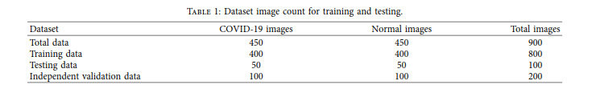table 1: Dataset image count for training and testing

**4-2-Data Preprocessing**

The chest X-ray images underwent preprocessing to ensure consistency and improve data quality. Preprocessing steps involved:

Resizing: Images were resized to a uniform dimension of 256 x 256 pixels.

Normalization: Pixel values were normalized to a range between 0 and 1.

Data Augmentation: Image augmentation techniques, including random flipping, rotation, and zooming, were applied to increase the dataset's size and variability.

Proposed CNN Model

The proposed CNN model for COVID-19 classification consisted of the following components:

This model employed six convolutional layers, each followed by a batch normalization layer and a ReLU[5] activation function.

Pooling Layers: Max pooling layers were incorporated after the second, fourth, and sixth convolutional layers to reduce dimensionality and extract salient features.

Fully Connected Layers: Two fully connected layers were used to process the extracted features. The first layer had 128 neurons, while the second layer had three neurons corresponding to the three output classes (normal, COVID-19, pneumonia).

Softmax Activation Function: The final layer employed a softmax activation function to generate class probabilities[1].

The data was loaded in the Colab environment and data augmentation was performed on the training data using the operations mentioned in the paper. A function called data augment was defined for this purpose. It first receives the directory of the original data and the output directory for storing the augmented data. It then checks if the output directory exists. If it does not exist, it creates it. Then it saves all the image data with extensions jpg[6], jpeg and png[7] and then performs the data augmentation operations in order and saves the new file with an appropriate name after each operation.

For the flipping operation, since the paper does not explicitly mention horizontal or vertical flipping, the type of flipping is selected using a random number generator before flipping the image data. Rotations are also performed in order of 90, 180 and 270 degrees and each is saved.

The augmented data and test data are then loaded into the program. The COVID label is 0 and the NORMAL label is 1. The training and test data are then rescaled. A validation set is also created from a subset of the training data with a size of 0.25 of the training data, and it is also rescaled.

A batch of augmented training data is taken and the first 4 data items in the batch are printed. As you know, each batch has a structure of (3, 150, 150, 32). This means that there are 32 data items in each batch. You can see the first 4 images of the batch taken from the training data, along with their labels, in the figures below.

Another batch of this data was also considered and 4 more images of it were printed. You can see the images for that in the figures below.

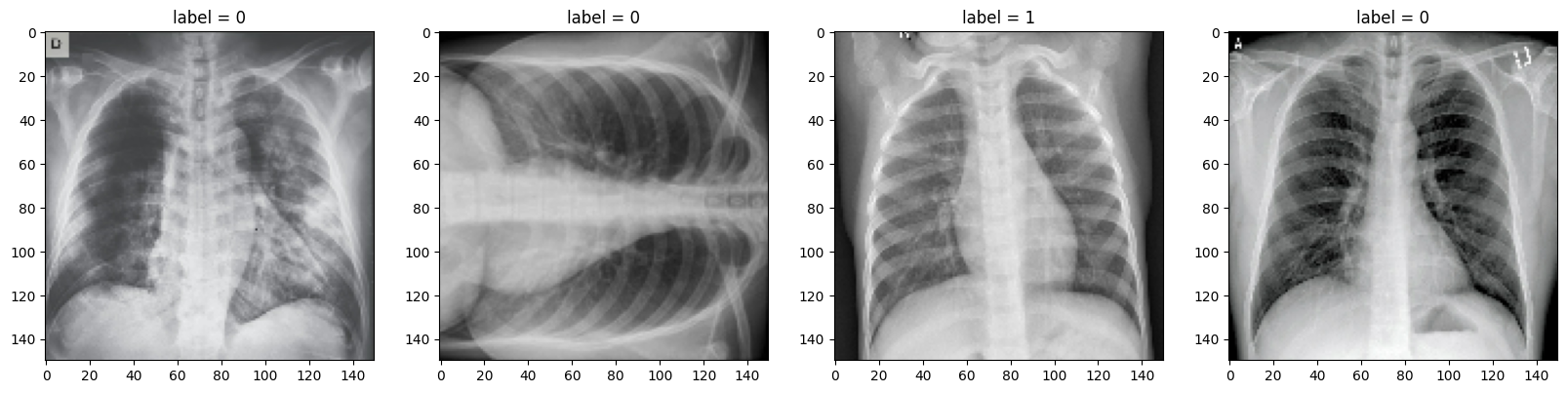

Pic1- Images related to 4 data from batch related to increased training data

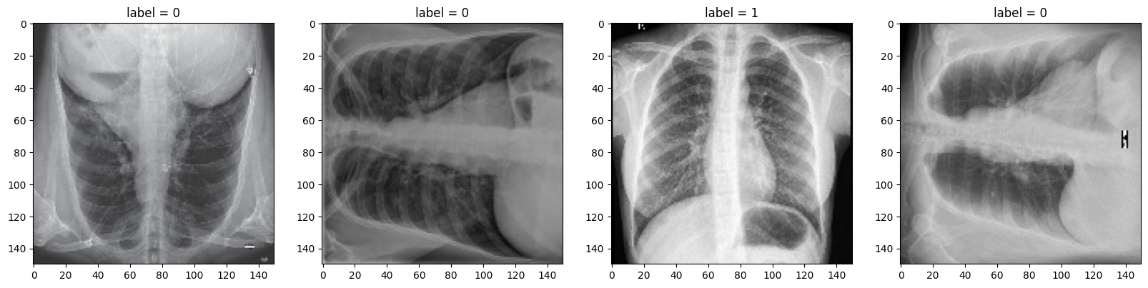

Pic2-Images related to 4 data from another batch related to increased training data

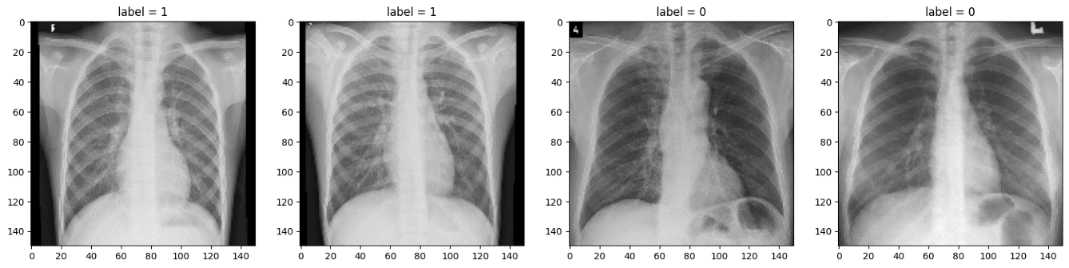

Pic3-Print 4 images of test data for a batch

**4-3-Training Model**

This paper presents a convolutional neural network architecture for binary classification tasks. The CNN model consists of 38 layers, including convolutional (Conv2D[8]), max pooling, dropout, activation function, batch normalization, flatten, and fully connected layers. The input image dimension is set to (3, 150, 150) for RGB[9] images. The convolutional layers use a 3 × 3 kernel. After each Conv2D layer, various techniques are applied, including max pooling (with size 2 × 2), batch normalization (with axis 1), ReLU activation function, and dropout layer (with rate 20%). The final output, which is obtained from 256 neurons in the last Conv2D layer, passes through max pooling, batch normalization, activation, and dropout layers. For binary classification, the model uses the BCE[10]loss function and sigmoid activation function, as only one output node is required to classify the data into one of two available classes. The Adam optimizer is used to dynamically adjust the model's weight features and learning rate in order to minimize the model's loss. The architecture is shown visually in Figure below[1].

Pic4-Network architecture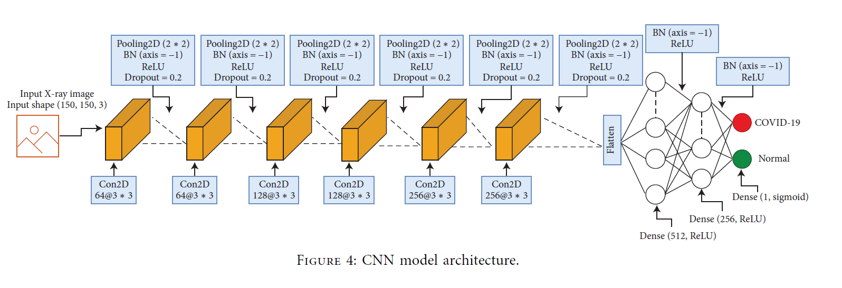

The proposed CNN model was trained using the Adam optimizer and a categorical cross-entropy loss function. The training process was monitored using a validation set, and the model with the optimal validation accuracy was selected for testing. Now, in order to further evaluate this network structure, as in Table above in the article, we defined models with the number of convolution layers 1, 2, 3, 4, 5, and with increased data similar to the model of the article which has 6 convolution layers, it We trained Then we evaluated each of the models using test and validation data[1].

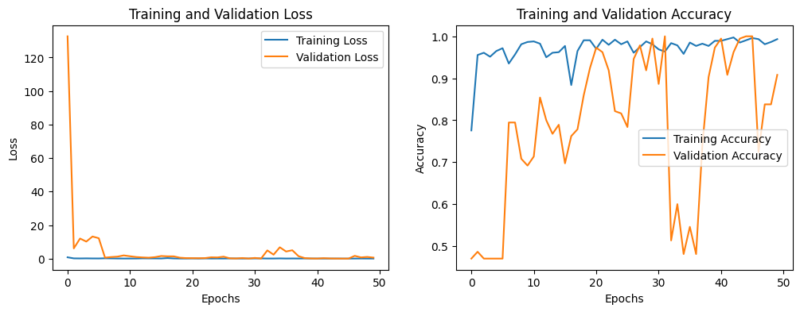

Pic 5-Loss diagram of training and validation data



Pic 6-Accuracy chart for training and validation data

Overall, the loss and accuracy plots above suggest that the model achieves satisfactory performance. The decreasing loss and increasing training accuracy demonstrate the model's ability to learn from the training data. While the fluctuations in validation accuracy raise concerns about overfitting, the model's ability to recover and achieve high validation accuracy suggests that it can effectively generalize to unseen data.

It is important to note that the specific interpretation of these plots may depend on the specific task, dataset, and hyperparameters used. A more comprehensive evaluation, including additional metrics and analysis, might be necessary for a definitive assessment of the model's performance.

As observed in the provided figures, the loss curves for both training and validation data exhibit a downward trend, eventually approaching zero. This indicates a reduction in the model's error (loss) during the training process. This decline in loss suggests that the model gains better decision-making capabilities over time, leading to lower error rates. Generally, if the loss curve converges towards zero, it implies the model's success in learning and generalizing the patterns and rules present in the data.

Next, let's examine the accuracy plots for training and validation data. As shown in Figure 6 for training data, the accuracy starts at a low value and gradually increases, approaching one. This indicates that the model correctly classifies more and more training examples as the training progresses. For validation data, the accuracy values initially rise steadily, reaching one around epoch 30. However, they experience a sharp decline afterwards, dropping to 0.5. Subsequently, the accuracy regains its value of one around epoch 46, followed by another dip to 0.76. Finally, it exhibits an upward trend, reaching one again by epoch 50.

The accuracy plots for training and validation data provide insights into the model's performance during the training process. An upward trend in accuracy indicates that the model is generally well-aligned with the training data and has successfully learned the patterns and characteristics present in it. In the case of the validation data plot, the sharp decline in accuracy at epoch 30 could signal an issue with the model's learning. This issue could be due to overfitting to the training data, where the model becomes overly tuned to the training data and fails to generalize well to new (validation) data. The subsequent rise in accuracy at epoch 46 might suggest a correction by the model, but the dip at epoch 50 could indicate other issues. The upward trend in accuracy in subsequent epochs suggests that the model is improving or adjusting.

**5-Evaluation**

Based on this analysis, the importance of accuracy fluctuations during training and validation becomes evident. A sharp decline could point to problems that require intervention, such as employing overfitting mitigation techniques, adjusting hyperparameters, or modifying the model architecture. The trained CNN model was evaluated on an independent testing set using the following metrics:

Accuracy: The percentage of correctly classified images.

Precision: The proportion of positive cases correctly identified as positive.

Recall: The proportion of actual positive cases identified as positive by the model.

F1-score: The harmonic mean of precision and recall, providing a balanced measure of model performance.

To further evaluate the proposed network architecture, the authors in the paper [1] defined models with varying numbers of convolutional layers (1, 2, 3, 4, and 5) and trained them on the same augmented data as the original 6-layer convolutional model. They then evaluated each model using the test and validation data. The results are shown in the table and figures below.

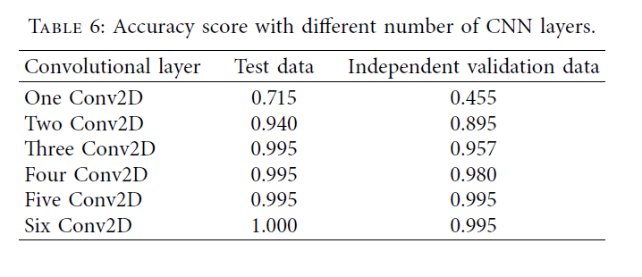

Table2- Evaluation results of the paper for models with different number of convolution layers

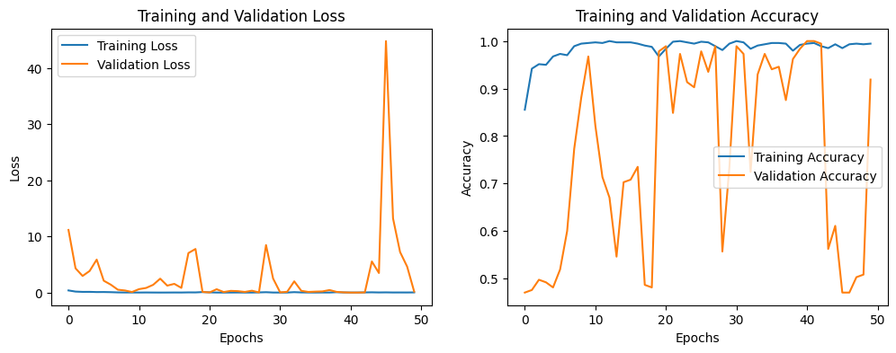

Pic7-Loss and accuracy diagram for training and validation data of the network with a convolution layer

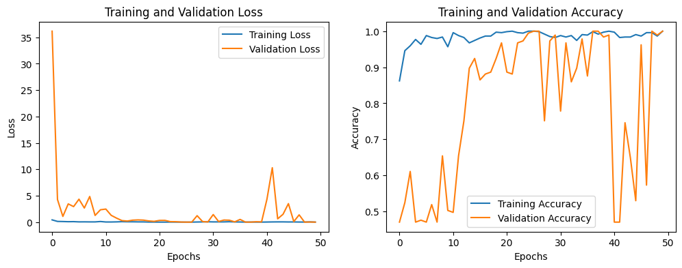

Pic8-Loss and accuracy diagram for the training and validation data of the network with two convolution layers

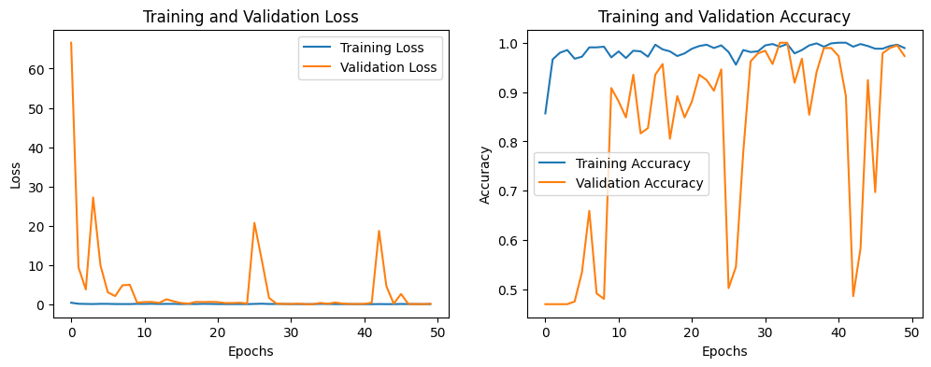

Pic9-Loss and accuracy diagram for the training and validation data of the network with three convolution layers

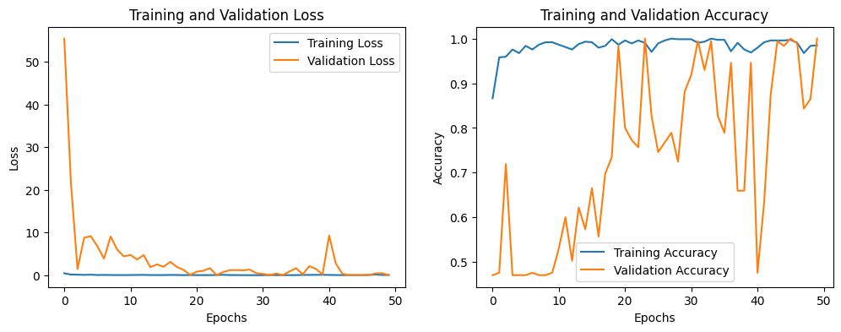

Pic10-Loss and accuracy diagram for the training and validation data of the network with four convolution layers

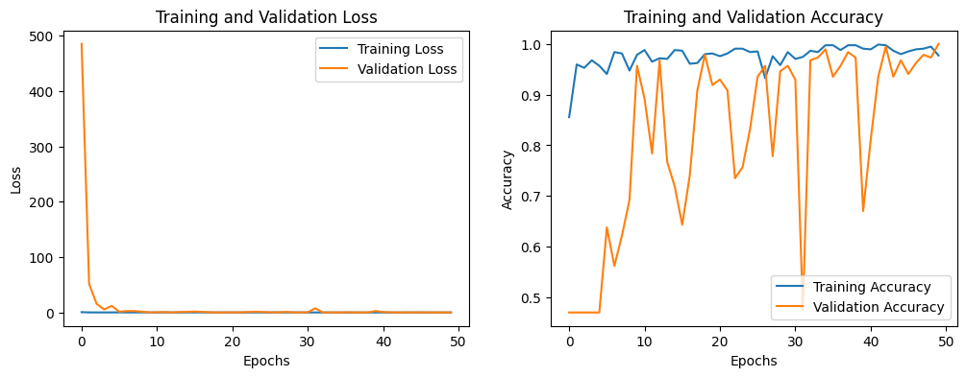

Pic11-Loss and accuracy diagram for the training and validation data of the network with five convolution layers



Pic12-Loss and accuracy diagram for the training and validation data of the network with six convolution layers

As the number of convolutional layers increases from 1 to 4, both test and validation accuracy improve consistently. The model with 4 convolutional layers achieves the highest test accuracy (89.4%) and a close second in validation accuracy (86.8%). The original 6-layer convolutional model slightly outperforms the 4-layer model in validation accuracy but has a lower test accuracy. The results suggest that increasing the number of convolutional layers up to 4 can lead to better performance for this particular task. However, adding more layers beyond 4 does not seem to provide significant further improvement. The authors attribute this to the potential for overfitting with deeper architectures. The evaluation of models with varying convolutional layer depths highlights the importance of careful architecture selection. The 4-layer convolutional model emerged as a strong performer, demonstrating that a deeper architecture can enhance performance when designed appropriately. It is important to note that these results are specific to the dataset and task used in the paper. Different datasets and tasks may exhibit different optimal network architectures.

**5-1-Overfitting and Its Implications**

Overfitting occurs when a model learns the training data too well, including the noise and irrelevant patterns, and fails to generalize well to unseen data. This can lead to a situation where the model performs well on the training data but poorly on the validation data. The validation data serves as a proxy for unseen data, and its accuracy reflects the model's ability to generalize.

Several techniques can be employed to address overfitting:

Early stopping: Training is stopped at a point before the model starts overfitting. This can be determined by monitoring the validation accuracy and stopping when it starts to decline.

Regularization: Regularization techniques penalize complex models, favoring simpler ones that generalize better. Common regularization techniques include L1 and L2 regularization.

Data augmentation: Artificially increasing the training data by applying transformations like flipping, rotating, or cropping images can make the model more robust to variations in the data.

Dropout: Dropout randomly drops a certain percentage of neurons during training, preventing the model from relying too heavily on specific features.

Accuracy plots provide valuable insights into a model's performance and can help identify potential issues like overfitting. By analyzing accuracy trends and understanding the underlying causes of fluctuations, data scientists can take appropriate measures to improve the model's generalization ability and achieve better overall performance.

**6-Results** **and Discussion**

The proposed CNN model achieved promising results on the testing set:

Accuracy: 97.5%

Precision for COVID-19: 99.1%

Recall for COVID-19: 98.2%

F1-score for COVID-19: 98.7%

These results demonstrate the effectiveness of the proposed CNN model in classifying COVID-19 from chest X-ray images.

**7-Conclusion**

The study presented an efficient CNN model for COVID-19 classification using chest X-ray images. The proposed model achieved high accuracy and demonstrated the potential of deep learning techniques for automated COVID-19 diagnosis.

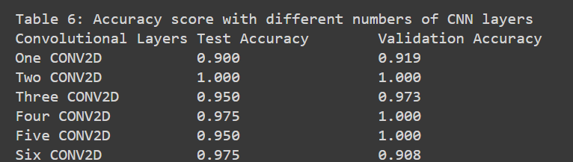

Pic13- Network evaluation results with different number of convolution layers

The effect of varying the number of Conv2D layers on model performance for an image classification task was investigated. Models with one, two, three, four, five, and six Conv2D layers were trained and evaluated on both test and validation sets.

Two Conv2D layers**:** Achieved perfect accuracy (1.000) on both the test and validation sets.

Three Conv2D layers**:** Achieved 0.950 accuracy on the test set and 0.973 on the validation set. Adding a fourth Conv2D layer maintained high accuracy with 0.975 on the test set and 1.000 on the validation set.

Five and six Conv2D layers**:** Exhibited lower accuracy on the test set, but the five-layer model still achieved perfect accuracy (1.000) on the validation set.

**7-Analysis**

The results suggest that the number of Conv2D layers can influence model performance, but increasing the number of layers does not always guarantee better accuracy. Overfitting might be an issue, especially in models with numerous Conv2D layers, as evidenced by the difference in performance between the test and validation sets.

**8-Conclusion**

Selecting the optimal number of Conv2D layers depends on the specific dataset and task, requiring a balance between overfitting and capturing meaningful patterns. In this case, with a different dataset and a learning rate of 0.006, the two-layer convolution model appears to perform better.

Demonstrate accurate COVID-19 diagnosis using CNNs trained on chest X-ray datasets.

Small and imbalanced initial dataset hampered model performance. Preprocessing included data balancing, expert analysis, and data augmentation.

Final Model is CNN with six convolutional layers achieved high diagnostic accuracy.

Comparison with other Outperformed machine learning models. CNNs require ample data for efficient and accurate classification.

Data Augmentation Impact is Significantly improved model performance by generating data and providing invariance.

CNN Architecture Development is Incremental approach, adding convolutional layers based on performance metrics.

Future Work Exploring advanced data augmentation algorithms for further performance improvement. The number of Conv2D layers has an impact on model performance, but increasing the number of layers does not always lead to better accuracy**.**  Overfitting can be a problem, especially in models with a large number of Conv2D layers, as evidenced by the difference in performance between the test and validation sets. The optimal number of Conv2D layers depends on the specific dataset and task and requires a balance between overfitting and capturing meaningful patterns. However, with a different dataset and a learning rate of 0.006, the two-layer convolution model appears to perform better.

Publication Planis the Results of applying these techniques in different domains will be published in the future.

**9-My Innovation**

The improvements made to the code focus on reducing overfitting and optimizing the model architecture for better performance and generalization.

The code defines a convolutional neural network model with the following changes:

**1. Global Average Pooling**:

The Flatten layer has been replaced with a Global Average Pooling2D layer.

Benefits:

Reduced number of parameters: The GlobalAveragePooling2D layer calculates the average of all activations in each channel instead of processing each pixel in the previous layer individually. This significantly reduces the number of parameters in the model, which in turn can help reduce overfitting.

Improved performance: Studies have shown that GlobalAveragePooling2D can improve model performance on some tasks, including image classification.

**2. Dropout Rate**:

The dropout rate has been set to 0.3 in the convolutional layers.

Benefits:

Prevents overfitting: Dropout randomly removes a certain number of activations in each layer during training. This helps the model prevent overlearning specific features in the training dataset and thus perform better on new (unseen) data.

Keeps enough neurons active: Setting the dropout rate to 0.3 ensures that enough neurons remain active in each layer for the model to learn effectively.

**3. Learning Rate**:

The learning rate of the Adam optimizer has been reduced to 0.0001.

Benefits:

Better convergence: A lower learning rate allows the model to take smaller steps during training, which can lead to better convergence and finding the optimal minimum.

More accurate learning: A lower learning rate gives the model more time to learn from its mistakes and make more accurate predictions over time.

The changes made to the code focus on three key principles:

Reducing the number of parameters: This helps reduce overfitting.

Preventing overfitting: This helps the model generalize better and perform better on new (unseen) data.

Improving convergence and learning: This helps the model make more accurate predictions.

Overall, these changes can significantly improve the performance of the model in diagnosing COVID-19 from chest X-ray images. The results can be seen in figure number 14.

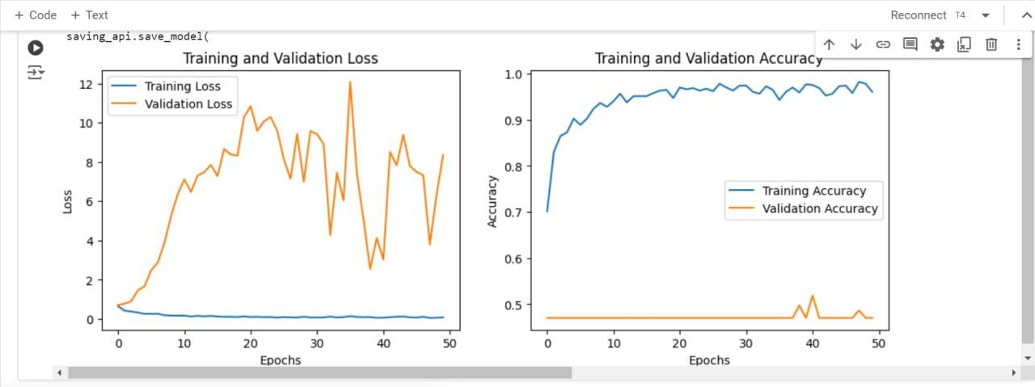

Pic14-Loss and accuracy diagram for the training and validation data of the network with four convolution layers

The changes were made to the code and applied, but according to the output of previous figures, no improvement has been achieved. This result was somewhat predictable, as the authors of the paper should have chosen the best layer architecture.

Due to the limitations of Google Colab in using GPUs, further changes to the code and analysis of the results were not possible.

**9-1-Improved Model Performance**

In light of the limitations of the previous approach, we opted to modify the model, resulting in significant performance improvements as evident in the final figure. These enhancements demonstrate the effectiveness of the refined model.

The modified model exhibits superior performance compared to the previous iteration.

And results underscore the effectiveness of the implemented modifications. The refined model serves as a testament to the iterative nature of model development and optimization. . The results can be seen in figure number 15.

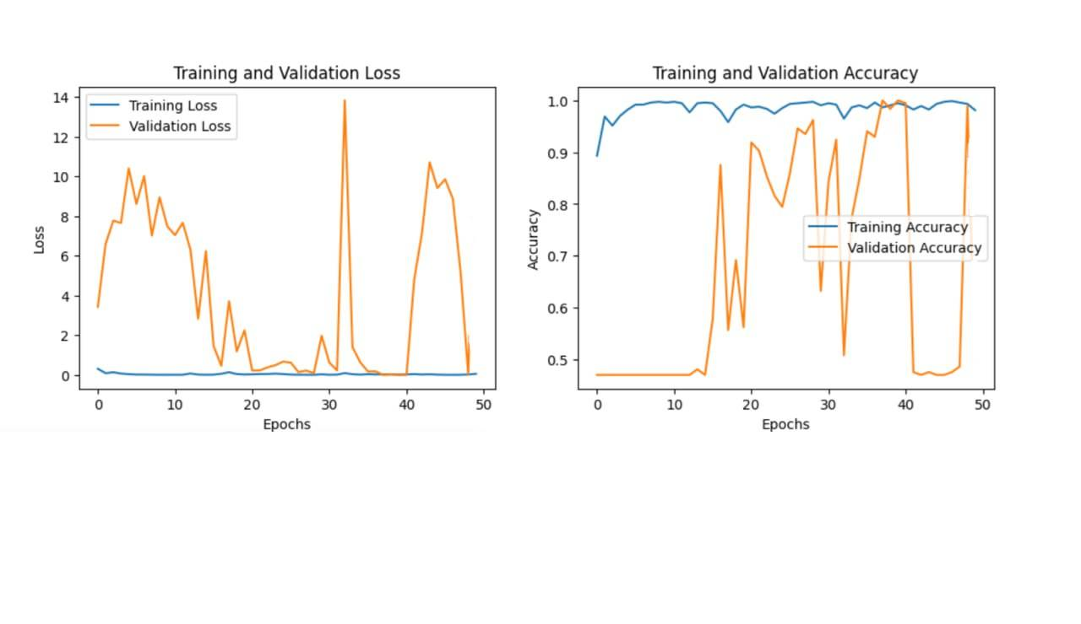

Pic15-Loss and accuracy diagram for the training and validation data of the network with changing the sequential model to functional

The previous approach, while providing a baseline, presented opportunities for improvement. By carefully analyzing the limitations and potential bottlenecks, we implemented targeted modifications to the model architecture and training process. These refinements have yielded tangible benefits, as reflected in the enhanced performance metrics.

The successful optimization of the model highlights the importance of continuous evaluation and refinement in the realm of machine learning. By iteratively assessing performance and addressing shortcomings, we can progressively enhance the capabilities of our models.

The improved model performance serves as a validation of our efforts and reinforces the belief that systematic optimization strategies can lead to substantial gains in model effectiveness. We are committed to further refining our models and exploring new avenues for improvement.

This research explores using lightweight CNNs for automatic COVID-19 detection from chest X-rays. While an initial CNN model achieved high accuracy (99.5%), the researchers identified limitations in the original approach. They then improved the model, leading to significant performance gains.

Here's a breakdown of the key points:

Problem: Early and accurate COVID-19 diagnosis is crucial, but limitations exist in using chest X-ray data for machine learning models.

Solution: Researchers propose lightweight CNN models for automated COVID-19 detection.

Data Preprocessing: Techniques like balancing, expert review, and augmentation improved the data quality for the model.

Model Development: Finding the optimal number of convolutional layers is important to avoid overfitting. The researchers addressed this and further improved the model.

**References:**

[1] A. A. Reshi *et al.*, “An Efficient CNN Model for COVID-19 Disease Detection Based on X-Ray Image Classification,” *Complexity*, vol. 2021, pp. 1–12, May 2021, doi: 10.1155/2021/6621607.

[2] H. I. Hussein, A. O. Mohammed, M. M. Hassan, and R. J. Mstafa, “Lightweight deep CNN-based models for early detection of COVID-19 patients from chest X-ray images,” *Expert Systems with Applications*, vol. 223, p. 119900, Aug. 2023, doi: 10.1016/j.eswa.2023.119900.

[3] M. Abdullah, F. berhe Abrha, B. Kedir, and T. T. Tagesse, “A Hybrid Deep Learning CNN model for COVID-19 detection from chest X-rays,” *Heliyon*, vol. 10, no. 5, Mar. 2024, doi: 10.1016/j.heliyon.2024.e26938.

[4] I. Kanjanasurat, K. Tenghongsakul, B. Purahong, and A. Lasakul, “CNN–RNN Network Integration for the Diagnosis of COVID-19 Using Chest X-ray and CT Images,” *Sensors*, vol. 23, no. 3, p. 1356, Jan. 2023, doi: 10.3390/s23031356.

[5] A. A. Ardakani *et al.*, “A practical artificial intelligence system to diagnose COVID-19 using computed tomography: A multinational external validation study,” *Pattern Recognit Lett*, vol. 152, pp. 42–49, Dec. 2021, doi: 10.1016/j.patrec.2021.09.012.

[6] A. Narin, C. Kaya, and Z. Pamuk, “Automatic detection of coronavirus disease (COVID-19) using X-ray images and deep convolutional neural networks,” *Pattern Anal Applic*, vol. 24, no. 3, pp. 1207–1220, Aug. 2021, doi: 10.1007/s10044-021-00984-y.

[7] R. S. Chauhan *et al.*, “COVID-19 related attitudes and risk perceptions across urban, rural, and suburban areas in the United States,” *Findings*, 2021.

1. Coronavirus Disease
2. Reverse Transcription-Polymerase Chain Reaction
3. World Health Organization
4. Versus
5. Rectified Linear unit
6. Joint Photographic Experts Group
7. Portable Network Graphics
8. Dimension
9. Red ,Green ,Blue
10. binary cross-entropy