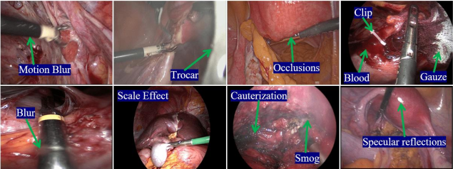

Figure (1): Examples of challenges in medical image analysis for surgical tool detection

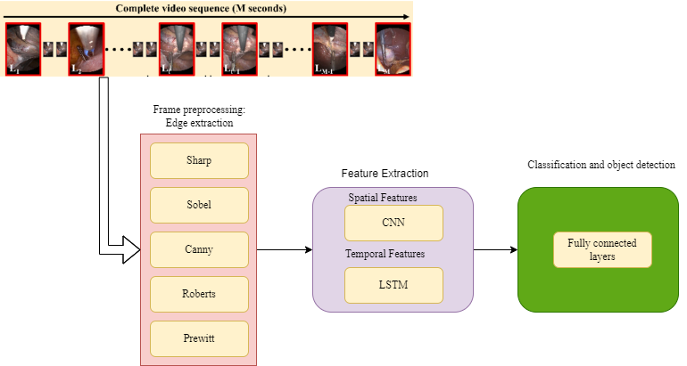

Figure (2): General Process of the Proposed Method

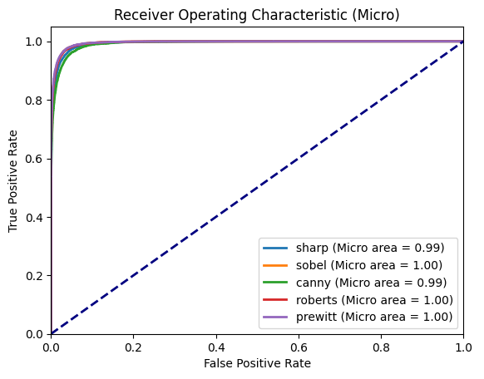

Figure 3: ROC curve for receiver operating characteristic (Micro)

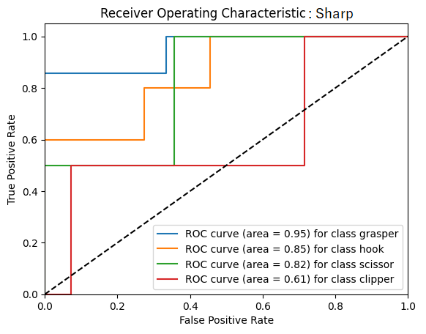

Figure 4: ROC curve for detecting the type of surgical instrument using the Sharp filter

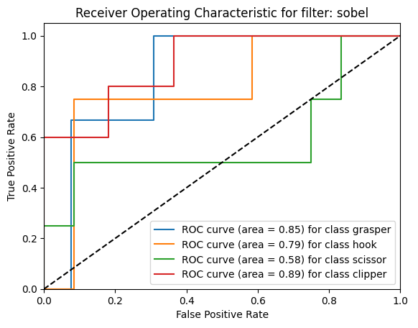

Figure 5: ROC curve for detecting the type of surgical instrument using the Sobel filter

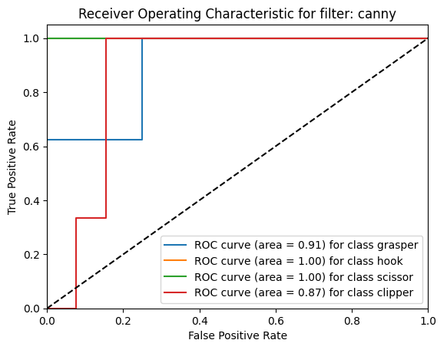

Figure 6: ROC curve for detecting the type of surgical instrument using the Canny filter

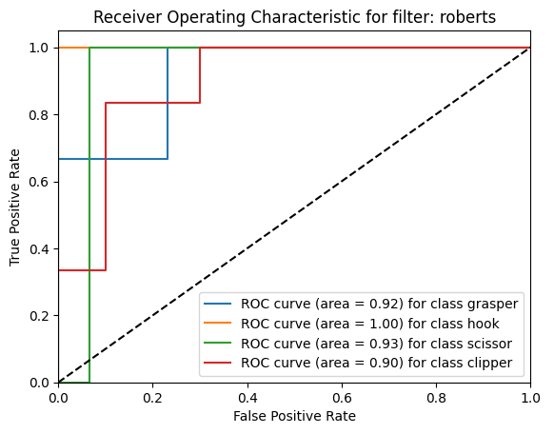

Figure 7: ROC curve for detecting the type of surgical instrument using the Roberts filter

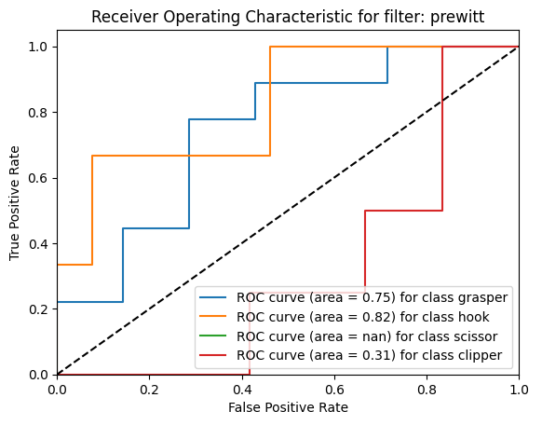

Figure 8: ROC curve for detecting the type of surgical instrument using the Prewitt filter