Chin00k

project

sql

Provided by Mahdiyeh Alavi

26/07/2024

DIAGRAM:

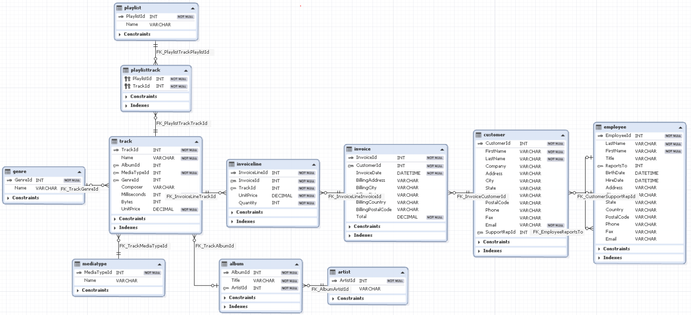

The **Invoiceline** table includes quantity and price of tracks so it can be the **FACT** type and The rest of the tables include the information and description of the parameters in this table ,so they are **DIM** tables. Because we have only one fact table and also some of DIM tables have branches, this diagram is similar to **snowflake** type.

1) The top 10 songs that have the most income are created along with the income:

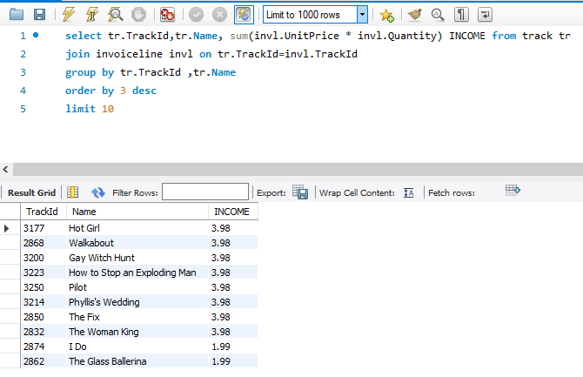

2) the most popular genre, in terms of number of songs sold and Income, respectively:

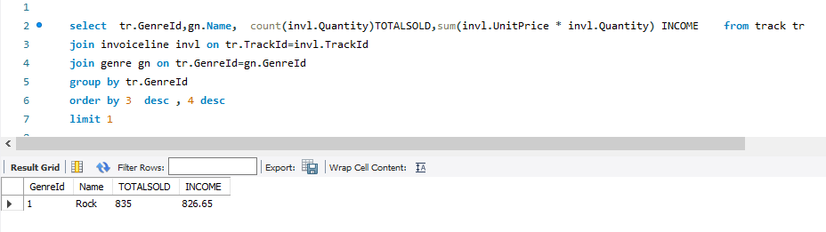

3) Users who have not purchased before:

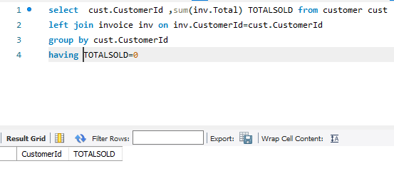

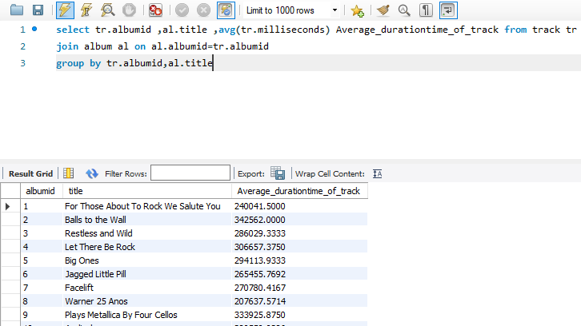4) Average time of songs in each album

5) The employee who had the highest number of sales :

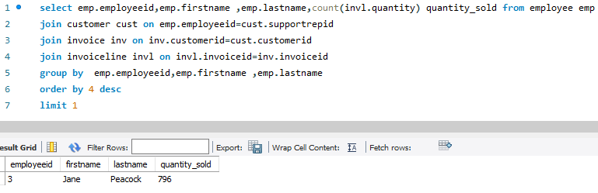

6) Users who buy from more than one genre:

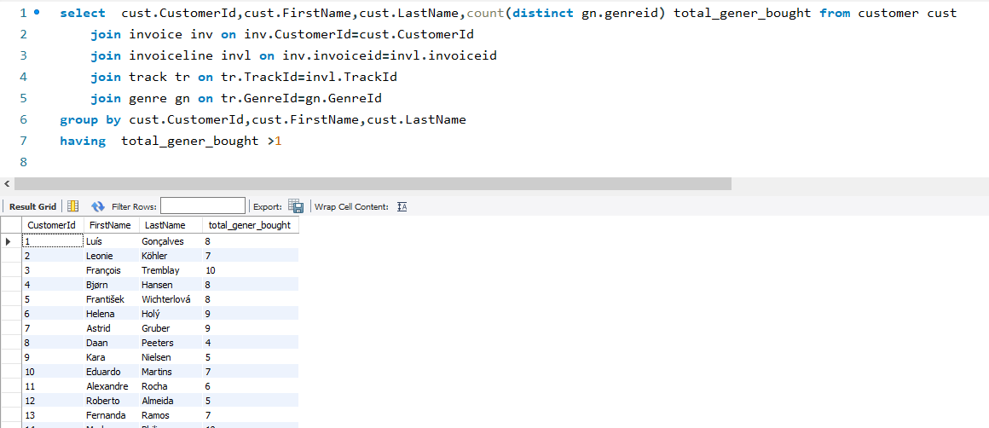

7) the top three songs in terms of sales revenue for each genre :

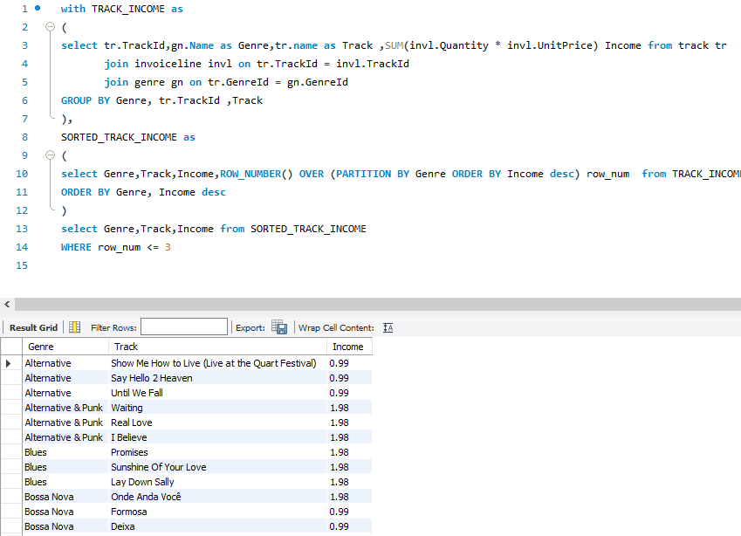

8) the number of songs sold cumulatively in each year

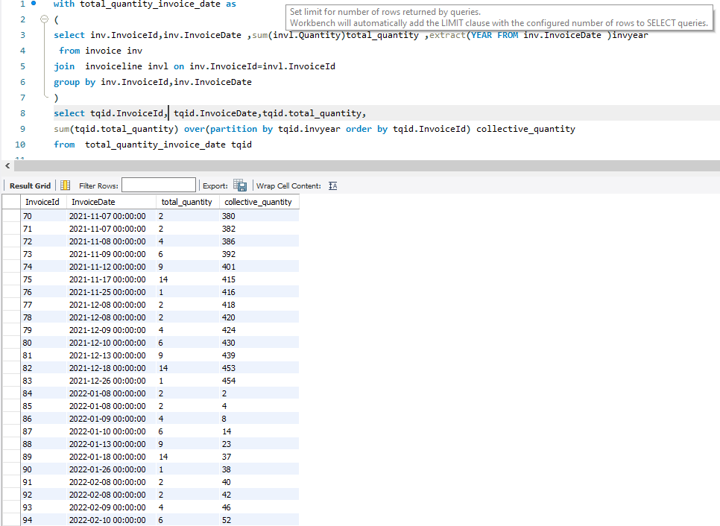

9) users whose total purchase is higher than the average total purchase of all users:

