CHARLES DARWIN UNIVERSITY
PRT661 – Data Science Practice
Assessment 1: Project Proposal and Design
Theme 2 – Predictive Analytics and Forecasting
Deep Learning-Based Classification of Early and Late Blight in Potato Leaves
Group Members | [Insert names – 3 to 5 members]
Student IDs | [Insert student IDs]
Lecturer/Tutor | [Insert name]
Semester | Semester 2, 2026
Submission Date | [Insert date]
GitHub Repository | [INSERT ACTIVE GITHUB URL]
Project Management Board | [INSERT ACTIVE GITHUB PROJECTS / JIRA / TRELLO URL]

1. Project Overview and Objectives
Plant diseases can reduce crop quality and productivity when visible symptoms are not recognised promptly. Manual inspection is useful but may be time-consuming and dependent on the observer’s experience. This project proposes a simple binary image-classification system that distinguishes potato leaves affected by Early Blight from those affected by Late Blight. The project will use the public PlantVillage image dataset and develop a convolutional neural network (CNN) to learn disease-related visual patterns. The intended output is a reproducible proof-of-concept decision-support tool rather than a replacement for professional crop diagnosis. The project objectives are to:
- acquire, organise and document a suitable public image dataset;
- preprocess potato-leaf images into a consistent modelling format;
- develop a CNN for Late Blight versus Early Blight classification;
- evaluate predictive performance using multiple binary-classification metrics; and
- visualise results and critically assess limitations, risks, ethics, privacy and security.

2. Theme Justification
The project fits Theme 2 Predictive Analytics and Forecasting because labelled images are used to train a model that predicts the class of a new image. The target is binary: Late Blight or Early Blight. It also covers data acquisition, storage, processing, machine-learning analytics and visualisation.

3. Problem Statement

Early Blight and Late Blight are two important potato diseases that can produce visually similar symptoms on leaves, making accurate differentiation challenging when relying only on manual inspection. Recognition may also vary with image quality, symptom severity, and observer experience. The research question for this project is:
Can a CNN accurately distinguish potato leaves affected by Early Blight from those affected by Late Blight using visible image characteristics?
The project will focus only on binary disease classification and performance evaluation. It will not provide treatment, pesticide, or disease-management recommendations.

4. Data Source and Initial System Architecture
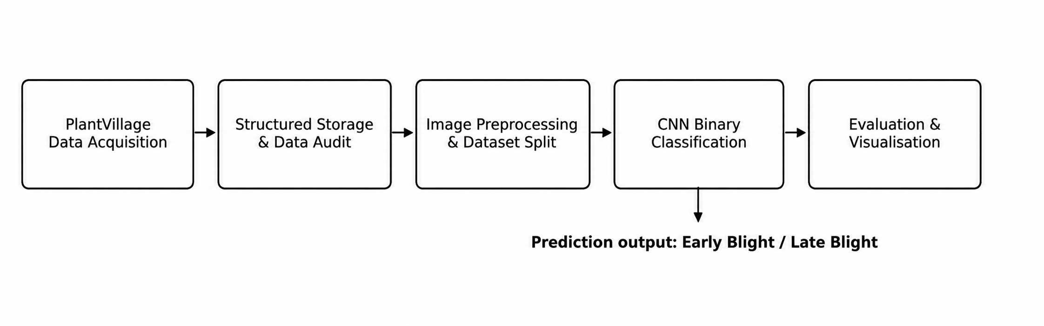
PlantVillage contains 54,306 leaf images across 38 crop-disease classes. This project will use only Potato_Early_blight and Potato_Late_blight, with 1,000 images in each class, giving a balanced dataset of 2,000 images. Images will be stored in structured folders, while GitHub will maintain code, documentation, and dataset links.

Figure 1. Initial architecture for the proposed binary leaf-disease classification system.

5. Workflow and Analytical Plan
The project will use Python with PyTorch, NumPy, Scikit-learn and Matplotlib. Image files and labels will first be checked and summarised. Images will be resized to 224 × 224 pixels and normalised. Horizontal flipping, small rotations and limited zoom will be applied only to training images. A stratified train-validation-test split will preserve class proportions, while a leaf-group-aware split will be preferred when available to reduce leakage.
A lightweight CNN will be the primary model, using convolution and pooling layers followed by dense layers and a sigmoid output. Class weighting will address imbalance. Performance will be reported using accuracy, precision, recall, F1-score, ROC-AUC and a confusion matrix. Early-Blight recall is important because a false negative is a diseased leaf predicted as healthy. Visualisations will include class distribution, sample images, learning curves, confusion matrix, ROC curve and prediction examples.
Table 1. Proposed workflow and milestones.
Stage | Key activity | Planned output
1 | Acquire and audit data | Dataset inventory and class summary
2 | Preprocess and split images | Reproducible train/validation/test sets
3 | Develop and train CNN | Saved model and training history
4 | Evaluate predictions | Metrics, confusion matrix and ROC curve
5 | Interpret and document | Figures, limitations and final report materials

6. Project Management and Task Allocation
A shared GitHub repository will support version control, code review and documentation. GitHub Projects will track tasks, milestones, ownership, progress, completion, the project timeline and scope changes using a Backlog–In Progress–Review–Done workflow. Members will have primary responsibilities but will review each other’s work. Commits and board activity will provide collaboration evidence.
Table 2. Proposed team structure and responsibilities.
Team member | Primary responsibility
Member 1 | Data acquisition and repository setup
Member 2 | Image preprocessing and exploratory analysis
Member 3 | CNN development and model training
Member 4 | Evaluation, visualization and error analysis
Member 5 | Documentation, ethics review and final integration

7. Initial Risk Analysis
Table 3. Initial project risks and mitigation strategies.
Risk | Potential impact | Mitigation
Visual similarity between diseases | Misclassification between Early Blight and Late Blight | Use image augmentation and class-specific evaluation metrics.
Overfitting | Poor generalization | Use augmentation, early stopping and regularization.
Data leakage | Inflated performance | Split data before augmentation and verify no overlap between sets.
Limited computing resources | Slow experiments | Use 224 × 224 images and a lightweight CNN.
Domain shift | Lower accuracy on real field images | Clearly state dataset limitations and recommend external field validation.
Version/data loss | Inconsistent team outputs | Use GitHub branches, regular commits and protected shared storage.

8. Ethics, Privacy and Security Considerations
The dataset contains plant images rather than identifiable human information, so privacy risk is low. The team will still respect licensing and attribution, maintain data provenance, control access to shared files and keep backups. The main ethical risk is overstating model capability. PlantVillage images were collected under controlled conditions, so performance may fall with field lighting, clutter, orientation changes or similar symptoms (Mohanty et al., 2016). Results will therefore be reported as experimental evidence only. The system will not recommend pesticides or treatments, and errors, class imbalance and limitations will be reported transparently. Future deployment would require independent field testing and expert agricultural oversight.
References
Hughes, D. P., & Salathé, M. (2015). An open access repository of images on plant health to enable the development of mobile disease diagnostics. arXiv. Link
LeCun, Y., Bengio, Y., & Hinton, G. (2015). Deep learning. Nature, 521, 436–444. Link
Mohanty, S. P., Hughes, D. P., & Salathé, M. (2016). Using deep learning for image-based plant disease detection. Frontiers in Plant Science, 7, 1419. Link
Shorten, C., & Khoshgoftaar, T. M. (2019). A survey on image data augmentation for deep learning. Journal of Big Data, 6, 60. Link
Project-AgML. (n.d.). PlantVillage classification dataset. Hugging Face Datasets. Link
PlantVillage dataset repository. (n.d.). PlantVillage deep learning paper dataset. Link
Dataset access: PlantVillage image dataset

