CHARLES DARWIN UNIVERSITY · PRT661 DATA SCIENCE PRACTICE

Deep Learning-Based Classification of Early and Late Blight in Potato Leaves

Unit | PRT661 – Data Science Practice
Assessment use | Assessment 4 - Group Project Report
Group members | [INSERT 3–5 TEAM MEMBER NAMES]
Student IDs | [INSERT STUDENT IDS]
Lecturer / tutor | [INSERT NAME]
GitHub repository | [INSERT CLICKABLE REPOSITORY URL]
Project workspace | [INSERT GITHUB PROJECTS / JIRA / TRELLO URL]
Submission date | [INSERT DATE]
Word count | [UPDATE AFTER TEAM REVIEW]

Table of contents
Table of contents 2
List of figures 5
List of tables 5
Executive summary 6
1. Introduction 7
1.1 Agricultural context 7
1.2 Problem statement 7
1.3 Research question, aim and objectives 7
1.4 Scope 8
2. Literature and analytical foundations 9
2.1 Plant-disease image datasets 9
2.2 Convolutional classification 9
2.3 Augmentation and representation shift 10
2.4 Interpretability and probability quality 10
2.5 Robustness 10
3. Project evolution and governance 11
3.1 From proposal to implemented system 11
3.2 Project evidence and team records 12
3.3 Status against coordinator expectations 12
3.4 Delivery sequence and milestone control 12
3.5 Roles, review and decision ownership 12
3.6 Evidence gaps and completion actions 13
3.7 Quality definition 13
4. Dataset, quality and governance 13
4.1 Composition 13
4.2 Partitioning 14
4.3 Preprocessing 14
4.4 Data provenance, licensing and privacy 15
5. Model and experimental method 15
5.1 Pipeline architecture 15
5.2 Architecture and optimization 16
5.3 Primary evaluation 16
5.4 Threshold protocol 16
5.5 Interpretability and feature analysis 17
5.6 Calibration and confidence 18
5.7 Ablation 19
5.8 Robustness protocols 20
6. Responsible prediction interface 20
6.1 Design and intended use 20
6.2 Safeguards and verification 20
7. Results 21
7.1 Primary held-out performance 21
7.2 Error analysis and Grad-CAM 24
7.3 Threshold stability 26
7.4 Segmented-image experiment 27
7.5 Controlled perturbations 27
7.6 External-domain evaluation and efficiency 28
8. Discussion 29
8.1 Answer to the research question 29
8.2 Why the clean score is credible 29
8.3 Why the score is not field evidence 29
8.4 Operational use case 29
8.5 Interpretation of embeddings and heatmaps 30
8.6 Comparison with prior studies 30
8.7 Interface value 30
8.8 Detailed interpretation of corruption behaviour 30
8.9 Decision costs and referral policy 31
8.10 Reproducibility and analytical restraint 31
9. Ethics, privacy, security and risk 31
9.1 Ethical boundaries 31
9.2 Privacy and data rights 32
9.3 Security 32
9.4 Updated risk register 32
9.5 Contingency 33
10. Limitations and future work 33
10.1 Limitations 33
10.2 Future analytical work 33
10.3 Readiness gates 33
10.4 Prioritisation rationale 34
11. Technical assurance and handover 34
11.1 Traceability 34
11.2 Release structure 34
11.3 Regression and acceptance testing 34
11.4 Demonstration plan 34
11.5 Maintenance and monitoring 35
11.6 Data-management lifecycle 35
11.7 Maintainable implementation 35
11.8 Statistical uncertainty 36
11.9 Alternative explanations 36
11.10 External field-study protocol 36
11.11 Product requirements for live inference 37
11.12 Project management and collaboration evidence 37
11.13 Sustainability and accessibility 37
11.14 Demonstration failure contingencies 38
11.15 Submission checklist 38
12. Conclusion 38
References 39
Appendix A. Individual work and contribution pages 42
A.1 Team member 1 – [INSERT NAME AND STUDENT ID] 42
A.2 Team member 2 – [INSERT NAME AND STUDENT ID] 43
A.3 Team member 3 – [INSERT NAME AND STUDENT ID] 44
A.4 Team member 4 – [INSERT NAME AND STUDENT ID] 45
A.5 Team member 5 – [INSERT NAME AND STUDENT ID] 46

List of figures
Figure 1. Representative Early-Blight and Late-Blight images from the controlled PlantVillage subset. 9
Figure 2. Balanced composition of the two-class PlantVillage potato-leaf subset. 14
Figure 3. Comparison of primary color-image performance and validation-calibrated segmented-image performance. 15
Figure 4. Validation-only selection of the primary colour-image operating threshold. 17
Figure 5. PCA projection of 128-dimensional learned test features, showing the dominant separation in the controlled domain. 18
Figure 6. Reliability diagram for Late-Blight probabilities on the primary test set. 19
Figure 7. Headline primary test performance of the lightweight PotatoCNN. 22
Figure 8. Grad-CAM overlays for misclassified images; highlighted regions indicate model sensitivity rather than confirmed pathology. 25
Figure 9. All five primary test errors with true label, predicted label and model probability. 26
Figure 10. Comparison of default and validation-selected thresholds; both produced the same primary test decisions. 27
Figure 11. Accuracy, F1 and ROC–AUC under six controlled image transformations. 28

List of tables
Table 1. Objectives, success criteria and completed evidence 7
Table 2. Implemented change log 11
Table 3. Dataset and split counts 14
Table 4. Regularization ablation 19
Table 5. Primary test metrics 21
Table 6. Project risk register 32

Executive summary
Potato Early- and Late-Blight image classification is an accessible computer-vision problem, but controlled leaf datasets can make performance look more transferable than it is. This project was therefore re-implemented after feedback as a stronger evidence pipeline rather than a single-CNN demonstration. It now includes pinned PlantVillage provenance, official leaf-group-aware splitting, leakage audits, a traditional logistic baseline, a compact custom PotatoCNN, transfer learning with MobileNetV2, validation-locked thresholds, held-out internal comparison, paired tests, explainability, calibration, ablation, controlled robustness, segmented-representation sensitivity, an external PlantDoc evaluation and a responsible probability-and-warning prototype.
The primary PlantVillage subset contains 2,000 RGB images, 1,000 Early Blight and 1,000 Late Blight, derived from 500 underlying leaf groups. The final group-aware split uses 350 leaf groups for training (1,400 images), 75 for validation (300 images: 148 Early, 152 Late) and 75 for testing (300 images: 152 Early, 148 Late). No leaf group is shared across partitions, and exact/near-duplicate cross-split audits found no overlap. Because the training classes are balanced, class weighting is disabled rather than applied automatically. Late Blight is defined consistently as the positive class for binary precision, recall and F1.
Three models were compared. The grayscale logistic baseline achieved internal test accuracy 0.9100, Late-Blight recall 0.9324, F1 0.9109 and ROC-AUC 0.9624 at validation-locked threshold 0.70. The 93,377-parameter custom PotatoCNN improved to accuracy 0.9533, recall 0.9662, F1 0.9533 and ROC-AUC 0.9952 at threshold 0.38. MobileNetV2 transfer learning was strongest internally: accuracy 0.9967, precision 1.0000, recall 0.9932, F1 0.9966 and ROC-AUC 1.0000 at threshold 0.64, with one false negative and no false positives. Exact McNemar tests found all three pairwise differences significant at 0.05.
The external PlantDoc experiment changes the interpretation of the high internal scores. On 222 independently sourced Early-/Late-Blight images with no exact or near-image overlap, MobileNetV2 achieved only accuracy 0.5856, F1 0.4831 and ROC-AUC 0.6210. PotatoCNN fell to accuracy 0.5135 and F1 0.1290, while logistic regression was approximately chance. Controlled perturbations tell the same cautionary story: darkness reduced custom-CNN accuracy to 0.4933 and F1 to 0.6607; bright images yielded accuracy 0.7000; segmentation required its own validation-calibrated operating point and produced F1 0.8784. Strong PlantVillage separation therefore does not demonstrate field generalisation.
The final package also addresses governance and communication feedback. Data provenance, licensing notes, five-V documentation, architecture/tool alternatives, risk controls, versioned splits, model artefacts, environment details and a manifest are supplied. An optional Gradio research prototype can return Early/Late probabilities, a low-confidence flag and a warning that the model covers only two disease classes and gives no diagnosis or treatment advice; it is disabled by default. The appropriate next step is a prospective, specimen-grouped field evaluation with Healthy/Other classes, capture-quality checks, calibration/abstention and expert oversight.

1. Introduction

1.1 Agricultural context
Crop disease can reduce production and place disproportionate pressure on growers who lack rapid access to specialist diagnosis. Savary et al. (2019) demonstrate the broader global burden that pathogens and pests place on major food crops. Potato blights are a suitable visual-computing case because leaf symptoms are observable in images, yet an automated prediction must be framed carefully. Early blight is commonly associated with Alternaria solani, whereas late blight is associated with Phytophthora infesting. They are biologically distinct and may present differently across disease stage, cultivar and environment. A two-class image model can learn patterns in labelled photographs; it cannot confirm a pathogen, recommend a fungicide or replace local agronomic assessment.
The Plant Village initiative made curated leaf imagery available to stimulate computer-vision research in plant health. Hughes and Salathé (2015) described the open repository, and Mohanty, Hughes and Salathé (2016) showed that deep networks could achieve very high performance across crop–disease classes in controlled imagery. That work also revealed a central caution: models evaluated on images collected against regular backgrounds may perform differently on real photographs. This project intentionally uses the controlled dataset as a reproducible experimental environment, then tests selected changes in lighting, blur, noise, rotation and segmentation to make the domain boundary visible.

1.2 Problem statement
Manual inspection can be slow, inconsistent and dependent on experience, particularly when symptoms overlap or photographs are poor. The analytical task is to learn a binary mapping from RGB leaf pixels to Early Blight or Late Blight. The decision is important enough that aggregate accuracy is inadequate: a system should reveal which class is missed, whether confidence is trustworthy, what image regions influence the output, whether results rely on background appearance and how latency might affect a user interface. The project therefore treats prediction as one component of an end-to-end data-science system rather than a standalone training score.

1.3 Research question, aim and objectives
The research question is: how well can conventional and deep image classifiers distinguish PlantVillage potato leaves labelled Early Blight from those labelled Late Blight when biological grouping, locked validation decisions and external domain shift are evaluated explicitly? The aim is an auditable proof of concept rather than a diagnostic service. Objectives are to document a balanced public subset; split by official leaf group before augmentation; compare a traditional logistic baseline, compact CNN and MobileNetV2 transfer model; evaluate complementary metrics at validation-locked thresholds; inspect errors, Grad-CAM, features and calibration; test ablation, segmentation and perturbation sensitivity; evaluate untouched PlantDoc images; measure efficiency; and communicate value, governance and limitations.
Table 1. Objectives, success criteria and completed evidence
Objective | Success criterion | Evidence
Data preparation | Balanced, traceable, leaf-group-isolated PlantVillage subset | 2,000 images / 500 groups; provenance and five-V audit
Evaluation design | Frozen group-aware train/validation/test; no external tuning | 1,400/300/300 images and 350/75/75 groups; zero overlap
Model comparison | Traditional, custom and transfer approaches | Logistic baseline, 93,377-param PotatoCNN, MobileNetV2
Critical evaluation | Internal + external evidence with diagnostics | McNemar, errors, Grad-CAM, calibration, ablation, robustness, PlantDoc
Usable communication | Probability-oriented interface with visible safeguards | Static evidence summary + optional guarded Gradio prototype
Responsible scope | No unsupported field/treatment claim | Risk, provenance, external-gap and limitation statements

1.4 Scope
The primary scope contains two diseased classes only: Early Blight and Late Blight, with Late Blight as the positive class. Healthy potato leaves, other diseases, nutrient deficiencies, pest damage and other crops are outside the trained decision space. The primary internal result uses original-colour PlantVillage images grouped by underlying leaf; artificial corruptions and segmentation are secondary sensitivity experiments. PlantDoc is used only as an external evaluation set and never for fitting or threshold selection. The project does not infer pathogen confirmation, severity, yield loss, treatment or chemical dose. The optional interface is a proof-of-concept probability display, not agronomic diagnosis.
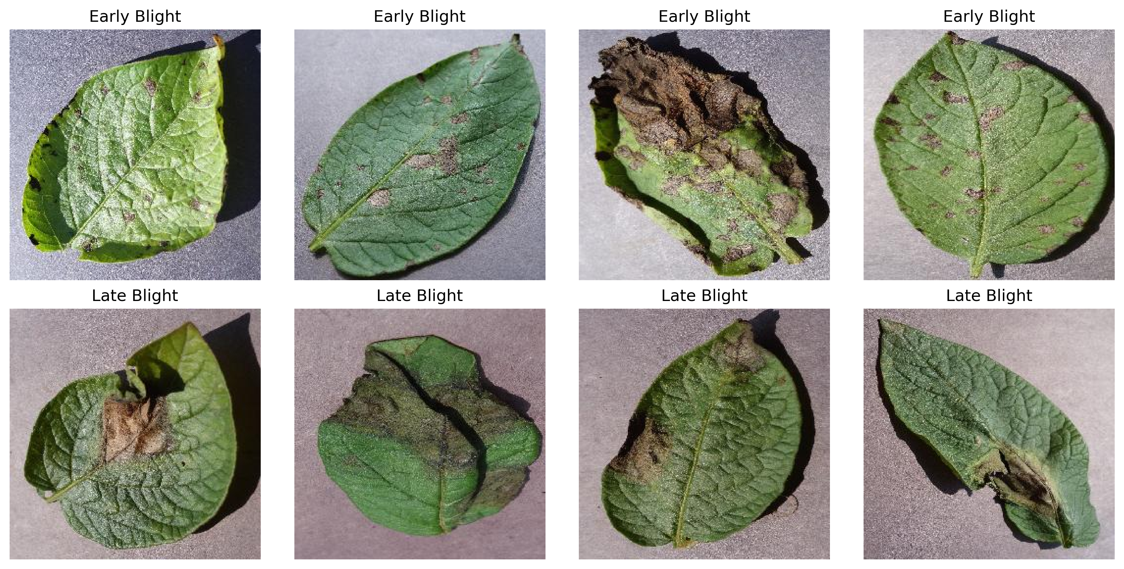
Figure 1. Representative Early-Blight and Late-Blight images from the controlled PlantVillage subset.

2. Literature and analytical foundations

2.1 Plant-disease image datasets
Public datasets lower the cost of reproducible experimentation and provide labels suitable for supervised learning. Plant Village contains tens of thousands of images across multiple crops and diseases; the project uses only 1,000 Early-Blight and 1,000 Late-Blight potato images. Controlled collection improves label clarity and reduces nuisance variation, which is useful when testing an architecture. It also makes the task easier than field diagnosis because the background, framing and leaf presentation are more regular. Barbedo (2018) discusses how dataset size and variety affect deep plant-disease recognition, while field-oriented studies consistently identify background and capture variation as major challenges. The dataset is therefore both an asset and a threat to external validity.
A critical leakage issue in the earlier implementation was that file-level random partitioning could place multiple photographs of the same underlying leaf in different splits. The re-implementation corrects this using the official leaf-group identifiers before augmentation. The final 500 leaf groups are divided 350/75/75 across train/validation/test, with zero group overlap. Exact and near-image audits also report zero cross-split matches. This stronger design materially improves the credibility of the internal test result, although group isolation within PlantVillage still cannot guarantee field-domain independence.

2.2 Convolutional classification
Deep learning builds representations across stacked transformations, and convolutional layers exploit local spatial structure and shared weights (LeCun et al., 2015). Krizhevsky, Sutskever and Hinton (2012) demonstrated the practical value of convolution, rectified activations, GPUs and dropout at large scale. Agricultural imaging later adopted these techniques: Ferentinos (2018) evaluated deep models for plant-disease diagnosis, and Too et al. (2019) compared fine-tuned architectures on plant datasets. The current project chooses a smaller custom network because the binary task is narrow, the input images are regular and an efficient model is attractive for an eventual web or mobile interface.
A compact custom network remains valuable because it is easy to reproduce and cheap to run, but the feedback-incorporated study no longer treats it as the only meaningful architecture. A traditional logistic model establishes a non-deep-learning reference and MobileNetV2 transfer learning tests whether pretrained visual features improve the narrow two-class task. The custom CNN retains augmentation and dropout; a controlled ablation shows all four regularisation combinations perform very strongly on the internal validation experiment, reinforcing that PlantVillage itself is highly separable rather than proving that regularisation is irrelevant to external data.

2.3 Augmentation and representation shift
Training augmentation exposes the model to plausible variations without collecting more labelled leaves. Shorten and Khoshgoftaar (2019) survey this strategy and its role in reducing overfitting. Horizontal flip, limited rotation and random resized crop were used here because leaf class should remain unchanged. They were applied after partitioning and only to the training loader. Validation and test images received deterministic resize and normalization. This order matters: augmenting first can create closely related versions across splits, while random evaluation transforms would make final metrics unstable.
Segmentation is treated as representation sensitivity rather than a performance enhancement. The colour-trained custom CNN shifts substantially when the background is removed. At its ordinary 0.50 rule, the segmented test collapses to no positive decisions despite ROC-AUC 0.9566; using a threshold calibrated only on segmented validation data yields accuracy 0.8800 and F1 0.8784. The lesson is that preprocessing, score calibration and threshold policy form one validated system and must not be mixed across representations without new validation.

2.4 Interpretability and probability quality
Grad-CAM produces a coarse class-relevant map from gradients at a convolutional layer (Selvaraju et al., 2017). Applied to misclassified potato leaves, it helps a reviewer see whether the network emphasized lesion areas, leaf boundaries or broad structures. It cannot identify the causal pathogen or prove that a highlighted spot is a disease lesion. PCA and t-SNE make the learned feature space visible; t-SNE is specifically a local-neighborhood visualization rather than a hypothesis test (van der Maaten & Hinton, 2008). These tools are diagnostic aids and are interpreted alongside predictions.
Confidence calibration asks whether numeric model scores correspond to observed frequencies. Guo et al. (2017) show that high-performing neural networks can still be poorly calibrated. The custom PotatoCNN reliability analysis is useful within the locked internal test, but the external PlantDoc collapse is stronger evidence that internal confidence cannot be treated as field certainty. Calibration should therefore be estimated and verified on representative deployment-domain data, with uncertainty and abstention rules tested prospectively rather than inferred from the controlled benchmark.

2.5 Robustness
Image classifiers can fail under ordinary corruptions even when clean accuracy is high. Hendrycks and Dietterich (2019) motivate systematic corruption benchmarks to reveal this gap. This project applies six controlled conditions to the same held-out leaves. The transformations are deliberately simple and do not represent the full distribution of smartphone cameras, shadows, soil, overlapping leaves or disease stages. Their value is diagnostic: darkness and brightness show that intensity changes alter threshold behaviour; blur and noise probe local texture reliance; rotation tests orientation tolerance. The results guide future data collection rather than claiming field validation.

3. Project evolution, governance and implementation status

3.1 Overall Project Architecture
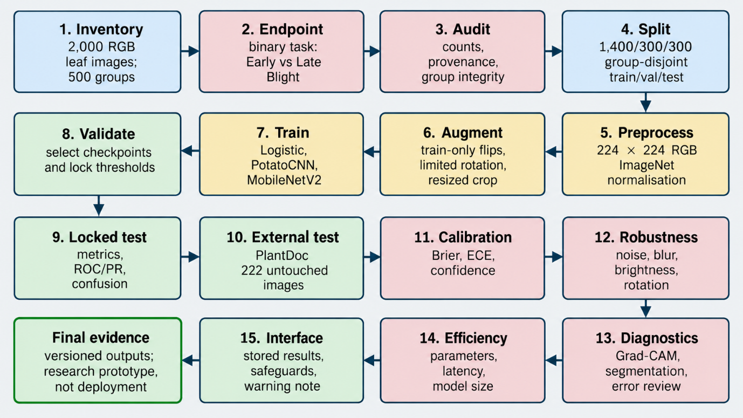
The proposal centred on a balanced PlantVillage subset, 224 x 224 preprocessing and a lightweight CNN. The feedback-incorporated implementation keeps that core while correcting leaf-level leakage risk and broadening the evidence: official leaf-group-aware splitting, exact/near duplicate audits, a traditional logistic baseline, MobileNetV2 transfer learning, consistent Late-positive metrics, conditional class weighting, validation-locked thresholds, McNemar tests, Grad-CAM/features, calibration, ablation, segmentation and controlled perturbations, plus an untouched PlantDoc external evaluation. A guarded probability-and-warning prototype and explicit five-V/governance artefacts complete the communication layer.
Table 2. Implemented change log
Area | Initial plan | Feedback-incorporated implementation | Reason
Partitioning | Image-level stratification | Official leaf-group-aware split before augmentation | Removes same-leaf leakage across partitions
Models | Lightweight CNN | Logistic baseline + PotatoCNN + MobileNetV2 | Adds traditional and transfer comparators
Metrics/semantics | Core metrics | Late=positive; conditional class weighting; locked thresholds; McNemar | Removes label/weight ambiguity
Robustness/generalisation | Synthetic sensitivity discussion | Perturbations + segmentation + untouched PlantDoc evaluation | Tests domain shift directly
Interface/governance | Static visualisations | Guarded probability prototype + 5Vs/provenance/risk/architecture evidence | Addresses communication and governance feedback

Governance requires thresholds to be tied to both model and input representation. For original colour images, validation selected 0.70 for logistic regression, 0.38 for PotatoCNN and 0.64 for MobileNetV2; those values were frozen before internal test evaluation and were not tuned on PlantDoc. The segmented-image experiment uses a separately validation-calibrated operating point because segmentation shifts the score distribution. Mixing thresholds or choosing them from final test labels would be a methodological error. Stored threshold curves are explanatory evidence, not permission for retrospective optimisation.

3.2 Project evidence and team records
The evidence package is organised around machine-readable artefacts: group-aware split CSVs, duplicate audits, model histories, validation thresholds, final internal predictions, paired McNemar tests, calibration and robustness outputs, segmentation results, PlantDoc external predictions/metrics, checkpoints/joblib, figures, environment/provenance documents and a manifest. These files make result claims traceable. Team-management evidence is intentionally represented only by templates because names, Jira/GitHub ownership, reviews and contribution records must be supplied from authentic project activity rather than inferred from the notebook.

3.3 Status against coordinator expectations
Against the coordinator feedback, the analytical requirements are implemented: users/value and five-V context are documented; architecture and tool alternatives are explicit; traditional and transfer baselines are present; group leakage is corrected; positive-class semantics and class-weight logic are fixed; explainability and external validation evidence are included; and a guarded interface contract is provided. Remaining gaps concern real collaboration evidence and any future production or field deployment, neither of which should be fabricated in the report.

3.4 Delivery sequence and milestone control
The delivery sequence now follows dependency order: pin and audit sources; identify underlying leaves; create group-disjoint frozen splits; fit the logistic, custom and MobileNetV2 models using training data only; select checkpoints and thresholds from validation evidence; run the locked internal test; then perform diagnostics, perturbations, segmentation and untouched PlantDoc evaluation. This order reduces leakage and makes the external result an evaluation of a frozen system rather than another tuning opportunity.
The high initial accuracy created a quality-control trigger rather than an early stopping point. The team needed to ask whether leakage, background regularity, threshold tuning or an easy test population explained the score. The duplicate audit, deterministic evaluation, misclassification export and segmentation/corruption tests are responses to that trigger. This is a useful project-management pattern: define conditions that cause additional validation. A board issue can link the unexpected result to the investigation tasks and their acceptance criteria. Closing that issue requires evidence, not only a statement that the score ‘looks correct.’

3.5 Roles, review and decision ownership
Decision ownership should be attached to actual team evidence at submission. The technical package supplies clear review points: a data owner can sign off the leaf-group split and provenance; a model owner can sign off training/checkpoint logic; an evaluation reviewer can verify positive-class definitions, thresholds and external isolation; and a safety reviewer can verify interface warnings and claim boundaries. The final report keeps placeholders for names and links rather than inventing them.
Important decisions should have both an owner and reviewer in the authentic project record. Examples include defining Late Blight as the positive class, using official leaf-group IDs before augmentation, disabling class weighting because the training set is balanced, selecting checkpoints and thresholds only on validation data, and keeping PlantDoc completely outside fitting/tuning. Review should reconstruct at least one metric and challenge one limitation claim. The report provides governance structure but intentionally does not invent team ownership or review history.

3.6 Evidence gaps and completion actions
The remaining project-management actions are external to the computational notebook: replace cover placeholders, add genuine project-board/repository URLs, map issues to commits or notebook sections, include peer-review evidence, and complete individual contribution/Lab records. The provided governance template can structure this information but is not itself proof that those activities occurred. This distinction protects assessment integrity.
The team should also decide which deliverable version belongs to each assessment. The 30-page Assessment 2 file should select concise progress evidence and preserve the original proposal, while the comprehensive report can support the later final submission. The presentation should demonstrate the actual interface and implementation, not future upload features. Maintaining separate release folders prevents the long report from being submitted to the wrong drop box or the presentation from linking to a private development path. A final submission owner can run the checklist, but every member remains responsible for the accuracy of their contribution page.

3.7 Quality definition
Quality is defined as more than a high clean-domain score. The implementation requires zero shared leaf groups across internal partitions; no tuning on test or PlantDoc; explicit Late-Blight-positive metrics; reproducible source/split/model artefacts; complementary accuracy, recall, specificity, F1 and AUC; model comparison; explainability and calibration; controlled stress tests; and visible reporting of the severe external-domain gap. A model can therefore pass internal accuracy yet still fail the broader readiness definition.
Completion should be based on auditable acceptance criteria: 2,000 PlantVillage images and 500 leaf groups are accounted for; train/validation/test contain 350/75/75 disjoint groups; model artefacts load; thresholds reproduce the saved comparison; the custom internal confusion matrix contains 14 errors; robustness and segmented outputs match their tables; PlantDoc predictions cover 222 external images with zero reported overlap and no tuning; and the report/prototype retain explicit scope warnings. Team links and contribution evidence must then be checked against authentic records before submission.

4. Dataset, quality and governance

4.1 Composition
The audited PlantVillage subset contains 2,000 256 x 256 JPEG images, 1,000 per class, and represents 500 underlying leaf groups. Its stored size is about 34.71 MiB. The dataset is static in this project, while an operational service would receive images individually or in batches. Variety comes from RGB appearance, orientation, segmented variants and the separate PlantDoc domain. Veracity controls include public labels, corruption checks, official leaf grouping, duplicate audits and external comparison; the intended value is preliminary Early-versus-Late triage/research, not diagnosis or treatment.
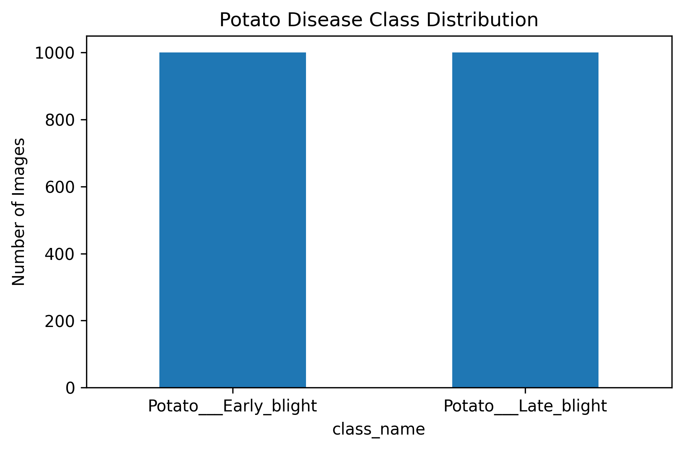
Figure 2. Balanced composition of the two-class PlantVillage potato-leaf subset.
Table 3. Dataset and split counts
Partition | Early Blight | Late Blight | Total | Leaf groups
Training | 700 | 700 | 1,400 | 350
Validation | 148 | 152 | 300 | 75
Test | 152 | 148 | 300 | 75
All | 1,000 | 1,000 | 2,000 | 500

4.2 Partitioning
Partitioning is group-aware rather than file-random. The 500 underlying leaves are split into 350 training, 75 validation and 75 test groups before augmentation. This produces 1,400 training images (700/700), 300 validation images (148 Early, 152 Late) and 300 test images (152 Early, 148 Late). The overlap audit reports zero shared leaf groups for every split pair. Validation controls model/threshold decisions; the final internal test is used once those decisions are locked.
The split is file-based. A duplicate audit reported zero exact and zero near match for Train–Validation, Train–Test and Validation–Test comparisons under the implemented method. This lowers the risk of obvious leakage. It does not establish that every image represents a biologically unique leaf. A future high-stakes study should use original-leaf grouping metadata or collect new photographs with explicit specimen identifiers, then group all views of a leaf within one partition.

4.3 Preprocessing
Source images were resized to 224 × 224. Training images were randomly flipped, rotated within a limited range and cropped with scale between 0.9 and 1.0 before conversion to tensors and ImageNet mean/standard-deviation normalization. Validation and test images were resized and normalized without random alteration. Although the network was not pretrained, ImageNet statistics provide a consistent channel scale. The fitted model, transform sequence and decision threshold must remain coupled; a change in resize, color order or normalization produces a new system that requires validation.
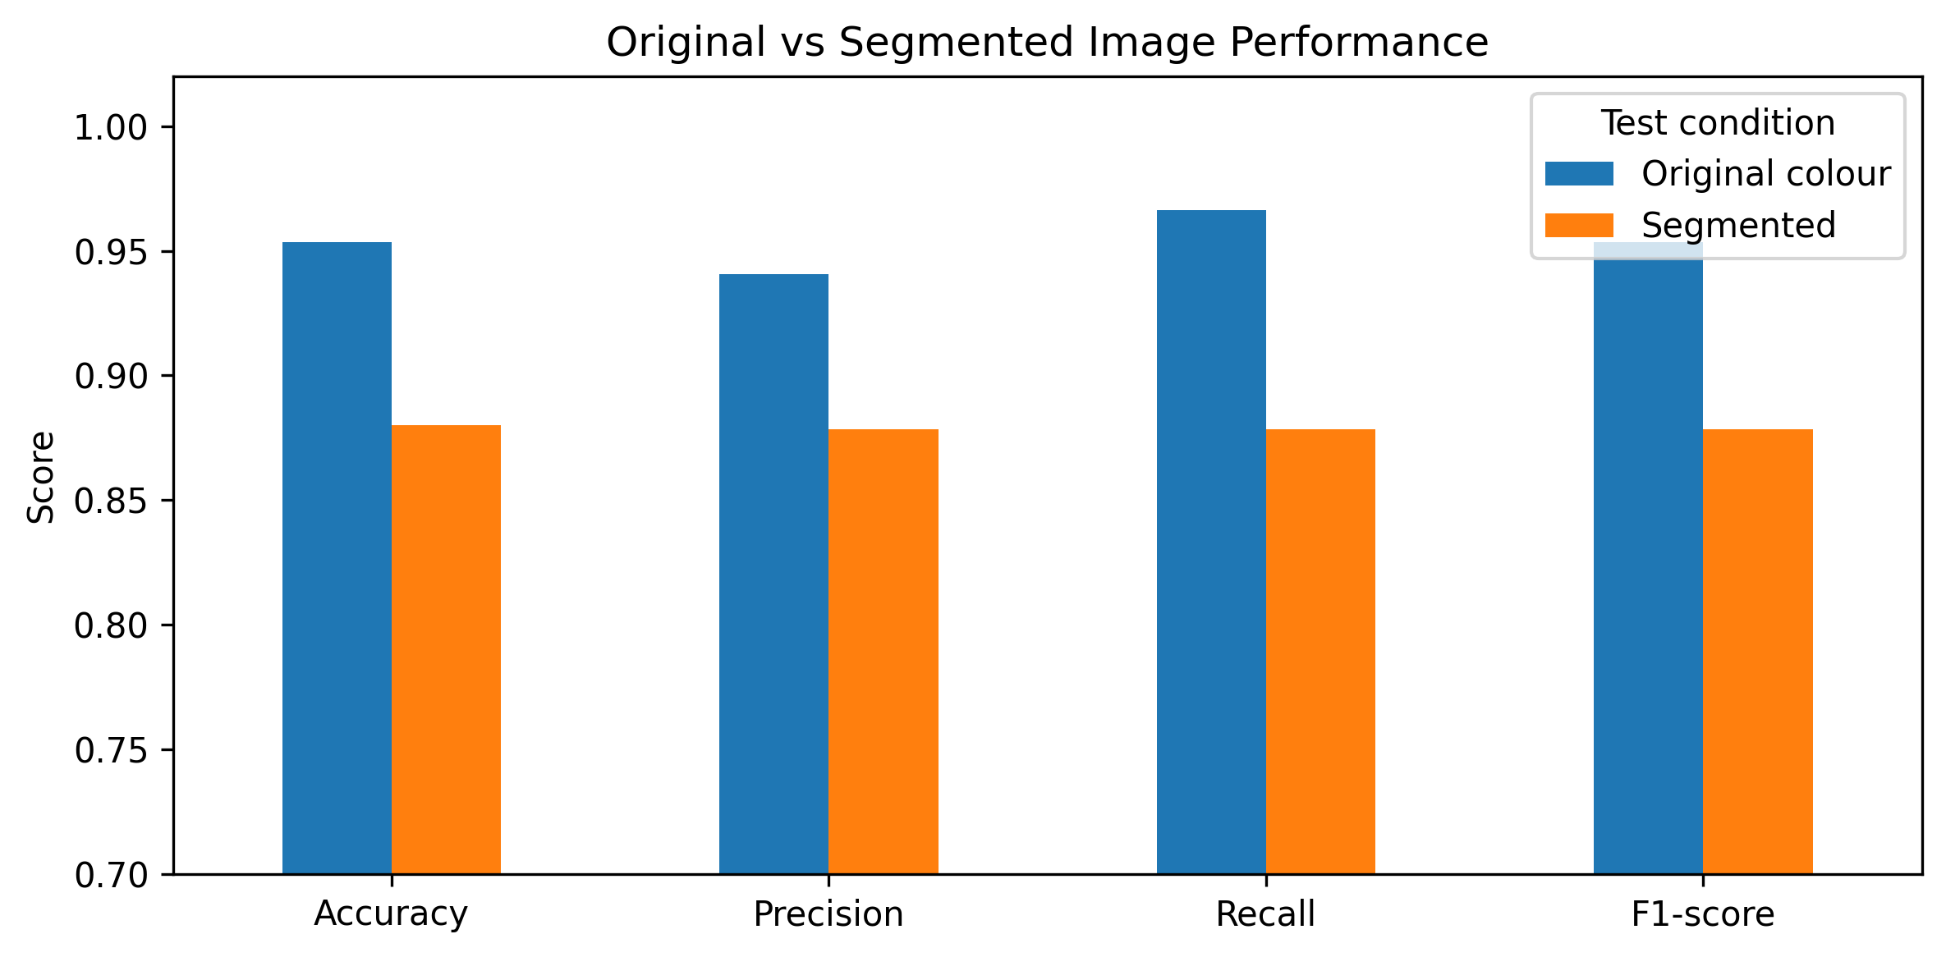
Figure 3. Comparison of primary colour-image performance and validation-calibrated segmented-image performance.

4.4 Data provenance, licensing and privacy
The primary PlantVillage repository is pinned at commit 7f7ecc7e1eaca78107e3affe7cb5abd9427e139a. No explicit LICENSE file was visible in the pinned repository, so redistribution terms should be confirmed with the dataset owner rather than assumed from public accessibility; the associated PlantVillage/Mohanty publications remain cited. The external PlantDoc source is pinned at commit 5467f6012d78d1c446145d5f582da6096f852ae8 and is documented as CC BY 4.0. The images contain plants rather than people, but a future field service could still collect farm, location or device metadata requiring consent, minimisation and retention controls.

5. Model and experimental method

5.1 Pipeline architecture
The final architecture is: pinned PlantVillage/PlantDoc sources -> source and count audit -> immutable raw records -> five-V audit and official leaf-group IDs -> versioned group-disjoint train/validation/test splits -> training-only augmentation -> traditional logistic, custom CNN and MobileNetV2 experiments -> validation-only checkpoint/threshold decisions -> locked PlantVillage test plus untouched PlantDoc evaluation -> error, Grad-CAM, feature, calibration, ablation, segmentation, robustness and efficiency evidence -> versioned CSV/PNG/model/environment/manifest outputs -> optional probability-and-warning prototype. Production would add authentication, file validation, encrypted transport, model registry, audit logging, drift monitoring, retention limits and expert feedback.

5.2 Architecture and optimization
PotatoCNN is a 93,377-parameter binary network using 224 x 224 RGB inputs, three convolutional blocks (32/64/128 channels), ReLU, 2 x 2 max pooling and dropout 0.30 before a one-logit output. BCEWithLogitsLoss is used without class weighting because the training classes are balanced, and Adam uses learning rate 0.001. MobileNetV2 provides the transfer-learning comparator through a staged head-training and fine-tuning schedule. The logistic baseline uses downsampled grayscale pixels. These three approaches deliberately span traditional, compact bespoke and pretrained representations.
The final custom-CNN run stopped after 15 epochs under validation-loss early stopping; its best validation loss occurred at epoch 10 (0.0348), with validation accuracy 0.9900 and F1 about 0.9902. MobileNetV2 trained for eight epochs, with the first four focused on the classification head and later epochs fine-tuning pretrained features; its final validation F1 was approximately 0.9967. The checkpoints are selected from validation evidence rather than from the held-out test, and the report does not interpret small differences between training epochs as external generalisation evidence.
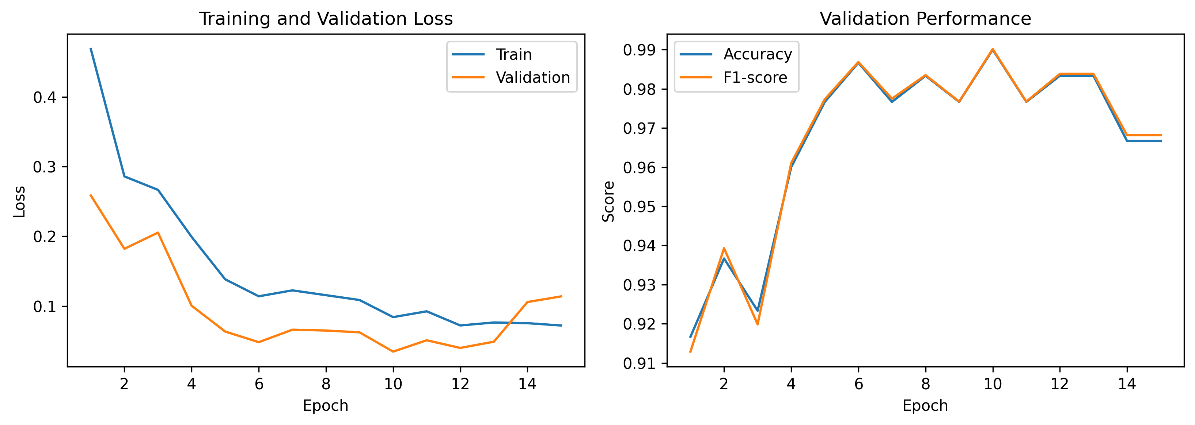
Figure 4. Final custom-PotatoCNN training history with validation-driven checkpoint selection and early stopping.

5.3 Primary evaluation
Each model generates a Late-Blight probability on the frozen internal test. Accuracy, Late precision/recall/F1, Early specificity, balanced accuracy, ROC-AUC and average precision are reported from the same prediction vectors. Validation-selected thresholds are applied without test retuning. MobileNetV2 is the strongest internal model, but the custom CNN remains central to diagnostics because it is the lightweight architecture used for detailed robustness, segmentation, calibration and Grad-CAM analyses. External PlantDoc metrics are reported separately to prevent controlled-domain and transfer performance from being conflated.

5.4 Threshold protocol
Validation-only threshold selection produced 0.70 for the logistic baseline, 0.38 for PotatoCNN and 0.64 for MobileNetV2. For PotatoCNN, the prespecified 0.50 threshold and validation-selected 0.38 threshold had the same 0.9533 test accuracy; the selected threshold slightly increased Late-Blight recall to 0.9662 while precision became 0.9408, yielding F1 0.9533. The locked threshold remains 0.38 because it is the validation-defined operating point. No threshold was tuned on PlantDoc.
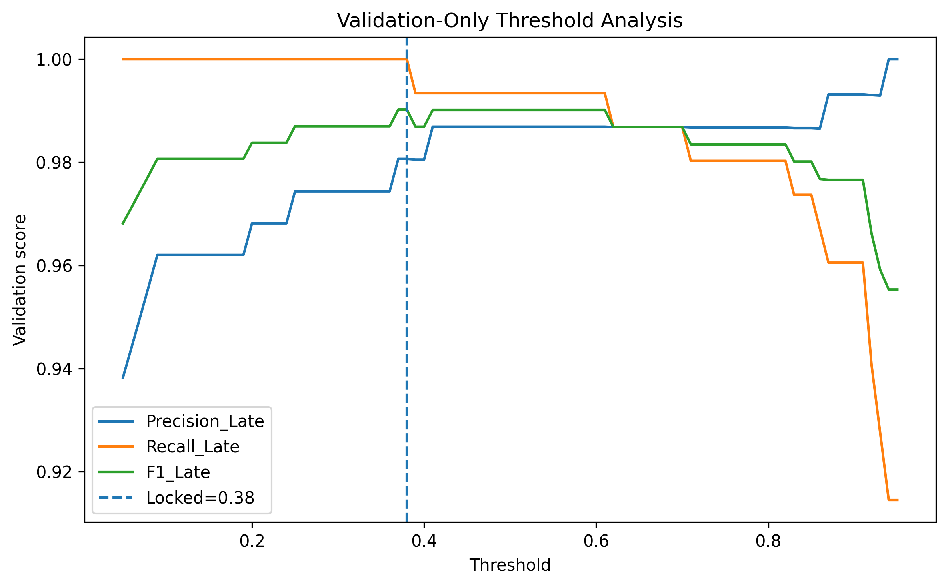
Figure 5. Validation-only threshold analysis for the custom PotatoCNN.

5.5 Interpretability and feature analysis
The custom model's 14 internal test errors (9 false positives and 5 false negatives) are saved with filenames and probabilities for direct inspection. Grad-CAM overlays show regions that influenced Early- or Late-Blight predictions, while PCA/t-SNE views describe the learned feature space. These visualisations are diagnostic rather than causal: attention can fall on leaf texture, lesions, edges or background, and a visually plausible heatmap does not prove pathogen-specific reasoning. The clean feature separation must also be interpreted alongside the external PlantDoc collapse.
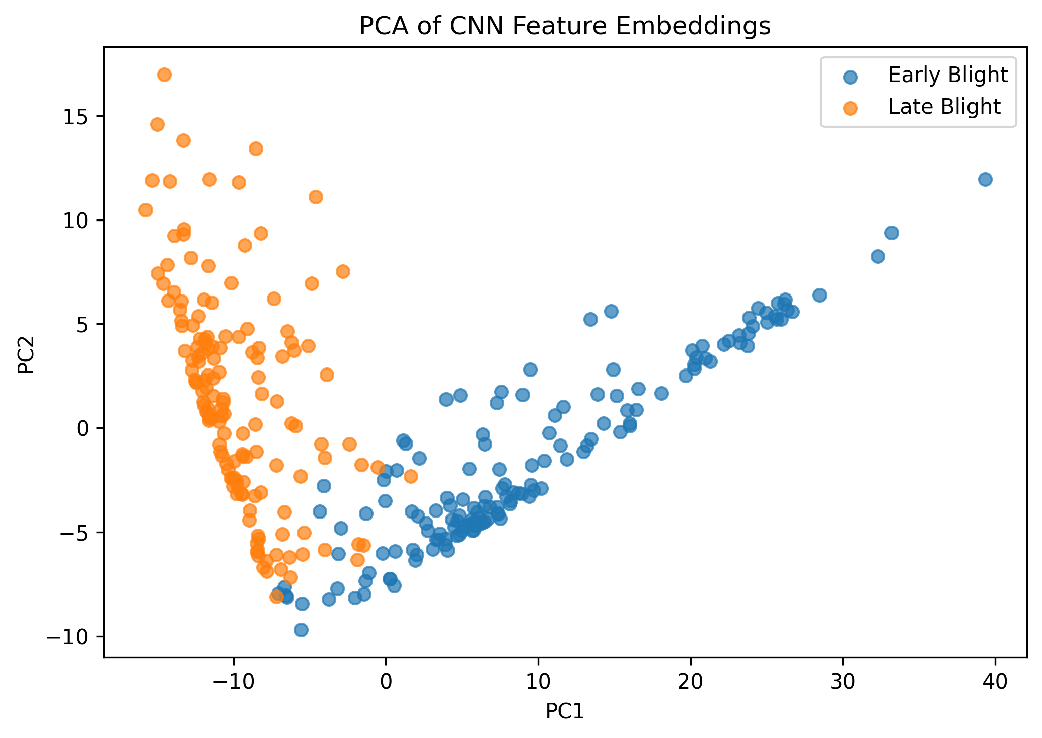
Figure 6. PCA projection of learned custom-PotatoCNN test features in the controlled domain.

5.6 Calibration and confidence
Calibration and confidence are analysed from the frozen custom-CNN probability vector and displayed with a reliability diagram and class-probability distributions. High internal confidence is not treated as evidence of field certainty, because the PlantDoc result demonstrates that score behaviour changes strongly under domain shift. For future deployment, calibration would need to be estimated on representative validation data, checked across acquisition conditions and coupled to abstention or human escalation when confidence or input quality is insufficient.
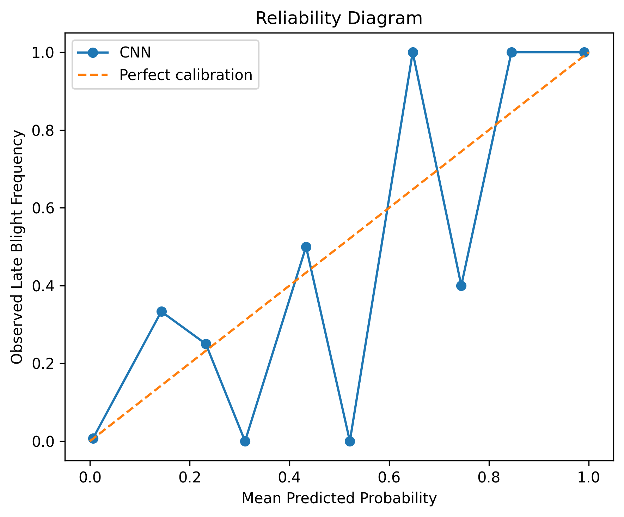
Figure 7. Reliability diagram for custom-PotatoCNN Late-Blight probabilities on the internal test set.

5.7 Ablation
The four regularisation ablations all perform very strongly in the controlled validation experiment. No augmentation + no dropout reached accuracy 0.9967 and F1 0.9967 over 15 epochs; augmentation + no dropout reached 0.9933/0.9935 over 14 epochs; no augmentation + dropout 0.9933/0.9935 over 15; and augmentation + dropout 0.9933/0.9935 over 14. The tiny differences show that this internal domain is easy for the candidate architecture; they do not justify removing regularisation from a field-oriented model.
Table 4. Regularisation ablation
Configuration | Accuracy | F1 | Epochs
No augmentation + no dropout | 0.9967 | 0.9967 | 15
Augmentation + no dropout | 0.9933 | 0.9935 | 14
No augmentation + dropout | 0.9933 | 0.9935 | 15
Augmentation + dropout | 0.9933 | 0.9935 | 14

5.8 Robustness protocols
Robustness is evaluated in three distinct ways. First, the custom model is tested on controlled darkness, brightness, contrast, blur, rotation and Gaussian noise while keeping the locked threshold. Second, background-segmented images are evaluated first with the ordinary decision rule and then with a threshold selected only on segmented validation data, exposing representation-induced score shift. Third, all frozen models are evaluated on 222 untouched PlantDoc images with no external fitting or threshold selection. Only the last experiment provides independent-domain evidence, and even it is limited by sample size and collection characteristics.

6. Responsible prediction interface

6.1 Design and intended use
The feedback-incorporated notebook includes an optional Gradio prototype for single-image demonstration. It loads the saved custom PotatoCNN, applies the validated colour preprocessing, returns Early- and Late-Blight probabilities, identifies the predicted class and adds a low-confidence flag when maximum probability is below 0.75. The prototype is disabled by default (LAUNCH_DEMO=False) and is not required to reproduce the report. Static report-ready figures remain the authoritative communication artefacts for the assessed results.
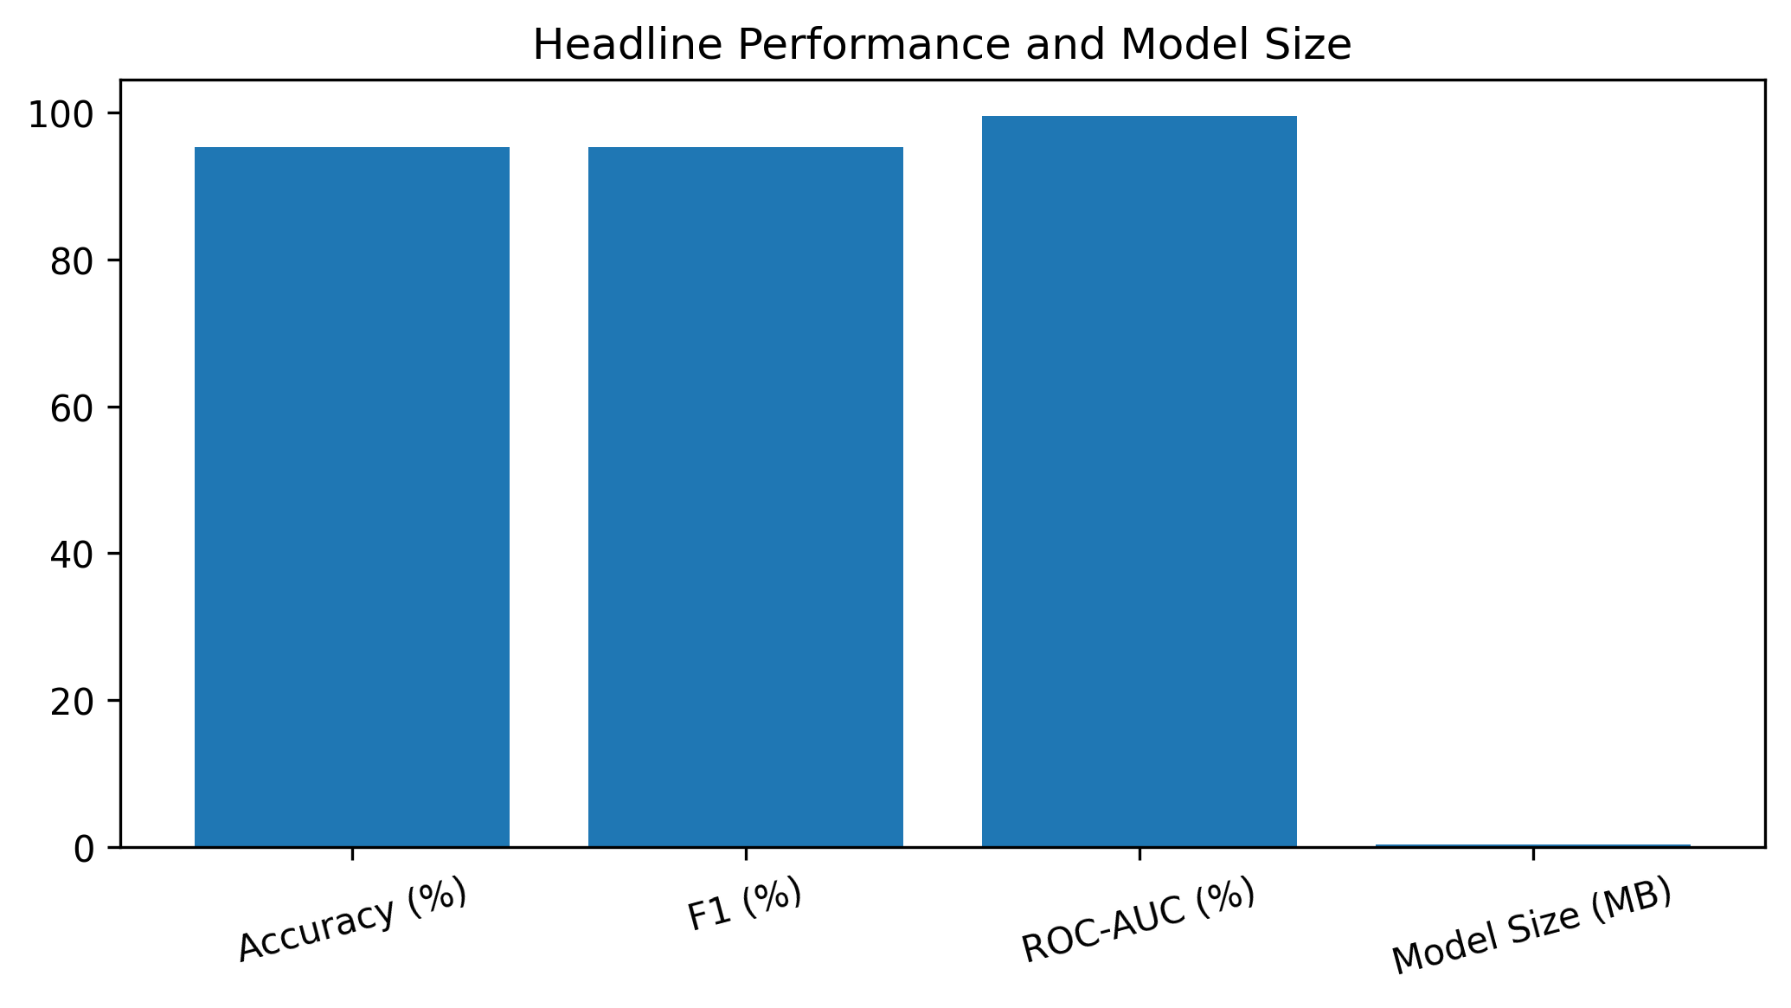
Figure 8. Feedback-integrated headline evidence summary for the potato-blight implementation.

6.2 Safeguards and verification
The interface warning states that only Early and Late Blight are represented and that the output is a proof-of-concept model prediction, not diagnosis or treatment advice. This warning is supported by the external evidence: even the best internal MobileNetV2 model falls to 0.5856 accuracy and 0.4831 F1 on PlantDoc. The prototype does not use PlantDoc to tune itself, does not claim to detect Healthy/Other conditions and should not be used to select agronomic treatment. Future live use would also require image-quality validation, security, model/version display and expert escalation.
Verification is limited to artefact consistency and function behaviour. The saved thresholds are 0.70/0.38/0.64 for logistic/custom/MobileNetV2; internal model-comparison CSVs reproduce the reported scores; leaf-group overlap is zero; and PlantDoc remains untouched by fitting. Any future user-facing deployment should additionally validate upload formats, decoded dimensions, colour channels, exposure/focus, out-of-distribution behaviour and safe failure modes. Those capabilities are future requirements, not present-tense claims.

7. Results

7.1 Primary held-out performance
The internal held-out comparison contains 300 group-isolated PlantVillage images. Logistic regression achieved accuracy 0.9100, Late precision 0.8903, recall 0.9324, F1 0.9109 and ROC-AUC 0.9624. PotatoCNN achieved accuracy 0.9533, precision 0.9408, recall 0.9662, specificity 0.9408, F1 0.9533 and ROC-AUC 0.9952. MobileNetV2 achieved accuracy 0.9967, precision 1.0000, recall 0.9932, specificity 1.0000, F1 0.9966 and ROC-AUC 1.0000. This is strong evidence of separation within the controlled PlantVillage domain after leaf-group isolation, not evidence of field readiness.
Table 5. Internal test metrics for Custom PotatoCNN and MobileNetV2
Metric | Custom PotatoCNN | MobileNetV2
Accuracy | 0.9533 | 0.9967
Precision (Late) | 0.9408 | 1.0000
Recall (Late) | 0.9662 | 0.9932
F1 (Late) | 0.9533 | 0.9966
ROC-AUC | 0.9952 | 1.0000
Validation-locked threshold | 0.38 | 0.64

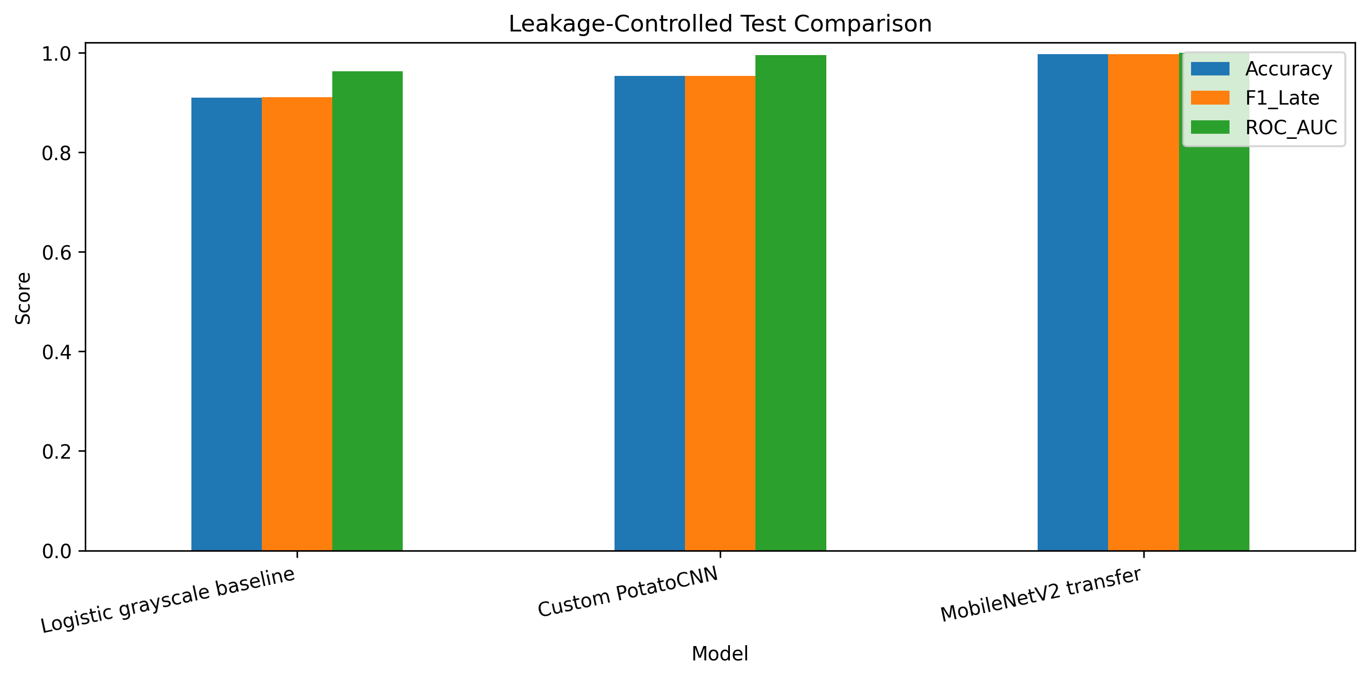
Figure 9. Internal held-out comparison of logistic regression, custom PotatoCNN and MobileNetV2 at locked thresholds.
For the custom PotatoCNN, the final confusion matrix contains 143 true Early predictions, 9 Early images incorrectly predicted Late, 5 Late images incorrectly predicted Early and 143 true Late predictions. Corresponding class metrics are balanced around F1 0.9533. MobileNetV2 makes only one internal error: 152 true Early, zero false positives, one false negative and 147 true Late. The gap is not just descriptive: exact McNemar p=0.0010 for Custom versus MobileNetV2, while Logistic versus Custom p=0.0241 and Logistic versus MobileNetV2 p<0.000001.
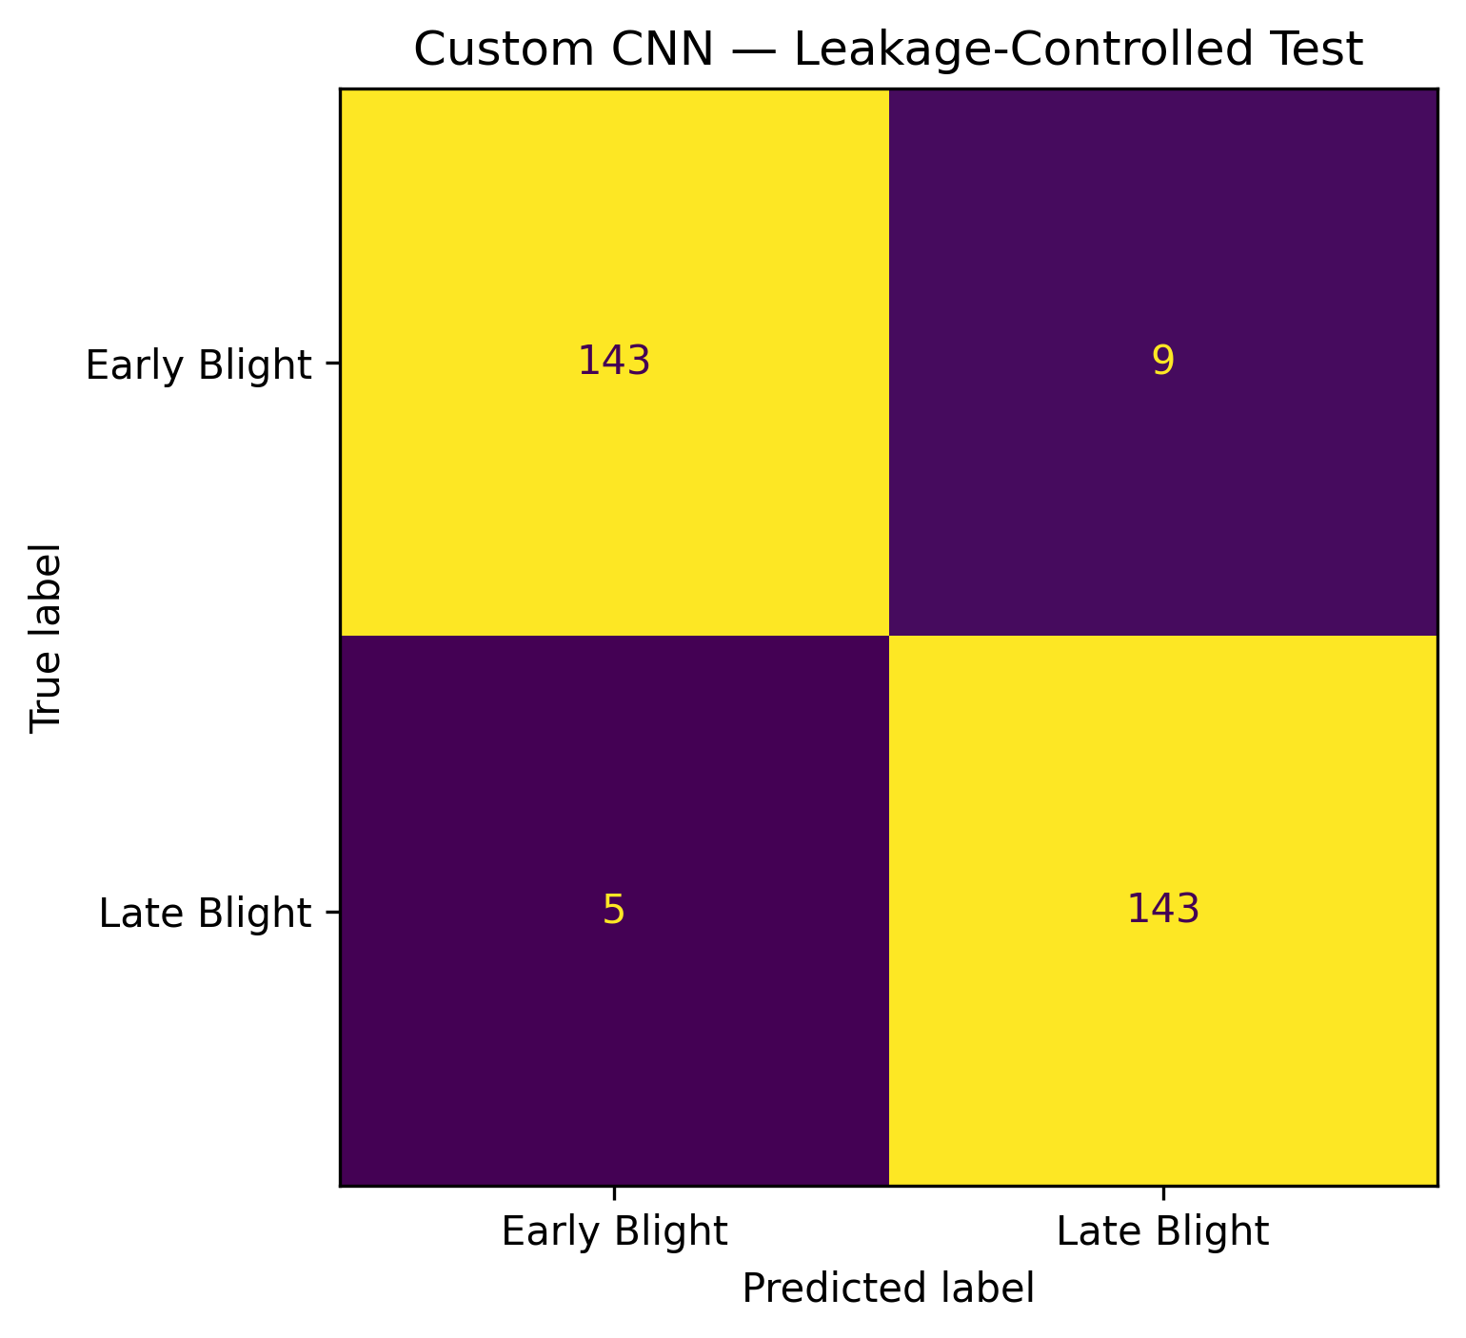
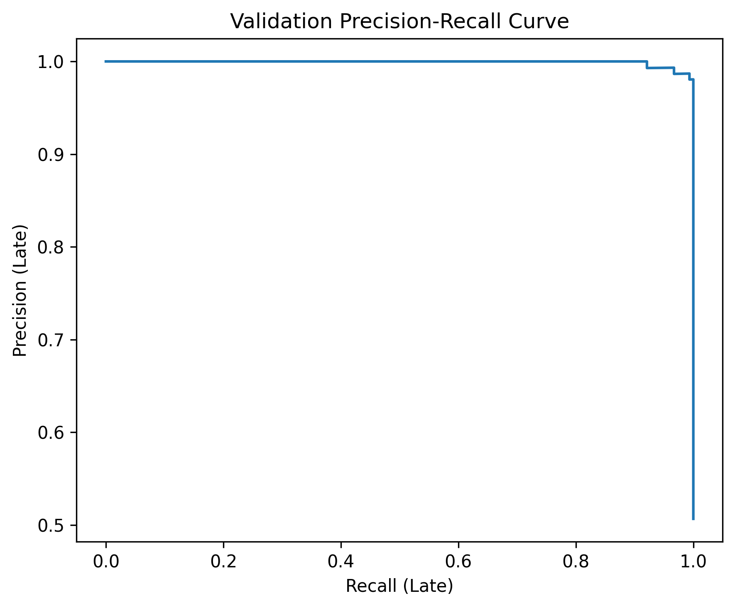
Figure 10. Custom PotatoCNN confusion matrix on the 300-image leaf-group-isolated internal test set at threshold 0.38.

Figure 11. Precision-recall curve for the custom PotatoCNN on the locked internal PlantVillage test.

7.2 Error analysis and Grad-CAM
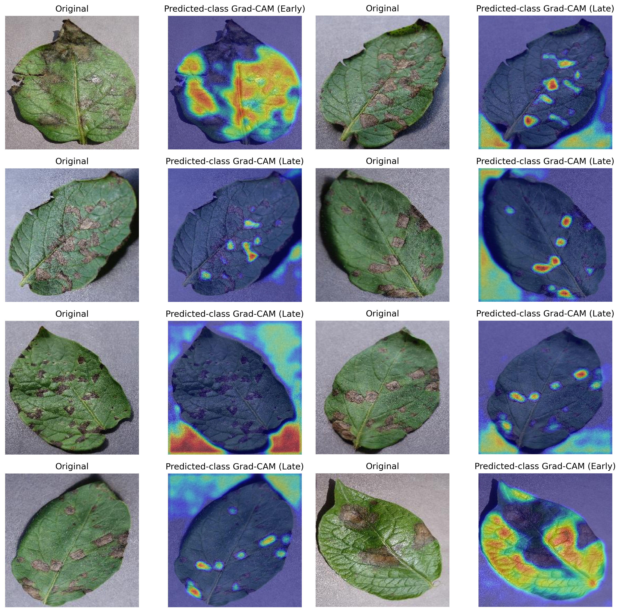
Figure 12. Predicted-class Grad-CAM examples; highlighted regions indicate model sensitivity rather than confirmed pathology.
The custom model makes 14 internal errors rather than the five reported in the earlier run. Error rows retain filenames, true labels, probabilities and predictions so failure cases can be reviewed directly. Nine are false positives and five are false negatives. Grad-CAM examples show that the network sometimes concentrates on plausible lesion regions but can also respond to broader leaf or background structure. The external PlantDoc result is therefore a more important generalisation check than visual plausibility on a few internal examples.
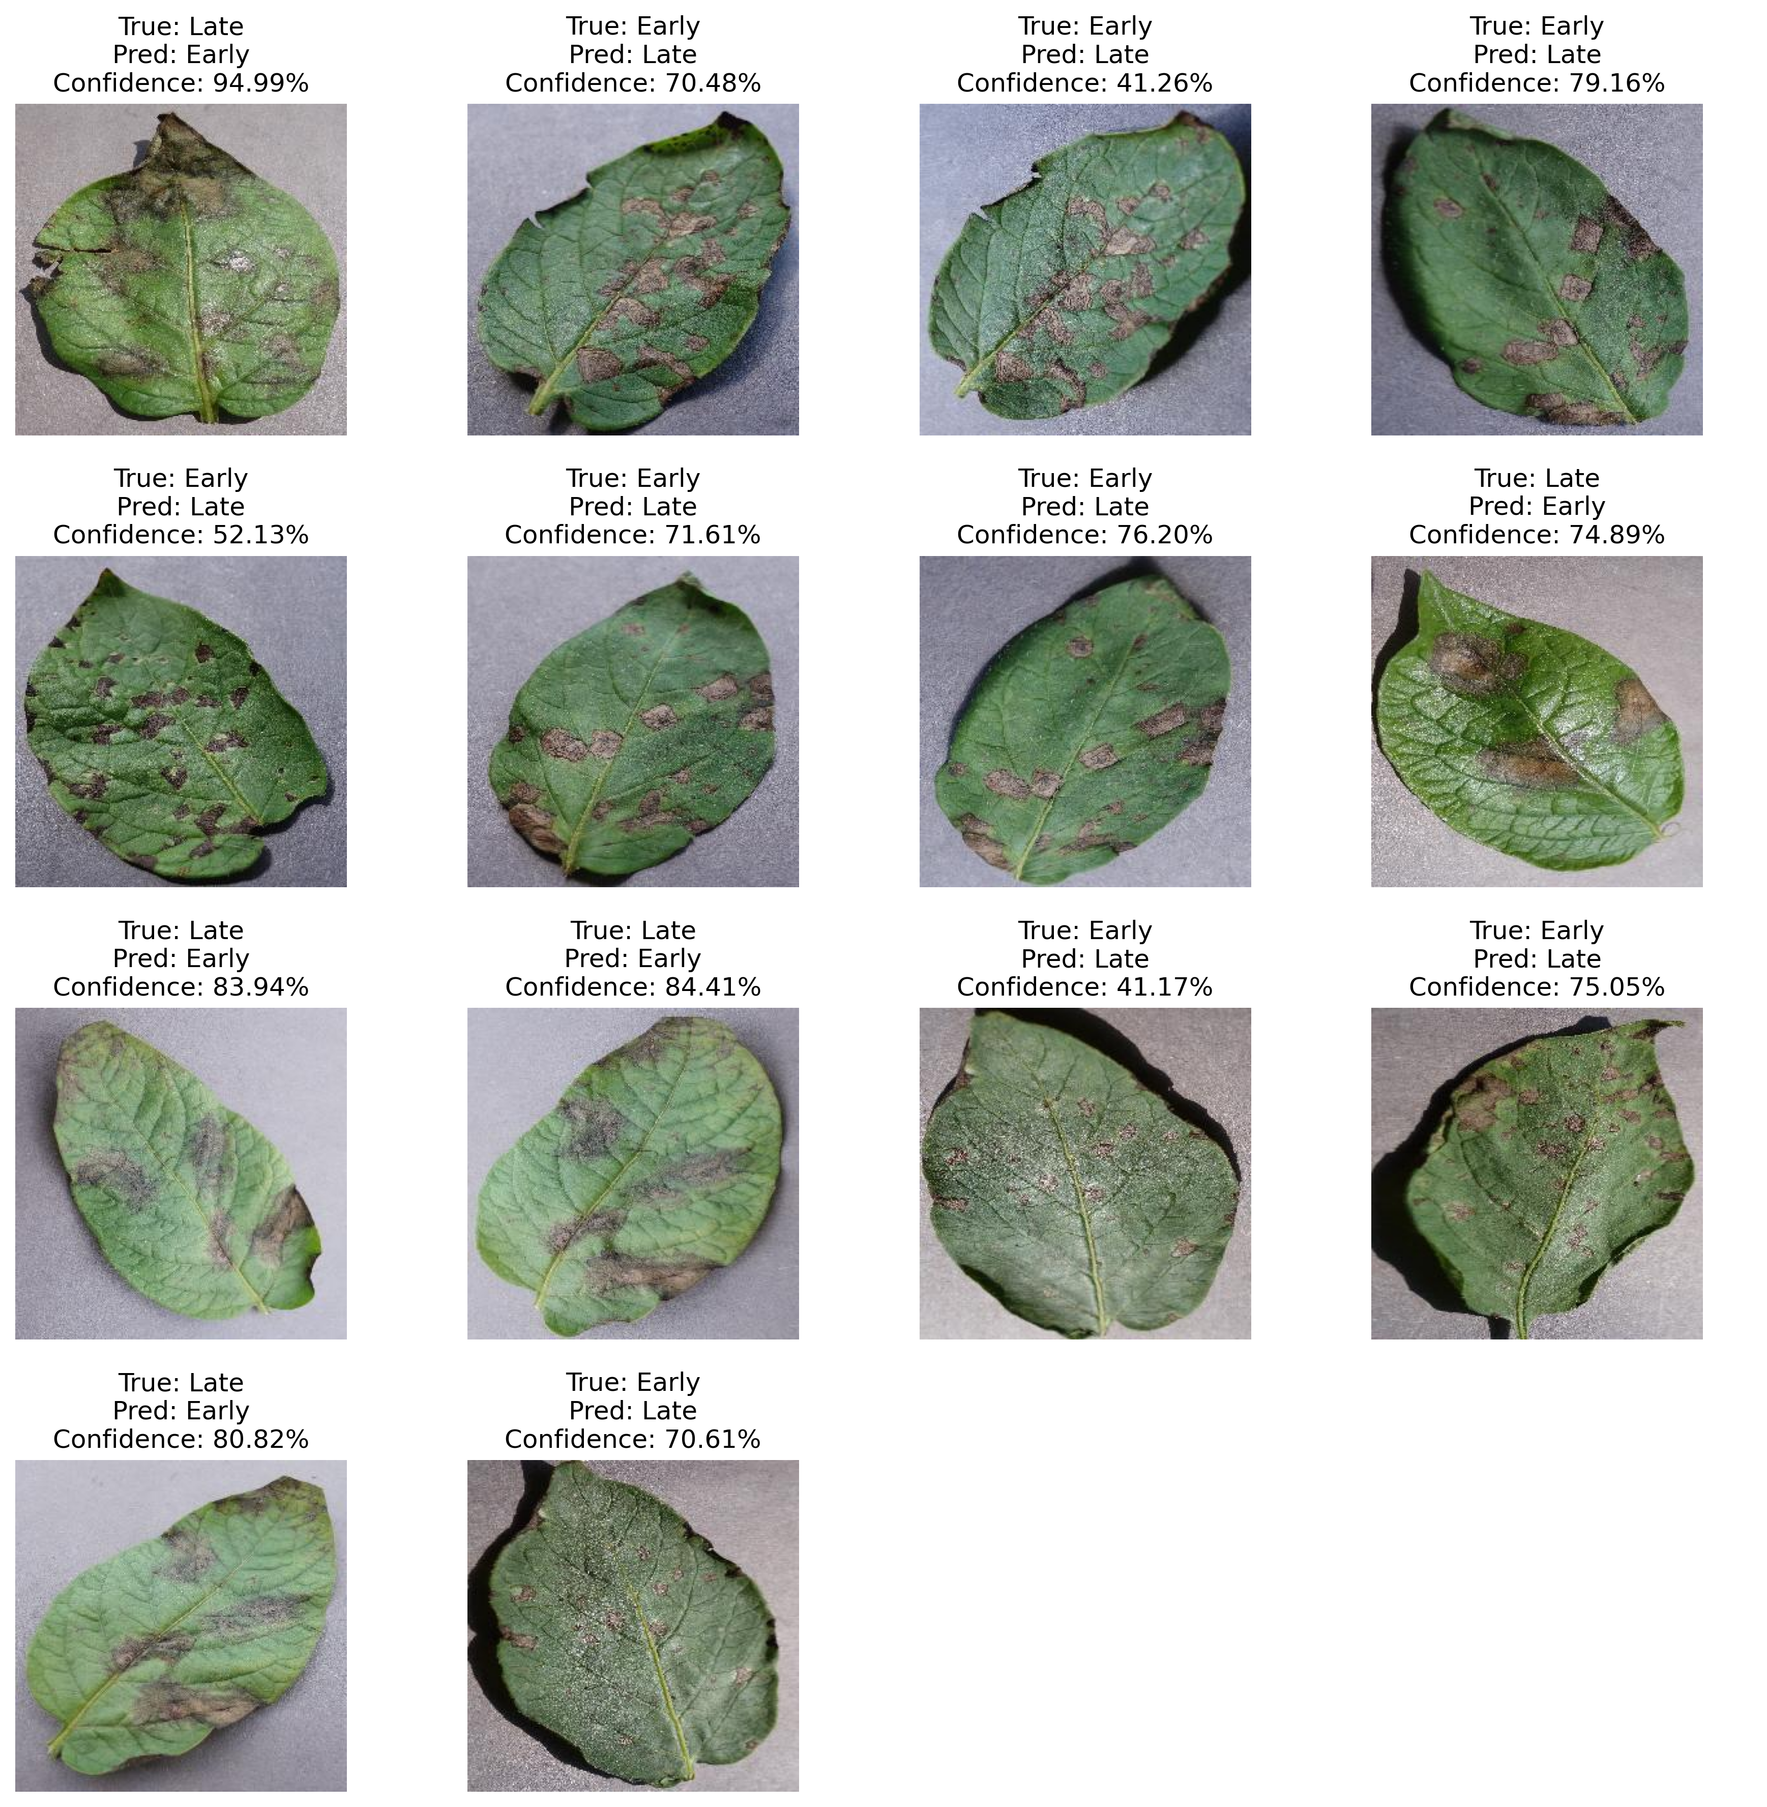
Figure 13. Representative custom-PotatoCNN misclassifications with true label, prediction and probability.
Grad-CAM on misclassified cases often emphasised lesion-bearing regions, but some attention spread to leaf edges and broader structure. The maps support the view that the classifier uses meaningful visual content while also revealing possible reliance on shape or background boundaries. They cannot distinguish whether attention within a lesion corresponds to the pathogen-specific cue a human expert would use. A stronger validation would collect lesion masks or expert explanations and test whether saliency overlaps them better than chance.

7.3 Threshold stability
The final custom threshold is 0.38 from validation F1. At the prespecified 0.50 rule, test accuracy is still 0.9533 with precision and recall both about 0.9527; at 0.38, precision becomes 0.9408 and recall increases to 0.9662, yielding F1 0.9533. The similarity of these internal results indicates reasonable margin near the operating point, but the large external-domain drop shows that threshold stability inside PlantVillage is not equivalent to calibration across data sources.
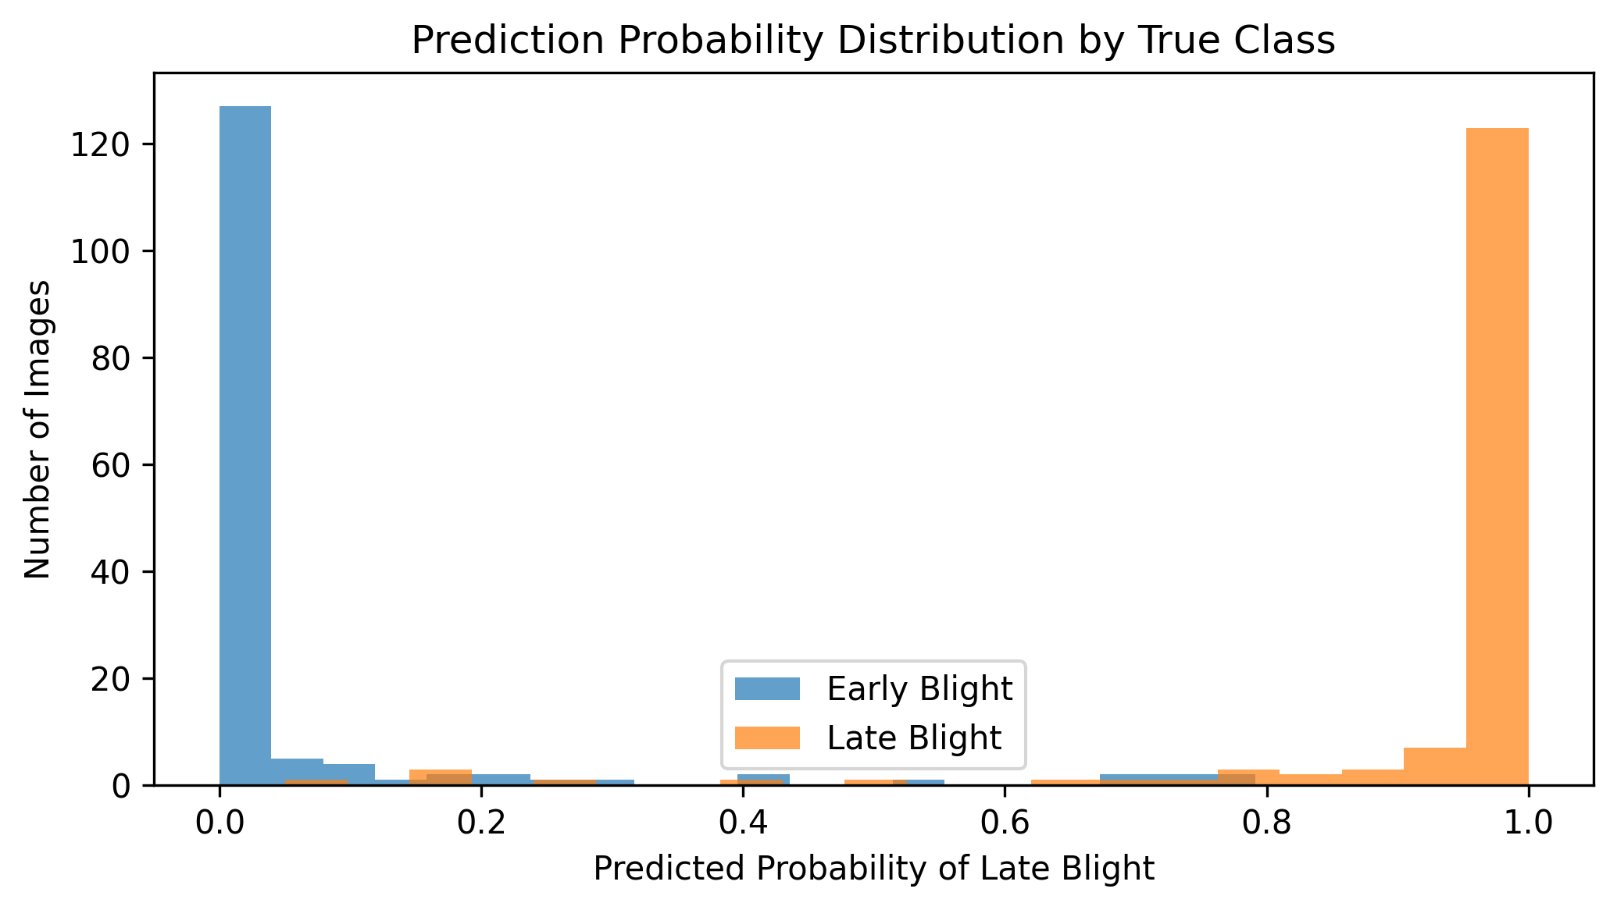
Figure 14. Distribution of custom-PotatoCNN Late-Blight probabilities by true class.

7.4 Segmented-image experiment
On segmented test images, the colour-trained custom model at the ordinary 0.50 threshold produced accuracy 0.5067 and no positive precision, recall or F1 even though ROC-AUC remained 0.9566. A representation-specific threshold selected from segmented validation data recovered accuracy 0.8800, precision 0.8784, recall 0.8784 and F1 0.8784. This is not a new primary result; it is evidence that changing preprocessing can shift probability scale enough to invalidate an existing threshold.
The segmented experiment reinforces a deployment rule: preprocessing and decision threshold must be versioned together. Recalibrating on segmented validation is methodologically acceptable for that separate representation, but its threshold must not be carried back to original colour images or selected from segmented test labels. A production pipeline should either maintain the validated colour representation or treat any segmentation change as a new model system requiring fresh validation.

7.5 Controlled perturbations
Table 6. Performance under controlled transformations
Condition | Accuracy | F1 | ROC-AUC
Original | 0.9533 | 0.9533 | 0.9952
Dark | 0.4933 | 0.6607 | 0.4951
Bright | 0.7000 | 0.5631 | 0.9761
Contrast | 0.8633 | 0.8783 | 0.9924
Blur | 0.8733 | 0.8862 | 0.9884
Rotation | 0.9500 | 0.9492 | 0.9947
Noise | 0.9500 | 0.9492 | 0.9934
At the locked custom-CNN threshold, original images achieved accuracy 0.9533, F1 0.9533 and ROC-AUC 0.9952. Darkness reduced accuracy to 0.4933 and F1 to 0.6607 with ROC-AUC 0.4951; brightness produced 0.7000/0.5631/0.9761; contrast 0.8633/0.8783/0.9924; blur 0.8733/0.8862/0.9884; rotation 0.9500/0.9492/0.9947; and Gaussian noise 0.9500/0.9492/0.9934. Darkness is the strongest failure and indicates loss of ranking, whereas brightness largely preserves ranking but shifts the fixed-threshold decision balance.
Darkness is the most severe controlled corruption: custom-CNN accuracy falls to 0.4933, F1 to 0.6607 and ROC-AUC to 0.4951, indicating loss of ranking as well as threshold performance. Brightness preserves ranking better (ROC-AUC 0.9761) but reduces F1 to 0.5631, showing strong score/threshold shift. Contrast and blur produce F1 0.8783 and 0.8862, while rotation and Gaussian noise remain near 0.9492. The pattern suggests that photometric variation is more damaging than the tested geometric/noise changes and should be investigated with representative development data rather than test-set tuning.
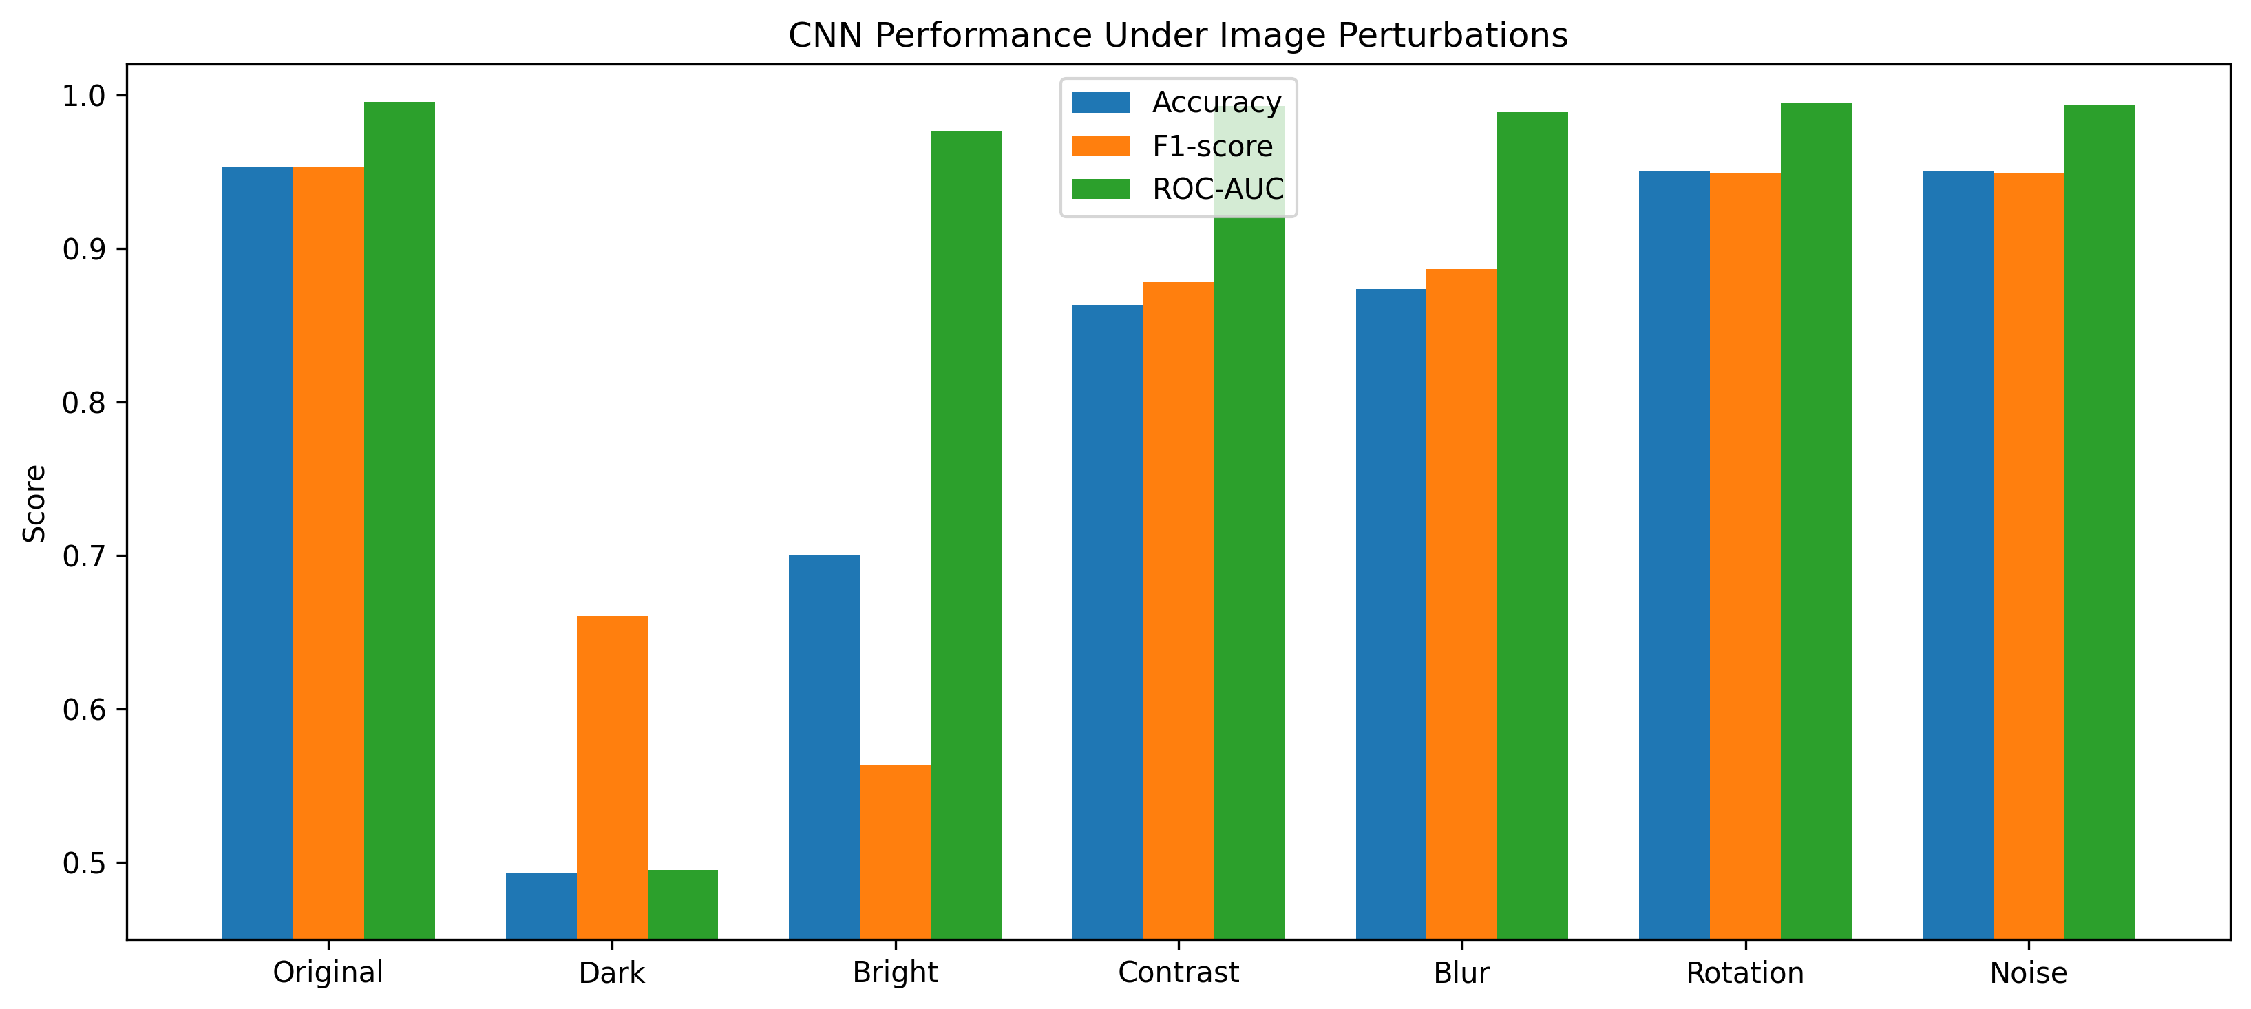
Figure 15. Accuracy, F1 and ROC-AUC under six controlled image transformations.
The robustness evidence shows why AUC and fixed-threshold metrics must be interpreted together. Under brightness, ROC-AUC remains 0.9761 while F1 falls to 0.5631; a model can preserve relative ordering yet be badly calibrated for its deployed cutoff. Darkness is more severe because both AUC and accuracy approach chance. Monitoring should therefore track image quality and score distributions, not only hard-class performance, and stress tests should be replaced by representative field data as soon as it becomes available.

7.6 External-domain evaluation and efficiency
The custom CNN is lightweight: 93,377 parameters, approximately 0.360 MB, measured latency 0.819 ms/image and throughput about 1,222 images/s in the reported CUDA environment. Efficiency alone does not establish usefulness. On the untouched 222-image PlantDoc evaluation, logistic regression achieved accuracy 0.4865 and ROC-AUC 0.5044; PotatoCNN 0.5135 accuracy, F1 0.1290 and ROC-AUC 0.5361; MobileNetV2, although best, reached only 0.5856 accuracy, F1 0.4831 and ROC-AUC 0.6210. This external gap is the strongest evidence against deployment claims.
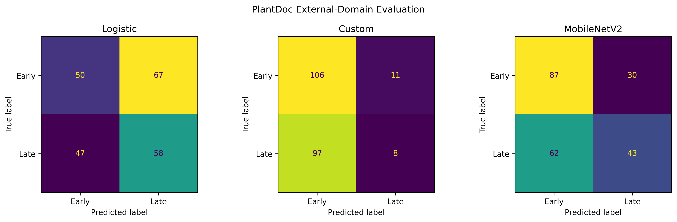
Figure 16. PlantDoc external confusion matrices for the frozen logistic, custom-CNN and MobileNetV2 models; no external fitting or threshold tuning was performed.

8. Discussion

8.1 Answer to the research question
The research question has two answers depending on the domain. Within group-isolated PlantVillage data, yes: all three models distinguish Early from Late Blight strongly, and MobileNetV2 is nearly perfect on the locked internal test. Across the independent PlantDoc source, however, performance drops sharply and even the best model reaches only 0.5856 accuracy. The scientifically defensible conclusion is therefore successful controlled-domain classification with direct evidence of poor cross-domain generalisation.

8.2 Why the clean score is credible
The internal result is more credible than the earlier run because biological grouping is now enforced before augmentation: no underlying leaf crosses train, validation or test. Thresholds are selected only on validation data, Late Blight is consistently the positive class, and pairwise McNemar tests compare predictions on the same test cases. The logistic baseline also establishes that the task has strong conventional pixel signal, while the transfer model shows additional capacity. These controls support the internal estimate without converting it into field evidence.

8.3 Why the score is not field evidence
PlantDoc demonstrates why a 99.67% internal MobileNetV2 accuracy cannot be advertised as expected farm performance. The external images differ in background, framing, acquisition and symptom presentation, and the binary two-disease scope omits Healthy/Other cases. The controlled perturbation and segmentation results independently show sensitivity to representation and score shift. This is exactly the kind of domain gap that public benchmark studies can hide if evaluation remains within one curated source.

8.4 Operational use case
The appropriate operational concept is assisted triage within a clearly defined and validated image-acquisition process. A future system could screen acceptable images, display calibrated Early/Late probabilities, abstain on low-quality or out-of-distribution cases and route uncertain cases to an agronomist. It should never imply that a binary choice excludes other diseases or determines treatment. The current evidence is sufficient for research demonstration and model-risk education, not production recommendations.

8.5 Interpretation of embeddings and heatmaps
The strong PCA separation and lesion-focused heatmaps are coherent with the classifier’s performance, but both can be overread. A background-correlated feature can produce separated embeddings, and a heatmap overlay can look persuasive regardless of whether it localises a causal symptom. The segmentation result actually warns that background and colour representation contribute to the learned decision surface. Interpretability should therefore generate questions—what region, which cases, what failure pattern—rather than certify the decision. Expert-annotated lesion masks and counterfactual occlusion would provide stronger evidence.

8.6 Comparison with prior studies
High PlantVillage accuracy is consistent with earlier deep-learning studies, including Mohanty et al. (2016), Ferentinos (2018) and Too et al. (2019). Direct ranking against their numbers would be misleading because class sets, architectures, splits and grouping differ. The present contribution is a compact two-class implementation and a critical evaluation package. Its most informative finding may be the contrast between near-perfect clean AUC and large fixed-threshold drops under simple intensity shifts. That gap turns a familiar benchmark result into a concrete lesson about deployment.

8.7 Interface value
The evidence summary and optional prototype make the generalisation lesson visible without requiring a reviewer to inspect notebook code. A demonstration can contrast MobileNetV2's 0.9967 internal accuracy with its 0.5856 PlantDoc accuracy, then show the custom model's darkness and segmentation failures. This communicates a more valuable data-science insight than a dashboard centred only on the clean benchmark score: validation design and domain representativeness matter at least as much as architecture.

8.8 Detailed interpretation of corruption behaviour
Dark and Bright conditions deserve separate interpretation because both retained high ROC–AUC but produced poor fixed-threshold decisions. Under darkness, AUC 0.9336 still indicates substantial ranking information, yet accuracy fell to 0.5200. This is consistent with a global downward score shift that changes which side of 0.50 cases occupy. Brightness produced AUC 0.9932 with accuracy 0.7667, showing an even clearer distinction between ranking and operating calibration. The result is not simply ‘the model cannot see dark leaves’; it is that the probability scale learned from original colour imagery is not stable under those transformations.
Contrast and blur reduce custom-CNN F1 to 0.8783 and 0.8862 while ROC-AUC remains above 0.988, so their threshold effect exceeds their ranking effect. Rotation and Gaussian noise retain F1 about 0.9492 and ROC-AUC above 0.993. Brightness is more revealing: AUC stays 0.9761 while F1 falls to 0.5631. Darkness is qualitatively worse because AUC itself falls to about 0.495. Together these conditions show that probability scale, fixed-threshold decisions and ranking robustness are distinct properties that should be monitored separately.
A proposed remedy must be evaluated rather than assumed. Histogram normalisation or brightness augmentation might stabilise scores, but it could also erase clinically relevant colour or intensity differences. Automatic segmentation might reduce background dependence, yet the present segmentation experiment created a severe probability shift. Training directly on a representative mix of original and transformed images is plausible, but test corruptions should not be repeatedly reused for design choices. A new development corruption set and a separate confirmation set would preserve the diagnostic value of the current results.

8.9 Decision costs and referral policy
Late Blight is the positive label throughout the final analysis so false negatives correspond to labelled Late-Blight images predicted Early. For the custom model, recall is 0.9662 (5 misses among 148 Late cases); MobileNetV2 recall is 0.9932 (1 miss). This orientation is a metric convention, not a statement that Early Blight is low consequence. A real referral policy would require agronomic input on the costs of both types of mistake, class prevalence, confirmatory pathways and the risk of unsupported Healthy/Other images. Maximum validation F1 is therefore an experimental criterion, not an operational treatment rule.
A future product should use abstention rather than forcing every image into Early or Late Blight. Low model confidence, poor image quality or out-of-distribution evidence could trigger 'review required.' The current prototype marks low confidence below 0.75 only as a demonstration; that threshold is not clinically or agronomically validated. Coverage, residual error and referral capacity would need prospective evaluation on representative field images with Healthy/Other classes.

8.10 Reproducibility and analytical restraint
The result is supported by saved partition, history and prediction artefacts, yet deep-learning execution can vary with software, device and nondeterministic operations. Reproducing the exact numerical result requires more than seed 42; it requires compatible Python, PyTorch, torchvision, CUDA, transform implementation and hardware settings. PyTorch’s reproducibility guidance notes that bitwise identity is not guaranteed across releases or platforms. A repeat should therefore compare metrics within declared tolerances and verify split and checkpoint hashes rather than assume that matching source code alone produces identical weights.
Analytical restraint also applies to the ablation. Four configurations all scored around 0.987 F1 on the same clean test set. It would be tempting to select the numerically highest row or assert that regularization is irrelevant. Differences are smaller than one test image, the configurations may have stochastic variation, and repeated viewing of the same test outcome makes it part of the design loop. The responsible conclusion is narrow: under the recorded short runs, clean-domain performance was insensitive to those two toggles. The main architecture remains justified by broader overfitting considerations and requires fresh external evaluation.

9. Ethics, privacy, security and risk

9.1 Ethical boundaries
The main ethical hazard is a false claim of diagnosis. A user may assume that a high probability confirms a pathogen and act on it. The model has only learned two dataset labels and has not been tested against healthy leaves, other disorders or field variation. Every deliverable therefore states that the work is a proof of concept and provides no treatment recommendation. Errors and transformation failures are reported beside the headline. If live inference is added, the interface should use decision-support language, invite expert confirmation and reveal when the image falls outside validated conditions.

9.2 Privacy and data rights
The public images carry low personal-privacy risk, but intellectual-property and provenance requirements still apply. Source, licence and transformations should be recorded. Future field collection may include location, property, crop-management or device information. Only data necessary for the agreed purpose should be collected; personal or farm identifiers should be separated from image identifiers, encrypted in transit and at rest, and deleted under a defined schedule. Public model demonstrations should strip metadata that can reveal GPS coordinates.

9.3 Security
A future upload application would accept untrusted files, creating risks from oversized images, malformed encodings, unsupported formats and denial of service. File type, decoded dimensions and memory limits should be checked before preprocessing. Model, normalisation and threshold must be versioned together, checkpoints should have hashes, and access logs should minimise retained image data unless authorised. The current optional Gradio prototype is a research demonstrator and does not satisfy these production controls; static CSV/figure evidence remains sufficient to reproduce the assessed conclusions without launching it.

9.4 Updated risk register
Table 7. Updated project risk register
Risk | Evidence | Impact | Current control | Next action
Field/domain shift | PlantDoc best accuracy 0.5856 | Incorrect or misleading disease support | External test + perturbations + no deployment claim | Prospective field validation
Unknown class forced binary | Only Early/Late classes | Confident irrelevant prediction | Visible class scope and warning | Healthy/Other + abstention
Leaf/data leakage | High risk in image-level splitting | Inflated internal score | Official group split before augmentation; hash audits | Preserve group IDs for all future data
Preprocessing/calibration shift | Segmentation changes score scale | Systematic threshold failure | Version transforms and thresholds together | Representative calibration/quality gates
Overconfidence | Strong internal confidence; external collapse | Automation bias | Probabilities, low-confidence flag, human escalation | Human-factors and calibration study
Version/data loss | Multiple sources/models/thresholds | Irreproducible or mismatched results | Pinned commits, splits, checkpoints, environment, manifest | Release hashes and regression checks

9.5 Contingency
If external performance is unacceptable, the test cohort should remain frozen. The team should collect a separate development set representing the failure modes, revise the training and quality-control pipeline, and reserve another confirmation set. If images fail quality checks, the system should abstain and direct the user to recapture or seek review. If model files or configuration hashes do not match, inference should stop. If a pilot increases reviewer errors through anchoring, model output should be hidden or redesigned until the combined workflow is safer than unaided review.

10. Limitations and future work

10.1 Limitations
The study remains limited to 2,000 controlled PlantVillage images and two disease classes, although the corrected leaf-group split removes a major internal leakage risk. There is no prospective farm, cultivar, seasonal or device cohort. The external PlantDoc set contains only 222 relevant images and is internet-sourced rather than a designed clinical/agronomic study. Robustness transformations and segmentation reuse the same internal leaves and therefore remain sensitivity tests. The strong PlantDoc degradation shows that domain shift is not a hypothetical limitation.

10.2 Future analytical work
- Collect field images with expert labels, device and specimen identifiers, then split by leaf, farm or acquisition session.
- Expand the target to include Healthy, Other/Unknown and relevant potato disorders, with an abstention option for inadequate images.
- Predefine a capture-quality protocol and quantify blur, exposure, leaf coverage and background shift before classification.
- Compare colour, segmented and field-trained pipelines end to end rather than changing preprocessing only at inference.
- Repeat training over multiple seeds and report uncertainty for clean and corrupted conditions.
- Evaluate probability calibration and threshold policy prospectively using explicit costs of missed and unnecessary referrals.
- Obtain expert lesion masks or symptom annotations if Grad-CAM is to support explanation, and test localisation quantitatively.
- Run a human-in-the-loop pilot measuring review time, agreement, override and downstream diagnostic confirmation.

10.3 Readiness gates
Progress toward use should be gated. Data readiness requires representative field images and specimen-level independence. Model readiness requires preregistered metrics, uncertainty, acceptable sensitivity across devices and classes, stable calibration and an unknown-input policy. Product readiness requires secure uploads, quality checks, audit logs, accessible wording and target-device timing. Governance readiness requires licensing, named accountability, change control and an incident response. Human readiness requires evidence that users understand the model and that the combined workflow improves outcomes. The current project demonstrates the controlled analytical and communication stages but does not meet every deployment gate.

10.4 Prioritisation rationale
Field data has higher priority than additional tuning on PlantVillage. The clean error rate is already five images, and the ablation shows little separation among regularization choices. Another architecture might improve one or two internal cases without addressing darkness, unknown classes or specimen dependence. A modest, well-labelled field development set with capture metadata would create more decision value because it tests the assumptions most likely to fail. The next sprint should therefore define sampling and annotation with an agronomy stakeholder before scheduling new model experiments.
The second priority is a safe rejection pathway. Quality checks and an Other/Unknown or abstention outcome reduce the harm of forcing every image into Early or Late Blight. The third is calibration and threshold policy on representative data. Live application engineering follows only after those analytical requirements are met. This order may feel slower than deploying the lightweight checkpoint immediately, but it prevents interface polish from turning a controlled benchmark into an unsupported diagnostic claim. Each priority maps directly to a failure observed or an exclusion documented in the current project.

11. Technical assurance and handover

11.1 Traceability
Each core claim has a machine-readable source: class and split summaries record 2,000 images and 500 leaf groups; the overlap audit verifies zero shared groups; training histories support checkpoint selection; model-comparison and McNemar tables support internal claims; robustness/segmentation files support sensitivity claims; and PlantDoc predictions/metrics support external-domain conclusions. Checkpoints, the logistic joblib artefact, provenance records, environment metadata and the manifest complete the reproducibility chain.

11.2 Release structure
A final handover should contain a README, environment specification, pinned-source citations/commits, versioned leaf-group splits, executable notebook/modules, the logistic joblib artefact, custom and MobileNetV2 checkpoints, thresholds, internal and PlantDoc prediction tables, diagnostics, figures, report, risk/governance records and a manifest. Team members should add only authentic repository/project-board, issue, review and contribution evidence. Temporary caches should be excluded from the release.

11.3 Regression and acceptance testing
Automated acceptance checks should assert 2,000 total PlantVillage images, 500 leaf groups, 1,400/300/300 images and 350/75/75 groups across train/validation/test, zero shared leaf groups, custom threshold 0.38, MobileNetV2 threshold 0.64 and no PlantDoc tuning. For the custom model, the expected internal confusion counts are 143 TN, 9 FP, 5 FN and 143 TP with F1 about 0.9533; for MobileNetV2 they are 152/0/1/147 with F1 about 0.9966. These checks protect against silent label-orientation and artefact mismatches.

11.4 Demonstration plan
A concise demonstration should begin with the corrected leaf-group split and explain why it matters, then compare logistic, custom and MobileNetV2 performance at locked thresholds. It should show the custom confusion matrix and Grad-CAM as internal diagnostics, then deliberately reveal the PlantDoc performance collapse and controlled darkness/segmentation sensitivity. The optional prototype can demonstrate probabilities and warnings at the end. This sequence presents the main scientific lesson rather than only the highest score.

11.5 Maintenance and monitoring
A pilot should monitor input resolution, colour distribution, brightness, blur and leaf coverage; prediction scores, positive rate and abstention; model version; reviewer overrides; and confirmed outcomes when available. Drift alerts should trigger investigation, not automatic learning from unverified labels. Every change to data, transforms, architecture, checkpoint, calibration or threshold should create a new version with an owner, rationale and rollback. Because the segmentation experiment shows how sharply scores can move, preprocessing changes deserve the same review as model changes.

11.6 Data-management lifecycle
Data should be managed in distinct layers. The source layer contains immutable PlantVillage files and original labels with licence and citation metadata. The working layer contains cached tensors, temporary segmentations and development outputs that can be recreated. The released evidence layer contains frozen split identifiers, the approved checkpoint, predictions, metrics and figures cited by the report. A data dictionary should define filepath identifier, class name, encoded label, dimensions, probability, thresholded prediction and correctness. Treating generated probability as a derived field rather than a new ground-truth label prevents circular reuse.
Release checks should validate every image identifier, label domain, partition count and probability range. They should assert that no identifier appears in more than one split, that validation and test transform pipelines contain no random augmentation, and that all figures have a source table. Original local paths such as a development drive letter should be converted to relative identifiers before repository publication. This both improves portability and avoids revealing unnecessary workstation information. Temporary augmented images need not be retained because transformations are generated during loading.

11.7 Maintainable implementation
The notebook is an effective experimental narrative, but a maintained application should extract configuration, data loading, model definition, training, prediction and evaluation into tested modules. Paths, class mapping, input size, normalisation, seed and thresholds should be declared once. The inference function should accept a decoded RGB image, apply the exact evaluation transform, load a named checkpoint and return a structured result containing score, class, model version and quality status. This reduces dependence on notebook cell order and prevents a stale variable from silently affecting output.
Unit tests can use synthetic arrays to verify that Late Blight is encoded as 1, logits become probabilities correctly, threshold equality is handled consistently, confusion-matrix orientation matches report labels, and confidence uses the predicted class. A small integration fixture can load a few known images and compare probabilities within tolerance. Tests should also confirm that segmented and original thresholds cannot be accidentally exchanged. Logging should avoid personal or farm data and should record configuration and input-quality summaries sufficient to reproduce an incident.

11.8 Statistical uncertainty
The 300-image internal test contains 14 errors for the custom CNN and only one for MobileNetV2, so the latter point estimate is necessarily uncertain despite being high. More importantly, same-source sampling uncertainty is smaller than the observed domain uncertainty: MobileNetV2 accuracy falls from 0.9967 internally to 0.5856 on PlantDoc. Future evaluation should therefore report confidence intervals within each cohort but prioritise independent, prospectively designed field cohorts over increasingly precise estimates on PlantVillage.
Comparisons between corruption conditions also reuse the same images, which is statistically efficient but paired. Apparent differences should be interpreted with paired uncertainty rather than independent-sample tests. Repeated random training seeds would add another variance component. For deployment assessment, a hierarchical analysis could separate variation across farms, devices, leaves and repeated views. The clean result is sufficiently strong to support the proof of concept, but formal uncertainty becomes essential if the team needs to claim a minimum acceptable field sensitivity.

11.9 Alternative explanations
An alternative explanation for the internal result is that the two PlantVillage classes contain acquisition, background or symptom-stage cues that are consistent within the repository. The PlantDoc evaluation supports this concern directly because the same frozen models lose substantial performance when those contextual regularities change. Another possibility is that endpoint symptoms are easier than early or mixed presentations. A prospective field study should stratify severity, cultivar, device and site and should include Healthy/Other classes to test these hypotheses.
Another explanation is that the two selected disease folders contain highly characteristic late-stage examples. An image model may perform well on those endpoints while failing on early symptoms, mixed infections or similar disorders. Severity-stratified expert labels would reveal this. The present binary task also omits healthy leaves, so high Early-versus-Late separation says nothing about disease detection. A future two-stage system might first assess whether the image is a valid potato leaf and whether it resembles any supported condition, then classify disease only when appropriate. Each stage would need its own evaluation.

11.10 External field-study protocol
A credible field study should be designed before collecting results. Sampling should cover more than one location, cultivar, growth stage, device and lighting condition. Each physical leaf needs a unique group identifier, and all views of a leaf must remain in the same partition. Reference labels should be assigned by qualified experts, with laboratory confirmation where feasible and an adjudication procedure for disagreement. Healthy leaves and common alternative diagnoses should be included so the classifier can be evaluated in a realistic candidate set rather than only between two known diseases.
Development and confirmation sites should be separated. The existing model can first be frozen and evaluated prospectively to measure transportability. If it fails, a field development cohort may support adaptation, but an untouched confirmation cohort must remain. Primary metrics should be declared in advance—likely class sensitivity, specificity, referral rate and calibration—with subgroup reporting by device and site. Image-quality rejection and abstention should be counted as outcomes rather than silently excluded. The evaluation should report how many cases the system can safely handle as well as accuracy on accepted images.
Human evaluation should accompany technical evaluation. Agronomists or trained reviewers can assess batches in randomised order with and without model support. Outcomes include review time, diagnostic agreement, confidence, override behaviour and confirmed errors. A model that improves individual accuracy but creates automation bias or excessive referrals may not improve the service. User interviews should test whether the wording ‘indicative classification’ and the limitations are understood. Data collection requires an approved privacy and consent process for any farm or participant information.

11.11 Product requirements for live inference
A future web or mobile product should have explicit functional requirements: accept or capture one image; validate type, dimensions, colour, focus and exposure; identify unsupported or out-of-distribution inputs; show the exact supported classes; return calibrated probabilities plus quality/abstention status; display model/version; offer expert escalation; and record consented feedback separately from training labels. Non-functional requirements include security, accessibility, latency on target devices, auditability, deletion/retention and rollback. The current Gradio prototype demonstrates only a small probability-and-warning subset of this design.
The user experience should discourage anchoring. The interface might show capture-quality feedback before revealing a class, or ask a reviewer to record an initial assessment before model output. Colour should not imply medical certainty, and probabilities should be calibrated or described as model scores. Grad-CAM should be optional and labelled as attention, because a vivid heatmap can create more trust than its evidence warrants. These requirements convert the ethical discussion into testable product behaviour.

11.12 Project management and collaboration evidence
Technical completion does not demonstrate teamwork by itself. The group should maintain a task board with backlog, in-progress, review and done states; assign owners and acceptance criteria; link issues to commits or notebook sections; and record decisions such as the segmented-threshold protocol. Pull requests or peer-review notes can show that another member checked label orientation, leakage, metrics and claims. A change log should state when a proposal item changed, why, who agreed and which artefact supplies evidence. These records support the unit outcome on nuanced project management.
Contribution statements should describe actual decisions and artefacts rather than generic claims. For example, one member may own the leaf-group/provenance audit, another modelling, another external/robustness analysis, another interface/testing and another governance/report integration - but only if the project records support those roles. Issues, commits, reviews and board items should be linked at submission time. The report intentionally leaves placeholders rather than inferring who completed which task.

11.13 Sustainability and accessibility
The custom model is resource-proportionate at approximately 0.360 MB and 0.819 ms measured latency per image in the supplied CUDA environment. MobileNetV2 is larger but provides much stronger internal accuracy; nevertheless, its PlantDoc result shows that spending more computation is not a substitute for representative data. Sustainable experimentation should cache predictions, regenerate figures from stored tables and avoid unnecessary retraining. Accessibility requirements for any future interface include keyboard use, readable text, non-colour-only cues and mobile/low-bandwidth behaviour.
Accessibility also applies to scientific communication. The report and static evidence figures remain usable when the optional prototype is not launched. A future mobile interface should use plain-language warnings, avoid traffic-light certainty cues and make the two-class limitation visible before a result is interpreted. Localisation and testing with target growers/agronomists would be needed before field use.

11.14 Demonstration failure contingencies
The demonstration should not depend on a live web service. If the optional Gradio prototype cannot launch, the same claims can be shown from the saved headline summary, comparison figures, PlantDoc confusion matrices and CSV tables. If a checkpoint cannot load, stored prediction records preserve the completed evaluation. These fallbacks maintain access to verified evidence without pretending that a missing live component was part of the validated system.

11.15 Submission checklist
- Replace names, IDs, dates, repository and project-board placeholders with authentic information.
- Add one genuine Lab 1 completion screenshot and contribution page per student where Assessment 2 requires them.
- Confirm that the final report is used for the correct assessment; Assessment 2 remains a 30-page consolidated progress submission.
- Update Word fields, inspect the searchable PDF, verify word count, references, figure captions and hyperlinks.
- Test the report-ready figures, saved CSVs and optional Gradio prototype on the demonstration computer; keep static screenshots/figures as the authoritative fallback.
- Keep field accuracy, diagnosis, treatment, external-validation and causality claims within the boundaries stated in this report.

12. Conclusion
The feedback-incorporated project delivers a complete Early-versus-Late-Blight evidence pipeline: pinned data sources, 500-leaf group-aware splitting, zero shared groups, training-only augmentation, a traditional logistic baseline, compact PotatoCNN, MobileNetV2 transfer learning, validation-only thresholds, locked internal comparison, paired tests, error/Grad-CAM/feature diagnostics, calibration, ablation, segmentation and corruption sensitivity, efficiency measurement, untouched PlantDoc external evaluation and a guarded probability-and-warning prototype.
Internal PlantVillage performance is strong after leakage correction. Logistic regression reached 0.9100 accuracy and F1 0.9109; PotatoCNN reached 0.9533 accuracy and F1 0.9533; MobileNetV2 reached 0.9967 accuracy, 0.9932 Late-Blight recall, F1 0.9966 and ROC-AUC 1.0000 with one false negative. The custom model's validation-locked threshold is 0.38 and MobileNetV2's is 0.64. These results support excellent separability within the controlled source.
External and stress-test evidence defines the boundary of that success. On untouched PlantDoc, MobileNetV2 fell to 0.5856 accuracy, F1 0.4831 and ROC-AUC 0.6210; custom PotatoCNN was near chance by accuracy and had F1 0.1290. Darkness and representation changes also shifted behaviour substantially. The correct conclusion is therefore not field-ready disease diagnosis, but a reproducible controlled-domain classifier whose re-implementation clearly demonstrates the importance of specimen-group leakage control, external validation, calibrated abstention and human oversight.

References
Barbedo, J. G. A. (2018). Impact of dataset size and variety on the effectiveness of deep learning and transfer learning for plant disease classification. Computers and Electronics in Agriculture, 153, 46–53. https://doi.org/10.1016/j.compag.2018.08.013
Ferentinos, K. P. (2018). Deep learning models for plant disease detection and diagnosis. Computers and Electronics in Agriculture, 145, 311–318. https://doi.org/10.1016/j.compag.2018.01.009
Guo, C., Pleiss, G., Sun, Y., & Weinberger, K. Q. (2017). On calibration of modern neural networks. Proceedings of the 34th International Conference on Machine Learning, 70, 1321–1330. https://proceedings.mlr.press/v70/guo17a.html
Hendrycks, D., & Dietterich, T. (2019). Benchmarking neural network robustness to common corruptions and perturbations. International Conference on Learning Representations. https://openreview.net/forum?id=HJz6tiCqYm
Hughes, D. P., & Salathé, M. (2015). An open access repository of images on plant health to enable the development of mobile disease diagnostics. arXiv. https://doi.org/10.48550/arXiv.1511.08060
Krizhevsky, A., Sutskever, I., & Hinton, G. E. (2012). ImageNet classification with deep convolutional neural networks. Advances in Neural Information Processing Systems, 25. https://proceedings.neurips.cc/paper/2012/hash/c399862d3b9d6b76c8436e924a68c45b-Abstract.html
LeCun, Y., Bengio, Y., & Hinton, G. (2015). Deep learning. Nature, 521, 436–444. https://doi.org/10.1038/nature14539
Mohanty, S. P., Hughes, D. P., & Salathé, M. (2016). Using deep learning for image-based plant disease detection. Frontiers in Plant Science, 7, 1419. https://doi.org/10.3389/fpls.2016.01419
Paszke, A., Gross, S., Massa, F., Lerer, A., Bradbury, J., Chanan, G., Killeen, T., Lin, Z., Gimelshein, N., Antiga, L., et al. (2019). PyTorch: An imperative style, high-performance deep learning library. Advances in Neural Information Processing Systems, 32. https://proceedings.neurips.cc/paper/2019/hash/bdbca288fee7f92f2bfa9f7012727740-Abstract.html
PlantVillage Dataset. (n.d.). PlantVillage dataset repository. GitHub. https://github.com/spMohanty/PlantVillage-Dataset
PyTorch Contributors. (2026). Reproducibility. PyTorch documentation. https://docs.pytorch.org/docs/stable/notes/randomness.html
Savary, S., Willocquet, L., Pethybridge, S. J., Esker, P., McRoberts, N., & Nelson, A. (2019). The global burden of pathogens and pests on major food crops. Nature Ecology & Evolution, 3, 430–439. https://doi.org/10.1038/s41559-018-0793-y
Selvaraju, R. R., Cogswell, M., Das, A., Vedantam, R., Parikh, D., & Batra, D. (2017). Grad-CAM: Visual explanations from deep networks via gradient-based localization. Proceedings of the IEEE International Conference on Computer Vision, 618–626. https://openaccess.thecvf.com/content_ICCV_2017/html/Selvaraju_Grad-CAM_Visual_Explanations_ICCV_2017_paper.html
Shorten, C., & Khoshgoftaar, T. M. (2019). A survey on image data augmentation for deep learning. Journal of Big Data, 6, 60. https://doi.org/10.1186/s40537-019-0197-0
Too, E. C., Yujian, L., Njuki, S., & Yingchun, L. (2019). A comparative study of fine-tuning deep learning models for plant disease identification. Computers and Electronics in Agriculture, 161, 272–279. https://doi.org/10.1016/j.compag.2018.03.032
van der Maaten, L., & Hinton, G. (2008). Visualizing data using t-SNE. Journal of Machine Learning Research, 9, 2579–2605. https://jmlr.org/papers/v9/vandermaaten08a.html

Singh, D., Jain, N., Jain, P., Kayal, P., Kumawat, S., & Batra, N. (2020). PlantDoc: A dataset for visual plant disease detection. Proceedings of the 7th ACM IKDD CoDS and 25th COMAD, 249-253. https://doi.org/10.1145/3371158.3371196
Sandler, M., Howard, A., Zhu, M., Zhmoginov, A., & Chen, L.-C. (2018). MobileNetV2: Inverted residuals and linear bottlenecks. Proceedings of the IEEE Conference on Computer Vision and Pattern Recognition, 4510-4520.

Appendix A. Individual work and contribution pages
Duplicate the following one-page template for every student. Replace all prompts with authentic evidence and keep each student’s page concise. These pages are intentionally incomplete because no member identities, Lab 1 screenshots, contribution records, or repository links were supplied.

A.1 Team member 1 – [INSERT NAME AND STUDENT ID]
Laboratory 1 evidence | [INSERT SCREENSHOT SHOWING LAB NAME, SCORE, COMPLETION STATUS, DATE AND TIME]
Project contribution | [DESCRIBE SPECIFIC TASKS, DECISIONS, TESTING AND DELIVERABLES]
Clickable evidence | [INSERT COMMIT / PULL REQUEST / ISSUE / NOTEBOOK / ARTEFACT LINKS]
Professional reflection | [WHAT WAS LEARNED, WHAT CHANGED, AND WHAT WOULD BE IMPROVED]

A.2 Team member 2 – [INSERT NAME AND STUDENT ID]
Laboratory 1 evidence | [INSERT SCREENSHOT SHOWING LAB NAME, SCORE, COMPLETION STATUS, DATE AND TIME]
Project contribution | [DESCRIBE SPECIFIC TASKS, DECISIONS, TESTING AND DELIVERABLES]
Clickable evidence | [INSERT COMMIT / PULL REQUEST / ISSUE / NOTEBOOK / ARTEFACT LINKS]
Professional reflection | [WHAT WAS LEARNED, WHAT CHANGED, AND WHAT WOULD BE IMPROVED]

A.3 Team member 3 – [INSERT NAME AND STUDENT ID]
Laboratory 1 evidence | [INSERT SCREENSHOT SHOWING LAB NAME, SCORE, COMPLETION STATUS, DATE AND TIME]
Project contribution | [DESCRIBE SPECIFIC TASKS, DECISIONS, TESTING AND DELIVERABLES]
Clickable evidence | [INSERT COMMIT / PULL REQUEST / ISSUE / NOTEBOOK / ARTEFACT LINKS]
Professional reflection | [WHAT WAS LEARNED, WHAT CHANGED, AND WHAT WOULD BE IMPROVED]

A.4 Team member 4 – [INSERT NAME AND STUDENT ID]
Laboratory 1 evidence | [INSERT SCREENSHOT SHOWING LAB NAME, SCORE, COMPLETION STATUS, DATE AND TIME]
Project contribution | [DESCRIBE SPECIFIC TASKS, DECISIONS, TESTING AND DELIVERABLES]
Clickable evidence | [INSERT COMMIT / PULL REQUEST / ISSUE / NOTEBOOK / ARTEFACT LINKS]
Professional reflection | [WHAT WAS LEARNED, WHAT CHANGED, AND WHAT WOULD BE IMPROVED]

A.5 Team member 5 – [INSERT NAME AND STUDENT ID]
Laboratory 1 evidence | [INSERT SCREENSHOT SHOWING LAB NAME, SCORE, COMPLETION STATUS, DATE AND TIME]
Project contribution | [DESCRIBE SPECIFIC TASKS, DECISIONS, TESTING AND DELIVERABLES]
Clickable evidence | [INSERT COMMIT / PULL REQUEST / ISSUE / NOTEBOOK / ARTEFACT LINKS]
Professional reflection | [WHAT WAS LEARNED, WHAT CHANGED, AND WHAT WOULD BE IMPROVED]

