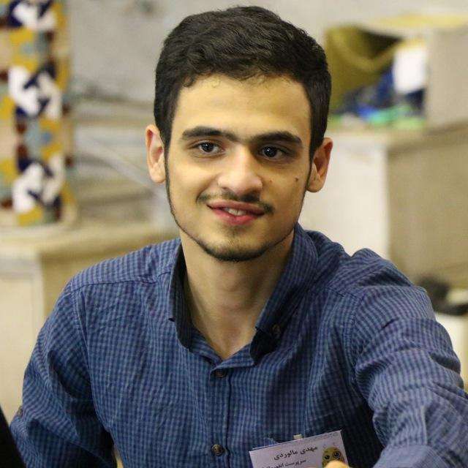Resume

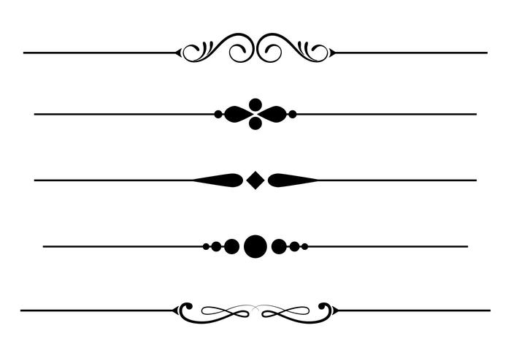

|  |  |  |
| --- | --- | --- |
| Name |  | Mahdi Malverdi |
| Phone |  | +989130196238 - +989033445111 |
| Email |  | Mahdi.Malverdi@Gmail.com |
| |  |  |  |  | | --- | --- | --- | --- | | [C:\Users\Mahdi\Downloads\github.png](https://github.com/mahdimalverdi) | [C:\Users\Mahdi\Downloads\linkedin.png](https://www.linkedin.com/in/mahdi-malverdi-996b1787/) | [C:\Users\Mahdi\Downloads\telegram.png](https://telegram.me/mahdimlv) | [C:\Users\Mahdi\Downloads\envelope.png](mailto:Mahdi.malverdi@gmail.com) | | | |



|  |  |
| --- | --- |
| Interests and professional activities | .Net Framework  Web development  Android development |



|  |  |  |
| --- | --- | --- |
| Work experience | https://quera.ir/media/public/profile/company_logo/6458155ea8e2dfdc0532b0de73ddb7cab6bfe36a.png  https://quera.ir/media/public/profile/company_logo/4215a57f49b9ac1288c87e55a9839d00a51858e7.png | Developer  Acctechco  From July 2018 to Present  Web Developer  MrMotarjem  From January 2017 to July 2017 |



|  |  |  |
| --- | --- | --- |
| Education | https://quera.ir/media/public/logos/7407653cf5e5470297bd7db9b8b244c7.png  https://quera.ir/media/public/logos/5269ccdb21b8485b98a3dbd5c1d348ff.png  https://quera.ir/media/public/logos/5269ccdb21b8485b98a3dbd5c1d348ff.png | Bachelor  Software Engineering  University Of Isfahan  From 2016 to now  High school  Mathematical Physics  Ezhei Hight school  From 2012 to 2016  The Junior School  Ezhei The Junior School  From 2009 to 2012 |



|  |  |  |
| --- | --- | --- |
| Project records | Asp.Net Mvc | * [C:\Users\Mahdi\Downloads\github.png](https://github.com/mahdimalverdi/BarmanCup2018)BarmanCup Website   BarmanCup.ir   * BistAfagh Website   [C:\Users\Mahdi\Downloads\github.png](https://github.com/mahdimalverdi/MyCalendar)20Visions.ir   * MyCalendar |
| Asp.Net Core | * Rayoo   Turn.rayoo.life   * PatchTools * General Solution |
| Windows Form | * BistAfagh Automation * HR AccTech |
| Qt C++ | * [C:\Users\Mahdi\Downloads\github.png](https://github.com/mahdimalverdi/Steganography)[C:\Users\Mahdi\Downloads\github.png](https://github.com/mahdimalverdi/WebCrawler)WebCrawler * Steganography |
|  | Python | * ERPNext |

