Irrigation Water Optimizer Decision Support Tool
Approach
Irrigation is one of the significant inputs of crop production. Crop production can greatly reduce if the water need of the plants is not met or if excess water is applied. Therefore, it is important to know the water need of the plants. The crop water production function shows the mathematical relationship between the obtained marketable yield and the amount of water used by the plants based on evapotranspiration (Varzi, 2016). Crop production can increase with applied irrigation, but to a certain extent, crop yield starts declining after the threshold of water need is passed (English, 1990). Since the groundwater sources are depleting and the sustainability of irrigation is at stake (Scanlon et al., 2012), the need for optimized irrigation management is more than ever to feed the growing population.
Crop water production functions help inform us of the amount of water needed to get the highest possible yield of a crop and help us determine the yield of a crop if we have limited access to water resources. In addition, based on the amount of water we have, we can select crop species to maximize crop production. Therefore, this irrigation water optimizer (IWO) tool will accommodate major crops grown in imperial county of southern California to help growers in the region make an informed decision on the selection of crops, irrigation application, and the expected yield.
The mathematical relationship between crop yields and their water need will be developed using results from irrigation management studies in the region or in place with similar soil and climatic conditions. The water production function model developed from these findings will be used to develop an interactive graphical user interface. Users will be able to input the crop of their interest, amount of water they have access to, soil texture, water salinity and production cost of the crop, which will help to predict the crop water need and potential yield. This tool will be free to access, and users will be benefited and be able to make an informed decision to make their farming profitable.
IWO Tool
Crop-specific Irrigation Recommendation
- Crop Selection: Select a crop for which you want to find out the maximum yield and irrigation water requirements.
- Irrigation Water Salinity (optional): If known, enter the amount of the salinity of the irrigation water used for irrigating the crop in the field. Otherwise, it will use the default value as 1.2dS/m.
- Soil Texture (optional): If known, select the texture of the soil in the field. The soil map (using the given link “Look up soil map”) can also be referred to check out the soil type. Else, the tool takes “Sandy Loam” as the default soil texture.
- Irrigation System (optional): If known, select the irrigation system used for irrigation. Irrigation efficiency has already been associated with the irrigation system as given in the paper (Shahrokhnia and Wu, 2021). If the user is still interested in using different value based on the field conditions, then there is an option to enter the user-defined value in the irrigation efficiency box. The common irrigation system, i.e., Flood system is used as the default one with irrigation efficiency of 68%.
- Now, click on “Find out yield and crop requirements” button to see the results.
If the data is entered randomly out of the possible values, then the tool gives a warning message to enter them within the range. Range of the inputs used in the tool are as follows:
Range of Irrigation water salinity: 0 to 2 dS/m
Range of Irrigation efficiency: 50 to 100%
Results obtained (with an assumption of ETa = ETm):
- Maximum yield (tons/ha): The actual maximum yield possible for the selected crop in tons per hectare is shown here. It is computed (Ya) using the following equation (Doorenbos and Kassam, 1979):
(1)
Where,
Ya – Actual yield of crop (tons/ha)
Ym – Maximum yield (tons/ha)
ETa – Actual Evapotranspiration (mm / growing period)
ETm – Maximum Evapotranspiration (mm / growing period)
ky - Yield response factor for total growing period
The crop-specific values of ky, ETm and Ym are mentioned in Table 2. ETm is the total evapotranspiration of crop in a growing season in millimeter.
- Leaching and Irrigation Water Requirement: The leaching requirement (LR) was originally defined by the U.S. Salinity Laboratory Staff (1954) as the lowest value of the leaching fraction (LF) that will result in salinity levels in the rootzone that will not reduce crop growth and yields. In other words, the LR is the amount of excess water that is required during irrigation so that the average root zone salinity does not exceed the salinity threshold of a particular crop (ECt) (Shahrokhnia and Wu, 2021).
  - Leaching Requirement (Standard Method): This pie graph shows the leaching requirement. Higher the irrigation water salinity, higher the leaching requirements. This fraction can be calculated using the traditional Rhoades (1974) LR equation (Shahrokhnia and Wu, 2021):
(2)
Where,
EC_{e}* - threshold ECe in the root zone for a given crop
EC_{iw} - EC of irrigation water (Irrigation water salinity)
The crop-specific values of EC_{e}* are given in the Table 1.
  - Leaching Requirement (SALEACH Method): The pie chart shows the leaching requirements (LR) obtained with the method used in SALEACH model (Shahrokhnia and Wu, 2021). The LR obtained using this method is dependent on the irrigation water salinity, soil texture and irrigation system. It is computed using the following equation:
(3)
Where,
EC_{t} - salinity tolerance of a specific crop
MAD - Maximum allowable depletion
C_{lz} - Leaching zone coefficient. It is a factor representing the effect of irrigation system on LR. Its values along with irrigation efficiency (IE) for common irrigation systems are given in Shahrokhnia and Wu, 2021.
M factor – soil type factor (modified soil water ratio). Its values associated with the soil type are given in Shahrokhnia and Wu, 2021 based on crop’s MAD values. However, for the crop-specific MAD values (Table 1), soil type associated M values are obtained with the help of linear regression.
The values of K coefficient (Shahrokhnia and Wu, 2021) used are given in Table 3. The crop-specific values of EC_{t} (Tanji and Kielen, 2002) and MAD (Allen et al., 1998) are mentioned in Table 1 for the crops grown in Imperial County.
- Irrigation Water Demand: The irrigation water (IW₃) depth required to meet the demand from all the three factors – the crop ET demand, LR, and the IE (Shahrokhnia and Wu, 2021) is:
(4)
Where,
ET – Evapotranspiration (mm)
LR – Leaching requirement (fraction)
IE – Irrigation efficiency (% /100)
LR is computed using the standard method (equation 2). The irrigation water demand graph shows the LRw, ET, IEw and IWR values. They represent the total water required for leaching, evapotranspiration for maximum yield, water required to meet the irrigation efficiency demands, and total crop water requirement based on ET, IE and LR, respectively. They are calculated as follows:
ET = ET_{m} (5)
IE_{w} = IW₃ - (IW₃ * IE) (6)
LR_{w} = IW₃ - ET - IE_{w} (7)
IWR = IW₃ = IE_{w} + ET + LR_{w} (8)
- Deficit Irrigation: It shows the percentage reduction in the crop yield (Y_{a}) with respect to % deficit in total irrigation water requirement (IWR), based on the yield equation given in equation 1. IWR and ET are directly related as per equations 4 and 8. There will be the same % of deficit in ET as in IWR.
For more information on leaching related yield reduction, please refer to the SALEACH model by following the given link (SALEACH).
The flowchart for crop-specific irrigation recommendation is displayed in Figure 1.
Optimum Crop Selection
This panel consists of options to run the irrigation and crop optimization for up to five crops. The steps to follow are as follows:
- Enter the total water available for irrigation in millimeters. If it is in acre-feet, then first convert it to mm of water using the equation:
volume of water (acre-feet) / area of the field (acre) * 30.48 = volume of water (cm height)
Total water available for irrigation (mm) = volume of water (cm height) * 10
- If known, enter the irrigation water salinity. Otherwise, the default value is 1.2 dS/m.
- If known, select the irrigation system, or enter the irrigation efficiency in %. If not known, 68% (for flood irrigation system) is used as the default.
- Select 1-5 crops for which the comparison or optimization of the results is required.
- If known, users are encouraged to enter the crop respective values of maximum expected yield in tons/ha, evapotranspiration for maximum expected yield in mm, crop price in $/ton, and production cost in $/ha. For the unknown data, leave the boxes blank and the tool will take the default values (refer Table 2 and Table 4). The default value of production cost is 20% of the crop revenue. The link provided (look up recent crop price) in the tool could be referred to check the updated crop prices.
- To see the results, click on either “Compare yield” button or “Compare profit” or “Compare water saving potential” button.
- Yield Graph: The bar graph shows the bars with the crop yield values for the comparison among the selected crops. It is computed using the equation 1.
If Total water available for irrigation > Total water required for irrigation:
Then equation 4 (for ETa) and 1 (for Ya) are used (where IW₃ is total water available for irrigation).
Else: ETa is computed using the equation below (without considering the LR into account):
IW₂ = ET / IE
Where, IW₂ is total water available for irrigation
Then, equation 1 is used for yield calculation.
- Profit Graph: The graph shows and compares the profit obtained for the selected crops, which is calculated as follows:
Profit ($/ha) = Crop revenue ($/ha) – Production cost ($/ha) (9)
Where, Crop revenue ($/ha) = Crop yield (tons/ha) * Crop price ($/ton) (10)
- Water Saving Potential graph: If the same amount of total irrigation water is applied/available to the selected crops, then this graph determines and compares the water saving potential of the crops. It shows the percentage of water that can be conserved while achieving the maximum possible yield after fulfilling the irrigation efficiency, crop evapotranspiration and leaching requirements. In case of deficit or correct amount of irrigation, there would be no such potential, thus, value shown would be zero on the graph.
Extra water = Total water available for irrigation – Total water required for irrigation
Water saving potential (%) = (Extra water *100) /(Total water available for irrigation) (11)
Total water available for irrigation – user will provide
Total water required for irrigation = IW₃ (from equation 4)
Graph - Water saving percentage (% of total water available for irrigation)
- Irrigation Management Tip: A message will be displayed here for each selected crop based on the crop scenario.
Calculations for each selected crop:
Water available after IE = Total water available for irrigation * IE
Water required for leaching = LRw (from equation 7)
Water left for leaching = Water available after IE – ETm
IE – Irrigation efficiency
Scenario 1: If (Water available after IE) < ETm
Then message – There may be yield reduction as deficit irrigation is practiced.
Deficit irrigation (%) = (ETm - Water available after IE) * 100 / (ETm)
Scenario 2: If (Water available after IE) > ETm, but Total water available for irrigation < Total water required
Then message – Not enough water for leaching. There could be yield reduction because of salinity build up.
Scenario 3: If Total water available for irrigation = Total water required
Then message – Maximum yield could be achieved, since IE, ET and leaching requirements are fulfilled.
Scenario 4: If Total water available for irrigation > Total water required
Then message - (Water saving potential) % of total water available for irrigation could be conserved and still maximum yield could be obtained.
Water saving potential % - From equation 11
The flowchart is displayed in Figure 2 to show the process of optimum crop selection.

Table 1. The crop-specific values of EC_{t}, and MAD
IC Crops | ECt (ECe*)(dS/m) | MAD  (%)
Alfalfa (hay) | 2 | 55
Sugar beets | 7 | 55
Wheat | 6 | 55
Bermuda Grass | 6.9 | 55
Klein Grass | 4.0 | 55
Sudan Grass | 2.8 | 55
Lettuce | 1.3 | 35
Carrots | 1 | 35
Broccoli | 2.8 | 45
Onions (bulb) | 1.2 | 50
Spinach | 2 | 30
Sweet Corn | 1.7 | 30

Table 2. The crop-specific values of ky, ET_{m} and Y_{m}
IC Crops | k_{y} | ET_{m} (mm) | Y_{m} (tons/ha)
Alfalfa (hay) | 1.0 | 1500 | 23
Sugar beets | 0.85 | 1050 | 120
Wheat | 1.05 | 620 | 7.5
Bermuda Grass | 0.9 | 1200 | 19
Klein Grass | 0.9 | 1250 | 24
Sudan Grass | 0.9 | 800 | 14
Lettuce | 1.15 | 320 | 20
Carrots | 1.1 | 600 | 110
Broccoli | 1.0 | 350 | 15
Onions (bulb) | 1.1 | 800 | 60
Spinach | 1.15 | 200 | 14
Sweet Corn | 1.1 | 600 | 27

Table 3. K values based on irrigation type
SALEACH Model | Irrigation Type | K
 | Flood | 0.682
 | Sprinkler | 0.769
 | Drip | 0.883
Crops | Price ($/Ton)
Alfalfa | 209.00
Sugar beets | 147.00
Wheat | 288.44
Bermuda grass | 200 (assumed)
Klein grass | 200 (assumed)
Sudan grass | 200 (assumed)
Lettuce | 683.93
Carrots | 464.29
Broccoli | 919.64
Onion | 503.57
Spinach | 1237.50
Sweet Corn | 1482.14

Table 4. Crop Prices

2021 California State Agriculture Overview:
https://www.nass.usda.gov/Quick_Stats/Ag_Overview/stateOverview.php?state=CALIFORNIA
USDA: https://www.nass.usda.gov/Publications/Todays_Reports/reports/agpr0721.pdf

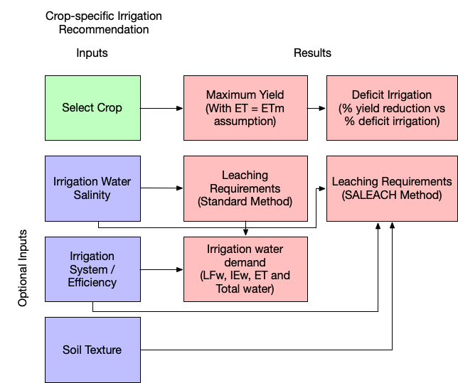
Figure 1. Flowchart for crop-specific irrigation recommendation
(Box color representations: Green – mandatory input, Blue – Optional inputs, Pink – results)
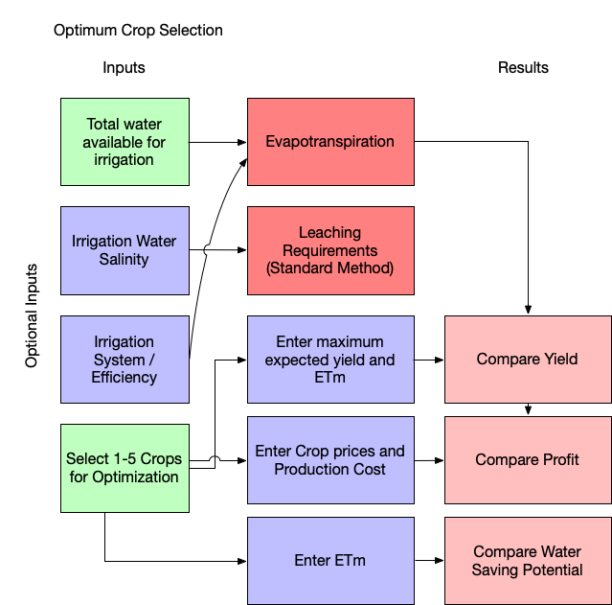
Figure 2. Flowchart for optimum crop selection
(Box color representations: Green – mandatory inputs, Blue – optional inputs, dark pinkish – relates the inputs processing behind the scene, Pink – results)

References
Allen, R.G., L.S. Pereira, D. Raes and M.J.F. Smith, Rome. 1998. Crop evapotranspiration-Guidelines for computing crop water requirements-FAO Irrigation and drainage paper 56. 300: D05109.
Doorenbos, J. and A.H. Kassam. 1979. Yield Response to Water; FAO Irrigation and Drainage, Paper No. 33; Food and Agriculture Organization of the United Nations.
English, M. 1990. Deficit Irrigation. I: Analytical Framework. 116: 399-412. doi:doi:10.1061/(ASCE)0733-9437(1990)116:3(399).
Scanlon, B.R., C.C. Faunt, L. Longuevergne, R.C. Reedy, W.M. Alley, V.L. McGuire, et al. 2012. Groundwater depletion and sustainability of irrigation in the US High Plains and Central Valley. 109: 9320-9325. doi:10.1073/pnas.1200311109 %J Proceedings of the National Academy of Sciences.
Shahrokhnia, H. and L. Wu. 2021. SALEACH: A new web-based soil salinity leaching model for improved irrigation management. Agricultural Water Management 252: 106905. doi:https://doi.org/10.1016/j.agwat.2021.106905.
Tanji, K.K. and N.C. Kielen. 2002. Agricultural drainage water management in arid and semi-arid areas. FAO IRRIGATION AND DRAINAGE PAPER 61FAO, Roma (Italia).
Varzi, M.M.J.J.o.A.S. 2016. Crop water production Functions—A review of available mathematical method. 8: 76.

