**Storm prediction using MLP neural network and mean-based fusion function by numerical weather prediction and satellite data**

Hadi Mahdipour, Alireza Sharifi

Abstract

Purpose

Prediction of thunderstorms can help traffic managers a lot. A fully connected multilayer perceptron neural network is utilized by some researchers to predict the storm in advance, where numerical weather predictions and satellite storm observations are used as the input and desired output data respectively. Since the used input data is very large and redundant, the major purpose of this paper is its efficiently reducing by a fusion technique where mean function as the simplest fusion function is utilized. Beside of this major purpose, some minor novelties including efficient selection of training, validation, and test data subsets, getting initial weights-free responses, k-fold validation strategy and nonlinear normalization of some input features are proposing to improve the prediction performance too.

Methodology

To predict thunderstorms, as usual, a fully connected multilayer perceptron neural network is utilized in this paper too. To efficiently reduce the input data, it will be fed to the NN after applying the mean function on as the simplest fusion method. Some other methodological improvements including efficient selection of training, validation, and test data subsets, getting initial weights-free responses, k-fold validation strategy and nonlinear normalization of some input features are proposed in this paper too. Although this application is known as a hot research subject and opportunity, very high amount of computational complexity has led to un-complete implementation of some proposed suggestions in the methodology domain (and probably some other similar suggestions) that can be considered as a big challenge for investigation in this domain.

Findings

Simulation results show overcoming on the big computational complexity challenge by the fusion idea where it reduces run time for more than 50 times (about 98%). Improvement in storm prediction performance by the proposed suggestions in the terms of Area Under Curve (AUC), False Positive Rate (FPR), True Positive Rate (TPR), classification rate and range sensitivity are achieved too. For example, in the case of applying K-fold validation, classification rate is improved by about 2 percent.

Originality

Considering one of newest and best storm prediction methods as the base model, it is going to express and compensate some of its weaknesses by some suggestions. Regarding the high amount of redundancy in the input data, the major novelty of this paper is applying fusion method on the input data that leads decreasing computational complexity and increasing the prediction performance. Some other suggestions containing efficient selection of train, validation, and test data subsets, getting to initial weights-free responses, k-fold validation strategy (because data is only available for one month, not more) and nonlinear (logarithmic and exponential) normalization of some input features are proposed too.

Keywords— multilayer perceptron (MLP); neural network (NN); Fusion; storm; numerical weather prediction.

1. Introduction

Convection is a known air hazard and turbulence, wind, lightning, and hail are elements that occur in lightning storms and can be catastrophic for aircraft. Since thunderstorms in Europe occur in the summer typically when air traffic demand increases on the airspace system, this combination causes significant disruption to air traffic management operations that lead to delays throughout the network. The cost associated with the weather's delay in 2018 is quantified at about 0.48 billion euros (Jardines et al., 2021, Aniel Jardines, 2020). Therefore, predicting lightning storms can help traffic managers to plan around the weather and improve air traffic flow management operations, thereby reducing the costs.

On the other hand, the difficulty of thunderstorm forecasting is a key reason in their disruption. Although some meteorological conditions are required for thunderstorm formation and can be forecasted in advance, the specific location and timing of convective initiation triggers is harder to identify. Consequently, thunderstorm prediction is usually performed using nowcasting (short term predictions, typically 1 - 3 hours), based on extrapolation of sensor data such as Doppler radars or satellite (Wilson et al., 1998). However, as the forecast horizon increases, extrapolation is rapidly degraded. To extend the lead time in thunderstorm prediction it is necessary to distance oneself from nowcasting methods and exploit the advances in Numerical Weather Prediction (NWP) tools. Advances in weather science and high-performance computing have greatly improved the prediction skill of NWPs in recent years (Jardines et al., 2021, Aniel Jardines, 2020).

Artificial intelligence (AI) and machine learning (ML) methods have been used successfully to work with big data in a variety of disciplines. Using artificial intelligence techniques combined with a physical understanding of the environment can improve forecasting skills for different types of high-impact climates.

In some research, ML, satellite data, Doppler radar images and NWPs have been used successfully to improve nowcasting of thunderstorms at shorter than 24 hours’ time horizons (Mecikalski et al., 2015, Li et al., 2019). Neural networks (NNs) and Deep NNs (DNNs) have been applied on NWP data to predict thunderstorms for longer time horizons too (Šaur, 2017, Collins and Tissot, 2015, He and Loboda, 2020, Simon et al., 2018). Convolutional NN has also applied on NWP products to predict multiple types of convective weather within a 6 hour period up to 72 hours in advance (Zhou et al., 2019). While these works have been successful in using ML to predict convective weather, their specific applications did not require spatial-temporal resolution nor the continental scale geographic domain necessary for pre-tactical ATFM application. While works predicting convective events with high spatial-temporal resolution do exist (Baldauf et al., 2011, Spiridonov et al., 2020), they rely on physics-based computational fluid dynamic models rather than ML, and are limited in their geographical domain.

Finally, Jardines et al. (Jardines et al., 2021, Aniel Jardines, 2020) used MLP NN to predict thunderstorms using NWPs at timescales greater than 24 (72) hours (required for the pre-tactical phase air traffic flow management) which has a huge computational complexity due to large volume of NWP as the input data. To avoid this huge amount of computational complexity, Jardines et al. have considered training data set portion of %50, while it must be about %70. Indeed considering more portion for training data set will result more suitable NN and result, but the computational complexity will be increased exponentially. Due to the same matter, getting initial weights-free responses by multiple-times applying of the NN on the input data and choosing the best one is not performed by Jardines et al. too, while it is usual in the state of utilizing NNs. Jardines et al. has not also used k-fold validation strategy (Beheshti et al., 2019) to train the NN while only one month's data is utilized (not more) due to the same reason.

On the other hand, data fusion is an effective way for optimum utilization of large volume data and combines different pieces of information into some new compatible information or more accurate data (Nazarko, 2002). Application of data fusion methods varies a lot from military applications (such as target tracking and target recognition) to non-military ones (for example machine vision, robotics and medical). Data fusion tries to perform: 1) fusion of temporal information or 2) fusion of dissimilar information and or 3) fusion of similar information from different sources (or in fixed sensing object, fusion of information obtained by one unique sensor in various conditions and times) (Nazarko, 2002, hadi et al., 2016). The used fusion idea in this paper is in the third category. Considering the inherent uncertainty of data that imply to the inaccuracy and problems in sensing and digitizing the real phenomena (Mowrer and Congalton, 2003), using the fusion methods can handle it as well and decrease the effect of outliers on the final output (hadi et al., 2016).

Finally, as mentioned, satellite data is the best tool for continuous monitoring of earth features, hazard management and change detection and many other applications, which is indicated by many studies (Abaspur Kazerouni et al., 2021, Hossein-Abad et al., 2020b, Hossein-Abad et al., 2020a, Mohammadi et al., 2021, Sharifi, 2021, Sharifi and Amini, 2015, Tariq et al., 2022, Zamani et al., 2022, Ghaderizadeh et al., 2022, Kosari et al., 2020, Sharifi et al., 2015, Sharifi et al., 2016, Sharifi et al., 2022). Regarding the mentioned studies which have utilized satellite data for storm prediction, it will be done in this research too.

In this paper, considering one of the best storm prediction methods (Jardines et al., 2021, Aniel Jardines, 2020) as the base model, it is going to express and compensate some of its weaknesses by some suggestions. A big flaw of the base model is its very high amount of computational complexity. Regarding the high amount of redundancy in the input data, the major novelty of this paper is applying fusion method on the input data before feeding to the fixed-structure NN (as base model) that leads to decreasing computational complexity and increasing the prediction performance. Some other suggestions containing efficient selection of train, validation, and test data subsets, getting to initial weights-free responses, k-fold validation strategy (because data is only available for one month, not more) and nonlinear (logarithmic and exponential) normalization of some input features are proposed for prediction performance improving too.

The rest of this paper is organized as follows. Materials and methods are presented in Section 2. This section describes utilized dataset firstly. Then, the proposed method and extensions are presented in continue. Simulation results of the proposed method and extensions applied on the dataset are presented in Section 3 while they are compared with two other methods. Finally, the conclusion is presented in Section 4.

1. **Materials and Methods**
   1. ***Data set***

As mentioned, the utilized data set in this research is as same as (Jardines et al., 2021, Aniel Jardines, 2020). It is for June 2018 with a geographical domain covering vast portions of Western Europe and northern Africa as Figure 1-a.

Since convection is an important phenomenon in the atmosphere, to develop the convection prediction model, data from ensemble Numerical Weather Prediction (NWP) forecasts and satellite thunderstorms observations from satellite are used. NWPs use computer simulations to model atmospheric processes on a computational grid. Fluid motion and thermodynamic properties of the atmosphere are modeled using partial differential equations, interactions between neighboring grid cells, and the calculation of an extensive set of atmospheric parameters for each grid cell. These NWP products can predict the weather several days into the future with relatively good accuracy. The model input, containing 23 features values as Table 1, is provided by ensemble NWP forecasts where these are available 36 hours in advance.

|  |  |
| --- | --- |
|  | Target_Image |

Figure 1. (a) Geographical domain of forecast and observational weather data (Jardines et al., 2021, Aniel Jardines, 2020). (b) Binary Storm Target Function for June 17th, 2018, at 19:00, storms are specified by polygons.

Table 1. Total list of parameters used in the model.

|  |  |  |  |
| --- | --- | --- | --- |
| No. | Parameter | Short Name | Type of applied non-linear normalization function |
|  | 2 meter dewpoint | 2d | - |
|  | 2 meter temperature | 2t | - |
|  | convective available potential energy | Cape | Logarithmic |
|  | convective available potential energy 1 hour before | cape-1 | - |
|  | convective available potential energy 2 hour before | cape-2 | - |
|  | convective available potential energy 3 hour before | cape-3 | - |
|  | convective inhibition | Cin | Logarithmic |
|  | convective precipitation | Cp | Exponential |
|  | convective rain rate | Crr | Exponential |
|  | height of convective cloud top | Hcct | Logarithmic |
|  | hour of day | Hour | - |
|  | K index | Kx | - |
|  | large scale precipitation | Lsp | Exponential |
|  | large scale rain rate | Lsrr | Exponential |
|  | surface latent heat ux | Slhf | Logarithmic |
|  | surface pressure | Sp | Logarithmic |
|  | surface sensible heat ux | Sshf | Logarithmic |
|  | range of forecast | Range | - |
|  | total cloud cover | Tcc | Exponential |
|  | total column water | Tcw | - |
|  | total column water vapor | Tcwv | - |
|  | total totals index | Totalx | - |
|  | geopotential | Z | Logarithmic |

On the other hand, created binary images for each hour are utilized as the desired output for training and evaluation of the model. This binary image is resulted from satellite images that are product of Rapid-Development Thunderstorm (RDT), developed by Météo-France within the EUMETSAT NWC-SAF (for more information see (Jardines et al., 2021, Aniel Jardines, 2020)). These satellite images provide an accurate representation of convective events for each 15 minutes. By merging all 4 images related to each hour, such that each point will be considered as the stormy one if the storm was occurred at least in one of those 4 images, a binary image will be obtained that shows the stormy regions (as a sample, see Figure 1-b).

As mentioned, the used input and desired output data in this research is the same as (Jardines et al., 2021, Aniel Jardines, 2020) and more details can be found in those research.

* 1. Methodology

As mentioned, preserving the NN construction, parameters and settings in performed research by Jardines et al. (Jardines et al., 2021, Aniel Jardines, 2020), some suggestions are proposed in this paper to improve the model performance. The considered NN to predict the storms, as illustrated in Figure 2, is a multilayer (MLP) NN with two hidden layers that each hidden layer has 16 neurons. Since the input data and obtained features’ values by 50 members at each time and for each point are very similar together, mean-based fusion function (simple averaging applied on 50 values of each input parameter at each time resulted by 50 members) is utilizing in this paper to reduce the computational complexity and also improving the storm prediction performance. Furthermore, some suggestions consist of efficient rearrange of data to choose the training, validation, and test sub-data sets, nonlinear (logarithmic and exponential) normalization of some input features with very low and very high dynamic range, get to initial weights-free response and k-fold validation strategy (because data is only available for one month, not more) are proposing in this paper to improve the storm prediction performance too. Besides improvement in storm prediction performance, most of latter suggestions increase the computational complexity hugely and it seems this problem is the main cause of not-using from latter suggestions in the previous research. For example, in the cases of considering data rearrangement and initial-weights free, simulation time takes more than three months (about 101 days) long. Therefore, except for the two mentioned suggestions that are applied on whole of data (partially, not completely), others are applied on a mini subset of data to examine their effects and prove their efficiency.

In the continuation of this section, all suggestions are described in two sub-sections entitled minor and major proposed suggestion(s) respectively.

Since the resulted output by NN is very dependence on its initial weights and biases, the usual method to overcome on this defect is multiple running of NN with different initial conditions and considering the average or best case (Li and Yeh, 2002, Hossein-Abad et al., 2013). This fact can be considered to get the better and initial-situation free response that will be used in this paper.

## Minor proposed suggestions

In the previous research by Jardines et al. (Jardines et al., 2021, Aniel Jardines, 2020), dividing data set to 4 days' subsets, %50 of data is considered as training data, %25 of it is considered as validation data and remained value (%25) is considered as test data. Therefore, considering the whole of data, training, validation, and test portions are 50, 25 and 25 percent respectively that is not usual and normal. The normal ration of them is 60-80, 10-20 and 10-20 percent respectively (Alqahtani and Whyte, 2016, Guimarães and Shiguemori, 2019, de Carvalho Paulino et al., 2020, Hossein-Abad et al., 2013, Sharifi et al., 2022).

Figure 2. Structure of utilized MLP model to predict the storm (Jardines et al., 2021, Aniel Jardines, 2020)

Therefore, in this paper the whole of data, consist of 1 month, is divided to 7 days' subsets (it means considering day#3 to day #9 as subset #1, day#10 to day #16 as subset #2, …, and day#24 to day #30 as subset #4) and 5 (%71.4), 1 (%14.3) and 1 (%14.3) day(s) from each data subset will consider as training, validation, and test portions, respectively.

The used data set for storm prediction can be seen from two different aspects. The first view as the simple and common one is this fact that the computation complexity of problem is very high. That is due to the huge amount of available data for processing. As illustrated in Figure 3, we have 1 month's data, containing 30 days that each day has information of 24 hours. Since weather forecast is produced at the mid-day and mid-night of each day by 50 members and also weather forecast information of no more than 36 hours is already utilized for storm prediction, therefore for storm prediction at each hour, 3 weather forecasts from 3 different hours are available named as 3 different ranges' information. For example, as illustrated in Figure 3, for the hour of 21:00, the weather forecasts (WF) from today's mid-day and yesterday's mid-night and mid-day are considered as WF#1 with Range=9, WF#2 with Range=21 (21=9+12) and WF#3 with Range=33 (33=9+24) respectively. Each WF consists of predictions of 50 members for 25,521 grids points that each member's prediction for each point has 23 features. The total number of features and digits for processing will be more than 63e+9 that is very high. Therefore, the first idea in this section can be fusion of 50 members' prediction for each point at each time and use the mean value of 50 values to decrease the computational complexity and increase the classification performance that will be described more later.

In another view and unlike the huge amount of very redundant data and very high amount of computation complexity, just information of one month's weather and storm is available in the used data set. Therefore, due to the less amount of information it seems k-fold validation strategy is necessary in this application and utilized data set to get an acceptable performance.

The data set has 23 input features that can be divided into 3 categories based on input feature's dynamic range, as low, normal, and high dynamic range. In this paper exponential and logarithmic normalization are proposed for low and high dynamic range features categories, respectively as mentioned in the last column of Table 1. Although, linear normalization (to have zero-mean, unit-variance features) will be applied finally on all features and three mentioned categories as (Jardines et al., 2021, Aniel Jardines, 2020) too.

## Major proposed suggestion

Data fusion tries to perform one of the following targets: 1. fusion of temporal information, 2. fusion of dissimilar information and or 3. fusion of similar information from different sources (or in fixed sensing object, fusion of information obtained by one unique sensor in various conditions and times) (Nazarko, 2002, hadi et al., 2016). As mentioned, since the NWP in this research’s data set is available for each point at each time by 50 members, it causes to have very redundant input data for the storm prediction. Therefore, in this paper the third category of fusion's try (fusion of similar information from different sources) is utilized. To this purpose, the 23 input features are categorizing to two groups. The first group of features, containing ‘hour’, ‘range’ and ‘z’, are fixed for all points of NWP corresponding to each member at a specific time. The second group of input features, containing 20 remaining input features that are changing for each point in the members predictions for each time, will be fused. The block diagram of this proposed method is illustrated in detail in Figure 4. The simplest fusion function Mean is utilized in this research. So that the mean of feature values obtained by 50 members for each point at each time for those 20 features will be considered as the input. In addition to the classification and storm prediction performance increasing that is achieved by the fusion, due to removing of outliers input effect on the output by fusion (hadi et al., 2016), this major novelty will decrease the computational complexity significantly too. Indeed, the volume of input data will be decreased 50 times by the fusion performing and computational complexity will decrease more than 50 times in the state of nonlinear effect of input data volume on the computational complexity. As mentioned, this major proposed suggestion makes it easy to completely apply amany ideas on the NN while the input data is same. Moreover, although the construction and structure of NN in this paper is as same as (Jardines et al., 2021, Aniel Jardines, 2020), but this fast running can help us to reconstruct the NN (number of hidden layers, numbers of neurons and their activation function etc.) and get better structure and setting in the next researches.

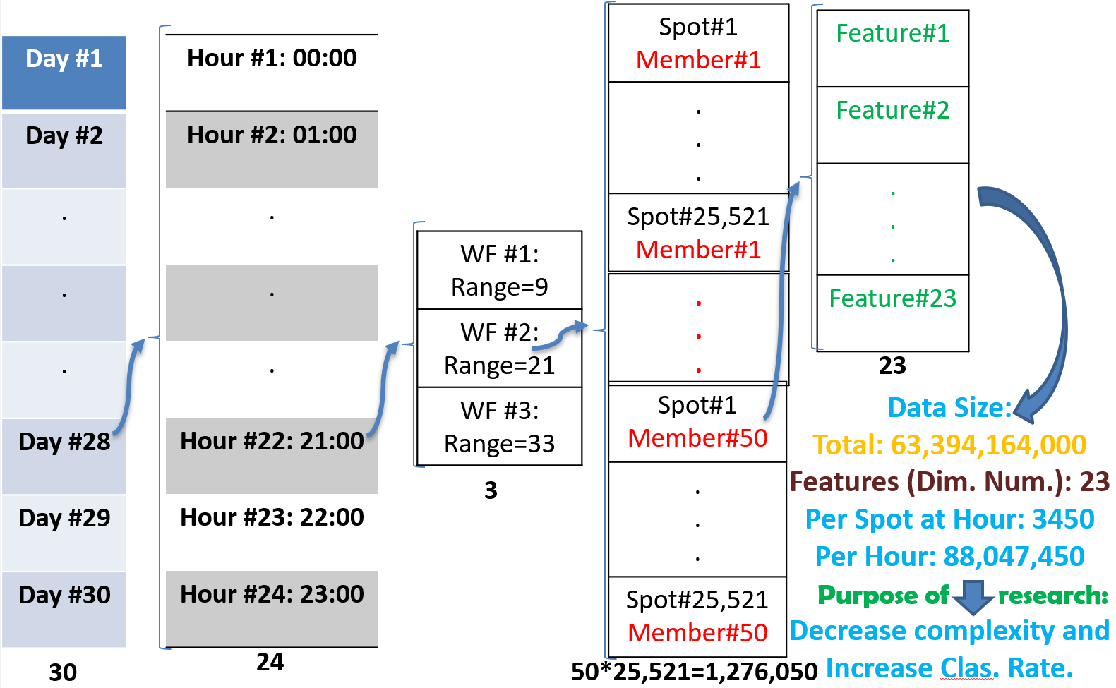

Figure 3. Structure of utilized input database in the research.

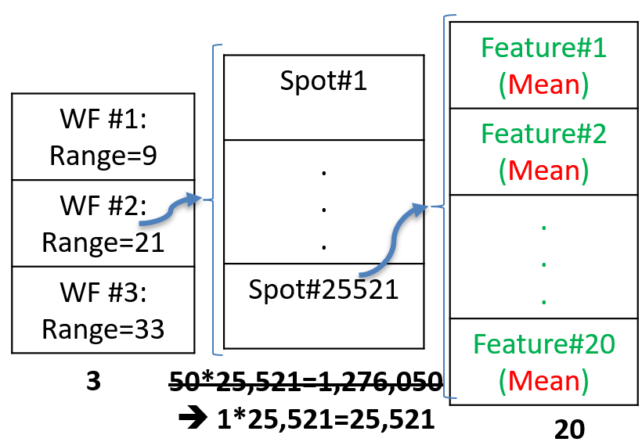

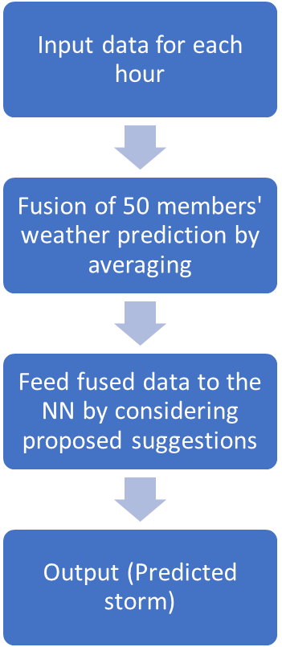

Figure 4. Block diagram of the major proposed method where the utilized data in each hour is expressed in detail where the effect of fusion is illustrated there by showing the input and the output data's structures.

1. Results and Discussion

As mentioned, the proposed extensions need a lot of time to run. For example, considering only two extensions of initial-weights free and data rearranging to have standard portion for training, validation, and test data, take long more than three months (101 days) for running.

Therefore, just two mentioned extensions are partially applied on whole of data set and their effects (named as PM-1 for not-fusing case and PM-2 and PM-3 for fusing case) are examined in this paper. Other extensions (except the fusion that after fusion process, NN will be applied on a new data set) and their effects on final output are examined while a mini subset of data base is utilized. As mentioned, some tricks and ideas to decrease the computational complexity significantly are most important challenges in this field research that some of them e.g., fusion of similar inputs by the mean function are simulated and reported as PM-2 and PM-3 in this paper. PM-2 indicates to 1 time applying of NN on fused data (as described in previous section) and PM-3 indicates to 10 times applying and choosing the best one.

Therefore, simulations are reporting in two subsections. In the first one, implementations related to two extensions of initial-weights free and rearranging data (for fusing 50 members’ weather prediction by mean function and not-fusing cases) when they are applying on whole of data will be reported. In the second subsection, it is going to implement the extensions of k-fold validation and non-linear normalization as much as possible.

In other side, the suggested extensions are compared with one of the best suggested algorithm until now (Jardines et al., 2021, Aniel Jardines, 2020) named as Method-1 (in this paper). Furthermore, baseline method which the results are outcoming from an existing NWP based convection indicator (González-Arribas et al., 2017) will be used for comparison too.

## Effects of fusion, initial-weights free and rearranging data

As mentioned, in this subsection two extensions of initial-weights free and rearranging data for two states fusing 50 members’ NWPs by the mean function (PM-2 and PM-3) and not-fusing (PM-1) are implementing while they are applying on whole of data. Simulation results show better performance of the proposed methods in the terms of Area Under Curve (AUC), True Positive Rate (TPR) and False Positive Rate (FPR) in Table 2 and Figure 5. As can be seen, proposed methods have better performance in storm detection term compared to other methods. Although the computational complexity in the PM-1 case is very high, PM-2 is very fast, and its detection performance is better than PM-1 too. The cause of this performance improvement in all terms of comparison relates to the benefits of fusion. Fusing operation reduces the effect of outliers on the output and decreases the redundancy very efficiently. Due to decreasing the volume of input data by about 98% (50 times), run time in PM-2 has already decreased a lot too. The results for PM-3 are very similar to PM-2 case with slight improvement in storm detection and a lot of degradation in run time.

In the case of range sensitivity, results are reported in Figure 6. As can be seen visually, increasing the range from 0-12 to 12-24 hours and then to 24-36 hours, the RUC performance is decreased for all models (e.g., for PM-3 it decreases from 0.9598 to 0.9586 and then to 0.9547), except the "Baseline" method. It is due to the fact that the "Baseline" method is very simple and cannot predict the storm well totally. It seems "Baseline" has the worst performance and this performance degradation by increasing the range is more obvious for it. While other methods' performances for different range periods are very similar together and it is hard to find the differences visually. The sensitivity of Method-1 to range increasing is slightly less than Baseline. But PM-1 is more robust to range increment in compared to the both methos of Baseline and Method-1. It seems it relates to more training of NN and better search by multiple times running. This improvement is more obvious in PM-2 due to using fusion and decreasing the outliers’ effect on output by averaging fusion. And finally, PM-3 has best robustness to range increasing and even better than PM-2; due to more searching for NN weights.

In the terms of normalized output, reported in Figure 7, the ideal output is the case of having two separate and sharp distributions on 0 and 1 for the non-convective (gray color) and convective (red color) classes, respectively. Naturally, if the distributions have minimum coverage (complete separately in the ideal case) and are sharper on points of 0 and 1 (or nearer point to them), it means better output in this term of comparison.

As can be seen in Figure 4, baseline method has the worst performance in this term too. The performances of Method-1, PM-1, PM-2 and PM-3 seem the same, although the distributions in the proposed suggestions cases (PM-1, PM-2 and PM-3) seem more separate (slightly) and sharper (obviously). The sharpness is more sensible for non-convective class’s distribution and on 0 point. The rank of under-studying methods in this term is as same as AUC case (see Table 2).

Table 2. Performance of the proposed methods in compare to other methods.

|  |  |  |  |  |
| --- | --- | --- | --- | --- |
| Method | %AUC | %FPR | %TPR | Run Time |
| Baseline (González-Arribas et al., 2017) | 80.83913 | 12.44321 | 72.25637 | couple of minutes |
| Method-1 (Jardines et al., 2021, Aniel Jardines, 2020) | 95.28233 | 11.96384 | 90.74992 | 10 days |
| PM-1 | 95.40195 | 12.10917 | 90.94430 | 30 days |
| PM-2 | 95.75532 | 11.55979 | 91.76360 | 5:20’ |
| PM-3 | 95.77761 | 11.04367 | 91.35065 | 53:10’ |

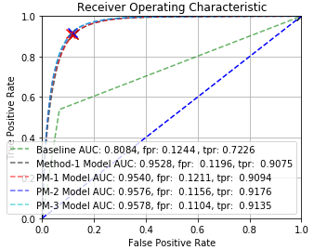

Figure 5. Operating Characteristic of Baseline (González-Arribas et al., 2017), Method-1 (Jardines et al., 2021, Aniel Jardines, 2020) and Proposed methods (PM-1, PM-2 and PM-3).

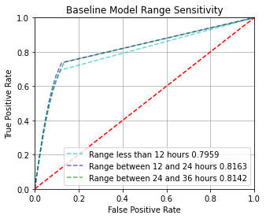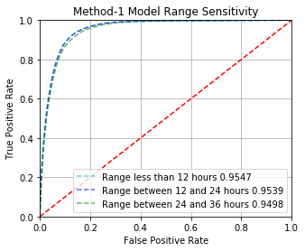

(b)

(a)

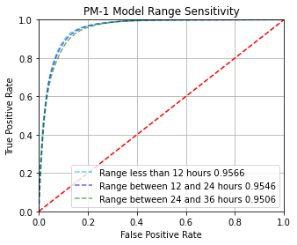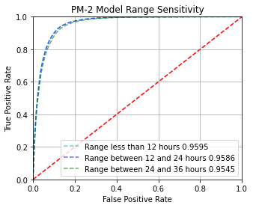

(c)

(d)

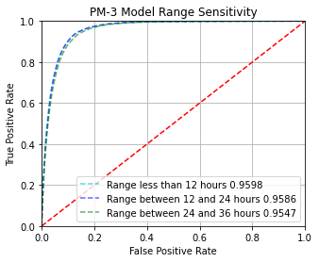

(e)

Figure 6. Range sensitivity of different range value in the methods of (a) Baseline [20]; (b) Method-1; (c) PM-1; (d) PM-2 and (f) PM-3.

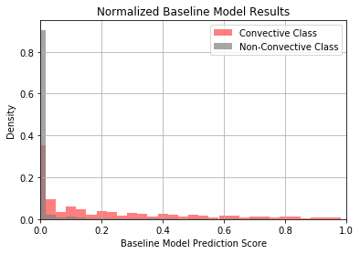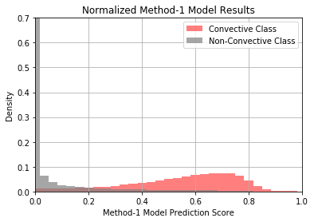

(a)

(b)

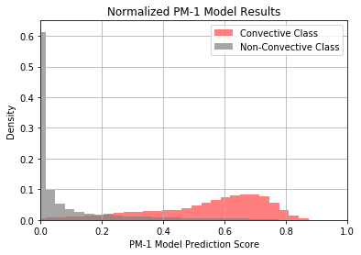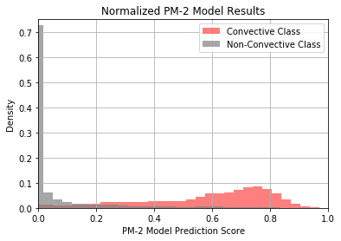

(d)

(c)

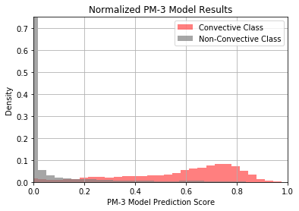

(e)

Figure 7. (a) Normalized output of Baseline; (b) Normalized output of Method-1; (c) Normalized output of PM-1; (d) Normalized output of PM-2; (e) Normalized output of PM-3.

For June 17th, 2018 at 19:00 while the maximum storms are occurred, just to see the visual results of the simulated methods, target and resulted storm prediction images of all simulated methods (where they are binarized by considering the threshold value of 0.5) are presented in Figure 8. Although the baseline has the worst performance and it can be seen in Figure 8-b, the benefits of the proposed method cannot be found easily and visually in this case too. Indeed, this term of comparison is a sample from the overall comparing that is done by AUC, FPR and TPR in Table 2 but the slight differences cannot be determined in this specific case.

|  |  |
| --- | --- |
| Target_Image  (a) | Baseline Model Prediction Score_Binary  (b) |
| Method-1 Model Prediction Score_Binary  (c) | PM-1 Model Prediction Score_Binary  (d) |
| PM-2 Model Prediction Score_Binary  (e) | PM-3 Model Prediction Score_Binary  (f) |

Figure 8. Binary image of storms; (a): target and predicted by (b): Baseline method, (c): Method-1, (d): PM-1, (e): PM-2 and (f): PM-3.

## Effects of k-fold validation and non-linear normalization

Since the remaining proposed suggestions, i.e., k-fold validation and non-linear normalization, increase the computational complexity severely, they are applied only on a mini subset of data. Therefore, in this case, the classification rate and running time are reported in Table 3.

In the k-fold validation process, k is 6. As mentioned, the linear normalization cannot be efficient for the features with very high or very low dynamic range. Therefore, in the first step of normalization, the logarithmic and exponential functions are applied to some features as mentioned in the last column of Table 1. Then, in the second step of normalization, the linear normalization (to have features with zero-mean and unit standard deviation) is applied on all features.

Table 3. Effect of k-fold validation and nonlinear normalization on the output, applied on a subset of data.

|  |  |  |
| --- | --- | --- |
| Method | %Classification Accuracy | Run Time |
| Method-1 (Jardines et al., 2021, Aniel Jardines, 2020) | 91.36543 | 22’:49’’ |
| k-fold validation | 93.42728 | 103’:51’’ |
| Nonlinear Normalization | 91.96320 | 39’:22’’ |

1. Conclusions

Convective air as a known hazard can be catastrophic for aircraft. To develop a storm prediction model as a new research opportunity, artificially neural network (NN) is utilized recently by some researchers, where Numerical Weather Prediction (NWP) is utilized as the input and satellite image data is considered as the desired output. This paper suggested some extensions and considerations for NN utilizing on that application. It was showed the suggestions (including efficient rearrange of data to select training, validation, and test data sets, get to initial weights-free response, k-fold validation strategy and nonlinear normalization of some input features) could increase the performance of storm prediction system in the terms of Area Under Curve (AUC), False Positive Rate (FPR), True Positive Rate (TPR), and classification accuracy. Although the complete implementation of the suggested extensions needs more than 500 days’ time and it is not possible in act. Therefore, a raised research challenge in this paper is the issue of extensions applying (e.g., the proposed suggestions in this paper) on this application. As an initial solution, mean-based fusion function (in the level of features) was suggested and examined in this paper. This solution could decrease the computational complexity very well by about 98%, while the storm detection performance was increased as well too. For example, in the case of applying K-fold validation, classification rate by the proposed method was improved by about 2 percent. Regarding the benefits of the fusion methods in the case of noise and outlier inputs free result, using the mean-based fusion function decreased the sensitivity of the model to the range increasing too. Utilizing other fusion methods, extending utilized data set to more than one month of this research, redesign NN (using deep NNs) and using spatial information of data can be considered as the next research lines in this application.

**References**

ABASPUR KAZEROUNI, I., MAHDIPOUR, H., DOOLY, G. & TOAL, D. 2021. Vector Fuzzy c-Spherical Shells (VFCSS) over Non-Crisp Numbers for Satellite Imaging. *Remote Sensing,* 13**,** 4482.

ALQAHTANI, A. & WHYTE, A. 2016. Estimation of life-cycle costs of buildings: regression vs artificial neural network. *Built Environment Project and Asset Management*.

ANIEL JARDINES, M. S., ALEJANDRO CERVANTESB, JAVIER GARCIA-HERAS 2020. Convection Indicator for Pre-Tactical Air Traffic Flow Management using Neural Networks. *International Conference on Recent Advances in Fluids and Thermal Sciences (iCRAFT) 2020.*

BALDAUF, M., SEIFERT, A., FÖRSTNER, J., MAJEWSKI, D., RASCHENDORFER, M. & REINHARDT, T. 2011. Operational convective-scale numerical weather prediction with the COSMO model: Description and sensitivities. *Monthly Weather Review,* 139**,** 3887-3905.

BEHESHTI, I., MAHDIPOUR HOSSEIN-ABAD, H., MATSUDA, H. & INITIATIVE, J.-A. S. D. N. 2019. Identification of Alzheimer’s Disease on the Basis of a Voxel-Wise Approach. *Applied Sciences,* 9**,** 3063.

COLLINS, W. & TISSOT, P. 2015. An artificial neural network model to predict thunderstorms within 400 km2 South Texas domains. *Meteorological Applications,* 22**,** 650-665.

DE CARVALHO PAULINO, Â., GUIMARÃES, L. N. F. & SHIGUEMORI, E. H. 2020. Assessment of noise impact on hybrid adaptive computational intelligence multisensor data fusion applied to real-time uav autonomous navigation. *IEEE Latin America Transactions,* 18**,** 295-302.

GHADERIZADEH, S., ABBASI-MOGHADAM, D., SHARIFI, A., TARIQ, A. & QIN, S. 2022. Multiscale dual-branch residual spectral–spatial network with attention for hyperspectral image classification. *IEEE Journal of Selected Topics in Applied Earth Observations and Remote Sensing,* 15**,** 5455-5467.

GONZÁLEZ-ARRIBAS, D., SOLER, M., SANJURJO-RIVO, M., GARCÍA-HERAS, J., SACHER, D., GELHARDT, U., LANG, J., HAUF, T. & SIMARRO, J. Robust Optimal Trajectory Planning under Uncertain Winds and Convective Risk. ENRI International Workshop on ATM/CNS, 2017. Springer, 82-103.

GUIMARÃES, L. N. F. & SHIGUEMORI, E. H. 2019. Hybrid adaptive computational intelligence-based multisensor data fusion applied to real-time UAV autonomous navigation. *Inteligencia Artificial,* 22**,** 162-195.

HADI, M., HADI, S. Y. & MORTEZA, K. 2016. Efficient Land-cover segmentation using Meta fusion. *Journal of Information Systems and Telecommunication (JIST)*.

HE, J. & LOBODA, T. V. 2020. Modeling cloud-to-ground lightning probability in Alaskan tundra through the integration of Weather Research and Forecast (WRF) model and machine learning method. *Environmental Research Letters,* 15**,** 115009.

HOSSEIN-ABAD, H. M., NEZAMABADI-POUR, H., ABBASI-MOGHADAM, D. & KHADEMI, M. 2013. Joint detection, channel estimation, and interference cancellation in downlink MC-CDMA communication systems using complex-valued multilayer neural networks. *annals of telecommunications-annales des télécommunications,* 68**,** 467-476.

HOSSEIN-ABAD, H. M., SHABANIAN, M. & KAZEROUNI, I. A. 2020a. Fuzzy c-means clustering method with the fuzzy distance definition applied on symmetric triangular fuzzy numbers. *Journal of Intelligent & Fuzzy Systems,* 38**,** 2891-2905.

HOSSEIN-ABAD, H. M., SHABANIAN, M. & KAZEROUNI, I. A. 2020b. Vectorized kernel-based fuzzy C-means: A method to apply KFCM on crisp and non-crisp numbers. *International Journal of Uncertainty, Fuzziness and Knowledge-Based Systems,* 28**,** 635-659.

JARDINES, A., SOLER, M., CERVANTES, A., GARCÍA-HERAS, J. & SIMARRO, J. 2021. Convection indicator for pre-tactical air traffic flow management using neural networks. *Machine Learning with Applications,* 5**,** 100053.

KOSARI, A., SHARIFI, A., AHMADI, A. & KHOSHSIMA, M. 2020. Remote sensing satellite’s attitude control system: rapid performance sizing for passive scan imaging mode. *Aircraft Engineering and Aerospace Technology,* 92**,** 1073-1083.

LI, H., LI, Y., LI, X., YE, Y., LI, X. & XIE, P. A Comparative Study on Machine Learning Approaches to Thunderstorm Gale Identification. Proceedings of the 2019 11th International Conference on Machine Learning and Computing, 2019. 12-16.

LI, X. & YEH, A. G.-O. 2002. Neural-network-based cellular automata for simulating multiple land use changes using GIS. *International Journal of Geographical Information Science,* 16**,** 323-343.

MECIKALSKI, J. R., WILLIAMS, J. K., JEWETT, C. P., AHIJEVYCH, D., LEROY, A. & WALKER, J. R. 2015. Probabilistic 0–1-h convective initiation nowcasts that combine geostationary satellite observations and numerical weather prediction model data. *Journal of Applied Meteorology and Climatology,* 54**,** 1039-1059.

MOHAMMADI, M., SHARIFI, A., HOSSEINGHOLIZADEH, M. & TARIQ, A. 2021. Detection of oil pollution using SAR and optical remote sensing imagery: a case study of the Persian Gulf. *Journal of the Indian Society of Remote Sensing,* 49**,** 2377-2385.

MOWRER, H. T. & CONGALTON, R. G. 2003. *Quantifying spatial uncertainty in natural resources: theory and applications for GIS and Remote Sensing*, CRC Press.

NAZARKO, S. 2002. *Evaluation of data fusion methods using Kalman filtering and transferable belief model.* Master’'s thesis, University of Jyväskylä.

ŠAUR, D. Forecasting of convective precipitation through NWP models and algorithm of storms prediction. Computer Science On-line Conference, 2017. Springer, 125-136.

SHARIFI, A. 2021. Development of a method for flood detection based on Sentinel‐1 images and classifier algorithms. *Water and Environment Journal,* 35**,** 924-929.

SHARIFI, A. & AMINI, J. 2015. Forest biomass estimation using synthetic aperture radar polarimetric features. *Journal of Applied Remote Sensing,* 9**,** 097695-097695.

SHARIFI, A., AMINI, J., SRI SUMANTYO, J. T. & TATEISHI, R. 2015. Speckle reduction of PolSAR images in forest regions using fast ICA algorithm. *Journal of the Indian Society of Remote Sensing,* 43**,** 339-346.

SHARIFI, A., AMINI, J. & TATEISHI, R. 2016. Estimation of forest biomass using multivariate relevance vector regression. *Photogrammetric Engineering & Remote Sensing,* 82**,** 41-49.

SHARIFI, A., MAHDIPOUR, H., MORADI, E. & TARIQ, A. 2022. Agricultural Field Extraction with Deep Learning Algorithm and Satellite Imagery. *Journal of the Indian Society of Remote Sensing,* 50**,** 417-423.

SIMON, T., FABSIC, P., MAYR, G. J., UMLAUF, N. & ZEILEIS, A. 2018. Probabilistic forecasting of thunderstorms in the Eastern Alps. *Monthly Weather Review,* 146**,** 2999-3009.

SPIRIDONOV, V., BAEZ, J., TELENTA, B. & JAKIMOVSKI, B. 2020. Prediction of extreme convective rainfall intensities using a free-running 3-D sub-km-scale cloud model initialized from WRF km-scale NWP forecasts. *Journal of Atmospheric and Solar-Terrestrial Physics,* 209**,** 105401.

TARIQ, A., YAN, J., GHAFFAR, B., QIN, S., MOUSA, B., SHARIFI, A., HUQ, M. E. & ASLAM, M. 2022. Flash flood susceptibility assessment and zonation by integrating analytic hierarchy process and frequency ratio model with diverse spatial data. *Water,* 14**,** 3069.

WILSON, J. W., CROOK, N. A., MUELLER, C. K., SUN, J. & DIXON, M. 1998. Nowcasting thunderstorms: A status report. *Bulletin of the American Meteorological Society,* 79**,** 2079-2100.

ZAMANI, A., SHARIFI, A., FELEGARI, S., TARIQ, A. & ZHAO, N. 2022. Agro climatic zoning of saffron culture in miyaneh city by using WLC method and remote sensing data. *Agriculture,* 12**,** 118.

ZHOU, K., ZHENG, Y., LI, B., DONG, W. & ZHANG, X. 2019. Forecasting different types of convective weather: A deep learning approach. *Journal of Meteorological Research,* 33**,** 797-809.