

Project in Computer Security Workshop
2009

Doron Friedland
Erez Alon
Bar Katz
Yael Smith

Overview:
The problem:
A number of people, lets say n, want to compute a certain function together, with n inputs, one for each player.
The problem is: the players don't want to share their inputs with each other, they just want to know the final result.
Lets think, for example, about an electronic vote- each player wants to give his vote (in favor, against, avoid) and eventually they want to know the votes outcome, but no one wants to expose his vote.

The solution:
The solution to the problem is a mathematical solution, with the principle of dividing each player's secret to n parts, which don't reveal the secret itself.
This way, each player can compute the function, with the inputs being the parts of the other players' secrets, instead of the secrets themselves.
How do we divide a number to n parts? The principle is to randomize a polynomial and hiding the secret in the polynomial's free coefficient (as in Shamir secret sharing scheme).

How does it really work?
- First, we need to turn the given function to a computation circuit that includes only addition, subtraction and multiplication gates.
This is the circuit that will be computed by the players.
- Each player divides its secret to n parts and shares each of the other players with one different part of it.
- Each one of the players computes the circuit with the parts he has.
In case of a multiplication gate the players have to perform one more communication step (passing information to each other), as will be explained later.
- At the end of the process the players can share their results with each other, which are actually a part of the final result.

Working over a finite field:
The mathematical solution requires performing all the calculation in a finite field.
This means that we decide on a prime number p, that defines a finite field, E, of size p
(0, 1, …, p-1).
All the mathematical calculations are performed over this field (mod p).

Implementation- Main modules:

GUI
Parser
Connection Controller
MPC Protocol
Create Circuit
Circuit Object
Create Connections
Send/Receive from other players
Circuit Object +
configurations

Results

The compiler module:
The compiler module is responsible of creating a Circuit object out of a written code – that is given as an input by a String or a path to a file.
We shall first elaborate about the Circuit object.
The Circuit representation (the circuit package):
The Circuit object (Circuit.java) is actually just a list of gates – each gate represents a real gate in the computation process – and the list order is mandatory, meaning, gates should be computed in the order they appear in the list (this will promise a correct order of calculation).

The Gate object (Gate.java) contains the operation it should compute (multiply, addition, subtraction or division), a list of wires that are the inputs to the gate and a list of wires that are the outputs of the gate (notice that a gate may output several wires – each one feeds a different gate in the circuit).
In addition, the gate contains the prime p that defines the finite field (necessary for the calculations) and a field that contains the result of the calculation (which is null as long as the calculation function was not called yet.
The main public method of this object is:
public Zp calculate (List<Zp> inputs, MPCProtocol protocol, String gatePrefix)
Which is used to calculate the output of the gate, using the inputs, the protocol (in case we need to ask it to run a reduction step) and a gatePrefix used for the logger. After running this method, the output of the gate is available (it is the returned value) and will be used in other gates calculations when needed.

The Wire object (Wire.java) represents a wire in the circuit – thus contains several optional fields:
- inputIndex – if the wire represents an input to the circuit, this field will not be null and will contain the index of the input (actually, the index of the player which should supply this input).
- OutputIndex – same as input – if this wire represents an output, this field will not be null and will contain the index of the output (which may not be 0 in case of multiple outputs).
- sourceGate – reference to the origin gate of this wire.
- targetGate – reference to the target gate of this wire.
- constValue – in case this wire has a const value, this field will not be null and will contain this value.
Note that in all time only one field that feeds the wire should not be null (inputIndex, sourceGate and constValue – only one is not null) and that only one output should not be null (targetGate and outputIndex).

The parser module actually contains only one class – Parser.java. As we mentioned before, the parser creates a Circuit from a code – which is transferred in the constructor as a String – that may be either the code itself or a path to a ".txt" file containing the code.
The parser uses very simple function found in the String library – such as "split", "indexOf" etc.
In addition, it makes some use in regular expressions in order to identify patterns and decide, before starting to read the line – what type of line we are going to parse (Input declaration, output declaration or a setting of an arithmetical value).
Parsing an input/output declaration is quite easy – all we should do is identify the variables and save them. Actually we save a map between the var name and the wire representing it in the circuit – this mapping is used for inputs, outputs and temporary variables. We save different lists for inputs and outputs in order to identify them.
Parsing the arithmetical expressions may be a bit harder.
The first challenge is to parse "*" and "+" operations while maintaining the correct order ("*" before "+"). This is done using extensive recursion and iteration – when we see "a + {exp}" expression we use recursion – meaning, we should create a gate for adding 'a' and the expression – which is calculated by the same function. When we see "a * {exp}" expression we use iteration – we have to calculate the "*" gate first – and we cannot use recursion for the {exp}.
After overcoming this challenge, we now need to refer to the other possible tokens – parenthesis, '?' and ':' and '=='. Treating parenthesis is quite easy – after identifying the '(' we search for the corresponding ')' – and just calling the main function (again, using recursion) with the expression inside. Treating the other operations is more unique – having us to create a different function and a "special" code the deal with them.

The main function that should be called in order to parse is –
public boolean parse () throws Exception
which may throw exception in case of a parsing error. The returned value is true iff a valid circuit was created.
The function
private void readLine(String line) throws ParseException
Is used to read one line of the input, using, indirectly, the most important method –
private Wire getWireFromExpression(String line) throws ParseException
Which converts an expression (line) to a wire, creating any Gate/Wire needed to support this expression (it may create few gates and wires representing an entire circuit – which its output is the returned Wire). This method is called whenever we use recursion, for example, calling this method with the expression 'a + {exp}' will create a '+' gate – which its inputs will be the wire represented by 'a' and the wire received from calling the getWireFromExpression method with {exp}.

The connection controller module:
The connection control provides an "easy" interface to the MPC Protocol module.
This has 2 major operations:
- Creating the connections between players – done once at the beginning.
- Sending & Receiving data between players.
To create the connections, the connection controller needs the IP/ports of the players.
It's possible to get those either from an XML file which contains this data, or by connecting to the server (see "The server" section).
After getting those inputs, each player establishes a SSL connection with all of the other participates. Note that in order to establish these connections each of the players has to have a signed certificate. Since most of us don't have one, we are ignoring the certificate when establishing the SSL connection.
After connections are established, the MPC protocol can send & receive data from all players. Of course, the interface also provides to rule out a player (if a layer is detected).

The server:
The server is an additional, stand alone, application.
The server enables several players to commit a MPC without the need of actually knowing all the other players IP and ports. To use this feature, each player fills in only his own IP/port/index, and the outputs/inputs in the XML file of all the players, and chooses the "Use server" radio button (see "The GUI module").
The text boxes should contain the IP and Port of the server (which is configurable). The server also executes some sanity check to see that all the players are coordinated:
- Checks that there are no 2 players with the same indexes.
- Checks that all the players have the same inputs/outputs list (making sure that there isn’t a player who requests to see all the outputs, even though he isn't allowed to)
- Checks that all the players are working on the same field.
In case that all players are coordinated, the information (IPs/ports) is sent to all players.
Then connections are established and calculation begins.
Of course, if the server saw any mismatch between players, an error message is sent, and calculation is aborted gracefully.
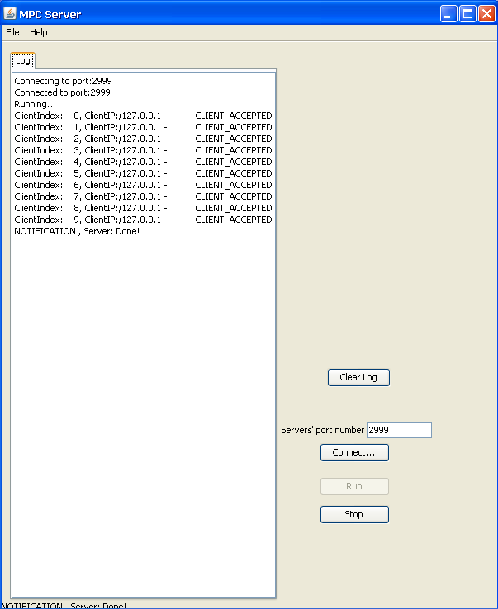

The MPC Protocol module:
Our implementation of the MPC protocol was done in two phases.
First, we implemented the "regular" protocol (t-private protocol) as described in BGW article.
This implementation includes:
- Matrices and regular numbers manipulations over finite fields.
- Secret Sharing and recombination according to Shamir Secret Sharing scheme.
- BGW and GRR multiplication step*.

* Currently we are using the GRR algorithm in the multiplication step because it requires less communication steps.

As described in BGW article, the regular protocol is t-private.
It means that "any set of at most t players cannot compute after the protocol more then they could jointly compute solely from their set of private inputs and outputs".

On the second phase, we implemented the Byzantine case protocol (t-private and t-resilient protocol) as described in BGW article.
This implementation includes:
- Absolute verification of a secret
- GRR multiplication step**.
- Ran Canetti suggestion for multiplication step algorithm.
- Welch-Berlekamp decoder for BCH codes.
- Exclusion of an exposed cheater player from the calculation process.

** We have found a problem in GRR multiplication step which enforced us to use another algorithm.

As described in BGW article, the Byzantine case protocol is t- resilient.
It means that "no set of t or less players can influence the correctness of the outputs of the remaining players".

Implementation notes:
The "MPCProtocol" class has a public method which launches the calculation.
This function prototype is:
public Map<Integer, Zp> calculate(Zp input, boolean partialCircuit, String numPrefix) throws IOException
This function is being called by the GUI Module after the creation of the protocol object. The same function is being used in its derived class, "MPCProtocolByzantineCase".
It can be said that the "MPCProtocol" and the "MPCProtocolByzantineCase" differ at three main functions which are being overridden by the "MPCProtocolByzantineCase", as described in BGW article.
The prototypes of those three functions are:
1) protected List<Zp> inputStage(Zp input) throws IOException
2) public Zp reductionRandomizationStep(Zp ab) throws IOException
3) protected Zp getRecombinedResult(List<Zp> recvList, int prime)

The inputStage function is naturally different in the two protocols.
While the "MPCProtocol" performs a simple secret sharing the "MPCProtocolByzantineCase" performs a VSS (Absolute verification of a secret).

A cheater player may want to damage the calculation process in the middle of it. One should remember that the players would communicate in the middle of the calculation process only if they need to perform a randomization and a reduction to the calculation polynomial, i.e. only if the calculation circuit contains multiplication (or division). Naturally this difference is reflected in the reductionRandomizationStep function.

The last phase a cheater player could try to damage the calculation process is the results recombination phase. Upon results shares, a player should perform an error correcting code algorithm to the received codeword. This difference if reflected in the getRecombinedResult function.

For example, we also created a demo of a naïve cheater player.
We have created an Input stage cheater and a Multiplication step cheater in order to test the correctness of our implementation.
The creation of a cheater player is easy:
The Input stage cheater needs the same capabilities as a regular player that participate in the calculation, except it needs to override the inputStage function to a Byzantine one.
The same is true for the Multiplication step cheater and the reductionRandomizationStep function.

For more details please read the following articles:
- Completeness Theorem for Non-Cryptographic Fault-Tolerant Distributed Computation - BGW(88)
- Simplified VSS and Fast-track Multiparty Computations with Applications to Threshold Cryptography – GRR(98)
- Algorithmic Introduction to Coding Theory – Madhu Sudan (2001)

The GUI module:
The main principle of the GUI is to be user friendly- this was the main idea that guided us when creating it.
When the user opens the application, it takes him step by step, and makes it very clear what should be done to continue correctly.
Every step is checked to see there are no errors, before continuing to the next step.
During the computation itself, the user can see the progress and all the data that is sent, received and computed in the progress log.
Every important output to the user (errors, messages, results) is displayed to the user in a pop-up message box.

The main steps of using the application are:
- Loading/writing a function, and compiling it to check its syntax and create the computation circuit.
- Choosing the wanted configuration for the computation and entering the secret.
- Defining the players (IP, port number) with a configuration file, or using the server.
- Activating the computation and watching the results.

The use of the application and all the steps that need to be done in order to operate it will be explained in detail in the user guide below.

User Guide:
When you first run the application, this is what you'll see:
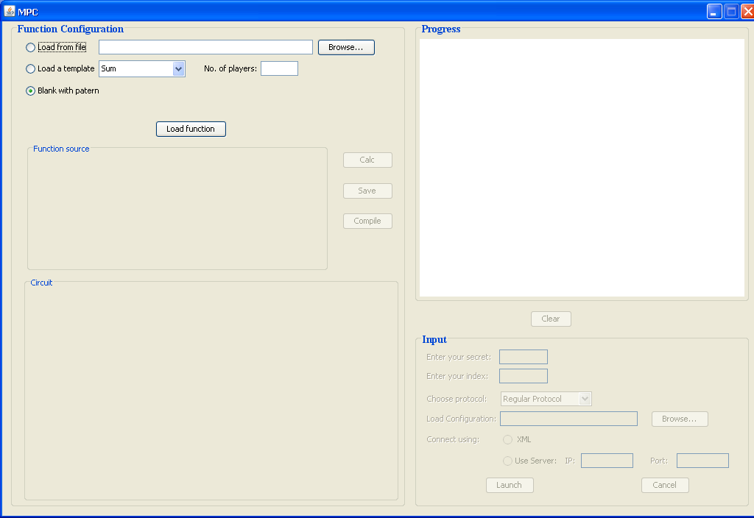

Note: the next time you'll open the application, all the choices you selected and all the inputs you entered will be saved and displayed automatically.

Step 1:
You have 3 ways to load a function:
- From a simple text file that contains the function's code.
- From a prepared template: addition, multiplication, equality or vote.
In this case you also need to enter the number of players.
- "Blank with pattern" choice- a basic code that defines the syntax.

After you made your choice, press the "Load function" button.
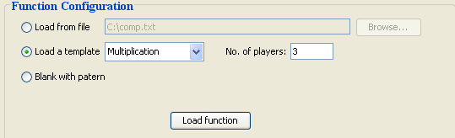

Step 2:
After loading the code, it will appear in the "Function source" text area.
At this point you can change the code, unless it was created from a template.
When you're done you can save your code to a file, using the "Save" button.

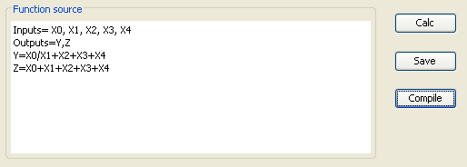

The supported syntax is:
- Addition, subtraction, multiplication and division, using mathematical priority.
- Using brackets to change the order of the operations.
- Using undefined integer type variables.
- The equality operation a==b, that checks if the 2 operands are equal.
The expression value is 1 if they are equal and 0 otherwise.
- The a = b ? c : d operation.
If b=0 then a=d, otherwise a=c.
- Defining inputs and output of the circuit simply using the Inputs line and Outputs line.
- We treat the Inputs by there order in this line- the first one will be the first player's input, the second one will be the second player's input and so on.
- The Outputs each player gets to see will be defined later.
Note: The "Calc" button gives the user the option to simulate the circuit results on given inputs (n inputs).

Step 3:
After writing the code, you need to compile it, using the "Compile" button.
In case of a compilation error, the operation will fail and a message box will appear explaining the error.
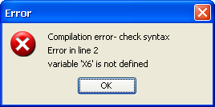

If the code is legal, you can see the computation circuit that was created.
For simplicity, we mark input i with {i}, and constant i with i.

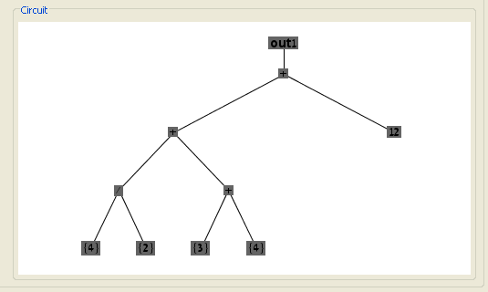

Note: you can zoom in\out by left\right clicking the circuit. You can also mark a part of the circuit (rectangle) by clicking and dragging the mouse around the wanted area and it will be zoomed in.

Step 4:
Enter your secret and your index.
The index is a number between 0 to n-1 identifying you as a player.

Note: when using the "Vote" template you can choose your "secret" from: in favor, against, avoid.

Choose the protocol you want to use- you can choose from the Regular Protocol, the Byzantine Protocol, the Input Stage Cheater or the Multiplication Stage Cheater.
And last, load the configuration file.
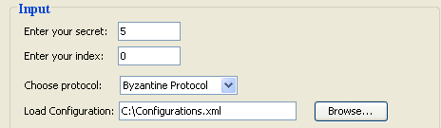

The configuration file:
This file has 2 main purposes: defining the players and defining the SSL.
- When defining the SSL, you should only define the location of the key you are using.
- When defining the players, you need to define for each one:
  - IP and port.
  - Index.
  - Outputs- the circuit's outputs the player is allowed to see, according the order
they were defined in the function's code and in the circuit.

Note: when using the server to define the other players, you only need to define your IP and port, and for the other players you only need to define their indexes and the outputs they are allowed to see.

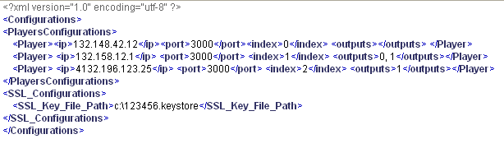

Step 5:
Choose the way you want to get other players connection details:
- Using a XML file- this is the configuration file that contains the other player's connection details.
- Using a server- enter the server's IP and port number.
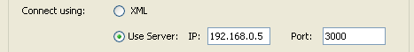

Step 6:
Press the "Launch" button and wait for the result.
You can see the connection process and the computation in the Progress window.
If there are any warnings or errors, they will appear in green and red color respectively.
At any time you can clear the progress window, and scroll up and down.

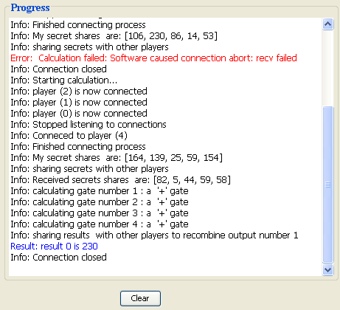

When the computation is over, you will see a message window with the results you are allowed to see:
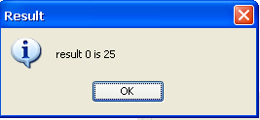
Or this message, if you are not allowed to see any outputs:
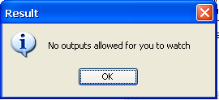

Note: At any given time, before launching the computation, you can go back to previous steps to change your function and inputs.
After launching it, you can cancel the connection process or the computation process, using the "Cancel" button.

At the end, your application will look something like this:
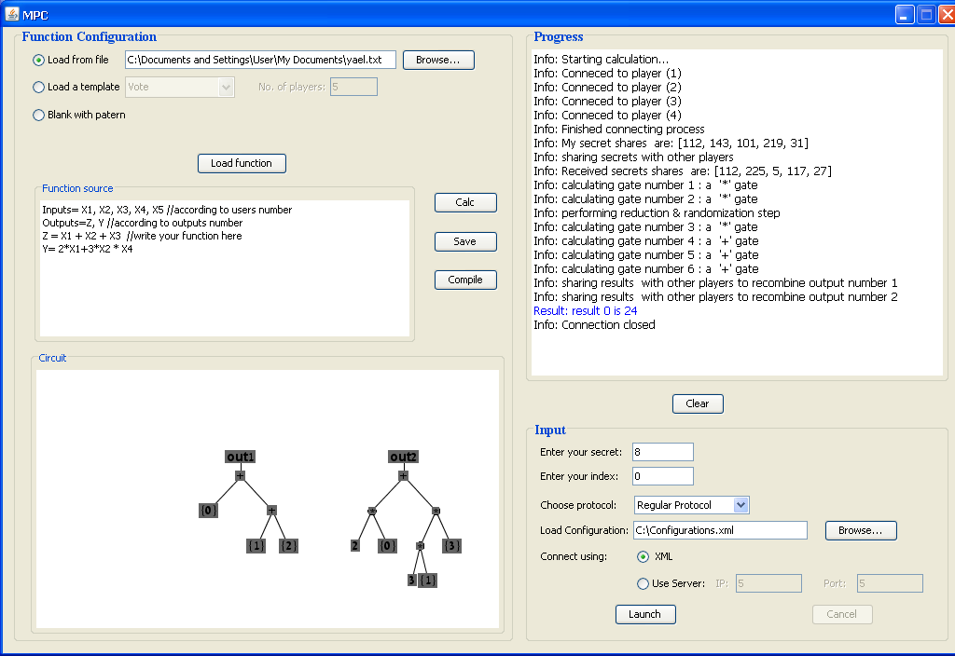

TO DOs …
- Implementing a bulletin board protocol.
Currently the Byzantine case protocol uses a naive Bulletin board implementation as a black box.

- Adding support at operators like "X>Y" in the computation circuit.

- Optimizing the computation order of circuit gates to a parallel computation in order to increase performance.

