

IFB299 - Personal Portfolio

Victoria Holm

N9472168

Team 19

Workshop 1 - Mustafa

**ROLE: Client**

**FAQ’s Suggested Client Role Based Artefacts:**

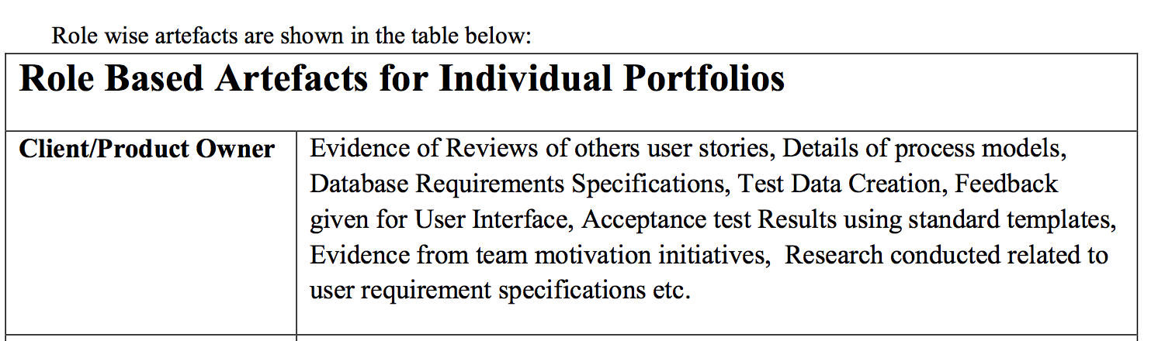

**ARTEFACT 1: Client / Combined Requirements**

As I have the role of the Client for my Team I originally worked to write up all of the client requirements which I based off a combination of the given case task, research and my own intuition. This created value as it would clearly demonstrate to the developers what features were designed from the client and potential users.

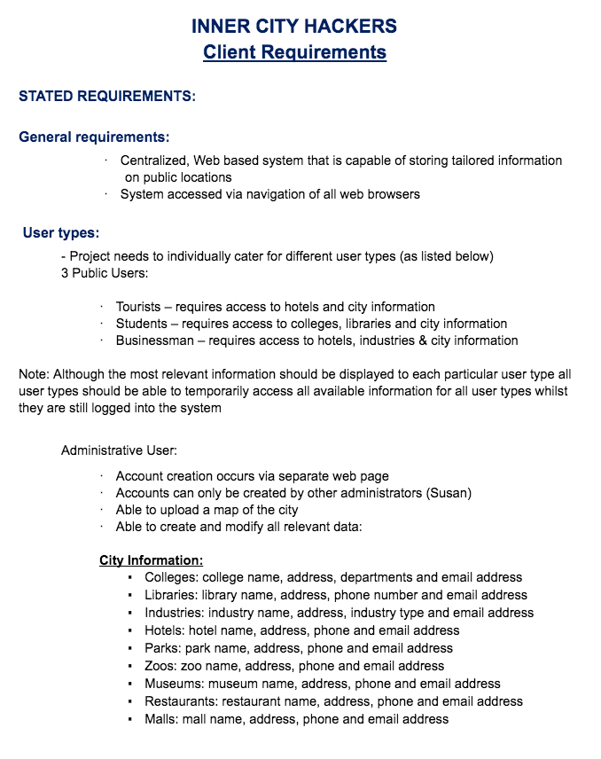

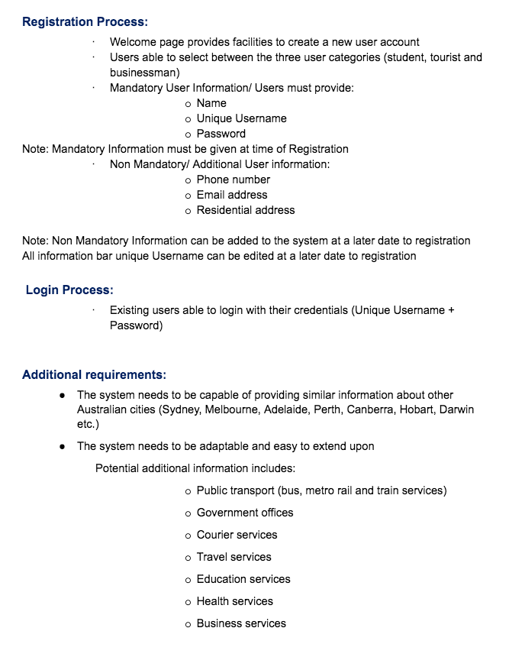 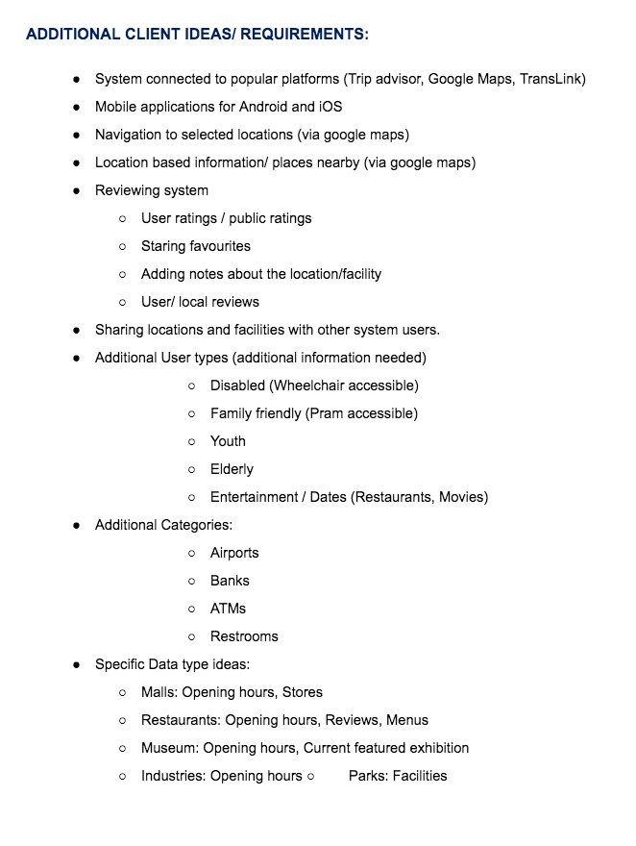

**Research Conducted:**

As mentioned previously I conducted some research whilst developing the client requirements list below are some samples of interviews conducted with potential users as a form of research:

Interviewees were informed of the concept behind “Smart City” and asked what features they would like to see if the product actually existed.

Key Quotes are detailed below:

Student Interview:

Name: Ashleigh Age: 24 Degree: Bachelor of Arts

Date Conducted: 2nd August

* “The Uni and Library thing sounds great but maybe you could also include cafes for students? I know that I like to study in Cafes and not just at libraries and on campus”
* “I think It would be really cool if you could set up your own account and like uh… see reviews of places that you friends have visited. Maybe you could even share places with other people?”

Ideas Developed from Research:

* Inclusion of Cafés for Student Users
* User Reviewing and sharing components

Businessman Interview:

Name: Brad Age: 43 Occupation: Optical Dispenser

Date Conducted: 5th August

* “I like that all the business information will be listed in one place. It can be a pain to find everything at times”
* “I sometimes get sent to different places like Rockhampton for work so I would be really handy if that City thing would extend to locations besides Brisbane “
* “Being able to book restaurants and hotels through that thing could also be handy”

Ideas Developed from Research:

* System connected to popular platforms like Trip advisor and google maps
* Implemented Booking system
* Location Based Information
* Mobile Application

**Combined Requirements:**

Due to my lack of technical knowledge a meeting was planned and held with the development team to discuss to the requirements. Working with Developer Ian and the team a Key list of combined requirements was created. These requirements were narrowed down by what the development team thought was feasible. A clear understanding of the requirements allowed the team to create comprehensive User Stories. If we had time and were progressing ahead of schedule we decided that we could add more of my previously written client requirements.

Team meeting:

Place: QUT Gardens Point

Date: 31st July 2017

Time: 12.00pm – 1:30pm

Present: Rachel, Victoria, Ian, Matthew

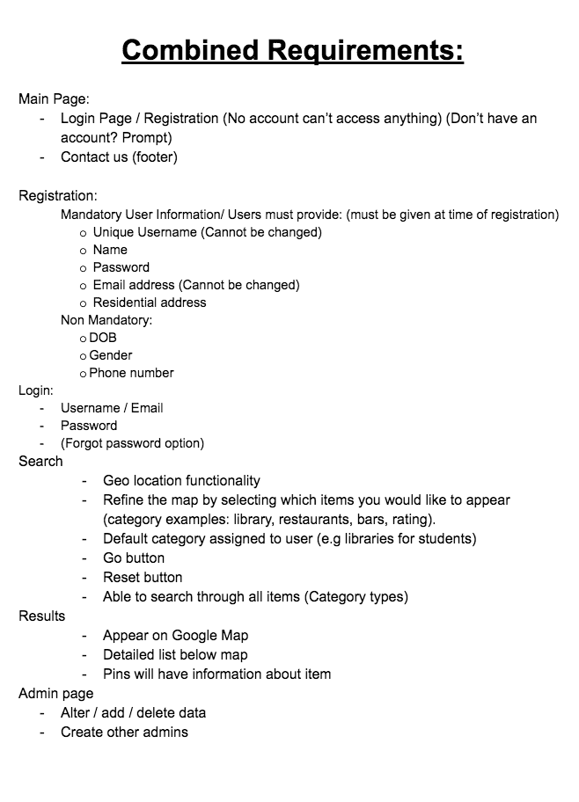

**ARTEFACT 2: User Stories**

Listed below is all of the user stories my team created for this project. Writing the user stories was shared out amongst the team however as the client I had a strong contribution in not only the writing and prioritizing through MOSCOW, but also reviewed and edited all of the User stories This created value as it portrayed what user stories I found valuable as the client and what stories would give the developers “Wins” in the Client’s eyes.

**Reviewed and Edited User Stories:**

|  |  |  |  |  |  |  |  |  |
| --- | --- | --- | --- | --- | --- | --- | --- | --- |
| **Story ID #** | **Feature** | **User Types** | **Story** | **Acceptance Criteria** | **Comments** | **Business Priority MoSCoW** | **Release** | **Story Point Estimation 1pt = 1 Hr** |
| **S01** |  | Student | As a Student, I want to be able to search for libraries near me so that I can find places to study and research more easily | University students will be able to search for libraries University students will receive a list of local libraries and basic information which will include Library Name, address, phone number and email address |  | M | 1 | 2 |
| **S02** |  | Student | As a Student, I want to be able to search for colleges near me so I can make an informed choice of where to go and study. | University student conducts a search of colleges and is provided with a list of colleges. The list also allows them to view information which will include college name, Email address, departments and email address. |  | M | 1 | 2 |
| **S03** |  | Tourist | As a Tourist, I want to be able to search for hotels so that I can easily choose which hotel I want to stay at. | Tourists will be able to search for hotels nearby their location. Tourists will then be displayed a list of the hotels as well as them showing up on the map. Hotel information will include hotel name, address, phone and email address |  | M | 1 | 2 |
| **S04** |  | Tourist | As a Tourist, I want to be able to search city information so that I can plan my holiday sightseeing and decide where to visit. | Tourist are able to see all city information data in the system once they have logged in. City information will include: ▪ Colleges: college name, address, departments and email address ▪ Libraries: library name, address, phone number and email address ▪ Industries: industry name, address, industry type and email address ▪ Hotels: hotel name, address, phone and email address ▪ Parks: park name, address, phone and email address ▪ Zoos: zoo name, address, phone and email address ▪ Museums: museum name, address, phone and email address ▪ Restaurants: restaurant name, address, phone and email address ▪ Malls: mall name, address, phone and email address |  | M | 1 | 2 |
| **S05** |  | Businessman | As a Businessman I want to be able to search industries so that I can plan work related scenarios. | Businessmen will be able to find information regarding industries through searching in the system. Businessmen will receive a list of relevant industries. They will receive a list that specifies the industry, how prominent it is in that city and the general location to set up meetings for that industry. |  | M | 1 | 2 |
| **S06** |  | Businessman | As Businessman I want to be able to search city information so that I can plan my sightseeing and decide where to visit. | Businessmen should be able to search for city POI near their location. Businessmen will the be displayed a list of city POI as well as each of them being displayed on the map. |  | M | 1 | 2 |
| **S07** |  | Businessman | As a Businessman I want to be able to search hotels so that I can easily choose which hotel I want to stay at. | A Businessman user is able to search for hotels, and is provided with details regarding hotels within a location. Hotel information will include hotel name, address, phone and email address |  | M | 1 | 2 |
| **S08** |  | Admin | As an Administrative User I want to be able to create accounts for new administrators to that I can add more Administrative help as the system expands. | Administrative users will be able to create new administrative user accounts and grant account access to new administrators. New administrator users have sufficient privileges that normal users will not. Normal users cannot create administrator accounts. New Administrative accounts will be created via a separate webpage. |  | M | 1 | 3 |
| **S09** |  | Admin | As an Administrative User I want to be able to upload a map of the city to improve the visual representation of the software | Administrative users will be able to uploads maps of the city. The map will be generated from Google API |  | M | 1 | 5 |
| **S10** |  | Admin | As an Administrative User I want to be able to add New POI's to keep the system updated. | Administrative users are able to create new POI data entries |  | M | 1 | 3 |
| **S11** |  | User | As a User I want to access the SmartCity page by entering the url into my browser to that I can access the system quickly | Users are able to type the url into any browser and they will be able to access the Smart City page. |  | M | 1 | 2 |
| **S12** |  | User | As a User I want to be able to login with a unique username and password to maintain my privacy | Users are required to login with a username and password to access their unique account from the main page. |  | M | 1 | 2 |
| **S13** |  | User | As a User I want to be able to search all available data types regardless of my User type | Users will be able to search all available data. They will not be constricted by their user type. Information will include: ▪ Colleges: college name, address, departments and email address ▪ Libraries: library name, address, phone number and email address ▪ Industries: industry name, address, industry type and email address ▪ Hotels: hotel name, address, phone and email address ▪ Parks: park name, address, phone and email address ▪ Zoos: zoo name, address, phone and email address ▪ Museums: museum name, address, phone and email address ▪ Restaurants: restaurant name, address, phone and email address ▪ Malls: mall name, address, phone and email address |  | M | 1 | 2 |
| **S14** |  | User | As a User I want to be able to create an account, so that the system can remember my information and personalize my experience. | Users will be able to create accounts from the welcome page. A User will be required to submit mandatory information such as Name, Unique Username, password and user type (Student, Tourist, Businessman). Non mandatory information includes Phone number, Email address and Residential address |  | M | 1 | 3 |
| **S15** |  | User | As a User I want the system to know my location, so that it can give me information regarding POI’s close to my current location | The system will use the user's geolocation to display POI's within a 10km radius |  | S | 1 | 5 |
| **S16** |  | User | As a User I want the location of POI’s to be shown in a map format, so that I can easily find and visualize a POI’s location. | Location of POI’s are shown in a map format that will be generated using the google maps API |  | S | 1 | 5 |
| **S17** |  | User | As a User I want the system to have a recover password function so that I can always login even If i have lost my password. | If a User forgets their password they can activate a recover password function that sends an temporary password to either their phone or email |  | S | 1 | 3 |
| **S18** |  | User | As a User, I want to be able to use the system outside of Brisbane so that use the system when visiting other cities | Users are able to use the City Smart in all major cities across Australia. They will be able to search using their location or input the location they want to look at |  | S | 2 | 3 |
| **S19** |  | Admin | As an Administrative User I want to be able to create new POI type categories so new searches can be conducted in the future. | Administrative Users can create new POI categories such as Public Transport. In order to add new POI categories, they must have at least 20 places that they can add into that category |  | C | 1 | 3 |
| **S20** |  | Student | As a Student, I want to be able to find cheap cafes near me so that I can afford to eat out. | University students can see an additional tailored category of cheap eating spots. This will be sorted via proximity to the location that had been searched. |  | C | 1 | 2 |
| **S21** |  | User | As a User I want to be able to compare hotels so that I can make an informed choice of which hotel to stay at | Tourists conducts a search of hotels and is provided with a list of hotels. The list also allows them to view information about the hotels and compare them to one another |  | W | 1 | 2 |
| **S22** |  | Student | As a Student, I want to be able to compare what colleges are near me so that I can make an informed choice of where to go and study. | University student conducts a search of colleges and is provided with a list of colleges. The list also allows them to view information about the colleges and compare them to one another |  | W | 1 | 2 |
| **S23** |  | User | As a User, I want to be able to filter my results by ratings so that I can determine which POI's are popular to visit. | Users can use a filter by ratings. Ratings range from 1-5 stars |  | W | 2 | 2 |
| **S24** |  | User | As a User I want to be able to see public reviews and ratings so that I can see other user's insights into different POI's. | Users will be able to read reviews that other users have written. They will be pulled from the database and shown in order of data they were written so that the most recent reviews are shown first |  | W | 2 | 3 |
| **S25** |  | User | As a User I want to be able to to rate and create POI reviews so that I can share my insight on various POI's | Users will be able to add reviews by clicking on the place they visited and uploading a review. These reviews will be stored on the database. |  | W | 2 | 5 |
| **S26** |  | User | As a User I want to be able to cancel my account in order to maintain my privacy | Users will be able to cancel their accounts. When they cancel their account, their data will be removed from the database |  | W | 2 | 2 |
| **S27** |  | User | As a User I want to be able to book hotels through the system so that I can easily organize my accommodation. | Users are able to search hotel using the search function. Users will then be able to click on the results and book through a click through link to a hotel booking platform. |  | W | 2 | 20 |
| **S28** |  | User | As a User I want to be able to book restaurants through the system so that I can easily make eating plans | Users are able to search restaurants using the search function. Users will then be able to click on the results and book through the application through a click through link to a restaurant booking platform |  | W | 2 | 20 |
| **S29** |  | User | As a User I want to be able access the system as an application on a smartphone so that I can use the system on multiple platforms. | Users can access the City Smart via an app available for iOS and Android through the App Store and Google Play Store |  | W | 2 | 200 |

**ARTEFACT 3: Test Cases**

The test cases detailed below were written by myself (Client) and the Scrum Master (Rachel). When developing the test cases, we aimed to make them clear for the development team to easily understand yet comprehensive enough to allow us test the user stories.

|  |  |  |  |  |  |  |
| --- | --- | --- | --- | --- | --- | --- |
| **Test Case ID #** | **Title** |  | **Story** | **Description** | **Test Step** | **Expected Result** |
| **TC01** | Student search for libraries |  | As a Student, I want to be able to search for libraries near me so that I can find places to study and research more easily | A registered student should be able to search for the libraries near them. Precondition: the user must be registered to the system with a username, password and user type. The user needs to be correctly logged in | 1. Student logs in. 2. Search displays available libraries in a list. 3. Check to confirm all test libraries are displayed. | The libraries that are in the specified area are listed |
| **TC02** | Student search for colleges |  | As a Student, I want to be able to search for colleges near me so I can make an informed choice of where to go and study. | A registered student should be able to search for colleges near them Precondition: the user must be registered to the system with a username, password and user type. The user needs to be correctly logged in | 1. Student logs in. 2. Search displays available colleges in a list. 3. Check to confirm all test colleges are displayed. | The colleges that are in the specified area are listed |
| **TC03** | Tourist search for hotels |  | As a Tourist, I want to be able to search for hotels so that I can easily choose which hotel I want to stay at. | A registered user should be able to search for hotels near them Precondition: the user must be registered to the system with a username, password and user type. The user needs to be correctly logged in | 1. Tourist logs in. 2. Search displays available hotels in a list. 3. Check to confirm all test hotels are displayed. | The hotels that are in the specified area are listed |
| **TC04** | Tourist search for City Information |  | As a Tourist, I want to be able to search city information so that I can plan my holiday sightseeing and decide where to visit. | A registered tourist should be able to search for city information near them Precondition: the user must be registered to the system with a username, password and user type. The user needs to be correctly logged in | 1. Tourist logs in. 2. Search displays available city information in a list. 3. Check to confirm all test city information is displayed. | The city information that is relevant to that specified area is displayed |
| **TC05** | Businessman search for industries |  | As a Businessman I want to be able to search industries so that I can plan work related scenarios. | A registered Businessman should be able to search industries near them Precondition: the user must be registered to the system with a username, password and user type. The user needs to be correctly logged in | 1. Businessman logs in. 2. Search displays available industries in a list. 3. Check to confirm all test industries are displayed. | The relevant industries are displayed |
| **TC06** | Businessman search for cities |  | As Businessman I want to be able to search city information so that I can plan my sightseeing and decide where to visit. | A registered Businessman should be able to search for City Information. Precondition: the user must be registered to the system with a username, password and user type. The user needs to be correctly logged in | 1. Businessman logs in. 2. Search displays available city information in a list. 3. Check to confirm all test city information is displayed. | The city information that is relevant to that specified area is displayed |
| **TC07** | Businessman search for hotels |  | As a Businessman I want to be able to search hotels so that I can easily choose which hotel I want to stay at. | A registered Businessman should be able to search for hotels near them. Precondition: the user must be registered to the system with a username, password and user type. The user needs to be correctly logged in | 1. Businessman logs in. 2. Search displays available hotels in a list. 3. Check to confirm all test hotels are displayed. | The hotels that are in the specified area are listed |
| **TC08** | Administrative User create new account |  | As an Administrative User I want to be able to to create accounts for new administrators to that I can add more Administrative help as the system expands. | An Administrative User should be able to create new Administrative Accounts Precondition: the user is an already registered Administrator and is correctly logged into the system. | 1. Admin logs in. 2. Admin can click find a user 3. Admin can give that user administrative access |  |
| **TC09** | Administrative User upload map |  | As an Administrative User I want to be able to upload a map of the city to improve the visual representation of the software | An Administrative user should be able to upload a map Precondition: the user is an already registered Administrator and is correctly logged into the system. | 1. User clicks on a city. 2. User clicks edit. 3. User clicks upload map. 4. User clicks confirm |  |
| **TC10** | Administrative User add POI |  | As an Administrative User I want to be able to add New POI's to keep the system updated. | An Administrative User should be able to add new POI's to the system Precondition: the user is an already registered Administrator and is correctly logged into the system. | 1. Admin logs in. 2. Admin goes to portal  3. Admin clicks add new POI |  |

**Testing Procedure:**

The Trello board show below was created by the Scrum Master (Rachel) to track the teams progress as we moved though our tasks. This sample of the Trello board shows the testing tasks that I was involved in which we completed at a team meeting. These tests cases and testing created value as it ensured that the client requirements have been met and that the system is operating correctly.

Team meeting:

Place: QUT Gardens Point

Date: 11th September 2017

Time: 12.00pm – 1:30pm

Present: Rachel, Victoria, Ian, Matthew

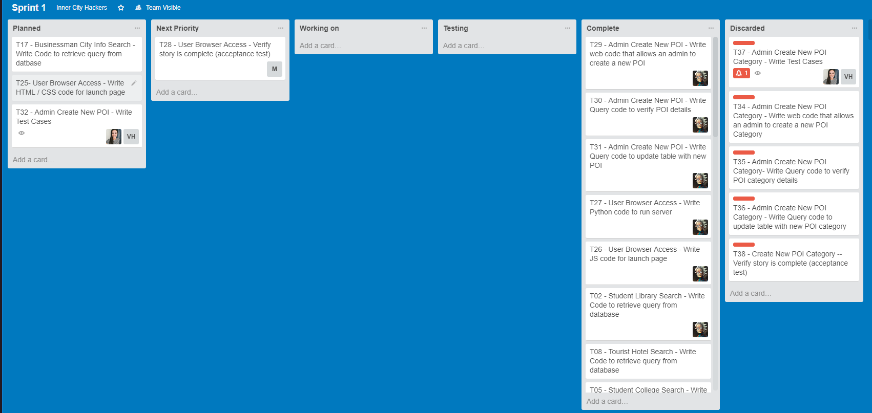

**ARTEFACT 4 – Diagram Data Flow Diagram**

Listed Below are two sample Data Flow Diagrams that I created as potential representations of the flow of data in the Smart City Project. These Diagrams created value as they are easy to interpret by both clients and developers and maps out the flow of information in the system to achieve clarity.

**Data Flow Diagram 1:**

Based of Class Slides

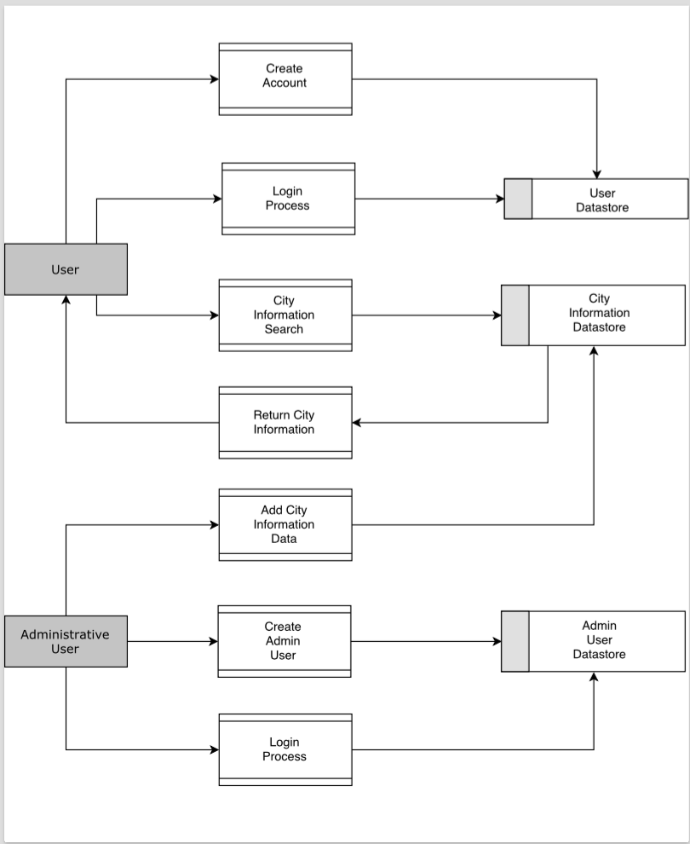

**Data Flow Diagram 2:**

Based of Business Analysis BABOK Guide.

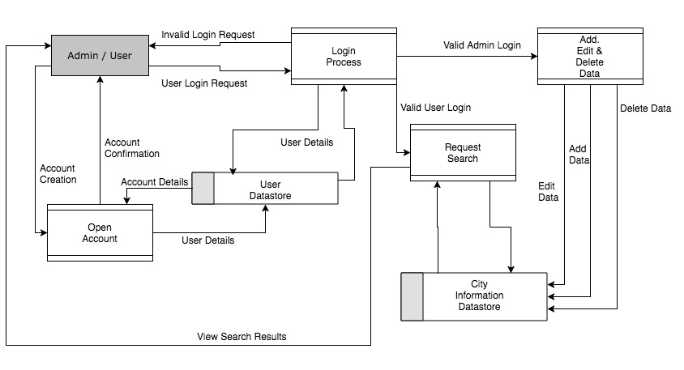

**ARTEFACT 5 –Class Diagram**

Below is a Class diagram I created to show the internal structure of classes as well as relationship of the classes with each other. It’s a valuable diagram as it aids in the understanding from a development perspective and provides a visual representation of class structure

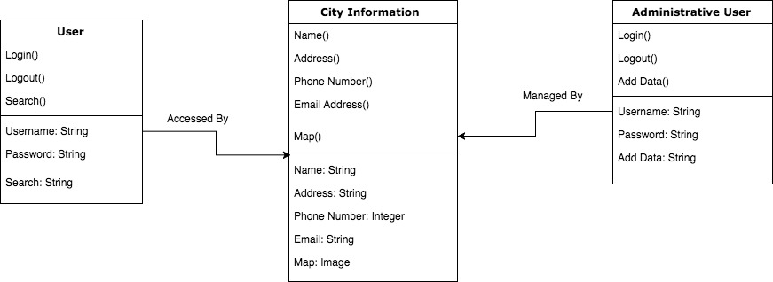

**ARTEFACT 6 – Mock-ups / Web Prototyping tool to create User Interface Examples**

I have included some examples of the user interface mock-ups that. We worked as a team to sketch them out on paper and then I made these mock-ups using proto.io. Designed a logo, minimal programming and Html knowledge.

**Hand Drawn Wire Frames**

|  |  |
| --- | --- |
| https://lh3.googleusercontent.com/KBq4PY6wHNkT06xVpQ64aF8ZMazsFTv3gr09gWNK2nJHUqa5vnphXmycjH4E9npmG3tEYM5FmEX9gLlC0VeaFIAwBOwcwpPx5Bsi2uK8sIvAIACCNxTv9P9capYTxIVM0-K5__s6 | Home Page / Login Page |
| https://lh5.googleusercontent.com/sBB0QUnZEC_yLMpp0ct6MFMYriuAsX6sCkvkUwsutKo6ll0CTtJqQmMJIkDaqZfya6ngTwvJtTgeoCNhfGmcl6ZUGgH5I3kyWZQJjWFTJy9XfegBJYBgoDfNLl_QOPRNL0tf4j4j | Search Page |
| https://lh4.googleusercontent.com/fR9wTBbfFC0P9iEq5ZwSW2-yWkIcmFEnaIUq7PuAvnpQvBgyZrqfWtHrpUT0HvHm2wlRg5FSDaTnoo4p3cxkW54JfyJV-cVdbN3v4nxyEqzI6tjttMYHQucQB3IrdgSdR0XkAH2w | Results Page |
| https://lh6.googleusercontent.com/Nh_BlVjcOWzX-F_xEG6LV-7ML3P8KzGk8GkASqVOCmL7hHA6JVGHaaQPp0Z-DeMm7mzk73GYbfvkDMCNeXoGAm0EsAmWhi5AgKo7qSI8JViyhu-yGEWysSxvLp31NTvgGHmcyx58 | Register / Account Creation Page |
| https://lh6.googleusercontent.com/0TWBX3-xmeqtuAvzTG8YmYqnvClYjcR6L6-lX1ZBo4sjsAJKzpNbX_BNlNrrC479TjUBI5WA6lUDjFuiJLrtB1PWawwtAEq2RvAIb1jGkF6L3F5QuDas0mtVq6PQJ842qc8UX6hc | Account Settings |

**Potential User Interface Designs:**

After developing some hand-drawn wireframes and due to a lack of programming and html skills I utilized an online prototyping tool Proto.IO to develop some high level UI designs. These designs created value as it demonstrated to the Development team what sort of designs the client expects, likes and understands how to operate.

|  |  |
| --- | --- |
| **Item** | **Responses** |
| https://lh3.googleusercontent.com/r7pzL63P47-2yu7Xw5kDtptPU9dpmVhXc8eC9qo6loGJpMlfbRiYZsL04Frk-rVYECP7qLUUEkwvj1F_jAGumn5049TqcQh2Kx1vkomrPDX7MkqoFxQpJylNmbUoia8CKTQxFHxf | Logo - Long Version   * The Logo was received positively by the rest of the team and has been used in the final UI design |
| https://lh4.googleusercontent.com/JfMyA7oqhzqWfhz5gQxqkWcz57oDSX3UbIfyOzJEwKIomsSDmVG_UNOwApDbeHGYu4btncAGi-wlPP7d1JQdDwUUPucV-FmqQ6taoGdZVvXiGfmmpvesaRP0cdB3Mz2AkPCeUPJc | Logo   * The Logo was received positively by the rest of the team and has been used in the final UI design * At the suggestion of the development team the a second logo was designed to provide different layout options |
| https://lh3.googleusercontent.com/Boa8Pz9iCaU-DnzQOXPtw0uLn8NkvbjxrB_fFfU9wQIxKefAgq5ihGVP11sOdri1DnERdesN-8tluDOM0QanIXoS5liImk3o9pn-RMFwbXSHLv-02sHOO0-GJW4Qyqc11m8Iv01X | User Login Page   * Fellow Students who I have spoken to really liked the colour schemes that I used * The Development team decided that they wanted login and register to be on the same page to make the system more streamlined |
| https://lh5.googleusercontent.com/-3QW3E4vFUxFN_bRMgXF_oBFtLiYgw92oDeWPG_gCFeWibpPYTPOhfp4cu7k_WMuy08JBkSVaUheB2da3QkYOBM8CJ5KC0h39tKXteqEj6fuRP87M9tRH6pN2SWsFWgM_4ccOfDY | User Register Page   * The Development team decided that they wanted login and register to be on the same page to make the system more streamlined * I received mixed responses on the icons for users some believed it was a little childish whilst others liked how clear it made the categories |
| https://lh3.googleusercontent.com/sng0LAKhzo-qv8I-6fSmugUooAF5YenO2zLC62VfflENpb78LWCS8GTfI1ticgATMYTmYrzmGhet_AaJ-wIr3-fpeBygcEQCzQkzfZR2g6TL7XVRM8SRa-o5Nyn_v5fSkqz-ZQ1r | Search Page   * Tutor told the team that he liked the idea of having checkboxes for the search categories |
| https://lh6.googleusercontent.com/IzGd4nxfC78KhkfVMzfzDOnBT4QBTvLnvz4jmdKGIGyHg8va3uIQRB2IUfqZSV_rwUm9Z2-f7o03Ei46YEbOeodqTLUQErjKjqC5iLbL9scDOtpy_jntZnlDIPmwcAstiiGQ9tjM | Results Page   * Potential users liked how clear and easy to understand this format was. |