**Coding questions**

**Marks:- 10**

1. Create a Contact Us Form

**Task:**  
Build an HTML form titled "Contact Us" that collects the following information:

* Name (text input)
* Email (email input)
* Message (multi-line textarea)
* A "Send" submit button

**Requirements:**

* Use appropriate <label> tags for each input field.
* All fields should be required.

Example

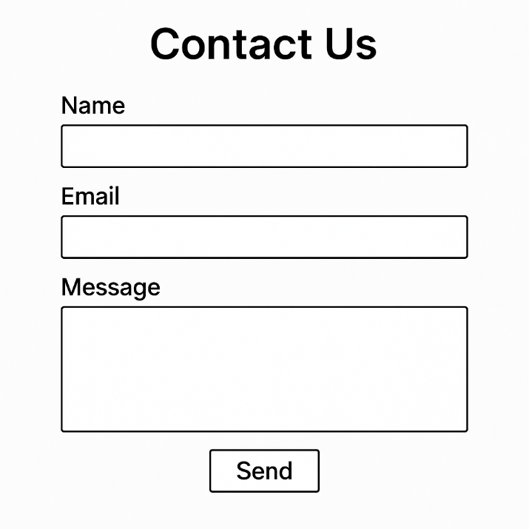

**Marks:- 5**

2. Build a Product Table

**Task:**  
Create an HTML table that displays a product list with the following columns:

* Product Name
* Price
* In Stock (Yes/No)

**Requirements:**

* The table should have a header row.
* Add at least three products as table rows.
* Use the <table>, <tr>, <th>, and <td> tags appropriately.

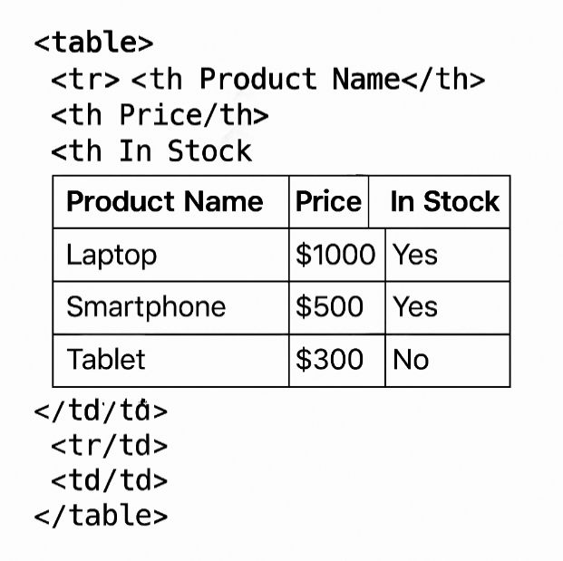

**Marks:- 5**

3. Create a Navigation Bar with Links

**Task:**  
Design a simple navigation bar using an unordered list. The navigation bar should have links to:

* Home
* About Us
* Services
* Contact

**Requirements:**

* Use the <nav> semantic tag to wrap the navigation bar.
* Each link should use the <a> tag with a placeholder href (e.g., #home).
* Use a list (<ul> and <li>) for the navigation items.