**MANIPAL ACADEMY of HIGHER EDUCATION**

**MTECH- Software Engineering**

**MATHS**

**(Submitted By: Gyanesh Kumar PANDEY(Roll No: 220928017))**

**Program to solve system of linear euation Ax=b using QR decompostion. Input for the program Q and R and b**

**Input for the program Q and R and b A QR decomposition of a matrix A is a decomposition of A into a product QR of an orthogonal matrix Q and an upper triangular matrix R.**

**If A is m×n with m≥n, then QR decomposition is unique.**

**If A is square, then the QR decomposition is unique**

**if and only if A is full rank; otherwise not unique.**

**A QR decomposition can be used to solve the linear system of equations Ax=b for x.**

**If A is m×n with m≥n, then the QR decomposition is:**

**A=QR where Q is an m×m orthogonal matrix and R is an m×n upper triangular matrix.**

**The linear system of equations can be rewritten as:**

**QRx=b Since Q is orthogonal, we have: QTx=Q−1**

**Therefore: Rx=Q−1b Since R is upper triangular,**

**the system of linear equations can be solved for x using backward substitution.**

A program to solve a system of linear equations Ax=b using QR decomposition logic of Python code would involve the following steps:

1. Import the NumPy library.

2. Define the matrix A and vector b.

3. Use the QR decomposition function to decompose matrix A.

4. Use the solve function to solve the system of linear equations.

5. Print the solution vector x.

The equation to be solved is of the form Ax = B. In this particular case, the matrix A = QR, where Q is an orthogonal matrix and R is an upper triangular matrix.

[Ax=B]

[A=QR]

What are the properties of an orthogonal matrix?

It is a square matrix;

Multiplying Q for its transpose, we obtain the identity matrix;

QQ^{T}=Q^{T}Q=I

The inverse of an orthogonal matrix is equal to its transpose.

Q^{T}=Q^{-1}

Moreover, from matrix algebra we remember that if A has n linearly independent columns, then the first n columns of Q form an orthonormal basis for the space of columns of A. In general, the first k columns of Q form an orthonormal basis for the subspace of the first k columns of A, for each 1\leq k\leq n.

An identity matrix is a square matrix in which the elements of the main diagonal are 1 and all other elements are zeros.

Now We can restate the initial problem Ax=B this way:

[QRx=B]

[Rx=Q^{-1}B]

[Rx=Q^{T}B]

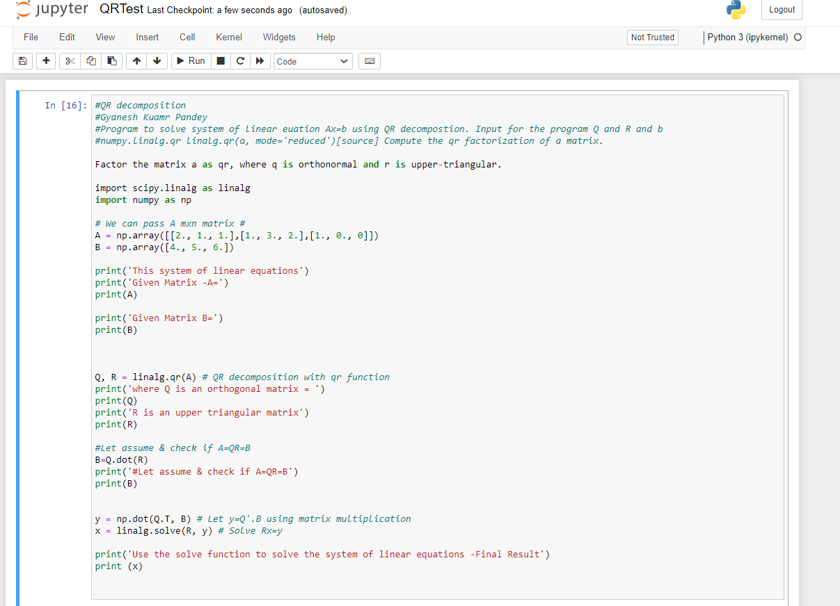

Output

