# Project Title

**Online Hotel Reservation System**

**Submitted To**

**Md Mahedee Hasan**

**Submitted By**

|  |  |  |  |
| --- | --- | --- | --- |
| Team Name: Lazy | | | |
| SL | **Name** | **Email** | **Contact Number** |
| 1 | Salehin Shuvo | mdsalehinshuvo@gmail.com | +8801817402019 |
| 2 | Md Sharif Hossain | [msharif5322@yahoo.com](mailto:msharif5322@yahoo.com) | +8801681225055 |
| 3 | Saadikul Azad | saadikulazad@gmail.com | +8801838438032 |
| 4 | Rifat Haider | rifat.hdr@gmail.com | +8801673204434 |
| 5 | Raihan Abu Bakar | absraihan@gmail.com | +8801843693882 |
| 6 | Sadnam Arif | Sadnam.arif@gmail.com | +8801950084828 |

**Date of Submission: May 10, 2017**

Table of Contents

Project Title 1

1 Project Description 3

1.1 Current Scope: 3

1.2 Future Scope: 3

2 User Story: 3

2.1 My Accounts 3

2.2 Find Hotels 3

2.3 Booking Hotels 4

# 1 Project Description

Tourism is getting popularity in upcoming days but there are no online service for this sector. This website will give the information of hotels, resorts and many packages to explore the country. People can also book hotels, motels, resorts and tour packages, Flights, rent Car and in discover option people can gather information of new historical place. It will make easy the visitor tour and explore more.

## 1.1 Current Scope:

Currently we develop online hotels booking system. By this system user can booking a hotel, booking best deals, find top destination and find more places all over the country. In this website we consider two types of user

1. Administrator(Management of company)
2. Customer

## Future Scope:

In future we will add some new feature like pay online, flights booking, car rental, buy bus and rail tickets.

# 2 User Story:

|  |  |
| --- | --- |
| SL | Story Name |
| 1 | All Countries |
| 2 | Top currencies |
| 3 | My Accounts |
| 4 | Finds Hotels |
| 5 | Booking Hotels |
| 6 | Find Holidays Package |
| 7 | Discover |
| 8 | Top Destination |
| 9 | Today Best Deals |
| 10 | Filter Search |

# 3. System Administrator:

The system admin has the ability to make new users, edit their information and to delete user accounts. The database admin initially create a system admin which able to create new admin. The system admin when login to the system get a dashboard.

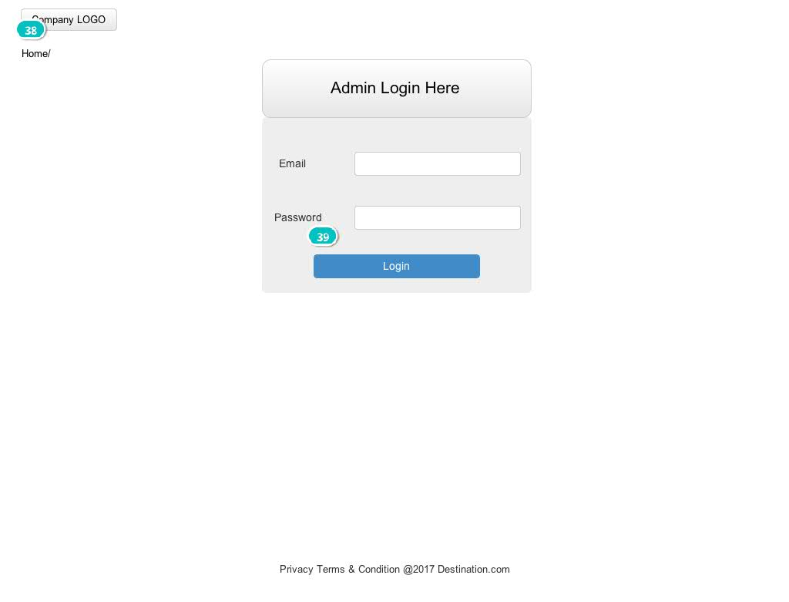

Figure 1: Admin login form



Figure 2: Admin dashboard

All country name and their information input by the system admin.

Top Currencies:

## 2.1 My Accounts

User use this feature sign up to the system. For new user booking any hotel or package that user need sign up to the system. Then user manage their booking details and if needed to cancel their booking. If visitor new for the site, register from the sign up form. For previous visitor just log in to the system and booking their best hotel or package.

Sign up form:

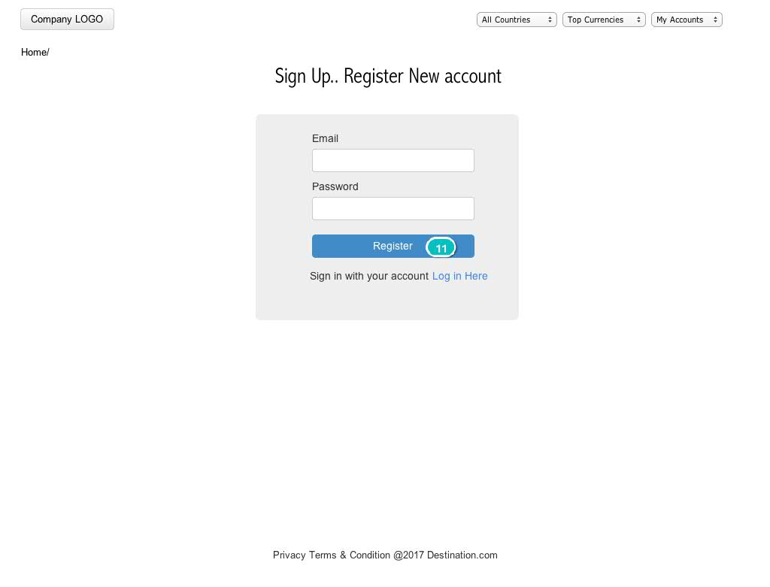

Figure 1: Sign up form

Sign in form:

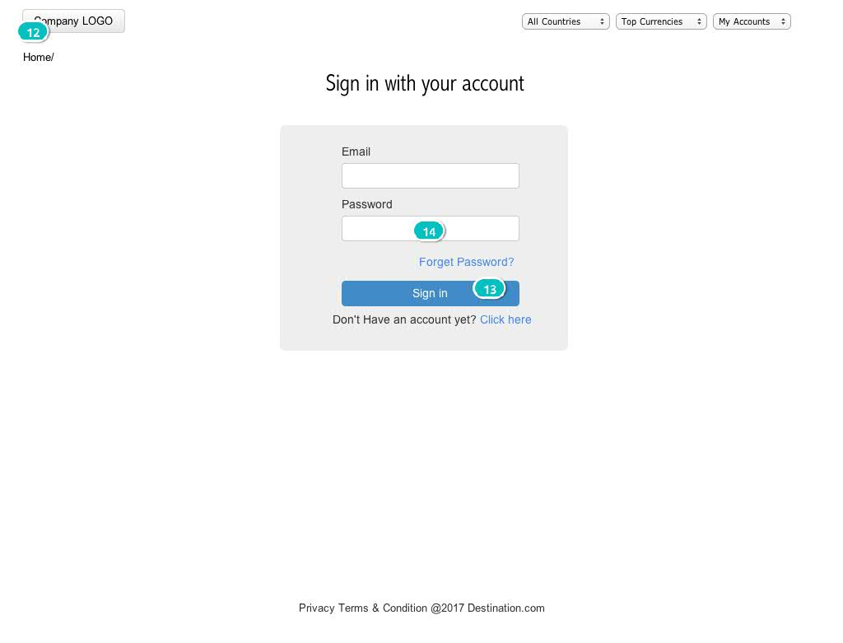

Figure 2: Sign in form

## 2.2 Find Hotels

User use this UI find out their destination by search the name of countries, city, location or hotel name.

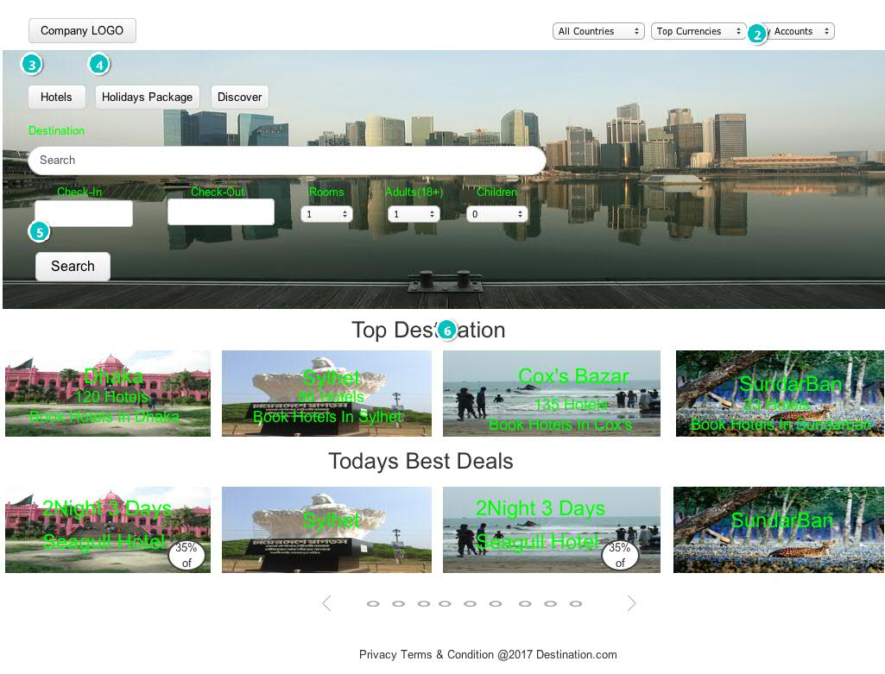

Figure 3: Find hotel/location

## 2.3 Booking Hotels

User use this UI booking their best hotel. First of all system admin store all hotel information. The visitor booking their hotel in some steps 1. Visitor choose their best hotel, 2. Fill up guest information, after that

02. Screens / bookingSystem

Hotels

|  |
| --- |
|  |

Interactions

|  |  |
| --- | --- |
| 2 | **on Click:** goes to 'sign up' 🡪 |
| 3 | **on Click:** goes to 'Hotels' 🡪 |
| 4 | **on Click:** goes to 'HPackage' 🡪 |
| 5 | **on Click:** goes to 'FindHotels' 🡪 |
| 6 | **on Click:** goes to 'FindHotels' 🡪 |

02. Screens / bookingSystem

FindHotels

|  |
| --- |
|  |

Interactions

|  |  |
| --- | --- |
| 7 | **on Click:** goes to 'sign up' 🡪 |
| 8 | **on Click:** goes to 'Hotel Details' 🡪 |
| 9 | **on Click:** goes to 'Hotel Details' 🡪 |

02. Screens / bookingSystem

HPackage

|  |
| --- |
|  |

Interactions

|  |  |
| --- | --- |
| 10 | **on Click:** goes to 'sign up' 🡪 |

02. Screens / bookingSystem

sign up

|  |
| --- |
|  |

Interactions

|  |  |
| --- | --- |
| 11 | **on Click:** goes to 'sign in' 🡪 |

02. Screens / bookingSystem

sign in

|  |
| --- |
|  |

Interactions

|  |  |
| --- | --- |
| 12 | **on Click:** goes to 'Hotels' 🡪 |
| 13 | **on Click:** goes to 'sign up' 🡪 |
| 14 | **on Click:** goes to 'Reset Pass' 🡪 |

02. Screens / bookingSystem

Hotel Details

|  |
| --- |
|  |

Interactions

|  |  |
| --- | --- |
| 15 | **on Click:** goes to 'sign up' 🡪 |
| 16 | **on Click:** goes to 'Book Now' 🡪 |
| 17 | **on Click:** goes to 'Book Now' 🡪 |

02. Screens / bookingSystem

Book Now

|  |
| --- |
|  |

Interactions

|  |  |
| --- | --- |
| 19 | **on Click:** goes to 'sign up' 🡪 |
| 20 | **on Click:** goes to 'Confirmation' 🡪 |

02. Screens / bookingSystem

Confirmation

|  |
| --- |
|  |

Interactions

|  |  |
| --- | --- |
| 21 | **on Click:** goes to 'sign up' 🡪 |
| 22 | **on Click:** goes to 'Reset Pass' 🡪 |
| 23 | **on Click:** goes to 'sign in' 🡪 |

02. Screens / bookingSystem

Reset Pass

|  |
| --- |
|  |

Interactions

|  |  |
| --- | --- |
| 24 | **on Click:** goes to 'sign up' 🡪 |