Contents

ATS System Architecture 1

Logical Layer of ATS 2

External Interface 2

External Interfacing 3

# ATS System Architecture

**M**

**o**

**d**

**e**

**l**

**O**

**b**

**j**

**e**

**c**

**t**

**s**

Master Page

Membership Provider

Membership

**ASP.NET 2.0**

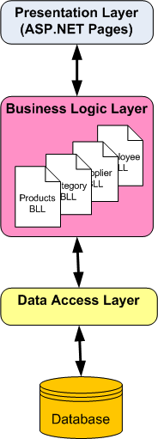

**ASP.net Business Components**

Investor Info, Charges Margin, Trades, Accounts

**Business Components**

**SQL Server**

BlueChipDB

iBCDB

SMSDB

Helper

Factory

DAL

Interface

**Data Access Components**

Figure 1: ATS System Architecture

# Logical Layer of ATS



Figure 2: Logical Layers for "ATS"

# External Interface

 [External Interfacing]

# External Interfacing

