**User story of ATS**

**History Card**

|  |  |  |  |
| --- | --- | --- | --- |
| **Version#** | **Modification History** | **Update Date** | **Created/Reviewed by** |
| 1.0 | Prepared User Story | 27 November 2017 | Md. Aftab Uddin Kajal |
| 1.1 | Writ up Story | 28 November 2017 | Md. Aftab Uddin Kajal |

Table of Contents

Project Name 3

Team Name 3

Team Members 4

Submitted to 4

Project Description 4

Current Scope 4

Future Work 4

User story 4

1. System Settings 5

1.1 Installation 5

2. Admin Settings 7

2.1 Branding Settings 7

2.2 General Settings 8

2.3 Security 11

2.4 Groups 11

2.5 Notifications 12

2.6 Asset Tags 14

2.7 Barcode Settings 14

2.8 Label Settings 15

2.9 LDAP/AD Settings 16

2.10 Backups 18

3. Settings 18

3.1 Fieldsets & Custom Fields 18

3.2 Status Labels 19

3.3 Manufacturers 20

3.4 Categories 21

3.5 Depreciations 22

3.6 Asset Model 23

3.7 Supplier 24

3.8 Companies 26

3.9 Locations 27

3.10 Department 27

4. Asset 28

4.1 Asset Create 28

4.2 List All Asset 30

4.3 Deployed Assets 30

4.4 Ready to Deploy Assets 30

4.5 Pending Assets 30

4.6 Un-deployable Assets 31

4.7 Archived Assets 31

4.8 Requestable Assets 31

4.9 Bulk Checkout 32

4.10 Requested Assets 32

4.11 Deleted Assets 32

4.12 Asset Maintenances 32

4.13 Bulk Audit 33

4.14 View Asset 33

4.15 Create Asset Maintenance 34

5. Licenses 35

5.1 Software Licenses 35

5.2 All Software License 37

5.3 View License 37

6. Accessory 37

6.1 New Accessory Add 37

6.2 Accessories 38

7. Consumables 39

7.1 Create Consumables 39

7.2 List of Consumable 40

8. Component 41

8.1 Create Component 41

8.2 Component List 41

9. User Management 43

9.1 User Create 43

9.2 View a User 48

10. Requestable 48

10.1 Requestable Asset List 48

11. Reporting 48

11.1 Activity Report 48

11.2 Audit Log 49

11.3 Depreciation Report 49

11.4 License Report 49

11.5 Asset Maintenance Report 50

11.6 Unaccepted Assets 50

11.7 Accessory Report 50

11.8 Custom Asset Report 50

References 52

# Project Name

* Asset Tracking System(ATS)

# Team Name

* Dot

# Team Members

|  |  |  |  |
| --- | --- | --- | --- |
| SL# | Name | Email | Contact Number |
| 1 | Md. Aftab Uddin Kajal | [kajal.alpha@gmail.com](mailto:kajal.alpha@gmail.com) | 01717839097 |

# Submitted to

|  |  |  |  |
| --- | --- | --- | --- |
| SL# | Name | Email | Contact Number |
| 1 | Md. Mahedee Hasan | [Mahedee.hasan@gmail.com](mailto:Mahedee.hasan@gmail.com) |  |
| 2 | Md. Ashiqur Rahman |  | 01811448069 |

# Project Description

Asset Tracking Systems known as ATS is a web-based application to automate company’s Asset related activity. This system is for asset management and tracking for a small organization. organization has various branches (i.e. DHK, CTG), Departments(HR, Sales etc) which it distributes various assets (Table, Chair, Desktop, Laptop, Server etc.) also Private organization has to manage its own asset and Private organization organizes various purposes regarding which Private organization has to purchase assets.

It's difficult to manage this asset and tracking the assets.

# Current Scope

Our current scope is to develop Asset Tracking System known as ATS and relevant configuration setup interfaces.

# Future Work

Integrate with LDAP/AD

# User story

|  |  |
| --- | --- |
| **SL#** | **Story Name** |
| 1 | System Install |
| 2 | Admin settings |
| 3 | Settings |
| 4 | Asset Management |
| 4 | License |
| 5 | Accessory |
| 6 | Consumables |
| 7 | Component |
| 8 | User Management |
| 9 | Request |
| 10 | Reporting |

## System Install

### 1.1 Installation

In this setup page user will setup Pre-Flight & Setup for the first time. ATS comes with a pre-flight check and setup to help make sure environment is set up correctly, create the database tables and add your first admin user. In the second step(Fig-2), here user give site Name, user Name, Name(First Name and Second Name), email, Password. If user want email credential details then need to tik on the check box. This user will be first user and super user. Super user can do everything.

Figure 1 Asset Pre-flight Step 1

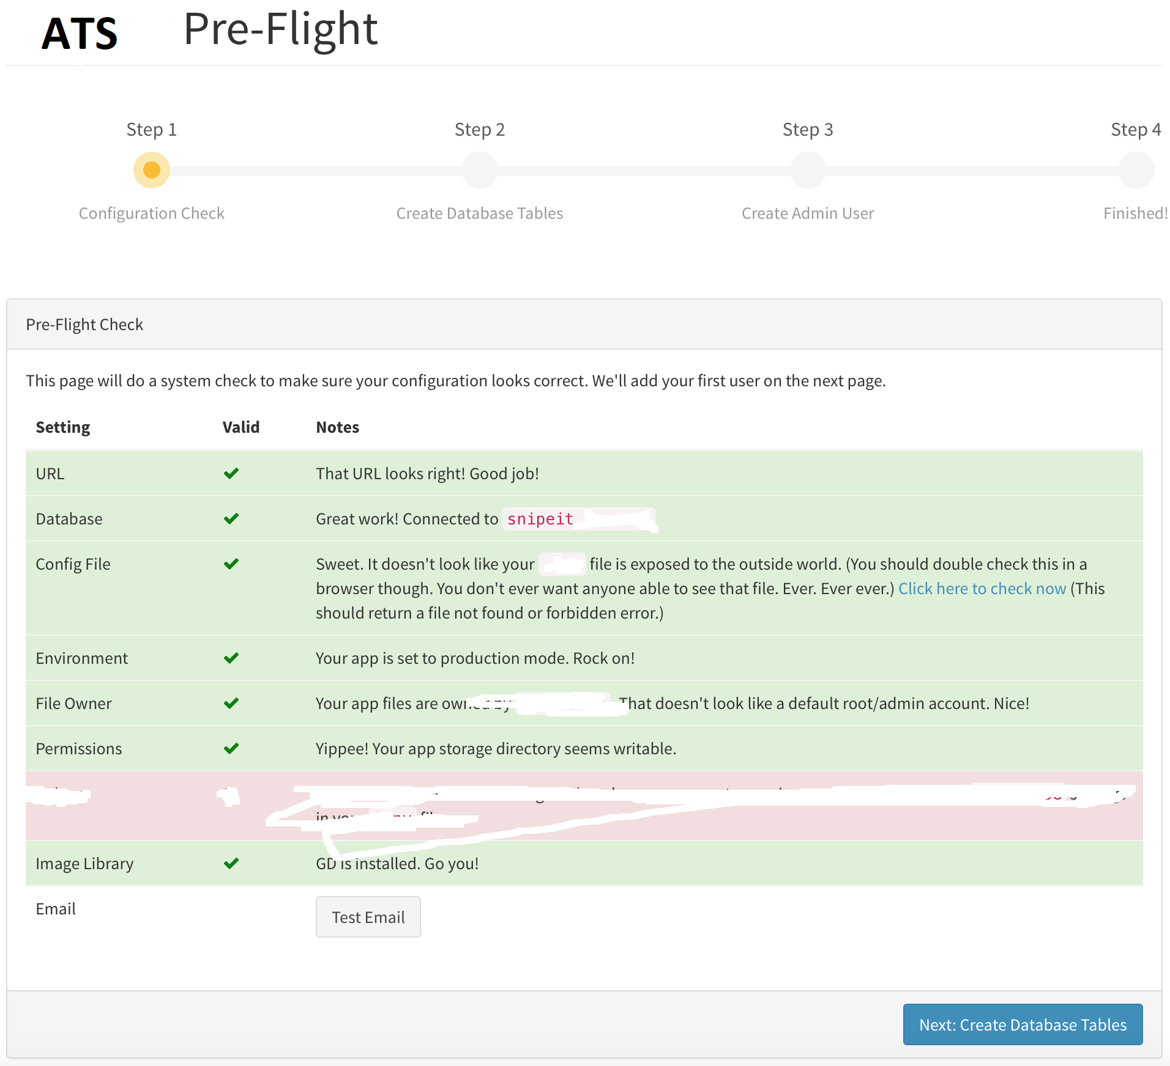

Figure 2 Asset Pre-flight Step 2

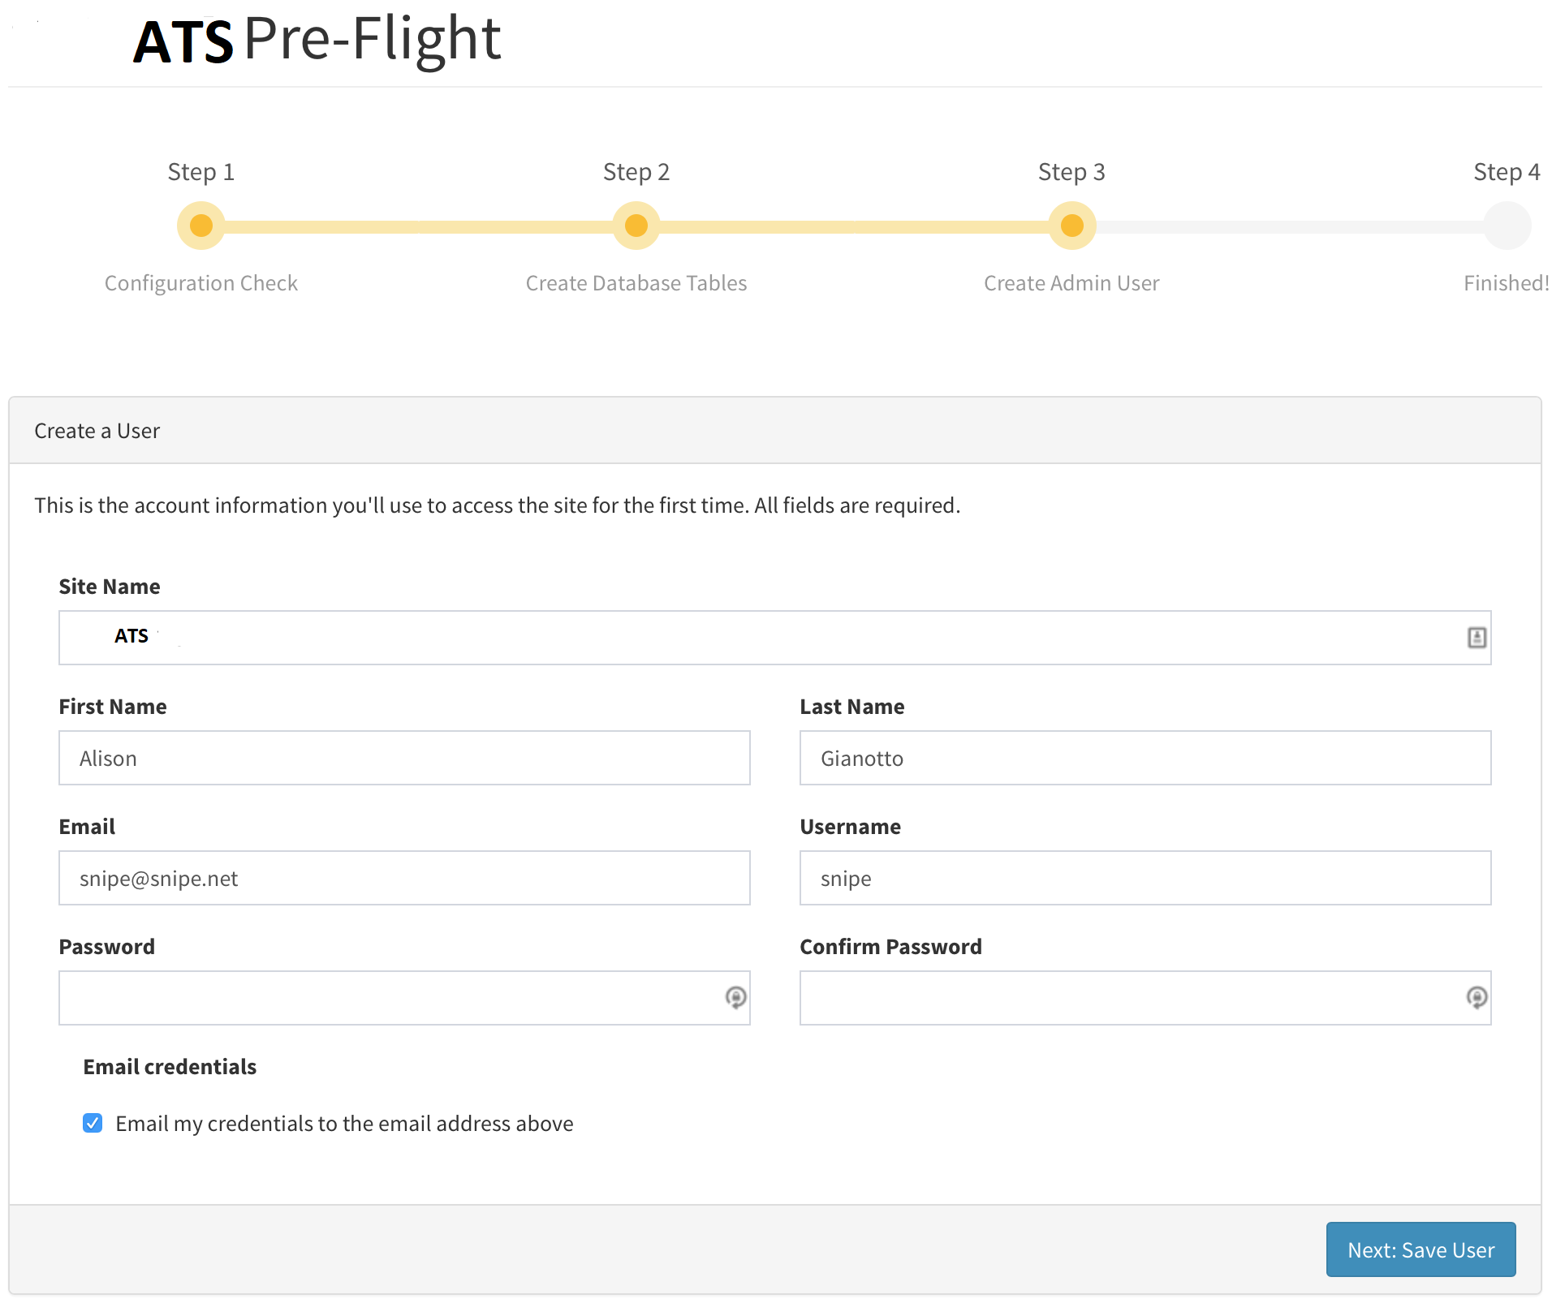

Figure 3Asset Pre-flight Step final

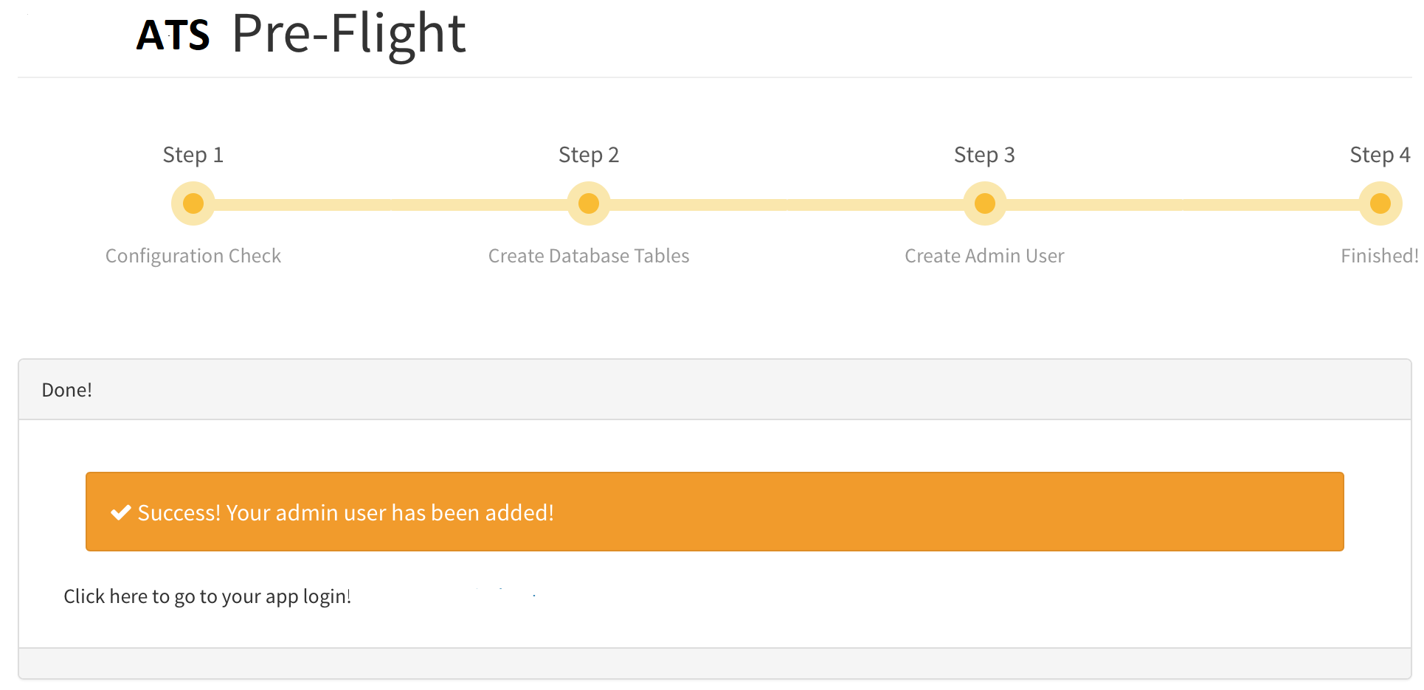

## Admin Settings

Admin setting will available for only Super Admin and they control settings such as branding, colors, logo, alert thresholds, password security and much more.

### 2.1 Branding Settings

In Brand Settings user will can be change Brand Name, Logo, Custom CSS, Header color. There Branding will be only Text/Text and logo/logo.

Figure 4 Branding Settings

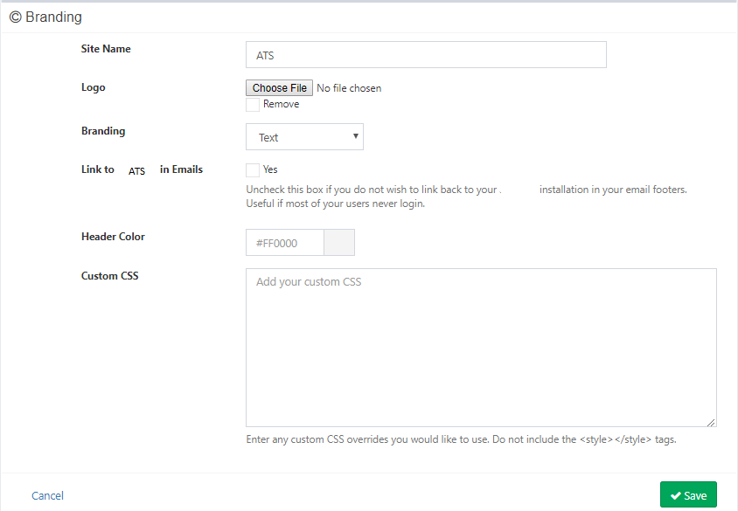

### 2.2 General Settings

In this page user can update general settings of applications. Like following picture

The General Settings panel allows users to configure aspects of your install such as Full Company Support, whether or not to require physical (digital) signatures on assets, and so on.

**Full Multiple Companies Support:**

If user decide to enable this feature, you will need to create companies in the Companies interface and assign assets and users to those companies in order for the restrictions to apply. Super-admins can always see all users, assets, etc and are never restricted by company.

If you would like to track assets by company but do not need to restrict users, you can still use the Admin > Companies section, just don't enable full company support in the settings. In that case, a user or asset's associated company will be displayed, but no restrictions will be placed on them.

**Email Domain:**

The email domain should be set to whatever your company's primary email domain is, for example, example.com. This setting is used in conjunction with the Email Format setting (below) to generate email addresses when importing if email addresses are not provided.

**Email Format:** Used with the Email Domain (pic), set this to the standardized format user organization uses for email formatting - first initial, last name, first name last name, etc.

**Username Format:** This works the same as Email Format (pic), but for usernames.

**Results Per Page**

Specify how many results per page you wish to display. If users ATS listing pages seems a little slow, you may wish to make this number smaller. You will also be able to override this value on each of the listing pages.

**Max Thumbnail Height**

This is the maximum number in pixels that can be displayed in the listing view. Unless you wish to display much larger images in your listing pages, you should be able to leave this as its default value. The maximum value for this field is 500.

**Default EULA**

ATS will allows you to set up a general EULA or Terms of Service that will be emailed to users when an asset is checked out to them if the category the asset belongs to has EULAs enabled.

You may also override this EULA with category-specific EULAs in the Categories interface. This can be helpful if you have an overall organization EULA for assets, but a specific set of EULAs for mobile devices, tablets, etc.

**Login Note**

You may optionally include a few sentences on your login screen, for example to assist people who have found a lost or stolen device, or to direct people to your LDAP interface to allow them to reset their LDAP password.

Figure 5General Settings

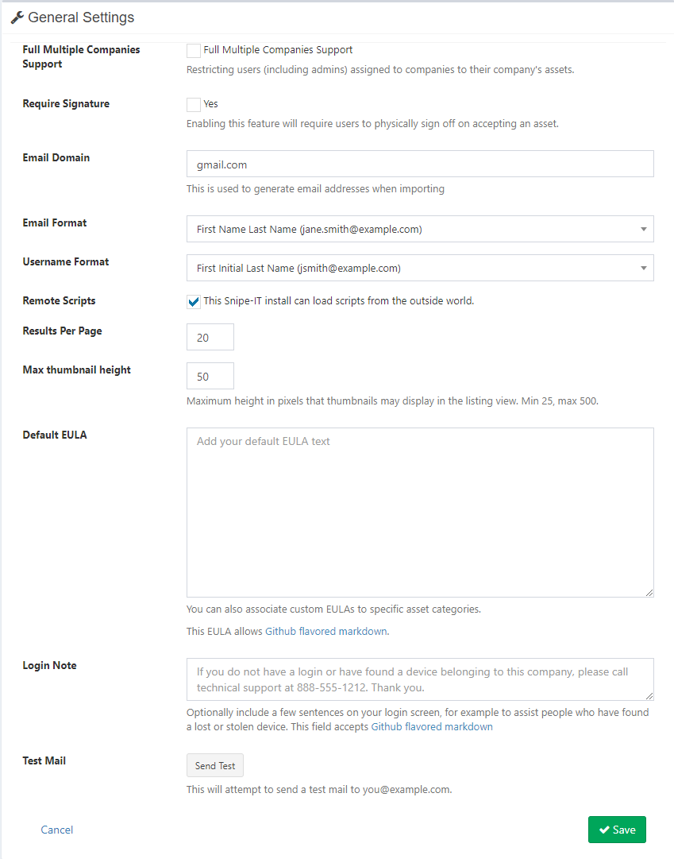

### 2.3 Security

Super User can define minimum password length, two-factor authentication; prevent common password and password complexity. If super admin enable Two Factor Authentications from here, then normal can be use.

Figure 6Security Page

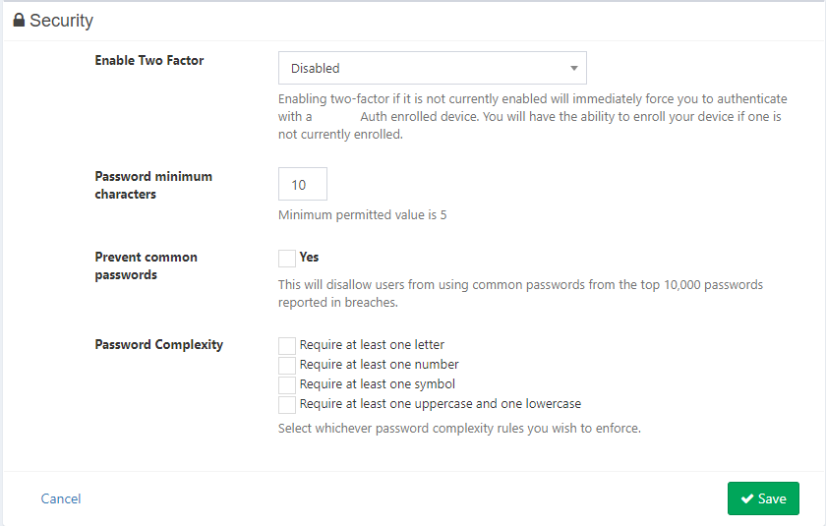

### 2.4 Groups

Groups are a way to easily manage permissions for a large numbers of users. The easiest way to manage user permissions in a larger organization is through groups (versus having to manually apply granular permissions to each user.)

By managing a user's group membership, Admin can control what they can see, what they can edit, Can search and so on. This works especially well in role-based environments, where you can mass-assign multiple users the ability to perform a specific task or tasks, simply by adding them to a group.

Clicking into the Group will display a breakdown of their permissions and the users that are currently associated with that group.

Users will be able to -

** create group and can be apply rules for the group

** Modify/remove group permission, users

** find specific group

** show table data as per need.

** take backup group details with csv, TXT, PDF etc format.

Figure 7 Group Management

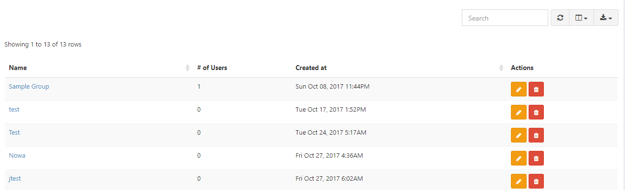

### 2.5 Notifications

From Notification section user will able to set/manage Email alert, show alert in top menu, sending alert in email, expiring alert threshold(In days), Inventory alert threshold, Audit Interval, Audit Warning threshold.

**Email Alerts Enabled**

If selected, this will send email alerts to the Send Alerts To address (below), if there are any alerts triggered. Alerts include low inventory, license expiration, and warranty expiration notifications.

**Show Alerts in Top Menu**

You can enable or disable inventory alerts in the top navigation bar by enabling or disabling this option.

Figure 8Notification

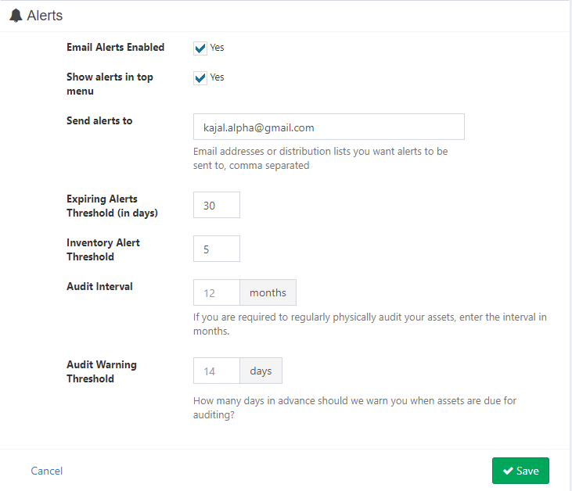

### 2.6 Asset Tags

Asset tags are the unique identifier of an asset within the ATS system. No two assets can have the same asset tag - which makes sense, since that could get confusing.

**Generate Auto-Incrementing IDs**

If this selected, System will pre-populate the Create Asset form with the next logical asset tag.

**Prefix (optional)**

If your asset tags should have a prefix, enter it here.

**Length of Asset Tags**

This setting will standardize the length of the asset tag, for example, asset tag 123 will become 000000123 if you had 9 set here. This helps prevent some sorting issues when sorting by asset tag, since the database otherwise does not know how to logically sort tags that have a mix of numbers and letters of varying lengths.

Figure 9 asset tag settings

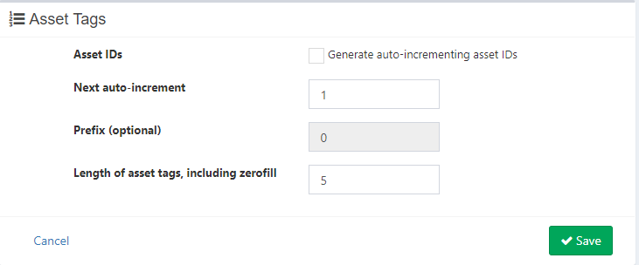

### 2.7 Barcode Settings

User will be able to Manage Barcode display style, type, 2d barcode type, 1d barcode type

Figure 10 Barcode Settings

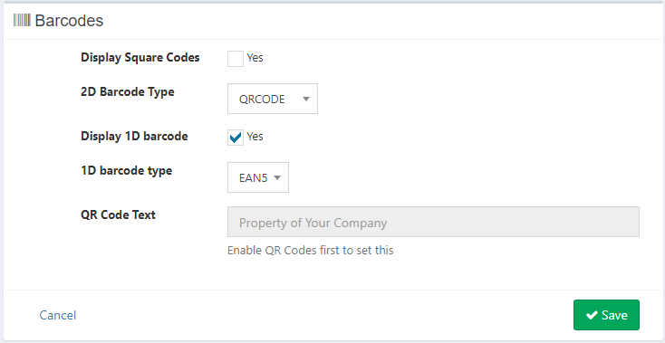

### 2.8 Label Settings

User can Manage label settings from here. Label setting will be suppose Labels per page, label size, label font size, label dimensions(inches), label spacing(inches), page margin, label visible field(i. e. Asset Name, Serial, Asset Tag, Company Name) and so on.

Figure 11 Label Settings

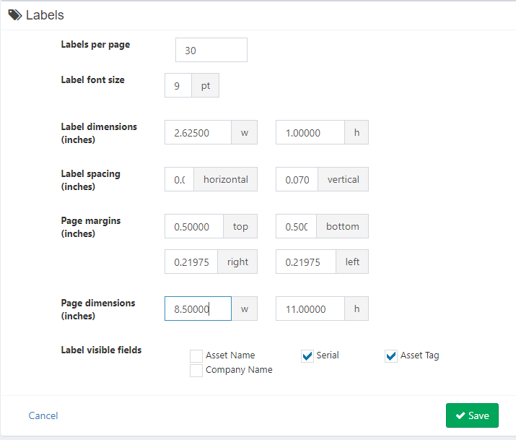

### 2.9 LDAP/AD Settings

If user need integrate LDAP/AD connect then User able to add LDAP/Active Directory. It’s for future work.

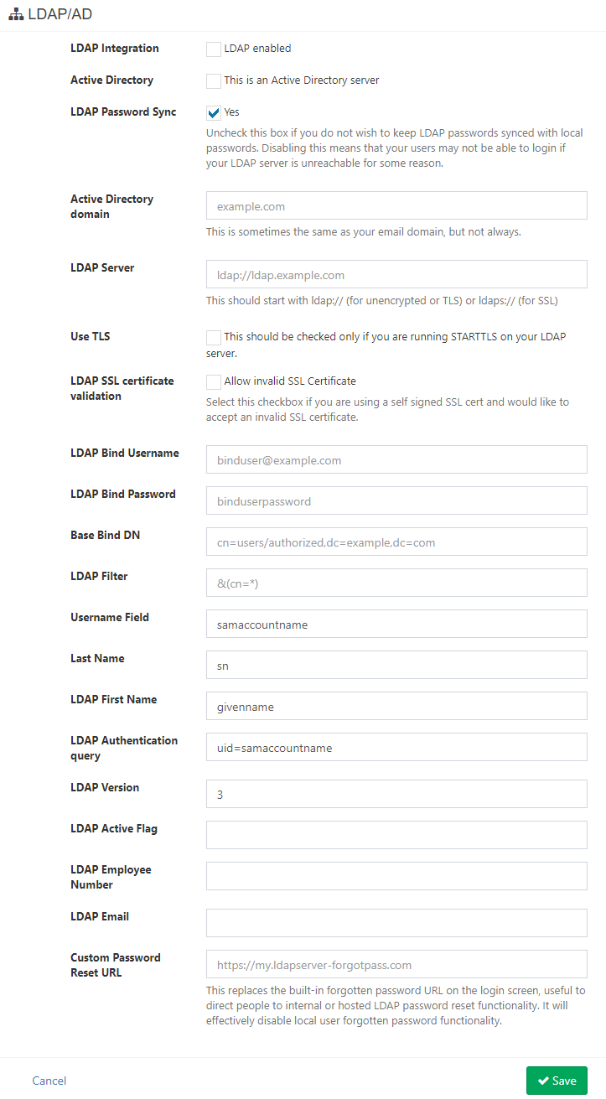

Figure 12 LDAP/AD Settings

### 2.10 Backups

Super User can take backup files or data. File type will be txt, pdf, csv etc.

## Settings

### 3.1 Fieldsets & Custom Fields

Fieldsets allow user to create groups of custom fields that are frequently re-used used for specific asset model types. It’s used in Asset Model.

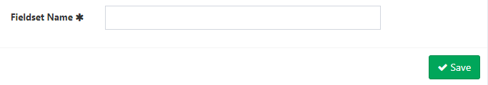

Figure 13 Adding Fieldsets

**Custom Fields:** Custom fields allow you to add arbitrary attributes to assets. Form Element will be Text Box or List Box. if List Box then Add selectable options, one per line. Blank lines other than the first line will be ignored in Field Values. Format will be alpha, email, date, any, custom regex etc.

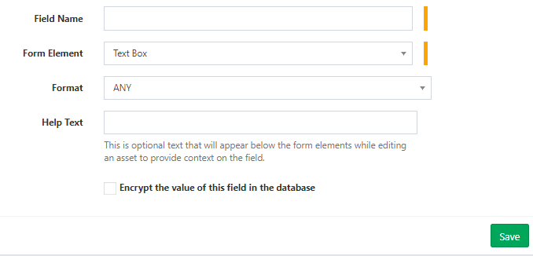

Figure 14 Add Custom Field

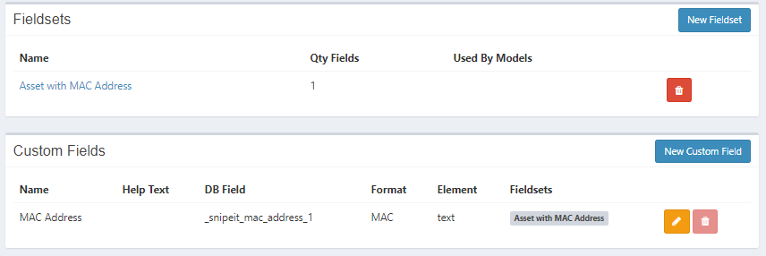

Figure 15 Manage Custom Fields

### 3.2 Status Labels

Status labels are used to describe the various states your assets could be in. They may be out for repair, lost/stolen, etc. user will be able to create new status labels for deployable, pending and archived assets.

**Deployable**: These assets can be checked out. Once they are assigned, they will assume a meta status of Deployed.

**Pending:** These assets can not yet be assigned to anyone, often used for items that are out for repair, but are expected to return to circulation.

**Undeployable:** These assets cannot be assigned to anyone.

**Archived:** These assets cannot be checked out, and will only show up in the Archived view. This is useful for retaining information about assets for budgeting/historic purposes but keeping them out of the day-to-day asset list.

Figure 16 Add new Status Label

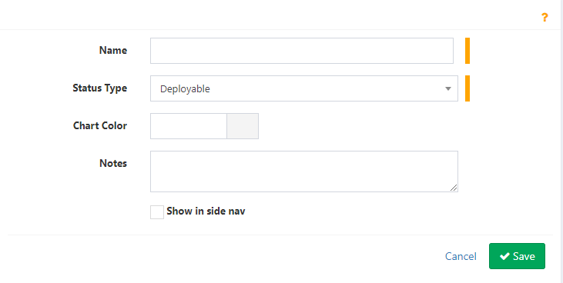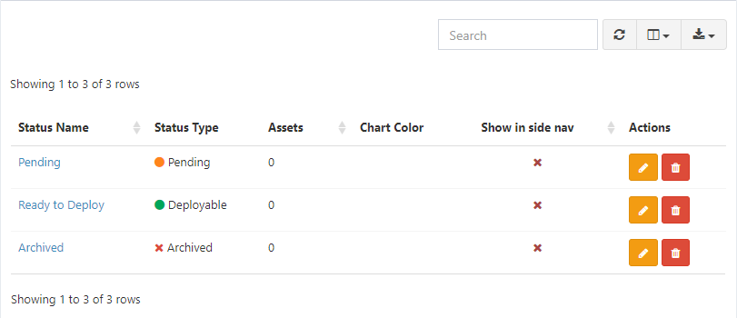

Figure 17List of all status Label

### 3.3 Manufacturers

User will able to create Manufacturer information in the database and it will be reuse when need to add asset, license etc. Manufacturer example Dell, HP etc.

Manufacture Information will be-

* Name
* URL
* Support URL
* Support Phone
* Support Email
* Upload Image

Figure 18 Asset Manufacturers

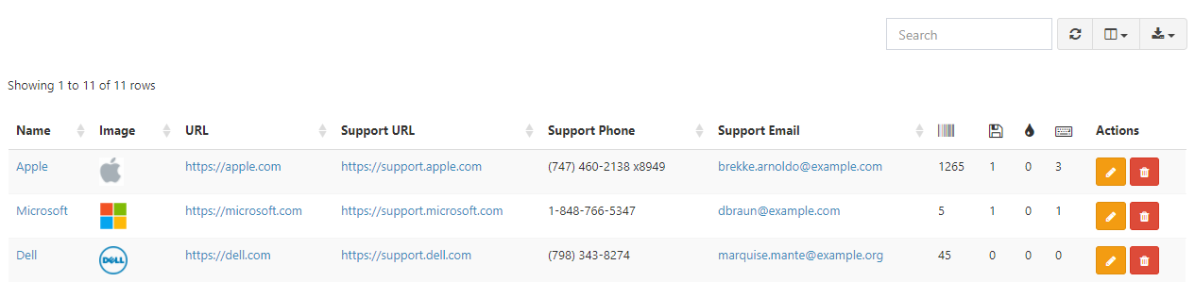

Figure 19 Create Manufacturer

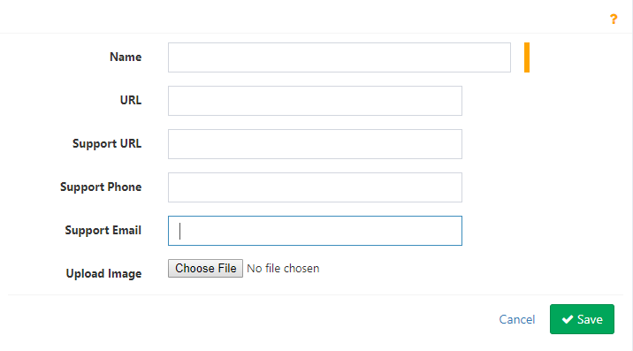

### 3.4 Categories

Adding Asset Category and list off Asset Categories.

Both assets and accessories use categories. Categories describe the general type of asset or accessory, such as “wireless keyboards”, “laptops”, and so on. Categories are important because they contain attributes that are inherited by both the assets and accessories that belong to them, such as whether to require the user to click on a link to show that they have received the asset or accessory, and whether or not the user should be emailed a EULA.

Every asset and accessory needs to belong to a category, so will need to set these up before adding assets.

Category Information will be-

* Category Name
* Type
* Category EULA [This field (Text Area) allows you to customize your EULAs for specific types of assets. If you only have one EULA for all of your assets, you can check the box below to use the primary default.]
* Upload Image

Will need also some required check box

* Use the primary default EULA instead. No primary default EULA is set. Please add one in Settings.
* Require users to confirm acceptance of assets in this category.
* Send email to user on checkin.

Figure 20 Asset Categories

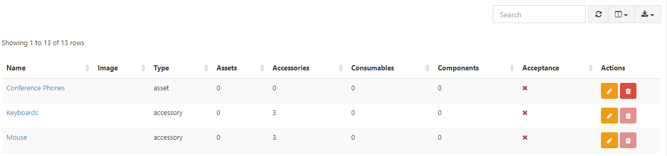

Figure 21 Create Category

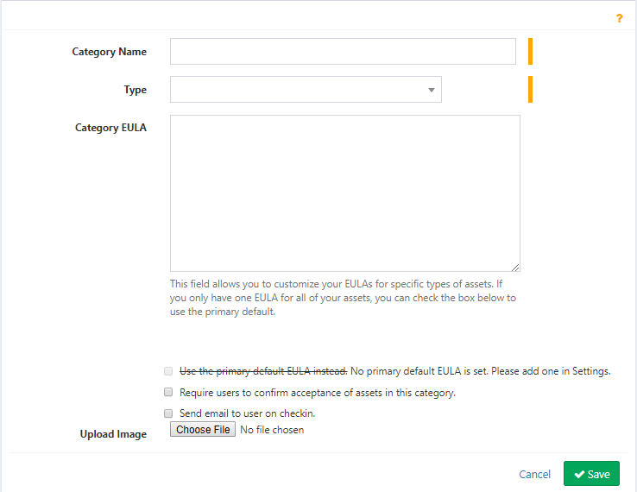

### 3.5 Depreciations

You can set up asset depreciations to depreciate assets based on straight-line depreciation.

Figure 22 Create Depreciation

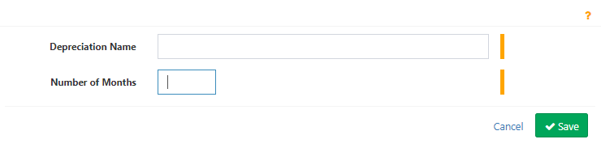

Figure 23 Asset Depreciations

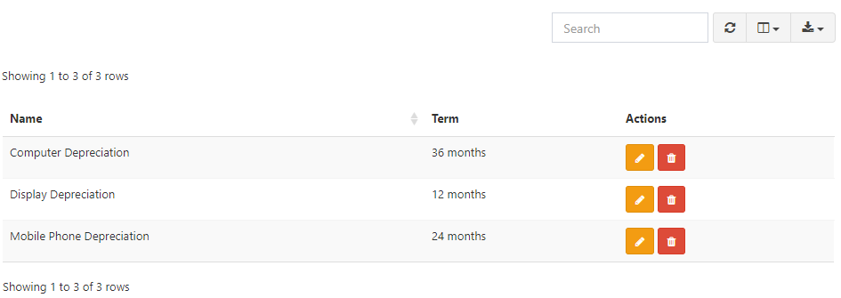

### 3.6 Asset Model

Every asset needs an asset model, so setting these up next will help you start adding assets. Asset models can be things like the make and model of a laptop or desktop machine (Apple 13″ Retina, for example). When you create new assets, you’ll select whichever asset model makes sense.

Asset models are important because they carry certain attributes which are inherited by the assets you, such as depreciation type, end of life, and whether or not to show MAC address fields on the asset.

For Create a model will need following information.

* Asset Model Name
* Manufacturer
* Category Name
* Model No.
* Depreciation
* Do Not Depreciate
* EOL
* Fieldset
* Notes
* Model Image

Figure 24 Create Asset Model

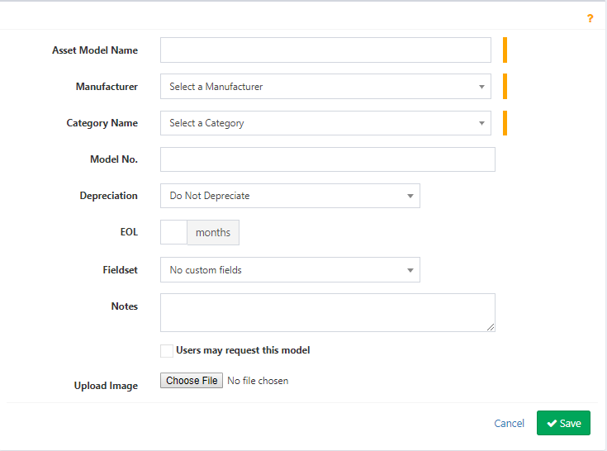

**View Models:** User will able to see all models. There will be a search option for searching models.

Model selection system. Also user will able to delete, edit and clone a model. Model name will be linked asset where had been used this model. Same will be for Manufacturer, Category, Depreciation. From View Models user’s will able to download list of models.

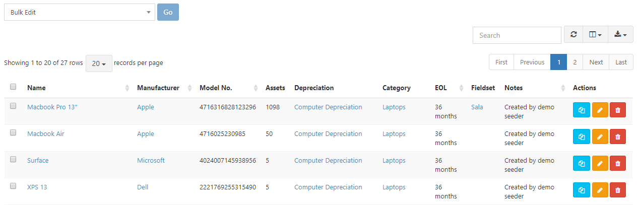

Figure 25 View Models

### 3.7 Supplier

Admin user will be able to create a supplier. Supplier Information will be

* Supplier Name
* Address
* City
* State
* Country
* Zip
* Contact Name
* Phone
* Fax
* Email
* URL
* Notes
* Supplier Image

After adding a Supplier there will be show list of all supplier. User will able search a supplier by name. every supplier will be edit, delete. In the list of all supplier, each supplier ID will show total assets, list of every assets. There will be search option. User also can be download company information from list. There will be Custom select option for showing Column.

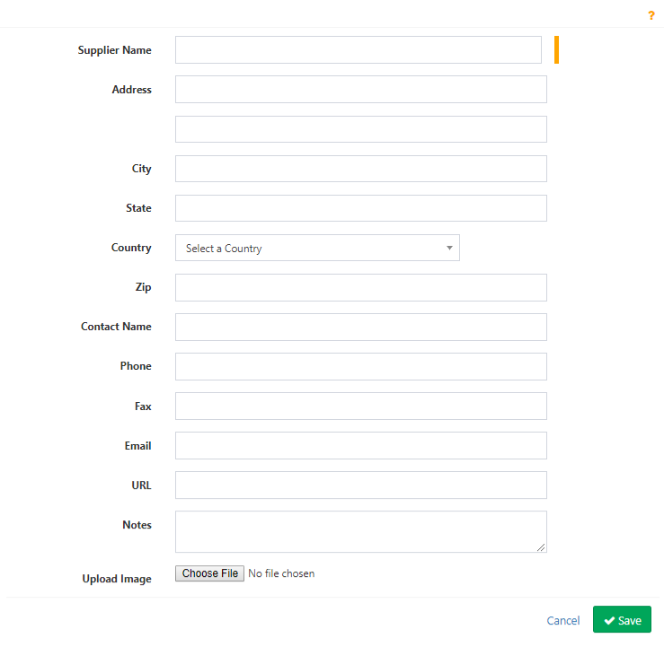

Figure 26 Create Supplier

Figure 27 Suppliers

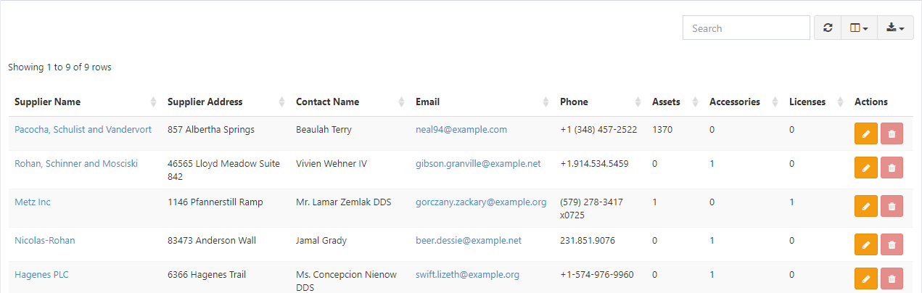

### 3.8 Companies

You can use companies as a simple informative field, or you can use them to restrict asset visibility and availability to users with a specific company by enabling Full Company Support in your Admin Settings.

Figure 28 Create Company

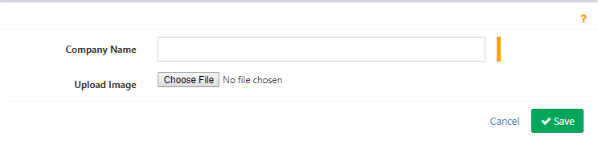

In Company, list user will be able to update company, can be edit and remove. There will be search option. Each company will shows how many assets/License/accessory/user etc. have. User also can be download company information from list. There will be Custom select option for showing Column.

Figure 29 Companies

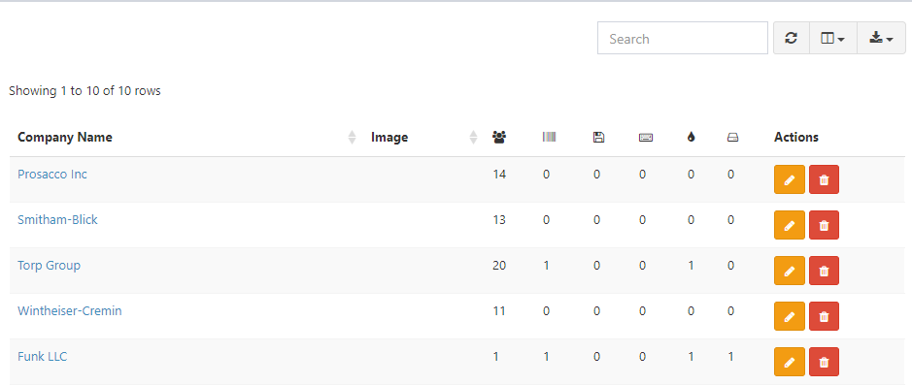

### 3.9 Locations

Location represent Branch of a company. Will need some following information when create a Location.

* Location Name
* Parent
* Manager
* Location Currency
* Address
* City
* State
* Country
* Zip
* Location Image

Figure 30 Create Location

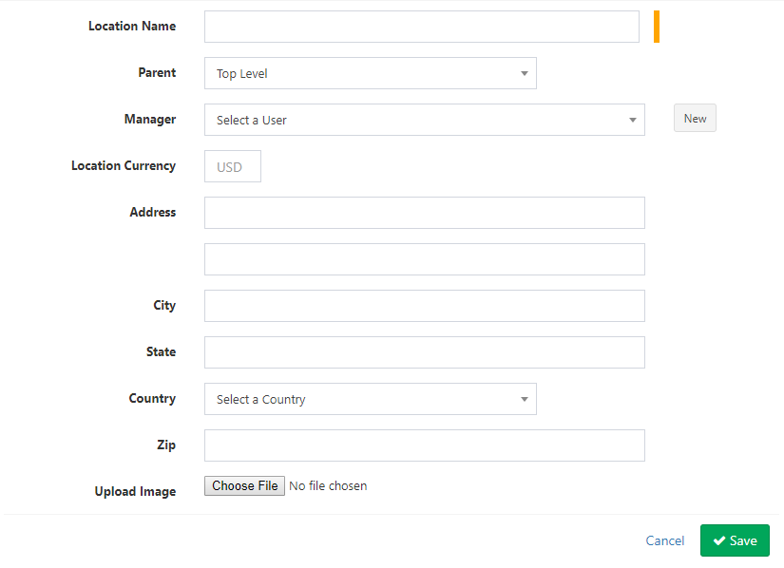

In the list all locations every locations will show total number of assets, asset assigned, total users. Every locations will edit, delete. There will be a search options to search location, a download option to download list of location. Custom Select option for select column for showing data in table. There will show manager for each location. Manager will show his used asset history.

Figure 31 Locations

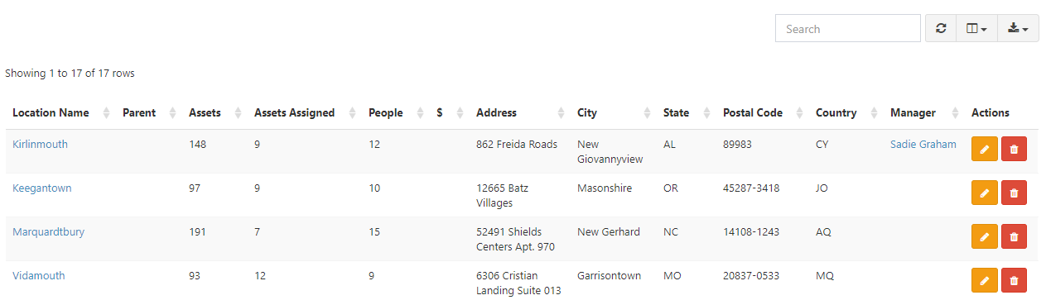

### 3.10 Department

Admin User will be able to create a department. Information will for create a department given below.

* Department Name
* Company
* Manager
* Location
* Upload Image

Figure 32 Create Department

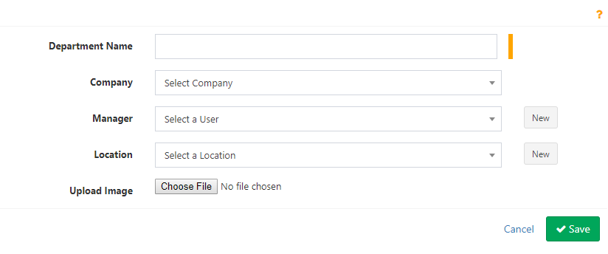

In the list of all departments, every department will show their total users, location, and company information. User will able to view all user of that department, also will able to view of the location used asset list and user list. There will be a search option for search department. There will be also download option, column selection option.

Figure 33 Departments

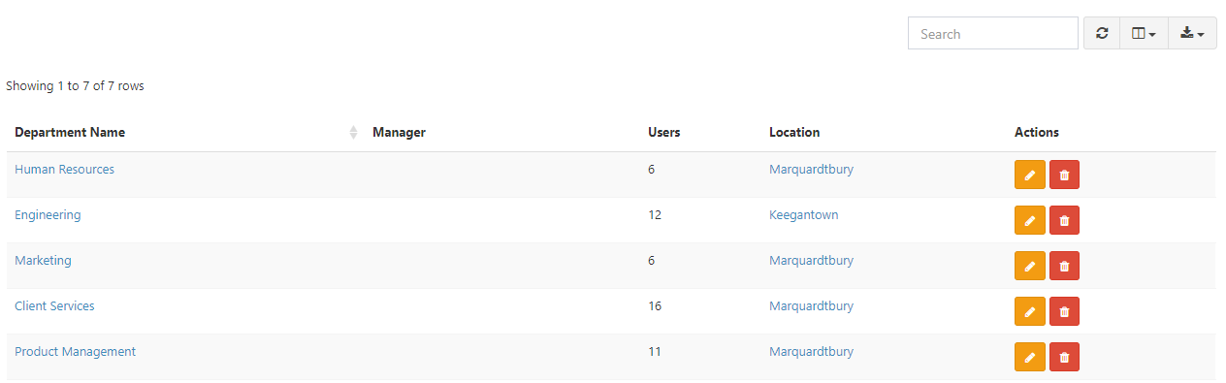

## Asset Management

In this module user will able to create asset, can be see list of asset, all deployed asset, all ready to deploy, all pending, all Un-deployable and so on. All asset related activity will be manage from here. Asset will checkin by admin/user and will checkout to user/asset/locations.

### Asset Create

Admin user will able to create asset when newly asset will entrance. For add new asset user will need following information.

* Company
* Asset Tag
* Model
* Status
* Serial
* Asset Name
* Purchase Date
* Supplier
* Order Number
* Purchase Cost
* Warranty
* Notes
* Default Location
* Requestable
* Upload Image

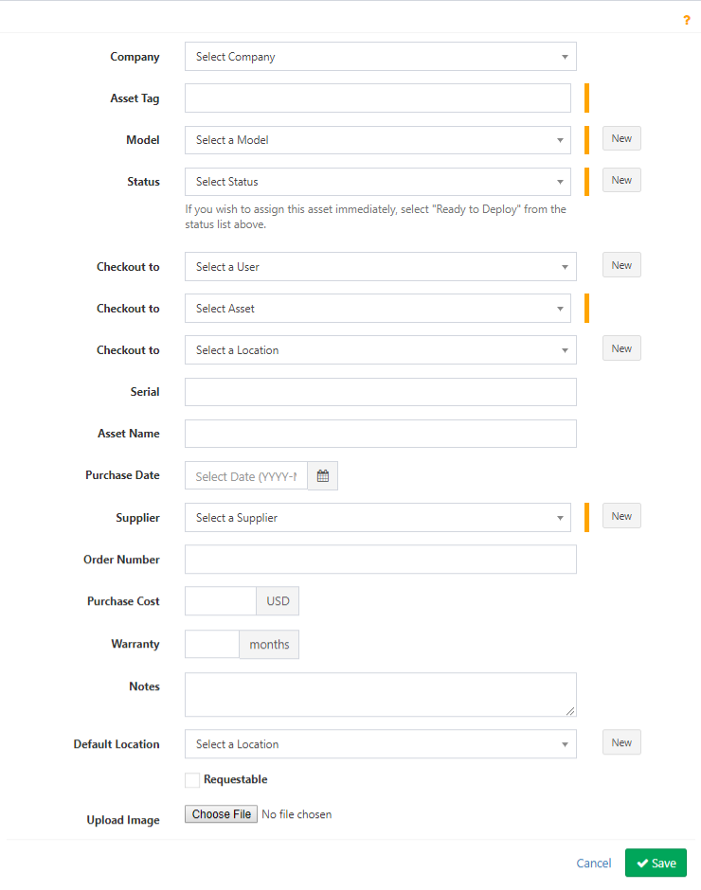

Figure 34 Create Asset

### List All Asset

Here user can be see list of all assets. There will be a label generate option, search option, download option for asset list download as pdf, csv format, delete, clone option. User also will able to view each asset details where will be include asset details, software details, components details, maintenance details, History and so on. In maintenance details user can be add new issue also.

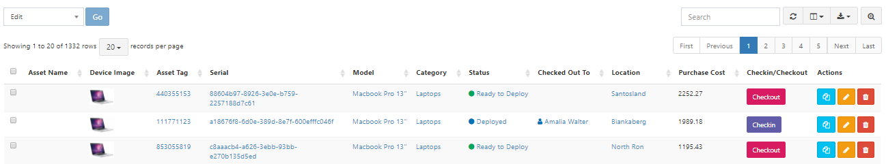

Figure 35 All Assets

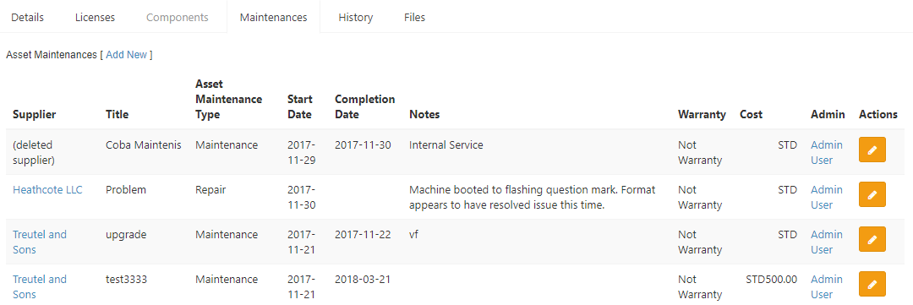

Figure 36 View Page example

### Deployed Assets

Here user can be see list of all Deployed assets. There will be a label generate option, search option, download option for asset list download as pdf, csv format, delete, clone option. User also will able to view each asset details where will be include asset details, software details, components details, maintenance details, History and so on. User can be add new issue also in maintenance details. User also can check list of product by model, Category.

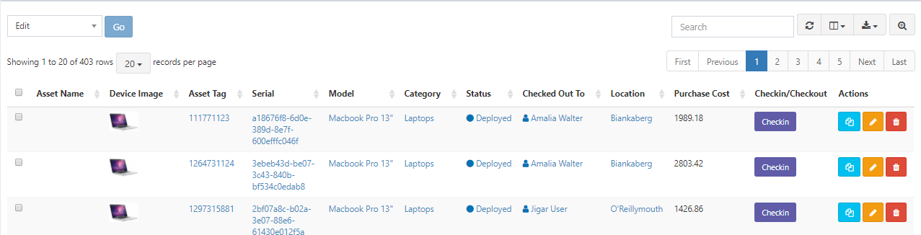

Figure 37 List of all Deployed Assets

### Ready to Deploy Assets

Here user can be see list of all assets which is ready to deploy. There will be a label generate option, search option, download option for asset list download as pdf, csv format, delete, clone option. User also will able to view each asset details where will be include asset details, software details, components details, maintenance details, History and so on. In maintenance, details user can be add new issue also. User also can check list of product by model, Category.

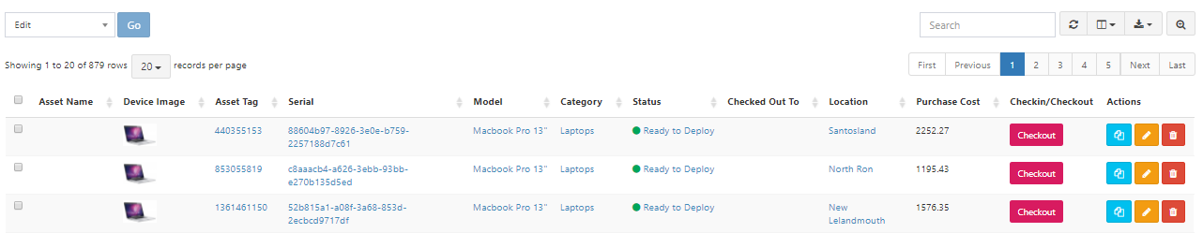

Figure 38 Ready to deployable assets

### Pending Assets

Here user can be see which asset are pending.

Here user can be see list of all assets which is Pending. There will be a label generate option, search option, download option for asset list download as pdf, csv format, delete, clone option. User also will able to view each asset details where will be include asset details, software details, components details, maintenance details, History and so on. In maintenance, details user can be add new issue also. User also can check list of product by model, Category.

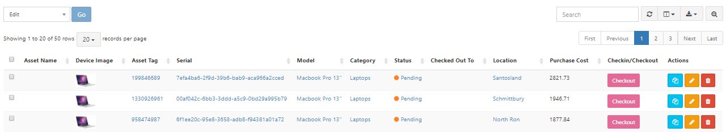

Figure 39 List of Pending Assets

### Un-deployable Assets

Here user can be see list of all assets which is Un-deployable. There will be a label generate option, search option, download option for asset list download as pdf, csv format, delete, clone option. User also will able to view each asset details where will be include asset details, software details, components details, maintenance details, History and so on. In maintenance, details user can be add new issue also. User also can check list of product by model, Category. There will be filtering options. Admin can be checkout/checkout asset.

Figure 40 List of Un-deployable Assets



### Archived Assets

Here user can be see list of all assets which is Archived. There will be a label generate option, search option, download option for asset list download as pdf, csv format, delete, clone option. User also will able to view each asset details where will be include asset details, software details, components details, maintenance details, History and so on. In maintenance, details user can be add new issue also. User also can check list of product by model, Category. There will be filtering options. Admin can be checkout/checkout asset.

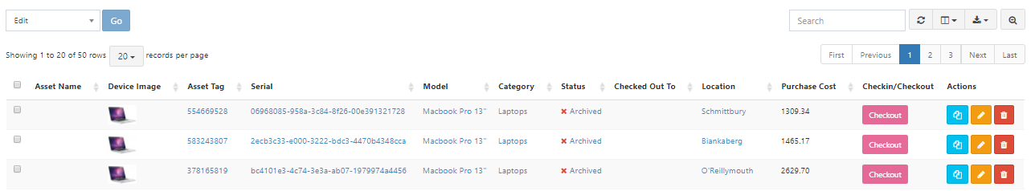

Figure 41 list of archived asset

### Request able Assets

Here user can see all request able assets.

Here user can be see list of all assets which is request able. There will be a label generate option, search option, download option for asset list download as pdf, csv format, delete, clone option. User also will able to view each asset details where will be include asset details, software details, components details, maintenance details, History and so on. In maintenance, details user can be add new issue also. User also can check list of product by model, Category. There will be filtering options. Admin can be checkout/checkout asset.

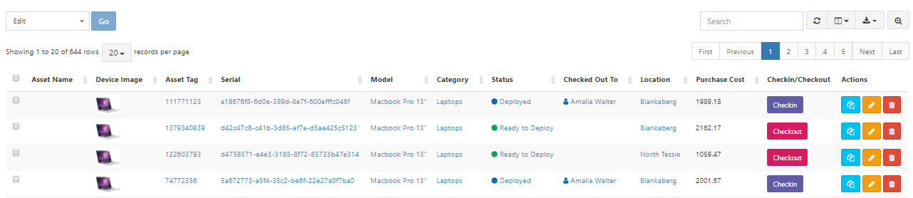

### Bulk Checkout

Here user can checkout multiple asset to an user. In the assets field(Editable dropdown) user can be add multiple assets tag.

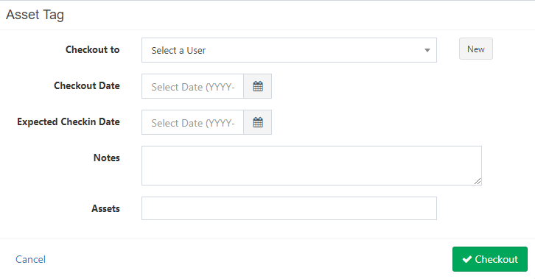

Figure 42 Checkout Assets to User

### Requested Assets

User can be see requested all assets by user.

Here user can be see list of all assets which is requested by user . There will be search option, download option for asset list download as pdf, csv format, delete, clone option. User also will able to view each asset details where will be include asset details, software details, components details, maintenance details, History and so on. In maintenance, details user can be add new issue also. User also can check list of product by model, Category.

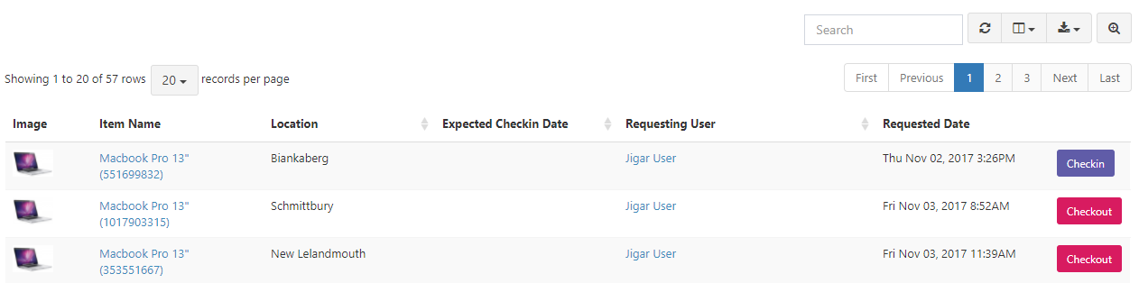

### Deleted Assets

User also can be see all deleted assets.

### Asset Maintenances

Here user can be see which assets are under maintenances.

Here user can be see list of all assets which is ready to deploy. There will be a search option, download option for asset list download as pdf, csv format, delete, clone option. User also will able to view each asset details where will be include asset details, software details, components details, maintenance details, History and so on. In maintenance, details user can be add new issue also. User also can check list of product by model, Category.

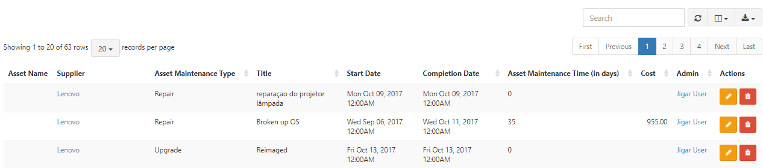

Figure 43 List of asset Maintenances

### Bulk Audit

Here user can be set a date for next audit for an asset.

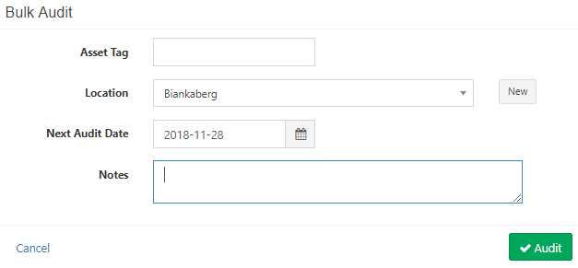

### View Asset

In Details Page user can be see details of an asset. In the License tab user will see list of software license. In the component tab user will see list of additional component details. In the maintenance tab user will see the maintenance history of asset. If need user can add a maintenance issue. User will see the used history of asset in history tab.

Figure 44 Details Page for an asset

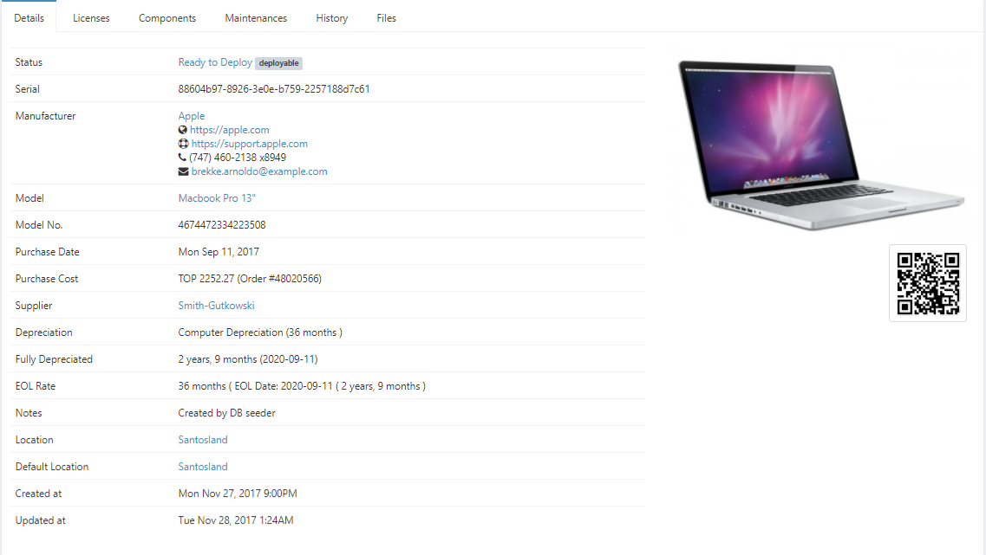

Figure 45 Maintenance History

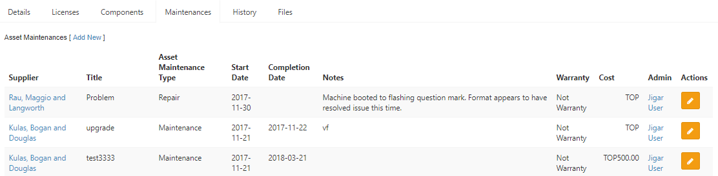

### Create Asset Maintenance

User can be create a maintenance for an assets to supplier.

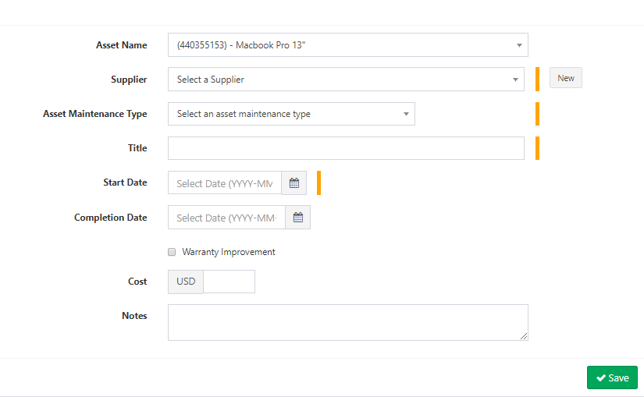

## Licenses

### Software Licenses

User can be add a Software Licenses from following form.

Figure 46 Software Licenses add

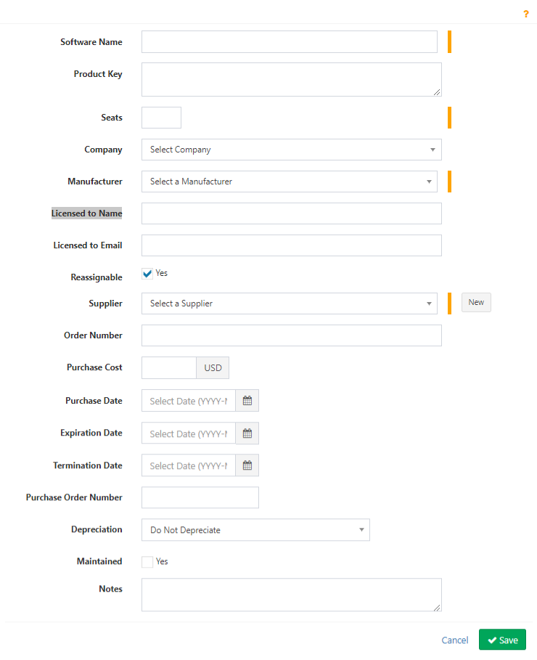

### All Software License

Figure 47 Software License

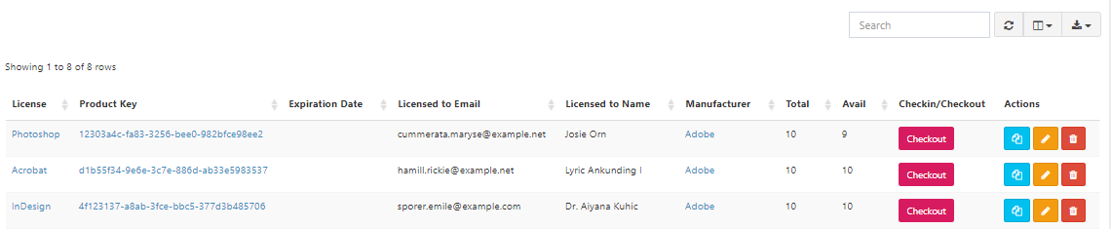

### View License

User can be view a software license. Also user can be see Checkout history.

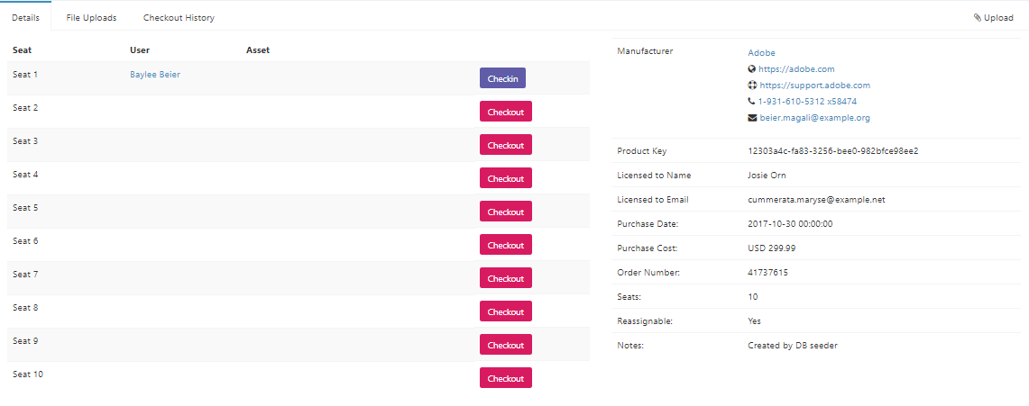

## Accessory

### New Accessory Add

Figure 48 Add an Accessory

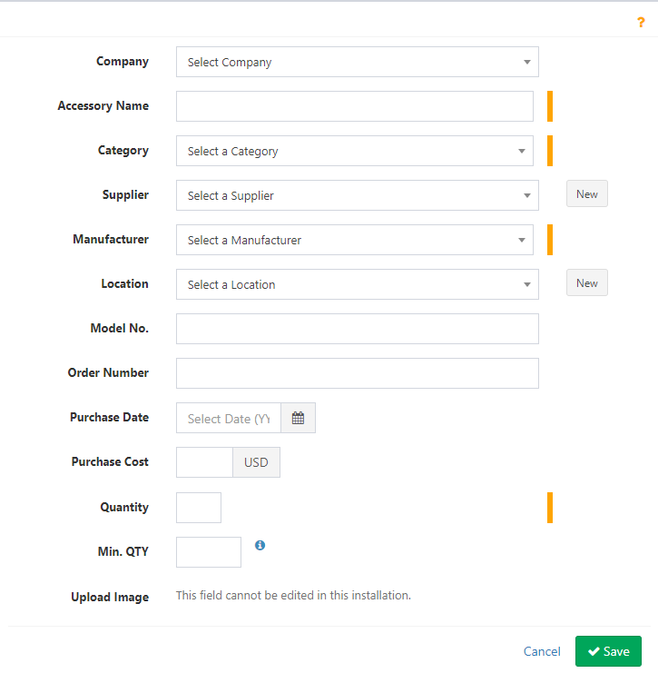










### Accessories

In this page user can see all record of Accessory

Figure 49 List of Accessory

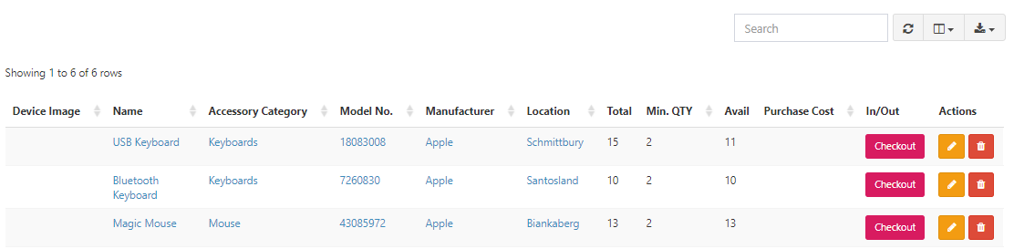

## Consumables

### Create Consumables

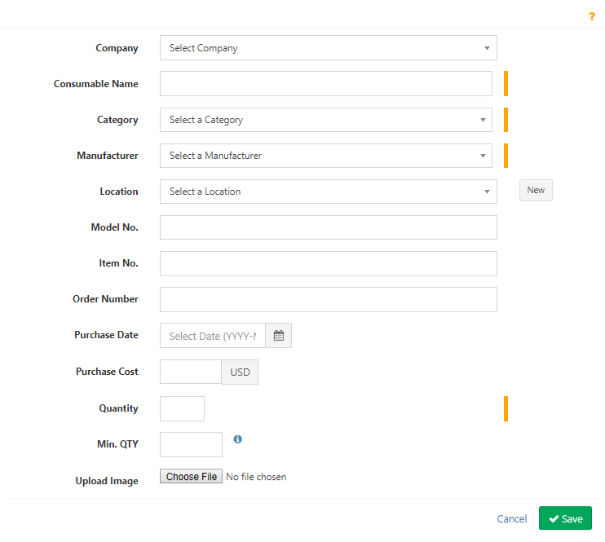

### List of Consumable

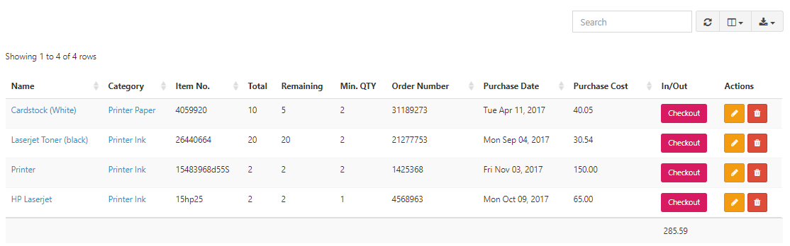

## Component

### Create Component

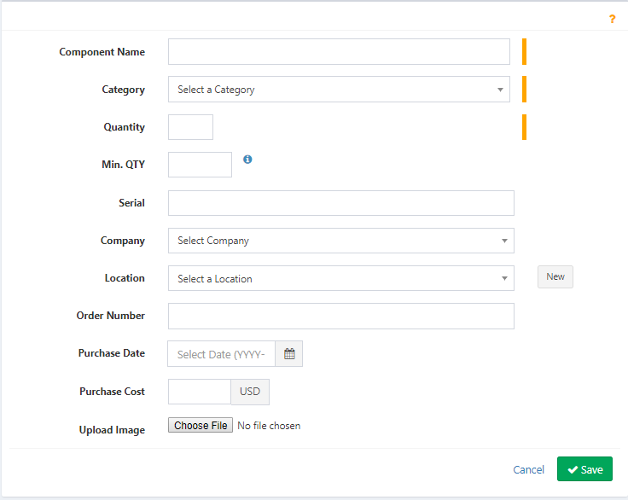

### Component List

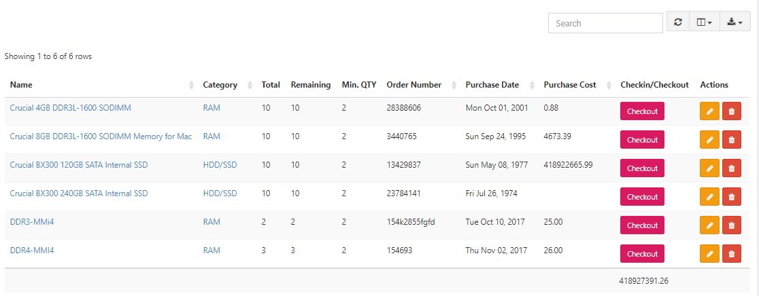

## User Management

### User Create

Figure 50 Add a New User

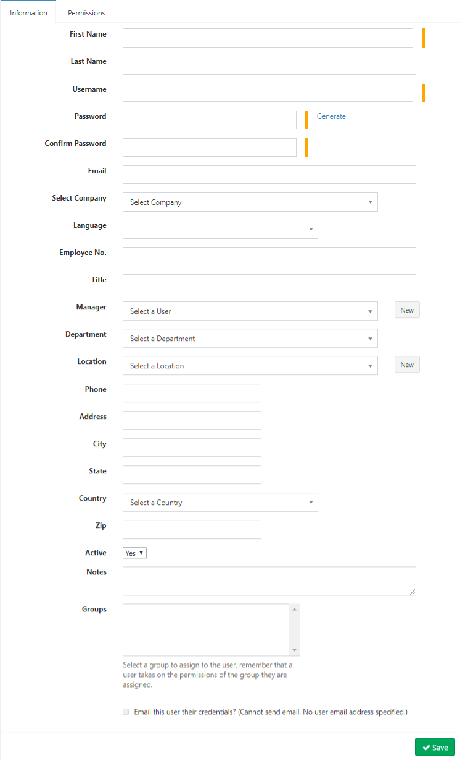

Super admin

Can edit ALL admin settings, create new Groups, Locations, Status Labels, etc, and is NOT constrained by Company scoping when Full Company Support is enabled.

Admin

Can NOT access Admin Settings, and IS constrained by Company scoping when Full Company Support is enabled, but can perform all functions (create, edit, delete, etc) for all other aspects of the app.

Other

Can NOT access Admin Settings. All other privileges are granted on a group-level or individual level.

Figure 51 Permission set

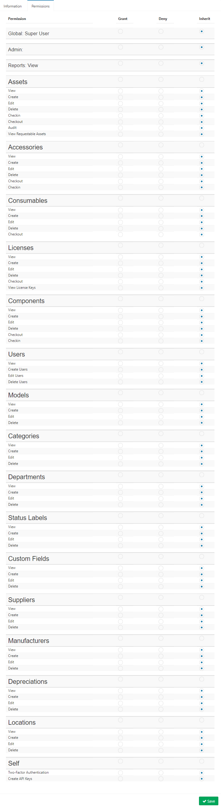

### View a User

This page is for Role setup. Where role name will be provided. In this page user can be see which asset/license/consumables/accessories used by this user. Also can see history.

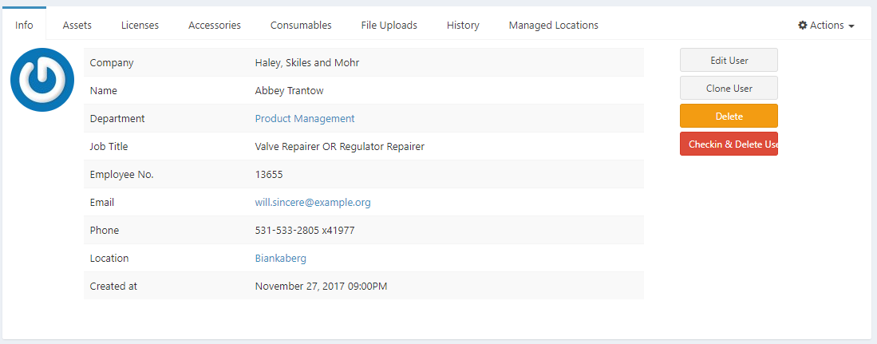

## Requestable

### Requestable Asset List

Uaer can see here requestable asset list. Also can be see by asset model

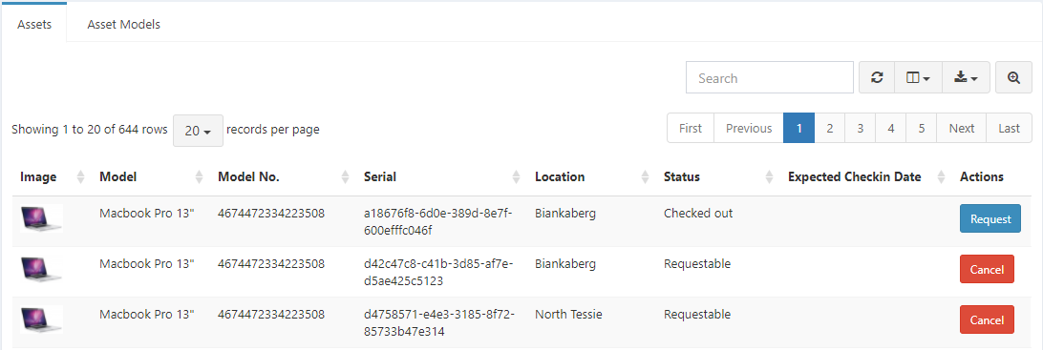

## Reporting

### Activity Report

Figure 52 Activity Report

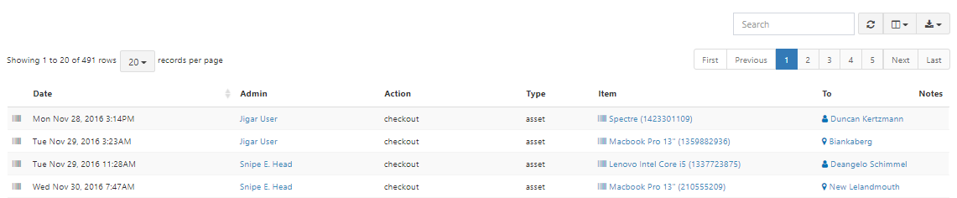

### Audit Log

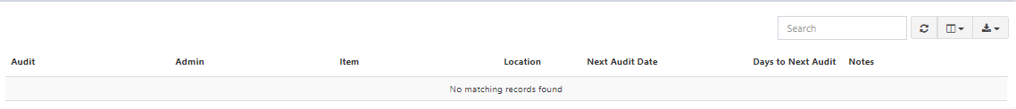

### Depreciation Report

Figure 53 Depreciation Report

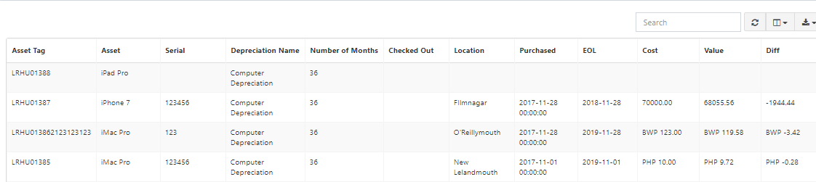

### License Report

Figure 54 License Report

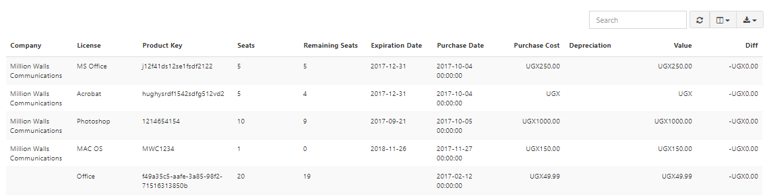

### Asset Maintenance Report

Figure 55 Maintenance Report

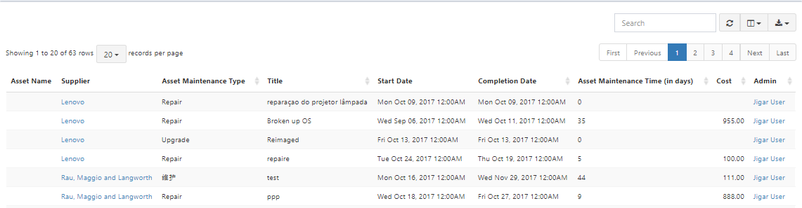

### Unaccepted Assets

### Accessory Report

Figure 56 Accessory Report

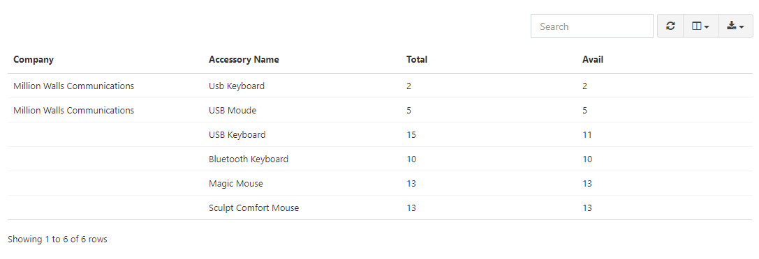

### Custom Asset Report

User can be customized report from following picture.

Figure 57 Custom Asset Report

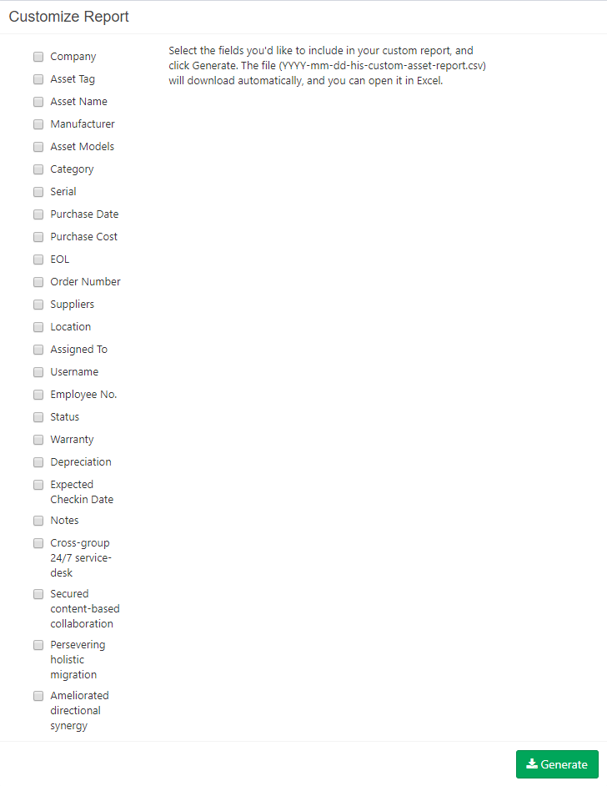

# References

1. https://snipeitapp.com