**User story of School Management System**

**History Card**

|  |  |  |  |
| --- | --- | --- | --- |
| **Version#** | **Modification History** | **Update Date** | **Created/Reviewed by** |
| 1.0 | Create/Initial | 4 May 2017 | Shrabonti Kundu |
| 1.1 | Review | 5 May 2017 | Md. Saddam Hossain |
| 2.1 | Modify | 6 May 2017 | Shrabonti Kundu |
| 2.2 | Review | 7 May 2017 | Asif Iqbal Khan |
| 2.3 | Review | 7 May 2017 | Md. Saddam Hossain |
| 3.1 | Modify | 8 May 2017 | Asif Iqbal Khan |
| 3.2 | Review | 10 May 2017 | Shrabonti Kundu |
| 4.1 | Modify | 15 May 2017 | Md. Saddam Hossain |
| 5.1 | Modify | 16 May 2017 | Shrabonti Kundu |
| 5.2 | Review | 17 May 2017 | Md. Saddam Hossain |
| 5.3 | Review | 18 May 2017 | Asif Iqbal Khan |
| 6.1 | Modify | 21 May 2017 | Md. Saddam Hossain |
| 6.2 | Review | 22 May 2017 | Shrabonti Kundu |
| 6.3 | Review | 23 May 2017 | Asif Iqbal Khan |
| 7.0 | Modify | 24 May 2017 | Md. Saddam Hossain |

Table of Contents

Project Name 2

Team Name 2

Team Members 2

Submitted to 2

Project Description 3

Current Scope 3

Future Work 3

**User story** 3

Overview: 4

1. Settings 5

1.1. Institution 5

1.2. Class Entry 6

1.3. Fee Settings 6

1.4. Look Up Table 7

1.5. Subject Entry 8

*2.* Admission 8

2.1. Student registration form 8

2.2. Employee registration form 9

3. Academic 10

3.1. Class Schedule 10

3.2. Exam Schedule 10

3.3 Result Entry 11

4. Notice 12

5. Attendance 12

5.1. Student Attendance 12

5.2. Employee Attendance 13

# Project Name

* Modern School  (School Management System)

# Team Name

* **Newbies**

# Team Members

|  |  |  |  |
| --- | --- | --- | --- |
| SL# | Name | Email | Contact Number |
| 1 | Asif Iqbal Khan | uzanoclock@gmail.com | 01680992237 |
| 2 | Shrabonti Kundu | kshrabonti@yahoo.com | 01683669455 |
| 3 | Md. Saddam Hossain | ariful.hossain1992@gmail.com | 01619080707 |
|  |  |  |  |
|  |  |  |  |

# Submitted to

|  |  |  |  |
| --- | --- | --- | --- |
| SL# | Name | Email | Contact Number |
| 1 | Md. Mahedee Hasan | [Mahedee.hasan@gmail.com](mailto:Mahedee.hasan@gmail.com) | 01755618129 |

# Project Description

School Management System is an application that will represent a school’s whole management system that will have all the students, teacher and stuff members’ information. It will also have the information of the class schedule, exam schedule and result information. It will trace both the students and the teachers’ and the staff member’s attendance.

# Current Scope

Our current scope is to add a students, teachers, staffs member to the system. Add attendance input system. Also have a class schedule system for putting the students and teachers in the classes accordingly. Also have student and teacher authentication and authorization to survey the site respectively.

# Future Work

We will develop exam schedule and result input system so that the result can be distributed to the students securely and correctly.

# 

# **User story**

|  |  |
| --- | --- |
| **SL#** | **Story Name** |
| 1 | Settings |
| 2 | Admission |
| 3 | Academic |
| 4 | Notice |
| 5 | Photo Gallery |
| 6 | Attendance |
| 7 | Reports |

# Overview:

Here we have presented the overview of our proposal where the homepage is contained with eight stories including **Home, Gallery, Admission, Academic, Notice, Settings, Attendance, Result** and **Report**. In Admission there have three contents (Student, Teacher and Staff), Academic is included four contents (Class Schedule, Exam Schedule and Result Entry), Settings with four contents (Institutions, Class Entry, Fee Settings, Look Up Table), there have three groups (Student, Teacher, Staff) attendance’s information entry and in Report from where there will get the information of students’ academic and attendance and the attendance of teachers’ and staffs’. These all contents are controlled by admin for inserting, deleting and updating the data.

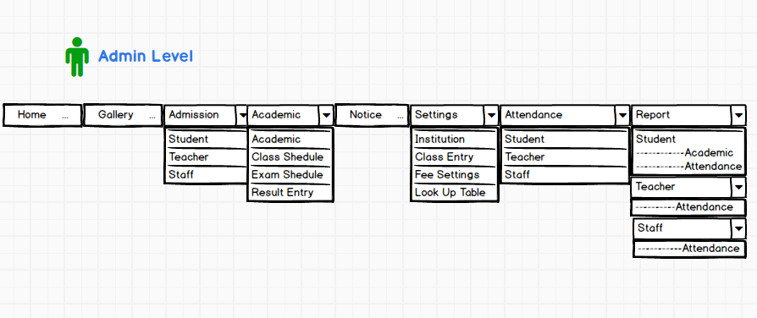

This is the privacy field for modifying or checking the information. When admin log in by username and password then only he can access this field.

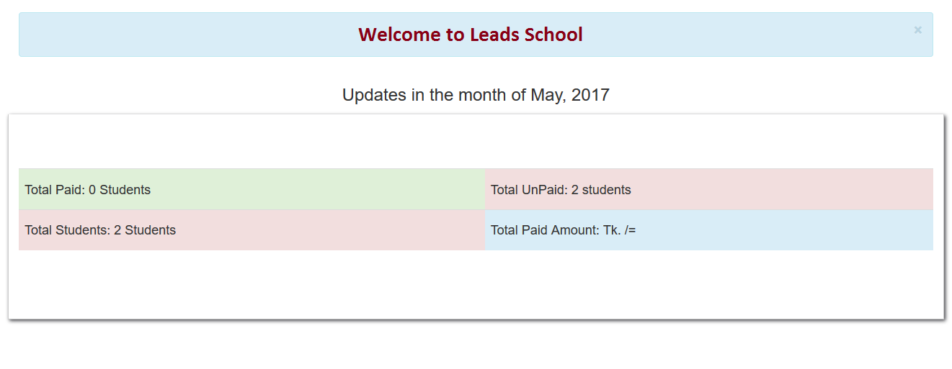

# Settings

## Institution

By using this section the information (Name, Slogan, Address, Code, Logo and Established Year) can be saved of the institution. This is general for any institution user so if want the information also can be modified.

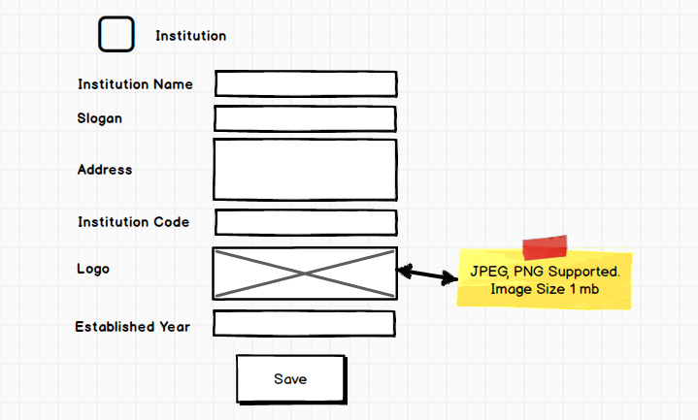

## Class Entry

In this section all the class name will be saved which are found in dropdown list as option in any other section where class name is needed.

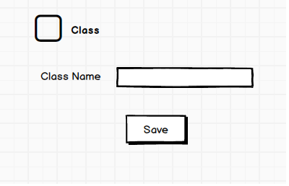

## Fee Settings

For collecting the monthly fee this form will be used. By selecting specific class the fee will be collected and the date of collecting also be saved. There is no delete option of recording data.

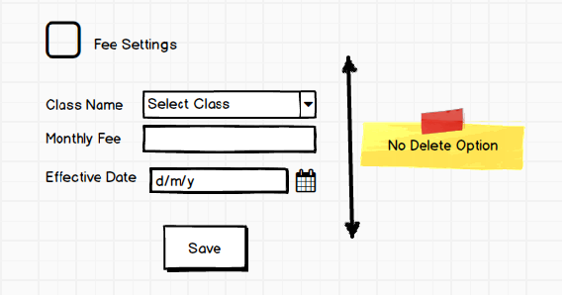

## Look Up Table

Here, the group, shift, section all data will be inserted under the parent then these data can be accessed by calling parent ID.

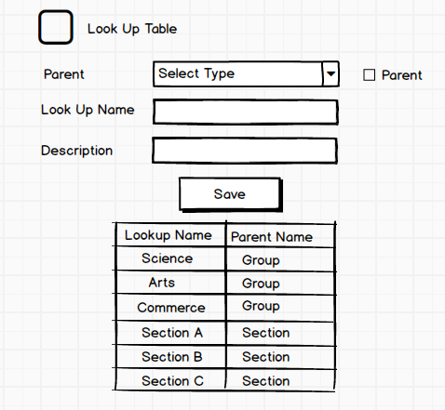

## Subject Entry

By using this table class name, subject code, corresponding subject name and types of exam will be saved which will be used for recording the contents consist in admission, academic, attendance and report.

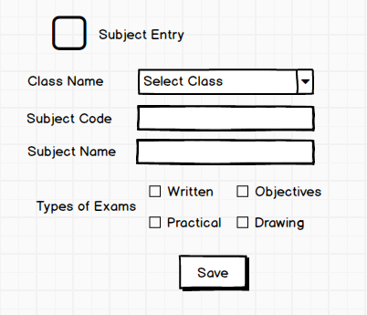

# Admission

## Student registration form

In this content, the public who want to be a student will fill up the registration from. From this form the administration can access students’ information in future for retrieving, deleting or updating. There are two steps to registry students’ information.

**Step-1:** The student will fill up the following information given below chart and also add a photo by browsing. If he/she gets any discount that will be mentioned in fixed amount (tk) or percentage. After finishing this form with valid information another form will be filled up by clicking “Next” button. If any section in Step-1 is missing the next form could not open.

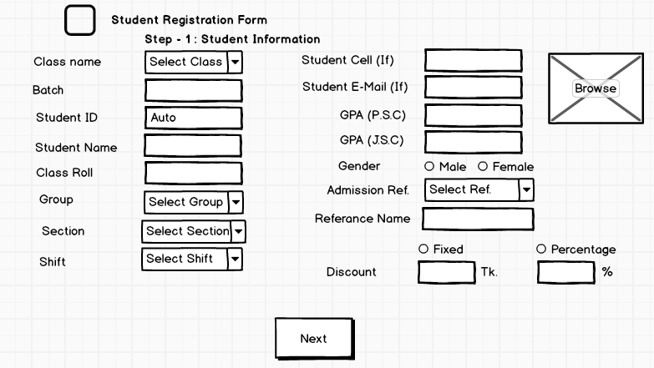

**Step-2:** In there will fill up the following information of parents given below chart and also add three photos (Father, Mother and Guardian).  
Then by clicking “submit” button information of Step-1 and Step-2 will be saved.

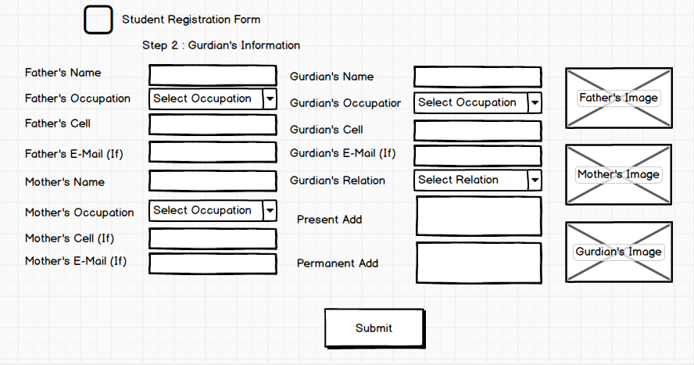

## Employee registration form

This is the registration form for Employee consisting Administrative, Principle, Teacher and Staff. When they fill up this form at the joining time the mentioning information given in table will be saved and from this form in future the admin can access this information for necessity.

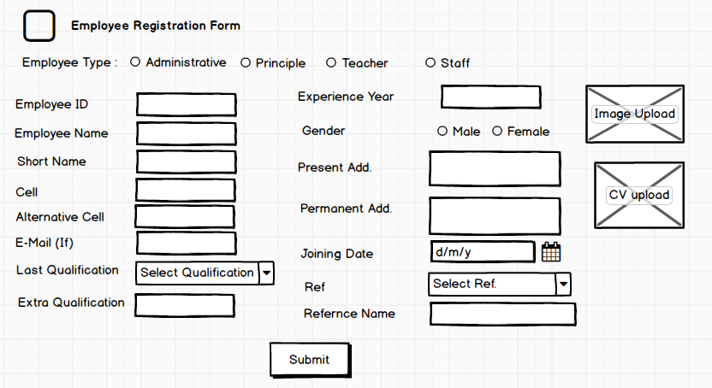

3. Academic

## 3.1. Class Schedule

By this table admin can save the routine/schedule of any class. Some data will be inserted by dropdown list by which specific data can be inserted.

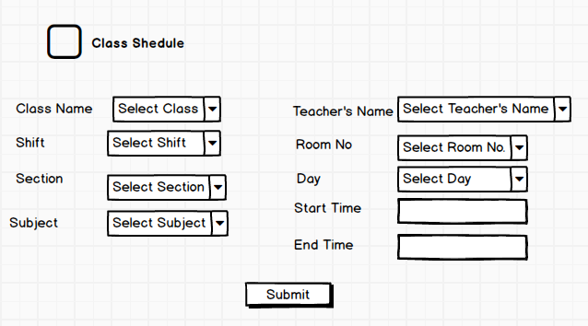

## 3.2. Exam Schedule

This section is represented the information during examination by Two steps.   
**Step-1:** By this table admin can save the information of any examination. Some data will be inserted by dropdown list by which specific data can be inserted. After submitting these information one exam code will be automatic generated which will be called in step-2.

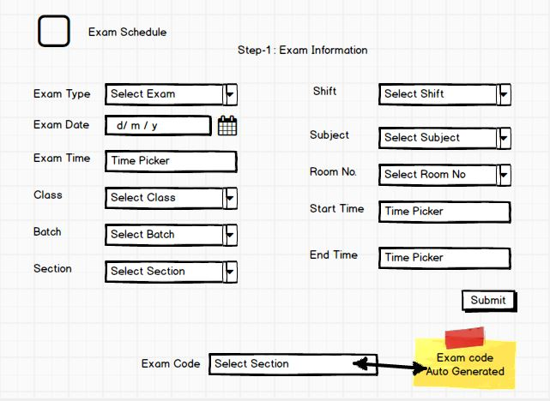

**Step-2:** Here firstly exam code from step-1 should be selected for mentioning the specific information of exam and under this code the duty teacher (one or more) will be saved.

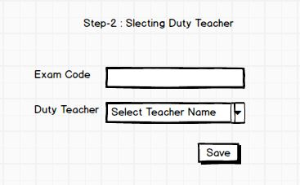

## 3.3 Result Entry

For result calculating, admin will select the class, shift, batch, section and subject then the student list will open corresponding these information and the teacher’s name will automatic visible. Then all the marks will be inserted for each student one by another. There have also delete and edit option for future modification.

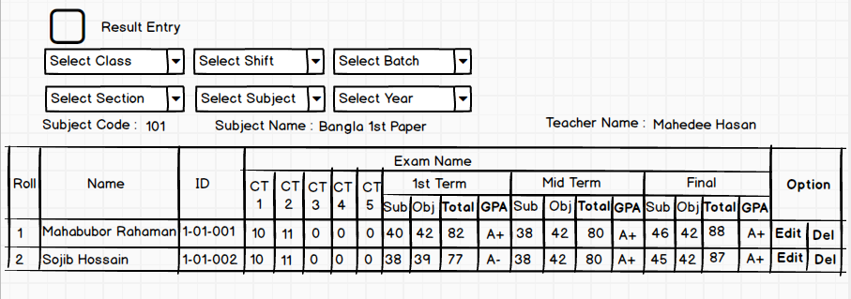

# 4. Notice

By this section admin can insert, delete or update any necessary notice by uploading file with the school related activities. The notice can see the student, teacher, staff and public.

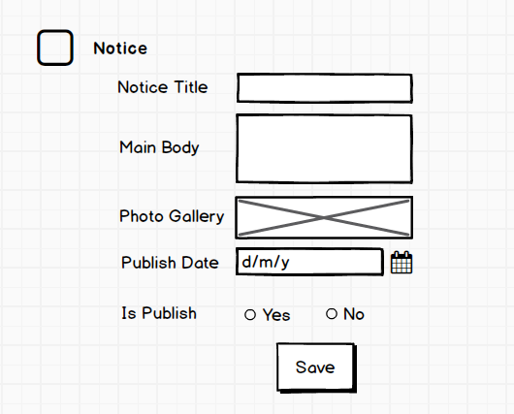

# 5. Attendance

## 5.1. Student Attendance

For calculating students’ attendance this form will be used. There will be selected some section including class, shift, branch, section, year, month. Then total attend and absent student will be counted of corresponding information. There also will have a comment box for each student. These all information can be saved by “Save” button.

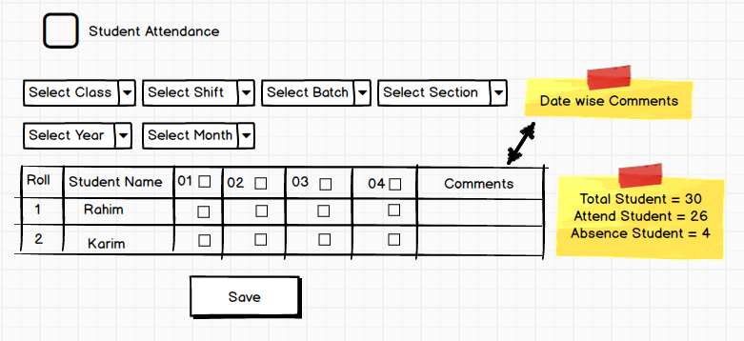

## 5.2. Employee Attendance

For calculating Employees’ attendance this form will be used. There will be selected including year and month. Then total attend and absent will be counted of corresponding employee. There also will have a comment box for each teacher. These all information will be saved by “Save” button.



