FACEBOOK & INSTAGRAM ADS PORTFOLIO
Seven Case Studies in Creative-Led Performance Marketing
Built and rebuilt for Meta's Andromeda update
7  Client Accounts | 334  Campaigns Run | $9,988  Total Spend | 14.0M  Impressions

Prepared from live Meta Ads Manager reporting across all managed accounts

Portfolio Snapshot
This portfolio brings together seven live Meta Ads accounts spanning fragrance, fashion, beauty, education, travel, web development, and overseas-study consultancy. Across 334 campaigns and $9,988.16 in managed ad spend, these accounts generated over 14 million impressions and reached more than 5.5 million people - almost entirely on small, daily-budget campaigns rather than large one-off pushes. What ties them together is a shared response to Meta's Andromeda update: broad targeting, messaging-first creative, and a constant rotation of new ad variations built to keep pace with a system that now ranks ads primarily on creative signal, not audience definition.
AD ACCOUNTS | CAMPAIGNS | TOTAL SPEND | IMPRESSIONS | REACH
7 | 334 | $9,988.16 | 14,012,864 | 5,554,167

CONTEXT

Why Andromeda Changes the Playbook
In 2026, Meta finished rolling out Andromeda - the AI retrieval engine that now decides which ads even get a chance to enter the auction. Where the old system matched ads to audiences using interests and demographics, Andromeda reads the creative itself: hooks, pacing, message, format. It predicts who will respond before targeting settings matter much at all.
For small and mid-size advertisers, that changes the job. It means fewer manually stacked interest sets and more creative variations; broader ad sets so the algorithm has room to learn; and campaign structures built around signals Andromeda can act on quickly, like Messenger conversations and video ThruPlays. Every account in this portfolio was run with that shift in mind - smaller ad sets, stacking dozens of scrappy new tests, rather than one polished ad left to run for months.

CASE STUDIES

Client Results
CASE STUDY 1

Sumon’s Aroma & Sister Brands
Fragrance, Beauty & D2C Messenger Commerce
SPEND | CAMPAIGNS | IMPRESSIONS | REACH
$756.71 | 36 | 1,609,197 | 1,021,224
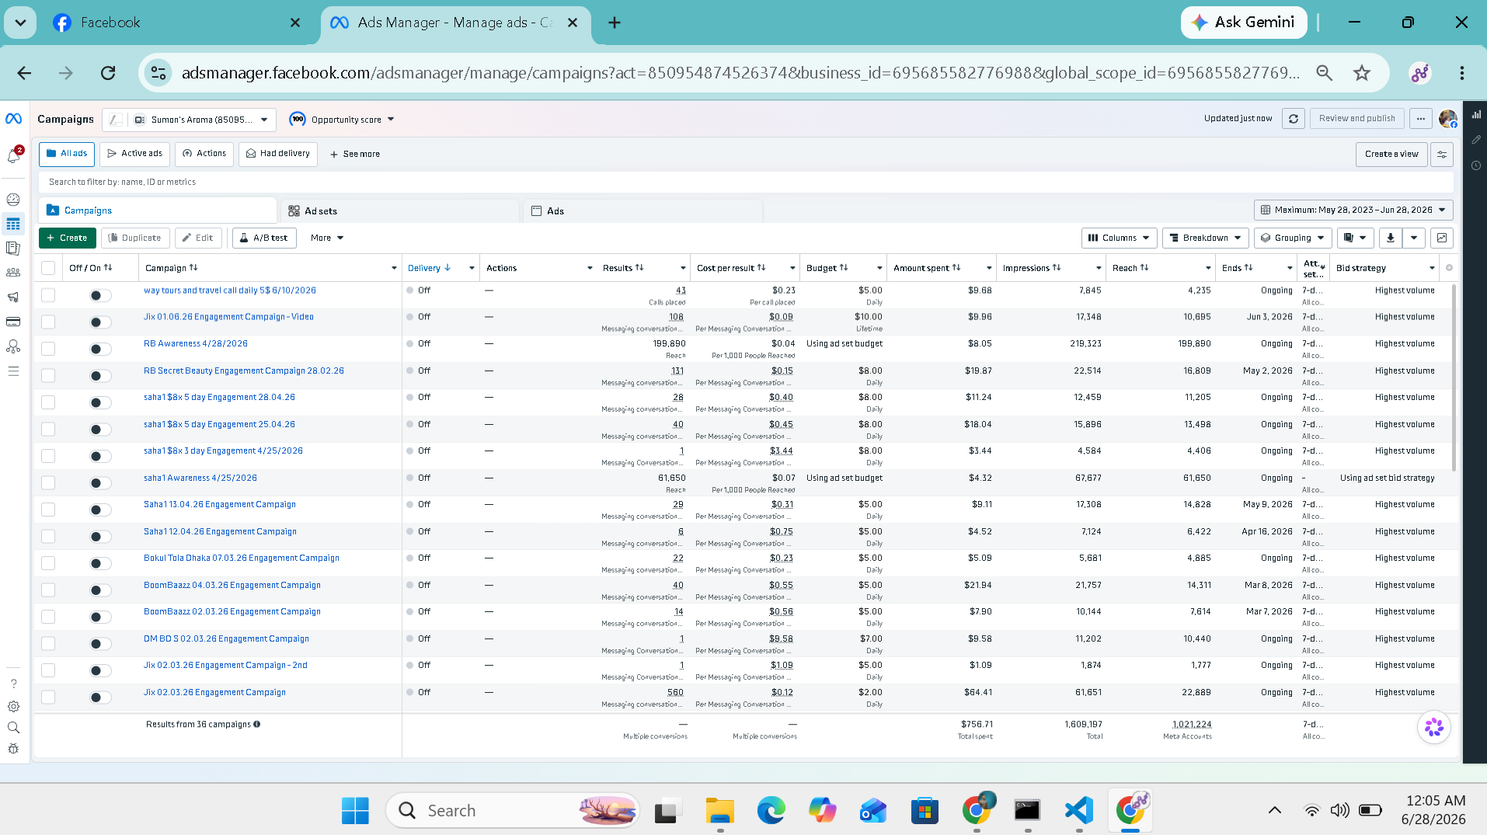
Ads Manager view: Sumon's Aroma account, 36 campaigns
This account manages Sumon’s Aroma alongside several partner brands (RB, Saha, Bokul Tula Dhaka, BoomBaazz) that sell primarily through Facebook Messenger rather than a checkout page. The strategy leans almost entirely on Engagement campaigns optimized for Messaging Conversations Started, with new campaigns launched every few days on $3–$10 daily budgets instead of one large evergreen ad set.
That cadence - dozens of small, fast-moving tests - is exactly the kind of creative diversity Andromeda rewards. Several campaigns landed a cost per messaging conversation under $0.10, and reach tracked impressions closely across the account, a sign the creative was being shown broadly rather than repeated at the same narrow segment. Over 36 campaigns, $756.71 in spend returned 1.6 million impressions and put the brand in front of over a million unique people - a blended cost per thousand impressions under $0.50.
ANDROMEDA ALIGNMENT: Frequent, low-cost creative refreshes across many small partner brands - the exact volume-over-polish pattern the retrieval engine now favors.
CASE STUDY 2

Riha Webtech
Web Design & Local Digital Services
SPEND | CAMPAIGNS | IMPRESSIONS | REACH
$431.00 | 18 | 275,332 | 118,321
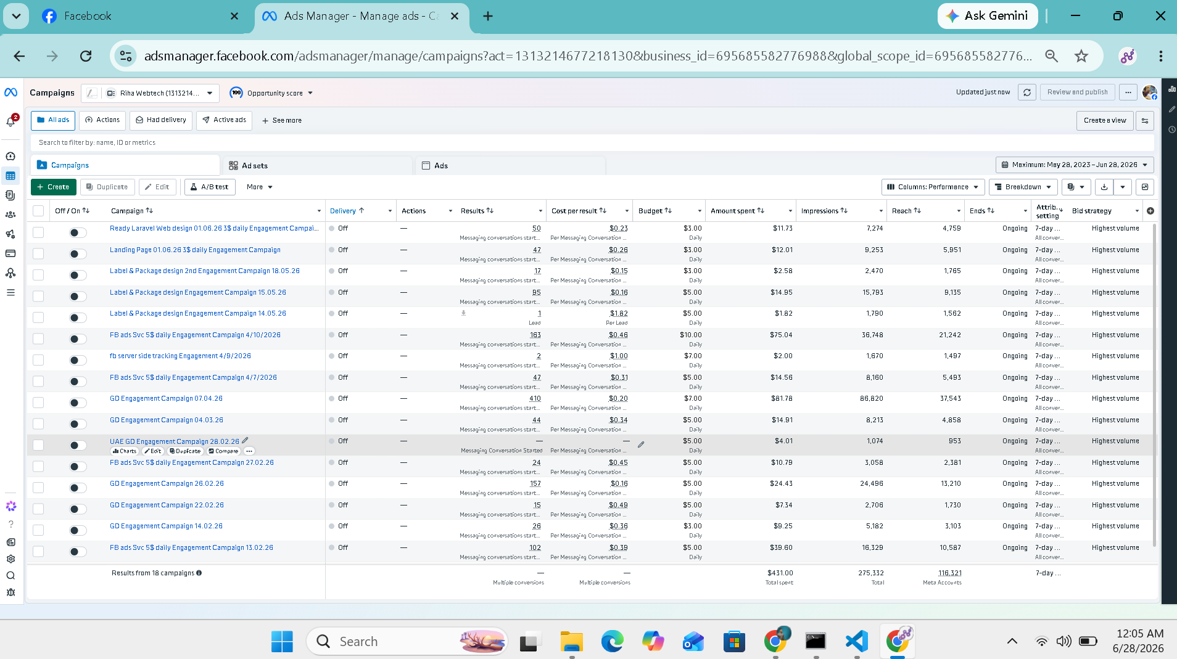
Ads Manager view: Riha Webtech account, 18 campaigns
Riha Webtech sells technical services - Laravel development, landing page builds, label and package design, and Meta Conversions API / server-side tracking setup - a harder sell than a physical product, and one that depends on trust-building creative rather than a flashy offer. Campaigns were split by service line so each ad's creative could speak to one specific buyer instead of one generic pitch trying to cover everything.
That specificity matters under Andromeda, which now matches creative to intent rather than matching audience definitions to demographics. On a modest $431 spend across 18 campaigns, the account generated 275K impressions and drove messaging conversations at costs as low as $0.04, with the more competitive landing-page and tracking-setup campaigns settling around $0.15–$0.20 per conversation - solid economics for a B2B service offer.
ANDROMEDA ALIGNMENT: One creative angle per service line, not one ad trying to sell everything - giving the retrieval engine a cleaner signal to match against buyer intent.
CASE STUDY 3

IPB Edu & Happy Tours
Education Consultancy & Travel Booking
SPEND | CAMPAIGNS | IMPRESSIONS | REACH
$1,141.45 | 37 | 1,828,839 | 731,828
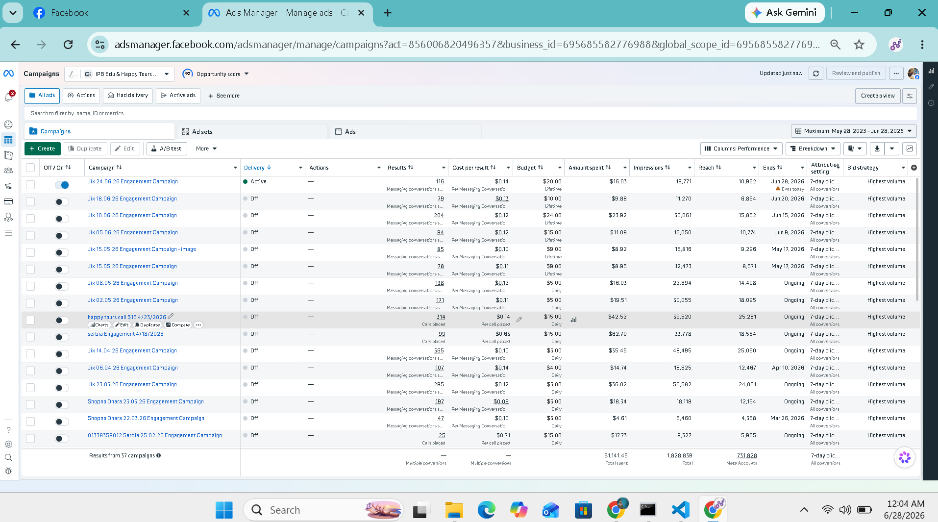
Ads Manager view: IPB Edu & Happy Tours account, 37 campaigns
This account runs two distinct verticals side by side - IPB's education-consultancy inquiries and Happy Tours' travel bookings - using a mix of Messenger and click-to-call campaigns depending on which converts better for each service. The weekly “Jix” campaign series (24.06, 18.06, 10.06, 05.06…) iterated every few days rather than running one ad indefinitely, and a Serbia-focused visa and travel campaign targeted a specific outbound-migration audience.
Cost per messaging conversation stayed remarkably tight throughout, frequently landing between $0.09 and $0.15, and one May campaign pushed 30,000-plus impressions off a $5 daily budget. Across 37 campaigns, $1,141.45 in spend delivered 1.83 million impressions - proof that consistent weekly refreshes, not bigger budgets, kept costs down as Andromeda rewarded the newest creative in the pool.
ANDROMEDA ALIGNMENT: A weekly refresh cadence, rather than a single long-running ad, is what Andromeda's creative-diversity filters are built to reward.
CASE STUDY 4

Ruposhi Mart & Partner Brands
Fashion & Beauty E-Commerce, Multi-Brand Portfolio
SPEND | CAMPAIGNS | IMPRESSIONS | REACH
$6,315.66 | 138 | 7,280,153 | 1,806,088
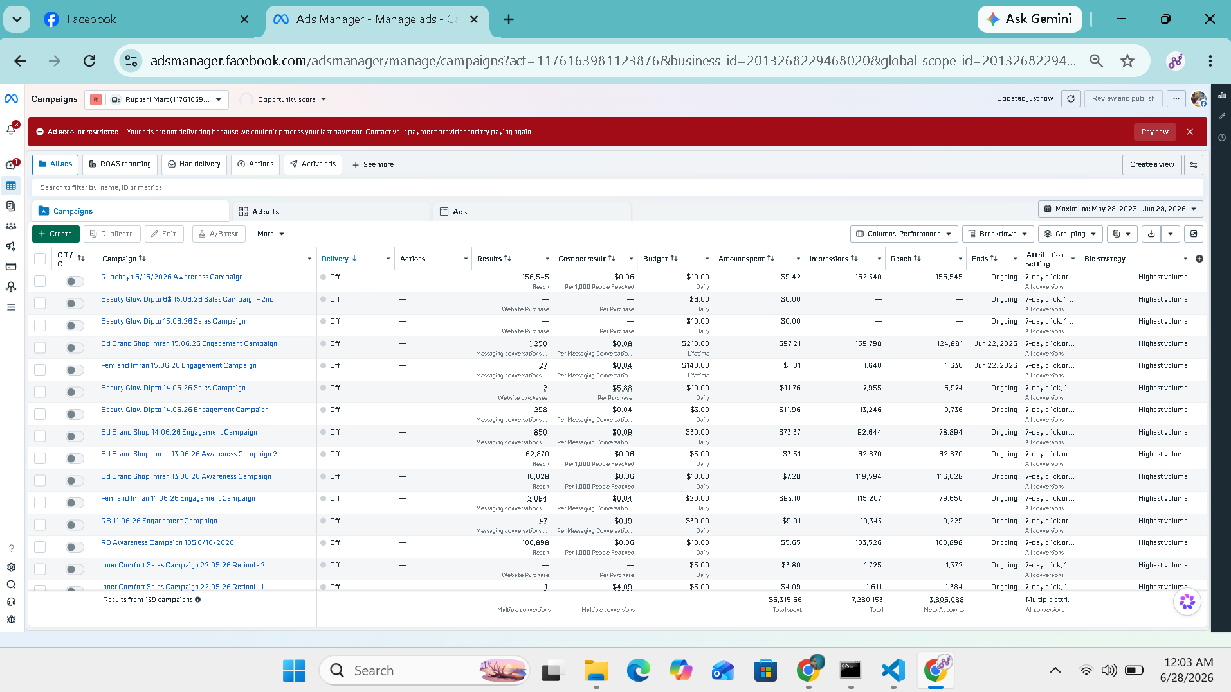
Ads Manager view: Ruposhi Mart account, 138 campaigns
This is the largest and most complex account in the portfolio - six e-commerce brands, 138 campaigns, and a genuine mix of objectives: Sales campaigns optimized for on-site purchases (Inner Comfort, Beauty Glow), Awareness campaigns for pure reach (Rupchaya alone hit 156,545 reach off a single $10/day push), and Engagement campaigns feeding Messenger for brands still selling conversationally (Bd Brand Shop, Femland).
Rather than consolidating everything into one mega-campaign, spend stayed distributed across dozens of small, brand-specific tests - the structure Andromeda's Advantage+ system favors, since it hands the retrieval engine more distinct creative signals to learn from at once. The scale shows in the numbers: $6,315.66 in total spend produced 7.28 million impressions and reached 1.8 million people, with frequency staying low across most Awareness campaigns - a sign the account was genuinely expanding its audience rather than re-showing the same users.
ANDROMEDA ALIGNMENT: Six brands, dozens of parallel small-budget campaigns - maximum creative surface area for the retrieval engine to sort through.

CASE STUDY 5

Luxury Beauty – RWT
Beauty & Skincare, Direct-Response Sales
SPEND | CAMPAIGNS | IMPRESSIONS | REACH
$350.23 | 23 | 488,251 | 388,554
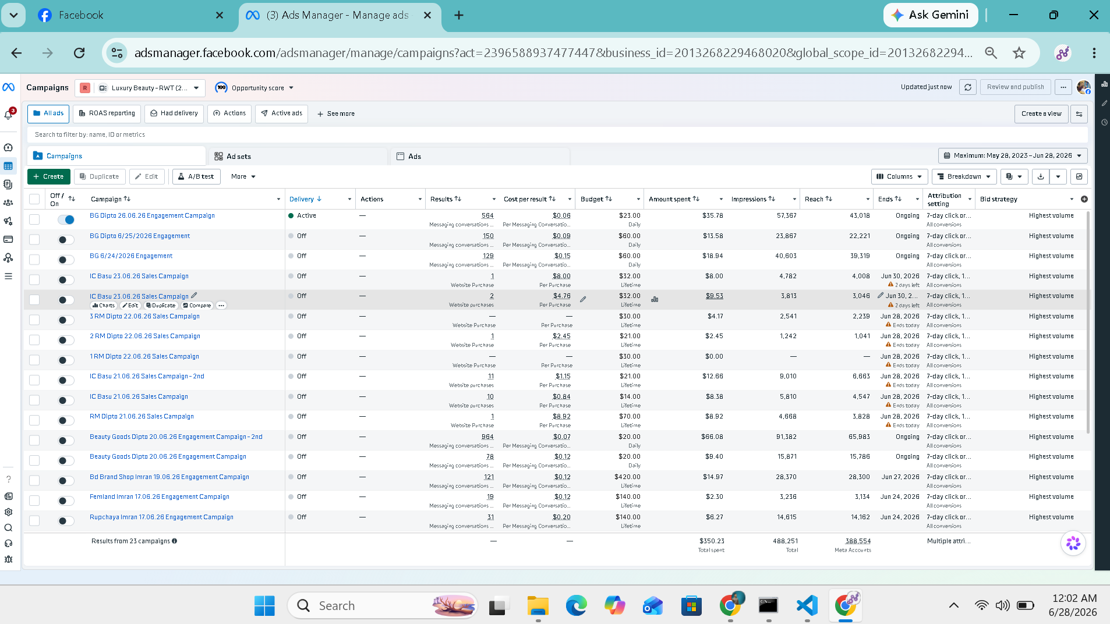
Ads Manager view: Luxury Beauty - RWT account, 23 campaigns
Luxury Beauty's account runs a tight rotation of Sales campaigns (IC Basu, 1RM/2RM/3RM Dipto) optimized directly for website purchases and per-purchase cost control, layered with Engagement campaigns (BG Dipto) to keep the Messenger pipeline warm between sales pushes. Budgets were kept small and campaigns short-lived - many wrapped within a week - which meant creative was constantly refreshed rather than left to fatigue.
That habit lines up directly with Andromeda's preference for active creative rotation over long-running, set-and-forget ads. On $350.23 in spend, the account reached 388,554 people with 488,251 impressions, and purchase-optimized campaigns held cost-per-purchase in the low single digits - efficient economics for a beauty brand with modest average order values.
ANDROMEDA ALIGNMENT: Short-lived, fast-rotating sales campaigns avoid the creative fatigue that Andromeda's filters increasingly penalize.
CASE STUDY 6

RPL Consultancy
Overseas Education & Immigration Consultancy
SPEND | CAMPAIGNS | IMPRESSIONS | REACH
$273.17 | 8 | 1,151,904 | 663,407
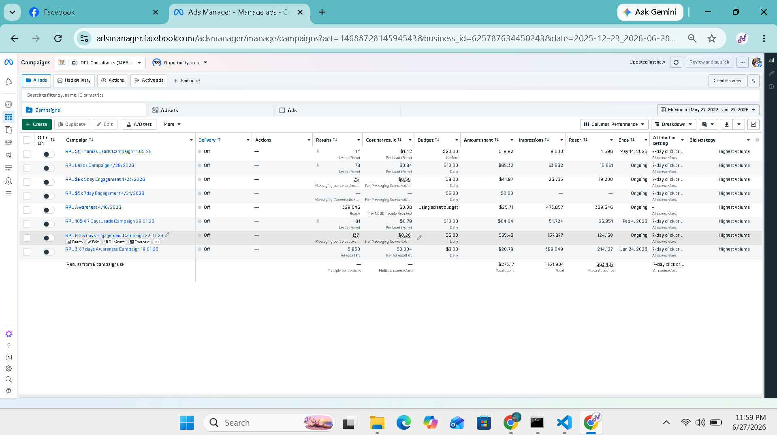
Ads Manager view: RPL Consultancy account, 8 campaigns
With only 8 campaigns, RPL Consultancy shows what focus looks like: a lead-form campaign converting at $1.42 per lead, a broad Awareness push that hit 329,646 reach using Meta's ad-set budget optimization, and a handful of ThruPlay video Engagement campaigns priced at fractions of a cent per view.
Rather than testing dozens of angles, this account concentrated spend on a smaller number of well-targeted, high-intent formats - lead forms for bottom-funnel prospects, awareness and recall for top-funnel visibility - and let Andromeda's broad-targeting logic do the audience-finding. The result: 1.15 million impressions and 663,407 people reached from just $273.17 in spend, one of the most efficient cost-per-impression ratios in the entire portfolio.
ANDROMEDA ALIGNMENT: Fewer, sharper formats plus genuinely broad targeting - proof the engine doesn't need audience segmentation to find the right people.
CASE STUDY 7

Travel & Lifestyle Testing Engine
Travel Agencies, Visa Services & Lifestyle Products
SPEND | CAMPAIGNS | IMPRESSIONS | REACH
$719.94 | 74 | 1,379,188 | 824,745
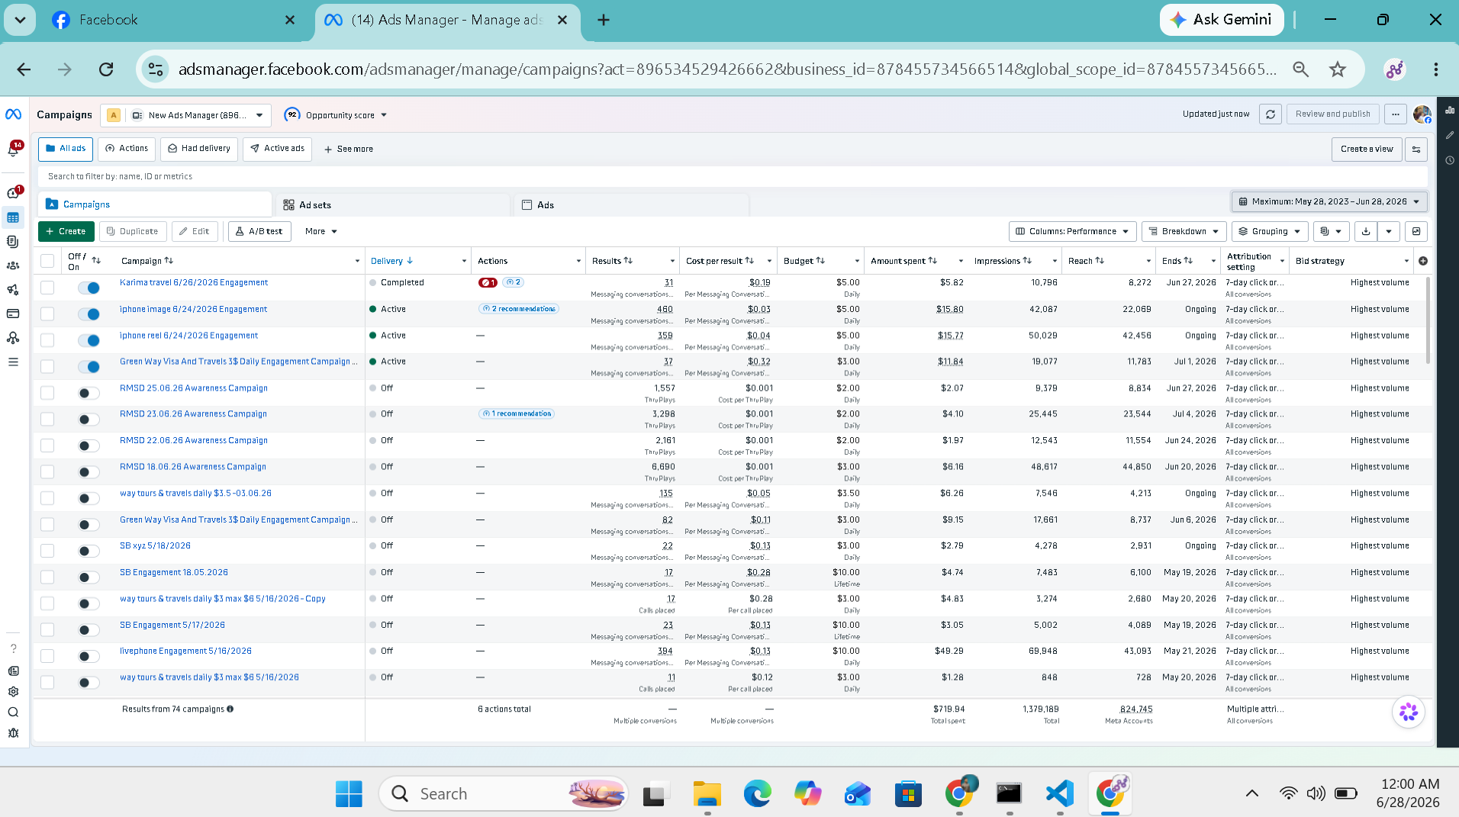
Ads Manager view: Travel & Lifestyle testing account, 74 campaigns
This account is the portfolio's testing engine - 74 campaigns across Karima Travel, Green Way Visa & Travels, an iPhone product push, and the RMSD ThruPlay video series, all run on tight daily budgets between $2 and $5. It's a direct illustration of the “more variants, smaller budgets” playbook Andromeda rewards: an iPhone reel campaign was tested head-to-head against an iPhone static-image campaign to see which format the retrieval engine favored, and RMSD ran four separate ThruPlay awareness campaigns back-to-back through June, each a slightly different cut, at a cost of roughly $0.001 per ThruPlay.
Messaging-conversation campaigns for the travel agencies held costs in the $0.03–$0.32 range depending on competitiveness. Across all 74 campaigns, $719.94 in spend generated 1.38 million impressions and reached 824,745 people - a campaign count nearly four times the account's spend in dollars, underlining just how much this strategy leans on volume of creative tests rather than budget size.
ANDROMEDA ALIGNMENT: Volume of tests over size of budget - 74 campaigns on under $750 is the clearest example in this portfolio of feeding the algorithm rather than out-spending it.

CLOSING

The Common Thread
No single account in this portfolio relies on a big budget. What repeats across all seven - fragrance, web design, education, travel, fashion, beauty, and consultancy - is the same operating rhythm: small daily budgets, frequent creative refreshes, messaging-first conversion paths, and campaign structures broad enough for Meta's Andromeda engine to do the targeting work on its own.
Combined, these seven accounts spent $9,988.16 to generate over 14 million impressions and reach 5.5 million people. The lesson carries past any single client: in the Andromeda era, creative velocity - how many honest new variations you can put in front of the algorithm - outperforms budget size almost every time.

Figures compiled from Meta Ads Manager reporting (lifetime account totals as of late June 2026) across all seven managed accounts.

