MCP Server for Employee Dashboard Documentation

1. Overview

For our Northwind employee platform, we are building a Python Model Context Protocol (MCP) server that exposes a local Spring Boot employee-management backend as MCP tools, resources, and prompts. Its purpose is to let MCP-compatible clients and agents query and optionally modify employee data through a stable tool interface while keeping the business data and persistence logic in the existing Java backend. It helps separate agentic actions from our application’s data by letting the MCP layer act as the communication and transport mechanism and sending responses in JSON format.

At runtime, the MCP server:
1. Starts a FastMCP server.
2. Reads connection and feature configuration from environment variables.
3. Creates an asynchronous HTTP client wrapper for the Spring Boot backend.
4. Registers MCP tools, resources, and prompts.
5. Serves requests over the selected MCP transport, typically stdio or streamable HTTP via JSON.

The MCP package is intentionally a bridge layer. It does not own the employee database, persistence rules, or Java domain model. Those remain in the Spring Boot application under the Employee directory.

2. Repository Location
Relevant files:
northwind-mcp/
pyproject.toml
src/northwind_mcp/
__init__.py
server.py
tools.py
employee_response.py
intent_extractor.py
schemas.py

Employee/
src/main/java/com/details/employee/
Employee.java
EmployeeController.java
EmployeeService.java
EmployeeRepository.java
EmployeeNotFoundException.java
GlobalExceptionHandler.java
src/main/resources/application.properties

Note: the current MCP client wrapper is implemented in employee_response.py. There is no employee_client.py file in the current working tree.

3. High-Level Architecture

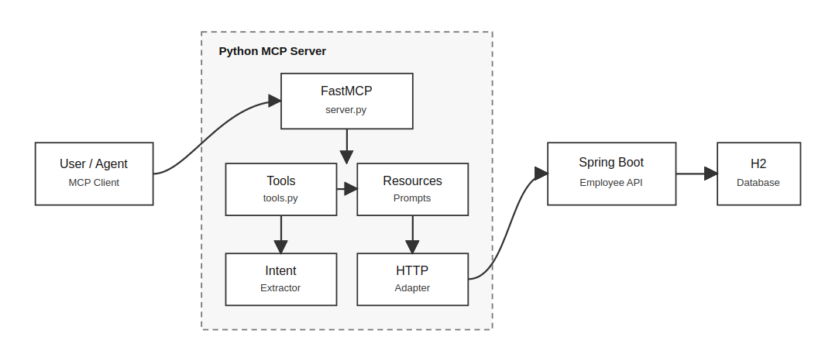

Architectural Responsibilities

Layer | Technology | Responsibility
MCP server | Python, mcp.server.fastmcp.FastMCP | Exposes MCP tools, resources, prompts, and transport runtime
Tool registration | tools.py | Defines callable MCP operations and maps them to backend adapter methods
Backend adapter | employee_response.py, httpx.AsyncClient | Converts MCP tool calls into HTTP requests to the Spring Boot API
Schemas | schemas.py, Pydantic v2 | Validates and serializes employee, statistics, and intent data
Intent extraction | intent_extractor.py | Provides deterministic natural-language intent, extractor, projections parsing for supported employee queries
Employee backend | Spring Boot | Owns business data, persistence, REST routes, and employee CRUD behavior
Database | H2 file database | Stores employee records under Employee/data/

4. Runtime Entry Point

The MCP server starts from:
northwind_mcp.server:main

pyproject.toml also exposes this as a console script:
[project.scripts]
northwind-mcp = "northwind_mcp.server:main"

The runtime flow is:

1. main() reads MCP_TRANSPORT, defaulting to stdio.
2. create_server() reads backend and MCP configuration.
3. A FastMCP instance named Employee Management is created.
4. An employeeResponse backend adapter is created with the configured backend URL.
5. A RuleBasedIntentExtractor is created.
6. register_tools() attaches tools, resources, and prompts to the MCP instance.
7. mcp.run(transport=transport) starts the selected transport.

5. Configuration
The MCP server is configured using environment variables.

Variable | Default | Description
NORTHWIND_BACKEND_URL | unset | Preferred backend base URL for the Spring Boot API
backend final default | http://localhost:8080 | Used when backend URL variable is not set
MCP_TRANSPORT | stdio | MCP transport passed to FastMCP.run()
MCP_PORT | 8000 | Port used by FastMCP for HTTP transports
MCP_STREAMABLE_HTTP_PATH | /sse | Streamable HTTP endpoint path
MCP_ENABLE_WRITE_TOOLS | false | Enables write tools when set to 1, true, yes, or on
MCP_ADMIN_TOKEN | unset | Shared admin token required by write tools

Example read-only streamable HTTP startup:
cd northwind-mcp
source .venv/bin/activate

MCP_TRANSPORT=streamable-http \
python -m northwind_mcp.server

Example write-enabled startup:
cd northwind-mcp
source .venv/bin/activate

MCP_TRANSPORT=streamable-http \
MCP_ENABLE_WRITE_TOOLS=true \
MCP_ADMIN_TOKEN="demo-admin-123" \
python -m northwind_mcp.server

Default streamable HTTP URL:
http://localhost:8000/sse

6. Python Package Dependencies

Declared package dependencies:

Dependency | Usage
mcp[cli]>=1.27,<2 | FastMCP server runtime and MCP primitives
httpx>=0.27 | Async HTTP calls to the Spring Boot backend
pydantic>=2.7 | Data validation and serialization
pydantic-settings>=2.3 | Declared dependency; not currently used directly in source
openai>=2.0 | Declared dependency; not currently used directly in the MCP server source

Python version requirement:
Python >= 3.11

7. MCP Surfaces

The server exposes three MCP surface types:

1. Tools: callable operations for employee reads, statistics, natural-language parsing, and optional writes.
2. Resources: read-only formatted snapshots for employees and statistics.
3. Prompts: reusable analytical prompt templates.

7.1 Read Tools

Read tools are always registered.

a. get_employee(employee_id: int) -> dict

Fetches one employee by ID.

Backend route:
GET /api/employees/{employee_id}

Response shape:
{
"employee": {
"id": 1,
"name": "Omnifi CX",
"email": "omni@kensium.com",
"department": "Engineering",
"role": "Developer",
"location": "Hyderabad",
"hireDate": "2024-01-15",
"salary": 90000.0,
"active": true
}
}

b. list_employees() -> dict

Lists active employees.

Backend route:
GET /api/employees

The Java service uses findByActiveTrue(), so this endpoint returns active employees only.

Response shape:
{
"employees": [],
"count": 0
}

c. search_employees(name: str) -> dict
Searches employees whose names contain the supplied text, case-insensitively.

Backend route:
GET /api/employees/search?name={name}

Response shape:
{
"employees": [],
"count": 0
}

d. get_employees_by_department(department: str) -> dict

Fetches employees in a department. The MCP adapter normalizes common aliases before calling the backend.

Backend route:
GET /api/employees/department/{department}

Supported aliases:
Input | Normalized value
eng | Engineering
engineering | Engineering
sales | Sales
hr | HR
human resources | HR
finance | Finance
marketing | Marketing
operations | Operations

Unknown department strings are whitespace-normalized and title-cased.

e. get_employee_count() -> dict

Returns total employee count.

Backend route:
GET /api/employees/count

Important behavior: the Java service currently uses employeeRepository.count(), so this count includes all rows, including inactive employees.

Response shape:
{
"count": 42
}

f. get_average_salary() -> dict

Returns the average salary across employees.
Backend route:
GET /api/employees/stats/average-salary

Important behavior: the Java service currently computes the average using employeeRepository.findAll(), so inactive employees are included.

Response shape:
{
"average_salary": 72500.0
}

g. get_employee_count_by_department() -> dict

Returns employee counts grouped by department.

Backend route:
GET /api/employees/stats/by-department

Important behavior: the Java service currently groups over employeeRepository.findAll(), so inactive employees are included.

Response shape:
{
"departments": {
"Engineering": 10,
"Sales": 8
}
}

7.2 Natural-Language Tools

a. parse_business_request(question: str) -> dict

Runs deterministic rule-based intent extraction without executing the resulting backend call.

Response shape:
{
"intent": "get_employee",
"entities": {
"employee_id": 7
},
"projection": ["name", "salary"],
"confidence": 0.9,
"explanation": "Found an employee id in the question."
}

Supported intents:
Intent | Entity requirements
get_employee | employee_id
search_employees | name
get_employees_by_department | department
get_employee_count | none
get_average_salary | none
get_employee_count_by_department | none
unknown | none

b. execute_business_request(question: str) -> dict

Runs intent extraction and executes the matching read operation.

Response shape:
{
"intent": {
"intent": "get_average_salary",
"entities": {},
"projection": [],
"confidence": 0.9,
"explanation": "Question asks for average salary."
},
"result": {
"average_salary": 72500.0
}
}

If the intent is unknown or unsupported, the tool returns the extracted intent plus:
{
"error": "Unsupported or unknown intent."
}

7.3 Optional Write Tools

Write tools are registered only when:
MCP_ENABLE_WRITE_TOOLS=true

or another accepted truthy value is used: 1, true, yes, on.

Every write tool requires an admin_token argument. The supplied token is checked against MCP_ADMIN_TOKEN using secrets.compare_digest().

If MCP_ADMIN_TOKEN is not set while write tools are enabled, write calls fail with:
Write tools are enabled, but MCP_ADMIN_TOKEN is not set.

If the provided token is wrong, write calls fail with:
Invalid admin token.

a. add_employee(name, email, department, salary, admin_token) -> dict

Creates a new employee.

Backend route:
POST /api/employees

Payload sent to backend:
{
"name": "Jane Doe",
"email": "jane@example.com",
"department": "Engineering",
"salary": 90000.0
}

The MCP adapter normalizes the department before sending it.

b. update_employee(employee_id, name, email, department, salary, admin_token) -> dict

Updates an employee.

Backend route:
PUT /api/employees/{employee_id}

Payload sent to backend:
{
"name": "Jane Doe",
"email": "jane@example.com",
"department": "Engineering",
"salary": 95000.0
}

Important behavior: the MCP update tool currently sends only name, email, department, and salary. The Java backend can update role, location, hireDate, and active, but the MCP tool does not expose those fields.

c. deactivate_employee(employee_id, admin_token) -> dict

Soft-deletes an employee by setting active=false.

Backend route:
PATCH /api/employees/{employee_id}/deactivate

d. delete_employee(employee_id, admin_token) -> dict

Permanently deletes an employee row.

Backend route:
DELETE /api/employees/{employee_id}

This is a hard delete. Use deactivate_employee for reversible operational workflows.

8. MCP Resources

Resources are registered in tools.py.

employees://all

Returns a formatted text snapshot of all active employees. Internally calls get_all_employees(), which maps to:
GET /api/employees

If no active employees exist, the resource returns:
No employees found.

If the backend cannot be reached, it returns an error string instead of raising to the MCP client.

employees://{employee_id}

Returns formatted text details for one employee.

Invalid non-numeric IDs return:
Invalid employee ID '{employee_id}'.

Backend/API errors are returned as formatted error strings.

stats://summary

Returns formatted workforce statistics:

1. Total employees.
2. Average salary.
3. Counts by department.

Internally calls:
get_employee_count()
get_average_salary()
get_employee_count_by_department()

9. MCP Prompts

The server registers three prompts.

department_report(department: str)

Generates an HR analyst prompt that instructs the client to:

1. Call get_employees_by_department().
2. Summarize headcount, names, roles, salary range, and notable patterns.
3. Flag unusual salary or team-size patterns.
4. Close with recommendations supported by data.

salary_analysis()

Generates a compensation-analysis prompt that instructs the client to:

1. Call get_average_salary().
2. Call get_employee_count_by_department().
3. Call list_employees().
4. Compute mean and standard deviation.
5. Flag employees more than 1.5 standard deviations from the company mean.
6. Present objective findings.

onboarding_helper()

Generates a guided onboarding prompt that helps collect details for a new employee and then calls add_employee() only after confirmation.

This prompt assumes write tools are available. If the server is running read-only, the final add step will not be callable.

10. Data Model and Schemas

The MCP server uses Pydantic models in schemas.py.

Employee
class Employee(BaseModel):
id: int
name: str
email: str
department: str
role: str | None = None
location: str | None = None
hireDate: date | None = None
salary: float
active: bool = True

Schema behavior:

1. Extra fields from the backend are ignored because model_config = ConfigDict(extra="ignore").
2. hireDate is parsed as a Python date and serialized to JSON as an ISO date string.
3. status is exposed as a Python property, but it is not included in model_dump() output unless explicitly added in future code.

Response Models

Model | Shape
EmployeeResponse | { "employee": Employee }
EmployeeListResponse | { "employees": list[Employee], "count": int }
CountResponse | { "count": int }
AverageSalaryResponse | { "average_salary": float }
DepartmentCountResponse | { "departments": dict[str, int] }
IntentExtraction | intent, entities, projection, confidence, explanation

11. Backend HTTP Adapter

employee_response.py contains the employeeResponse class, which is the MCP server's backend adapter.

Despite the lowercase class name, this class is the primary integration point between MCP tools and the Spring Boot REST API.

Responsibilities

1. Build backend URLs from a configured base_url.
2. Execute async HTTP requests using httpx.AsyncClient.
3. Raise a domain-specific EmployeeApiError for HTTP and connection failures.
4. Validate backend JSON into Pydantic response models.
5. Normalize department names for department-based reads and writes.

Timeout

The adapter default timeout is:
timeout = 10.0

Error Mapping

HTTP status errors are converted to:
Employee API returned HTTP {status_code} for {url}

Connection and request failures are converted to:
Could not connect to Employee API at {base_url}. Start the Spring Boot app first.

Tool calls generally allow these exceptions to propagate to the MCP runtime. Resource handlers catch EmployeeApiError and return formatted error text.

12. Intent Extraction

RuleBasedIntentExtractor provides deterministic parsing for a limited set of employee questions. It does not call an LLM.

Processing steps:

1. Lowercase and whitespace-normalize the user question.
2. Extract requested projection fields.
3. Check for employee ID patterns.
4. Check for salary/statistics/count phrasing.
5. Check for known department names.
6. Check for likely name-search patterns.
7. Return unknown if nothing matches.

Employee ID Detection

Matches patterns like:
employee 7
emp 7
id 7
employee #7

Projection Detection

The extractor can detect requests for selected fields:

Field | Example keywords
id | id, employee id, employee number
name | name, names, who
email | email, mail, email address
department | department, team
role | role, title, job
location | location, located, where
hireDate | hire date, hired, joining date, join date
salary | salary, pay, compensation, earn, wage, income
active | active, inactive, status

When a projected response contains employee records, _apply_projection() trims each employee object to only the requested fields that are present.

13. Spring Boot Backend Contract

The MCP server depends on these backend routes from EmployeeController.

Method | Route | Used by MCP | Description
GET | /api/employees | yes | List active employees
GET | /api/employees/{id} | yes | Get employee by ID
POST | /api/employees | yes, optional write | Create employee
PUT | /api/employees/{id} | yes, optional write | Update employee
PATCH | /api/employees/{id}/deactivate | yes, optional write | Soft delete
DELETE | /api/employees/{id} | yes, optional write | Hard delete
GET | /api/employees/department/{department} | yes | Employees by department
GET | /api/employees/search?name={name} | yes | Search by name
GET | /api/employees/count | yes | Total count
GET | /api/employees/stats/average-salary | yes | Average salary
GET | /api/employees/stats/by-department | yes | Count by department
GET | /api/employees/salary-range?min=&max= | no | Backend-only route
GET | /api/employees/paged?page=&size=&sortBy=&sortDir= | no | Backend-only route

Backend Persistence

The backend uses H2 in file mode:
spring.datasource.url=jdbc:h2:file:./data/employeedb;AUTO_SERVER=TRUE
spring.jpa.hibernate.ddl-auto=update

The H2 web console is enabled at:
/h2-console

14. Request Flow Examples

Read Tool Flow
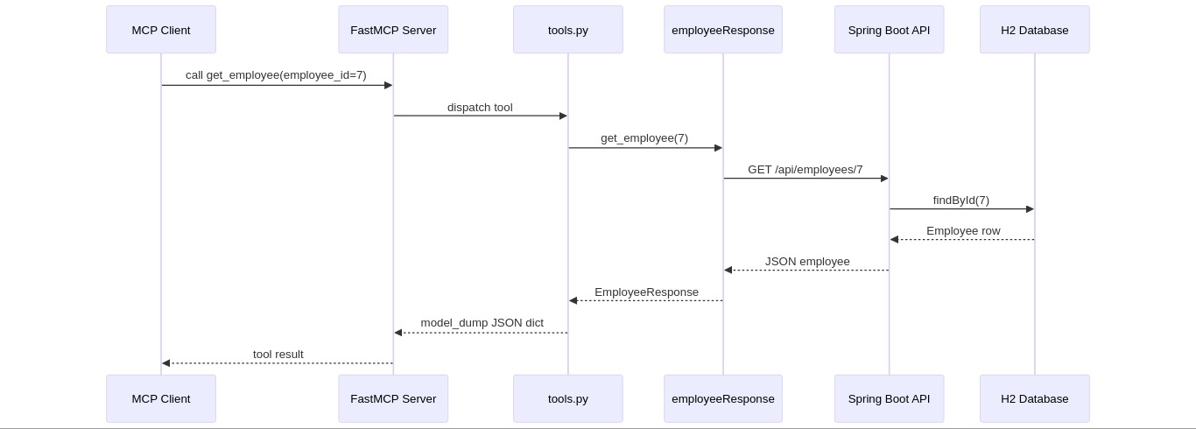

Natural-Language Execution Flow
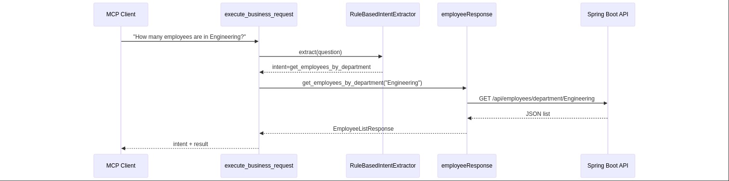

Write Tool Flow
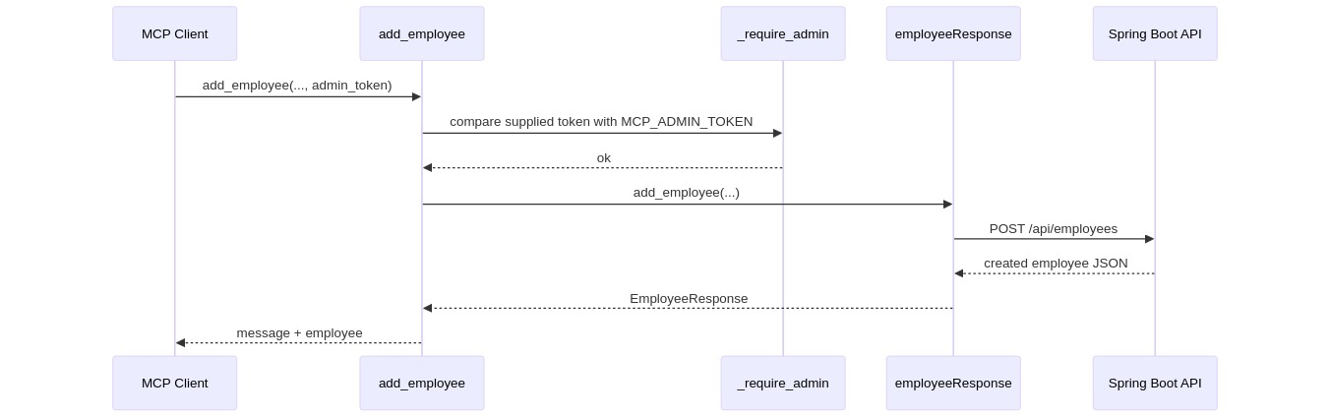

15. Security Model

The MCP server has a simple local-development security model.

Read Access
Read tools and resources are always registered and do not require authentication.

Write Access
Write tools are hidden unless MCP_ENABLE_WRITE_TOOLS is enabled. When enabled, each write tool requires a caller-provided admin_token.

The token is compared using constant-time comparison:
secrets.compare_digest(provided_token, expected_token)

Security Limitations

1. The admin token is a shared secret, not a full authentication system.
2. The token is passed as a tool argument, so MCP hosts and logs may be able to observe it.
3. The Spring Boot backend routes themselves are not protected by this MCP token.
4. There is no per-user authorization or audit logging in the MCP layer.
5. The default setup is appropriate for local development and demos, not direct exposure to untrusted networks.

Recommended production hardening:
1. Put authentication and authorization in front of both MCP and backend services.
2. Use HTTPS for remote transports.
3. Avoid passing secrets as ordinary tool arguments where host logs may capture them.
4. Add backend-level authorization for write routes.
5. Add structured audit logs for write operations.
6. Restrict CORS/network access if the backend is exposed beyond localhost.

16. Operational Runbook
On each terminal, run:

Start Backend
cd Employee
./mvnw spring-boot:run

Backend base URL:
http://localhost:8080

Start MCP Server in Read-Only Mode
cd northwind-mcp
source .venv/bin/activate

MCP_TRANSPORT=streamable-http \
python -m northwind_mcp.server

Start MCP Server with Write Tools
cd northwind-mcp
source .venv/bin/activate

MCP_TRANSPORT=streamable-http \
MCP_ENABLE_WRITE_TOOLS=true \
MCP_ADMIN_TOKEN="demo-admin-123" \
python -m northwind_mcp.server

Inspect the server with MCP Inspector Code block: bash
npx -y @modelcontextprotocol/inspector

Connection settings:
Transport: Streamable HTTP
URL: http://localhost:8000/sse

17. Extension Points

Add a New Read Tool
1. Add or confirm the backend route in EmployeeController.
2. Add an async method to employeeResponse.
3. Add a Pydantic response model if the shape is new.
4. Register a new @mcp.tool() function in register_tools().
5. Add intent extraction support if natural-language execution should call it.
6. Document the tool contract.

Example backend-only routes that could be exposed next:
1. Salary range filtering: /api/employees/salary-range.
2. Pagination and sorting: /api/employees/paged.

Add a New Resource
1. Define a stable URI pattern with @mcp.resource().
2. Return formatted text, not raw Python objects.
3. Catch EmployeeApiError if a user-readable resource failure is preferred.

Add a New Prompt
1. Define a function with @mcp.prompt().
2. Make the prompt explicit about which tools the client should call.
3. Avoid asking the model to invent data not returned by tools.

18. Current Limitations and Technical Debt
1. There is no automated test suite for the MCP package in the current tree.
2. Read/list behavior is not fully consistent across backend routes:
- GET /api/employees returns active employees only.
- count, average salary, and department counts currently include all employees.
3. The MCP layer does not retry transient backend failures.
4. The MCP layer does not perform input validation beyond Pydantic type coercion and backend validation.
5. The natural-language parser is rule-based and intentionally limited.
6. openai and pydantic-settings are declared dependencies but are not used directly in the current MCP source.

19. Recommended Next Improvements

1. Add focused unit tests for RuleBasedIntentExtractor, normalize_department(), and projection behavior.
2. Add integration tests with a mocked backend using httpx.MockTransport.
3. Add MCP tools for salary range and paged employee queries.
4. Add structured logging around backend calls and write operations.
5. Move configuration into a typed settings object if configuration grows.
6. Consider backend-auth enforcement for write routes rather than relying only on MCP-layer gating.

20. Summary

The northwind-mcp server is a focused MCP bridge around the Spring Boot employee API. It provides:
1. Read tools for employee lookup, listing, search, department filtering, and workforce statistics.
2. Optional write tools protected by an MCP-layer admin token.
3. Resources for formatted employee and statistics snapshots.
4. Prompts for department reporting, salary analysis, and onboarding.
5. A deterministic natural-language intent parser for common employee questions.

The design keeps MCP-specific concerns in Python and business data ownership in the Java backend, making the system easy to run locally, inspect with MCP tooling, and extend incrementally.

